Supplementary Information

Multisite atomic-chlorine-passivation stabilizes perovskite interfaces for efficient H₂O₂ photosynthesis from seawater
Genping Meng^{1#}, Shuai Wei^{1#}, Ning Li^{1#}, Yuhui Yin¹, Bin Dong¹, Shihao Sun¹, Guowen Hu¹, Hao Wang^{1,} and Baodui Wang^{1,}
¹State Key Laboratory of Applied Organic Chemistry, Key Laboratory of Nonferrous Metal Chemistry and Resources Utilization of Gansu Province, College of Chemistry and Chemical Engineering, Lanzhou University, Gansu, Lanzhou, 730000. P. R. China.
#These authors contributed equally to this work.
Email: wangh2019@lzu.edu.cn; wangbd@lzu.edu.cn

Supplementary Information
1. Supplementary Methods 3
2. Supplementary Figures 6
3. Supplementary Tables 42
4. References 58

- Supplementary Methods
Materials and Chemicals. 2,5-Dichloroterephthalaldehyde (PDA-Cl, 95%), 2,5-dibromoterephthalaldehyde (PDA-Br, 95%), and 2,5-diiodoterephthalaldehyde (PDA-I, 95%) were obtained from Zhongke Yanshen Technology Co., Ltd. (Jilin, China). Lead(II) iodide (PbI₂, 99.99%) were procured as perovskite-grade reagents from Tokyo Chemical Industry (TCI). Cesium iodide (CsI, 99.99%) was obtained from Aladdin Industrial Corporation. Oleic acid (OA, 90%) and oleylamine (OAm, 98%) were purchased from Sigma-Aldrich. 4-Aminobenzonitrile (C₇H₆N₂, 98%), trifluoromethanesulfonic acid (CF₃SO₃H, 98%), 2,2,6,6-tetramethylpiperidine (TEMP, 99%), and 5,5-dimethyl-1-pyrroline N-oxide (DMPO, 97%) were acquired from Macklin Biochemical Co., Ltd. Potassium iodide (KI, analytical grade) was supplied by Cologne Chemicals Co., Ltd. Potassium hydrogen phthalate (KHC₈H₄O₄, 99.9%) was purchased from Tianjin Chemical Reagent Research Institute. All other reagents and solvents were sourced from standard laboratory chemical suppliers. All chemicals were used as received without any further purification.
Characterization. The sample morphology was examined using a field emission scanning electron microscope (FE-SEM; FEI Sirion 200). Transmission electron microscopy (TEM) analyses were conducted on an FEI Tecnai G2-F30 electron microscope at an accelerating voltage of 200 kV. Powder X-ray diffraction (PXRD) patterns were obtained using an AXS D8-Advanced diffractometer with Cu-Kα radiation. Nitrogen adsorption-desorption measurements were performed on a fully automated surface area and porosity analyzer (ASAP 2020M); the specific surface area was calculated based on the Brunauer-Emmett-Teller (BET) model, and the pore size distribution was evaluated using the non-local density functional theory (NLDFT) model. X-ray photoelectron spectroscopy (XPS), valence band XPS (VB XPS), and ultraviolet photoelectron spectroscopy (UPS) measurements were carried out using a PHI5702 multifunctional spectrometer with Al-Kα radiation. Fourier-transform infrared (FTIR) spectra at room temperature were recorded on a Nicolet FT-170SX spectrometer. Thermogravimetric (TG) analysis was performed using a TGA/DSC3+/Sartorius/MCA125S-2CCN-1 thermogravimetric/differential thermal analyzer. Contact angle measurements were conducted using an SZ-CAMB3 instrument. Photoluminescence (PL) spectra and time-resolved fluorescence decay spectra (TRFDS) were collected using an Edinburgh Instruments FLS920 steady-state fluorescence spectrometer and a transient fluorescence spectrometer, respectively. Solid-state UV-Vis diffuse reflectance spectra (DRS) were measured using a UV-2006 ultraviolet spectrophotometer. The photoelectrochemical properties of the samples were tested using a CHI760E electrochemical workstation (Shanghai Chenhua Instrument Co., Ltd, China). Photocatalytic tests were performed using a xenon lamp (HSXF/UV 300) equipped with 400-800 nm filters. Proton nuclear magnetic resonance (¹H NMR and ¹³C NMR) spectra were acquired on a JEOL ESC 400 M instrument using tetramethylsilane (TMS) as the internal standard. Time-resolved spectra were fitted with a biexponential function, and the average lifetime was calculated using the following formula: Standard silica particles dispersed in water were used as the reference.
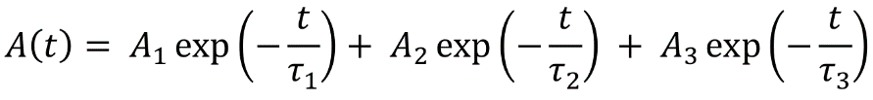
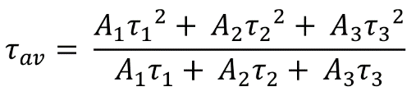
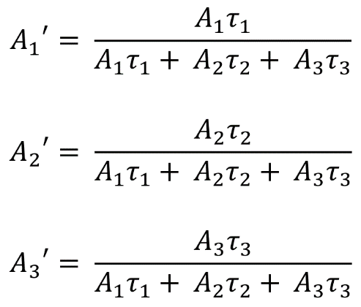
H₂O₂ Detection. The hydrogen peroxide (H₂O₂) content was measured using the iodometric method^{[1]}. Specifically, 1 mL of potassium iodide solution (0.4 mol·L⁻¹) and 1 mL of potassium hydrogen phthalate solution (0.1 mol·L⁻¹) were mixed, followed by the addition of 0.5 mL of the centrifuged reaction supernatant to the mixture. The resulting solution was left to stand for 30 minutes to ensure that H₂O₂ reacted sufficiently with I⁻ under acidic conditions to form I₃⁻ (H₂O₂ + 3I⁻ + 2H⁺ → I₃⁻ + 2H₂O). The absorbance of I₃⁻ at 350 nm was then measured using UV-visible spectroscopy, and the H₂O₂ content was calculated based on a standard curve.
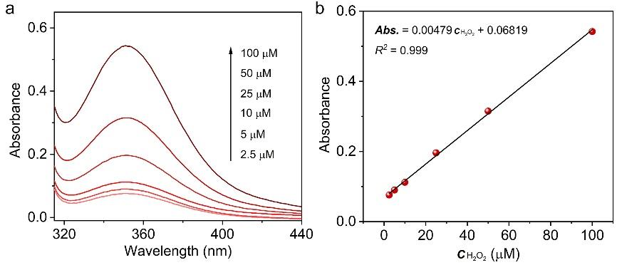
Figure S1. (a) The UV-Vis absorption spectra of different H₂O₂ concentrations, (b) The standard curve of H₂O₂.

Apparent quantum yield (AQY) measurement. The AQY of H₂O₂ over CsPbI₃@COF-Cl was measured with irradiation light through different wavelength band pass filter (420, 450, 500, 550 and 650 nm). The photon flux of incident light was measured by a NBT 300UV photo radiometer. The AQY was calculated according to the following equation^{[2]}:
$$AQY \left(\%\right)=\frac{N_{h}}{N_{p}}×100\%=\frac{2×N_{A}×M×h×c}{P×S×λ×t}×100\%$$
Where N_{h} denotes the amount of reaction holes, N_{p} represents the number of incident photons, N_{A} is the Avogadro’s constant, M is the molar amount of H₂O₂, h refers to the Planck constant, c indicates the speed of light, P is the intensity of the irradiation, S denotes the irradiation area, λ is the irradiation wavelength and t represents the irradiation time.
Solar-to-chemical conversion. The solar-to-chemical conversion (SCC) efficiency was determined by a 300 W xenon lamp was used as light source and thereafter was calculated using the following equation^{[2]}:
$SCC efficiency \left(\%\right)=\frac{\left[∆G for H_{2}O_{2} generation \left(J {mol}^{-1}\right)\right]×[H_{2}O_{2} formed \left(mol\right)]}{\left[Total input power \left(W\right)\right][Reaction times (s)]}×100$%
Where the free energy for H₂O₂ formation is 117 kJ mol⁻¹.
Theoretical Calculation Methods. All density functional theory (DFT) calculations were performed using CP2K, which employs the Gaussian and plane waves (GPW) method. Periodic systems were optimized using the PBE functional and the DZVP-MOLOPT-SR-GTH pseudopotential basis set, combined with DFT-D3 (BJ) dispersion correction. Wavefunction analysis and visualization were conducted using Multiwfn and VESTA, respectively. In this study, gamma-point sampling was used, and a vacuum layer exceeding 15 Å in the z-direction was included to effectively avoid the influence of periodic boundary effects on the simulation results.

2. Supplementary Figures
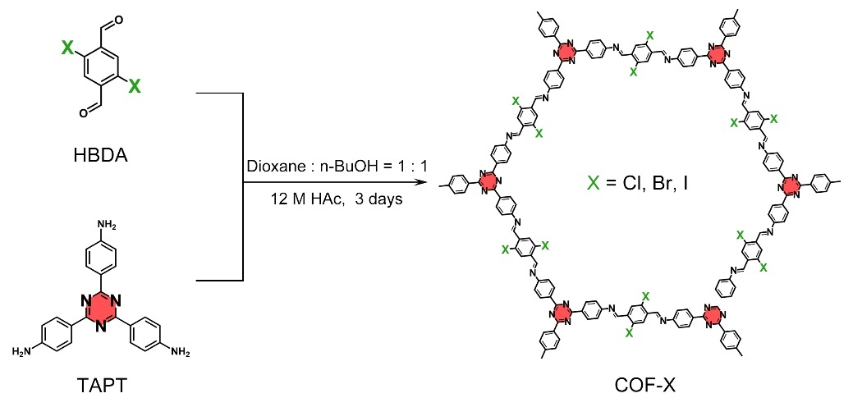
Figure S2. Schematic illustration of synthesis of COF-X matrixes.

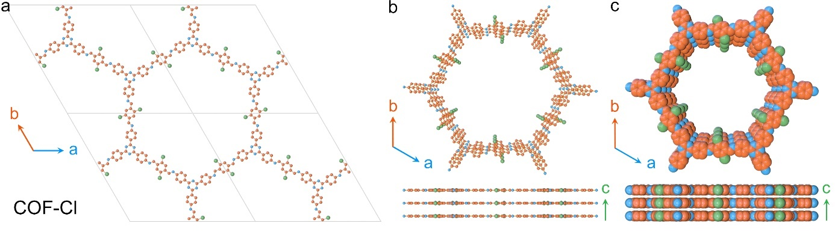
Figure S3. The topology network of the COF-Cl matrix.

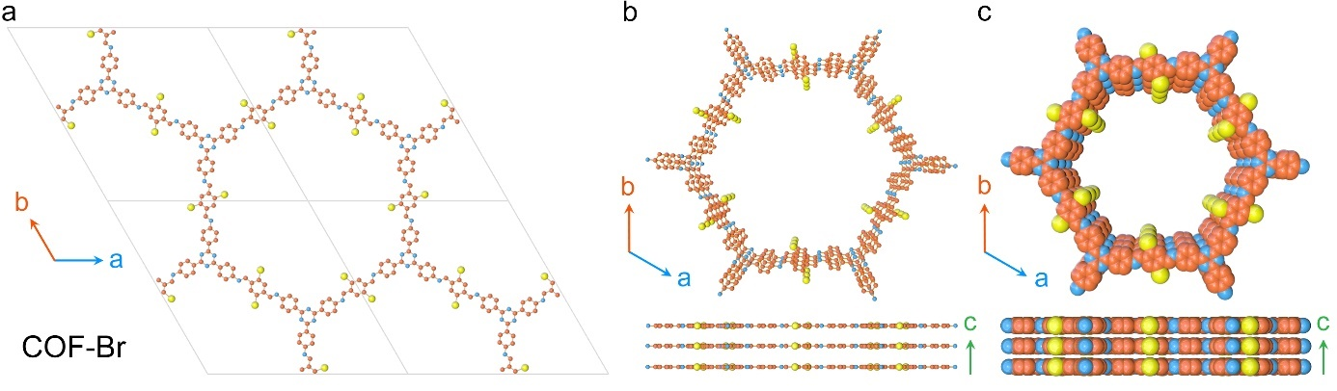
Figure S4. The topology network of the COF-Br matrix.

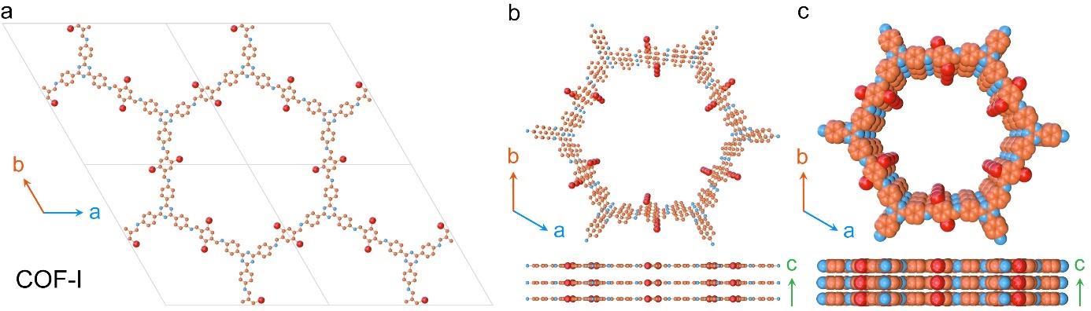
Figure S5. The topology network of the COF-I matrix.

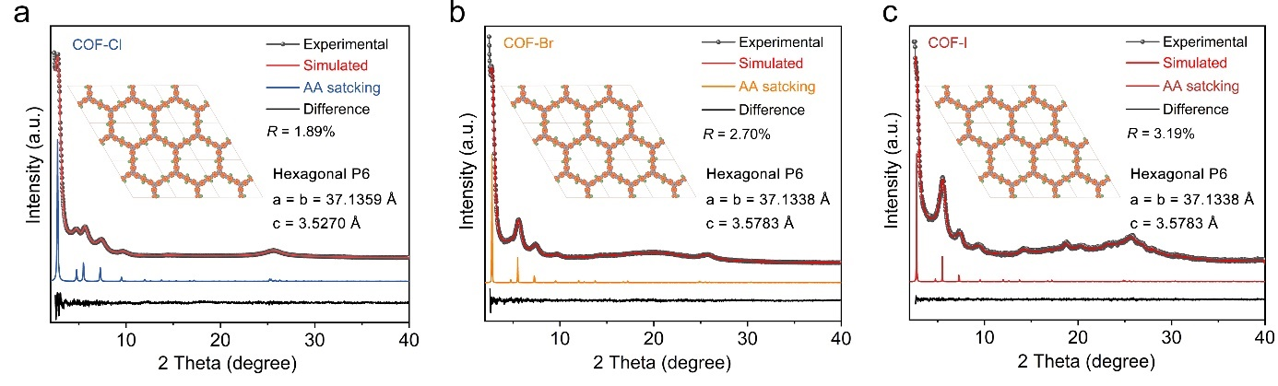
Figure S6. (a) Experimental (red dot) and simulated (blue line) PXRD patterns of the COF-Cl matrix. (b) Experimental (red dot) and simulated (orange line) PXRD patterns of the COF-Br matrix. (c) Experimental (red dot) and simulated (red line) PXRD patterns of the COF-I matrix. Insets are the modeled crystal structures.

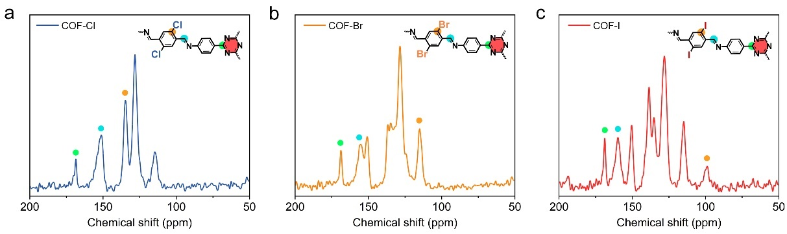
Figure S7. (a) ¹³C solid NMR spectra of COF-Cl matrixes. (a) ¹³C solid NMR spectra of COF-Br matrixes. (a) ¹³C solid NMR spectra of COF-I matrixes.

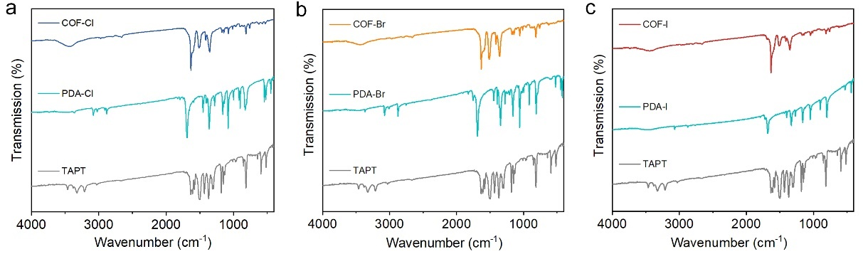
Figure S8. (a) The FTIR spectrum for COF-Cl matrixes. (b) The FTIR spectrum for COF-Br matrixes. (c) The FTIR spectrum for COF-I matrixes.

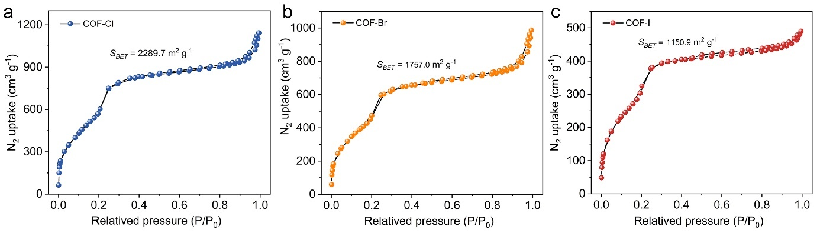
Figure S9. (a) N₂ adsorption-desorption isotherms for COF-Cl matrixes. (b) N₂ adsorption-desorption isotherms for COF-Br matrixes. (c) N₂ adsorption-desorption isotherms for COF-I matrixes.

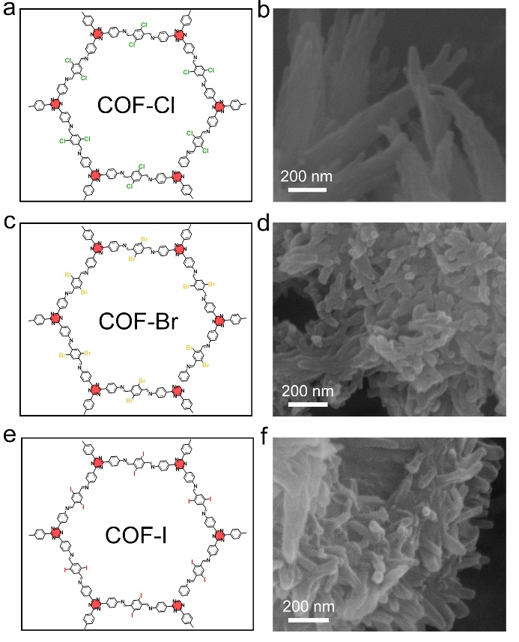
Figure S10. (a) The schematic structure of the COF-Cl matrix. (b) The SEM image of the COF-Cl matrix. (c) The schematic structure of the COF-Br matrix. (d) The SEM image of the COF-Br matrix. (e) The schematic structure of the COF-I matrix. (f) The SEM image of the COF-I matrix.

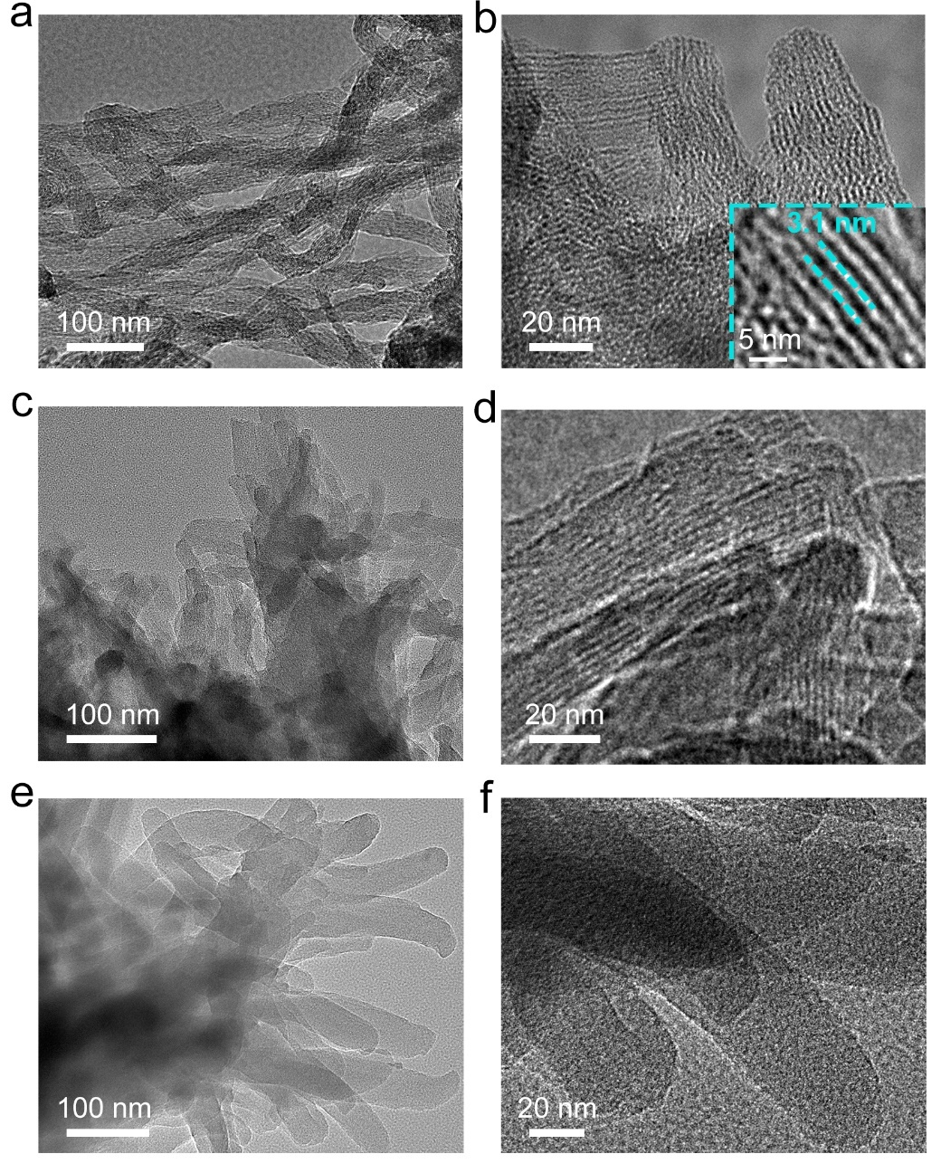
Figure S11. (a, b) The TEM image of the COF-Cl matrix. the inset is the high-resolution TEM image of the selected area. (c, d) The TEM image of the COF-Br matrix. (e, f) The TEM image of the COF-I matrix.

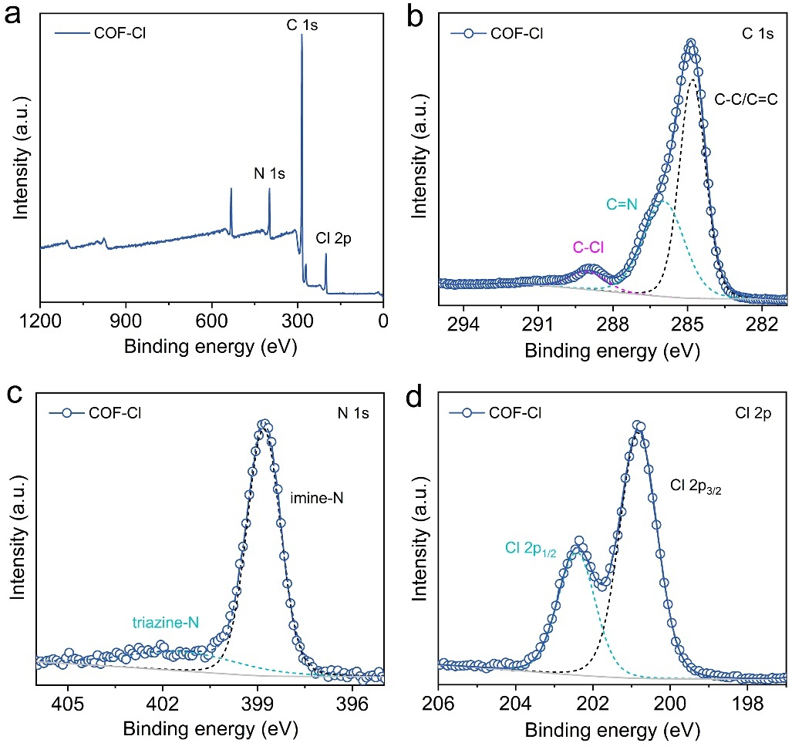
Figure S12. (a) The survey XPS spectra of COF-Cl matrix. (b) XPS high-resolution scans for C 1s. (c) XPS high-resolution scans for N 1s. (d) XPS high-resolution scans for Cl 2p.

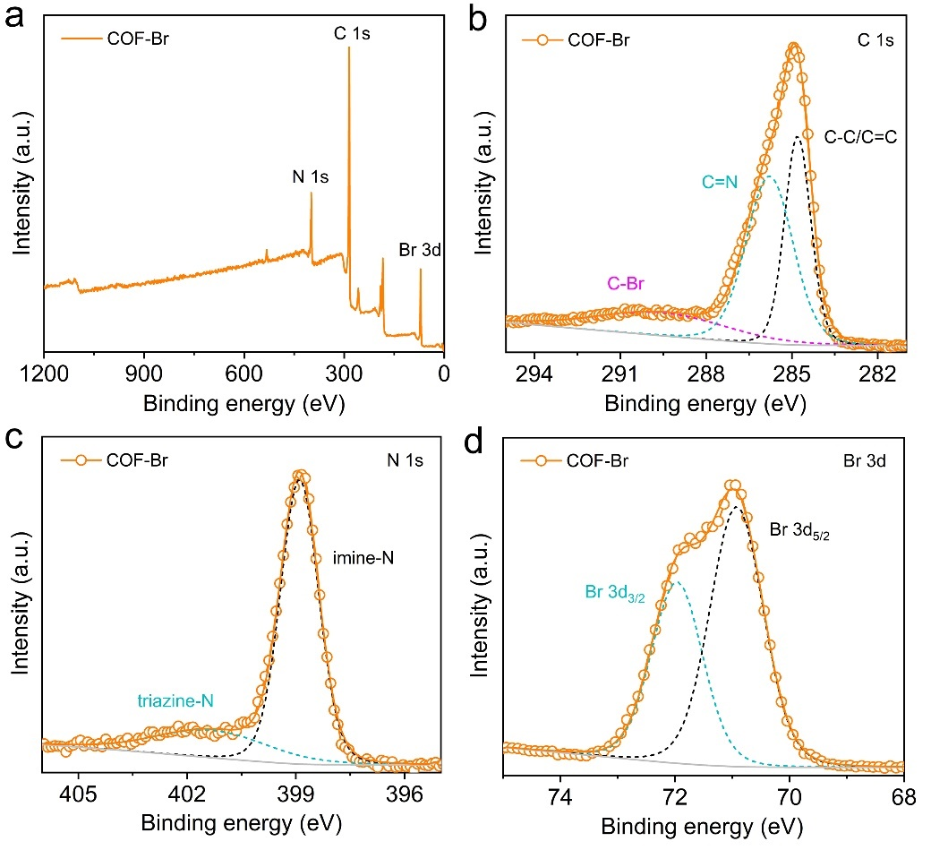
Figure S13. (a) The survey XPS spectra of COF-Br matrix. (b) XPS high-resolution scans for C 1s. (c) XPS high-resolution scans for N 1s. (d) XPS high-resolution scans for Br 3d.

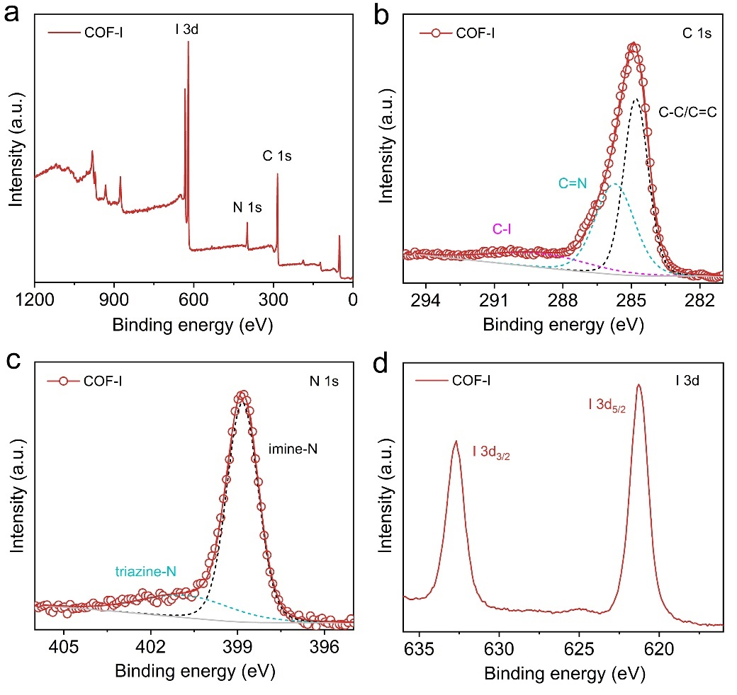
Figure S14. (a) The survey XPS spectra of COF-I matrix. (b) XPS high-resolution scans for C 1s. (c) XPS high-resolution scans for N 1s. (d) XPS high-resolution scans for I 3d.

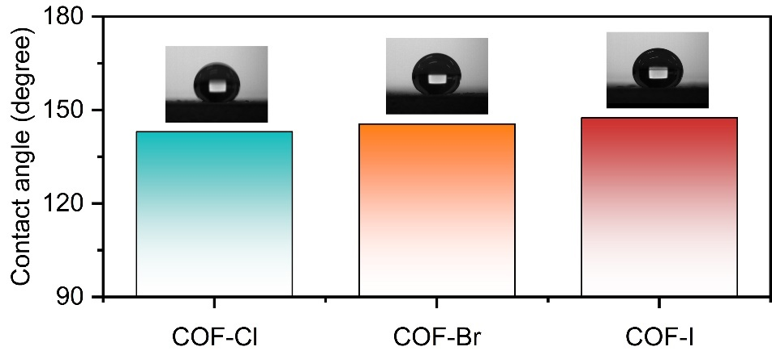
Figure S15. The water contact angle of the COF-X matries.

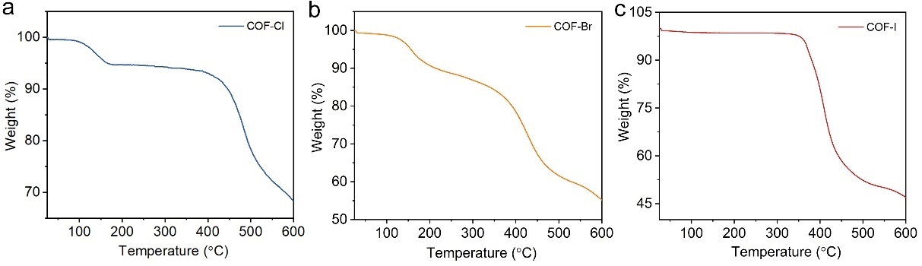
Figure S16. Thermo gravimetric analysis (TGA) of COF-Cl matrix (a), COF-Br matrix (b) and COF-I (c).

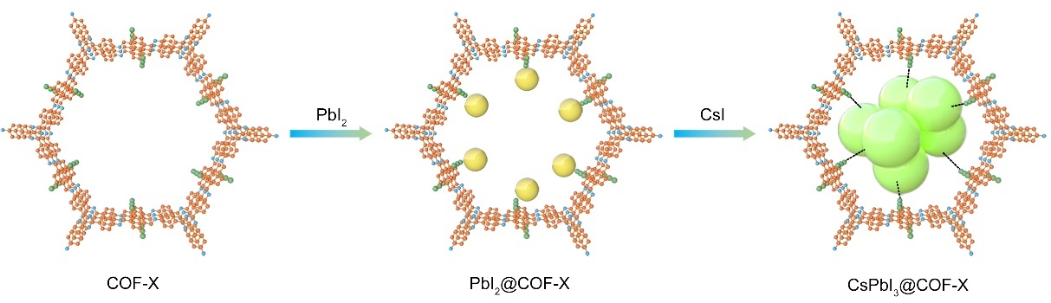
Figure S17. The synthetic route of the CsPbI₃@COF-Cl system.

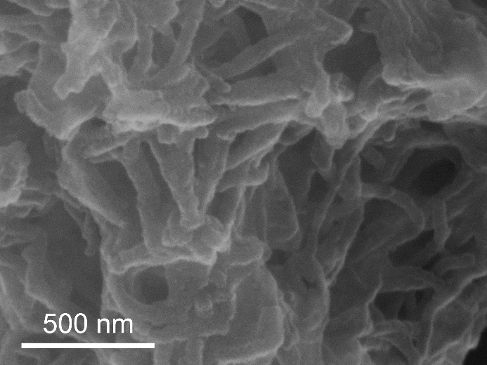
Figure S18. The SEM image of the CsPbI₃@COF-Cl system.

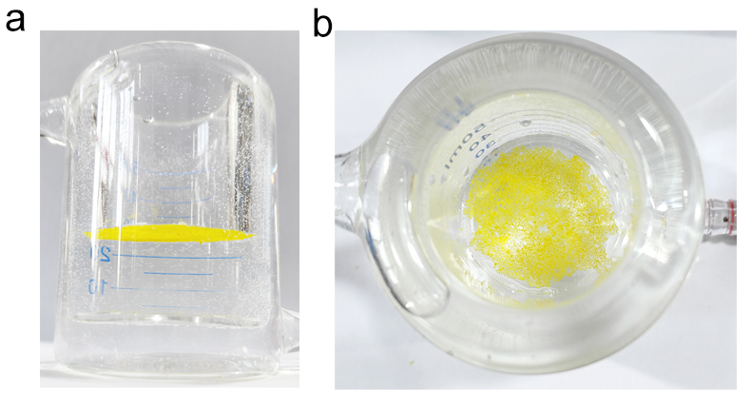
Figure S19. Photographs of the floating triple-phase interfacial catalyst.

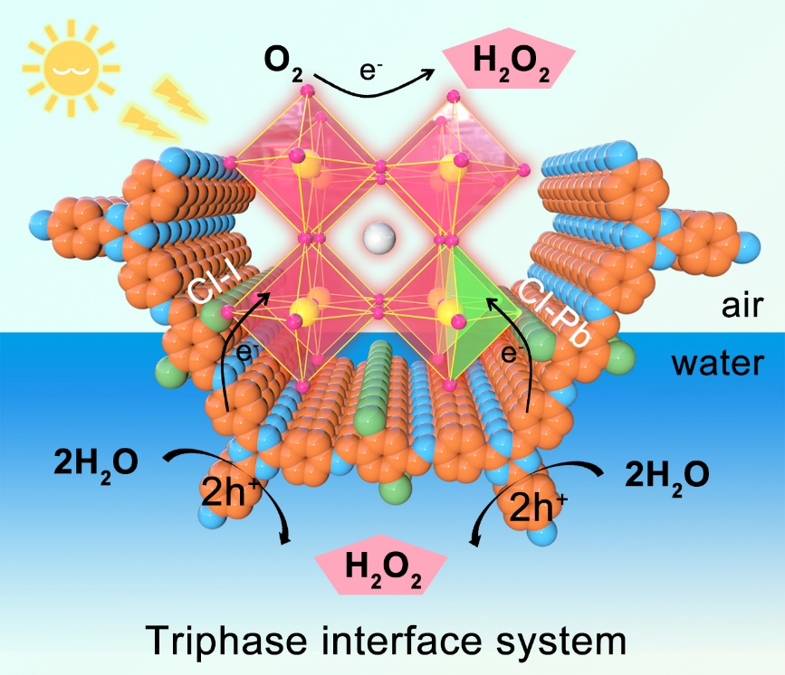
Figure S20. Schematic illustration of the CsPbI₃@COF-Cl system for photocatalytic H₂O₂ production at the triple-phase interface.
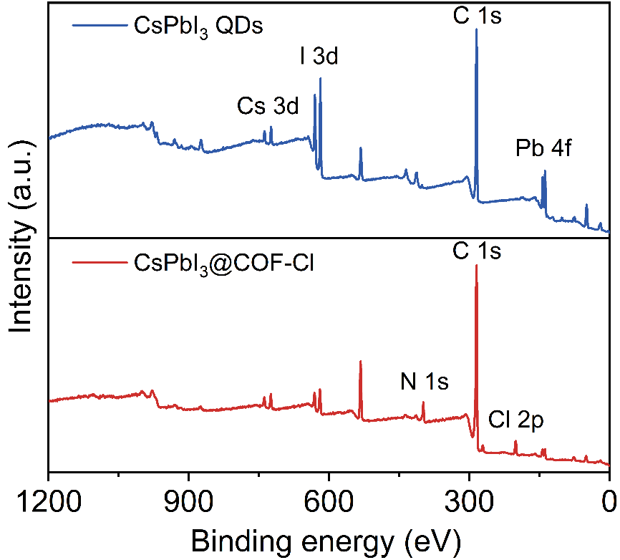
Figure S21. The survey XPS spectra of CsPbI₃ QDs and CsPbI₃@COF-Cl system.
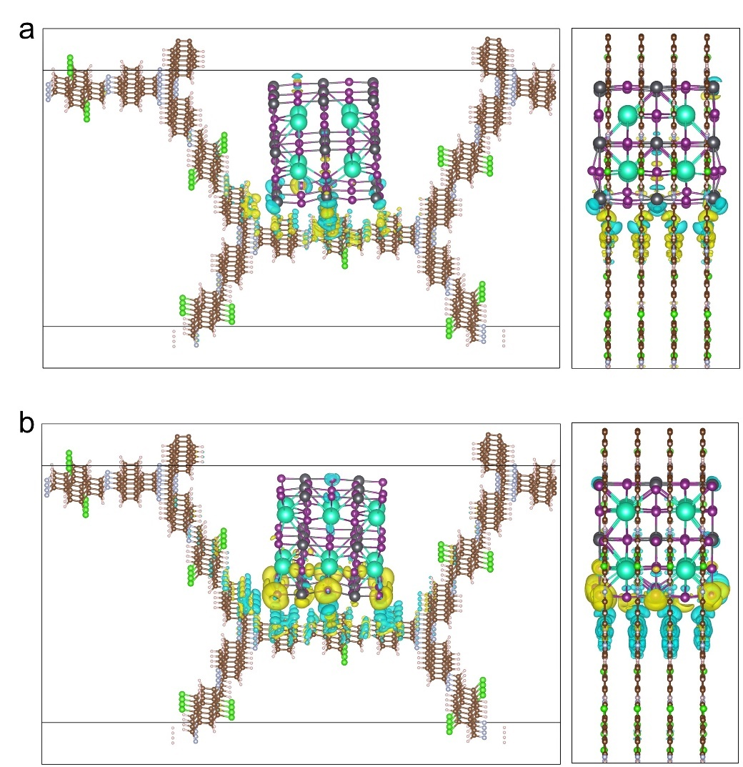
Figure S22. (a) Differential charge density map illustrating the passivation of adjacent defects between COF-Cl matrix and lead-rich CsPbI₃ perovskite surface (left: front view; right: side view). (b) Differential charge density map showing neighboring defect passivation at COF-Cl/CsPbI₃ perovskite iodine-rich interface.

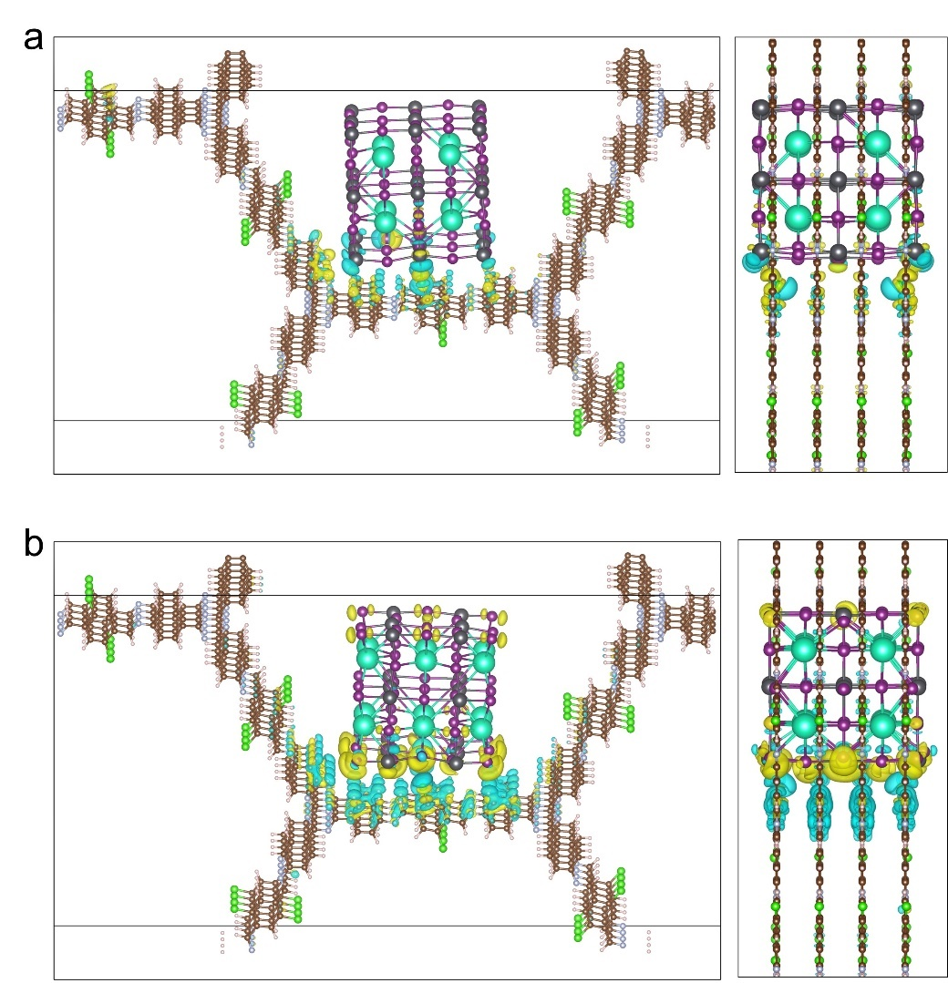
Figure S23. (a) Atomic structure demonstrating meta-position defect passivation between CsPbI₃ perovskite lead-rich surface and COF-Cl matrix with partial Cl functional group removal. (b) Atomic configuration of meta-defect passivation between iodine-rich CsPbI₃ perovskite surface and partially Cl-depleted COF-Cl matrix.

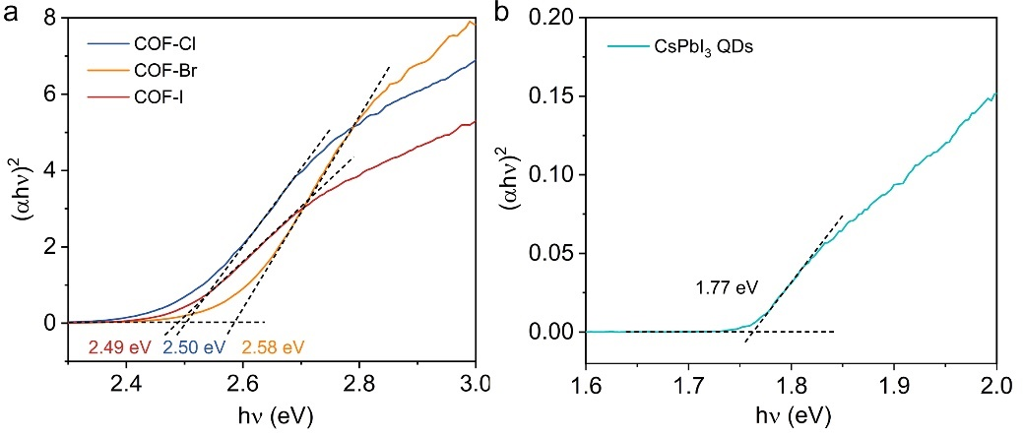
Figure S24. (a) Tauc-plots and band gap energies of COF-X matrix. (a) The Tauc-plot and band gap energy of CsPbI₃ QDs.

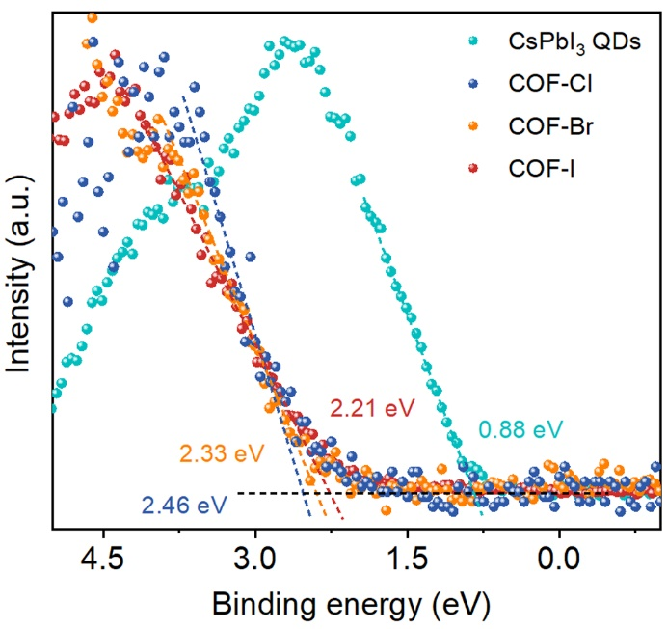
Figure S25. VB XPS spectra of CsPbI₃ QDs and COF-X matrix.

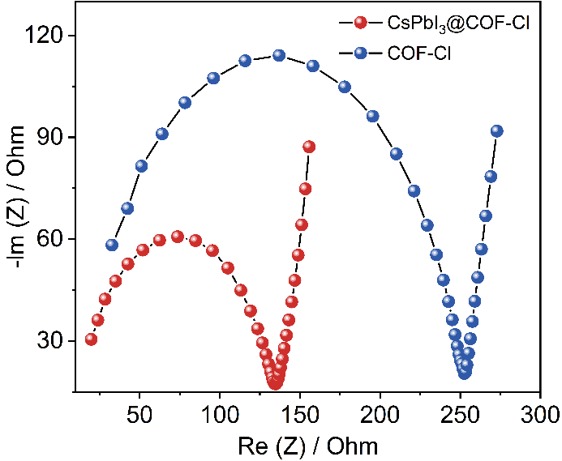
Figure S26. EIS curves of COF-Cl matrix and CsPbI₃@COF-Cl system.

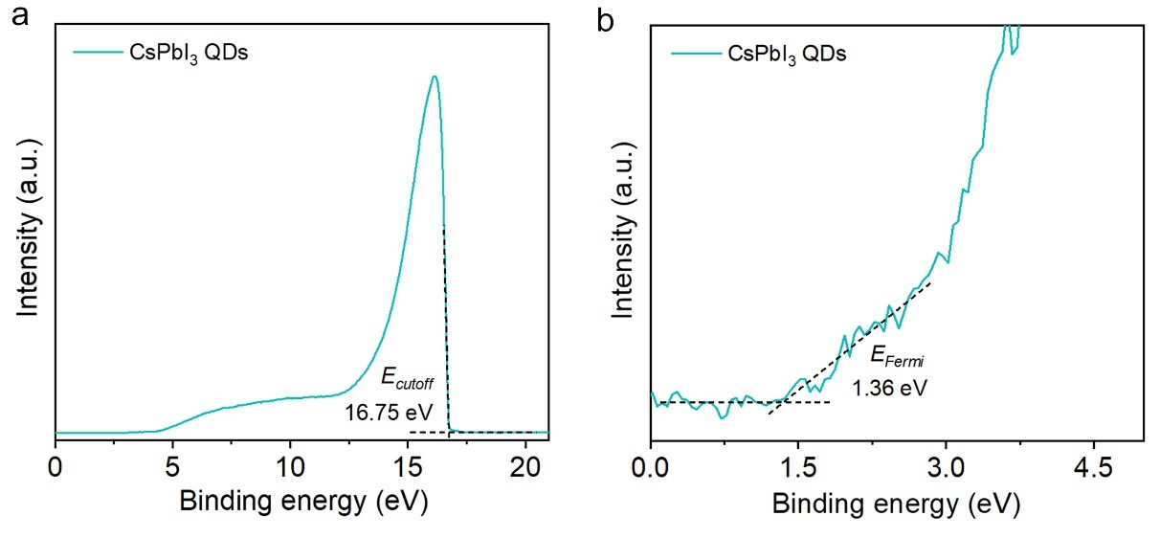
Figure S27. UPS spectrum of CsPbI₃ QDs.

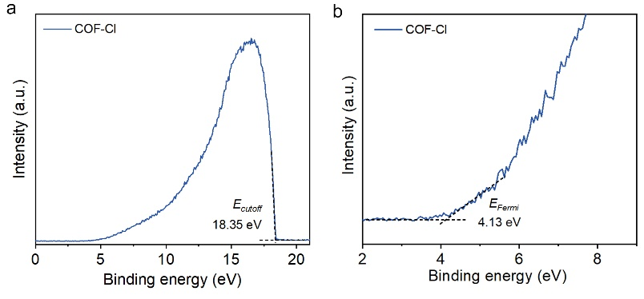
Figure S28. UPS spectrum of COF-Cl matrix.

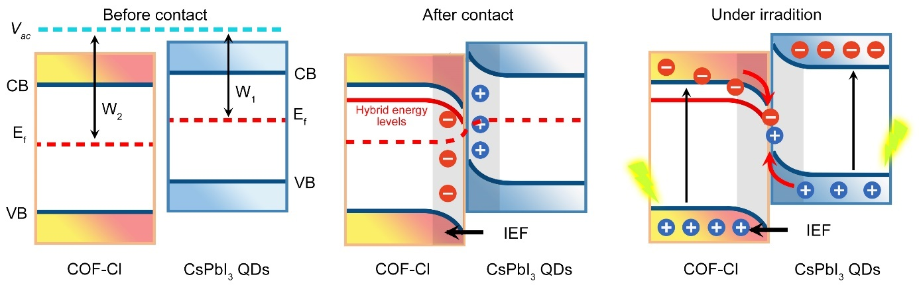
Figure S29. Mechanism diagram of photogenerated electron transfer at the interface of S-scheme CsPbI₃@COF-Cl system.
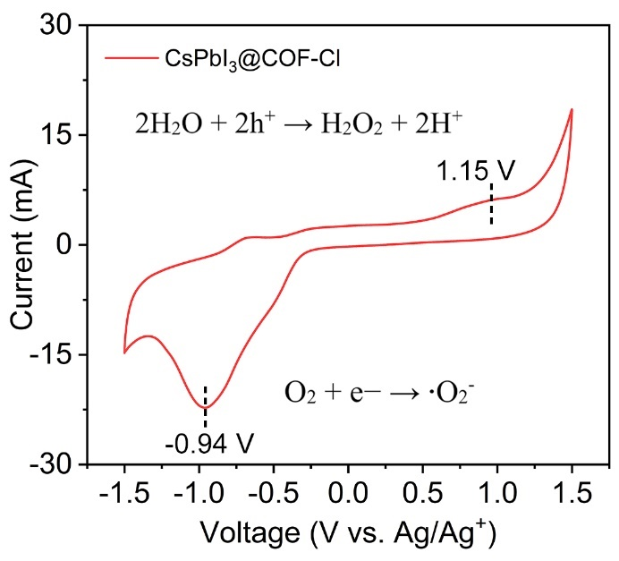
Figure S30. The CV curve of CsPbI₃@COF-Cl system.

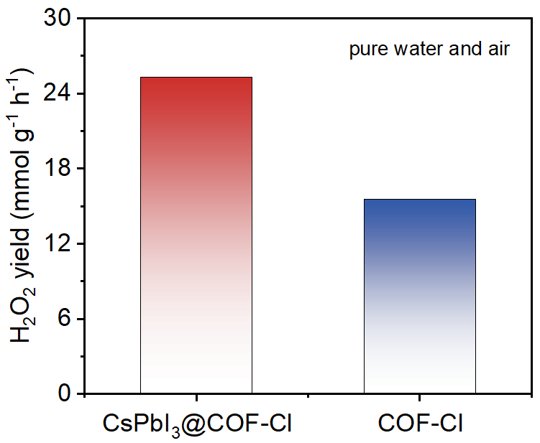
Figure S31. The photosynthesis rates by the COF-Cl matrix and CsPbI₃@COF-Cl system under pure water and air conditions.

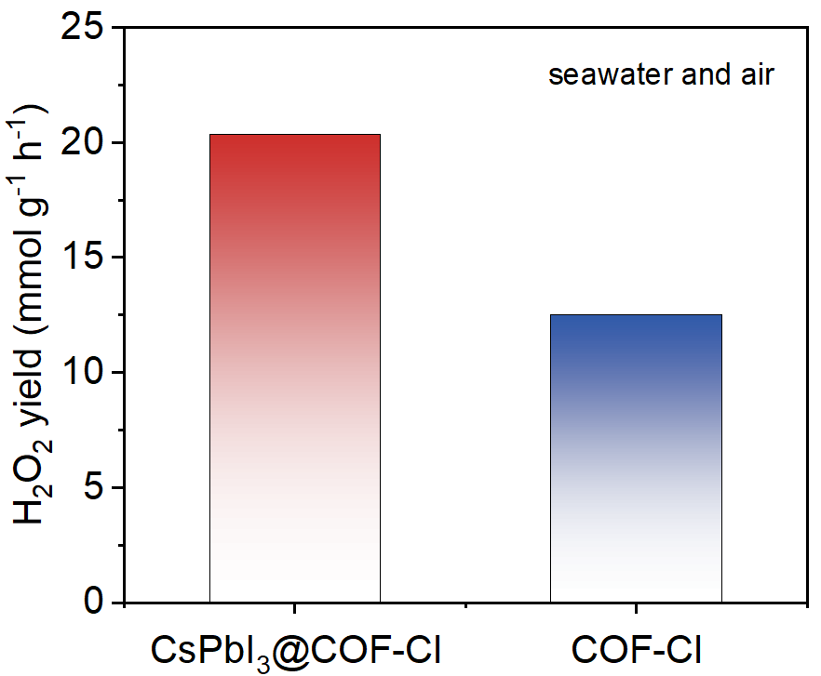
Figure S32. The photosynthesis rates by the COF-Cl matrix and CsPbI₃@COF-Cl system under seawater and air conditions.
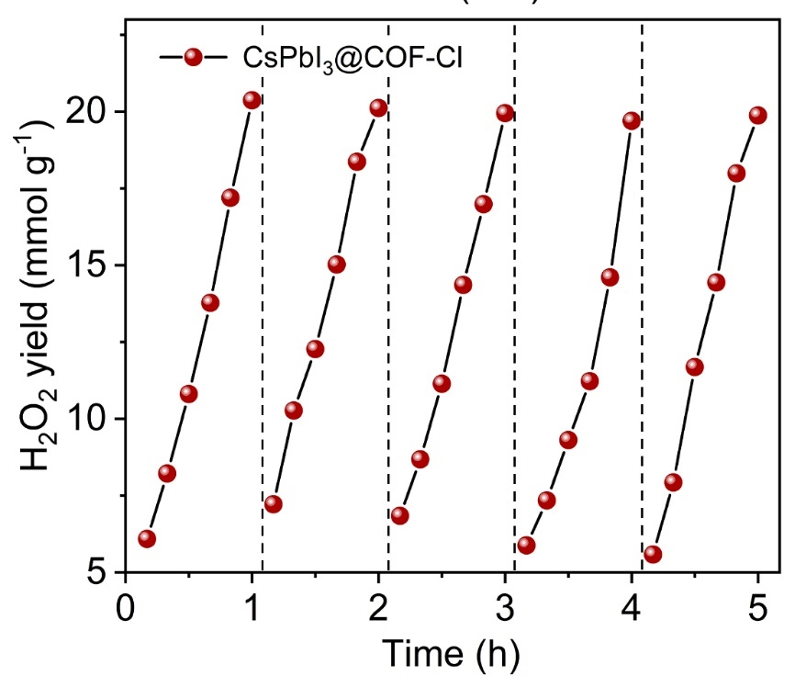
Figure S33. Cycling performance of CsPbI₃@COF-Cl system for H₂O₂ production.

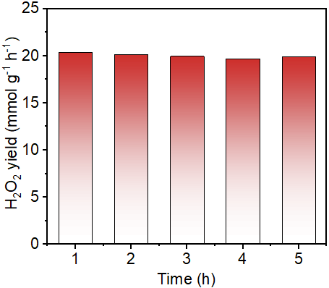
Figure S34. The cycling photosynthesis rates by the CsPbI₃@COF-Cl system under seawater and air conditions.
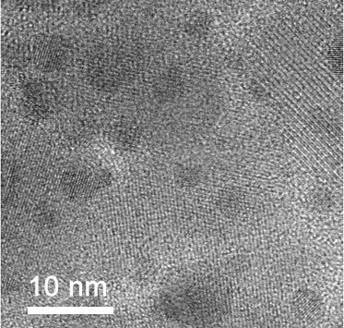
Figure S35. The TEM image CsPbI₃@COF-Cl system after five cycle tests in seawater.

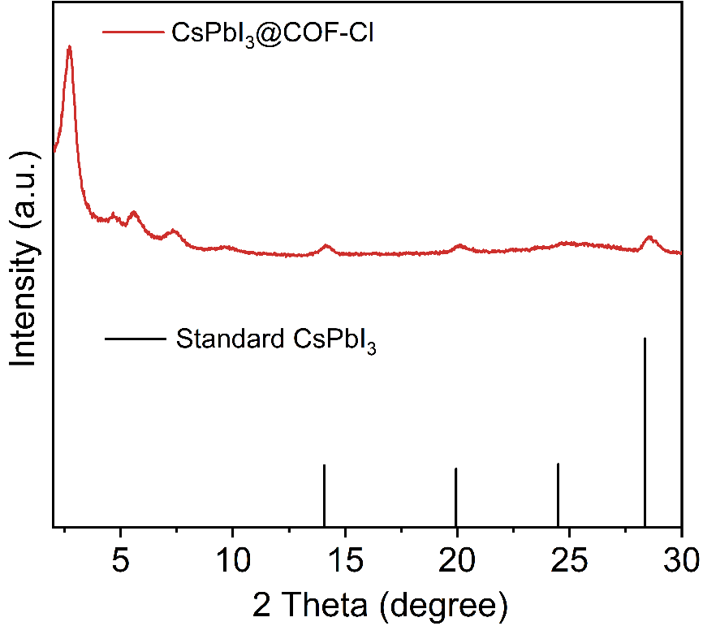
Figure S36. The XRD pattern of CsPbI₃@COF-Cl system after five cycle tests in seawater.

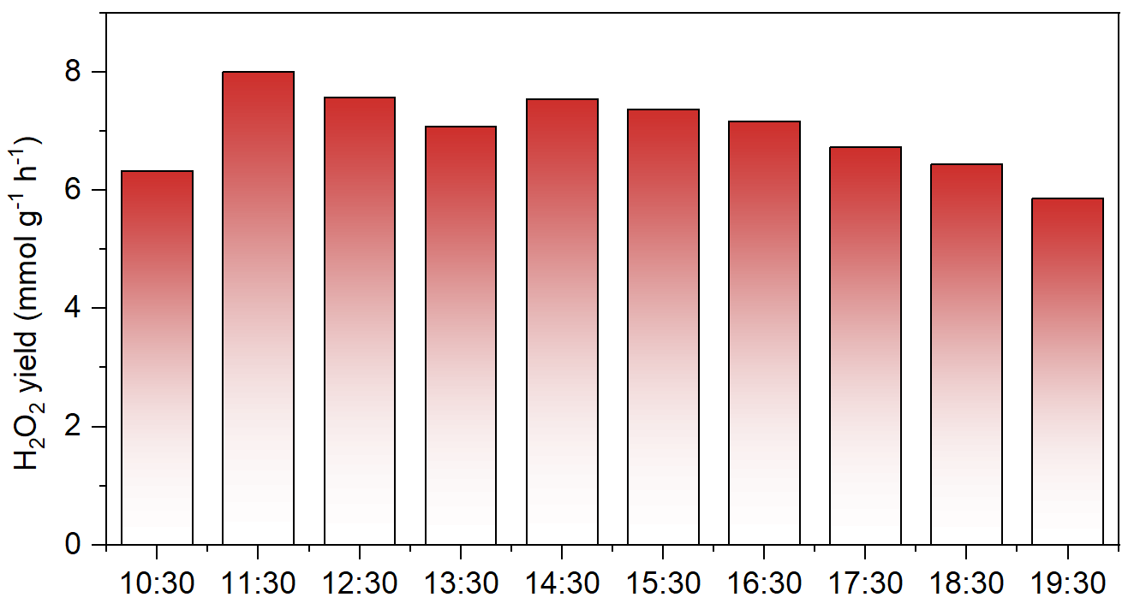
Figure S37. The H₂O₂ photosynthesis rates, system temperatures and light intensities of HDPC at different time in outdoor experiment.

3. Supplementary Tables
Table S1. The crystallographic parameters of COF-X (X = Cl, Br and I) matrixes.
Sample | a (Å) | b (Å) | c (Å) | N-N（Å） | X-X（Å）
COF-Cl | 37.135900 | 37.135900 | 3.670495 | 40.1283 | 31.2480
COF-Br | 36.977100 | 36.977100 | 3.746085 | 39.9460 | 30.7207
COF-I | 36.973900 | 36.973900 | 3.957944 | 39.9380 | 30.2872

Table S2. Specific surface areas calculated with BET method.
Sample | Specific Surface Area (m² g⁻¹) | Pore volume (m³ g⁻¹) | Pore size (nm)
COF-Cl | 2289.7 | 1.77 | 3.09
COF-Br | 1757.0 | 1.53 | 3.23
COF-I | 1150.9 | 0.76 | 2.63
CsPbI₃@COF-Cl | 1318.1 | 1.05 | -

Table S3. Fluorescence lifetimes of CsPbBr₃ QDs and CsPbI₃@COF-Cl.
Sample | τ₁ (ns) | Rel (%) | τ₂ (ns) | Rel (%) | τ₃(ns) | Rel (%) | τ_{av} (ns)
CsPbBr₃ QDs | 3.13 | 20.80 | 13.68 | 51.45 | 62.22 | 27.75 | 24.96
CsPbI₃@COF-Cl | 9.60 | 7.86 | 57.52 | 40.12 | 289.41 | 52.02 | 174.38

Table S4. Comparison of performance with reported photocatalysts.
Catalysts | H₂O₂ yield  (mmol h⁻¹ g⁻¹)  In pure water | H₂O₂ yield  (mmol h⁻¹ g⁻¹) in seawater | AQY (%) | SCC (%) | Ref.
CsPbI₃@COF-Cl | 25.29 | 20.37 | 15.76 | 1.38 | This work
COF-BD2 | 5.21 | 3.99 | 18.4 | 0.68 | 3
NQPD-3 | 3.06 | 3.56 | 12.8 | 0.27 | 4
TBA-COF | - | 8.88 | 9.56 | 0.62 | 5
2, 5-DhaTph | - | 1.50 | 0.15 | - | 6
COF PTTN-AO | 6.02 | 3.00 | - | 0.61 | 7
TAPT-2KtTb Pd COF | 3.23 | 2.68 | 9.5 | 1.39 | 8
TPB-COF | 7.87 | 5.70 | 6.89 | 0.3 | 9
UP-TP | - | 3.85 | 4.52 | 0.24 | 10
TD-COF | 4.06 | 3.36 | - | 0.15 | 11
DT₂TA-TAPB | 8.59 | - | 3.3 | - | 12
SSPM | 7.70 | - | - | - | 13
Re10-MFM-67 | 8.50 | - | - | - | 14

Table S5. Fractional atomic coordinates and the unit cell of COF-Cl.
space group: P6/m
α = 90.000°, β = 90.000°, γ = 120.000°
a = 37.135900 Å, b = 37.135900 Å, c = 3.670495 Å
Atom | x | y | z | Occupancy
H | 0.43928 | 0.75528 | 0.49835 | 1
H | 0.48151 | 0.83333 | 0.4991 | 1
H | 0.36856 | 0.83902 | 0.50018 | 1
H | 0.32743 | 0.76227 | 0.50041 | 1
H | 0.40934 | 0.90184 | 0.49579 | 1
H | 0.47451 | 0.05028 | 0.50543 | 1
N | 0.31376 | 0.68992 | 0.50018 | 1
C | 0.29237 | 0.64795 | 0.50049 | 1
C | 0.38058 | 0.75367 | 0.49928 | 1
C | 0.22196 | 0.58321 | 0.50018 | 1
C | 0.17878 | 0.56342 | 0.50018 | 1
C | 0.15818 | 0.58679 | 0.50042 | 1
C | 0.1828 | 0.63056 | 0.50064 | 1
C | 0.22601 | 0.65033 | 0.50085 | 1
N | 0.45585 | 0.88506 | 0.50018 | 1
C | 0.46881 | 0.55759 | 0.49805 | 1
C | 0.48485 | 0.52874 | 0.49935 | 1
C | 0.52803 | 0.54249 | 0.50018 | 1
C | 0.5426 | 0.51456 | 0.50068 | 1
Cl | 0.40448 | 0.96925 | 0.50404 | 1
H | 0.684 | 0.43922 | 0.50018 | 1
H | 0.24474 | 0.68406 | 0.50072 | 1
H | 0.56072 | 0.2447 | 0.50139 | 1
H | 0.31599 | 0.56077 | 0.50127 | 1
H | 0.75528 | 0.31596 | 0.50387 | 1
H | 0.64828 | 0.48146 | 0.49984 | 1
H | 0.1668 | 0.64835 | 0.50018 | 1
H | 0.51851 | 0.16667 | 0.50213 | 1
H | 0.3517 | 0.51853 | 0.50157 | 1
H | 0.83322 | 0.35168 | 0.50079 | 1
H | 0.52955 | 0.36851 | 0.50314 | 1
H | 0.16102 | 0.52961 | 0.49867 | 1
H | 0.63144 | 0.16097 | 0.48979 | 1
H | 0.47044 | 0.63148 | 0.49825 | 1
H | 0.83899 | 0.4704 | 0.49103 | 1
H | 0.56516 | 0.32738 | 0.50271 | 1
H | 0.23776 | 0.56523 | 0.49971 | 1
H | 0.67258 | 0.23771 | 0.49181 | 1
H | 0.43483 | 0.67261 | 0.49734 | 1
H | 0.76224 | 0.43478 | 0.49554 | 1
H | 0.5075 | 0.40933 | 0.49932 | 1
H | 0.09819 | 0.50757 | 0.50707 | 1
H | 0.59067 | 0.09816 | 0.51061 | 1
H | 0.49248 | 0.59066 | 0.49531 | 1
H | 0.90181 | 0.49241 | 0.5231 | 1
H | 0.42421 | 0.47446 | 0.49868 | 1
H | 0.94978 | 0.42423 | 0.50087 | 1
H | 0.5255 | 0.94972 | 0.49724 | 1
H | 0.57577 | 0.52552 | 0.50137 | 1
H | 0.05022 | 0.57579 | 0.49744 | 1
N | 0.62387 | 0.31371 | 0.50018 | 1
N | 0.31012 | 0.62391 | 0.50018 | 1
N | 0.68625 | 0.31008 | 0.49979 | 1
N | 0.37613 | 0.68628 | 0.49959 | 1
N | 0.68987 | 0.37609 | 0.49993 | 1
C | 0.64446 | 0.29233 | 0.49989 | 1
C | 0.3521 | 0.6445 | 0.49948 | 1
C | 0.70763 | 0.35206 | 0.49981 | 1
C | 0.35555 | 0.70767 | 0.49967 | 1
C | 0.6479 | 0.3555 | 0.5004 | 1
C | 0.62692 | 0.38052 | 0.50078 | 1
C | 0.24636 | 0.62698 | 0.50086 | 1
C | 0.61943 | 0.24633 | 0.49897 | 1
C | 0.37307 | 0.61946 | 0.49882 | 1
C | 0.75364 | 0.37303 | 0.49971 | 1
C | 0.6388 | 0.22192 | 0.49499 | 1
C | 0.41684 | 0.63883 | 0.49784 | 1
C | 0.77804 | 0.4168 | 0.49667 | 1
C | 0.36122 | 0.77807 | 0.49973 | 1
C | 0.58315 | 0.36116 | 0.50172 | 1
C | 0.61541 | 0.17874 | 0.49445 | 1
C | 0.43663 | 0.61544 | 0.49802 | 1
C | 0.82122 | 0.4366 | 0.49489 | 1
C | 0.3846 | 0.82125 | 0.49965 | 1
C | 0.56335 | 0.38455 | 0.50183 | 1
C | 0.57145 | 0.15816 | 0.4989 | 1
C | 0.41326 | 0.57147 | 0.49895 | 1
C | 0.84182 | 0.41324 | 0.49738 | 1
C | 0.42856 | 0.84184 | 0.49939 | 1
C | 0.58672 | 0.42851 | 0.50086 | 1
C | 0.5523 | 0.18278 | 0.50091 | 1
C | 0.36949 | 0.55233 | 0.50018 | 1
C | 0.81721 | 0.36947 | 0.49991 | 1
C | 0.44771 | 0.81722 | 0.49902 | 1
C | 0.63049 | 0.44765 | 0.50018 | 1
C | 0.57572 | 0.22597 | 0.50073 | 1
C | 0.34971 | 0.57576 | 0.50018 | 1
C | 0.77401 | 0.34968 | 0.50152 | 1
C | 0.42429 | 0.77402 | 0.49874 | 1
C | 0.65027 | 0.42423 | 0.5004 | 1
N | 0.5708 | 0.45582 | 0.50068 | 1
N | 0.11495 | 0.57085 | 0.49922 | 1
N | 0.54416 | 0.11494 | 0.49947 | 1
N | 0.42919 | 0.54417 | 0.49994 | 1
N | 0.88505 | 0.42919 | 0.49534 | 1
C | 0.91123 | 0.46879 | 0.50736 | 1
C | 0.44241 | 0.91124 | 0.49861 | 1
C | 0.53118 | 0.44239 | 0.50018 | 1
C | 0.08877 | 0.53122 | 0.50222 | 1
C | 0.55761 | 0.08876 | 0.50485 | 1
C | 0.95612 | 0.48486 | 0.50194 | 1
C | 0.47125 | 0.95613 | 0.50018 | 1
C | 0.51513 | 0.47124 | 0.50018 | 1
C | 0.04388 | 0.51516 | 0.50018 | 1
C | 0.52876 | 0.04387 | 0.50326 | 1
C | 0.98552 | 0.52804 | 0.49983 | 1
C | 0.45751 | 0.98556 | 0.50251 | 1
C | 0.47195 | 0.4575 | 0.49986 | 1
C | 0.01447 | 0.47199 | 0.50018 | 1
C | 0.5425 | 0.01444 | 0.50113 | 1
C | 0.02802 | 0.54262 | 0.4988 | 1
C | 0.48545 | 0.02804 | 0.50376 | 1
C | 0.45739 | 0.48542 | 0.49938 | 1
C | 0.97198 | 0.4574 | 0.50049 | 1
C | 0.51456 | 0.97196 | 0.49952 | 1
Cl | 0.43525 | 0.40447 | 0.50018 | 1
Cl | 0.03083 | 0.4353 | 0.50018 | 1
Cl | 0.59553 | 0.03075 | 0.49952 | 1
Cl | 0.56474 | 0.59551 | 0.50073 | 1
Cl | 0.96917 | 0.56472 | 0.49687 | 1

Table S6. Fractional atomic coordinates and the unit cell of COF-Br.
space group: P6/m
α = 90.000°, β = 90.000°, γ = 120.000°
a = 36.977100 Å, b = 36.977100 Å, c = 3.746085 Å
Atom | x | y | z | Occupancy
H | 0.43969 | 0.75509 | 0.50006 | 1
H | 0.48221 | 0.83357 | 0.50124 | 1
H | 0.36869 | 0.83927 | 0.50006 | 1
H | 0.32735 | 0.76206 | 0.49877 | 1
H | 0.40893 | 0.90157 | 0.49743 | 1
H | 0.47505 | 0.05105 | 0.50006 | 1
N | 0.31384 | 0.69006 | 0.49979 | 1
C | 0.29231 | 0.64795 | 0.50033 | 1
C | 0.38089 | 0.75374 | 0.49928 | 1
C | 0.2219 | 0.58312 | 0.50049 | 1
C | 0.17861 | 0.5633 | 0.50006 | 1
C | 0.15813 | 0.58693 | 0.50006 | 1
C | 0.1827 | 0.63087 | 0.50006 | 1
C | 0.22604 | 0.65069 | 0.50063 | 1
N | 0.45605 | 0.88521 | 0.50083 | 1
C | 0.46901 | 0.55782 | 0.50217 | 1
C | 0.48516 | 0.52903 | 0.50006 | 1
C | 0.52832 | 0.5425 | 0.49962 | 1
C | 0.5428 | 0.51447 | 0.4998 | 1
H | 0.68453 | 0.4397 | 0.50029 | 1
H | 0.24499 | 0.68456 | 0.50091 | 1
H | 0.56028 | 0.24489 | 0.49646 | 1
H | 0.31547 | 0.56035 | 0.5007 | 1
H | 0.75502 | 0.31545 | 0.49833 | 1
H | 0.64859 | 0.48221 | 0.50083 | 1
H | 0.16654 | 0.64865 | 0.49976 | 1
H | 0.51777 | 0.16642 | 0.49699 | 1
H | 0.35138 | 0.51782 | 0.49868 | 1
H | 0.83347 | 0.35135 | 0.50028 | 1
H | 0.52933 | 0.36867 | 0.49903 | 1
H | 0.16067 | 0.52934 | 0.50006 | 1
H | 0.6313 | 0.16074 | 0.50494 | 1
H | 0.47067 | 0.63133 | 0.4992 | 1
H | 0.83934 | 0.47066 | 0.50167 | 1
H | 0.56517 | 0.32734 | 0.49984 | 1
H | 0.23786 | 0.56515 | 0.50066 | 1
H | 0.67263 | 0.23794 | 0.50254 | 1
H | 0.43486 | 0.67269 | 0.50041 | 1
H | 0.76216 | 0.43486 | 0.50088 | 1
H | 0.50729 | 0.40893 | 0.50518 | 1
H | 0.09839 | 0.50731 | 0.50162 | 1
H | 0.59107 | 0.09841 | 0.49867 | 1
H | 0.49269 | 0.59106 | 0.50801 | 1
H | 0.90164 | 0.49269 | 0.49736 | 1
H | 0.42398 | 0.47502 | 0.49951 | 1
H | 0.94893 | 0.42397 | 0.49931 | 1
H | 0.52494 | 0.94893 | 0.5007 | 1
H | 0.57601 | 0.52497 | 0.50006 | 1
H | 0.05109 | 0.57602 | 0.49935 | 1
N | 0.62366 | 0.31383 | 0.49946 | 1
N | 0.30994 | 0.62368 | 0.50046 | 1
N | 0.68615 | 0.30995 | 0.49976 | 1
N | 0.37635 | 0.68619 | 0.50006 | 1
N | 0.69007 | 0.37635 | 0.49943 | 1
C | 0.64423 | 0.29231 | 0.49946 | 1
C | 0.35206 | 0.64427 | 0.50031 | 1
C | 0.70769 | 0.35206 | 0.49952 | 1
C | 0.35576 | 0.70771 | 0.49953 | 1
C | 0.64796 | 0.35575 | 0.4995 | 1
C | 0.62706 | 0.38089 | 0.49976 | 1
C | 0.24627 | 0.62706 | 0.50061 | 1
C | 0.61909 | 0.24626 | 0.49949 | 1
C | 0.37295 | 0.61915 | 0.50053 | 1
C | 0.75373 | 0.37294 | 0.49967 | 1
C | 0.6387 | 0.22194 | 0.50164 | 1
C | 0.41689 | 0.63875 | 0.50032 | 1
C | 0.7781 | 0.41689 | 0.50057 | 1
C | 0.36128 | 0.77807 | 0.49925 | 1
C | 0.58312 | 0.36127 | 0.4997 | 1
C | 0.61526 | 0.17864 | 0.50256 | 1
C | 0.43672 | 0.6153 | 0.50006 | 1
C | 0.8214 | 0.43671 | 0.50099 | 1
C | 0.38472 | 0.82136 | 0.50006 | 1
C | 0.56328 | 0.38471 | 0.4996 | 1
C | 0.57114 | 0.1581 | 0.50053 | 1
C | 0.41309 | 0.57117 | 0.49959 | 1
C | 0.84188 | 0.41308 | 0.50059 | 1
C | 0.42885 | 0.84189 | 0.50034 | 1
C | 0.5869 | 0.42884 | 0.50006 | 1
C | 0.55173 | 0.18263 | 0.49831 | 1
C | 0.36915 | 0.55177 | 0.49963 | 1
C | 0.8173 | 0.36914 | 0.50006 | 1
C | 0.44826 | 0.81736 | 0.50047 | 1
C | 0.63084 | 0.44825 | 0.50034 | 1
C | 0.57522 | 0.22598 | 0.4979 | 1
C | 0.34933 | 0.57528 | 0.50042 | 1
C | 0.77396 | 0.34932 | 0.49929 | 1
C | 0.42476 | 0.77401 | 0.49984 | 1
C | 0.65067 | 0.42475 | 0.50006 | 1
N | 0.5708 | 0.45605 | 0.49942 | 1
N | 0.11481 | 0.57083 | 0.49935 | 1
N | 0.54395 | 0.11478 | 0.50067 | 1
N | 0.42919 | 0.54395 | 0.49831 | 1
N | 0.8852 | 0.42917 | 0.50072 | 1
C | 0.91118 | 0.469 | 0.49912 | 1
C | 0.44217 | 0.91115 | 0.49944 | 1
C | 0.53098 | 0.44217 | 0.50175 | 1
C | 0.08884 | 0.531 | 0.50006 | 1
C | 0.55783 | 0.08884 | 0.50006 | 1
C | 0.95614 | 0.48516 | 0.49931 | 1
C | 0.47096 | 0.95612 | 0.50006 | 1
C | 0.51482 | 0.47097 | 0.50006 | 1
C | 0.04388 | 0.51484 | 0.49932 | 1
C | 0.52903 | 0.04387 | 0.50036 | 1
C | 0.98584 | 0.52832 | 0.49946 | 1
C | 0.4575 | 0.9858 | 0.50006 | 1
C | 0.47167 | 0.45749 | 0.49979 | 1
C | 0.01418 | 0.47168 | 0.49947 | 1
C | 0.54249 | 0.01418 | 0.5005 | 1
C | 0.02836 | 0.54281 | 0.49916 | 1
C | 0.48553 | 0.02832 | 0.50027 | 1
C | 0.45718 | 0.48552 | 0.49945 | 1
C | 0.97166 | 0.45718 | 0.49931 | 1
C | 0.51446 | 0.97165 | 0.50063 | 1
Br | 0.39865 | 0.96828 | 0.49933 | 1
Br | 0.56967 | 0.60137 | 0.49852 | 1
Br | 0.43032 | 0.39863 | 0.50055 | 1
Br | 0.03166 | 0.43032 | 0.50006 | 1
Br | 0.60134 | 0.03169 | 0.50006 | 1
Br | 0.96837 | 0.56968 | 0.50144 | 1

Table S7. Fractional atomic coordinates and the unit cell of COF-I.
space group: P6/m
α = 90.000°, β = 90.000°, γ = 120.000°
a = 36.973900 Å, b = 36.973900 Å, c = 3.957944 Å
Atom | x | y | z | Occupancy
H | 0.43983 | 0.75513 | 0.50279 | 1
H | 0.48231 | 0.83359 | 0.50239 | 1
H | 0.36875 | 0.83924 | 0.49987 | 1
H | 0.32745 | 0.76204 | 0.49968 | 1
H | 0.40892 | 0.90149 | 0.49557 | 1
H | 0.4755 | 0.05136 | 0.50109 | 1
N | 0.31392 | 0.69009 | 0.50081 | 1
C | 0.29234 | 0.64799 | 0.50154 | 1
C | 0.381 | 0.75374 | 0.5 | 1
C | 0.22194 | 0.58319 | 0.49876 | 1
C | 0.17864 | 0.56335 | 0.49821 | 1
C | 0.15815 | 0.58697 | 0.50088 | 1
C | 0.18271 | 0.63091 | 0.50241 | 1
C | 0.22606 | 0.65074 | 0.50283 | 1
N | 0.4561 | 0.88523 | 0.50058 | 1
C | 0.4689 | 0.55771 | 0.51024 | 1
C | 0.48532 | 0.52913 | 0.50385 | 1
C | 0.52848 | 0.54263 | 0.50278 | 1
C | 0.54272 | 0.51438 | 0.50055 | 1
H | 0.68463 | 0.43977 | 0.50137 | 1
H | 0.24501 | 0.6846 | 0.50392 | 1
H | 0.5602 | 0.24489 | 0.49714 | 1
H | 0.31539 | 0.56026 | 0.50085 | 1
H | 0.75503 | 0.31541 | 0.5022 | 1
H | 0.64871 | 0.4823 | 0.50178 | 1
H | 0.16654 | 0.64869 | 0.50271 | 1
H | 0.5177 | 0.16643 | 0.49792 | 1
H | 0.35132 | 0.51773 | 0.49618 | 1
H | 0.8335 | 0.35133 | 0.50147 | 1
H | 0.5294 | 0.36879 | 0.50265 | 1
H | 0.16071 | 0.52941 | 0.49442 | 1
H | 0.63125 | 0.16076 | 0.50465 | 1
H | 0.47062 | 0.63124 | 0.49496 | 1
H | 0.83933 | 0.47063 | 0.49669 | 1
H | 0.56523 | 0.32744 | 0.50221 | 1
H | 0.23791 | 0.56524 | 0.4967 | 1
H | 0.67256 | 0.23796 | 0.50384 | 1
H | 0.43477 | 0.67257 | 0.50203 | 1
H | 0.76213 | 0.43479 | 0.49811 | 1
H | 0.50742 | 0.40895 | 0.49576 | 1
H | 0.09848 | 0.50739 | 0.51351 | 1
H | 0.59108 | 0.09852 | 0.49976 | 1
H | 0.49243 | 0.59091 | 0.53014 | 1
H | 0.90154 | 0.4926 | 0.51457 | 1
H | 0.4241 | 0.47547 | 0.49995 | 1
H | 0.94861 | 0.42414 | 0.50185 | 1
H | 0.52448 | 0.94864 | 0.50295 | 1
H | 0.57586 | 0.52451 | 0.49968 | 1
H | 0.05143 | 0.57587 | 0.49982 | 1
N | 0.62364 | 0.31388 | 0.50109 | 1
N | 0.30993 | 0.62367 | 0.50226 | 1
N | 0.68611 | 0.30992 | 0.50109 | 1
N | 0.37638 | 0.68614 | 0.50109 | 1
N | 0.6901 | 0.37635 | 0.50109 | 1
C | 0.64419 | 0.29232 | 0.50109 | 1
C | 0.35204 | 0.64422 | 0.50237 | 1
C | 0.70769 | 0.35203 | 0.50109 | 1
C | 0.35584 | 0.7077 | 0.50054 | 1
C | 0.64798 | 0.35579 | 0.50109 | 1
C | 0.62713 | 0.38097 | 0.50152 | 1
C | 0.2463 | 0.62712 | 0.50137 | 1
C | 0.61902 | 0.24627 | 0.5006 | 1
C | 0.37289 | 0.61905 | 0.50295 | 1
C | 0.75373 | 0.37289 | 0.50109 | 1
C | 0.63863 | 0.22195 | 0.50252 | 1
C | 0.41683 | 0.63864 | 0.50185 | 1
C | 0.7781 | 0.41683 | 0.49955 | 1
C | 0.36138 | 0.77806 | 0.49952 | 1
C | 0.58319 | 0.36137 | 0.50198 | 1
C | 0.6152 | 0.17865 | 0.50284 | 1
C | 0.43667 | 0.6152 | 0.4988 | 1
C | 0.8214 | 0.43667 | 0.49926 | 1
C | 0.3848 | 0.82135 | 0.49954 | 1
C | 0.56336 | 0.38482 | 0.50194 | 1
C | 0.57107 | 0.15811 | 0.50109 | 1
C | 0.41303 | 0.57108 | 0.49844 | 1
C | 0.84189 | 0.41305 | 0.50109 | 1
C | 0.42893 | 0.8419 | 0.49999 | 1
C | 0.58699 | 0.42895 | 0.50137 | 1
C | 0.55166 | 0.18263 | 0.49915 | 1
C | 0.36908 | 0.55168 | 0.49879 | 1
C | 0.81732 | 0.36911 | 0.50159 | 1
C | 0.44836 | 0.81738 | 0.50109 | 1
C | 0.63094 | 0.44835 | 0.50153 | 1
C | 0.57515 | 0.22599 | 0.49877 | 1
C | 0.34925 | 0.57519 | 0.50139 | 1
C | 0.77397 | 0.34927 | 0.50184 | 1
C | 0.42487 | 0.77403 | 0.50109 | 1
C | 0.65076 | 0.42483 | 0.50147 | 1
N | 0.57086 | 0.45613 | 0.50109 | 1
N | 0.11482 | 0.57084 | 0.50005 | 1
N | 0.5439 | 0.11478 | 0.50144 | 1
N | 0.42915 | 0.5439 | 0.49488 | 1
N | 0.88522 | 0.42917 | 0.50019 | 1
C | 0.91118 | 0.46897 | 0.50644 | 1
C | 0.44222 | 0.91116 | 0.49831 | 1
C | 0.53105 | 0.44224 | 0.49849 | 1
C | 0.08885 | 0.53103 | 0.50579 | 1
C | 0.55778 | 0.08885 | 0.50088 | 1
C | 0.9562 | 0.48535 | 0.50327 | 1
C | 0.47083 | 0.95618 | 0.49958 | 1
C | 0.51465 | 0.47085 | 0.49909 | 1
C | 0.04384 | 0.51465 | 0.50286 | 1
C | 0.52916 | 0.04383 | 0.50131 | 1
C | 0.9859 | 0.52852 | 0.50161 | 1
C | 0.45735 | 0.98585 | 0.49913 | 1
C | 0.47148 | 0.45735 | 0.49817 | 1
C | 0.01414 | 0.47149 | 0.50216 | 1
C | 0.54264 | 0.01415 | 0.50184 | 1
C | 0.02841 | 0.54274 | 0.50109 | 1
C | 0.48562 | 0.02836 | 0.5007 | 1
C | 0.45724 | 0.4856 | 0.50031 | 1
C | 0.97163 | 0.45727 | 0.50215 | 1
C | 0.51437 | 0.97164 | 0.50166 | 1
I | 0.39222 | 0.96725 | 0.49591 | 1
I | 0.57499 | 0.60777 | 0.49866 | 1
I | 0.42494 | 0.39222 | 0.4949 | 1
I | 0.03267 | 0.42493 | 0.49917 | 1
I | 0.96735 | 0.57507 | 0.49789 | 1
I | 0.60776 | 0.03271 | 0.50283 | 1

4. References
1 Li Y, et al. Constructing Solid-Gas-Interfacial Fenton Reaction over Alkalinized-C₃N₄ Photocatalyst To Achieve Apparent Quantum Yield of 49% at 420 nm. J. Am. Chem. Soc. 138, 13289-13297 (2016).
2 Liu J, et al. Constructing Donor-Acceptor Covalent Organic Frameworks for Highly Efficient H₂O₂ Photosynthesis Coupled with Oxidative Organic Transformations. Angew. Chem. Int. Ed. 64, e202416240 (2025).
3. Cao D, Du J, Li J, Sun Q, Guan J, Liu J. Hydroxyl-Functionalized Donor-Acceptor Covalent Organic Frameworks for Efficient Photocatalytic Hydrogen Peroxide Production under Visible Light. ACS Catal. 15, 3584-3594 (2025).
4. Yu Z, Yu F, Xu M, Feng S, Qiu J, Hua J. Amidoxime-Functionalized sp²-Carbon-Conjugated Covalent Organic Frameworks for Overall Photocatalytic Hydrogen Peroxide Production. Adv. Sci. 12, e2415194 (2025).
5. Shi X, et al. Interfacial Engineering of β‐Ketoenamine‐Based COFs/Urea‐Linked Perylene Diimide for Overall Photosynthesis of H₂O₂ in Seawater. Adv. Funct. Mater. 35, 2414755 (2024).
6. Yue JY, Pan ZX, Zhang RZ, Xu Q, Yang P, Tang B. One‐Pot Synthesis of Fully Conjugated Covalent Organic Frameworks via the Pictet–Spengler Reaction for Boosting H₂O₂ Photogeneration in Real Seawater. Adv. Funct. Mater. 35, 2421514 (2025).
7. Hou Y, Liu F, Liang J, Li Z, Zhou P, Tong M. Building a Confluence Charge Transfer Pathway in COFs for Highly Efficient Photosynthesis of Hydrogen Peroxide from Water and Air. Angew. Chem. Int. Ed. 64, e202505621 (2025).
8. Yue JY, et al. Thiophene-Containing Covalent Organic Frameworks for Overall Photocatalytic H₂O₂ Synthesis in Water and Seawater. Angew. Chem. Int. Ed. 62, e202309624 (2023).
9. Huang Y, et al. Nb2C MXene quantum dots modulate built-in electric field within heterostructures for efficient solar-to-H2O2 conversion from seawater. Appl. Catal. B Environ. 371, 125262 (2025).
10. Yue J-Y, et al. Overall solar H2O2 generation in water and real seawater by covalent organic frameworks with kgd topology. Chem. Eng. J 504, (2025).
11. Tang B, et al. Photocatalytic Synthesis of Hydrogen Peroxide by Rhenium Modified Metal-Organic Frameworks Incorporating Bianthracene Ligands. J. Am. Chem. Soc., 10.1021/jacs.1025c00603 (2025).
12. Hu ZY, Liu T, Yang YR, An AK, Liew KM, Li WW. Binder-Free Immobilization of Photocatalyst on Membrane Surface for Efficient Photocatalytic H₂O₂ Production and Water Decontamination. Nanomicro Lett. 17, 301 (2025).
13. Ju Y, et al. Regulating the electronic structure of covalent organic frameworks via heterocyclic isomers for highly efficient photocatalytic H₂O₂ generation. Nat. Commun. 16, 5658 (2025).
14. Zhou J, et al. Covalent Organic Frameworks with Constrained Palladium Nanoclusters Lock the Enol-Keto Tautomerism Enhancing Hydrogen Peroxide Photosynthesis. Small 21, e2409006 (2025).

