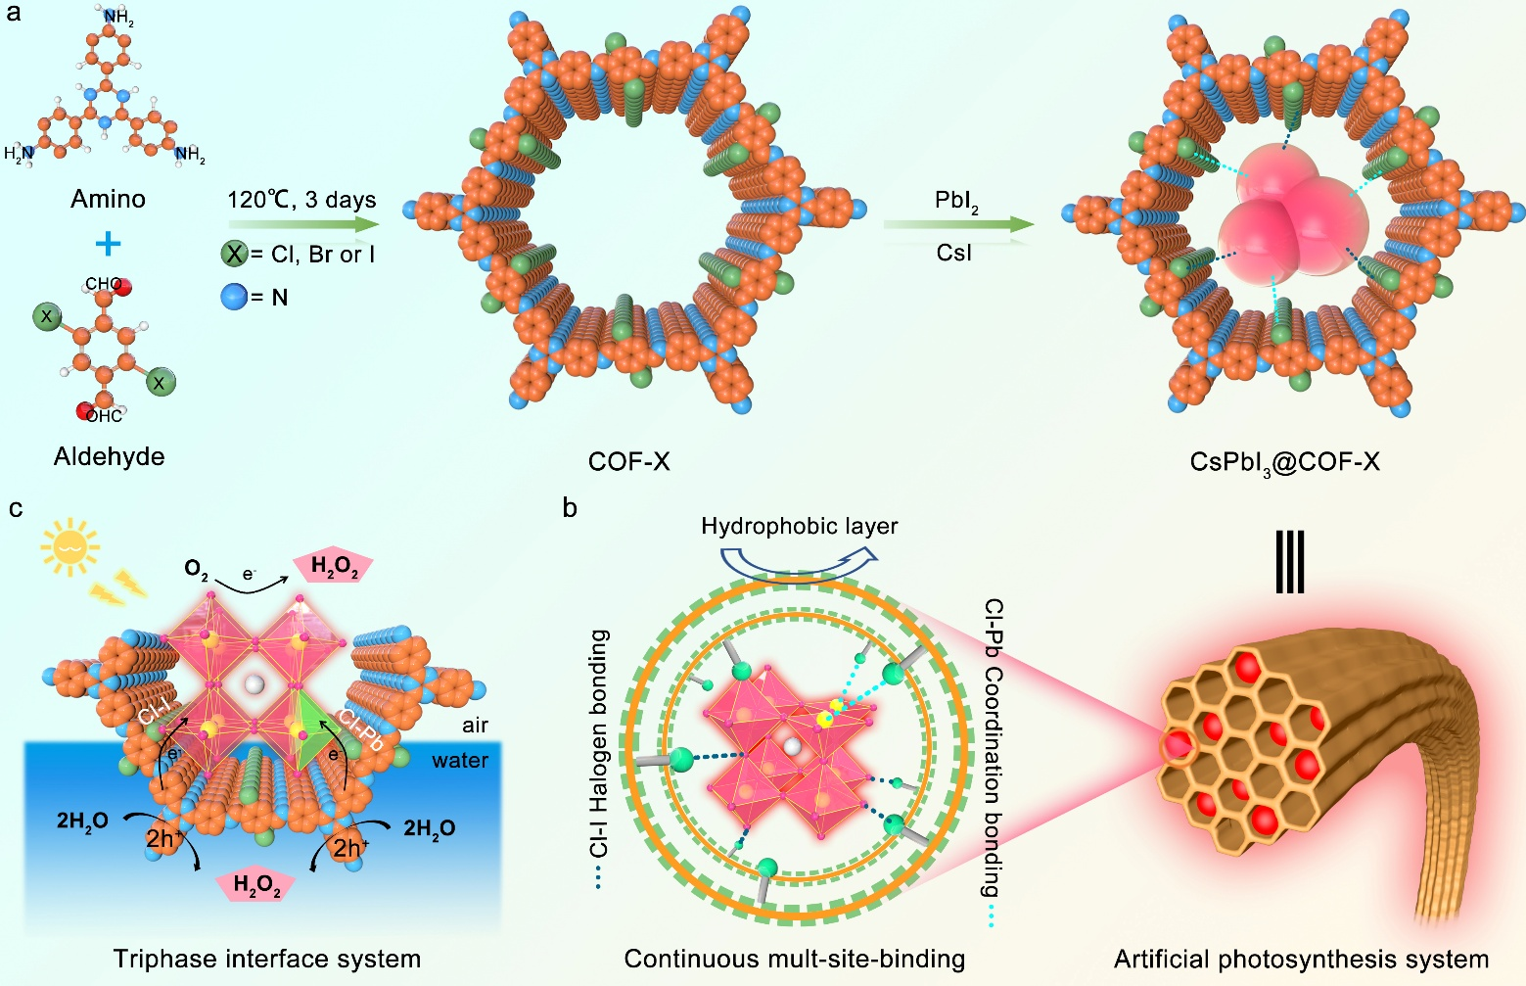
Scheme 1.The schematic diagram of the synthesis of the triphase interface artificial photosynthetic system CsPbI₃@COF-X (X = Cl, Br, I). (a) Synthesis route of CsPbI₃@COF-X system. (b) Continuous in-situ passivation mechanism of COF-Cl matrix on CsPbI₃ QDs. (c) Photochemical synthesis of H₂O₂ at the triphase interface in the CsPbI₃@COF-Cl system.

