Supporting Information for
Regionalized Characterization Factors for Microplastic Emissions in Life Cycle Assessment Considering Multimedia Fate Modelling
Juliette Louvet¹, Joris T. K. Quik², Anne-Marie Boulay¹
¹Department of Chemical Engineering, CIRAIG, Polytechnique Montréal, Montreal, QC, Canada
²National Institute for Public Health and Environment (RIVM), Centre for Sustainability, Health and Environment, Bilthoven, the Netherlands

Table of contents

1. Table of contents 1
2. Descriptions of the changes made in SimpleBox4Plastics 2
2.1. Model scales 2
2.2. Removal of the other soil compartment 2
2.3. Calculation of the degradation mechanism and removal of the fragmentation 2
2.4. Modification of runoff 3
2.5. Modification of the sedimentation rate 3
2.6. Aggregation of the air and the cloud water compartment 3
2.7. Aggregation of the different species of plastic particles 4
2.8. Regionalization 4
2.8.1. Land area fractions 4
2.8.2. Depths of lake water and freshwater 5
3. Calculation of the SDFs 5
3.1. Marine ecosystem 5
3.1.1. Fraction continental/global 5
3.2. Freshwater ecosystem 6
3.2.1. Fraction sediment/water column 6
3.2.2. Fraction continental/global 6
3.3. Terrestrial ecosystem 6
3.3.1. Fraction natural soil/agricultural soil 6
3.3.2. Fraction continental/global 6
4. Details on the case study 7
4.1. Inventory 7
4.2. CFs used 7
4.3. Method used 7
5. Additional figure: CF_{comp} matrix 8
6. Additional figure: CFs by region in PDF·m²·year/kg 8
7. References 9

Descriptions of the changes made in SimpleBox4Plastics

Model scales
To align more closely with USEtox, the original scales of SimpleBox4Plastics—regional, continental, and global—are reduced to two: continental and global. The continental scale refers to a continent where emissions of microplastics can occur and the global scale refers to the rest of the world from this emission continent. This adjustment involves using the original regional and continental scales of SB4P and removing the advection link between continental and global air and ocean. Subsequently, the landscape settings of the regional and continental scales are modified to match the parameters of a specific continent (continental scale) and its rest of the world (global scale), respectively with the regionalized data (see SI 3).

Removal of the other soil compartment
In SB4P, 11 environmental compartments are represented at both regional and continental scales: air, cloud water, lake water, freshwater, seawater, their respective sediments, natural soil, agricultural soil, and other soil. In this case, other soil refers to urban soil and is part of the technosphere. As we want to consider only the impacts of microplastic emissions in the biosphere, the other soil compartment is removed. The fraction area previously allocated to other soil and all transfers associated with other soil are set to zero.

Calculation of the degradation mechanism and removal of the fragmentation
In SB4P, the removal rate within a compartment is composed of two components: the degradation rate and the fragmentation rate.
The fragmentation rate here represents the rate at which microplastic particles break down into nanoparticles due to physical, chemical, and biological factors (Andrady, 2022). Since nanoplastics are also likely to impact Ecosystem Quality, we chose not to consider the fragmentation rate as a removal mechanism and set it to zero.
The degradation rate incorporated in SB4P is the same across polymers, though in reality, the degradation rate of plastic particles varies as a function of the polymer type and environmental conditions of the different compartments. While this later aspect is not yet integrated, Corella-Puertas et al. (2023) proposed the following equation (Equation 1) to calculate a polymer-specific degradation rate adapted for LCIA, based on the work of Chamas et al. (2020) and using specific surface degradation rates available in the literature for different polymers (Chamas et al., 2020; Maga et al., 2022).
$$\begin{aligned}k_{degradation, sphere}= \frac{4k_{SSDR}f_{c}}{r_{max}} \#\left(1\right)\end{aligned}$$
Where r_{max} is the initial radius of spherical microbeads, f_{c} a surface area correction factor and k_{SSDR} the specific surface degradation rate.
The constant present in SB4P is replaced by this equation. The calculation of the different specific surface degradation rates can be found in SI 3.

Modification of runoff
In SB4P, the transport rate of microplastics from soil to freshwater is calculated by considering both runoff and erosion. The model currently assumes that all microplastics are carried by runoff. As Han et al. (2022) emphasize the critical role of vegetation in influencing this transport mechanism, this assumption thus overestimates the transfer rate of microplastics from soil to freshwater compartments. Specifically, vegetation cover reduces the mobility of microplastics and retains them in the soil during rainfall events. Consequently, a microplastic interception rate by vegetation has been incorporated into the model. This interception rate was determined by averaging the rates for low, medium, and high densities of shrub and herb vegetations reported by Han et al. (2022). This results in an interception rate of 97.15% and has been applied to the runoff calculations in SB4P.

Modification of the sedimentation rate
In SB4P, settling velocity ($v_{set}$) is calculated thanks to the density of the polymer ($ρ_{p}$) and the density of water ($ρ_{w}$) (Equation 2):
$$\begin{aligned}v_{set}=\frac{2\left(ρ_{p}-ρ_{w}\right)*g*{r_{p}}^{2}}{9*μ_{w}} \#\left(2\right)\end{aligned}$$
With $r_{p}$ representing the radius of the polymer particle and $μ_{w}$ the dynamic viscosity of water. When a polymer particle has a density inferior to water, the settling velocity is equal to zero, meaning the particle remains suspended and does not settle. However, over time, a layer of microorganisms, plants, algae can accumulate on the polymer’s surface, altering its density and causing it to sink. This process is known as biofouling (Chubarenko et al., 2016; Jalón-Rojas et al., 2019). Biofouling rates could not be directly integrated into the model. However, to account for the unlikely scenario of low-density microplastics never settling, default sedimentation rates for each low-density polymer were incorporated based on the study by Corella-Puertas et al. (2023) with the intention of providing a more realistic representation of low-density microplastic behavior in the environment. The specific values are provided in SI 3.

Aggregation of the air and the cloud water compartment
SB4P distinguishes the air and the cloud water compartments. The air compartment is linked to soil and water by a transfer called “dry deposition” and the cloud water compartment is linked to soil and water through “wet deposition”. To simplify the number of compartments in the model, the air and the cloud water compartments are grouped into a unique compartment called air and the deposition mechanisms are added together. This is done following the methodology of Salieri et al. (2019) that recalculates the mass balance inside the new compartment.

Aggregation of the different species of plastic particles
In SB4P, three forms of plastic particles are represented: free, aggregated, and attached. “Aggregated” particles represent particles mixed with natural particles smaller than 450 nanometers, while “attached” particles refer to particles combined with natural particles larger than 450 nanometers. The transfer rates are calculated using the properties of the different free, aggregated or attached particles. To simplify the model, after the rate calculations, the transfer rates for the three forms of particle are added together using the method developed in Salieri et al. (2019).

Regionalization
Finally, the model is regionalized by parametrizing the landscape settings using the same 8 regions implemented in USEtox (Kounina et al., 2014 ; Shaked, 2011). The different parameters specific for each region are:
- the land area and the sea area at continental and global scales
- the land area fractions of natural soil, agricultural soil, lake water and freshwater at continental and global scales
- the rain rate at continental and global scales
- the depths of lake water and freshwater at continental and global scales
- the fraction of runoff at continental and global scales
- the irrigation rate at continental and global scales
The land area, sea area, rain rate, fraction of runoff and irrigation rate are taken from the settings of USEtox for the different regions (Kounina et al., 2014).
The land area fractions and depths are derived from LakeATLAS and RiverATLAS (Lehner et al., 2022; Linke et al., 2019) two comprehensive global databases of hydro-environmental characteristics for lakes and river reaches worldwide. LakeATLAS provides detailed data on 1.4 million lakes, while RiverATLAS covers 8.5 million river reaches, offering insights into surface area, depth, and country of origin for each water body.

Land area fractions
In USEtox, land is categorized into three compartments: freshwater, natural soil, and agricultural soil, with each region having a specific area fraction allocated to these compartments. Freshwater refers to rivers and lakes. However, our model distinguishes between lake water and river water (referred to as freshwater). Therefore, it is necessary to calculate the proportion of surface water attributed to lakes and the proportion attributed to rivers.
All lakes and rivers from LakeATLAS and RiverATLAS are categorized into the model's eight regions based on their country of origin. The total surface areas of lakes and rivers are then calculated for each region. Using these surface areas, the proportions of surface water attributed to lakes and rivers are determined for each region and scale. These proportions are multiplied by the fraction of land allocated to surface water from USEtox to calculate the fractions of land assigned to lake water and river water.

Depths of lake water and freshwater
From LakeATLAS and RiverATLAS, an area-weighted average depth is calculated for all lakes and rivers within each region, resulting in a mean depth for both the lake compartment and the freshwater compartment at the continental scale.
At global scale, the mean depths of the lake water and river water compartments for each region are determined by calculating the area-weighted average depth of all lakes and rivers across all regions, excluding the region being assessed.
Detailed calculations, along with all the values used for regionalization, are provided in SI 3.

Calculation of the SDFs
All data and calculations of SDFs can be found in SI 4.

Marine ecosystem

Fraction continental/global
SDFs for the continental and global scales are calculated using The IUCN Red List (IUCN, 2024). The data on The IUCN Red List includes non-threatened and threatened species and gives information on location, habitat, ecology, population size, threats etc. 163,040 different species are currently assessed by The IUCN Red List, including 16,996 marine species. For the marine ecosystem, only marine species are considered. The continental scale includes coastal species specific to the region, while the global scale incorporates coastal species from other regions and oceanic species, species inhabiting the open ocean. Species are classified according to FAO's major fishing areas (FAO, 2020), with each area assigned to one or more of the eight regions based on its location. For each region, we calculate the number of coastal species living in the region (${CS}_{region}$), the number of coastal species found in the rest of the world (${CS}_{RoW}$) and the number of oceanic species ($OS$). The fractions of species at the continental (${Frac}_{MarineSpecies_{C}}$) and global (${Frac}_{MarineSpecies_{G}}$) scales are then derived using Equation 3 and Equation 4.
$$\begin{aligned}{Frac}_{MarineSpecies_{C}}= \frac{{CS}_{region}}{{CS}_{region}+{CS}_{RoW}+OS}\#\left(3\right)\end{aligned}$$

$$\begin{aligned}{Frac}_{MarineSpecies_{G}}= \frac{{CS}_{RoW}+OS}{{CS}_{region}+{CS}_{RoW}+OS} \#\left(4\right)\end{aligned}$$

Freshwater ecosystem

Fraction sediment/water column
The fraction of species in the sediment and water column for the aquatic ecosystem is calculated using data from the database www.freshwaterecology.info (Schmidt-Kloiber & Hering, 2015; Schmidt-Kloiber & Hering, 2024). This database includes more than 20,000 European freshwater organisms and their ecological preferences. Species distribution between sediment and water column is analyzed for 3,105 macroinvertebrates, 242 fish, 1,101 macrophytes, 8,591 phytobenthos, and 2,512 phytoplankton, totaling 15,551 species. Macrophytes and phytobenthos are categorized as sediment feeders, while phytoplankton are classified as water column feeders. For fish, a specialized dataset on feeding habitats is used (Grenouillet & Schmidt-Kloiber, 2006; Schinegger & Friedrich, 2024), classifying species based on whether they feed in the sediment or water column. The proportions of fish feeding in each habitat are then calculated. For macroinvertebrates, a dataset categorizes species by feeding type, which is linked to either the sediment or the water column, allowing the calculation of the fraction of macroinvertebrates feeding in each compartment.
The fractions of species inhabiting rivers and lakes are determined using data from The IUCN Red List, which covers 69,330 species (IUCN, 2024). Species are classified by habitat, with each habitat assigned to a category: river, lake, wetland, saline water, or groundwater. Only species from the river and lake categories, totaling 45,672 species, are considered. From this, the fractions of species residing in rivers and in lakes are calculated.

Fraction continental/global
Additionally, the fractions of species living in the continental or global scale are calculated using The IUCN Red List (IUCN, 2024). A total of 40,279 species is assessed, with freshwater species categorized by country. Each country is then linked to one of the eight regions in our model, based on Shaked (2011). Using the approach outlined in Section 2.4.1.a, the number of species inhabiting the region and the number of species living in the rest of the world are determined and the different fractions are calculated.

Terrestrial ecosystem

Fraction natural soil/agricultural soil
The fractions of species inhabiting natural and agricultural soils are determined using Indicator Z9 from the Swiss Biodiversity Monitoring (BDM) (Montgomery et al., s. d.). This indicator measures species diversity across different land-use types, allowing direct attribution to either natural or agricultural soils.

Fraction continental/global
The fractions of terrestrial species at both continental and global scales are assessed using data from The IUCN Red List (IUCN, 2024), following the same methodology applied for the aquatic ecosystem (Section 2.4b). In total, 115,211 species are evaluated.

Details on the case study

Inventory
Plastic particles are emitted as primary microplastics during polymer and material production, transport with TRWP emissions or as macroplastics that fragments into secondary microplastics during use. A fragmentation rate of 100% is assumed, based on the estimation that over an infinite time horizon, the film in agricultural soil will eventually break down into microparticles due to UV radiation and microbial activity. The inventory of plastic emissions is sourced from the original study (De Sadeleer & Woodhouse, 2024). In the first scenario, 90% of the mulch film is removed from the soil, while 10% is assumed to be emitted to the environment. In the other two scenarios, 100% of the film is left on the field after use and is considered emitted. Emissions during the use phase are limited to the soil compartment. Given that the particle size is unspecified, the thickness of the film is used as a reference (20 and 15 μm for LDPE and starch-blend respectively).

CFs used
CFs are derived specifically for these dimensions. Our fate model calculates CFs for spherical particles; however, not all emissions correspond to this shape. For instance, the fragmentation of mulch films is associated with film fragment particles. In the absence of alternative CFs for terrestrial emissions based on a fate model that accounts for particle-specific physical characteristics, using our CFs as a proxy was the most suitable option available. CFs following the approach considering the species density over a surface in PDF·m²·year/kg are used as they are directly compatible with IMPACT World+ (Bulle et al., 2019), the impact assessment method used.
In scenario 1, the emissions from production and use are multiplied by the CF for 20 μm LDPE particles emitted to continental agricultural soil in Northern regions. For scenarios 2 and 3, the same approach is followed, using the CF for 15 μm starch blend particles in the same compartment. For emissions during transport, the CF for 100 μm TRWP particles emitted to freshwater and natural soil in Northern regions is applied across all three scenarios.

Method used
The LCA results are computed using OpenLCA v.2.1 with ecoinvent v.3.10 (Wernet et al., 2016) and Agribalyse 3.1.1 (Colomb et al., 2015) for the Life Cycle Inventory (LCI). The version of IMPACT World+ used is 2.0.1 and all impact categories affecting ecosystem quality are evaluated. Case study calculations are available in SI 5.

Additional figure: CF_{comp} matrix

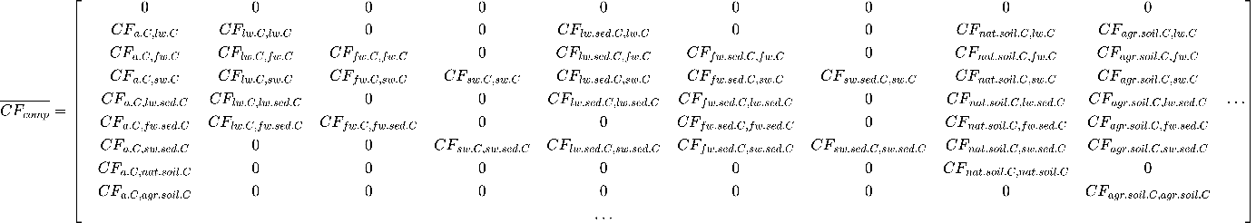
Figure 1 Part of the Characterization Factor compartment matrix for the continental scale C.

Additional figure: CFs by region in PDF·m²·year/kg

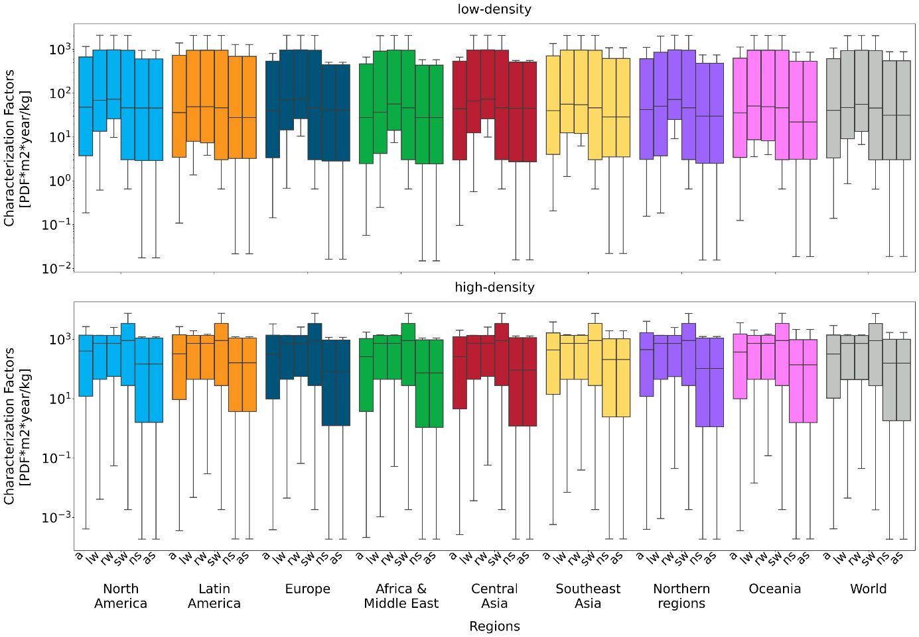
Figure 2 Distribution of the endpoint characterization factors (CFs) calculated in PDF⸱m²⸱year/kg_{emitted} with added ecosystems for all polymers and sizes for the different regions and emission compartments at the continental scale with a: air, lw: lake water, rw: river water, sw: sea water, ns: natural soil, as: agricultural soil. The length of the box represents the difference between the 75th and the 25th percentiles, the bar in the middle is the median and the upper and lower whiskers are the minimum and maximum data values, excluding outliers.

References

Andrady, A. L. (2022). Weathering and fragmentation of plastic debris in the ocean environment. Marine Pollution Bulletin, 180, 113761. https://doi.org/10.1016/j.marpolbul.2022.113761
Bulle, C., Margni, M., Patouillard, L., Boulay, A.-M., Bourgault, G., De Bruille, V., Cao, V., Hauschild, M., Henderson, A., Humbert, S., Kashef-Haghighi, S., Kounina, A., Laurent, A., Levasseur, A., Liard, G., Rosenbaum, R. K., Roy, P.-O., Shaked, S., Fantke, P., & Jolliet, O. (2019). IMPACT World+ : A globally regionalized life cycle impact assessment method. The International Journal of Life Cycle Assessment, 24(9), 1653‑1674. https://doi.org/10.1007/s11367-019-01583-0
Chamas, A., Moon, H., Zheng, J., Qiu, Y., Tabassum, T., Jang, J. H., Abu-Omar, M., Scott, S. L., & Suh, S. (2020). Degradation Rates of Plastics in the Environment. ACS Sustainable Chemistry & Engineering, 8(9), 3494‑3511. https://doi.org/10.1021/acssuschemeng.9b06635
Chubarenko, I., Bagaev, A., Zobkov, M., & Esiukova, E. (2016). On some physical and dynamical properties of microplastic particles in marine environment. Marine Pollution Bulletin, 108(1‑2), 105‑112. https://doi.org/10.1016/j.marpolbul.2016.04.048
Colomb, V., Ait Amar, S., Mens, C. B., Gac, A., Gaillard, G., Koch, P., Mousset, J., Salou, T., Tailleur, A., & Van Der Werf, H. M. G. (2015). AGRIBALYSE ® , the French LCI Database for agricultural products : High quality data for producers and environmental labelling. OCL, 22(1), D104. https://doi.org/10.1051/ocl/20140047
Corella-Puertas, E., Hajjar, C., Lavoie, J., & Boulay, A.-M. (2023). MarILCA characterization factors for microplastic impacts in life cycle assessment : Physical effects on biota from emissions to aquatic environments. Journal of Cleaner Production, 418, 138197. https://doi.org/10.1016/j.jclepro.2023.138197
De Sadeleer, I., & Woodhouse, A. (2024). Environmental impact of biodegradable and non-biodegradable agricultural mulch film : A case study for Nordic conditions. The International Journal of Life Cycle Assessment, 29(2), 275‑290. https://doi.org/10.1007/s11367-023-02253-y
FAO. (2020, novembre). FAO Major Fishing Areas. https://www.fao.org/fishery/en/area/search
Grenouillet, G., & Schmidt-Kloiber, A. (2006). Fish Indicator Database. Euro-limpacs project, Workpackage 7—Indicators of ecosystem health, Task 4. (Version 8.0) [Dataset].
Han, N., Zhao, Q., Ao, H., Hu, H., & Wu, C. (2022). Horizontal transport of macro- and microplastics on soil surface by rainfall induced surface runoff as affected by vegetations. Science of The Total Environment, 831, 154989. https://doi.org/10.1016/j.scitotenv.2022.154989
IUCN. (2024). The IUCN Red List of Threatened Species. https://www.iucnredlist.org
Jalón-Rojas, I., Wang, X. H., & Fredj, E. (2019). A 3D numerical model to Track Marine Plastic Debris (TrackMPD) : Sensitivity of microplastic trajectories and fates to particle dynamical properties and physical processes. Marine Pollution Bulletin, 141, 256‑272. https://doi.org/10.1016/j.marpolbul.2019.02.052
Kounina, A., Margni, M., Shaked, S., Bulle, C., & Jolliet, O. (2014). Spatial analysis of toxic emissions in LCA : A sub-continental nested USEtox model with freshwater archetypes. Environment International, 69, 67‑89. https://doi.org/10.1016/j.envint.2014.04.004
Lehner, B., Messager, M. L., Korver, M. C., & Linke, S. (2022). Global hydro-environmental lake characteristics at high spatial resolution. Scientific Data, 9(1), 351. https://doi.org/10.1038/s41597-022-01425-z
Linke, S., Lehner, B., Ouellet Dallaire, C., Ariwi, J., Grill, G., Anand, M., Beames, P., Burchard-Levine, V., Maxwell, S., Moidu, H., Tan, F., & Thieme, M. (2019). Global hydro-environmental sub-basin and river reach characteristics at high spatial resolution. Scientific Data, 6(1), 283. https://doi.org/10.1038/s41597-019-0300-6
Maga, D., Galafton, C., Blömer, J., Thonemann, N., Özdamar, A., & Bertling, J. (2022). Methodology to address potential impacts of plastic emissions in life cycle assessment. The International Journal of Life Cycle Assessment, 27(3), 469‑491. https://doi.org/10.1007/s11367-022-02040-1
Montgomery, G., Hauser, H., & Schmill, J. (s. d.). Swiss Biodiversity Monitoring BDM. Environmental Studies.
Salieri, B., Hischier, R., Quik, J. T. K., & Jolliet, O. (2019). Fate modelling of nanoparticle releases in LCA : An integrative approach towards “USEtox4Nano”. Journal of Cleaner Production, 206, 701‑712. https://doi.org/10.1016/j.jclepro.2018.09.187
Schinegger, R., & Friedrich, T. (2024). Dataset « Fish ». Www.freshwaterecology.info—The taxa and autecology database for freshwater organisms (Version 8.0) [Dataset].
Schmidt-Kloiber, A., & Hering, D. (2015). Www.freshwaterecology.info – An online tool that unifies, standardises and codifies more than 20,000 European freshwater organisms and their ecological preferences. Ecological Indicators, 53, 271‑282. https://doi.org/10.1016/j.ecolind.2015.02.007
Schmidt-Kloiber, A., & Hering, D. (2024). www.freshwaterecology.info—The taxa and autecology database for freshwater organisms (Version 8.0) [Dataset].
Shaked, S. (2011). Multi-Continental Multimedia Model of Pollutant Intake and Application to Impacts of Global Emissions and Globally Traded Goods. University of Michigan.
Wernet, G., Bauer, C., Steubing, B., Reinhard, J., Moreno-Ruiz, E., & Weidema, B. (2016). The ecoinvent database version 3 (part I) : Overview and methodology. The International Journal of Life Cycle Assessment, 21(9), 1218‑1230. https://doi.org/10.1007/s11367-016-1087-8

