Decoding preparatory movement state-based motor imagery with multi layer energy decoder
Supplementary material
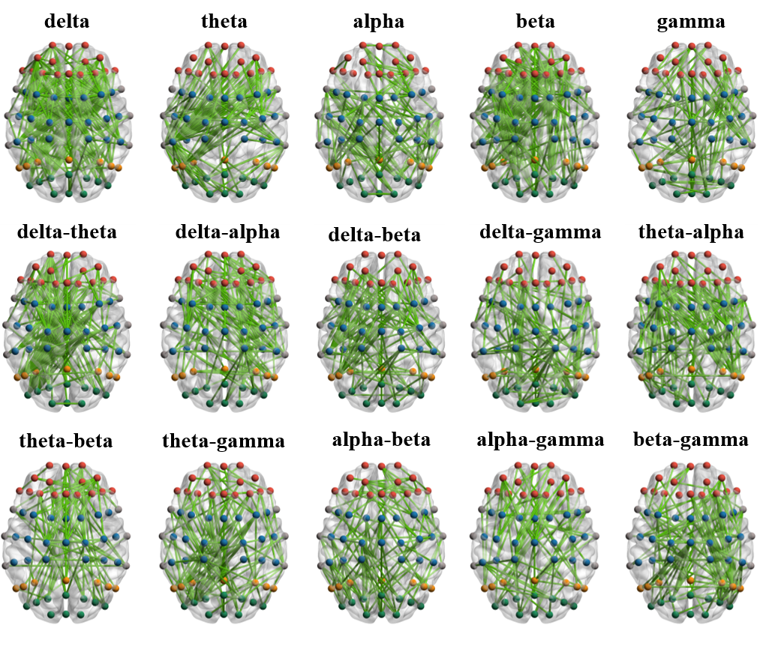
Fig. S1. Statistically significant patterns of brain network connectivity of intra-frequency and cross-frequency for AO-MI.

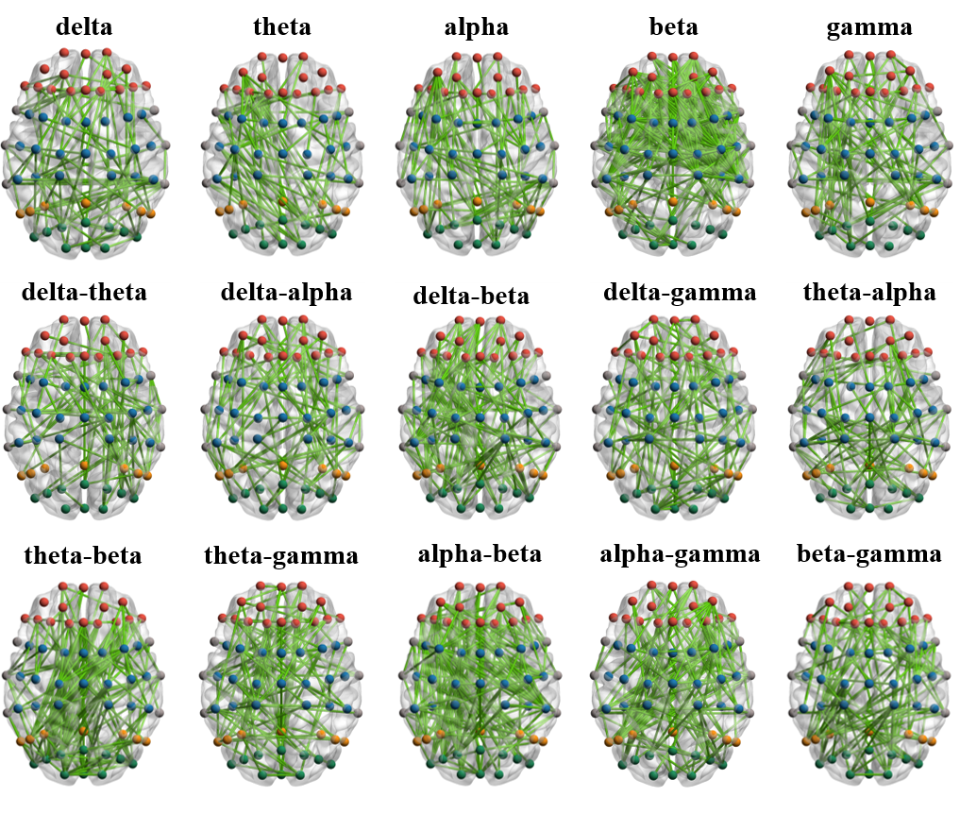
Fig. S2. Statistically significant patterns of brain network connectivity of intra-frequency and cross-frequency for PMS-MI during prepared movement period.

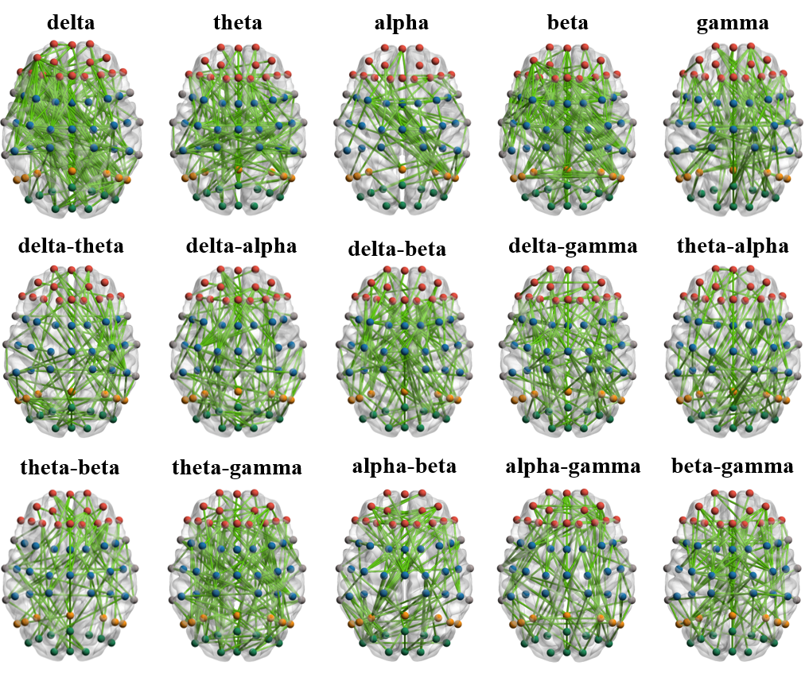
Fig. S3. Statistically significant patterns of brain network connectivity of intra-frequency and cross-frequency for PMS-MI during MI period.

