Table 1. The SNPs of multivariable MR analysis on mQTLs and eQTLs.
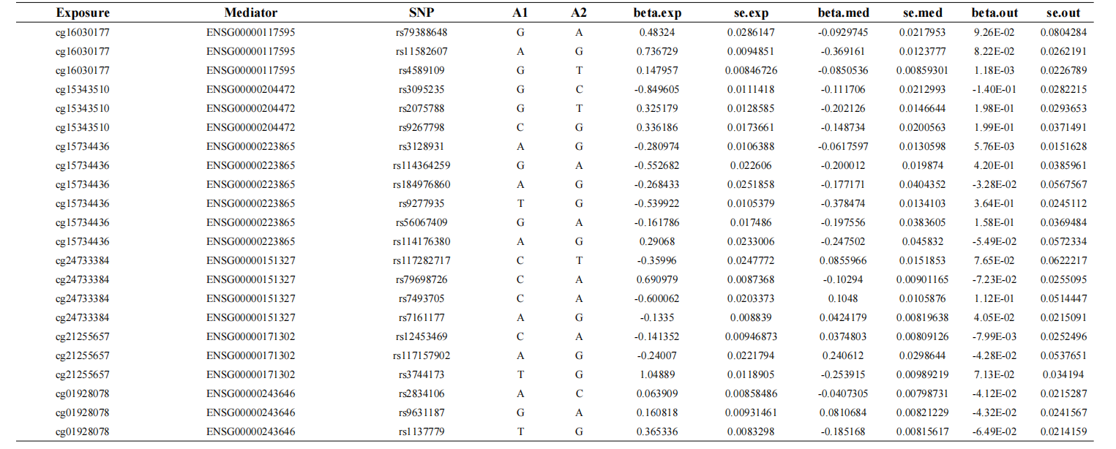

Table 2 . The results of gene mutations in Mouse Genome Informatics.
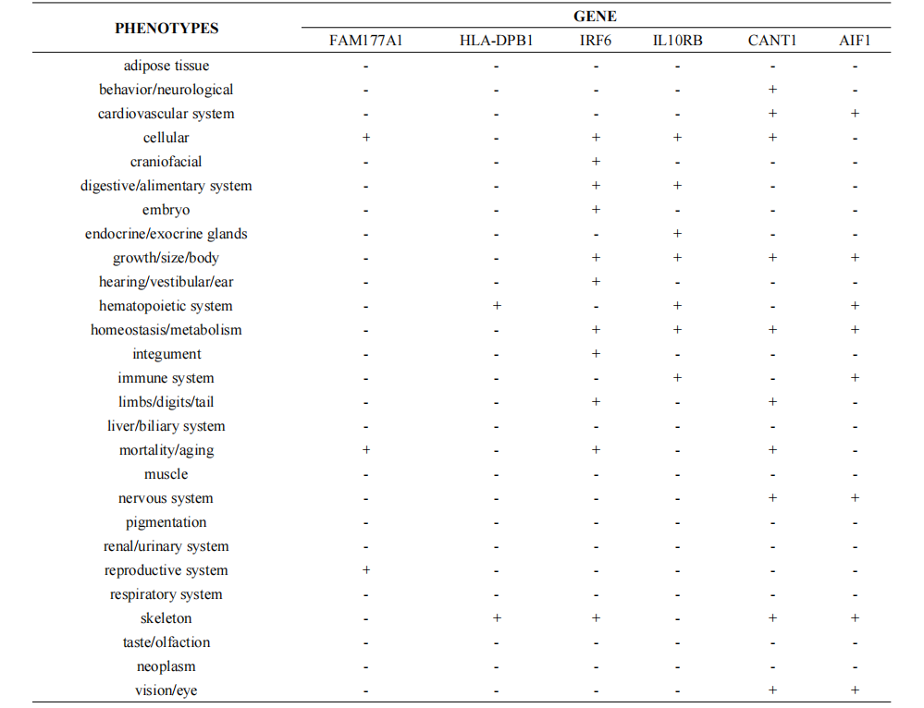

Table 3 . The results of gene expression in Mouse Genome Informatics.
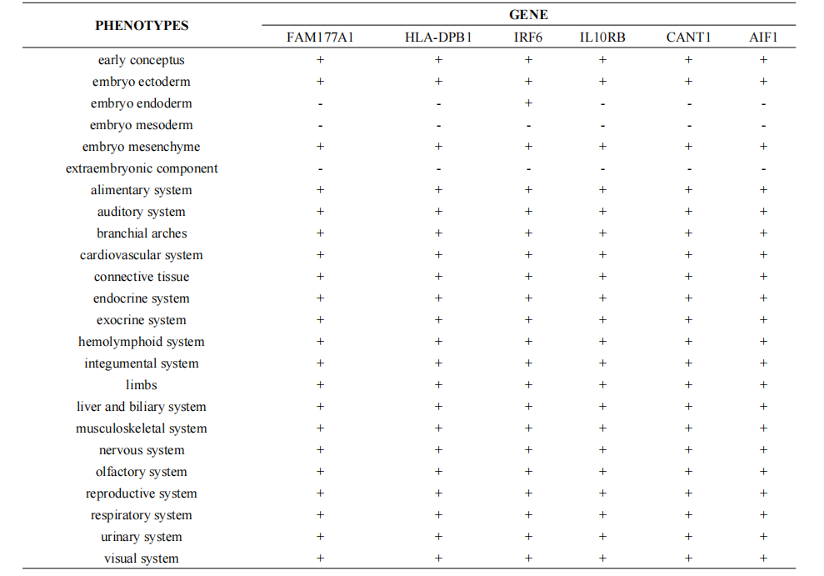
p
p
p

