APPENDICES

Table 1. Higher Education Institutions in at least one of the top 15 positions in at least one of the rankings over the last 10 years: 2014-2023
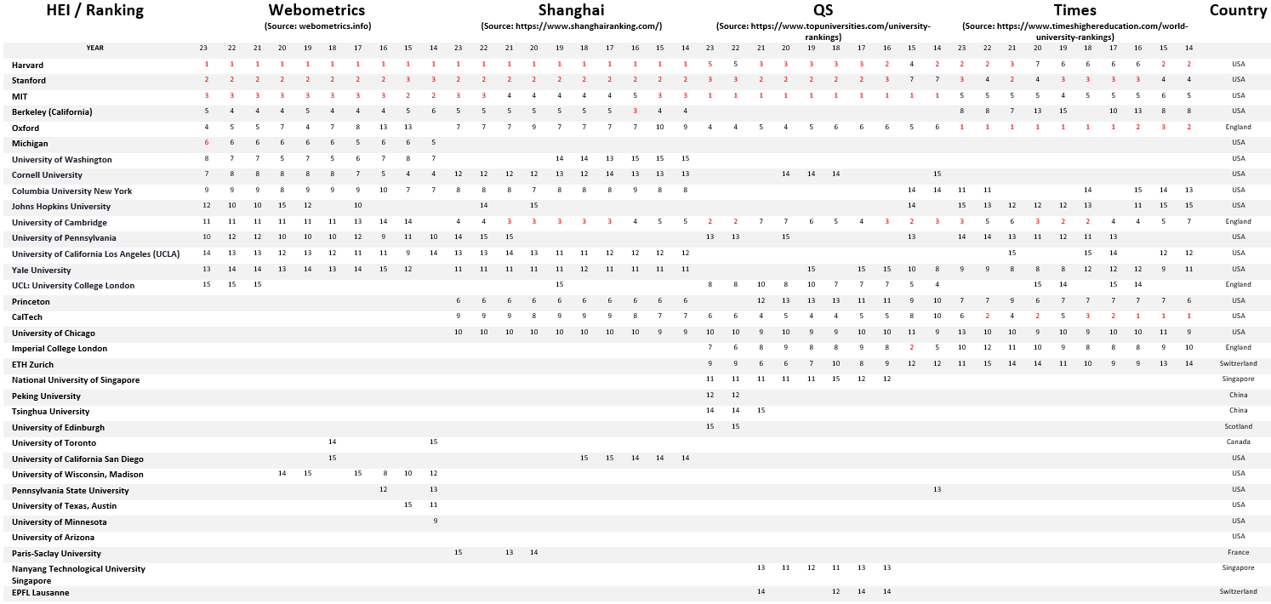

Table 2. Higher Education Institutions ranked at least once in the top 15 positions in all 4 rankings between 2014-2023
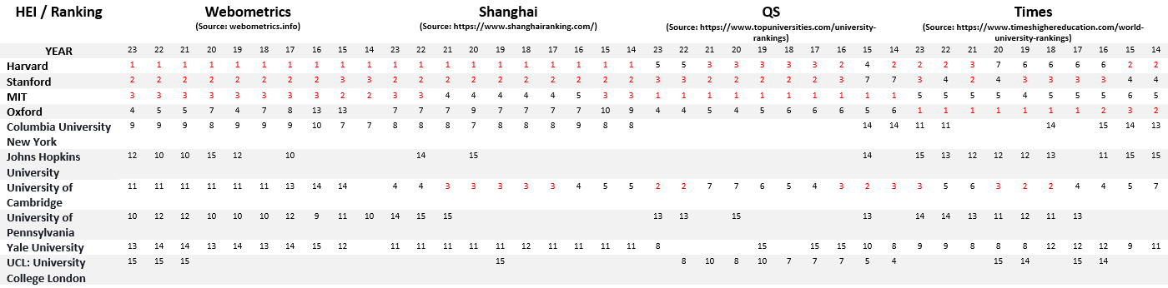

Table 3. Top Ten Higher Education Institutions where n = sum (position in year) / number of years
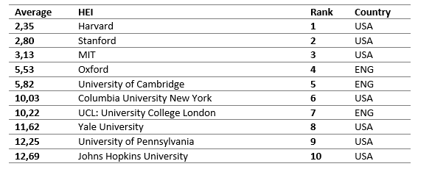

Table 4. Relationship between current challenges and their correspondence with the SDGs
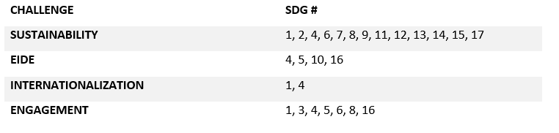

Table 5. Modern challenges and the responses of the Top 10 HEIs in the 4 Top GURs, according to their websites
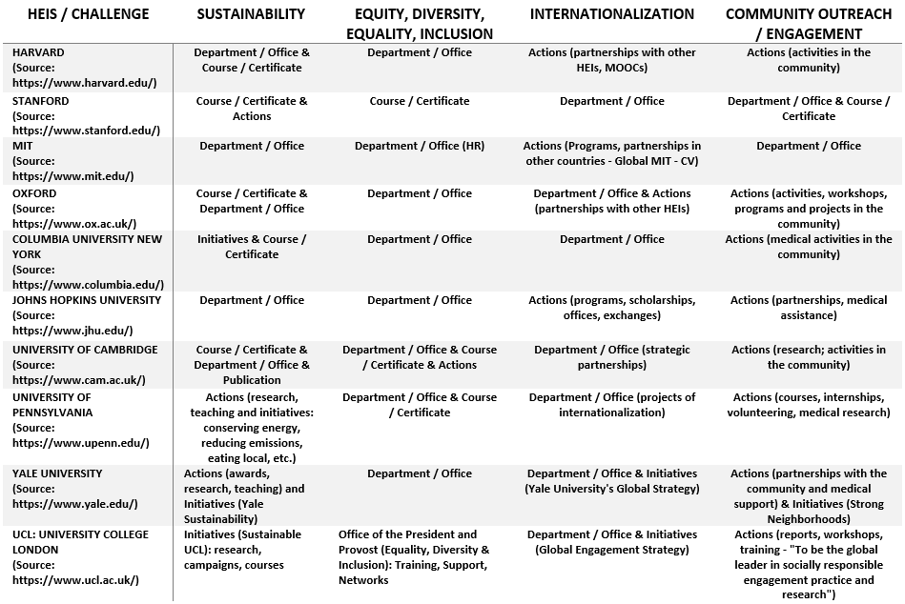

Table 6. HEIs in the Sustainability and SDG Rankings (2023)
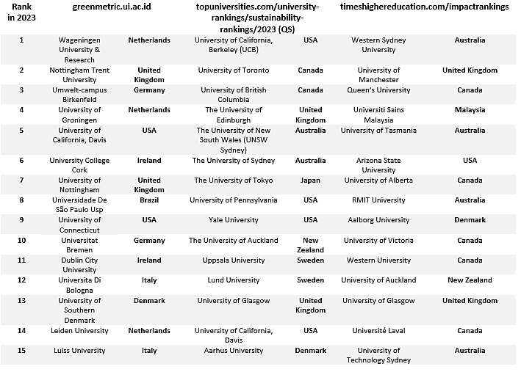

Table 7. Interviews analysis
