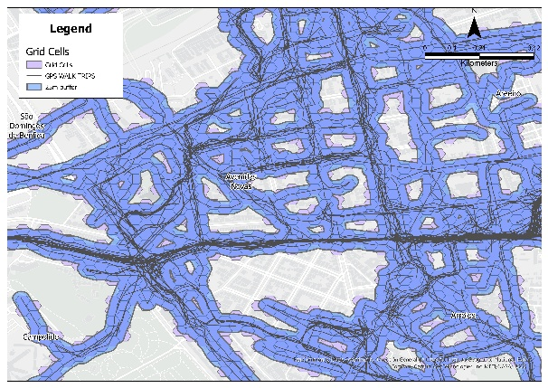  Figure S1.Grid cells and buffered GPS walking paths | 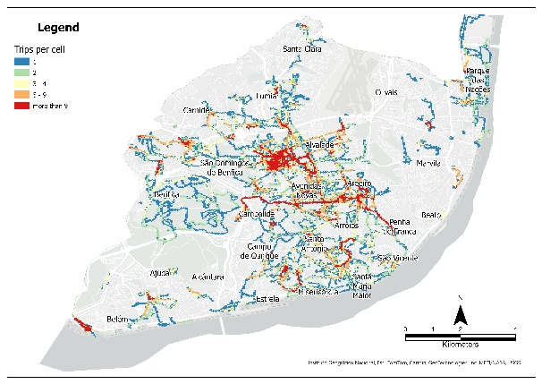  Figure S2.Density of Walking Trips Across the Study Area
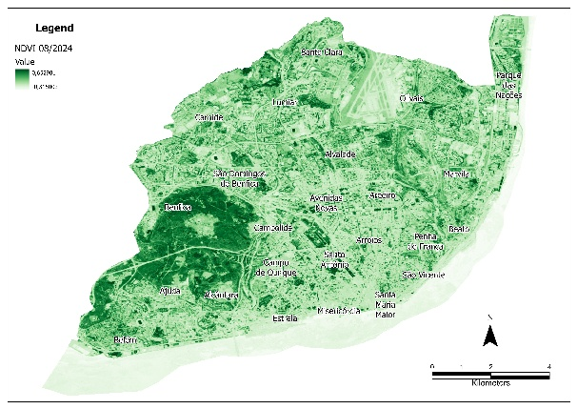  Figure S3.NDVI 08/2024 | 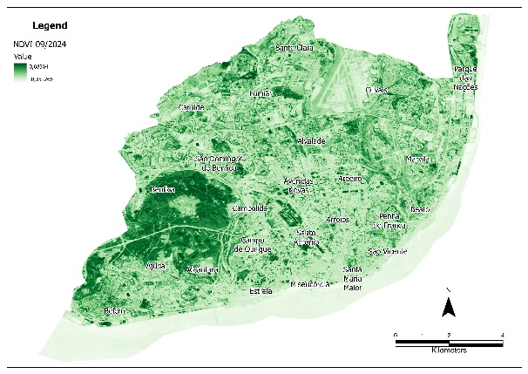  Figure S4.NDVI 09/2024
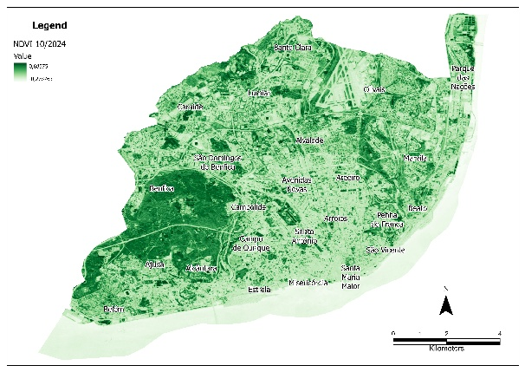  Figure S5. NDVI 10/2024 | 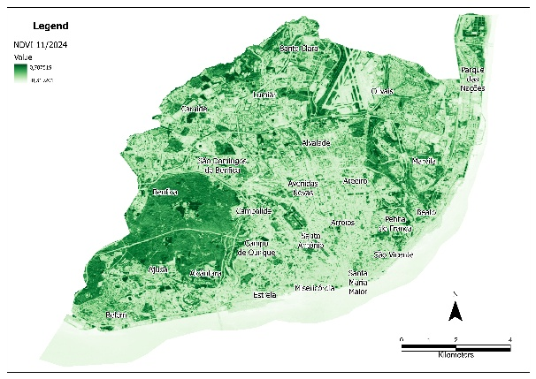  Figure S6. NDVI 11/2024
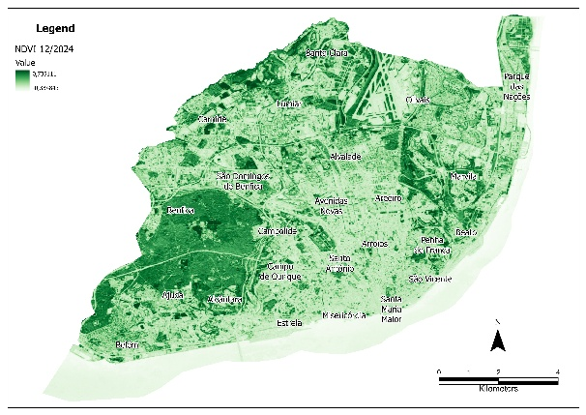  Figure S7. NDVI 12/2024 | 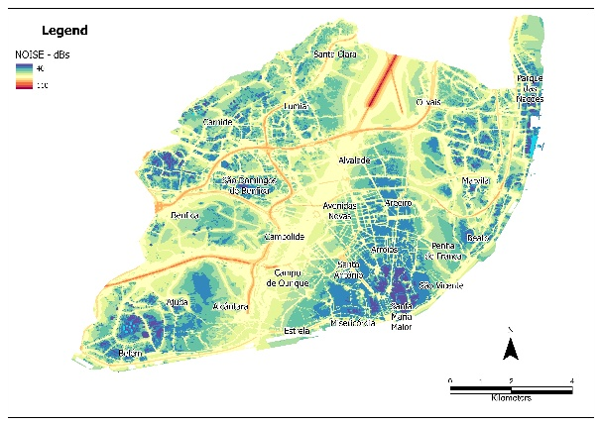  Figure S8. Noise map
Supplementary Material

