Supporting Information

g-C₃N₄ homophase junction with high crystallinity using MoS₂ as cocatalyst for robust visible-light-driven photocatalytic pollutant degradation

Ying Liuª, Jun Hanª, Xianpeng Zengª, Zongju Tianª, Feifan Yuª, Xiyin Sunª, Wei Wang^{a,b*}, Qinghua Liu^{c*}

a.Key Laboratory for Green Processing of Chemical Engineering of Xinjiang Bingtuan, School of Chemistry and Chemical Engineering, Shihezi University, Shihezi 832003, P.R. China
b.Carbon Neutralization and Environmental Catalytic Technology Laboratory, Shihezi University, Shihezi 832003, P.R. China
c.National Synchrotron Radiation Laboratory, University of Science and Technology of China, Hefei 230029, China

*Corresponding author: Wei Wang. E-mail: wangw@shzu.edu.cn

Content of supporting information

Fig.S1 SEM of OMSHCN-25
Fig.S2 SEM of UMSHCN-25
Fig.S3 HRTEM image of HCN-4
Fig.S4 TEM of UOMSHCN-25
Fig.S5 TEM, HRTEM and element mapping of UOMSHCN-25
Fig.S6 Band gaps of HCN-4, DCHCN-4, UOMSHCN-25, UMSHCN-25 and OMSHCN-25
Fig.S7 Mott- Schottky plots of HCN-4, DCHCN-4, UOMSHCN-25, UMSHCN-25 and OMSHCN-25
Fig.S8 Photocatalytic activities of CNU, CND, HCN-4 and DCHCNs for MO degradation
Fig.S9 Photocatalytic activities of UMSHCN-25, OMSHCN-25 and UOMSHCN-25 for MO degradation
Fig.S10 Cyclic stability test of OMSHCN-25 for MO degradation
Fig.S11 Cyclic stability test of UMSHCN-25 for MO degradation
Fig.S12 XRD patterns of UOMSHCN-25 before and after the degradation of MO
Fig.S13 The reaction kinetics of UMSHCN-25, OMSHCN-25 and UOMSHCN-25 for MO degradation
Fig.S14 Photocatalytic activity of UOMSHCN-25 for Rh B degradation
Fig.S15 The reaction kinetic of UOMSHCN-25 for Rh B degradation
Fig.S16 Cyclic stability test of UOMSHCN-25 for Rh B degradation
Tab.S1 The interlamellar spacing (d value) of all samples
Tab.S2 Pore volume of DCHCN-4, MoS₂ and UOMSHCN-25
Tab.S3 The kinetic rate constants of DCHCN-4, UOMSHCNs, UMSHCN-25, and OMSHCN-25

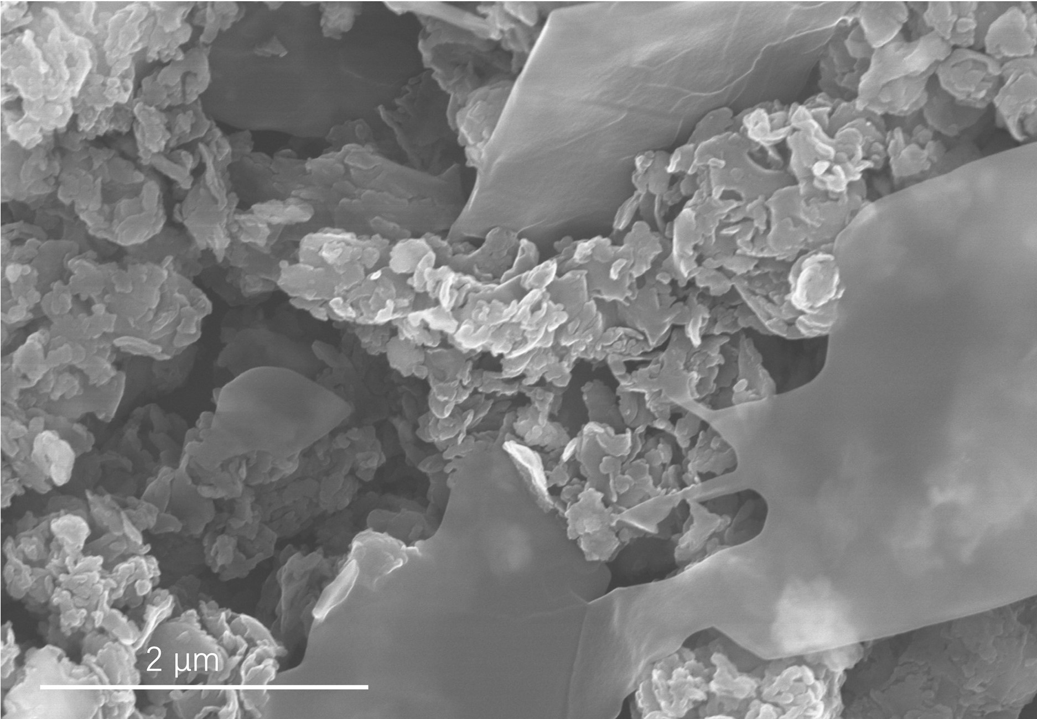
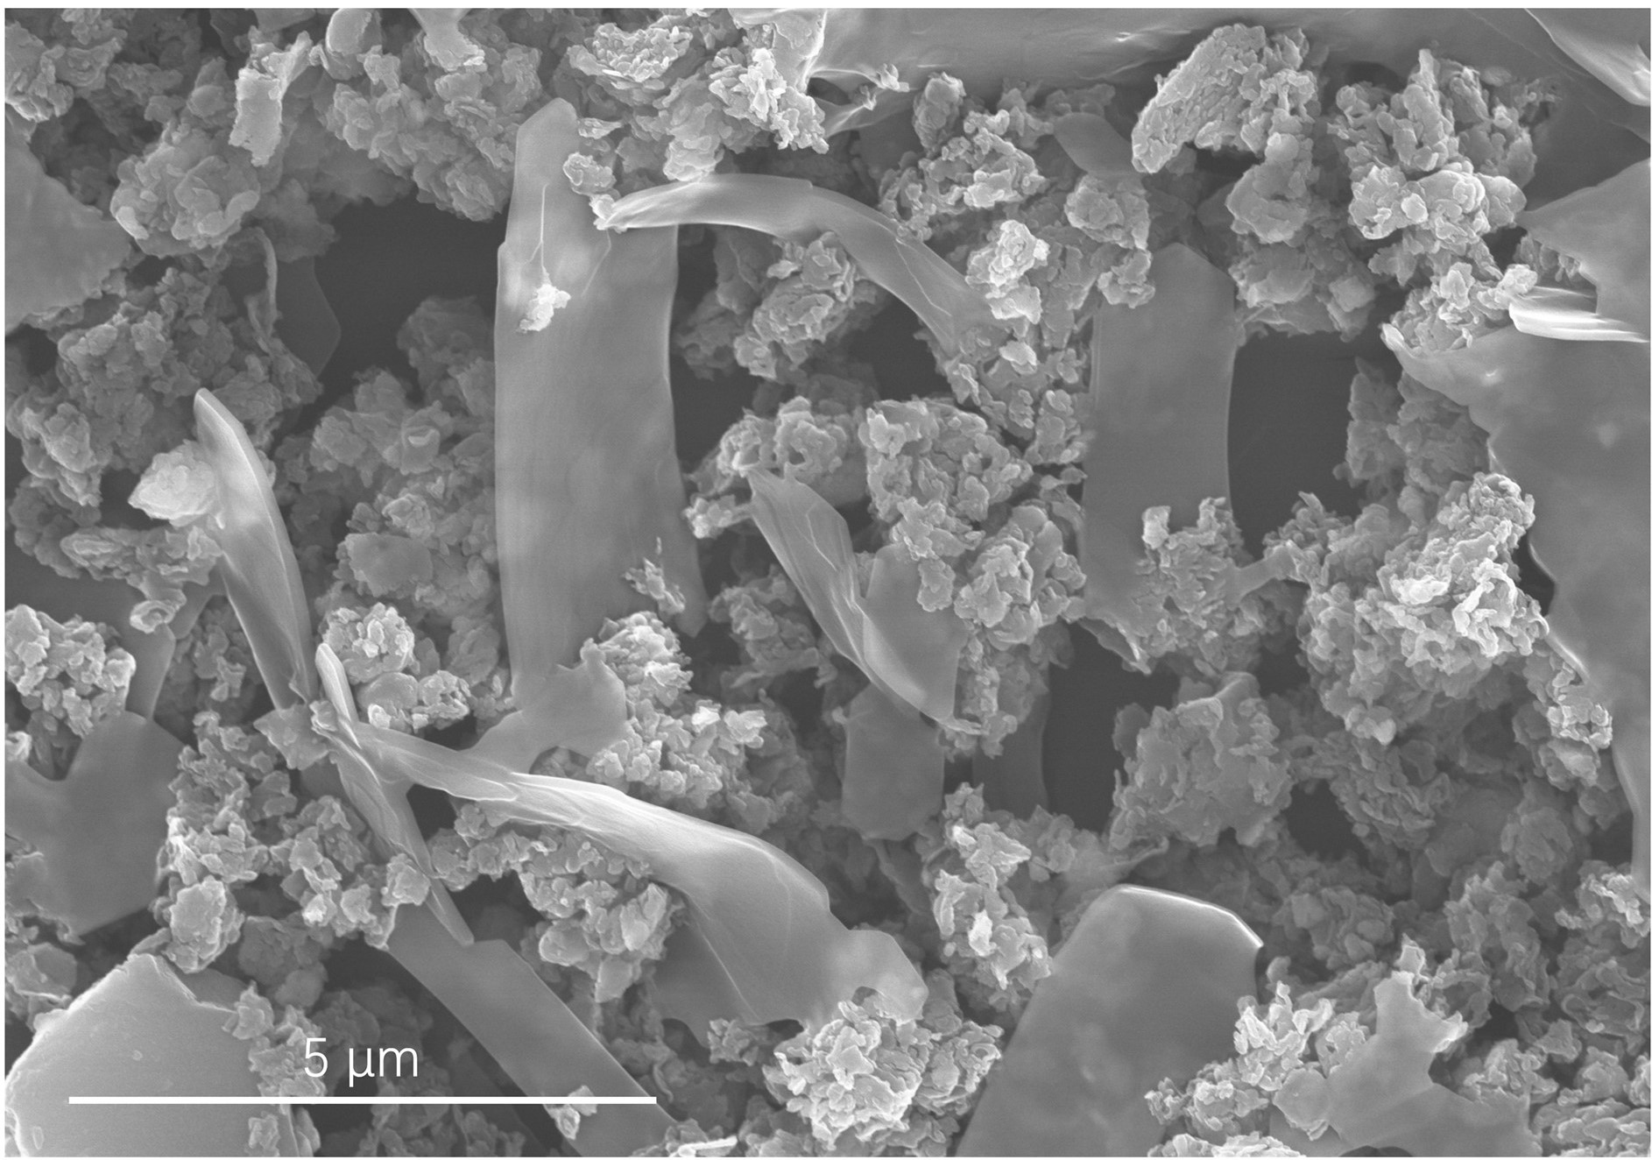
Fig.S1 SEM of OMSHCN-25

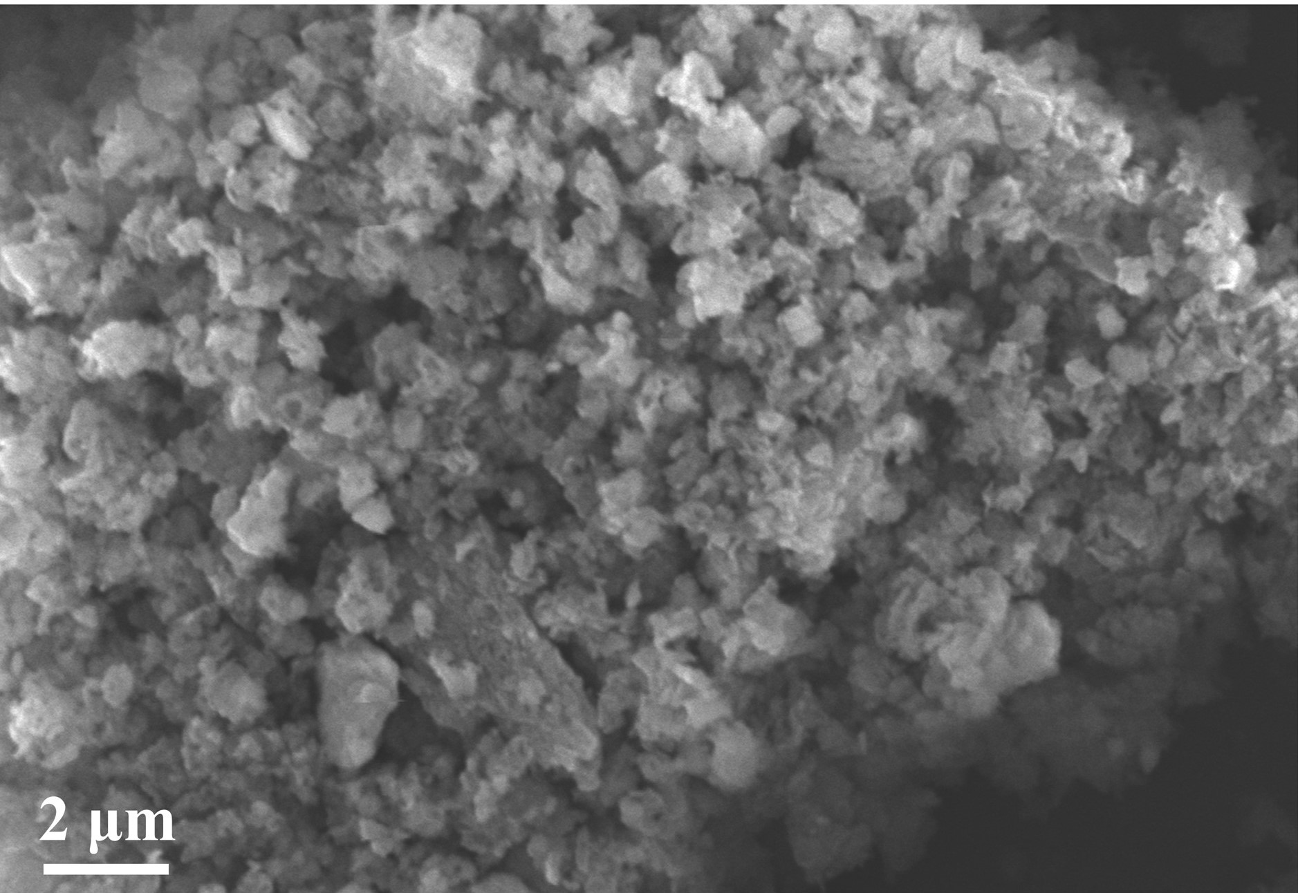
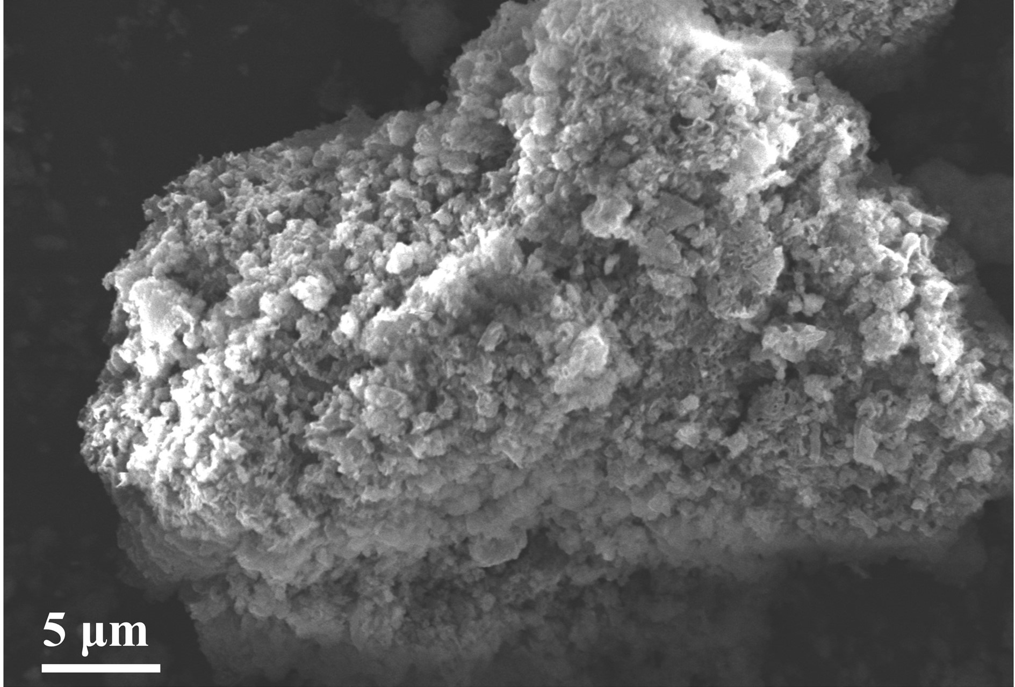
Fig.S2 SEM of UMSHCN-25

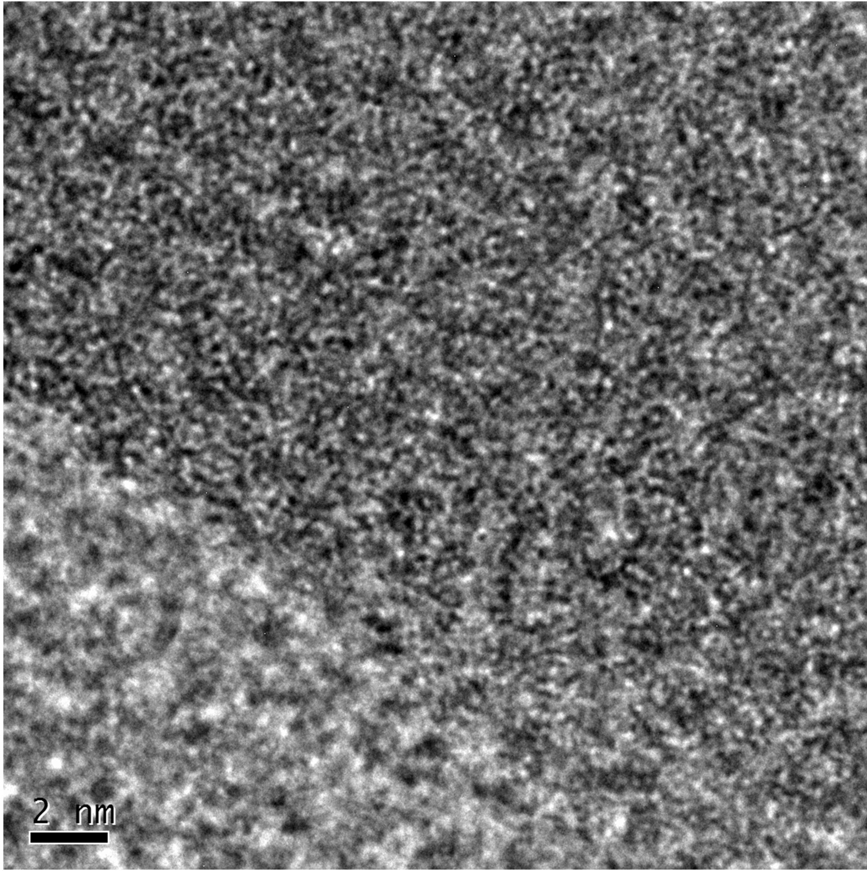
Fig.S3 HRTEM image of HCN-4

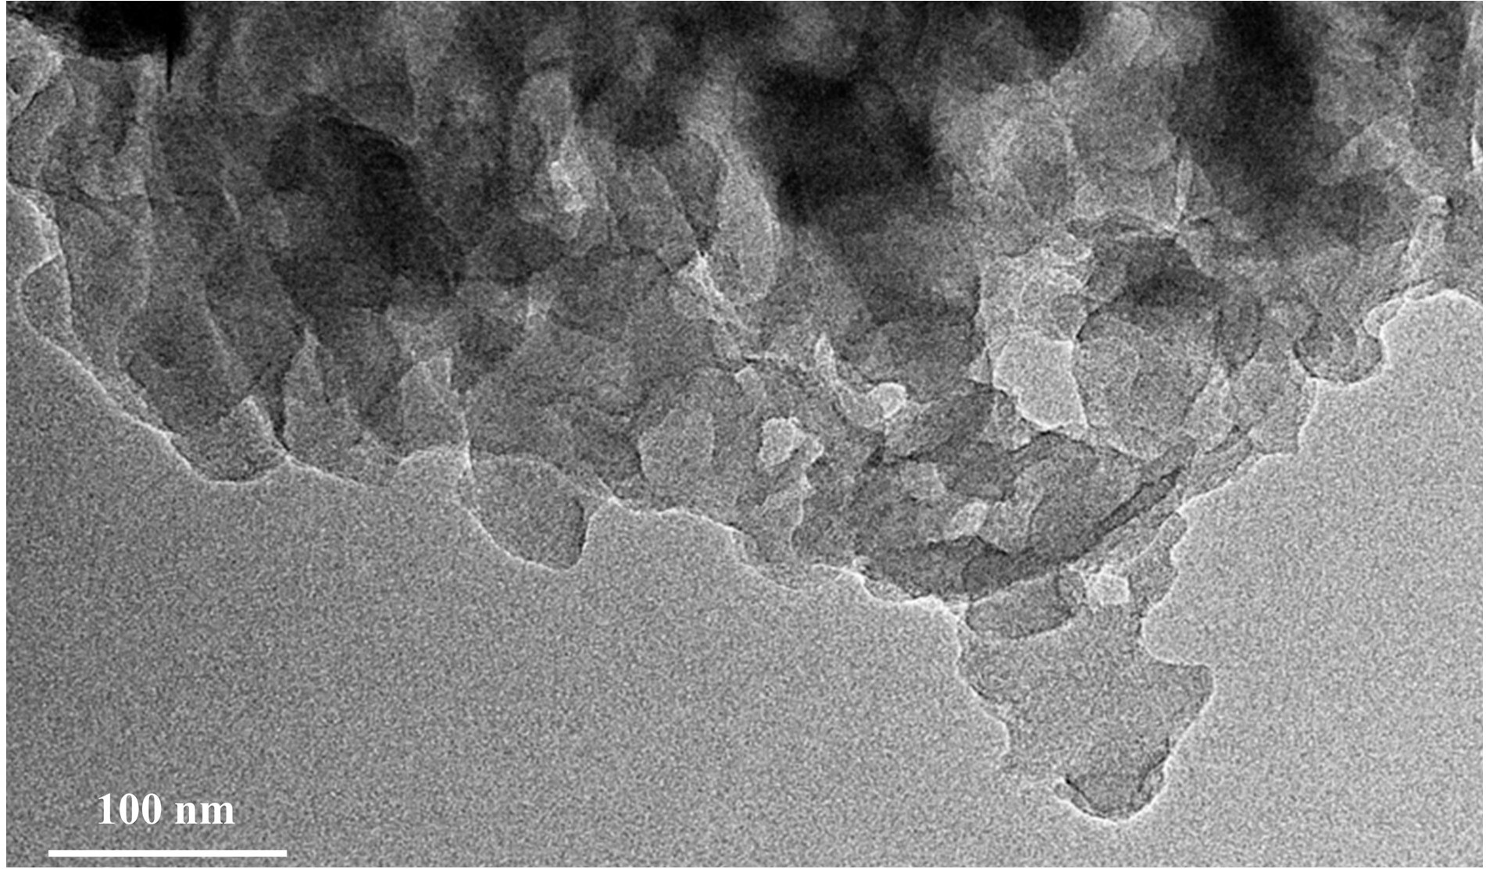
Fig.S4 TEM of UOMSHCN-25

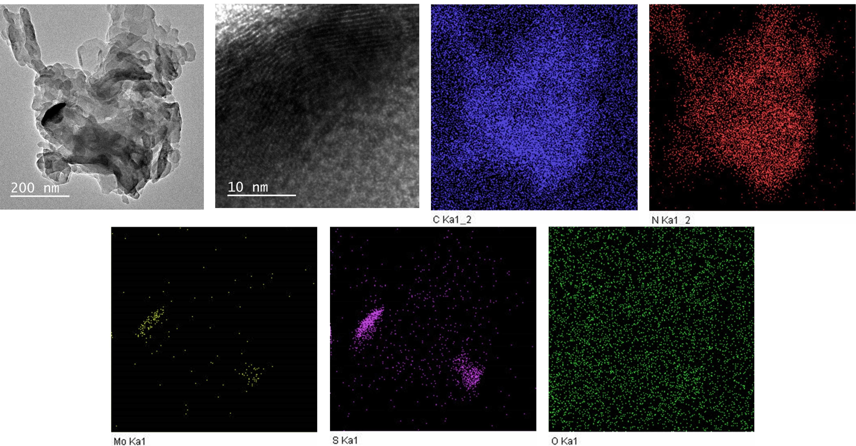
Fig.S5 TEM, HRTEM and element mapping of UOMSHCN-25
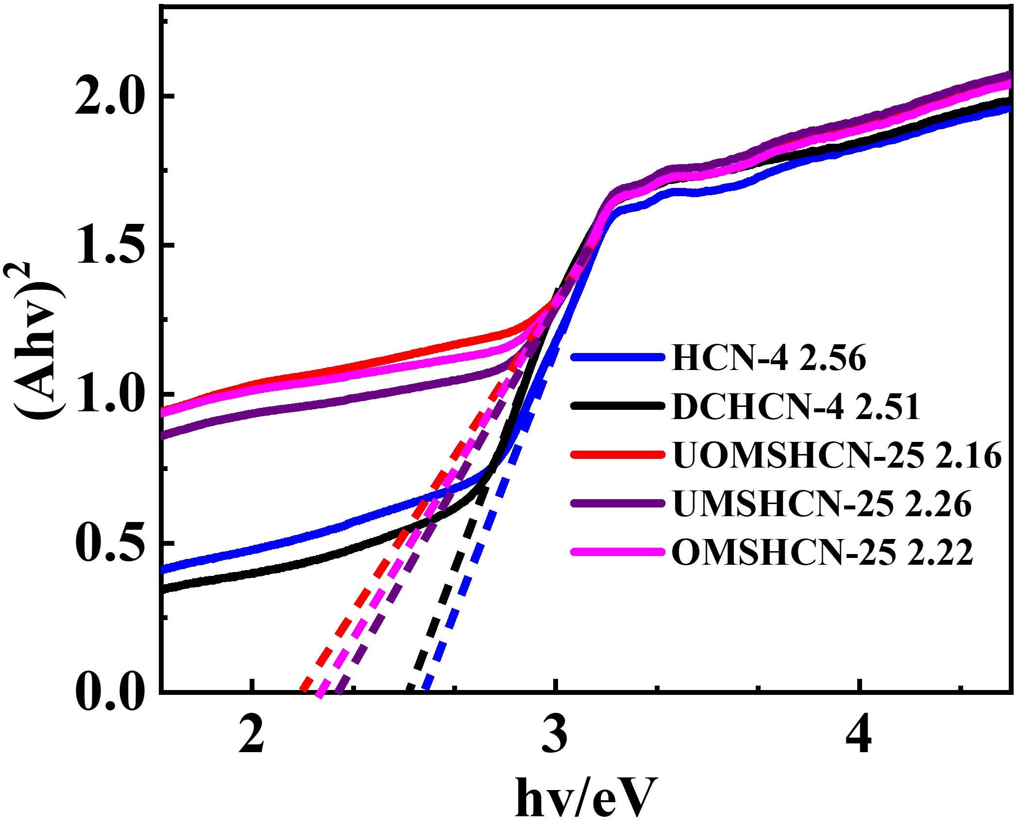
Fig.S6 Band gaps of HCN-4, DCHCN-4, UOMSHCN-25, UMSHCN-25 and OMSHCN-25

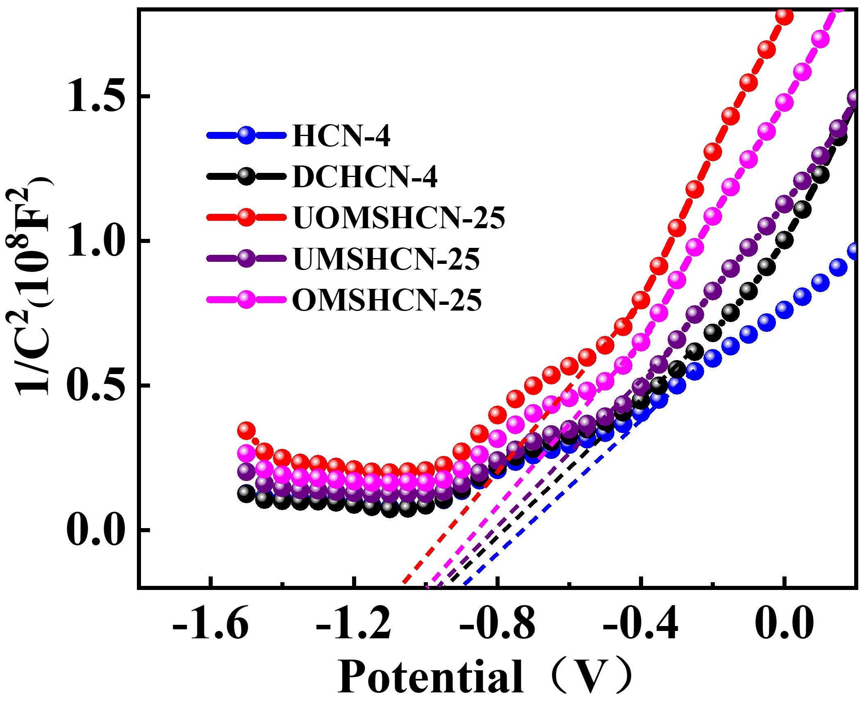
Fig.S7 Mott- Schottky plots of HCN-4, DCHCN-4. UOMSHCN-25, UMSHCN-25 and OMSHCN-25

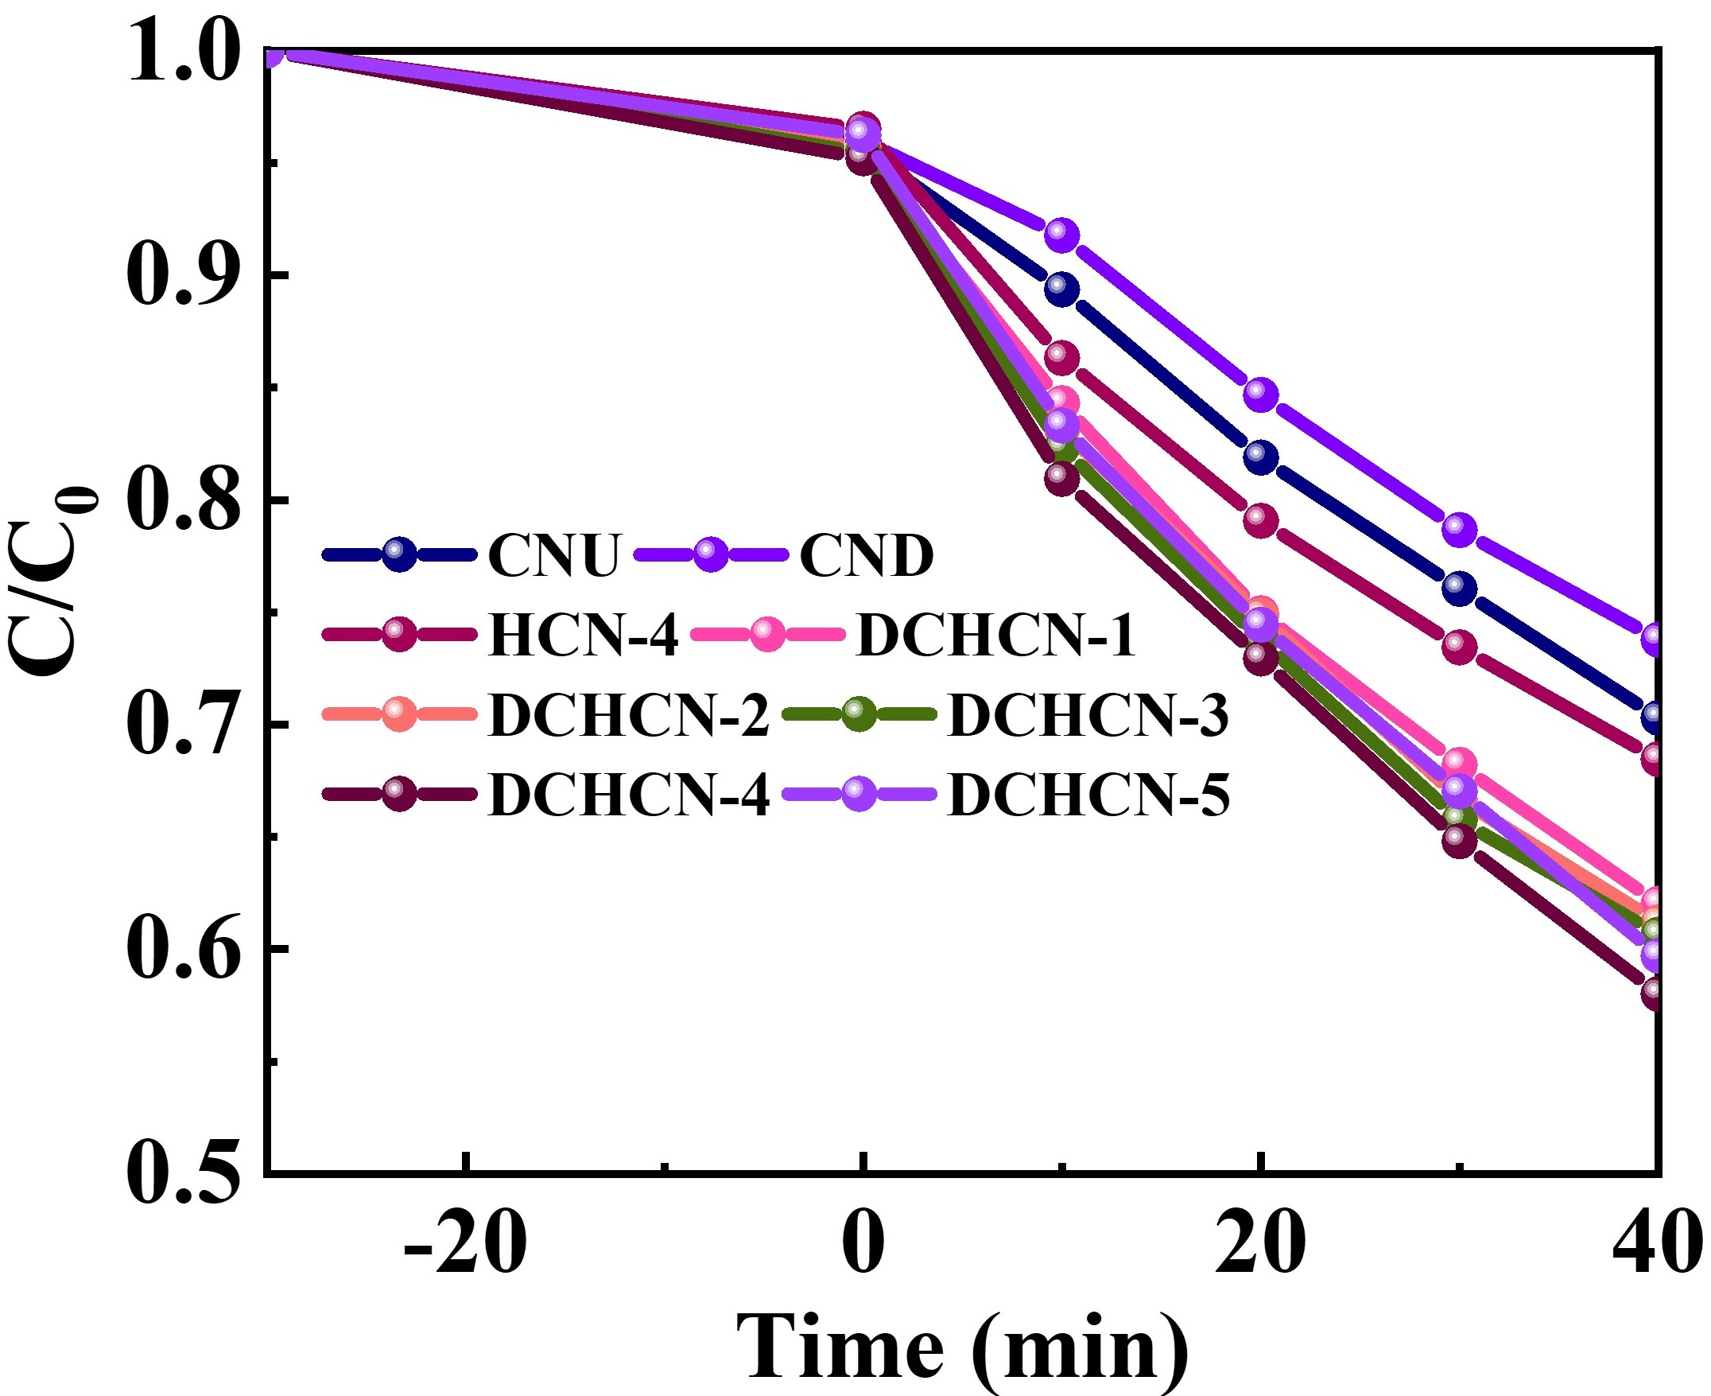
Fig.S8 Photocatalytic activities of CNU, CND, HCN-4 and DCHCNs for MO degradation

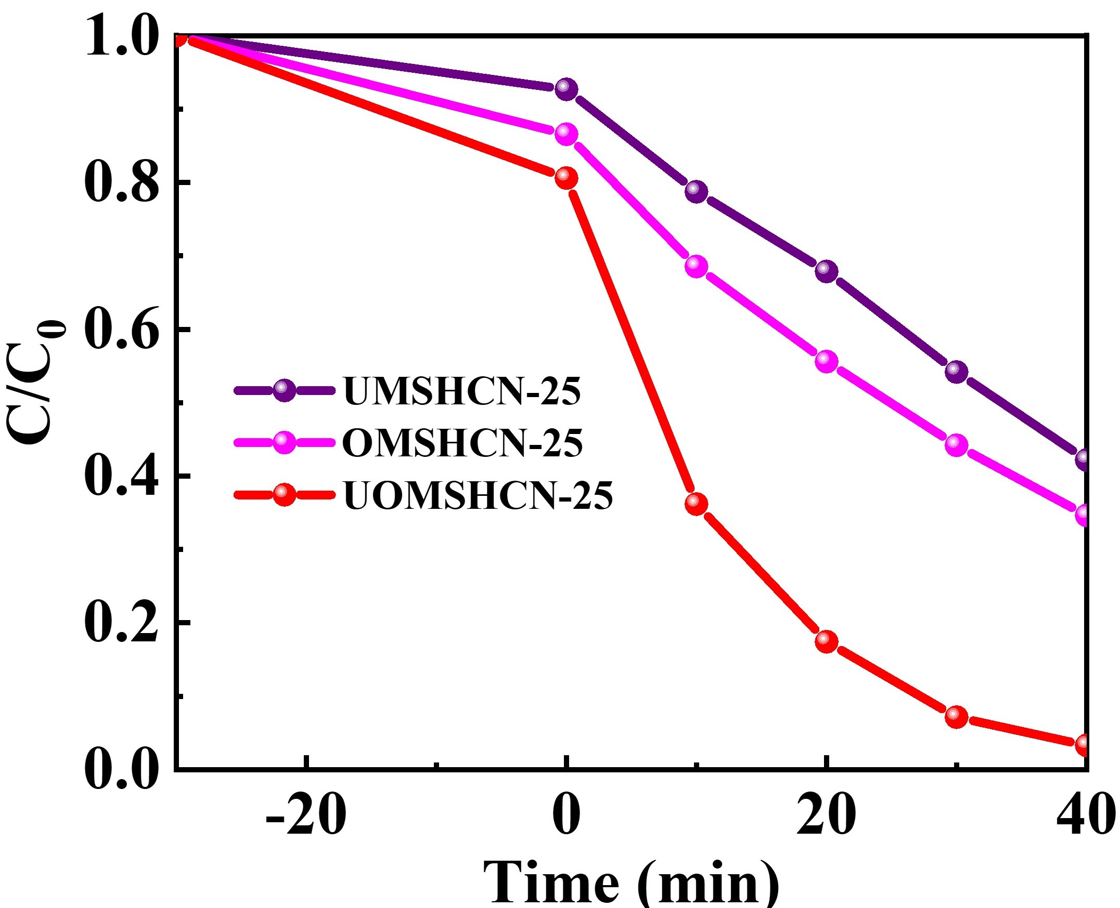
Fig.S9 Photocatalytic activities of UMSHCN-25, OMSHCN-25 and UOMSHCN-25 for MO degradation

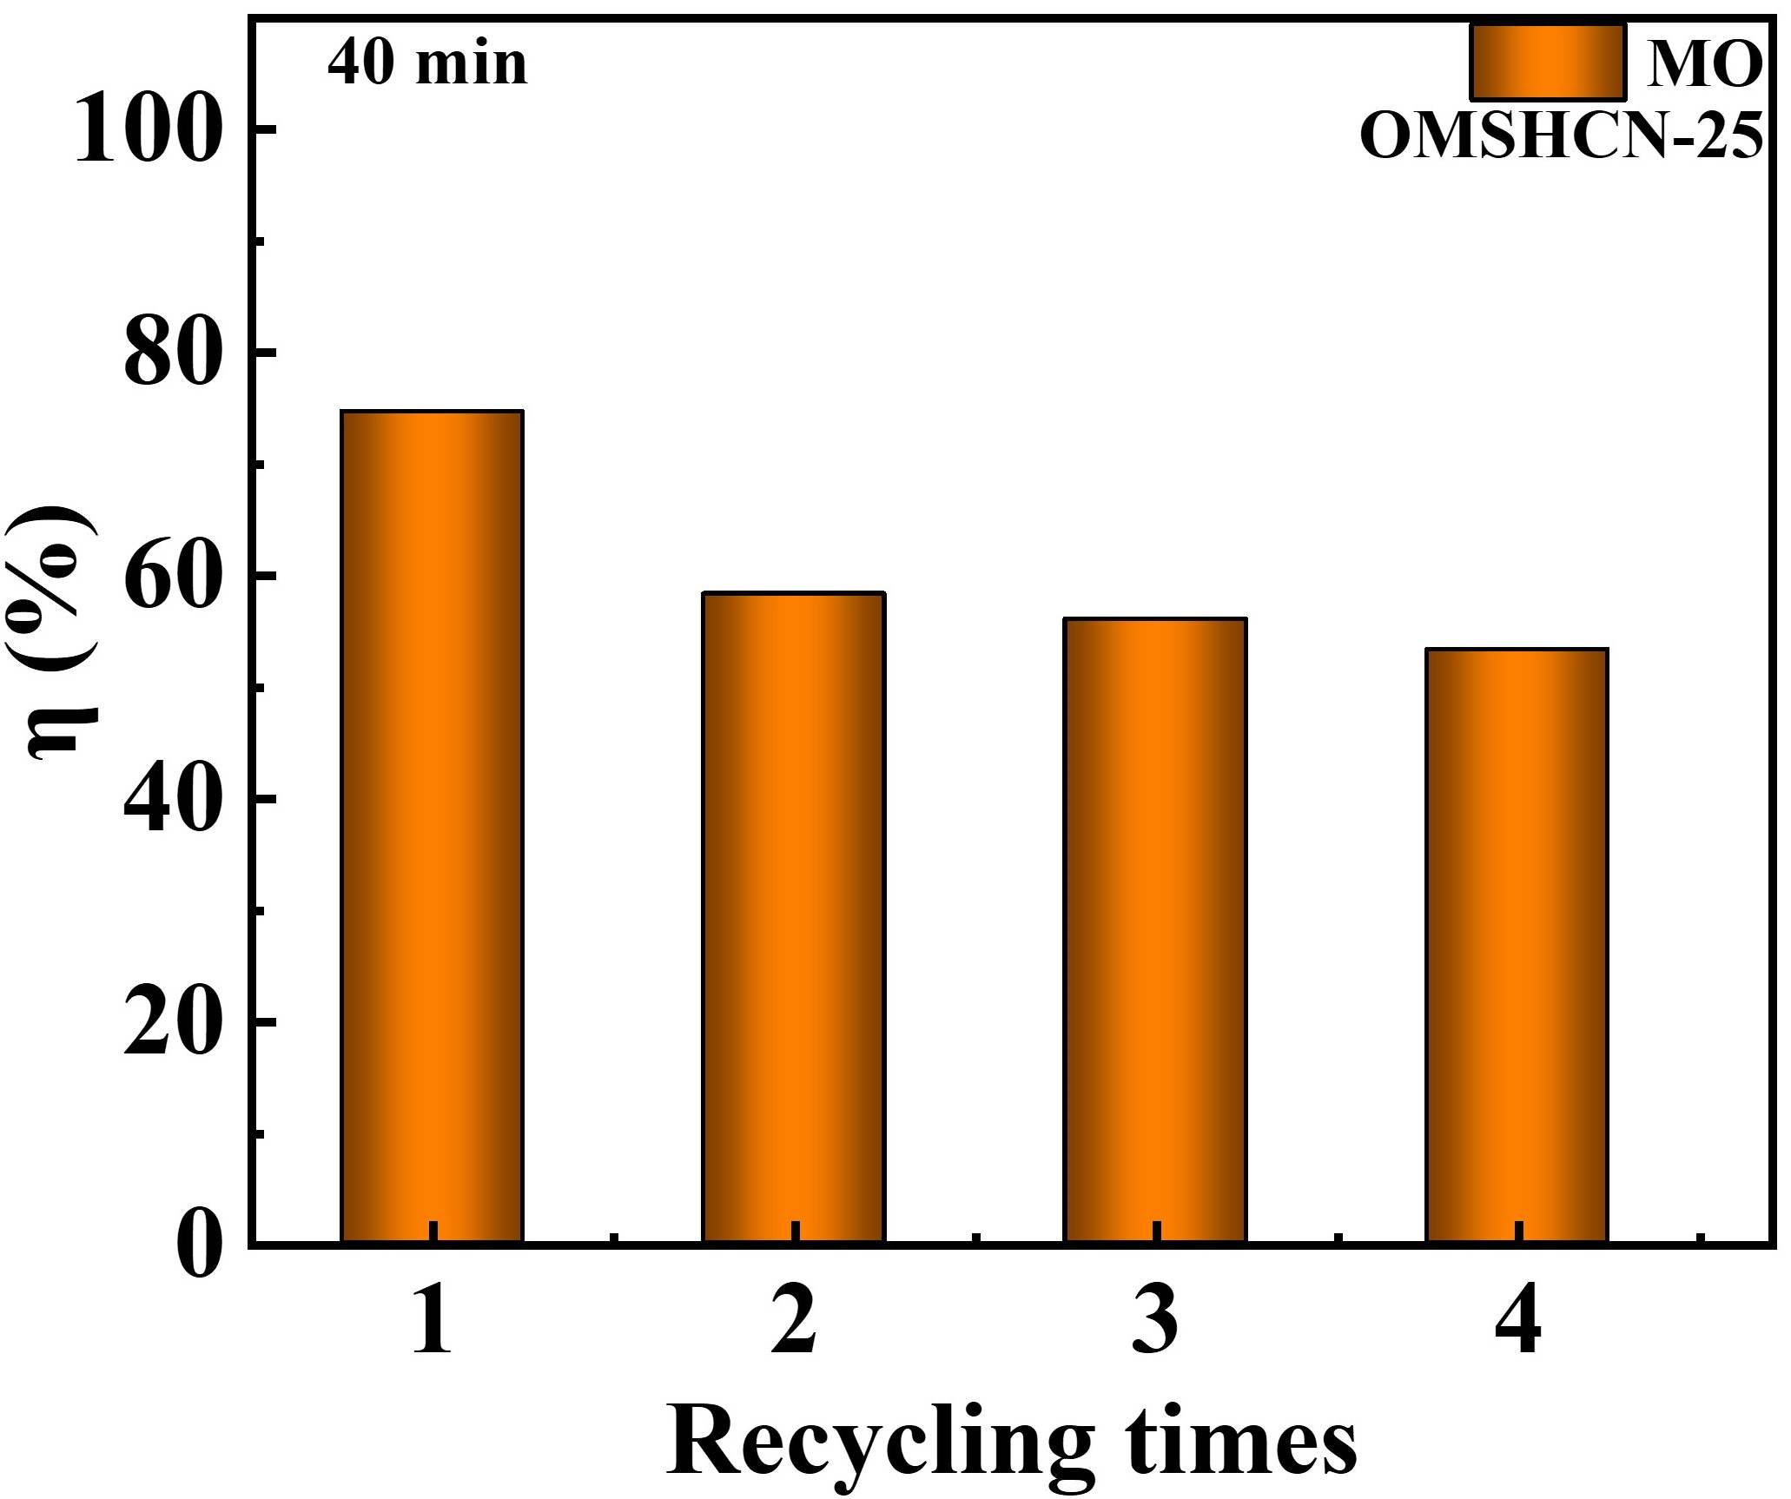
Fig.S10 Cyclic stability test of OMSHCN-25 for MO degradation

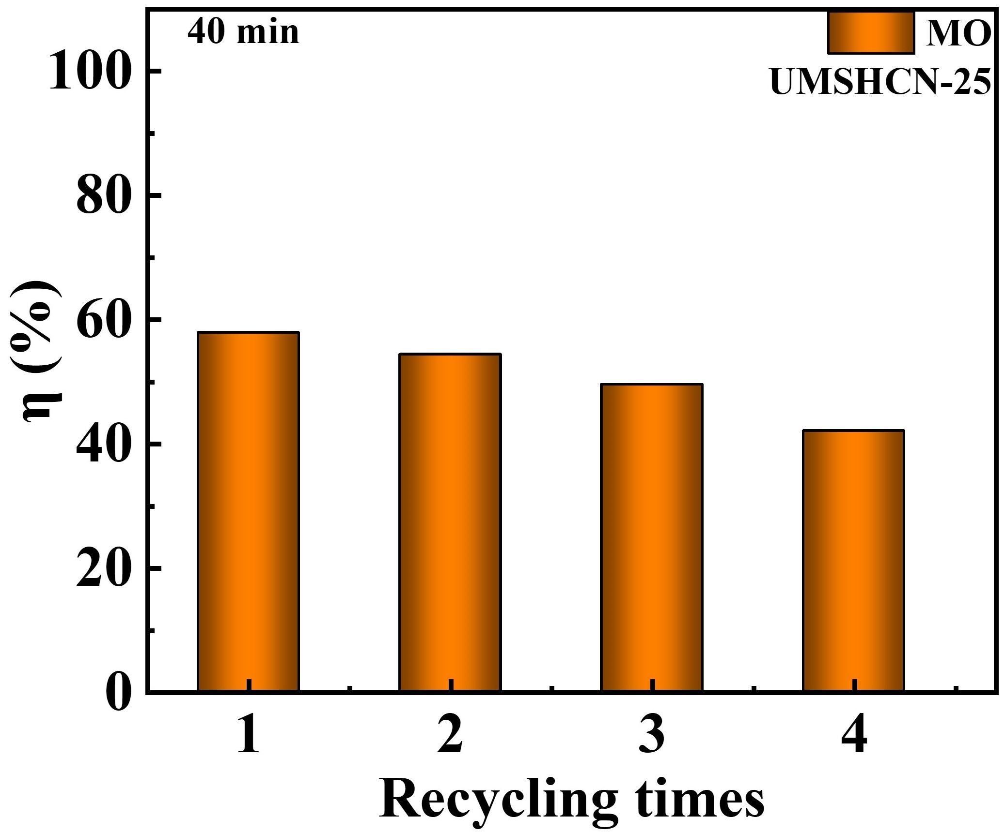
Fig.S11 Cyclic stability test of UMSHCN-25 for MO degradation

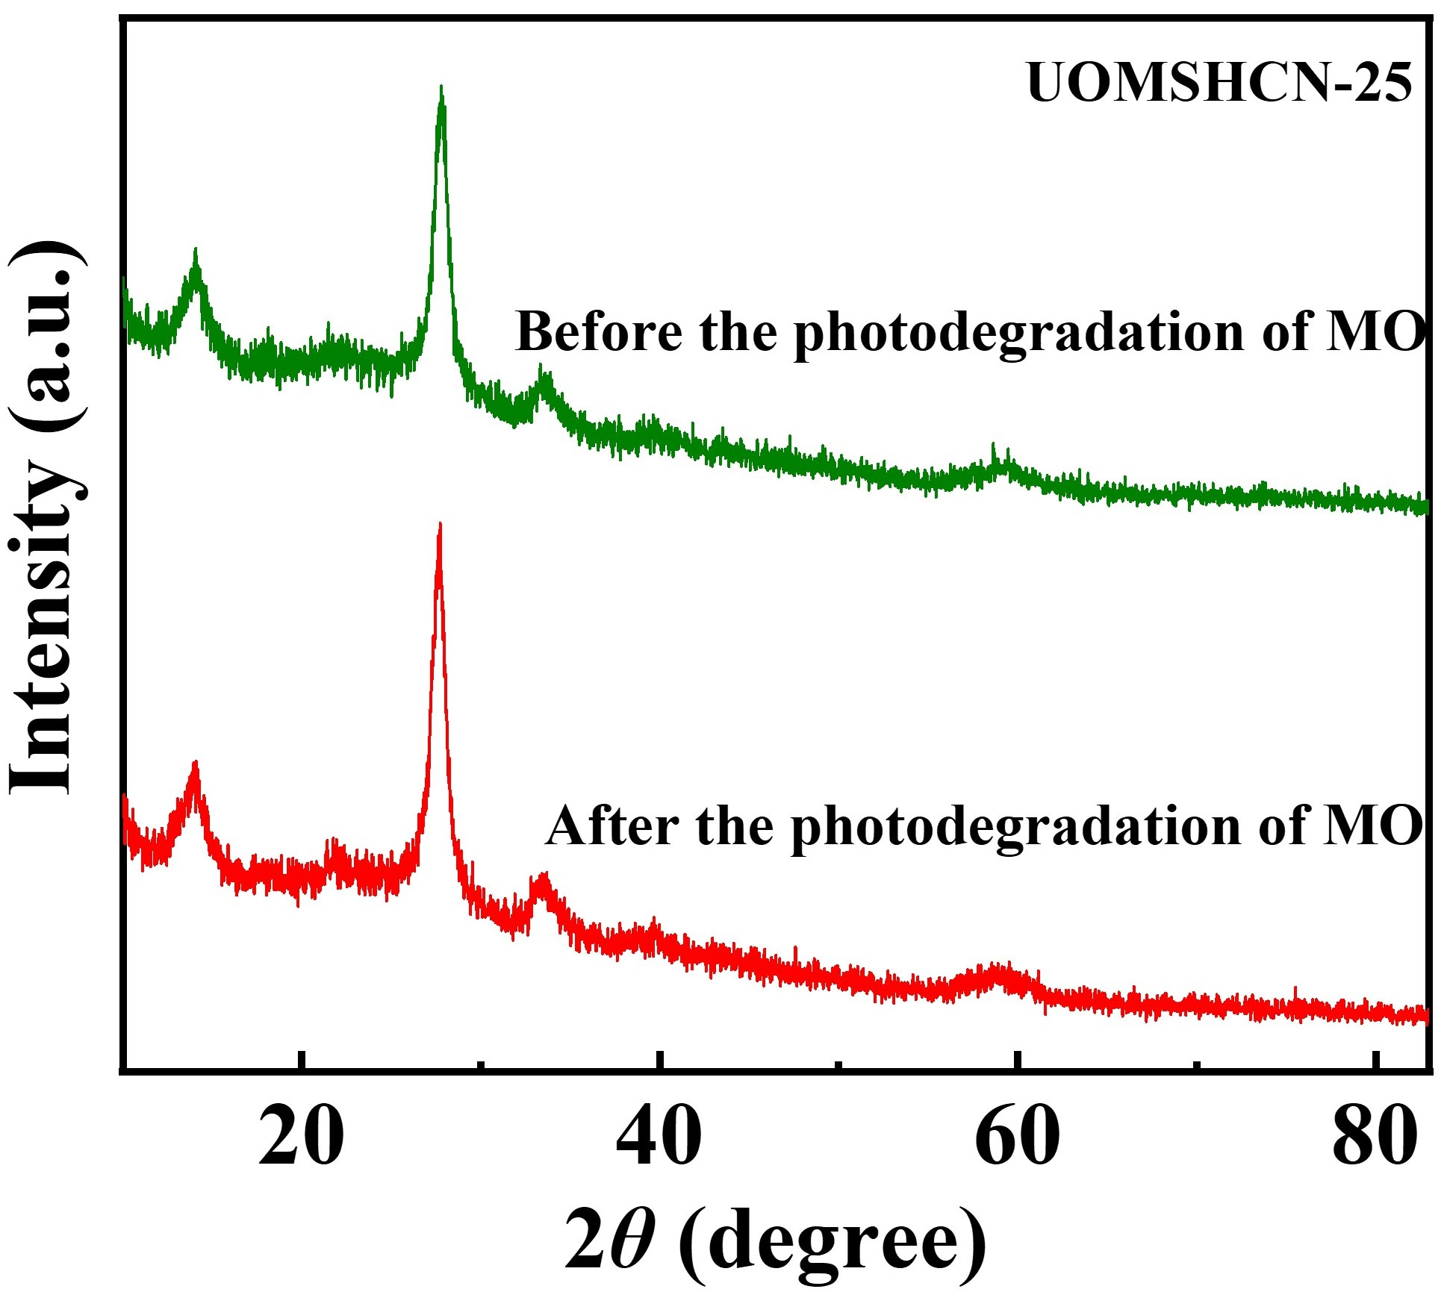
Fig.S12 XRD patterns of UOMSHCN-25 before and after the degradation of MO

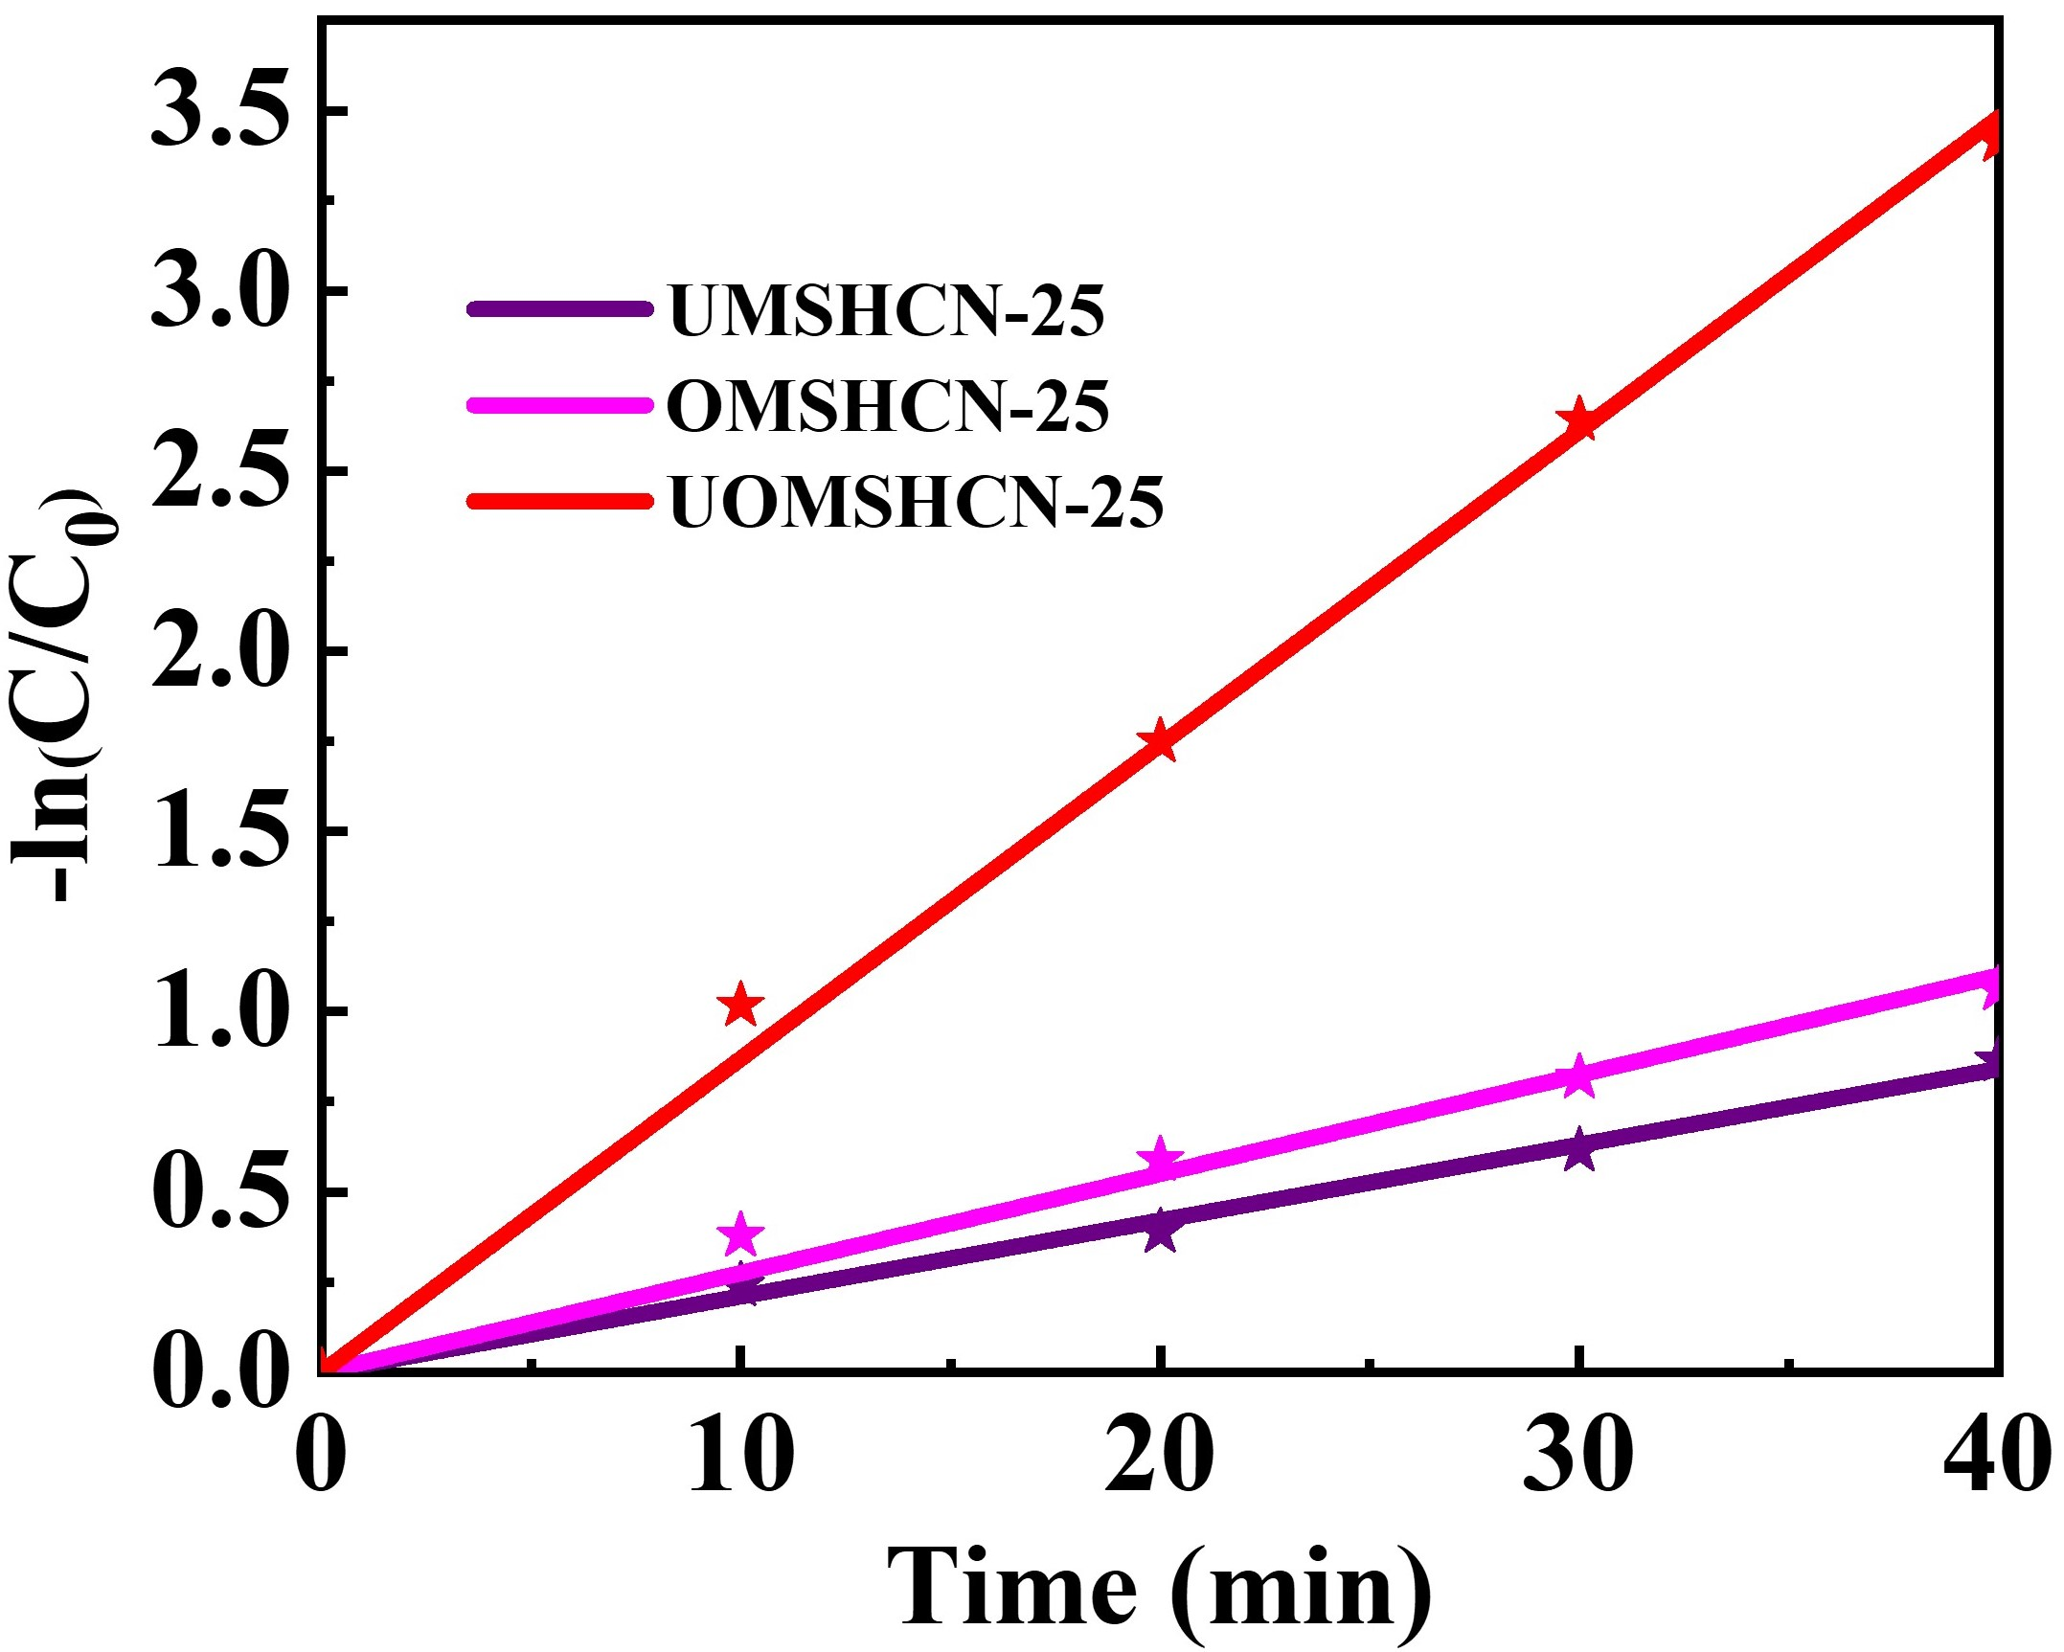
Fig.S13 The reaction kinetics of UMSHCN-25, OMSHCN-25 and UOMSHCN-25 for MO degradation

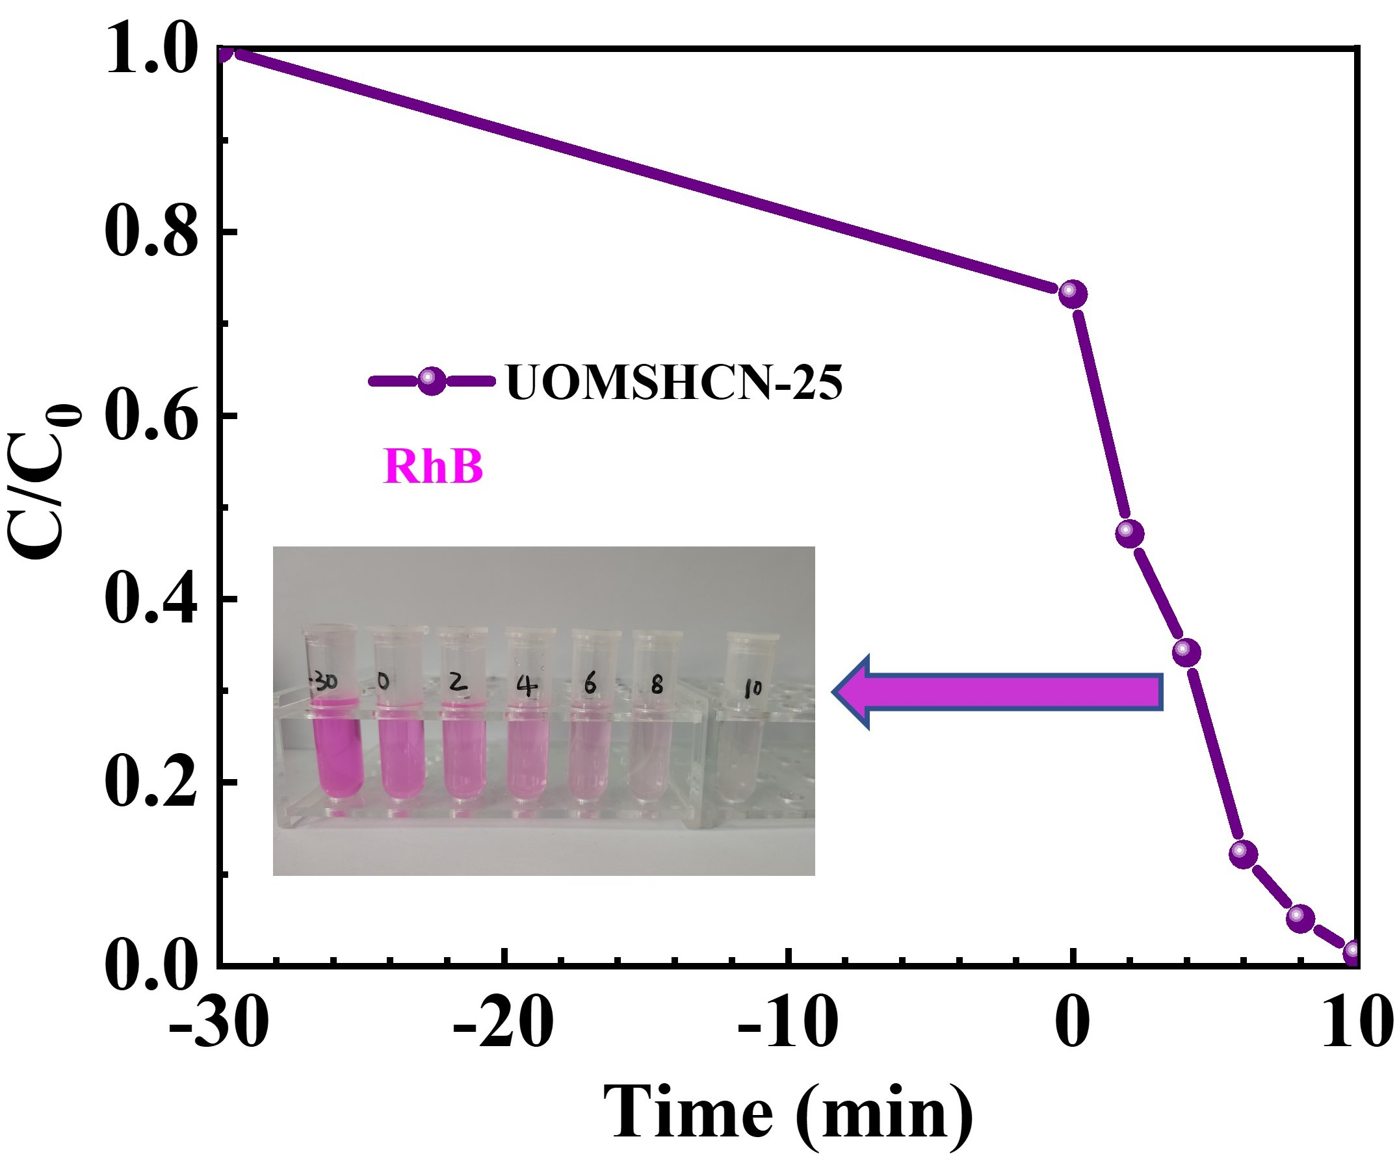
Fig.S14 Photocatalytic activity of UOMSHCN-25 for Rh B degradation

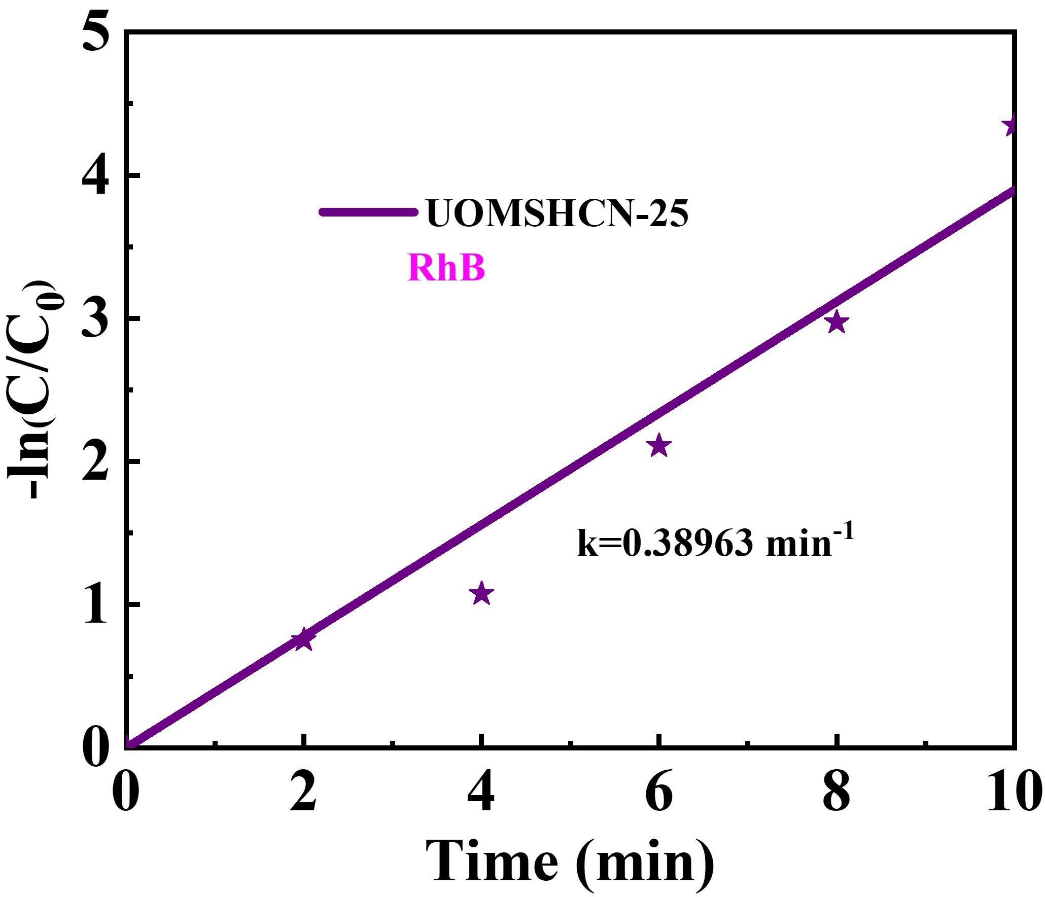
Fig.S15 The reaction kinetic of UOMSHCN-25 for Rh B degradation

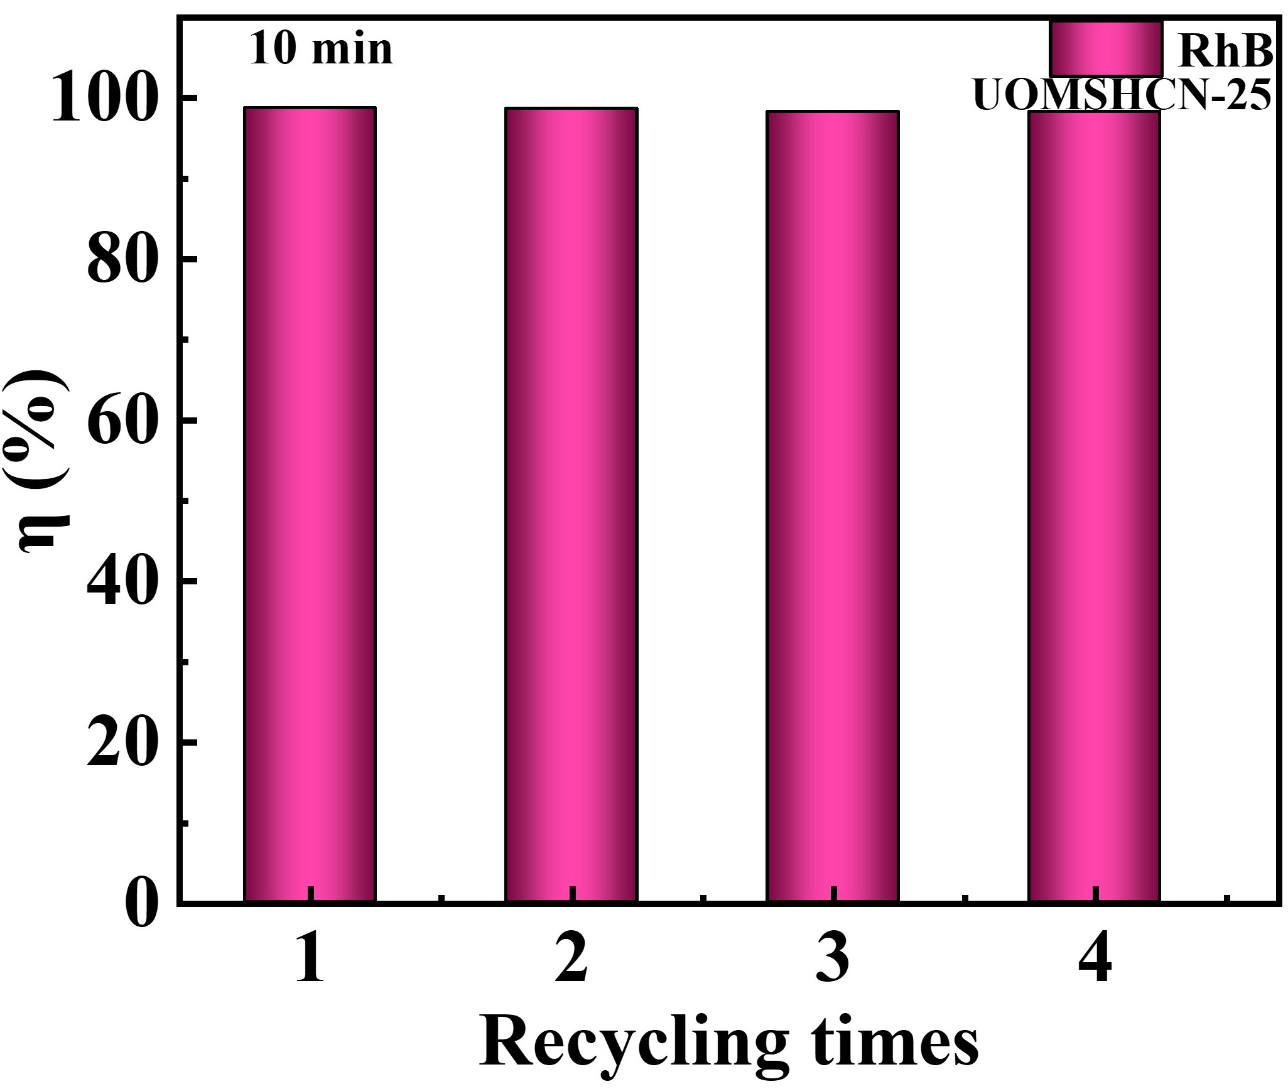
Fig.S16 Cyclic stability test of UOMSHCN-25 for Rh B degradation

Tab.S1 The interlamellar spacing (d value) of all samples
Samples | HCN-4 | DCHCN-4 | UOMSHCN-5 | UOMSHCN-15 | UOMSHCN-20
2θ | 27.62 | 27.73 | 27.71 | 27.69 | 27.68
d | 0.3227 | 0.3214 | 0.3216 | 0.3219 | 0.3220
Samples | UOMSHCN-25 | UOMSHCN-35 | OMSHCN-25 | UMSHCN-25
2θ | 27.64 | 27.61 | 27.74 | 27.70
d | 0.3224 | 0.3226 | 0.3213 | 0.3218

Tab.S2 pore volume of DCHCN-4, MoS₂ and UOMSHCN-25
Samples | DCHCN-4 | MoS₂ | UOMSHCN-25
Pore volume (cm³/g) | 0.382 | 0.072 | 0.493

Tab.S3 The kinetic rate constants of DCHCN-4, UOMSHCNs, UMSHCN-25, and OMSHCN-25
Samples | DCHCN-4 | UOMSHCN-5 | UOMSHCN-15 | UOMSHCN-20
k/min⁻¹ | 0.01442 | 0.02302 | 0.05263 | 0.05352
Samples | UOMSHCN-25 | UOMSHCN-35 | UMSHCN-25 | OMSHCN-25
k/min⁻¹ | 0.08700 | 0.07281 | 0.02103 | 0.02750

