Supplementary Figures

PRISMA flow diagram

Identification of studies via databases and registers

Records removed before screening:
Duplicate records removed (n = 315)
Records removed for other reasons (n = 0)
Records identified from:
Databases (n = 845)

Identification

Titles screened
(n = 533)
Records excluded
(n = 507)

Reports sought for retrieval
(n = 26)
Reports not retrieved
(n = 0)

Screening

Reports excluded:
Ineligible populations (n = 7)
Mixed THA/TKA populations without subgroup analyses for each (n=4)
Reviews (n = 1)
Ineligible statistical measures (n = 1)
Reports assessed for eligibility
(n = 26)

Studies included in review
(n = 13)

Included

Forest Plots

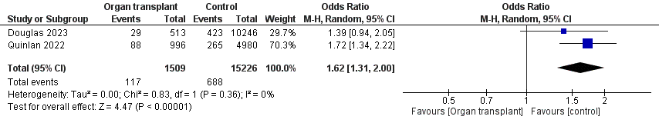
Solid organ transplant (all types) vs control, 30 day readmission, total hip arthroplasty

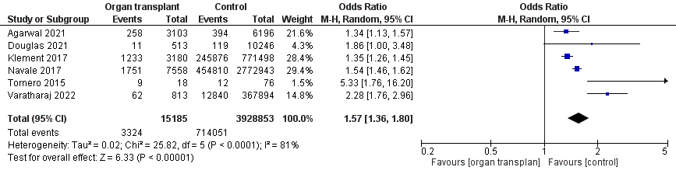
Solid organ transplant (all types) vs control, blood transfusion, total hip arthroplasty

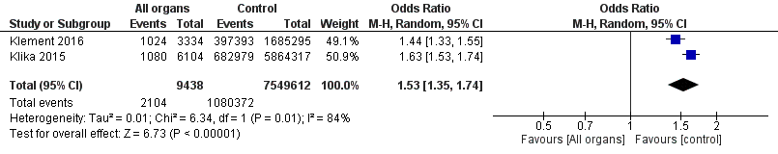
Solid organ transplant (all types) vs control, blood transfusion, total knee arthroplasty

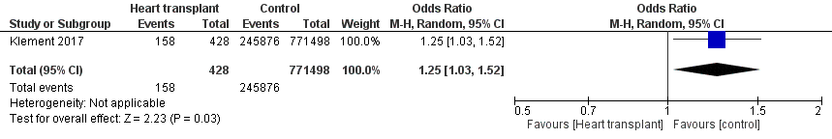
Solid organ transplant (heart) vs control, blood transfusion, total hip arthroplasty

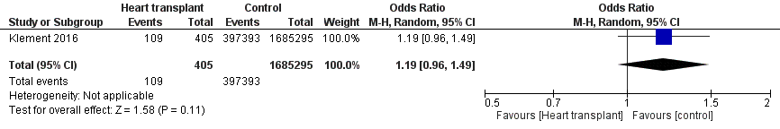
Solid organ transplant (heart) vs control, blood transfusion, total knee arthroplasty

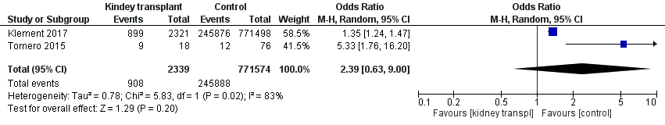
Solid organ transplant (kidney) vs control, blood transfusion, total hip arthroplasty

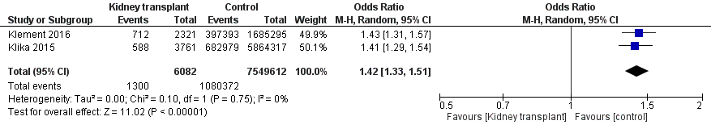
Solid organ transplant (kidney) vs control, blood transfusion, total knee arthroplasty

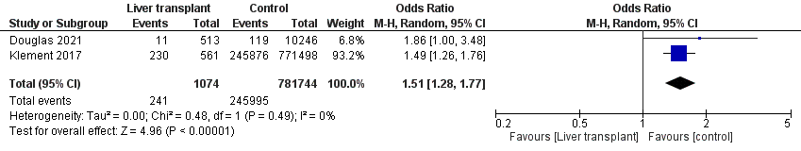
Solid organ transplant (liver) vs control, blood transfusion, total hip arthroplasty

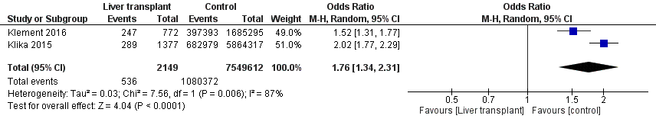
Solid organ transplant (liver) vs control, blood transfusion, total knee arthroplasty

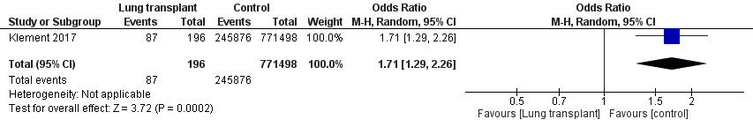
Solid organ transplant (lung) vs control, blood transfusion, total hip arthroplasty

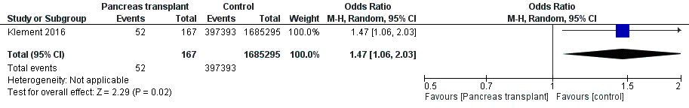
Solid organ transplant (lung) vs control, blood transfusion, total knee arthroplasty

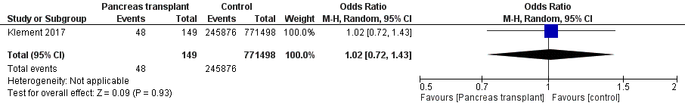
Solid organ transplant (pancreas) vs control, blood transfusion, total hip arthroplasty

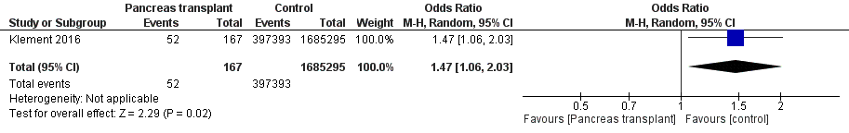
Solid organ transplant (pancreas) vs control, blood transfusion, total knee arthroplasty

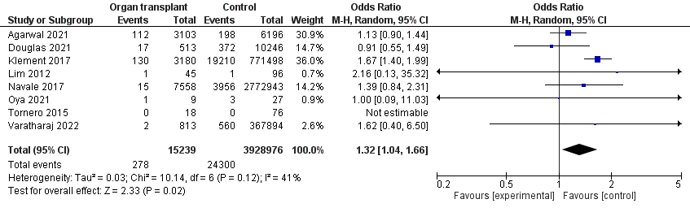
Solid organ transplant (all types) vs control, DVT, total hip arthroplasty

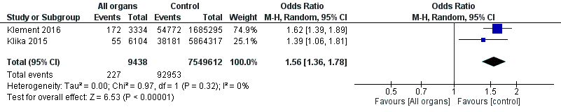
Solid organ transplant (all types) vs control, DVT, total knee arthroplasty

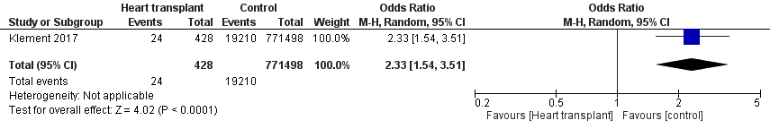
Solid organ transplant (heart) vs control, DVT, total hip arthroplasty

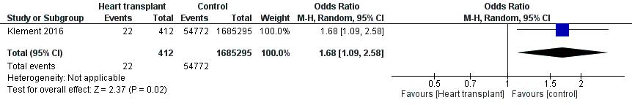
Solid organ transplant (heart) vs control, DVT, total knee arthroplasty

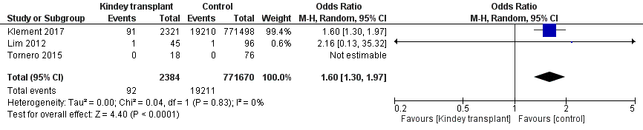
Solid organ transplant (kidney) vs control, DVT, total hip arthroplasty

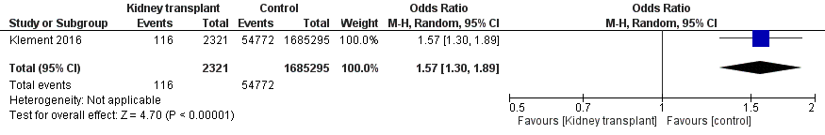
Solid organ transplant (kidney) vs control, DVT, total knee arthroplasty

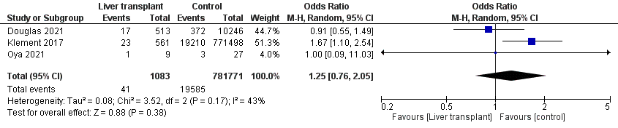
Solid organ transplant (liver) vs control, DVT, total hip arthroplasty

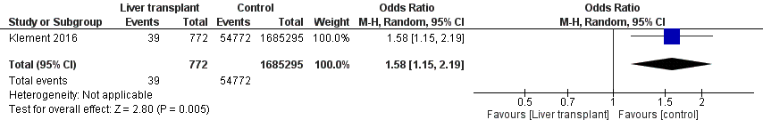
Solid organ transplant (liver) vs control, DVT, total knee arthroplasty

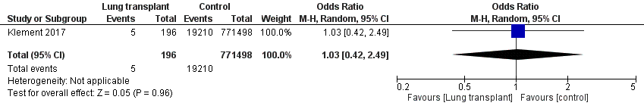
Solid organ transplant (lung) vs control, DVT, total hip arthroplasty

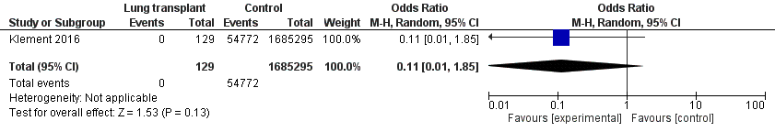
Solid organ transplant (lung) vs control, DVT, total knee arthroplasty

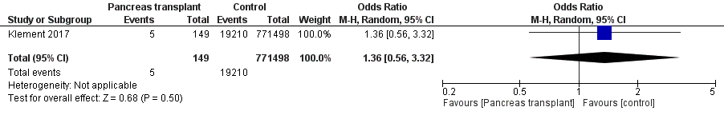
Solid organ transplant (pancreas) vs control, DVT, total hip arthroplasty

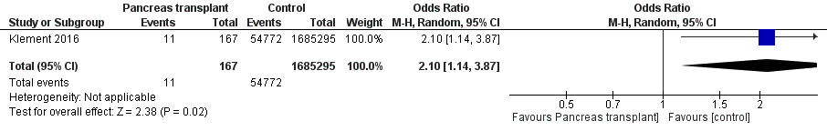
Solid organ transplant (pancreas) vs control, DVT, total knee arthroplasty

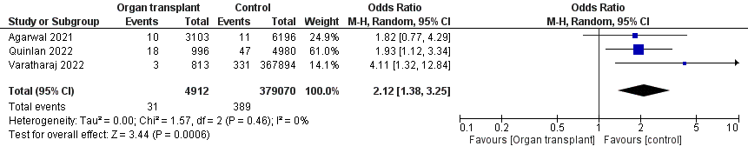
Solid organ transplant (all types) vs control, mortality, total hip arthroplasty

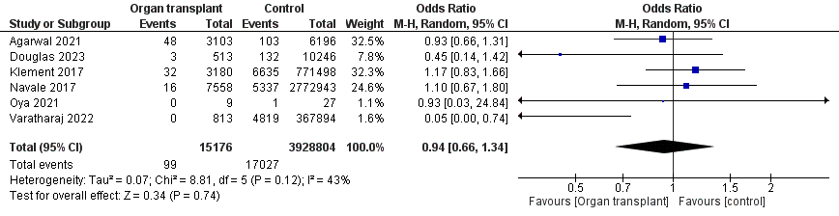
Solid organ transplant (all types) vs control, PE, total hip arthroplasty

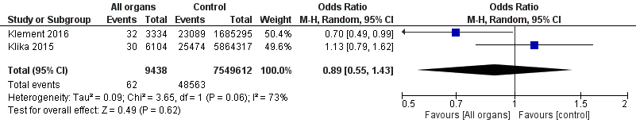
Solid organ transplant (all types) vs control, PE, total knee arthroplasty

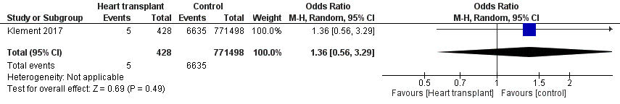
Solid organ transplant (heart) vs control, PE, total hip arthroplasty

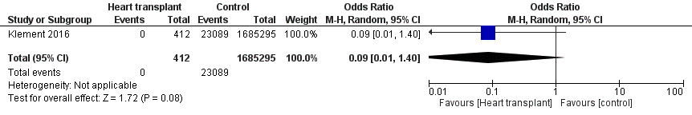
Solid organ transplant (heart) vs control, PE, total knee arthroplasty

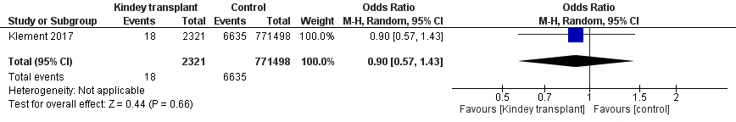
Solid organ transplant (kidney) vs control, PE, total hip arthroplasty

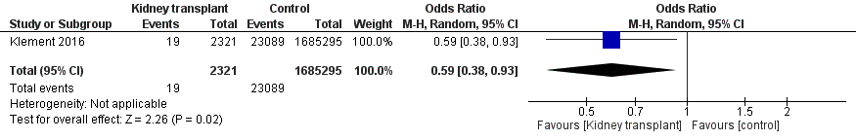
Solid organ transplant (kidney) vs control, PE, total knee arthroplasty

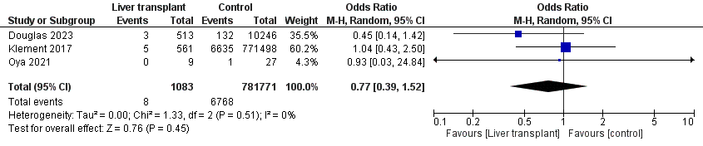
Solid organ transplant (liver) vs control, PE, total hip arthroplasty

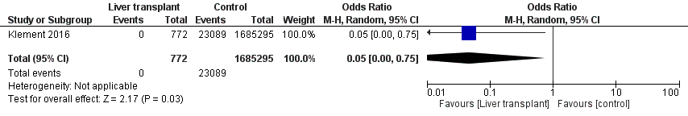
Solid organ transplant (liver) vs control, PE, total knee arthroplasty

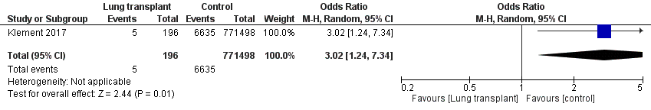
Solid organ transplant (lung) vs control, PE, total hip arthroplasty

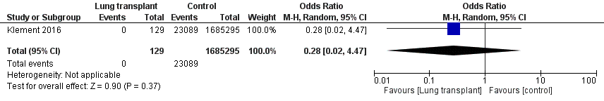
Solid organ transplant (lung) vs control, PE, total knee arthroplasty

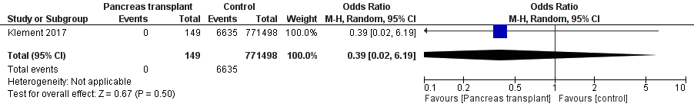
Solid organ transplant (pancreas) vs control, PE, total hip arthroplasty

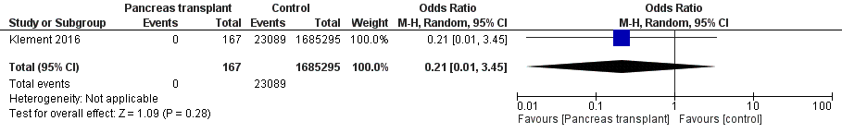
Solid organ transplant (pancreas) vs control, PE, total knee arthroplasty

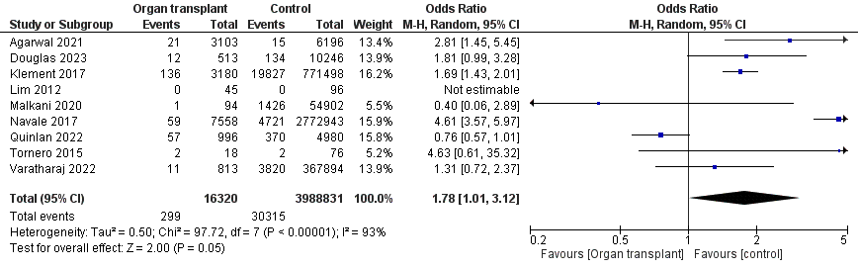
Solid organ transplant (all types) vs control, PJI, total hip arthroplasty

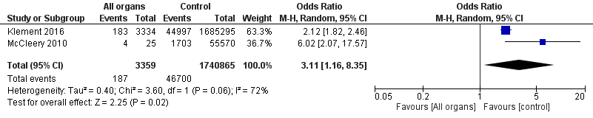
Solid organ transplant (all types) vs control, PJI, total knee arthroplasty

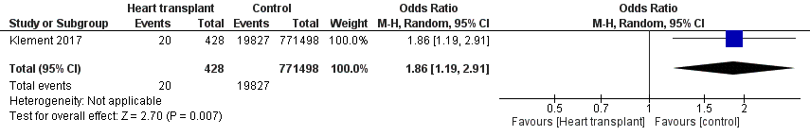
Solid organ transplant (heart) vs control, PJI, total hip arthroplasty

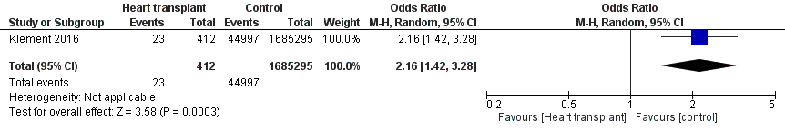
Solid organ transplant (heart) vs control, PJI, total knee arthroplasty

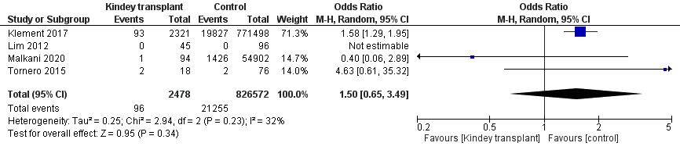

Solid organ transplant (kidney) vs control, PJI, total hip arthroplasty

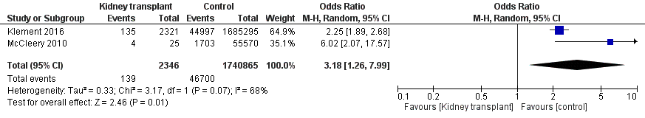
Solid organ transplant (kidney) vs control, PJI, total knee arthroplasty

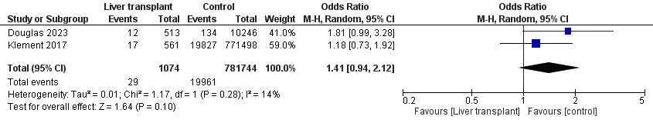
Solid organ transplant (liver) vs control, PJI, total hip arthroplasty

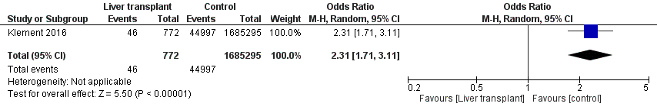
Solid organ transplant (liver) vs control, PJI, total knee arthroplasty

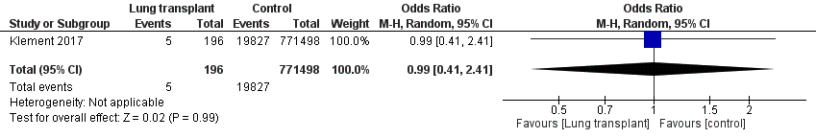
Solid organ transplant (lung) vs control, PJI, total hip arthroplasty

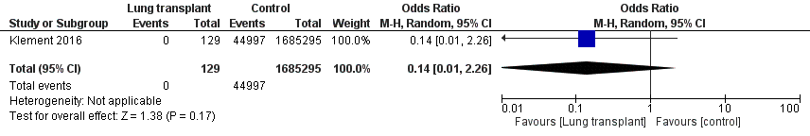
Solid organ transplant (lung) vs control, PJI, total knee arthroplasty

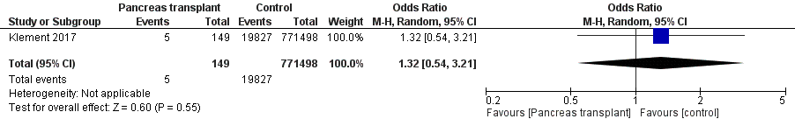
Solid organ transplant (pancreas) vs control, PJI, total hip arthroplasty

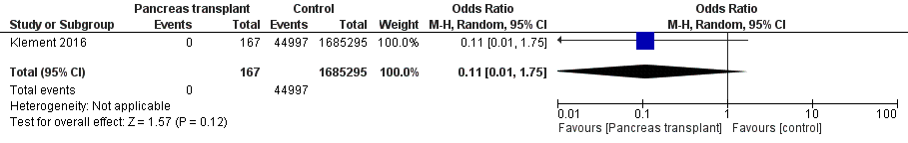
Solid organ transplant (pancreas) vs control, PJI, total knee arthroplasty

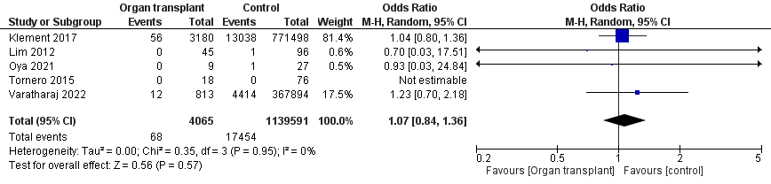
Solid organ transplant (all types) vs control, PP#, total hip arthroplasty

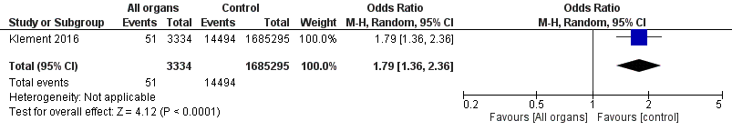
Solid organ transplant (all types) vs control, PP#, total knee arthroplasty

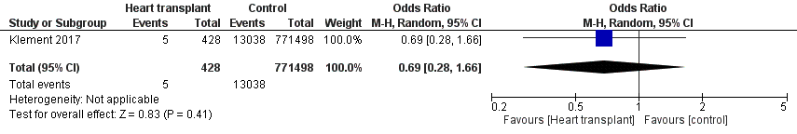
Solid organ transplant (heart) vs control, PP#, total hip arthroplasty

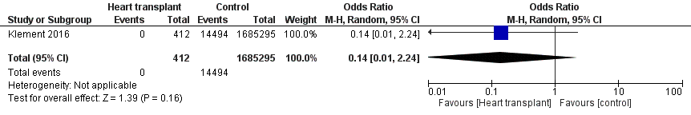
Solid organ transplant (heart) vs control, PP#, total knee arthroplasty

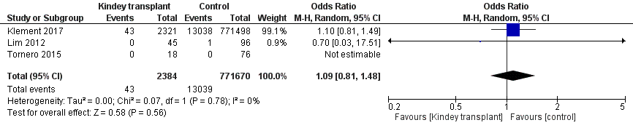
Solid organ transplant (kidney) vs control, PP#, total hip arthroplasty

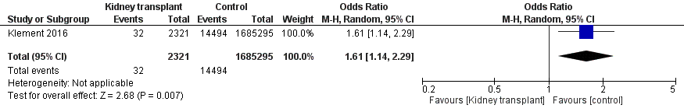
Solid organ transplant (kidney) vs control, PP#, total knee arthroplasty

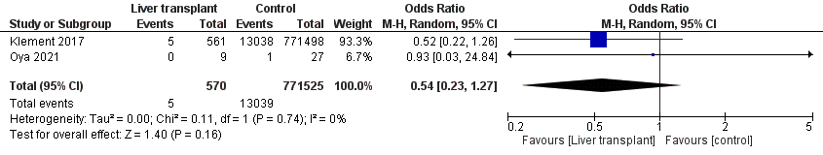
Solid organ transplant (liver) vs control, PP#, total hip arthroplasty

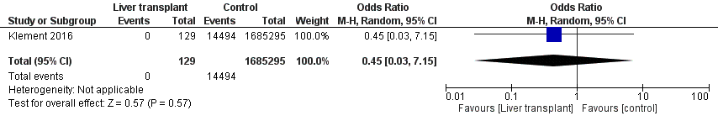
Solid organ transplant (liver) vs control, PP#, total knee arthroplasty

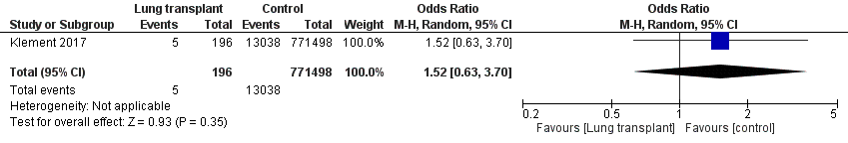
Solid organ transplant (lung) vs control, PP#, total hip arthroplasty

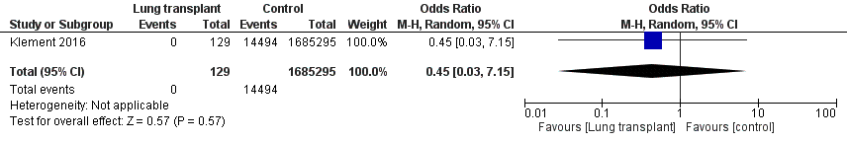
Solid organ transplant (lung) vs control, PP#, total knee arthroplasty

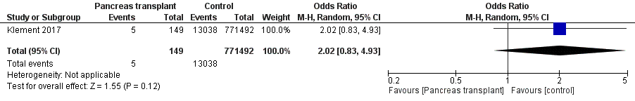
Solid organ transplant (pancreas) vs control, PP#, total hip arthroplasty

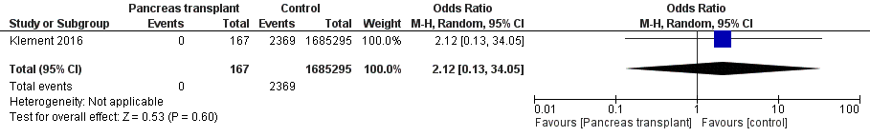
Solid organ transplant (pancreas) vs control, PP#, total knee arthroplasty

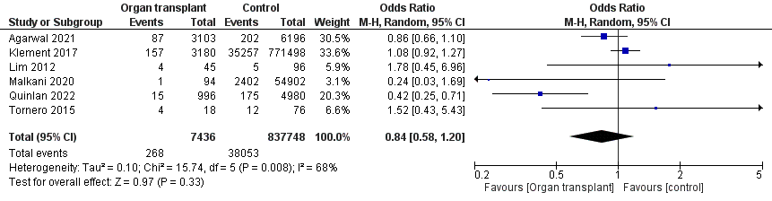
Solid organ transplant (all types) vs control, revision, total hip arthroplasty

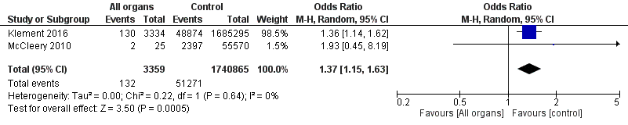
Solid organ transplant (all types) vs control, revision, total knee arthroplasty

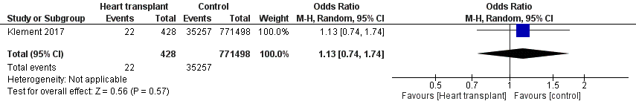
Solid organ transplant (heart) vs control, revision, total hip arthroplasty

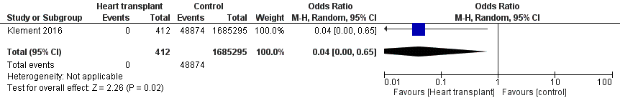
Solid organ transplant (heart) vs control, revision, total knee arthroplasty

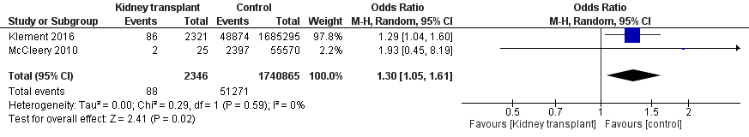
Solid organ transplant (kidney) vs control, revision, total hip arthroplasty

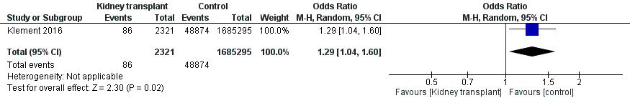
Solid organ transplant (kidney) vs control, revision, total knee arthroplasty

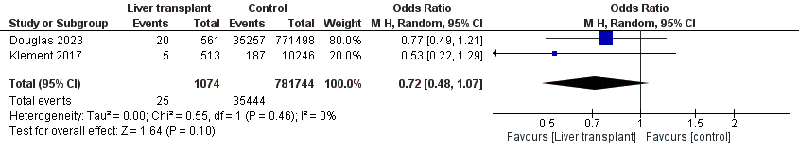
Solid organ transplant (liver) vs control, revision, total hip arthroplasty

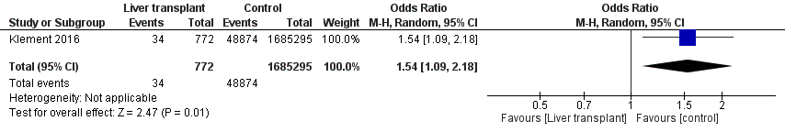
Solid organ transplant (liver) vs control, revision, total knee arthroplasty

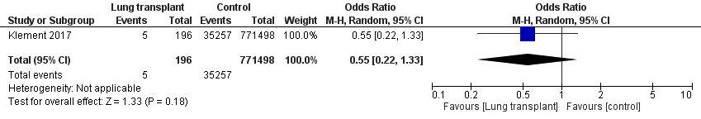
Solid organ transplant (lung) vs control, revision, total hip arthroplasty

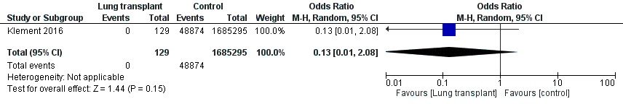
Solid organ transplant (lung) vs control, revision, total knee arthroplasty

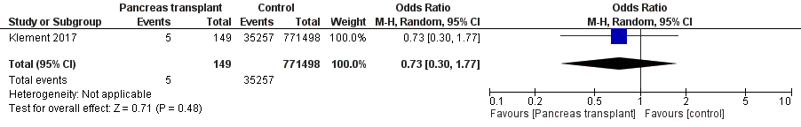
Solid organ transplant (pancreas) vs control, revision, total hip arthroplasty

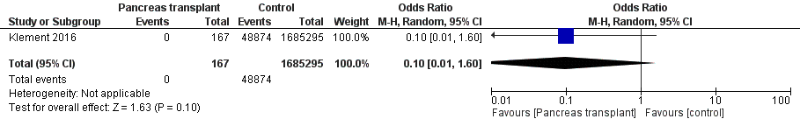
Solid organ transplant (pancreas) vs control, revision, total knee arthroplasty

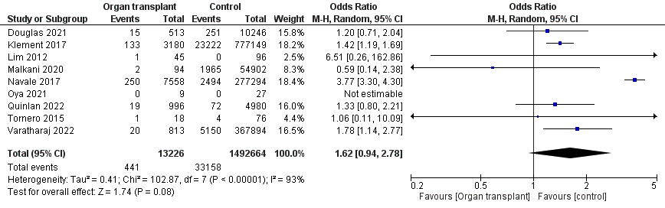
Solid organ transplant (all types) vs control, dislocation, total hip arthroplasty

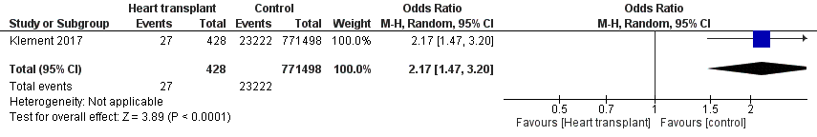
Solid organ transplant (heart) vs control, dislocation, total hip arthroplasty

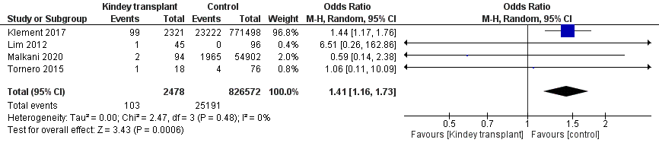
Solid organ transplant (kidney) vs control, dislocation, total hip arthroplasty

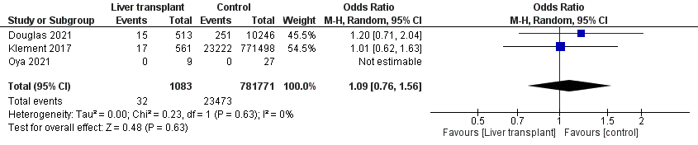
Solid organ transplant (liver) vs control, dislocation, total hip arthroplasty

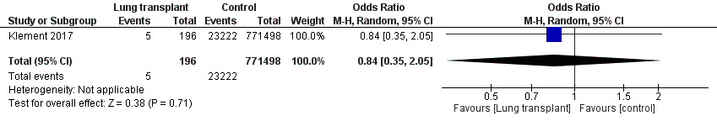
Solid organ transplant (lung) vs control, dislocation, total hip arthroplasty

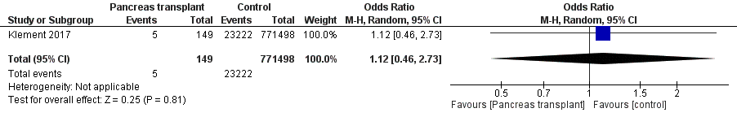
Solid organ transplant (pancreas) vs control, dislocation, total hip arthroplasty

