Table 1. Enantioselective sulfoximine synthesis via the UPO catalysed oxygenation of sulfilimines, using a kinetic resolution approach. Unless stated, the following reaction conditions were used: KPi pH 7 buffer (24 mL), artUPO secretate (1 mL) and 4 (0.3 mmol), H₂O₂ (0.180 mmol) added over 4 h, followed by stirring overnight at RT. ª scale up reactions performed using 1 mmol 4 with additional H₂O₂ additions used until ≈50% conversion was observed by ¹H NMR analysis (see Supplementary Information section 2.5).
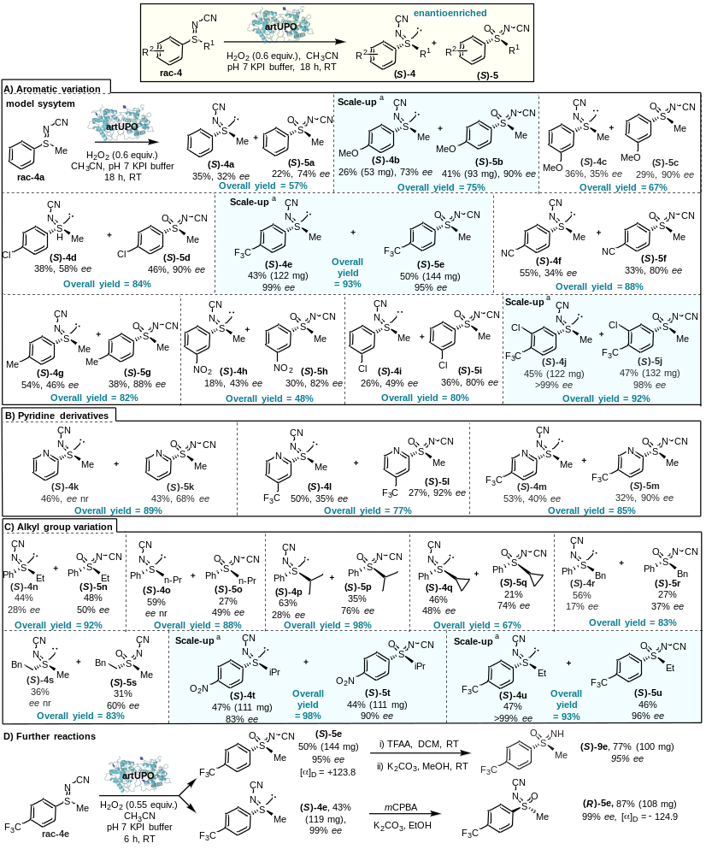

Table 2. Stereodivergent, enantioselective synthesis of both sulfinimine enantiomers via UPO catalysed oxygenation of sulfenimines. Unless stated, the following reaction conditions were used: KPi pH 7 buffer (10 mL), rAaeUPO-PaDa-I-H or art UPO and 6 (0.2 mmol), H₂O₂ (0.2 mmol) added over 10 h, followed by stirring for a further 6 h at RT. ª scale up reaction performed using 3 mmol of 6 (see Supplementary Information for full details).
