Supplementary Material

Well-Controlled Emulsion Polymerization of Methyl Methacrylate Using (Hg,Cd)-Diphenylcarbazone Catalysts: An attempt to create Hg-free, nontoxic, γ-radiation and thermal stable films
El-Said H. El-Mosallamy and Hany M. AbdelDayem*

Chemistry Department, Faculty of Science, Ain Shams University, 11566 Abassia, Cairo, Egypt.

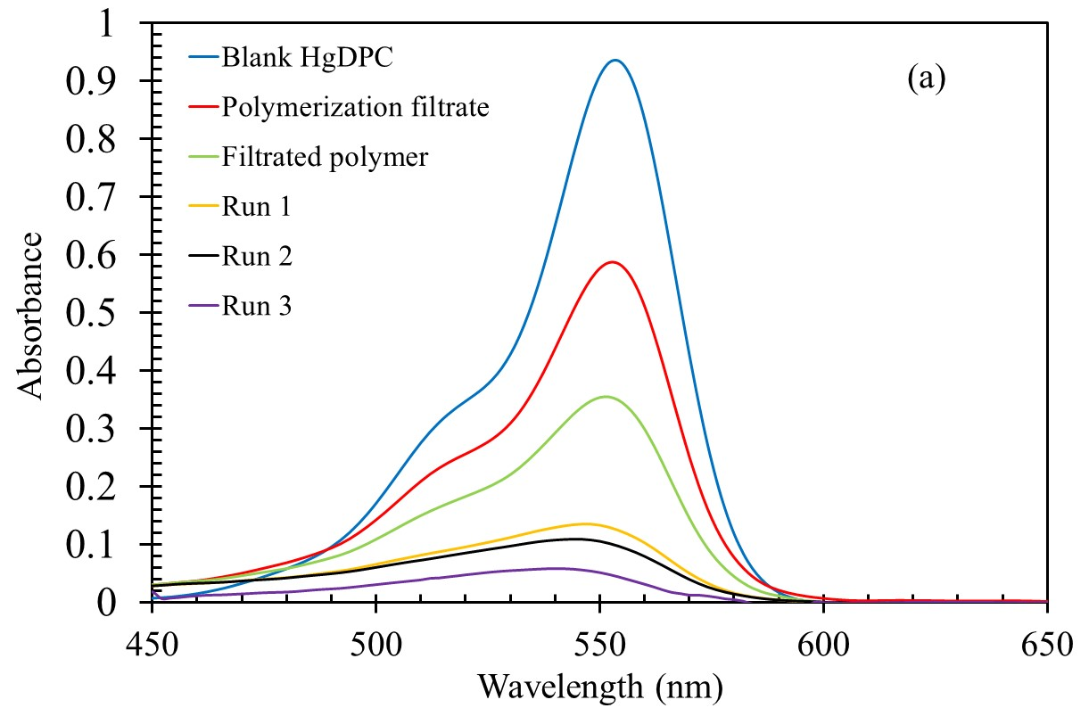
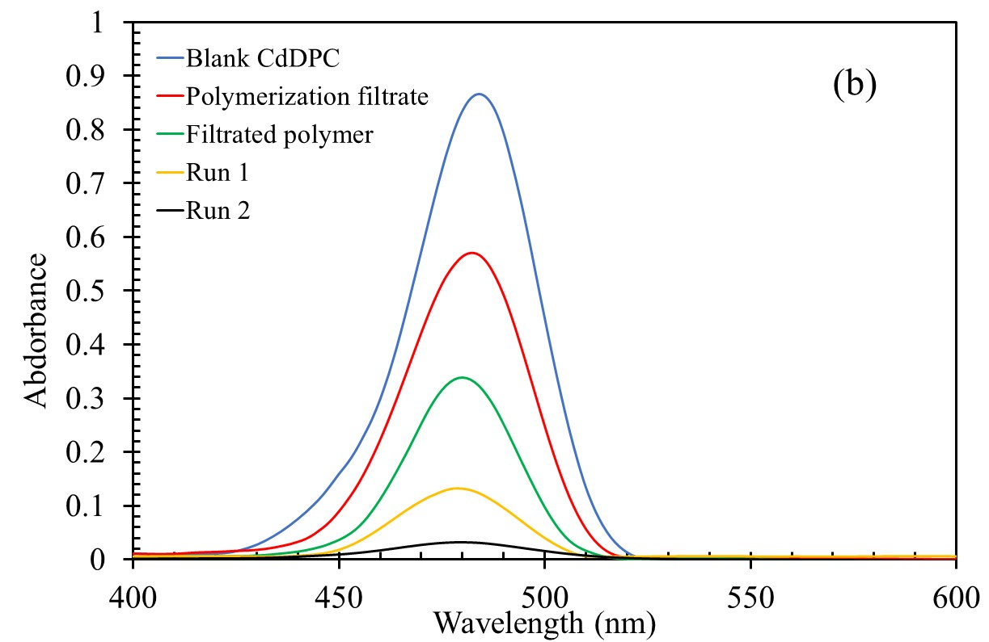
Fig. S1 UV-visible absorption spectra of (a) HgDPC and (b) CdDPC of initial concentration of 0.0002 g mol/L at the different stage of MMA polymerization and different runs of removal from PMMA (spectra were recorded for polymer solution in toluene after each removal run).
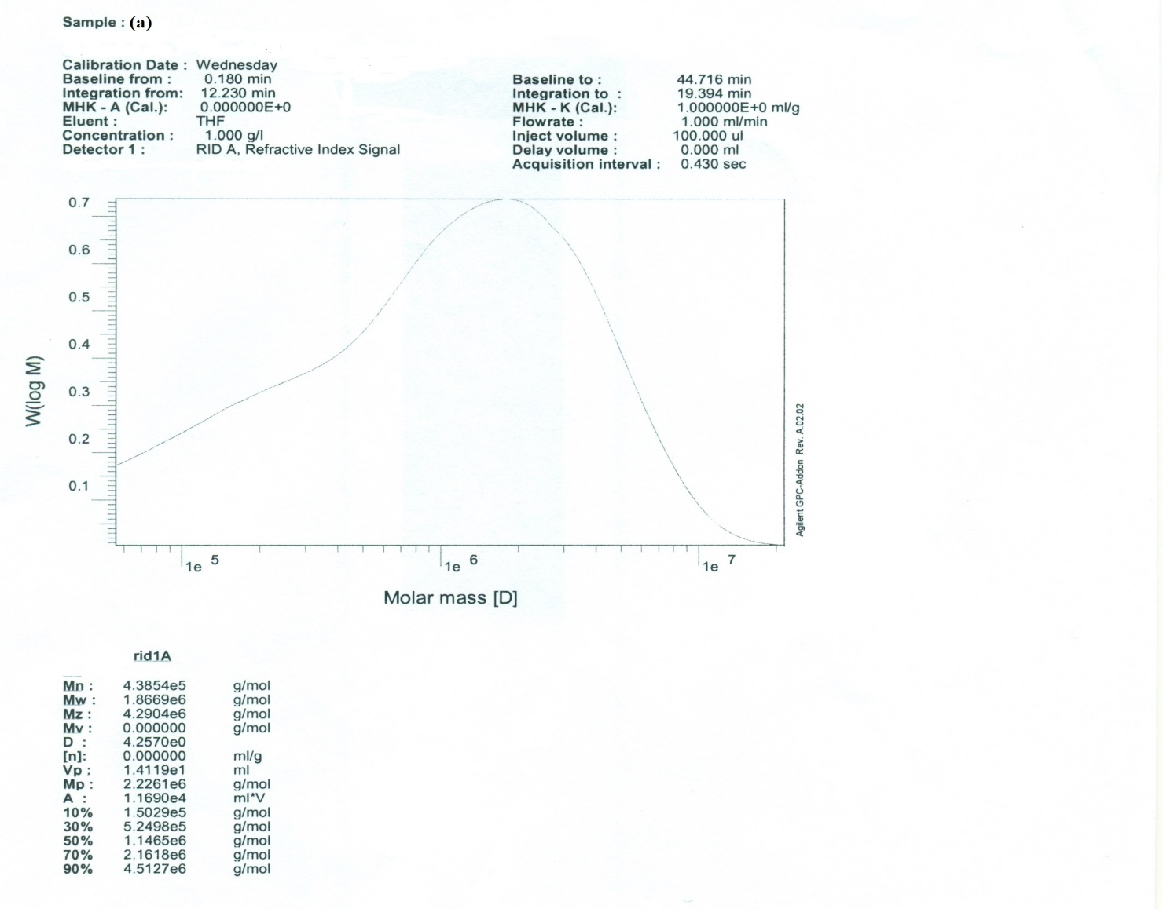

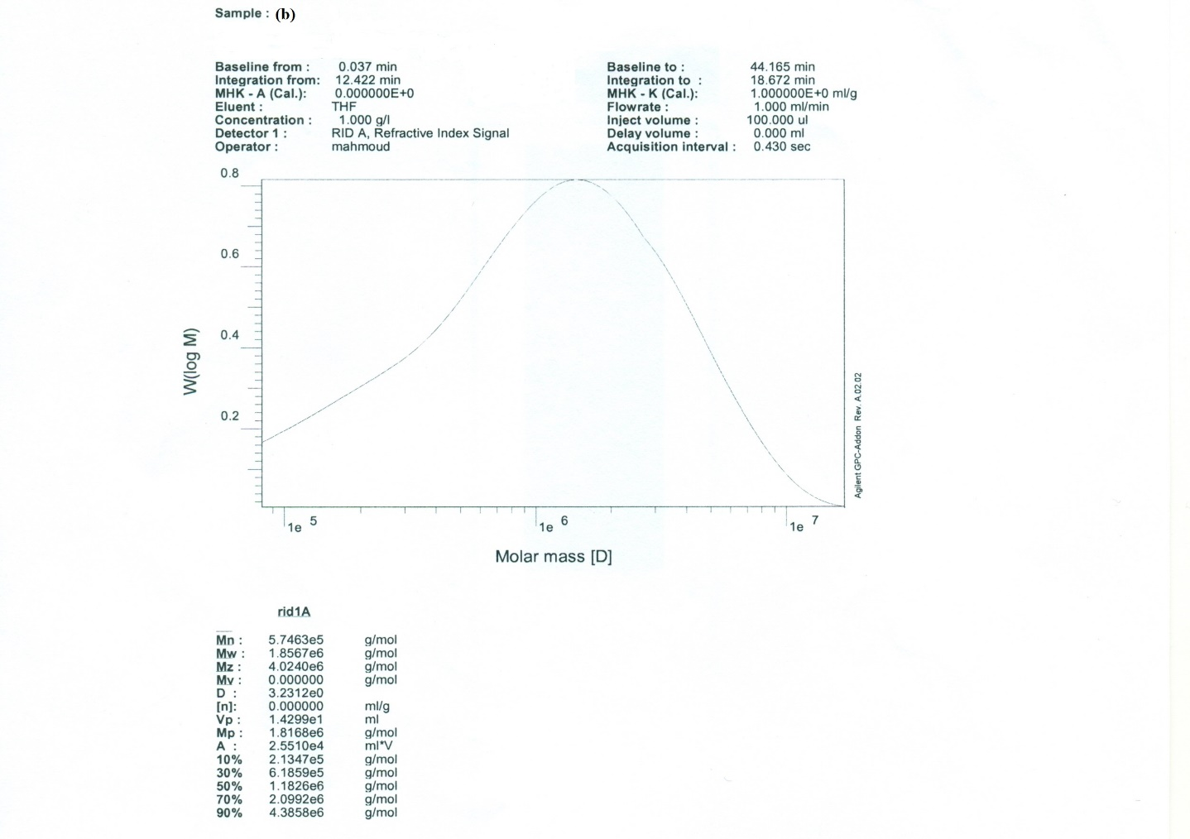

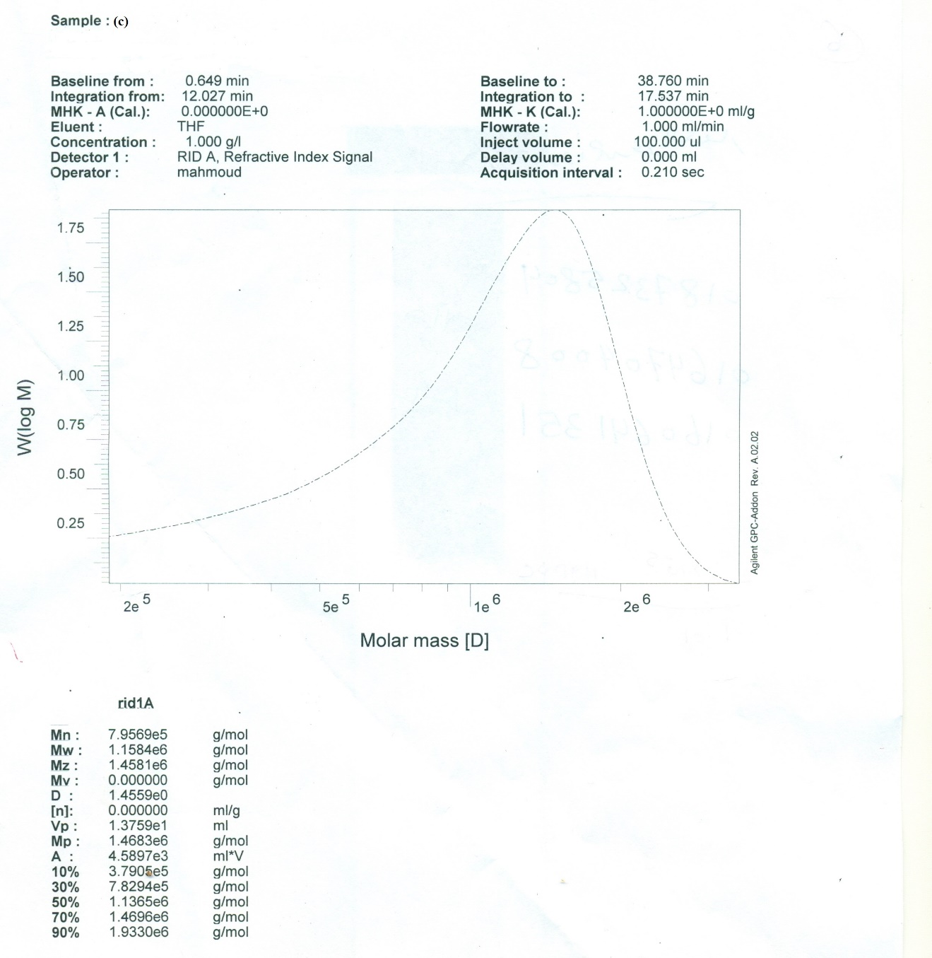

Fig. S2 Gel permeation chromatography spectra and data measured for synthesized in absence of carbazone complex (a) blank and in presence of 0.000025 g mol/L CdDPC (b) and HgDPC (c) complexes.

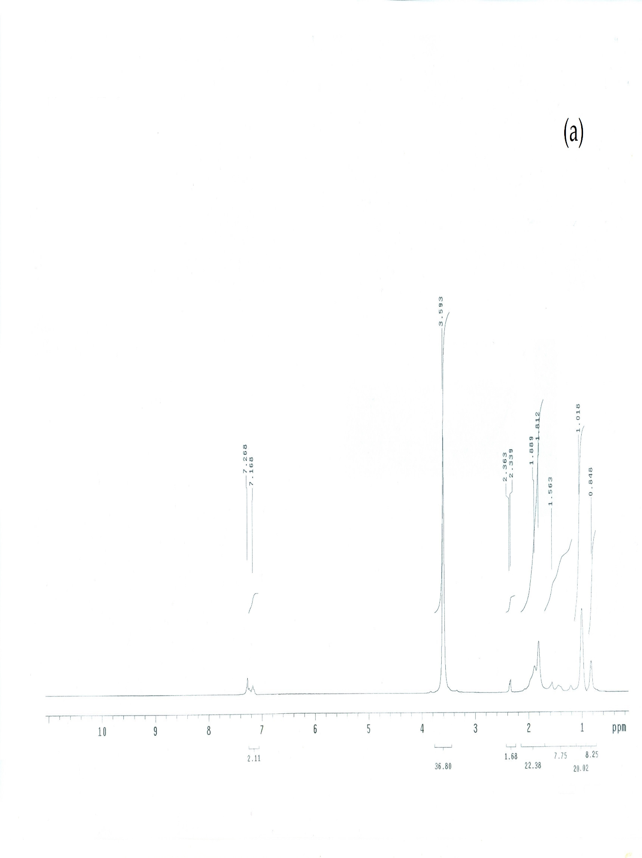
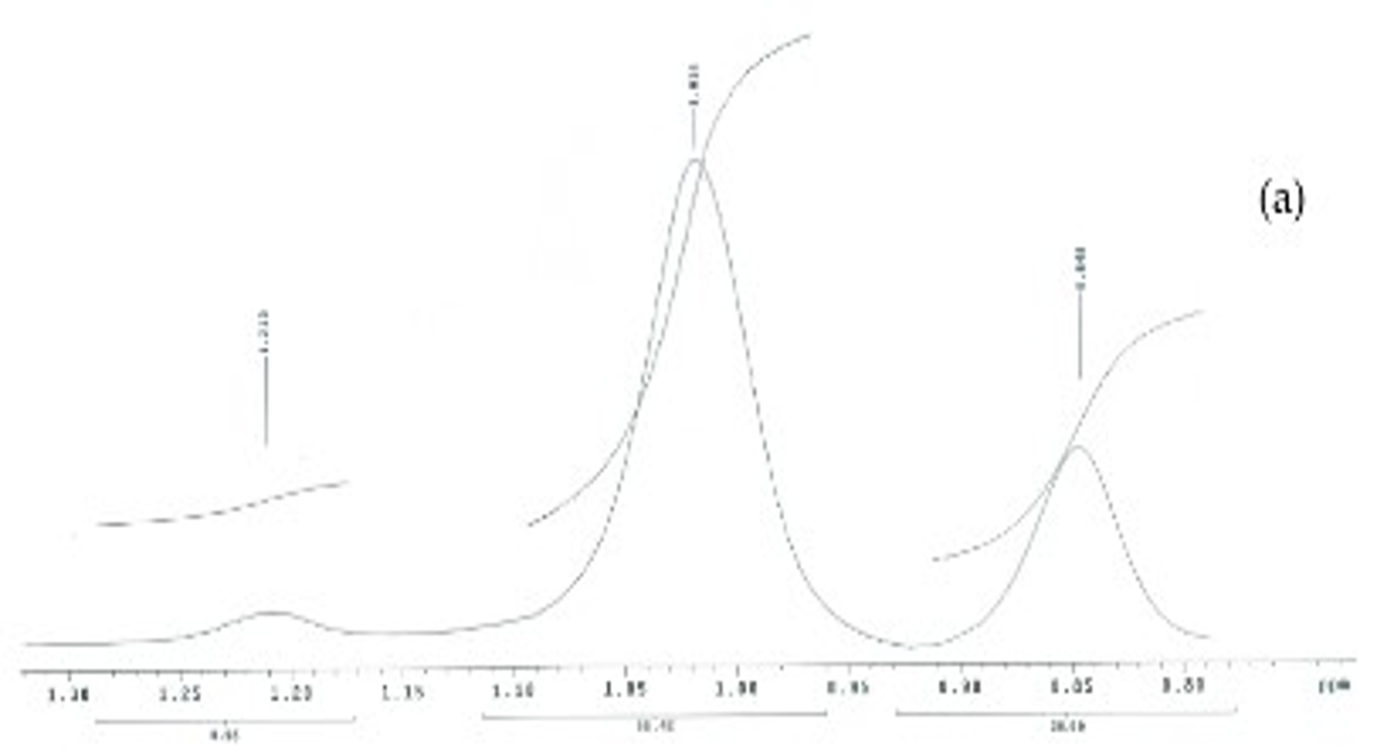

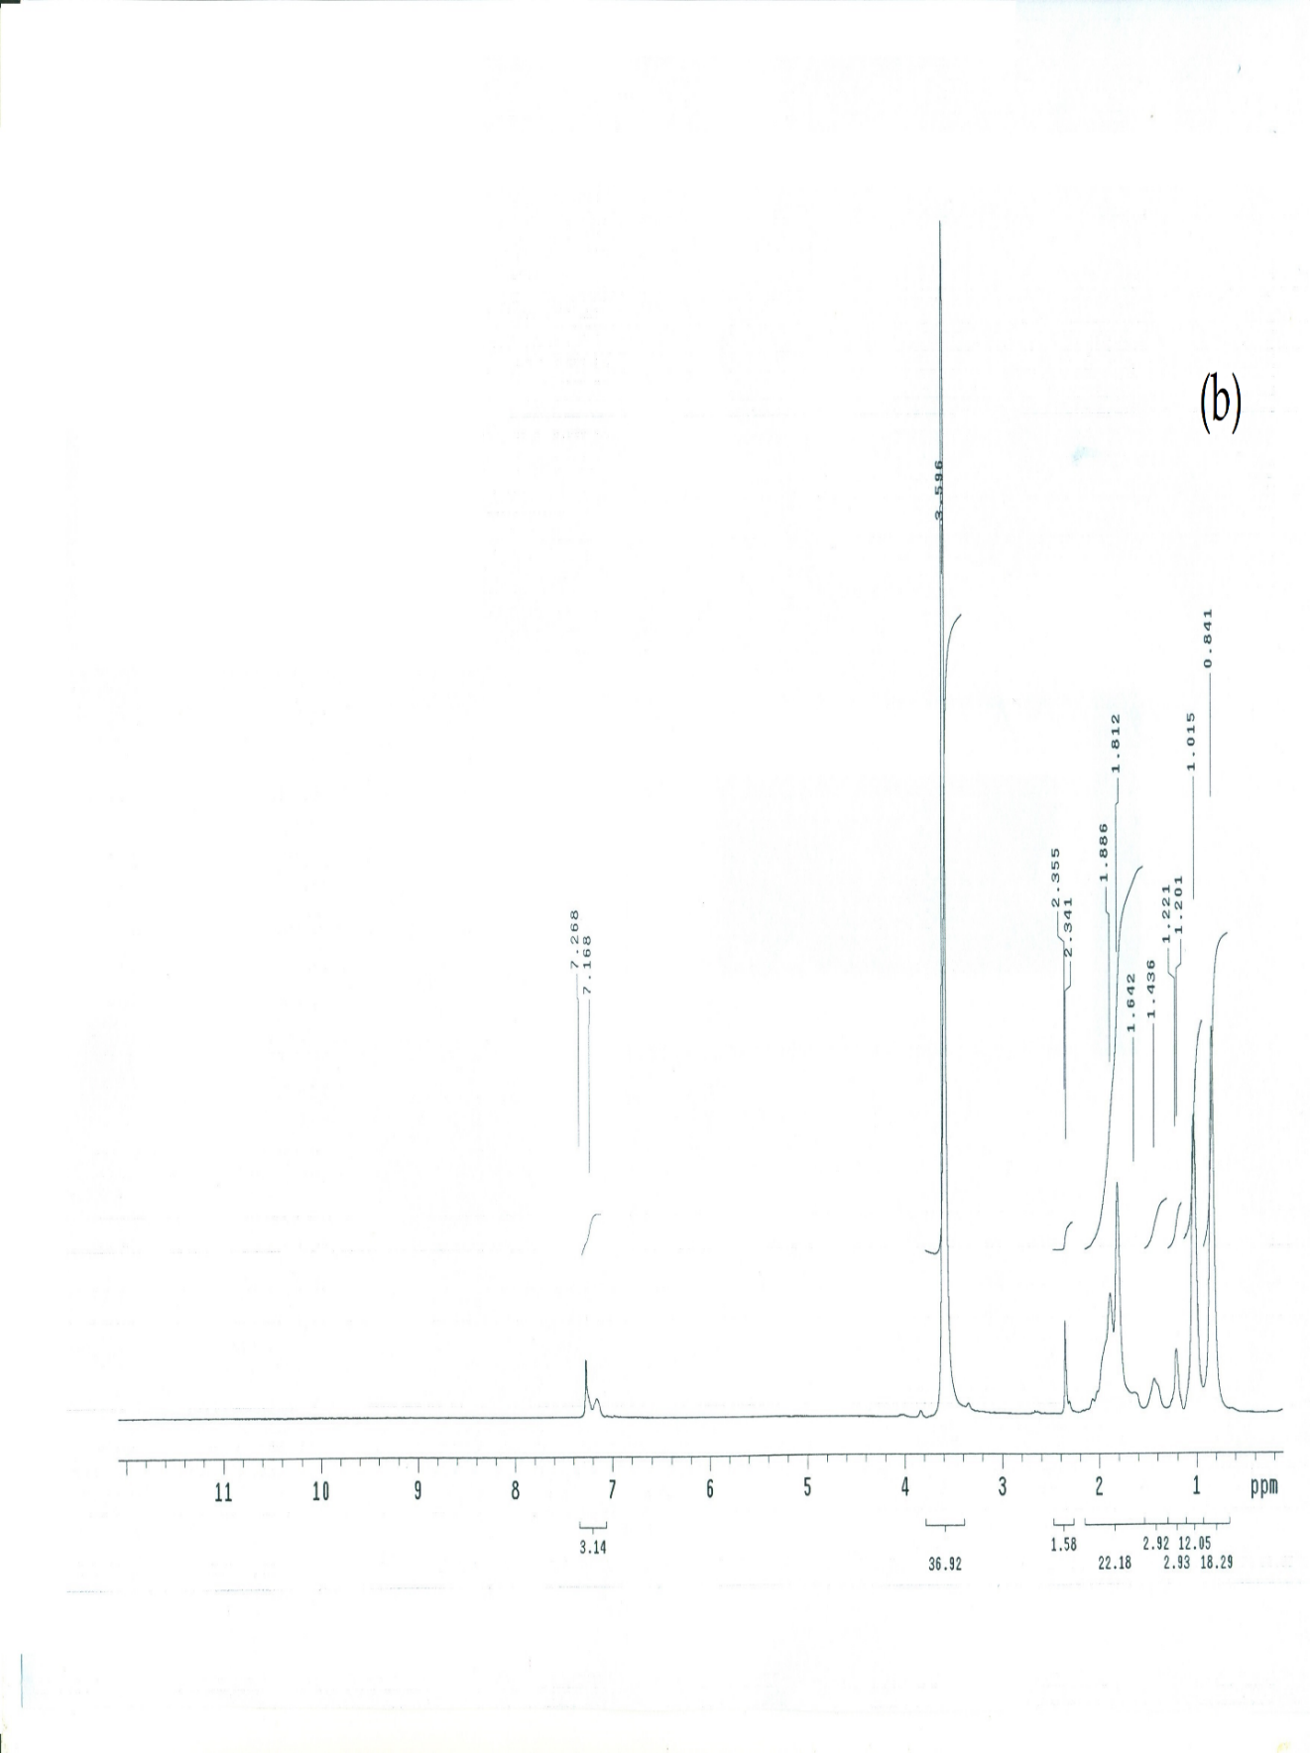
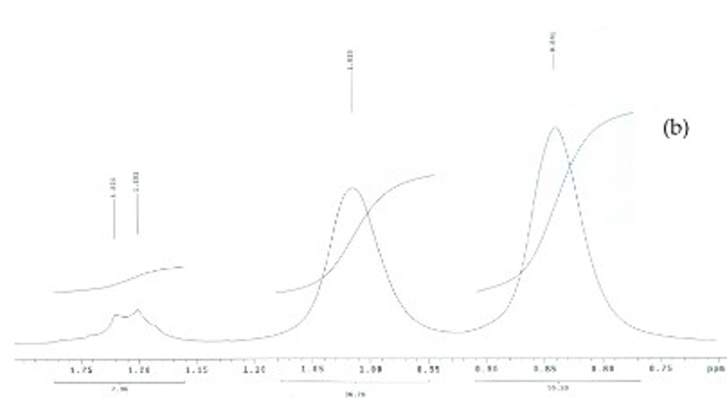
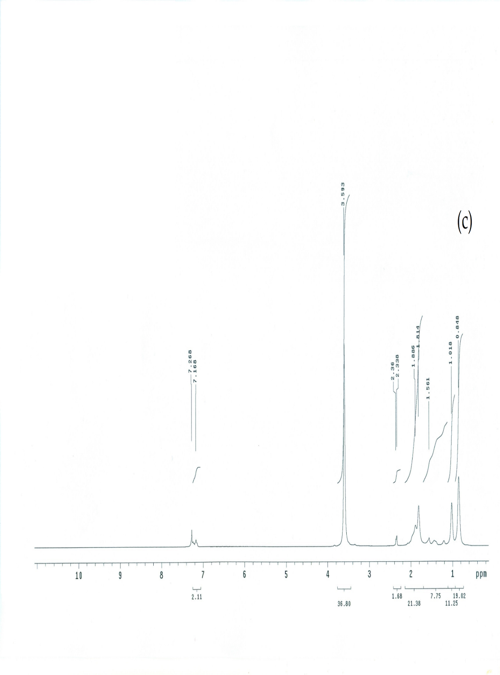
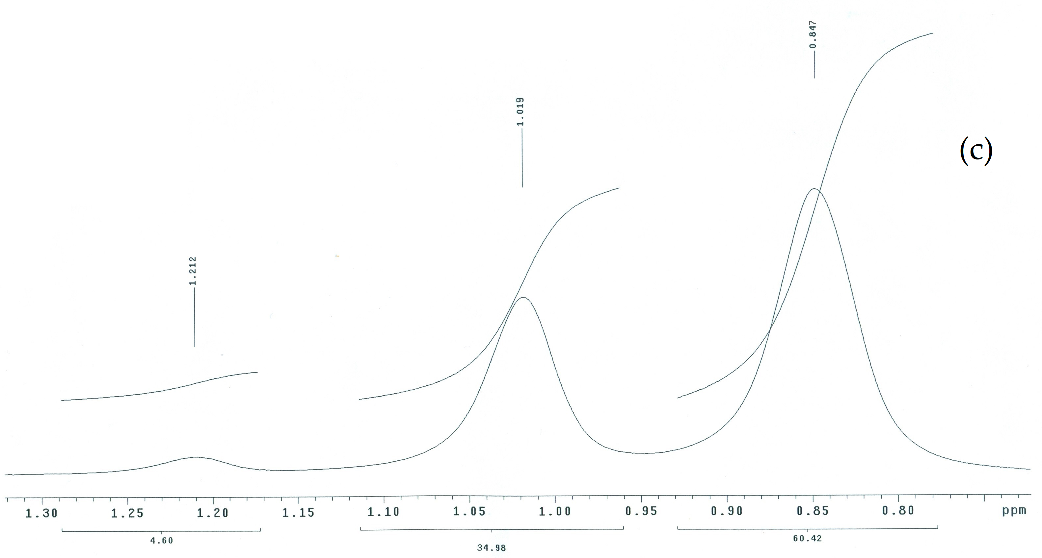
Fig. S3 NMR spectra of PMMA polymers synthesized in absence of carbazone complex (a) blank and in presence of 0.0002 g mol/L CdDPC (b) and HgDPC (c) complexes. Fig.s inset is α-Methyl proton NMR spectra of PMMA polymers .

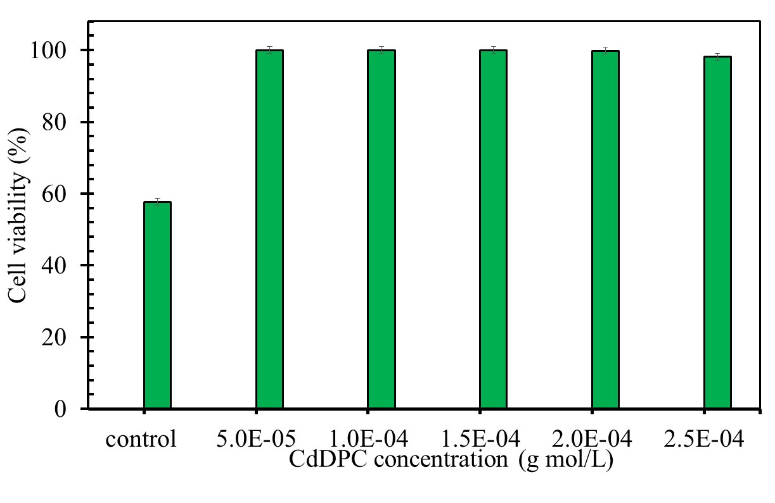
Fig. S4 Evaluation of cytotoxicity (cell viability%) of PMMA films synthesized using different concentration of CdDPC complex as a catalyst. Using different concentration of 3.125μg/mL PMMA.

