Table 1 Oil components
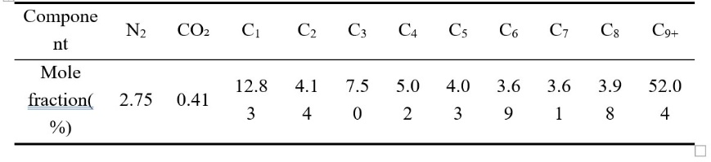
Table 2 Model parameter setting
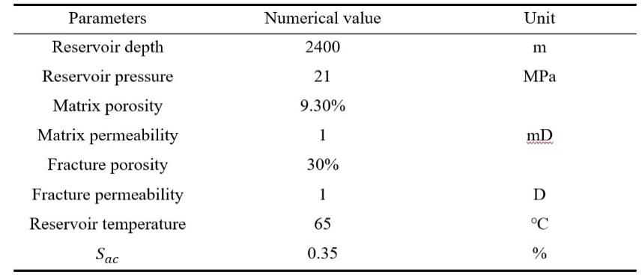
Table 3 Parameter Settings for Different Injection Schemes
