Supporting Information

Facile investigation of reversible nanostructure changes in flexible crystals

Shotaro Hayashi^{1,2}

¹ School of Environmental Science and Engineering, Kochi University of Technology, 185 Tosayamada Miyanokuchi, Kami, Kochi, 782-8502, Japan. E-mail: hayashi.shotaro@kochi-tech.ac.jp
² Research Center for Molecular Design, Kochi University of Technology, 185 Tosayamada Miyanokuchi, Kami, Kochi, 782-8502, Japan.

Experimental Procedures
Synthesis
To a mixture of 4-bromobenzyl cyanide (431 mg, 2.2 mmol) and 2,5-dimethoxybenzene-1,4-dicarboxaldehyde (194 mg, 1.0 mmol) in ethanol (15 mL), sodium methoxide in methanol (1.0 M, 5 mL) was added and stirred for 10 min at room temperature under air. The reaction mixture was diluted with a large amount of methanol (100 mL), and then filtered to remove solid. The solid was washed with an ethanol (10 mL), and dried under vacuum to give as a powder. Yield: 97% (531 mg). Orange-colored solid. ¹H NMR (300 MHz, CDCl₃): δ 7.99 (Ar-H, s, 2H), 7.98 (Ar-H, s, 2H), 7.53 (-CH=CCN- and Ar-H, s, 8H), 3.96 (OCH₃, s, 6H). ¹³C NMR (75.45 MHz, CDCl₃): δ 156.8, 153.2, 152.3, 136.2, 133.7, 132.3, 127.7, 111.4, 110.6, 109.7, 56.5. HRMS (ESI) m/z: calcd for C₂₆H₁₈N₂O₂Br₂ [M]⁺, 547.9730; found, 547.9795.

Instrumentals and Measurements
Unless otherwise noted, all the experiments were conducted at 25 °C. Liquid-state ¹H (300 MHz) and ¹³C (75.45 MHz) nuclear magnetic resonance (NMR) spectra were recorded on a JEOL EX-300 spectrometer. Chemical shifts (δ) are expressed relative to the resonances of the residual non-deuterated solvents for ¹H [CDCl₃: ¹H(δ) = 7.26 ppm] and ¹³C [CDCl₃: ¹³C(δ) = 77.16 ppm]. Absolute values of the coupling constants are given in Hertz (Hz), regardless of their sign. Multiplicities are abbreviated as singlet (s), doublet (d), triplet (t), and multiplet (m). Mass spectral analysis was performed by Bruker microTOF II. UV-vis absorption spectra were obtained on an Ocean Optics USB4000-XR1 fiber spectrometer with DH2000-BAL tungsten halogen light source. Fluorescence spectra were obtained on an Ocean Optics USB4000 fiber spectrometer with PX-2 pulsed xenon light source. Absolute quantum yield was obtained by Hamamatsu C9920-02. Life-time measurement was performed by time-resolved absorption spectrum analyzing system (C6743-94, ORCA-R2 digital CCD camera, lens A2098, V12303-01 for C7700, mount table A11350-13, high dynamic range streak camera C7700, detector f = 300 nm C11119-02, digital delay generator DG535, YAG laser, Xenon lamp 150W CW L8004). Crystal images and video were obtained by optical microscope, Olympus FV1000 and KEYENCE VH-Z500R. Spatially resolved μPL spectra were measured by an analyzing system (405 nm UV laser OptoSigma LDU33-405-3.5, micro-PL spectra using a USB400 and a R200-7-UV-VIS probe). The excitation laser was filtered with a band-pass filter (YIF-BA460IFS) and focused on the microrod with an objective (5×, NA = 0.15). The collected emission was then guided to a spectrometer (Ocean Optics) and recorded by a CCD (OptoSigma, HC-MV90). Samples were measured on a glass plate. Straight (original) crystals were taken out from the sample tube and placed on a glass plate. Spectrum measurement was carried out by aligning the laser light and the detector at the same position. Bent crystals were pasted on a substrate supported with Scotch tape. Spectrum measurement was carried out by aligning the laser light and the detector at the bent position. 1D XRD analysis of the crystals was performed by JEOL JDX-3530 X-ray diffractometer system. Powder XRD pattern of straight and bent crystals were also collected with Bruker Advance: Cu K_{α} radiation, voltage = 40 kV, and current = 40 mA. Data were collected at 2θ = 5 to 25º at a continuous scan rate of 1.0º/min. The crystallographic data were collected on a Bruker SMART APEX II ULTRA/CCD diffractometer equipped with monochromated Mo Kα radiation (λ = 0.71073 Å) at 90 K. Calculations were carried out using the program packages APEX III and ShelXle for Windows. The positional and thermal parameters of non-hydrogen atoms were refined anisotropically on F² by the full-matrix least-squares method using SHELXL-2014. Hydrogen atoms were placed at calculated positions and refined with a riding mode on their corresponding carbon atoms. All non-hydrogen atoms were refined anisotropically and hydrogen atoms were included at their calculated positions.

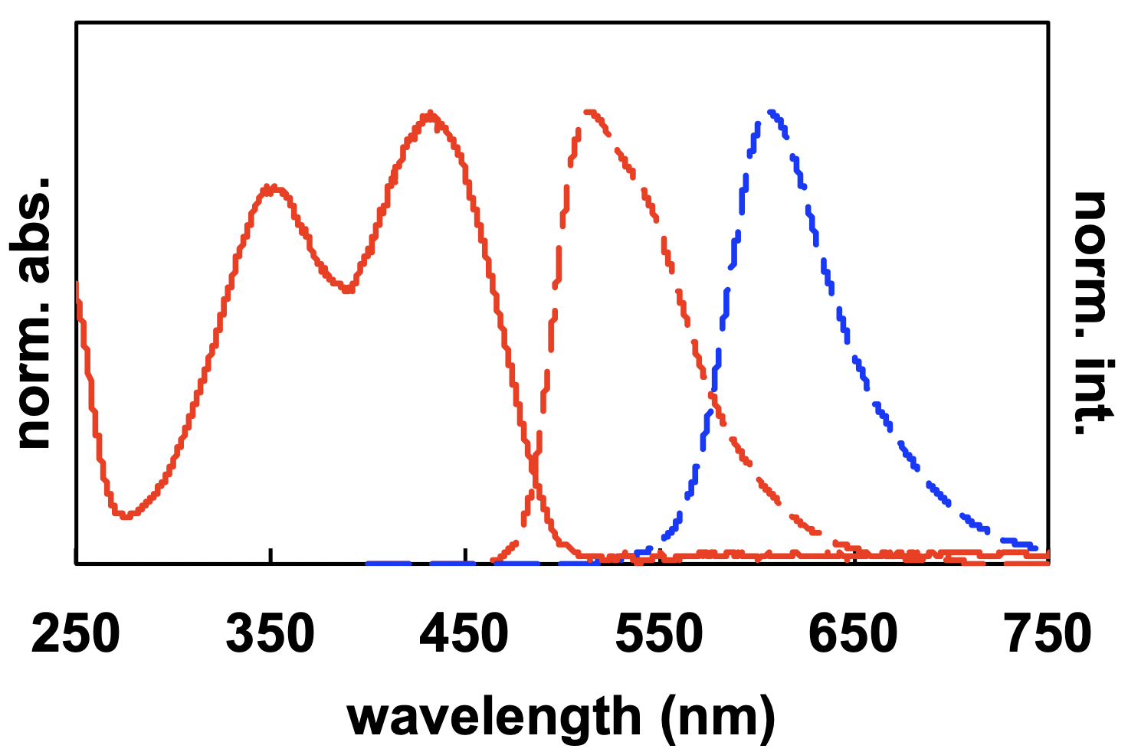
Supplementary Fig. S1 UV-vis absorption (solid line) and fluorescence (dotted line) spectra in dichloromethane (red line) and crystal (blue line).

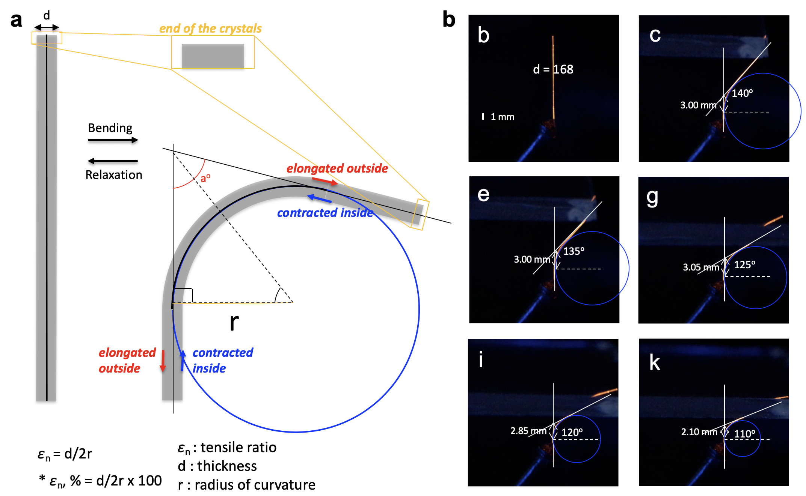
Supplementary Fig. S2 a Schematic illustration of the bending of the crystal, and definitions of the parameters (d: thickness, and r: radius of curvature). b Microscope images of the bent crystals and their radii.

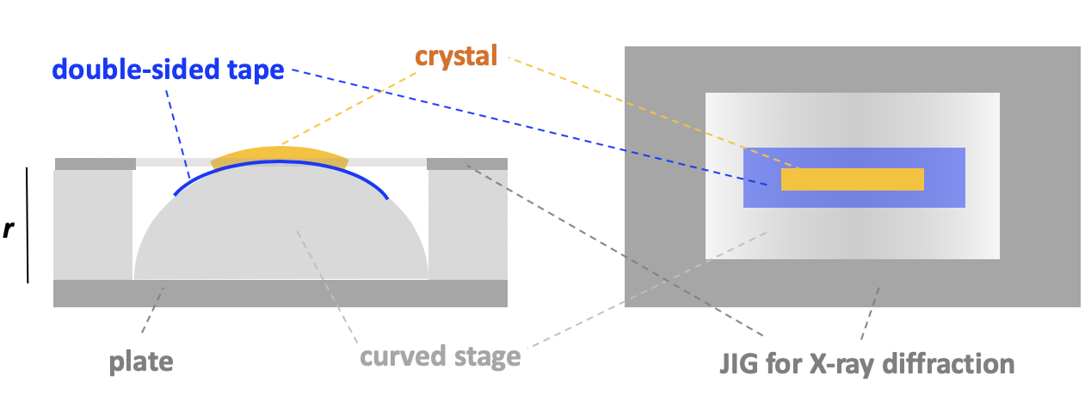
Supplementary Fig. S3 Schematic illustration of analytical set-up for measurement of Δε₍₁₀₀₎ and Δε₍₀₀₁₎.

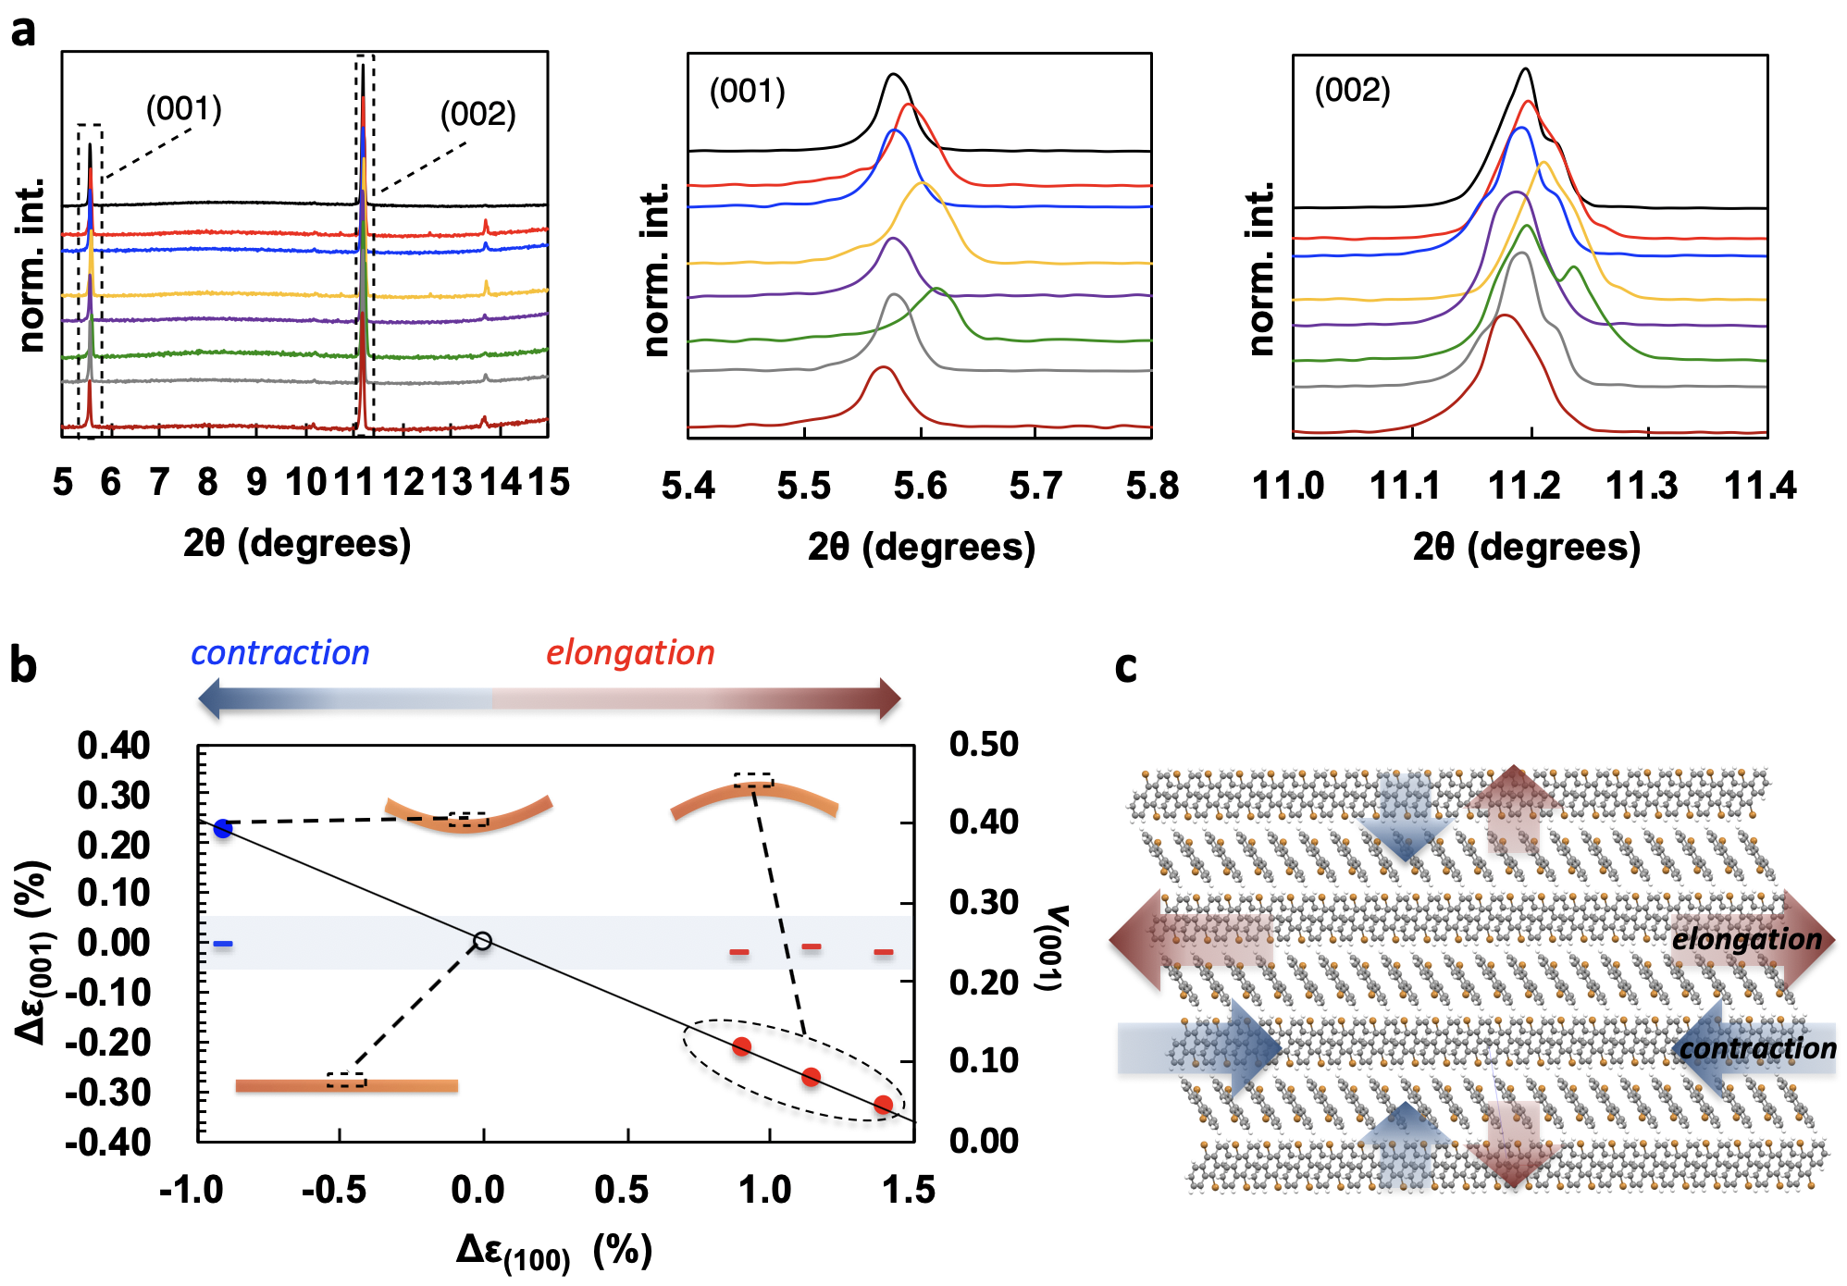
Supplementary Fig. S4 a 1D XRD patterns of a 9,10-dibromoanthracence crystal. b Plots of elongation/contraction ratio Δε₍₁₀₀₎, ○, and Poisson’s rate v₍₀₀₁₎, -, against strain, Δε₍₀₁₀₎. White: straight and relaxed crystal. Red: front side of the bent crystal. Blue: back side of the bent crystal. c Schematic illustration of the crystal shape and structure change out of the crystal plane.

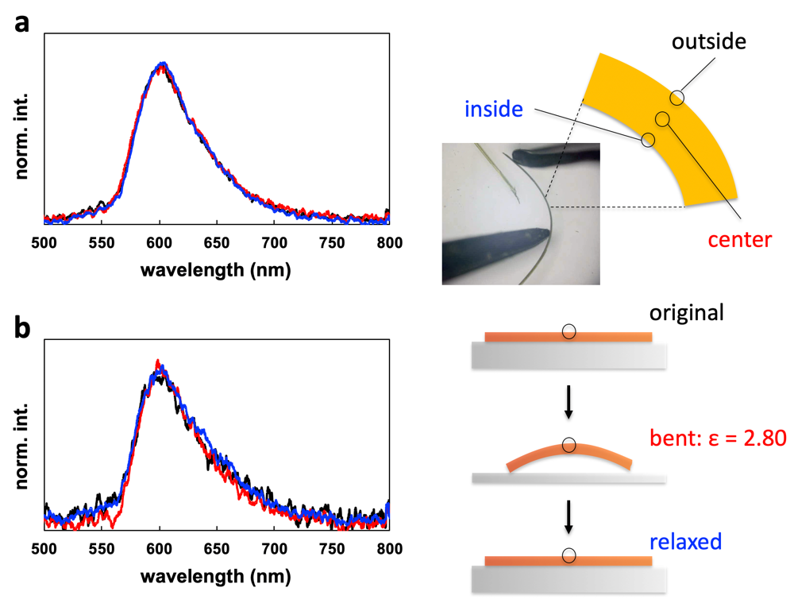
Supplementary Fig. S5. Spatially resolved microscopic photoluminescence (μPL) measurement of the crystal. a Emission spectra of the bent crystal at the inside (red), center (black), and outside (blue). b Emission spectra of the original (black), bent (red), and relaxed (blue) crystals.

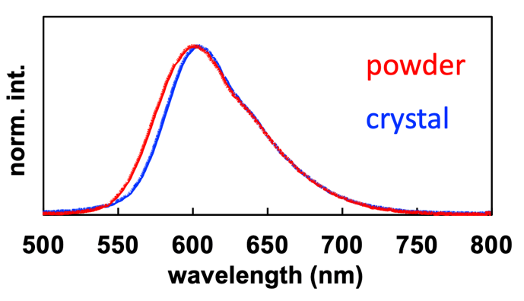
Supplementary Fig. S6 Fluorescence spectra of 3bb in powder (red line) and crystal (blue line).

Crystal Data
A specimen of C₂₄H₁₄Br₂N₂ was used for the X-ray crystallographic analysis. The X-ray intensity data were measured. The integration of the data using a triclinic unit cell yielded a total of 12115 reflections to a maximum θ angle of 28.74° (0.74 Å resolution), of which 4813 were independent (average redundancy 2.517, completeness = 93.2%, R_{int} = 11.62%, R_{sig} = 13.31%) and 2148 (44.63%) were greater than 2σ(F²). The final cell constants of a = 6.8650(13) Å, b = 7.5782(14) Å, c = 20.212(4) Å, α = 85.118(2)°, β = 86.874(3)°, γ = 71.572(2)°, volume = 993.6(3) Å³, are based upon the refinement of the XYZ-centroids of reflections above 20 σ(I). The final anisotropic full-matrix least-squares refinement on F² with 253 variables converged at R1 = 5.19%, for the observed data and wR2 = 17.05% for all data. The goodness-of-fit was 0.753. The largest peak in the final difference electron density synthesis was 1.061 e⁻/Å³ and the largest hole was -0.812 e⁻/Å³ with an RMS deviation of 0.132 e⁻/Å³. On the basis of the final model, the calculated density was 1.639 g/cm³ and F(000), 484 e⁻.

Supplementary Table 1. Sample and Crystal Data

Identification code | SHA
Chemical formula | C₂₄H₁₄Br₂N₂
Formula weight | 490.19 g/mol
Temperature | 296(2) K
Wavelength | 0.71073 Å
Crystal system | triclinic
Space group | P -1
Unit cell dimensions | a = 6.8650(13) Å | α = 85.118(2)°
 | b = 7.5782(14) Å | β = 86.874(3)°
 | c = 20.212(4) Å | γ = 71.572(2)°
Volume | 993.6(3) Å³
Z | 2
Density (calculated) | 1.639 g/cm³
Absorption coefficient | 4.091 mm⁻¹
F(000) | 484

Supplementary Table 2. Data Collection and Structure Refinement

Theta range for data collection | 1.01 to 28.74°
Index ranges | -8<=h<=9, -10<=k<=9, -27<=l<=27
Reflections collected | 12115
Independent reflections | 4813 [R(int) = 0.1162]
Refinement method | Full-matrix least-squares on F²
Refinement program | SHELXL-2014/6 (Sheldrick, 2014)
Function minimized | Σ w(F_{o}² - F_{c}²)²
Data / restraints / parameters | 4813 / 0 / 253
Goodness-of-fit on F² | 0.753
Final R indices | 2148 data; I>2σ(I) | R1 = 0.0519, wR2 = 0.1222
 | all data | R1 = 0.1388, wR2 = 0.1705
Weighting scheme | w=1/[σ²(F_{o}²)+(0.1000P)²]  where P=(F_{o}²+2F_{c}²)/3
Largest diff. peak and hole | 1.061 and -0.812 eÅ⁻³
R.M.S. deviation from mean | 0.132 eÅ⁻³

Supplementary Table 3. Atomic coordinates and equivalent isotropic atomic displacement parameters (Å²)

 | x/a | y/b | z/c | U(eq)
Br1 | 0.59838(11) | 0.72563(9) | 0.50191(3) | 0.0756(3)
Br2 | 0.00726(12) | 0.93427(9) | 0.58697(3) | 0.0770(3)
N1 | 0.3239(8) | 0.3991(8) | 0.2100(2) | 0.0700(15)
N2 | 0.4679(8) | 0.1195(8) | 0.8950(2) | 0.0711(15)
C1 | 0.7049(8) | 0.6355(7) | 0.4187(2) | 0.0438(12)
C2 | 0.9100(9) | 0.5955(7) | 0.4031(2) | 0.0482(13)
C3 | 0.9855(8) | 0.5314(6) | 0.3413(2) | 0.0432(12)
C4 | 0.8577(7) | 0.5081(6) | 0.2950(2) | 0.0335(10)
C5 | 0.9380(7) | 0.4452(6) | 0.2287(2) | 0.0337(10)
C6 | 0.8249(7) | 0.4151(6) | 0.1814(2) | 0.0364(11)
C7 | 0.8735(7) | 0.3560(6) | 0.1147(2) | 0.0333(10)
C8 | 0.7106(7) | 0.3533(7) | 0.0767(2) | 0.0408(12)
C9 | 0.7387(7) | 0.2970(7) | 0.0136(2) | 0.0417(12)
C10 | 0.9336(7) | 0.2401(6) | 0.9825(2) | 0.0335(10)
C11 | 0.9450(7) | 0.1840(6) | 0.9153(2) | 0.0355(11)
C12 | 0.1005(7) | 0.1308(6) | 0.8702(2) | 0.0338(10)
C13 | 0.0792(7) | 0.0783(6) | 0.8029(2) | 0.0349(11)
C14 | 0.8877(8) | 0.0903(7) | 0.7798(2) | 0.0467(13)
C15 | 0.8688(9) | 0.0433(7) | 0.7160(2) | 0.0506(13)
C16 | 0.0383(9) | 0.9874(7) | 0.6746(2) | 0.0460(13)
C17 | 0.6493(8) | 0.5480(7) | 0.3124(2) | 0.0484(13)
C18 | 0.5756(8) | 0.6103(7) | 0.3738(2) | 0.0507(13)
C19 | 0.1535(9) | 0.4177(7) | 0.2169(2) | 0.0439(12)
C20 | 0.0982(7) | 0.2401(7) | 0.0206(2) | 0.0415(12)
C21 | 0.0681(7) | 0.2949(7) | 0.0841(2) | 0.0418(12)
C22 | 0.2484(8) | 0.0159(6) | 0.7604(2) | 0.0448(12)
C23 | 0.2282(9) | 0.9702(7) | 0.6968(2) | 0.0510(14)
C24 | 0.3054(8) | 0.1252(7) | 0.8854(2) | 0.0439(12)
U(eq) is defined as one third of the trace of the orthogonalized U_{ij} tensor.

Supplementary Table 4. Bond Lengths (Å)

Br1-C1 | 1.891(5) | Br2-C16 | 1.887(5)
N1-C19 | 1.136(6) | N2-C24 | 1.129(6)
C1-C18 | 1.368(7) | C1-C2 | 1.368(7)
C2-C3 | 1.392(6) | C2-H14 | 0.93
C3-C4 | 1.376(6) | C3-H1 | 0.93
C4-C17 | 1.397(7) | C4-C5 | 1.479(6)
C5-C6 | 1.341(6) | C5-C19 | 1.436(7)
C6-C7 | 1.445(6) | C6-H4 | 0.93
C7-C21 | 1.396(6) | C7-C8 | 1.397(6)
C8-C9 | 1.364(6) | C8-H13 | 0.93
C9-C10 | 1.400(6) | C9-H12 | 0.93
C10-C20 | 1.402(6) | C10-C11 | 1.448(6)
C11-C12 | 1.349(6) | C11-H11 | 0.93
C12-C24 | 1.443(7) | C12-C13 | 1.476(6)
C13-C22 | 1.387(6) | C13-C14 | 1.393(7)
C14-C15 | 1.389(6) | C14-H7 | 0.93
C15-C16 | 1.370(7) | C15-H8 | 0.93
C16-C23 | 1.365(7) | C17-C18 | 1.379(7)
C17-H3 | 0.93 | C18-H2 | 0.93
C20-C21 | 1.367(6) | C20-H5 | 0.93
C21-H6 | 0.93 | C22-C23 | 1.384(6)
C22-H10 | 0.93 | C23-H9 | 0.93

Supplementary Table 5. Bond Angles (°)

C18-C1-C2 | 119.9(4) | C18-C1-Br1 | 119.6(4)
C2-C1-Br1 | 120.5(4) | C1-C2-C3 | 119.8(5)
C1-C2-H14 | 120.1 | C3-C2-H14 | 120.1
C4-C3-C2 | 121.4(5) | C4-C3-H1 | 119.3
C2-C3-H1 | 119.3 | C3-C4-C17 | 117.8(4)
C3-C4-C5 | 121.1(4) | C17-C4-C5 | 121.2(4)
C6-C5-C19 | 120.4(4) | C6-C5-C4 | 124.8(4)
C19-C5-C4 | 114.8(4) | C5-C6-C7 | 132.9(4)
C5-C6-H4 | 113.5 | C7-C6-H4 | 113.5
C21-C7-C8 | 115.6(4) | C21-C7-C6 | 127.0(4)
C8-C7-C6 | 117.4(4) | C9-C8-C7 | 122.5(4)
C9-C8-H13 | 118.8 | C7-C8-H13 | 118.8
C8-C9-C10 | 121.8(4) | C8-C9-H12 | 119.1
C10-C9-H12 | 119.1 | C9-C10-C20 | 116.1(4)
C9-C10-C11 | 117.0(4) | C20-C10-C11 | 126.8(4)
C12-C11-C10 | 133.2(4) | C12-C11-H11 | 113.4
C10-C11-H11 | 113.4 | C11-C12-C24 | 120.4(4)
C11-C12-C13 | 124.7(4) | C24-C12-C13 | 114.8(4)
C22-C13-C14 | 117.5(4) | C22-C13-C12 | 121.4(4)
C14-C13-C12 | 121.0(4) | C15-C14-C13 | 120.6(5)
C15-C14-H7 | 119.7 | C13-C14-H7 | 119.7
C16-C15-C14 | 120.3(5) | C16-C15-H8 | 119.8
C14-C15-H8 | 119.8 | C23-C16-C15 | 120.0(5)
C23-C16-Br2 | 120.4(4) | C15-C16-Br2 | 119.5(4)
C18-C17-C4 | 120.6(5) | C18-C17-H3 | 119.7
C4-C17-H3 | 119.7 | C1-C18-C17 | 120.6(5)
C1-C18-H2 | 119.7 | C17-C18-H2 | 119.7
N1-C19-C5 | 177.2(5) | C21-C20-C10 | 121.5(4)
C21-C20-H5 | 119.3 | C10-C20-H5 | 119.3
C20-C21-C7 | 122.6(4) | C20-C21-H6 | 118.7
C7-C21-H6 | 118.7 | C23-C22-C13 | 121.5(5)
C23-C22-H10 | 119.2 | C13-C22-H10 | 119.2
C16-C23-C22 | 119.9(5) | C16-C23-H9 | 120.0
C22-C23-H9 | 120.0 | N2-C24-C12 | 177.4(5)

Supplementary Table 6. Torsion Angles (°)

C18-C1-C2-C3 | 0.7(7) | Br1-C1-C2-C3 | -179.2(4)
C1-C2-C3-C4 | 0.4(7) | C2-C3-C4-C17 | -1.0(7)
C2-C3-C4-C5 | 178.2(4) | C3-C4-C5-C6 | 178.4(4)
C17-C4-C5-C6 | -2.4(7) | C3-C4-C5-C19 | -1.9(6)
C17-C4-C5-C19 | 177.3(4) | C19-C5-C6-C7 | -0.2(8)
C4-C5-C6-C7 | 179.5(5) | C5-C6-C7-C21 | 7.2(8)
C5-C6-C7-C8 | -175.0(5) | C21-C7-C8-C9 | -0.8(7)
C6-C7-C8-C9 | -178.8(5) | C7-C8-C9-C10 | -0.8(8)
C8-C9-C10-C20 | 1.5(7) | C8-C9-C10-C11 | -179.8(4)
C9-C10-C11-C12 | 176.4(5) | C20-C10-C11-C12 | -5.0(8)
C10-C11-C12-C24 | -1.0(8) | C10-C11-C12-C13 | -179.9(4)
C11-C12-C13-C22 | -176.6(4) | C24-C12-C13-C22 | 4.5(6)
C11-C12-C13-C14 | 3.5(7) | C24-C12-C13-C14 | -175.4(4)
C22-C13-C14-C15 | -0.8(7) | C12-C13-C14-C15 | 179.0(4)
C13-C14-C15-C16 | -1.1(8) | C14-C15-C16-C23 | 2.7(8)
C14-C15-C16-Br2 | -177.4(4) | C3-C4-C17-C18 | 0.6(7)
C5-C4-C17-C18 | -178.6(4) | C2-C1-C18-C17 | -1.2(8)
Br1-C1-C18-C17 | 178.8(4) | C4-C17-C18-C1 | 0.5(8)
C9-C10-C20-C21 | -0.8(7) | C11-C10-C20-C21 | -179.3(4)
C10-C20-C21-C7 | -0.8(8) | C8-C7-C21-C20 | 1.5(7)
C6-C7-C21-C20 | 179.4(4) | C14-C13-C22-C23 | 1.2(7)
C12-C13-C22-C23 | -178.7(4) | C15-C16-C23-C22 | -2.4(8)
Br2-C16-C23-C22 | 177.7(4) | C13-C22-C23-C16 | 0.4(7)

Supplementary Table 7. Anisotropic atomic displacement parameters (Å²)

 | U₁₁ | U₂₂ | U₃₃ | U₂₃ | U₁₃ | U₁₂
Br1 | 0.0941(6) | 0.0777(5) | 0.0490(4) | -0.0259(3) | 0.0101(3) | -0.0151(4)
Br2 | 0.1347(7) | 0.0644(4) | 0.0367(3) | -0.0077(3) | -0.0113(3) | -0.0357(4)
N1 | 0.042(3) | 0.112(4) | 0.063(3) | -0.032(3) | 0.002(2) | -0.028(3)
N2 | 0.040(3) | 0.113(4) | 0.065(3) | -0.033(3) | 0.004(2) | -0.026(3)
C1 | 0.051(4) | 0.045(3) | 0.032(2) | -0.007(2) | -0.001(2) | -0.010(2)
C2 | 0.057(4) | 0.046(3) | 0.044(3) | -0.007(2) | -0.012(2) | -0.015(3)
C3 | 0.037(3) | 0.047(3) | 0.046(3) | -0.006(2) | -0.005(2) | -0.012(2)
C4 | 0.037(3) | 0.029(2) | 0.034(2) | 0.0014(18) | -0.003(2) | -0.010(2)
C5 | 0.032(3) | 0.030(2) | 0.037(2) | 0.0035(19) | 0.000(2) | -0.009(2)
C6 | 0.027(3) | 0.040(3) | 0.040(3) | -0.004(2) | 0.000(2) | -0.006(2)
C7 | 0.026(3) | 0.033(2) | 0.040(2) | -0.0020(19) | -0.003(2) | -0.008(2)
C8 | 0.026(3) | 0.051(3) | 0.044(3) | -0.007(2) | 0.002(2) | -0.009(2)
C9 | 0.032(3) | 0.055(3) | 0.038(3) | -0.005(2) | -0.009(2) | -0.011(2)
C10 | 0.028(3) | 0.034(2) | 0.036(2) | -0.0004(19) | -0.001(2) | -0.008(2)
C11 | 0.029(3) | 0.038(3) | 0.039(2) | -0.003(2) | -0.006(2) | -0.009(2)
C12 | 0.032(3) | 0.033(2) | 0.037(2) | 0.0002(19) | -0.005(2) | -0.010(2)
C13 | 0.034(3) | 0.035(3) | 0.035(2) | 0.0010(19) | -0.002(2) | -0.011(2)
C14 | 0.042(3) | 0.054(3) | 0.042(3) | -0.004(2) | 0.000(2) | -0.013(3)
C15 | 0.057(4) | 0.058(3) | 0.039(3) | -0.001(2) | -0.014(3) | -0.020(3)
C16 | 0.073(4) | 0.037(3) | 0.028(2) | -0.003(2) | -0.005(3) | -0.017(3)
C17 | 0.040(3) | 0.066(4) | 0.038(3) | -0.010(2) | -0.005(2) | -0.014(3)
C18 | 0.042(3) | 0.062(3) | 0.046(3) | -0.006(3) | 0.003(2) | -0.014(3)
C19 | 0.035(3) | 0.059(3) | 0.040(3) | -0.015(2) | -0.004(2) | -0.014(3)
C20 | 0.025(3) | 0.057(3) | 0.043(3) | -0.008(2) | 0.001(2) | -0.013(2)
C21 | 0.029(3) | 0.059(3) | 0.040(3) | -0.010(2) | -0.006(2) | -0.013(2)
C22 | 0.044(3) | 0.047(3) | 0.044(3) | -0.008(2) | 0.000(2) | -0.013(2)
C23 | 0.063(4) | 0.048(3) | 0.038(3) | -0.007(2) | 0.012(3) | -0.013(3)
C24 | 0.034(3) | 0.057(3) | 0.041(3) | -0.011(2) | 0.004(2) | -0.015(3)
The anisotropic atomic displacement factor exponent takes the form: -2π²[ h² a^{*2} U₁₁ + ... + 2 h k a* b* U₁₂ ]

Supplementary Table 8. Hydrogen Atomic Coordinates and Isotropic Atomic Displacement Parameters (Å²)

 | x/a | y/b | z/c | U(eq)
H14 | 0.9987 | 0.6111 | 0.4336 | 0.058
H1 | 1.1252 | 0.5038 | 0.3311 | 0.052
H4 | 0.6876 | 0.4366 | 0.1941 | 0.044
H13 | 0.5781 | 0.3913 | 0.0951 | 0.049
H12 | 0.6253 | 0.2963 | -0.0095 | 0.05
H11 | 0.8192 | 0.1847 | -0.0998 | 0.043
H7 | 0.7714 | 0.1301 | -0.1927 | 0.056
H8 | 0.7404 | 0.0498 | -0.2986 | 0.061
H3 | 0.5594 | 0.5324 | 0.2822 | 0.058
H2 | 0.4367 | 0.6354 | 0.3849 | 0.061
H5 | 1.2309 | 0.2020 | 0.0023 | 0.05
H6 | 1.1818 | 0.2914 | 0.1078 | 0.05
H10 | 1.3783 | 0.0045 | -0.2251 | 0.054
H9 | 1.3438 | -0.0721 | -0.3307 | 0.061

Appendix

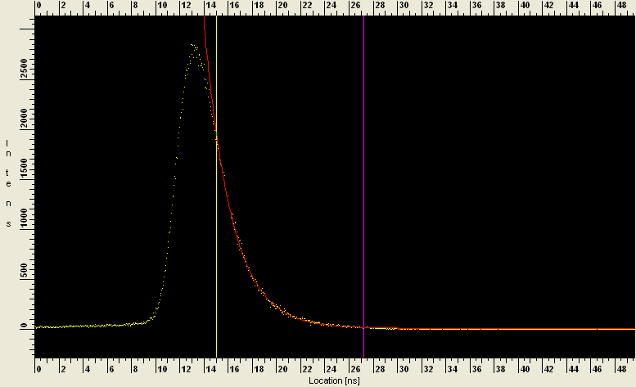
Fluorescence decay of β-COPV in dichloromethane.

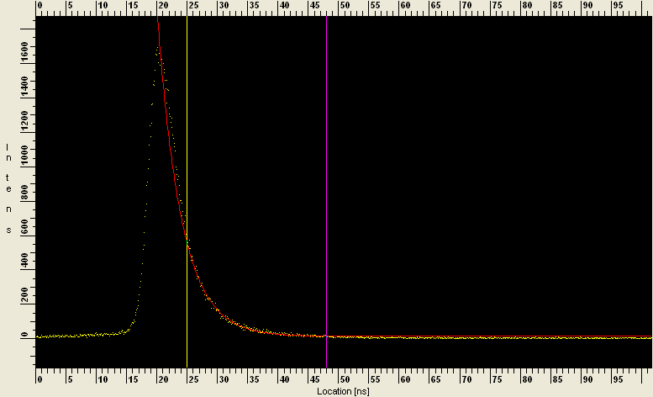
Fluorescence decay of β-COPV in crystal.

