SUPPLEMENTARY FIGURES AND TABLES

Supplementary Appendix I: Socio-demographic and medical questionnaire
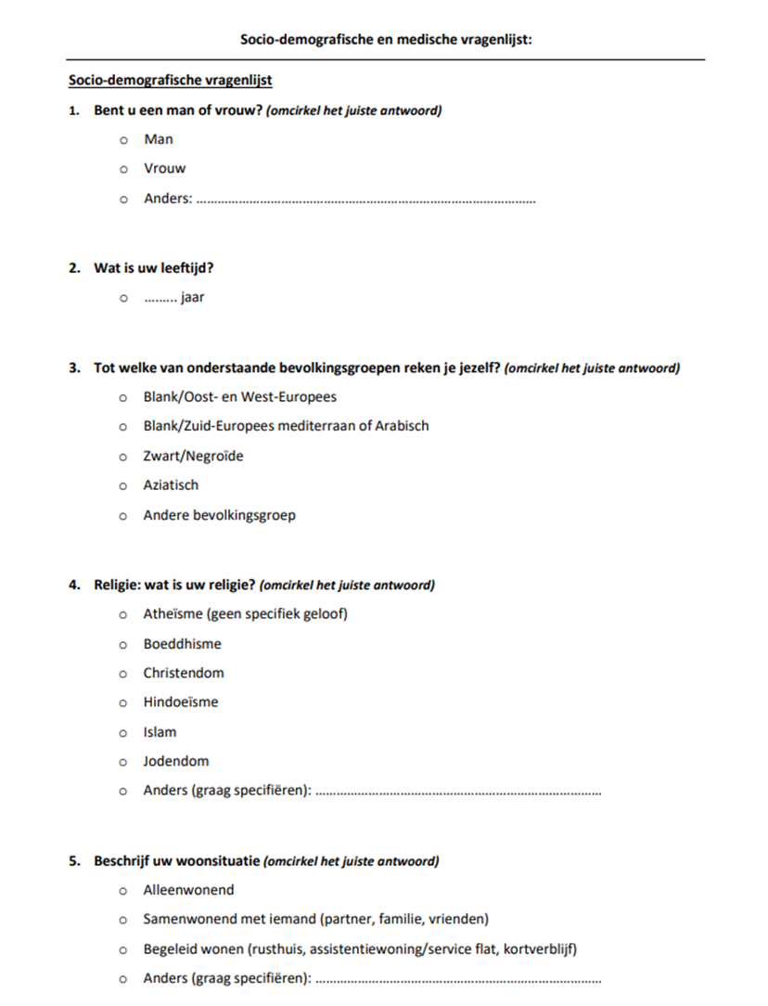

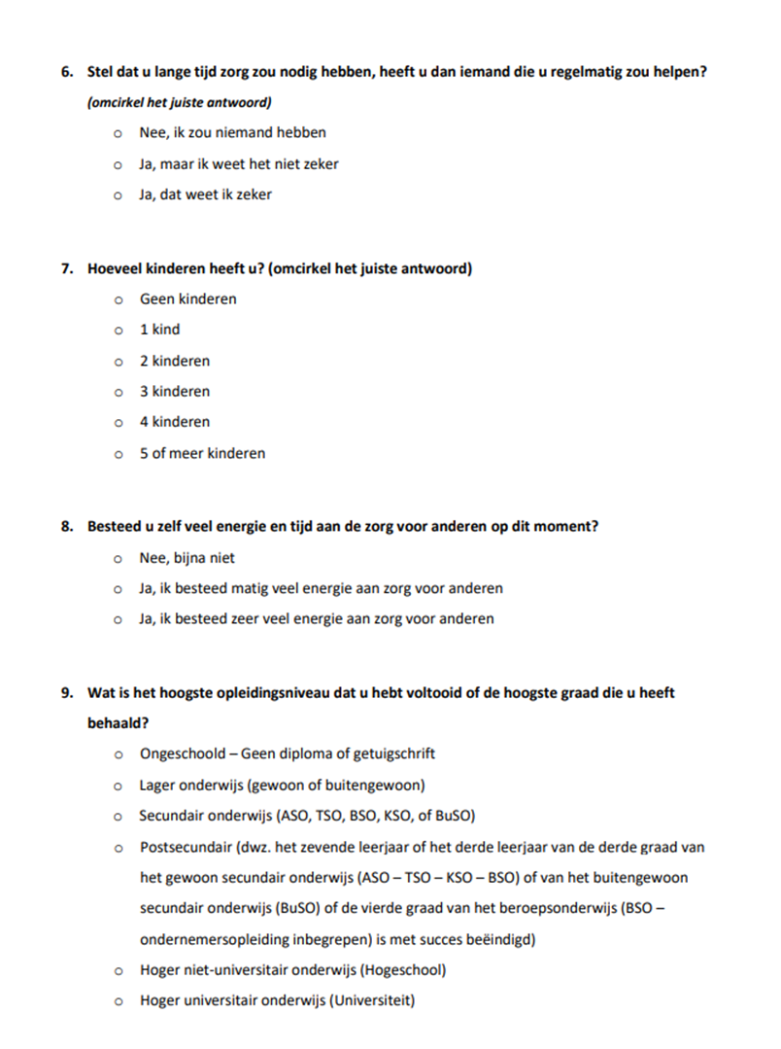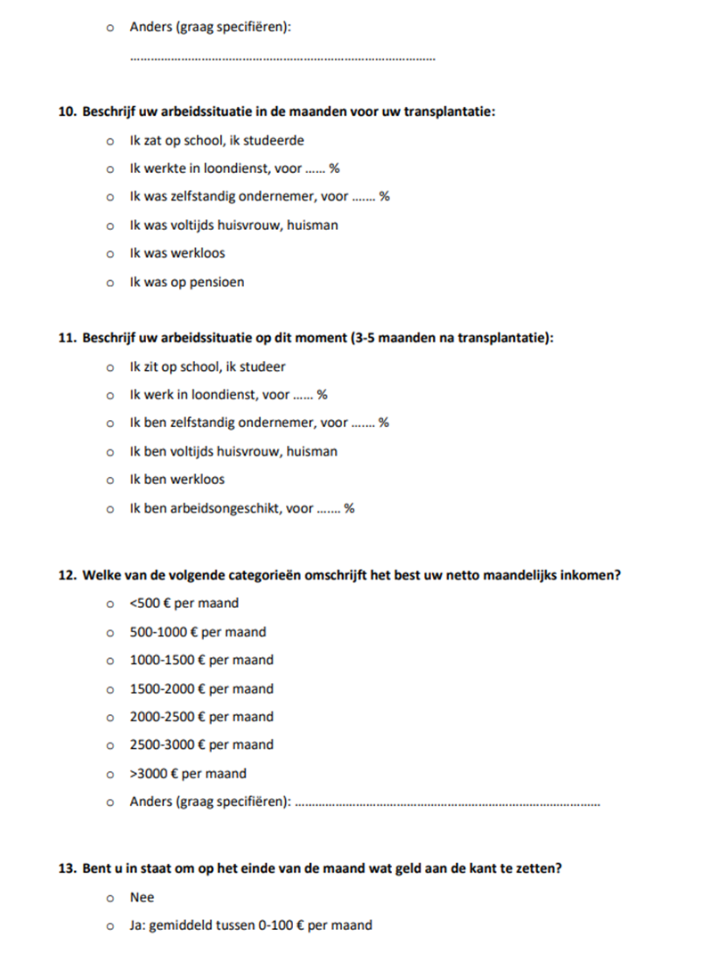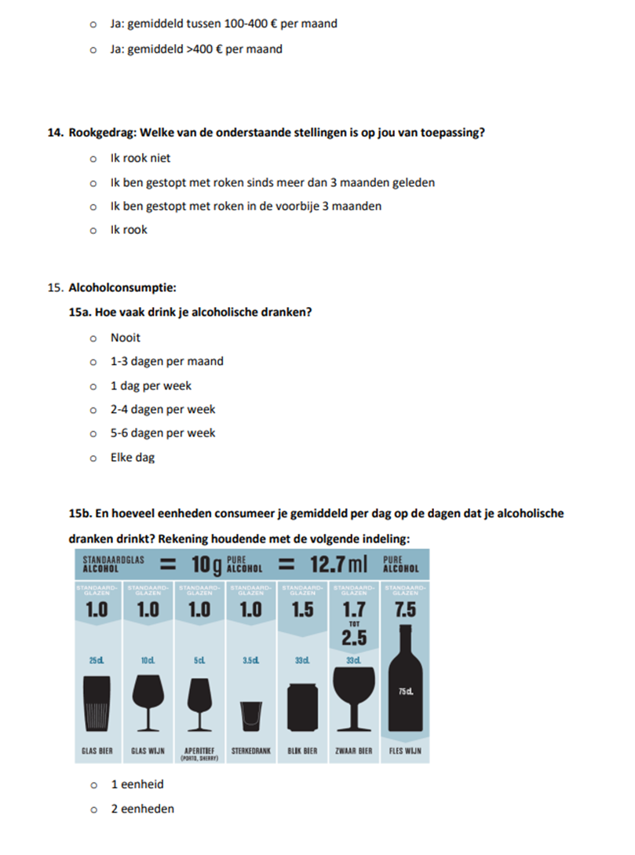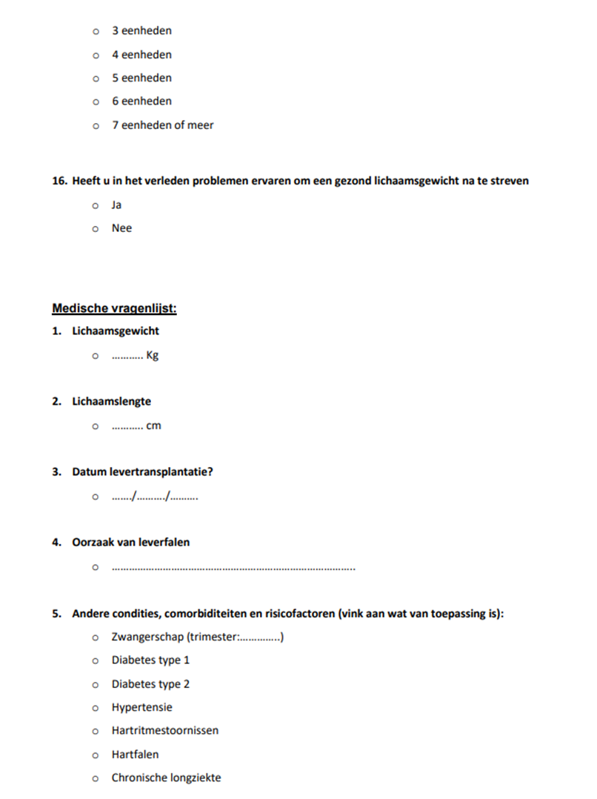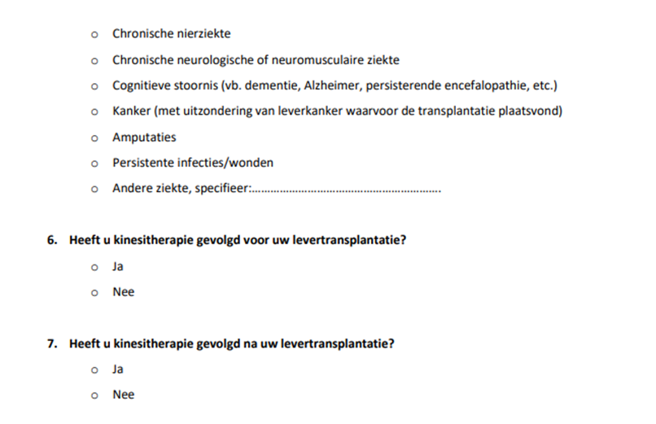

Supplementary Appendix II: Physical Activity Vital Sign

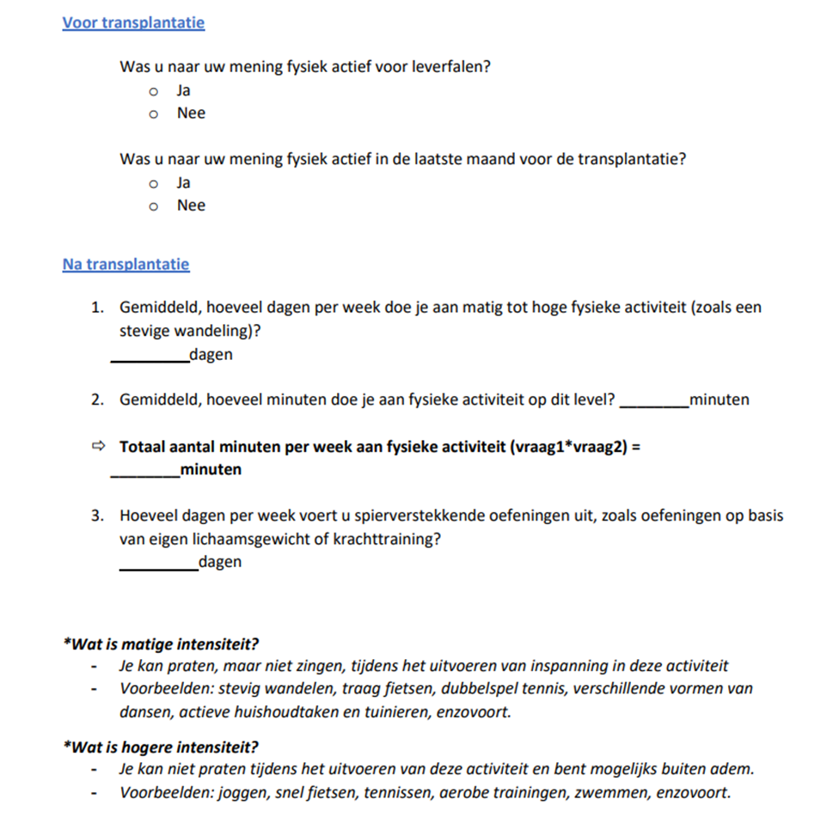

Supplementary Appendix III: Barriers and Motivators Questionnaire
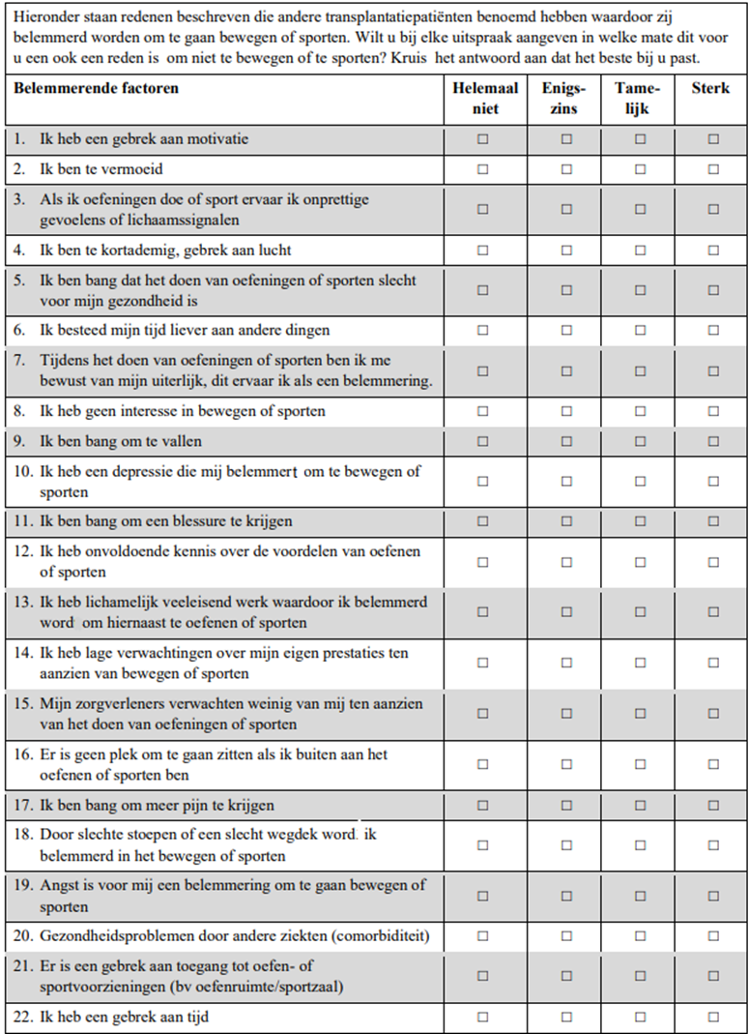
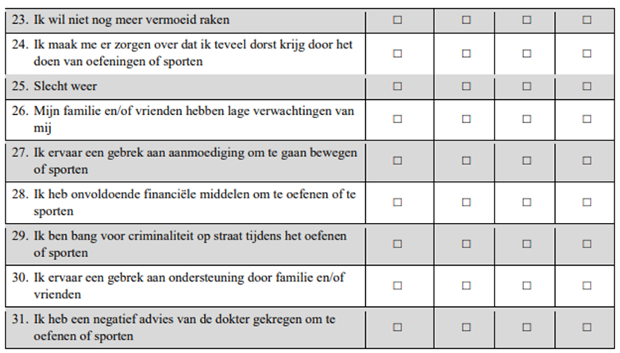
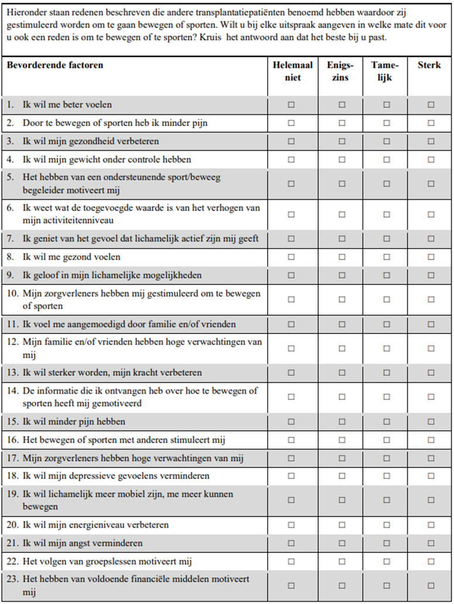

Supplementary Appendix IV: The main reason for unwilling to participate in the study
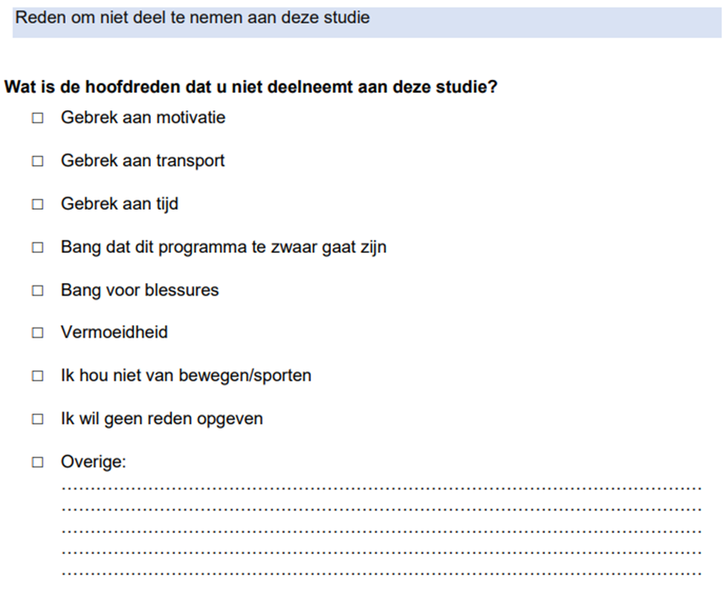

Supplementary Appendix V: Multiple logistic regression analysis to identify factors associated with willingness to participate in the exercise study
 | Participation in the study
Variable | AOR [95%CI] | p-value
Home-to-site distance (km)  Education  Motivator: Health & physical outcomes (score: 0-4 scale)  Barrier: lack of motivation or time (score: 0-4 scale) | 0.988 [0.976-1.000]  7.295 [0.777-68.500]  1.953 [0.595-6.413]  0.304 [0.084-1.108] | 0.056  0.082  0.270  0.071
Abbreviations: AOR, adjusted odd ratio; CI, confidence interval PA, physical activity; WHO, world health organization

