Supplementary 1: study protocol
Multilevel Intervention of Resistance Training Combined with Beta-Hydroxy Beta-Methylbutyrate (RTCHMB) in Critical Illness during Hospitalisation: A Study Protocol of a Four-Arm, Multicentre, Randomised Controlled Trial
Ting Ting Wu, PhD^{1,2,3*}, Yan Mu, MS^{1,2*}, Jing Xiong, MS⁴, Yue Qing Wei⁵ MS, Hong Li, PhD^{2,3}
- Department of Nursing, Fujian Provincial Hospital, Fujian, China.
- Shengli Clinical College of Fujian Medical University, Fujian, China.
- School of Nursing, Fujian Medical University, Fujian, China.
- Operating Room, Second Affiliated Hospital of Fujian Medical University, Fujian, China.
- Respiratory and Intensive Care Unit, Fujian Provincial Hospital, Fujian, China
* Ting Ting Wu and Yan Mu contributed equally to this manuscript.
Address for correspondence: Hong Li, PhD.
Professor of Nursing, School of Nursing, Fujian Medical University
Address:No.1 Xuefu North Road, Minhou County, Fuzhou City, Fujian Province 35001, China.
Telephone: +86-591-22866940
Fax: +86-591-22866940
Email: leehong99@126.com
Abstract
Background: Early rehabilitation and nutrition interventions have been extensively studied to improve the physical function of ICU patients, but optimal strategies remain unclear. ICU-acquired weakness (ICU-AW) negatively impacts both short- and long-term patient outcomes, placing a significant burden on families and society alike. Resistance training, beta-hydroxy beta-methylbutyrate (HMB), and the combined intervention have widely been used in clinical populations, and have shown positive effects in enhancing physical function. However, their application in treating ICU patients is still relatively limited. The purpose of the present study is to determine whether resistance training and/or HMB administration would also enhance outcomes in critically ill patients.

Methods: This four-arm, accessor-blind, multicentre randomised controlled trial will be conducted in 10 ICUs at five centres in Fujian province, China. Eligible participants will be randomised in a 1:1:1:1 ratio to receive either resistance training (hierarchical resistance training), HMB group (HMB alone), combination group (a combination of both interventions), or usual care group (conventional rehabilitation and nutritional therapy). The intervention will be administered five times per week through supervised training, with each session lasting 20-30 min during the entire hospitalisation. The four categories— physical function and structure impairment, activity limitation, participation limitation, and quality of life—will be repeatedly measured at baseline, ICU to discharge, and hospital discharge. Data will be analysed using a generalised linear mixed model and will follow the principles of intention-to-treat analysis.

Discussion: This multicenter with four-arm design of RCT will investigate the efficacy of resistance exercise, HMB, and their combined utilization in enhancing physical function among ICU patients. The outcomes of our study will provide optimal rehabilitation strategies for the prevention of ICU-AW for clinical application, and serve as a foundation for future research endeavors in this field.

Trial registration: ChiCTR2200057685 was registered on March 15th, 2022.

Keywords: ICU patients, resistance training, β-hydroxy-β-methylbutyrate, multilevel, RCT

Study strengths and limitations
1. This study is the first to investigate the efficacy of resistance training alone, HMB alone, and their combined effects through a multi-centre, four-arm, accessors-blind parallel randomised controlled trial.
2. We established a rigorous intervention protocol based on evidence and theoretical framework, with resistance training progressively implemented in a multilevel approach involving supine, sitting, and standing positions, allowing for flexible adaptation to the complex ICU environment.
3. The intervention throughout the entire hospitalization process, from ICU admission to ICU discharge and hospital discharge, has effectively improved the intervention period and maximized patient recovery.
4. There may be significant heterogeneity among critically illness patients, which can lead to outcome bias. We will attempt to control for confounding factors and address this issue through subgroup analysis.

1 Background
Recent medical advancements have led to an increase in severely ill patients surviving hospitalization[1], however, several invasive and non-invasive procedures used during ICU have long-term impacts on patients and may suffer from prolonged muscle weakness and physical impairment[2]. The latest meta-analysis in 2023 demonstrated that the prevalence of ICU-acquired weakness(ICU-AW) was 48% overall, which lost nearly 2% of their skeletal muscle per day during the first week of ICU admission[3], furthermore, skeletal muscle weakness persisted in 50% of these patients during the 5-year follow-up period[4].ICU-AW negatively impacts both short- and long-term patient outcomes[5], including prolonged ICU or in-hospital mortality, ICU or total length of stay, duration of mechanical ventilation, an increase in hospital costs, as well as a decrease in physical function, and prolonged recovery period. The next decade of ICU research agenda on ICU-AW[6] proposed that one of the highest-ranking research needs for further clarification of the effects of early rehabilitation and nutrition, and their interaction in ICU-AW patients.
The past two decades have seen a substantial increase in the attention paid to early rehabilitation in the ICU settings, many physical rehabilitations have been discussed, for instance, early mobilization[7], neuromuscular electrical stimulation[8], or cycling exercises[9], passive/active exercises and multicomponent[10], etc. However, recently quite a few meta-analyses[11-14] of these interventions have identified discordant effects. Therefore, the optimal exercise intervention remains unknown. Resistance training refers to a type of exercise where individuals rely on their own muscular strength to combat external resistance, such as from other individuals, dumbbells, barbells, resistance bands, etc., in order to increase muscle mass and strength[15]. Resistance training has been widely used and shown to have benefits for preventing muscle atrophy and improving muscle strength in elderly populations, it can activate the skeletal muscle, stimulate muscle protein synthesis, reduce decomposition, have anti-inflammatory effects, increase the number of muscle fibers, and strengthen skeletal muscle[16, 17]. Some single-center studies that developed a multicomponent intervention containing resistance training have demonstrated safety and feasibility in critically ill patients but showed discrepant results[18, 19]. Elastic resistance training is notable for its cost-effectiveness, practicality, and, most importantly, its portability, which enables individuals to engage in resistance training within their home setting, thus, elastic resistance training holds promise as a viable form of resistance training for individuals with ICU patients. Hence, a further multicenter evaluation of early elastic resistance training is needed, to reduce muscle weakness and physical complications after critical illness.
β-Hydroxy-β-methylbutyrate (HMB) is a metabolite of the amino acid leucine, and is considered to act by enhancing myogenic fibronectin production via the IGF-1-PI3K-Akt-mTOR pathway[20, 21], blocking many catabolic pathways including the ubiquitin pathway[22], and reducing protein hydrolysis in order to prevent fibronectin breakdown by reducing inflammatory response[23]. A meta-analysis[24] revealed that some evidence supports HMB alone or supplementation containing HMB enhanced skeletal muscle mass and strong evidence to support improving muscle strength in a variety of clinical conditions, such as sarcopenia, hospitalized elderly, cancer cachexia, maintenance hemodialysis, etc. There has been limited study of the effect of nutrients on muscle properties [25-27] and no previous examination of the effects of HMB interaction with physical rehabilitation intervention in ICU patients.
The purpose of the present study, therefore, is to determine whether resistance training and/or HMB administration would also increase outcomes in critically ill patients. To accomplish this task, we would conduct a multicenter, assessor-blinded, four-arms RCT to deliver resistance training alone, HMB alone, the combination of both interventions, versus usual care during hospitalization including ICU and general ward period. The hypothesis is this novel RCT is that the combined intervention will (1) improve physical functioning at the hospital discharge; (2) reduce muscle wasting and (3) improve patient-reported outcomes such as life quality at 6 months after discharge hospital.

2 Methods
2.1 Study design
This is a multicentre, assessor-blinded, four-arm RCT conducted at five academic and tertiary general hospitals in China, including Fujian Medical University Shengli Clinical College, the First Hospital of Nanping City of Affiliated Fujian Medical University, Putian College Affiliated Hospital, the First Hospital of Longyan City of Affiliated Fujian Medical University, Ningde Hospital affiliated with Ningde Normal College. These five centres are located in Fujian Province's central, eastern, western, southern, and northern regions, respectively. Medical centre enrolment criteria are more than 15 beds in each ICU, and more than 500 ICU patients admitted to each ICU per year. Finally, 10 ICUs from five participating hospitals were enrolled, including medical, respiratory, surgical, and comprehensive ICUs. This trial is funded by the Fujian Provincial Department of Science and Technology beginning in January 2022, with the trial duration expected to be three years.

2.2 Participants
2.2.1 Inclusion criteria:
(1) 18 years ≤ age ≤ 80 years;
(2) ICU stay ≥ 48h;
(3) Acute Physiology and Chronic Health Evaluation II (APACHEII) ≥ 8 points;
(4) Patients were awake and able to cooperate with five standardized questions ≥ 3 points[28];
(5) Patients could walk independently two weeks before transfer to ICU;
(6) Patients or proxies signed written informed consent.

2.2.2 Exclusion criteria:
(1) Not suitable for early activity or rehabilitation exercises: acute phase of myocardial infarction, ruptured thoracic aortic aneurysm, obstructive hypertrophic cardiomyopathy, uncontrolled lethal arrhythmia, pulmonary embolism, acute phase of asthma, severe pulmonary hypertension, myasthenia gravis, Guillain-Barré syndrome, spinal cord injury, unstable fracture, recent deep vein thrombosis (DVT) or venous thromboembolism (VTE), active uncontrolled bleeding, restriction of activity during hospitalisation due to medical condition and other factors;
(2) Acute phase of brain injury and its possible long-term physical dysfunction and impaired consciousness; cognitive dysfunction or mental impairment;
(3) Contraindication to enteral nutrition or the need for prolonged fasting;
(4) Inability to achieve muscle strength level 3 during ICU hospitalisation;
(5) During femoral arterial cannulation.
(6) Patients who engaged in resistance training or other exercise interventions, as well as those who participated in nutritional interventions such as HMB or protein supplementation studies.

2.2.3 Withdrawal criteria:
(1) Voluntary withdrawal from the study during the intervention;
(2) Acute complications making the continuation of the intervention impossible or necessitating termination of the intervention due to changes in condition, death, etc.;
(3) Received intervention for less than one week;
(4) Lost visit.

2.2.4 Participant recruitment and consent
Daily eligibility checks are conducted in the study site ICUs by skilled researchers to ascertain eligibility. Patients who fit any exclusion criteria will promptly be excluded, and those who are not will be checked every day to determine whether they satisfy any inclusion criteria. Once the study subjects meet the above criteria, the investigator meets with the legal proxies to go over the trial and ensure that they grasp study consent, and ask for their informed consent. For those who do, randomisation groups will be generated within 24 hours for individuals who meet all inclusion, and no exclusion, criteria. Figure 1 shows the planned flow of patients through the study.

2.2.5 Randomisation
A coordinator, who is not involved in site enrollment and is unaware of the site codes' mapping, will generate random numbers using a random number generator (https://www.random.org/), , stratified by mechanical ventilation status to ensure balance across key clinical subgroups. The coordinator will prepare a randomization list consisting of several sets of numbers, where numbers 1, 2, 3, and 4 represent resistance training alone, HMB supplementation, combined resistance training and HMB, and usual care, respectively. These random numbers will be placed in sequentially coded, sealed, and opaque envelopes. Similarly, each center will prepare a set of envelopes. Once a patient is enrolled in the study, the investigator will open the envelope with the smallest item number in the relevant stratification group. This means that each patient will be randomized in a 1:1:1:1 ratio to receive either (1) resistance training alone, (2) HMB supplementation, (3) combined resistance training and HMB, or (4) usual care.

2.2.6 Blinding
Due to the inherent characteristics of resistance training and HMB, blinding this study from patients, families, or ICU clinicians is not feasible. To minimise bias, outcome assessments are being conducted by blinded assessors and statisticians.

2.3 Study intervention
2.3.1 Develop resistance training intervention
The hierarchical resistance training intervention protocol used in this study was developed by the investigators through a systematic literature search and revised by Delphi expert consultation— see Table 1. The intervention protocol included three physical function levels—supine, sitting, and standing position—each level containing seven to eight actions, such as chest pressing, elbow flexion, rowing, ankle dorsiflexion, ankle plantarflexion, knee extension, and hip flexion, as well as bridge exercises and abdominal breathing, to stimulate the muscle groups in the upper body, lower body, and core muscle, training movements examples are shown in Supplementary Figure 1. This was done in accordance with the clinical guidelines[29] and consensus of experts[30] in the early rehabilitation of critically ill patients. The frequency (F) of the resistance training intervention will be performed five times per week by trained charge nurses or physiotherapists. The training intensity(I) will gradually be augmented through progressive overload, and the Rating of Perceived Exertion (Borg’s 6-20, 6-reflecting minimal exertion to 20-reflecting maximal exertion) will be employed. The duration time (T) will last 20-30min each day, including warming, exercise, and cooldown. The intervention will continue from randomisation until hospital discharge in supervised training by site-trained researchers, including patients both in ICU and those undergoing general hospitalisation. The type (T) of intervention will involve resistance against body weight or elastic bands. TheraBand elastic bands (The Hygenic Corporation, Akron, OH, U.S.) with lower rank two colour-coded levels of resistance (yellow and red) will be used in the rehabilitation intervention. The resistance of the elastic bands at 50% and 200% elongation are as follows: yellow = 0.83/1.69 kg, red = 1.10/2.26 kg.

2.3.2 HMB intervention description
HMB is provided in addition to usual care to target total energy delivery of 20-25kcal/kg per day in the acute phase, 25-30kcal/kg per day in the stable phase, and target total protein delivery of 1.2-2g/kg per day[31]. The nutritional supplement applied in this study was JIROU (EnterNutr, Guangzhou), which per 10g contains 8.32g of maltodextrin, 1.5g of HMBCa, 0.1g of a sweet orange powder, and 0.08g of sucralose, providing 34kcal of energy, and no protein. A total of 10g of supplement (containing 1.5g HMB) dissolved in 100ml of warm water, is administered orally or through tube feeding twice a day by nurses. HMB should be initiated when the patient is on enteral nutrition and should be suspended in case of intolerance to enteral nutrition.

2.3.3 Standard ICU co-interventions for all patients
Routine rehabilitation training and nutritional management of ICU patients are used, conducted by the supervising physician and charge nurse. Routine nutritional and rehabilitation measures for ICU patients followed the medical group treatment protocol, and no additional intervention will be imposed by investigators.
Rehabilitation training: According to the best evidence summary of early activities for patients with ICU-AW[32], early rehabilitation is carried out in conjunction with clinical practice, 20-30 min per day, with routine rehabilitation training modalities decided by the medical team. The rehabilitation training modalities received by ICU patients will be accurately recorded.
① Rehabilitation for patients who cannot actively cooperate includes passive joint activities in bed, assisted functional activities, passive sitting in bed, etc.;
② Rehabilitation contents for patients who can cooperate and perform partial rehabilitation activities focus on bedside sitting, bedside activities, bed-chair transfer, bicycle-assisted training, etc.;
③ Rehabilitation contents for patients who can move focus on active bedside activities, dynamic standing, assisted walking and a higher level of muscular endurance training
④ Patients with drainage tubes can gradually transition to choosing appropriate times each day for bed release, sitting, standing, trunk control, mobility activities, endurance training, and appropriate physical therapy.
Nutritional management: Following the American College of Critical Care Medicine Guidelines for the Implementation and Evaluation of Nutritional Support Therapy in Adult Critically Ill Patients, the energy goal for ICU patients is 20-25 kcal/kg/d in the acute phase and 25-30 kcal/kg/d in the stable phase, with a protein goal of 1.2-2 g/kg/d[31].

2.4 Outcomes measurements
According to the Core Outcome Set (COS) for rehabilitation-related outcome indicators in ICU patients[33] and the Core Outcome Measurement Set (COMS) [34], previous studies[35-37] have used the International Classification of Functioning, Disability and Health (ICF) theoretical framework^{[38]} to construct rehabilitation-related outcome indicators for ICU patients. The outcomes measurements in this study were categorized into four categories: physical function and structure impairment, activity limitation, participation limitation, and quality of life. In addition to these categories, characteristics, mortality, and daily assessment were included as part of the outcome measurements. The arrangement of time and personnel for data collection is shown in table 2.

2.4.1 Patient characteristics:
A case report form is made to collect information about patient demographics, physiological factors, disease severity, premorbid status, nutrition, therapy, and other variable assessments access the chart review, inquiry proxy, or in-person evaluation at study enrolment and daily throughout the study period, as shown in the table 3.

2.4.2 Physical function and structure impairment:
(1)Short Physical Performance Battery (SPPB) will be used to assess physical function, comprising a standing balance test, four-meter walking speed and five sit-to-stand tests, each item worth 0-4 points, with a total score of 0-12 points[38].
(2)Body composition: Bioelectrical Impedance Analysis (BIA, NUTRILAB, AKERN, Italy) will be utilised to assess fat-free mass (FFM), appendicular skeletal muscle mass (ASMM), skeletal muscle index (SMI), and phase angle (PhA).
(3)The MRC score will be used to assess the muscle strength of the six major muscle groups of the extremities (bilateral wrist extension, forearm flexion, shoulder abduction, ankle dorsiflexion, knee extension, and thigh flexion). Each group is divided into six levels according to the Oxford muscle strength scale, and the upper and lower extremities of the left and right sides are measured at the same time, with a total score of 0-60. Higher scores represent greater muscle strength. MRC is considered the gold standard for the diagnosis of ICU-AW, and a score <48 can be diagnosed as ICU-AW[39] .
(4)Grip strength: The CAMRY EH101 handheld electronic grasp strength device will be used to measure the voluntary contraction force of the dominant hand's musculature. The participant will be placed in a supine, neutral forearm position[40, 41], elbow flexed 90 degrees, repeated three times, with the maximal value recorded.
(5)Fatigue scale-14 (FS-14) will be used to evaluate recent fatigue symptoms and their severity[42], consisting of 14 items with two dimensions (1-8 is physical fatigue and 9-14 is cerebral fatigue), with a total score ranging from 0 to 14, with higher scores indicating greater fatigue; fatigue symptoms are considered present when the total score ≥7.
(6) Pittsburgh Sleep Quality Index (PSQI): Sleep quality was evaluated using the PSQI, a validated instrument developed by Buysse et al[43]. in 1989 to assess subjective sleep quality over the past month. The PSQI comprises seven components—subjective sleep quality, sleep latency, sleep duration, habitual sleep efficiency, sleep disturbances, use of sleep medications, and daytime dysfunction—each scored from 0 to 3. The global score ranges from 0 to 21, with higher scores indicating worse sleep quality. A score >5 denotes clinically significant sleep disturbance, with a reported sensitivity of 89.6% and specificity of 86.5%. The PSQI has demonstrated good internal consistency (Cronbach’s α = 0.85) and test–retest reliability (r = 0.87)[44].
(7)Mini-Mental State Examination (MMSE), a simple tool for assessing cognitive function. A total of 30 items with 30 points is stratified by education, with illiterate groups ≤ 17 points, primary groups ≤ 20 points, and secondary and above groups ≤ 24 points deemed to have abnormal cognitive function[45].
(8)Hospital Anxiety and Depression Scale (HADS) consists of two subscales, anxiety and depression, with seven items each and 14 items in total, each of which is scored on a 0-3 scale, with a maximum score of 21 for each component of anxiety and depression, with 0-7 being asymptomatic, 8-10 being suspicious for the presence of symptoms, 11-12 being definitely symptomatic, and >15 suggesting severe affective disorder, where a score of ≥8 is considered positive for anxiety or depressive symptoms[46].
(9)Revised Impact of Event Scale (IES-R) is a 22-item instrument that detects post-traumatic stress disorder (PTSD) symptoms[47]. It assesses the severity of avoidance, intrusion, and hyperarousal symptoms, the three categories of PTSD symptoms. The adoption of a threshold score of 33 out of 88 indicates severe psychological impact of a traumatic event.

2.4.3 Activity limitation:
(1) 6-Minute Walk Test(6MWT) To evaluate functional endurance capacity and mobility, participants were directed to walk independently along a 30-meter hospital corridor and cover as much distance as possible within a 6-minute duration. The recorded outcome, denoted in meters, is known as the 6-Minute Walk Distance (6MWD).

2.4.4 Participation limitation
The Barthel Index (BI) of activities of daily living (ADL)[48] will be used to measure functional status and dependency. There are 10 categories in total: feeding, bathing, grooming, dressing, bladder control, bowel control, toilet use, chair–bed transfer, mobility, and stair climbing. Scoring ranges from 0 to 100: a score of 100 is defined as being capable of ADL complete self-care.

2.4.5 Quality of life:
36-Item Short Form Health Survey (SF-36)[49], which comprises 36 questions with eight dimensions: Physical Functioning (PF), Physical Functioning (Role-Physical, RP), Body Pain (BP), General Health (GH), Vitality (VT), Social Functioning (SF), Emotional Functioning (RE), Mental Health (MH). The first four dimensions make up the Physical Component Summary (PCS), and the last four dimensions make up the Mental Component Summary (MCS).

2.4.6 Daily assessment
(1)Daily dietary intake: Patient daily dietary intake and gastrointestinal tolerance during hospitalisation will be recorded by the charge nurse or investigator, and the cumulative energy and protein deficit will be calculated using the lower limits recommended by the American College of Critical Care Medicine Guidelines for the Implementation and Evaluation of Nutritional Support Therapy in Critically Ill Adults[31] on target values for energy and protein intake, i.e., a daily target energy intake of 25 kcal/kg and a target protein intake of 1.2 g/kg.
(2)Daily activity: During the patient's ICU stay, the bedside nurse documents the amount of time the patient spends sitting in a bedside chair and walking, when transfer to the general ward is self-reported by the patient or caregiver and recorded by the charge nurse.
(3)CAM-ICU: The Confusion Assessment Method-ICU will be used by a trained bedside nurse to assess delirium at least every 12 hours.

2.5 Study outcomes
2.5.1Primary outcome
The primary outcomes are 6WMD and SPPB at hospital discharge.

2.5.2 Secondary outcomes
The secondary outcomes are body composition, MRC score, grip strength, FS-14, PSQI, MMSE, HADS, IESR, SF-36, CAM-ICU, and 60-day mortality.

2.6 Statistical analysis
2.6.1 Sample size determination
A pre-study power analysis conducted using G Power software estimated that approximately 24 patients per group (with a total of 96) were required to detect a 35% improvement in physical function between the control and treatment groups, with a power of 0.8 and an alpha level of 0.05.

R software will be used to process the data. Statistical tests are all two-sided, and the differences are considered statistically significant when P<0.05. We followed the principles of intention-to-treat analysis (ITT).

2.6.2 General characteristics analysis
Continuous variables will be tested for normality using the KS-test in conjunction with the PP-plot and QQ-plot; those conforming to normal distribution will be described using mean standard deviation, while those not conforming to normal distribution will be described using the median (interquartile spacing); categorical variables will be described statistically using frequency and percentage. Continuous variables obeying normal distribution will be analysed using the ANOVA test, whereas those not obeying normal distribution will be analysed using the Wilcoxon Rank Sum test; categorical variables will be analysed using the chi-square test, Fisher’s exact test, etc. The mean value will be used to fill in missing characteristics values.

2.6.3 Linear Mixed Model
Linear Mixed Model(LMM) will be used to analyse the differences and trends in FFM, ASMM, SMI, and PhA between the four groups at different assessment time points T0, T1w, T2w, and at discharge; LMM was used to analyse the differences between the four groups at discharge between SPPB and 6WMD, and between SF-36, IESR and at one month post-discharge; LMM was used to analyse the differences between the four groups in MRC scores, grip strength, and MMSE at T0, transfer out and discharge and the trend of change; LMM was used to compare the differences and change trends in FS-14, PSQI, HADS, at T0, transfer out and discharge, and one month post-discharge between the four groups. The differences in the incidence of ICU-AW at each time point between the four groups were analysed using LMM. The model will use group, time, and between group and time interactions as fixed effect measures to control for the effect of repeated measures of data, and the variable of centre as a random effect measure to control for the effect of population heterogeneity across centres. The regression coefficient β(95CI%) will be calculated for the resistance training group, HMB group, and combined group compared to the control group as a reference to compare the magnitude of the three intervention effects. The LMM allows for the presence of missing values, thus missing values in the ending indicator section are not treated specifically.

3 Discussion
Early rehabilitation and nutrition intervention have been studied extensively in terms of improving the physical function of ICU patients, but the optimal strategies remain unclear. This study is the first to implement a resistance training intervention combined with HMB for ICU patients. Our innovative approach to resistance training involves multilevel exercises in supine, sitting, and standing positions. Exercise types progress from body weight resistance to elastic band resistance, offering a flexible and feasible intervention plan to adapt to the complex ICU context. The intervention process spans from the time of ICU admission, once the patient's condition has stabilised, to transfer to a general ward and ultimately, to discharge. This ensures an effective intervention period, maximises patient recovery, and highlights the novelty of our intervention timing. Meanwhile, this study is the first to validate the effectiveness and effect size of resistance training alone, HMB supplementation alone, and their combination in comparison to usual care through a multi-centre, four-arm, accessor-blind, parallel randomised controlled trial. We also precisely estimate the impact of different intervention strategies on patient outcomes by employing a novel statistics linear mixed model effect size analysis, thereby allowing us to identify the optimal intervention strategy.

This protocol is subject to several limitations. On the one hand, it is challenging to blind participants and interveners with informed permission due to the nature of non-drug therapies, therefore, we will blind the outcome assessors and standardised crucial cointerventions, and we will report on how they are used in each group. On the other hand, ICU patients have complex and constantly changing conditions, which may introduce significant heterogeneity into the study population and bias the results. However, we made the effort to control for confounding bias by using a multicentre large sample size to reduce the impact of population heterogeneity, as well as by recording daily dietary and activity information, to determine whether there are differences in protein and energy intake, as well as activity levels, among the four groups. In addition, subgroup analysis will be used to reduce heterogeneity.

In conclusion, this study is a multicentre, randomised controlled trial with a four-arm design based on evidence-based principles, investigating the effectiveness of resistance exercise, HMB, and their combination in improving physical function in ICU patients. The outcomes of our study are expected to provide optimal rehabilitation strategies for the prevention of ICU-AW for clinical application, and serve as a foundation for future research endeavours in this field.

Declarations
Ethics approval and consent to participate
This study rigorously adheres to ethical principles and respects the preferences of all participants. Before the study is conducted, written informed consent will be obtained from all participants through an authorised surrogate decision-maker. The study purpose, content, and procedure must be completely explained, informed consent must be signed, and notification must be done properly. Under no circumstances may the researcher reveal the personal information or seclusion of the subjects. This protocol is carried out in accordance with the Helsinki Declaration. Ethical approval was secured from the Fujian Provincial Hospital's Ethics Committee (k2021-04-004).

Consent to publish
Informed consent for publication of photos/images were obtained from all participants. However, it is paramount to uphold the participants' right to privacy, thereby ensuring that their personal information remains confidential and undisclosed.

Availability of data and materials
The datasets generated and/or analysed during the proposed study will be available from the corresponding author upon reasonable request

Competing interests
The authors declare that they have no competing interests.

Funding
This study will be supported by Guidance project of Fujian Provincial Science and Technology Department., China (NO: 2021Y0051), the Innovation of Science and Technology, Fujian Province (Grant No. 2023Y9326), the Research Projects of the Chinese Nursing Association (Grant No. ZHKYQ202222).

Authors' contributions
TTW and HL designed the study and drafted the protocol; JX provided statistical advice and support; YM provided clinical expertise and advice; TTW and HL were responsible for developing the data collection and analysis plan and participated in the development of the ethical review and oversight plan.

Acknowledgements
None

Table 1 The intervention protocol for resistance training
Multilevel interventions | Training movements
Supine position level | Upper limb muscle group: supine chest press, supine elbow flexion[50, 51], supine chest expansion[50]
 | Lower limb muscle groups: ankle plantar flexion[51], ankle dorsiflexion, hip and knee flexion[50, 51], straight leg raise[50]
 | Core muscle group: Bridge exercise[52]、abdominal breathing[53-58]
Sitting position level | Upper limb muscle group: seated elbow flexion[59, 60]、seated row  [59, 61-65]、seated chest press[53, 55, 59-62, 64]
 | Lower limb muscle group: ankle dorsiflexion[60, 65]、ankle plantarflexion、seated knee extension[53, 62, 64, 66-69]、seated hip flexion[55, 59, 60, 62, 65, 68]
 | Core muscle group: abdominal breathing [53-58]
Standing position level | Upper limb muscle group: standing elbow flexion[63, 70-74]、standing rowing[63, 72, 73, 75]、standing chest press[63, 67, 74-77]
Lower limb muscle group: standing ankle dorsiflexion
[72]、bilateral heel raises[53, 67, 71, 72, 77]、sit-to-stand exercise
[64]
 | Core muscle group: abdominal breathing [53-58]
Frequency | 5 times per week
Intensity | The Borg 6-20 rating scale is controlled within a range of 11-13 points[78, 79], progressive resistance training through 1) training to anti one's own body weight to resistance band; 2) decreasing the width of the grasp on the resistance band; 3) changing the color of the resistance band from yellow to red; 4) raising the number of training sets.
Time | 20-30min per day, 1-2 sets each action, 10-15 repetitions each set
Type | Resistance training by anti-self-bodyweight or elastic band

Table 2 Outcome measurements and data collection arrangement
Outcomes measurement | T0 | T1w/T2w | ICU discharge | Hospital discharge | One month after hospital discharge | Evaluator
1.Physical function and structure impairment
①Body composition | √ | √ |  | √ |  | Investigator
②MRC score | √ |  | √ | √ |  | Investigator
③Grip strength | √ |  | √ | √ |  | Investigator
④SPPB |  |  |  | √ |  | Investigator
⑤FS-14 | √ |  | √ | √ | √ | Investigator
⑥PSQI | √ |  | √ | √ | √ | Investigator
⑦MMSE | √ |  | √ | √ |  | Investigator
⑧HADS | √ |  | √ | √ | √ | Investigator
⑨IESR |  |  |  |  | √ | Investigator
2.Activity limitation
①6MWD |  |  |  | √ |  | Investigator
3.Participation limitation
①BI | √ |  | √ | √ | √ | Investigator
4.Quality of life
①SF-36 |  |  |  |  | √ | Investigator
5.Daily assessment
①Daily nutrition |  |  |  |  |  | Nurse
②Daily activity |  |  |  |  |  | Nurse
③Delirium |  |  |  |  |  | Nurse

Table 3 Patient characteristics and the collection methods
Participant characteristics | Collected methods
Demographics: Age/sex/marital status/education level | Chart review
Body mass index | Chart review
Smoking/drinking | Chart review
Length of hospital stay prior to ICU admission | Chart review
Reason for ICU admission | Chart review
Primary diagnosis | Chart review
Charlson Comorbidity Index (CCI) | Chart review
APACHEII | Chart review
SOFA | Chart review
NUTRIC | Chart review
Duration of mechanical ventilation | Chart review
Length of ICU stay | Chart review
Length of hospital stay | Chart review
60-day mortality | Telephone interview

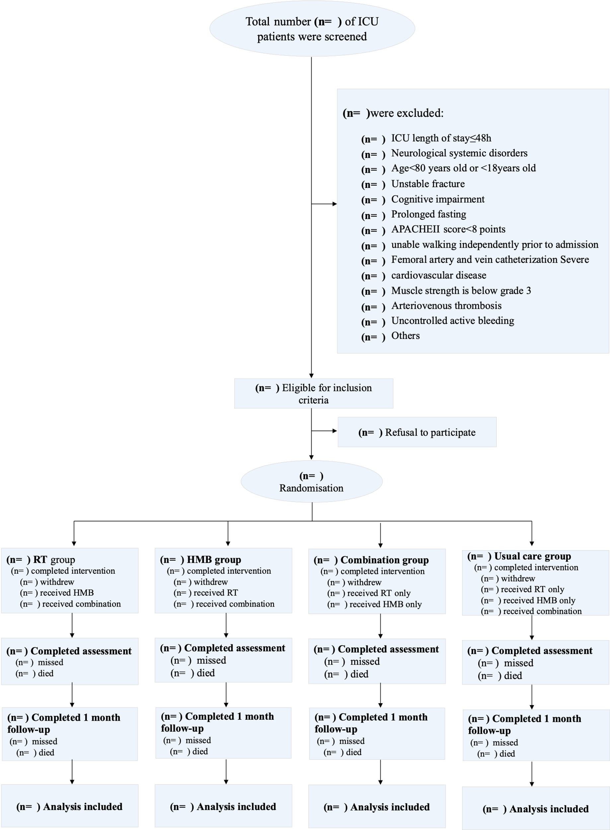
Figure 1 Participant flowchart

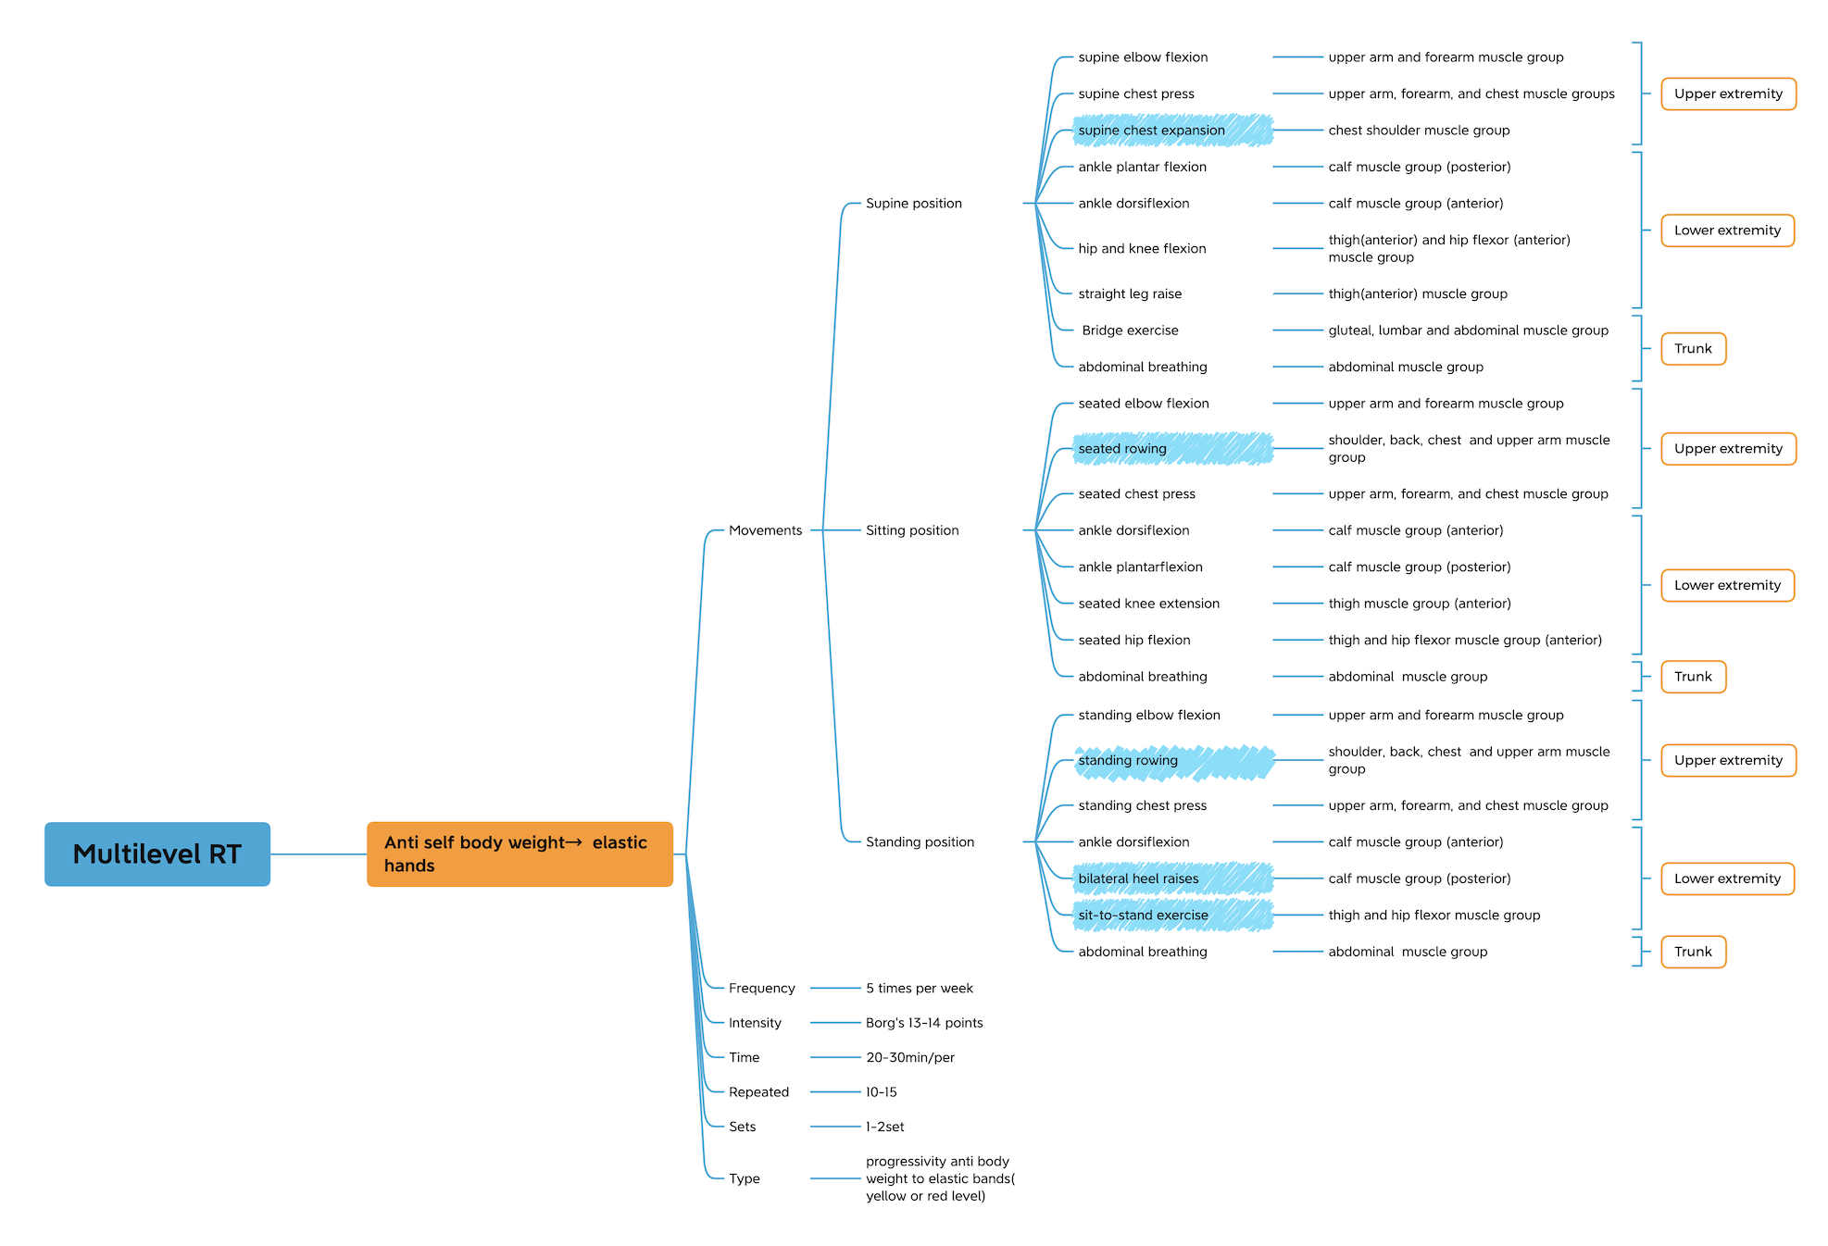
Figure 2. The intervention protocol overview

Supplementary: Examples of training movements
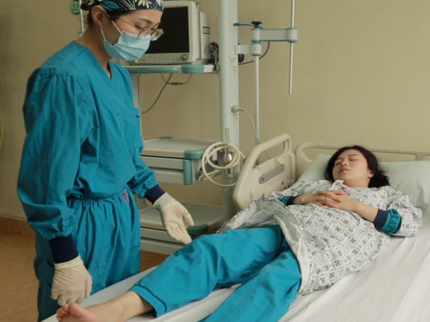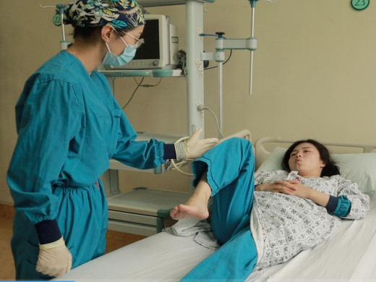
(a) (b)
Figure 3 Examples of training movements. Supine hip and knee flexion (a-b, anti-body weight): In a supine position, relax both lower limbs, with both hands placed by the sides or on the abdomen. While exhaling, simultaneously bend the knee and hip joints, attempting to achieve a 90-degree hip flexion. Maintain this position for 3-5 seconds. During inhalation, slowly return to the original position
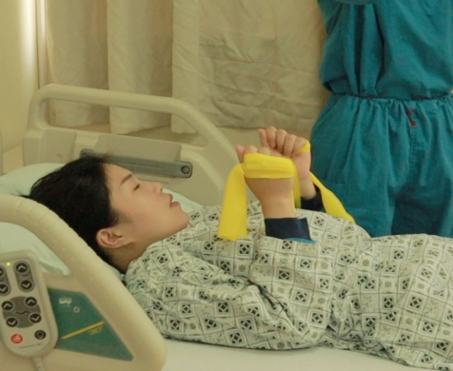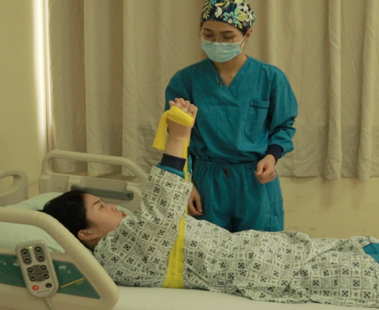
(c) (d)
Figure 3 Examples of training movements. Supine chest press (c-d, anti-elastic band): Assume a supine or semi-supine position, with the resistance band looped underneath the scapulae and extending from both sides of the axillae. Grasp the ends of the resistance band with both hands, palms facing each other, and maintain a neutral forearm position. Keep the arms close to the torso, fully extend them upwards, and position the hands above the shoulders. Hold this position for 3-5 seconds, then slowly relax and return to the initial position.
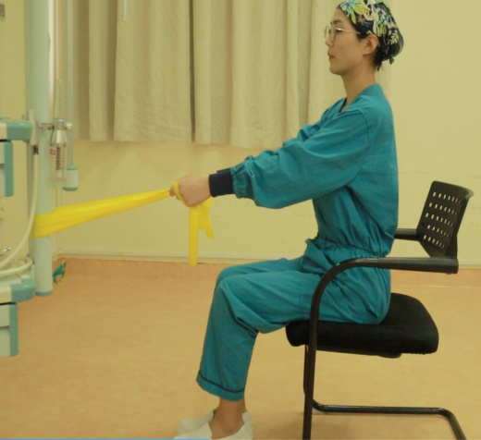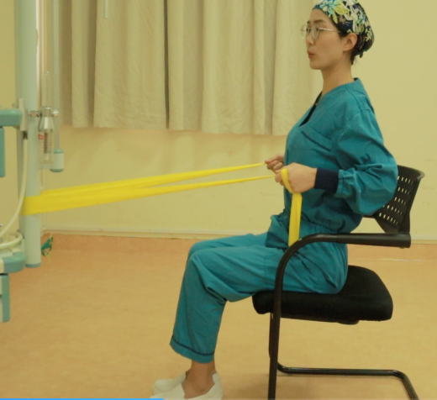
(e) (f)
Figure 3 Examples of training movements. Seated rowing (e-f, anti-elastic band): Sit down and fix the elastic band in front of the body at approximately waist height. Adjust the sitting position facing the elastic band, with the shoulders sinking, arms extended forward, and hands holding the two ends of the elastic band, palms facing each other, at an appropriate width. Keep the body stable, back straight, upper arms close to the trunk, shoulders extended backward, scapulae adducted, and chest lifted for 3-5 seconds before relaxing and returning to the initial position.
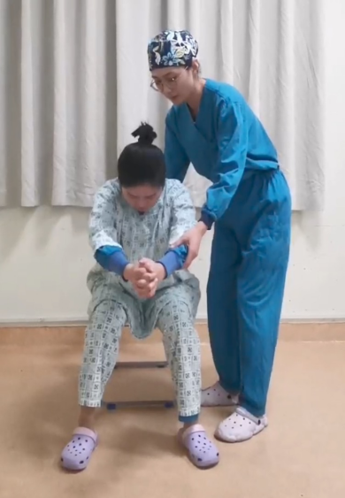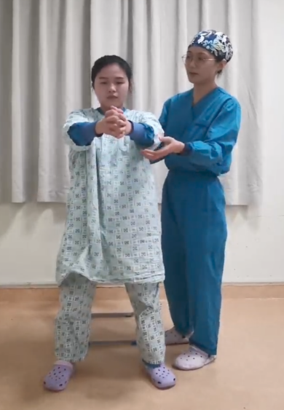
(g) (h)
Figure 3 Examples of training movements. Sit-to-stand exercise (g-h, anti-self-body weight): Select an appropriate height chair (approximately level with the lower leg), with the patient's feet flat on the ground and shoulder-width apart, toes inward, and knees beyond the ankles. Cross the patient's hands forward, lean forward, shift the center of gravity forward, and move the buttocks to the edge of the chair. The lower limbs exert force to stand up, extend the hip joint, and straighten the whole body. When sitting down, lean forward slightly, bend the hip and knee joints first, and then sit down slowly. If the patient is unable to complete the sit-to-stand exercise independently, the operator can assist the patient in standing up by pulling the patient's back waistband upwards.

References:
1. Kaukonen KM, Bailey M, Suzuki S, Pilcher D, Bellomo R: Mortality related to severe sepsis and septic shock among critically ill patients in Australia and New Zealand, 2000-2012. Jama 2014, 311(13):1308-1316.
2. Mikkelsen ME, Still M, Anderson BJ, Bienvenu OJ, Brodsky MB, Brummel N, Butcher B, Clay AS, Felt H, Ferrante LE et al: Society of Critical Care Medicine's International Consensus Conference on Prediction and Identification of Long-Term Impairments After Critical Illness. Crit Care Med 2020, 48(11):1670-1679.
3. Fazzini B, Märkl T, Costas C, Blobner M, Schaller SJ, Prowle J, Puthucheary Z, Wackerhage H: The rate and assessment of muscle wasting during critical illness: a systematic review and meta-analysis. Crit Care 2023, 27(1):2.
4. Dinglas VD, Aronson Friedman L, Colantuoni E, Mendez-Tellez PA, Shanholtz CB, Ciesla ND, Pronovost PJ, Needham DM: Muscle Weakness and 5-Year Survival in Acute Respiratory Distress Syndrome Survivors. Crit Care Med 2017, 45(3):446-453.
5. Vanhorebeek I, Latronico N, Van den Berghe G: ICU-acquired weakness. Intensive Care Med 2020, 46(4):637-653.
6. Latronico N, Herridge M, Hopkins RO, Angus D, Hart N, Hermans G, Iwashyna T, Arabi Y, Citerio G, Ely EW et al: The ICM research agenda on intensive care unit-acquired weakness. Intensive Care Med 2017, 43(9):1270-1281.
7. Hodgson CL, Bailey M, Bellomo R, Brickell K, Broadley T, Buhr H, Gabbe BJ, Gould DW, Harrold M, Higgins AM et al: Early Active Mobilization during Mechanical Ventilation in the ICU. N Engl J Med 2022, 387(19):1747-1758.
8. Fischer A, Spiegl M, Altmann K, Winkler A, Salamon A, Themessl-Huber M, Mouhieddine M, Strasser EM, Schiferer A, Paternostro-Sluga T et al: Muscle mass, strength and functional outcomes in critically ill patients after cardiothoracic surgery: does neuromuscular electrical stimulation help? The Catastim 2 randomized controlled trial. Crit Care 2016, 20:30.
9. Fossat G, Baudin F, Courtes L, Bobet S, Dupont A, Bretagnol A, Benzekri-Lefevre D, Kamel T, Muller G, Bercault N et al: Effect of In-Bed Leg Cycling and Electrical Stimulation of the Quadriceps on Global Muscle Strength in Critically Ill Adults: A Randomized Clinical Trial. JAMA 2018, 320(4):368-378.
10. Reid JC, Unger J, McCaskell D, Childerhose L, Zorko DJ, Kho ME: Physical rehabilitation interventions in the intensive care unit: a scoping review of 117 studies. J Intensive Care 2018, 6:80.
11. Balke M, Teschler M, Schafer H, Pape P, Mooren FC, Schmitz B: Therapeutic Potential of Electromyostimulation (EMS) in Critically Ill Patients-A Systematic Review. Front Physiol 2022, 13:865437.
12. Doiron KA, Hoffmann TC, Beller EM: Early intervention (mobilization or active exercise) for critically ill adults in the intensive care unit. Cochrane Database Syst Rev 2018, 3:CD010754.
13. Zayed Y, Kheiri B, Barbarawi M, Chahine A, Rashdan L, Chintalapati S, Bachuwa G, Al-Sanouri I: Effects of neuromuscular electrical stimulation in critically ill patients: A systematic review and meta-analysis of randomised controlled trials. Aust Crit Care 2020, 33(2):203-210.
14. Takaoka A, Utgikar R, Rochwerg B, Cook DJ, Kho ME: The Efficacy and Safety of In-Intensive Care Unit Leg-Cycle Ergometry in Critically Ill Adults. A Systematic Review and Meta-analysis. Ann Am Thorac Soc 2020, 17(10):1289-1307.
15. Feigenbaum MS, Pollock ML: Prescription of resistance training for health and disease. Med Sci Sports Exerc 1999, 31(1):38-45.
16. Westcott WL: Resistance training is medicine: effects of strength training on health. Curr Sports Med Rep 2012, 11(4):209-216.
17. Sardeli AV, Tomeleri CM, Cyrino ES, Fernhall B, Cavaglieri CR, Chacon-Mikahil MPT: Effect of resistance training on inflammatory markers of older adults: A meta-analysis. Exp Gerontol 2018, 111:188-196.
18. Morris PE, Berry MJ, Files DC, Thompson JC, Hauser J, Flores L, Dhar S, Chmelo E, Lovato J, Case LD et al: Standardized Rehabilitation and Hospital Length of Stay Among Patients With Acute Respiratory Failure: A Randomized Clinical Trial. JAMA 2016, 315(24):2694-2702.
19. Eggmann S, Verra ML, Luder G, Takala J, Jakob SM: Effects of early, combined endurance and resistance training in mechanically ventilated, critically ill patients: A randomised controlled trial. PLoS One 2018, 13(11):e0207428.
20. Aversa Z, Bonetto A, Costelli P, Minero VG, Penna F, Baccino FM, Lucia S, Rossi Fanelli F, Muscaritoli M: β-hydroxy-β-methylbutyrate (HMB) attenuates muscle and body weight loss in experimental cancer cachexia. Int J Oncol 2011, 38(3):713-720.
21. Eley HL, Russell ST, Baxter JH, Mukerji P, Tisdale MJ: Signaling pathways initiated by beta-hydroxy-beta-methylbutyrate to attenuate the depression of protein synthesis in skeletal muscle in response to cachectic stimuli. Am J Physiol Endocrinol Metab 2007, 293(4):E923-931.
22. Schwartz AL, Ciechanover A: The ubiquitin-proteasome pathway and pathogenesis of human diseases. Annu Rev Med 1999, 50:57-74.
23. Nunes EA, Lomax AR, Noakes PS, Miles EA, Fernandes LC, Calder PC: β-Hydroxy-β-methylbutyrate modifies human peripheral blood mononuclear cell proliferation and cytokine production in vitro. Nutrition 2011, 27(1):92-99.
24. Bear DE, Langan A, Dimidi E, Wandrag L, Harridge SDR, Hart N, Connolly B, Whelan K: beta-Hydroxy-beta-methylbutyrate and its impact on skeletal muscle mass and physical function in clinical practice: a systematic review and meta-analysis. Am J Clin Nutr 2019, 109(4):1119-1132.
25. Supinski GS, Netzel PF, Westgate PM, Schroder EA, Wang L, Callahan LA: A randomized controlled trial to determine whether beta-hydroxy-beta-methylbutyrate and/or eicosapentaenoic acid improves diaphragm and quadriceps strength in critically Ill mechanically ventilated patients. Crit Care 2021, 25(1):308.
26. Viana MV, Becce F, Pantet O, Schmidt S, Bagnoud G, Thaden JJ, Ten Have GAM, Engelen MPKJ, Voidey A, Deutz NEP et al: Impact of β−hydroxy-β−methylbutyrate (HMB) on muscle loss and protein metabolism in critically ill patients: A RCT. Clin Nutr 2021.
27. Nakamura K, Kihata A, Naraba H, Kanda N, Takahashi Y, Sonoo T, Hashimoto H, Morimura N: beta-Hydroxy-beta-methylbutyrate, Arginine, and Glutamine Complex on Muscle Volume Loss in Critically Ill Patients: A Randomized Control Trial. JPEN J Parenter Enteral Nutr 2020, 44(2):205-212.
28. De Jonghe B, Sharshar T, Lefaucheur JP, Authier FJ, Durand-Zaleski I, Boussarsar M, Cerf C, Renaud E, Mesrati F, Carlet J et al: Paresis acquired in the intensive care unit: a prospective multicenter study. Jama 2002, 288(22):2859-2867.
29. Bein T, Bischoff M, Brückner U, Gebhardt K, Henzler D, Hermes C, Lewandowski K, Max M, Nothacker M, Staudinger T et al: S2e guideline: positioning and early mobilisation in prophylaxis or therapy of pulmonary disorders : Revision 2015: S2e guideline of the German Society of Anaesthesiology and Intensive Care Medicine (DGAI). Anaesthesist 2015, 64 Suppl 1:1-26.
30. Sommers J, Engelbert RH, Dettling-Ihnenfeldt D, Gosselink R, Spronk PE, Nollet F, van der Schaaf M: Physiotherapy in the intensive care unit: an evidence-based, expert driven, practical statement and rehabilitation recommendations. Clin Rehabil 2015, 29(11):1051-1063.
31. Taylor BE, McClave SA, Martindale RG, Warren MM, Johnson DR, Braunschweig C, McCarthy MS, Davanos E, Rice TW, Cresci GA et al: Guidelines for the Provision and Assessment of Nutrition Support Therapy in the Adult Critically Ill Patient: Society of Critical Care Medicine (SCCM) and American Society for Parenteral and Enteral Nutrition (A.S.P.E.N.). Crit Care Med 2016, 44(2):390-438.
32. Yunhan Ding, Jian Luo, Lijuan Xiong, et al. The best evidence summary of early activities for patients with ICU-AW [J]. J Nurs Sci, 2021, 36(24):34-38.
33. Turnbull AE, Sepulveda KA, Dinglas VD, Chessare CM, Bingham CO, 3rd, Needham DM: Core Domains for Clinical Research in Acute Respiratory Failure Survivors: An International Modified Delphi Consensus Study. Crit Care Med 2017, 45(6):1001-1010.
34. Needham DM, Sepulveda KA, Dinglas VD, Chessare CM, Friedman LA, Bingham CO, 3rd, Turnbull AE: Core Outcome Measures for Clinical Research in Acute Respiratory Failure Survivors. An International Modified Delphi Consensus Study. Am J Respir Crit Care Med 2017, 196(9):1122-1130.
35. Turnbull AE, Rabiee A, Davis WE, Nasser MF, Venna VR, Lolitha R, Hopkins RO, Bienvenu OJ, Robinson KA, Needham DM: Outcome Measurement in ICU Survivorship Research From 1970 to 2013: A Scoping Review of 425 Publications. Crit Care Med 2016, 44(7):1267-1277.
36. Ohtake PJ, Lee AC, Scott JC, Hinman RS, Ali NA, Hinkson CR, Needham DM, Shutter L, Smith-Gabai H, Spires MC et al: Physical Impairments Associated With Post-Intensive Care Syndrome: Systematic Review Based on the World Health Organization's International Classification of Functioning, Disability and Health Framework. Phys Ther 2018, 98(8):631-645.
37. González-Seguel F, Corner EJ, Merino-Osorio C: International Classification of Functioning, Disability, and Health Domains of 60 Physical Functioning Measurement Instruments Used During the Adult Intensive Care Unit Stay: A Scoping Review. Phys Ther 2019, 99(5):627-640.
38. Guralnik JM, Simonsick EM, Ferrucci L, Glynn RJ, Berkman LF, Blazer DG, Scherr PA, Wallace RB: A short physical performance battery assessing lower extremity function: association with self-reported disability and prediction of mortality and nursing home admission. J Gerontol 1994, 49(2):M85-94.
39. Vanpee G, Hermans G, Segers J, Gosselink R: Assessment of limb muscle strength in critically ill patients: a systematic review. Crit Care Med 2014, 42(3):701-711.
40. Parry SM, Berney S, Granger CL, Dunlop DL, Murphy L, El-Ansary D, Koopman R, Denehy L: A new two-tier strength assessment approach to the diagnosis of weakness in intensive care: an observational study. Crit Care 2015, 19(1):52.
41. Chlan LL, Tracy MF, Guttormson J, Savik K: Peripheral muscle strength and correlates of muscle weakness in patients receiving mechanical ventilation. Am J Crit Care 2015, 24(6):e91-98.
42. Chalder T, Berelowitz G, Pawlikowska T, Watts L, Wessely S, Wright D, Wallace EP: Development of a fatigue scale. J Psychosom Res 1993, 37(2):147-153.
43. Buysse DJ, Reynolds CF, 3rd, Monk TH, Berman SR, Kupfer DJ: The Pittsburgh Sleep Quality Index: a new instrument for psychiatric practice and research. Psychiatry Res 1989, 28(2):193-213.
44. Backhaus J, Junghanns K, Broocks A, Riemann D, Hohagen F: Test-retest reliability and validity of the Pittsburgh Sleep Quality Index in primary insomnia. J Psychosom Res 2002, 53(3):737-740.
45. Folstein MF, Folstein SE, McHugh PR: "Mini-mental state". A practical method for grading the cognitive state of patients for the clinician. J Psychiatr Res 1975, 12(3):189-198.
46. Zigmond AS, Snaith RP: The hospital anxiety and depression scale. Acta Psychiatrica Scandinavica 1983, 67(6):361.
47. Christianson S, Marren J: The Impact of Event Scale - Revised (IES-R). Medsurg nursing : official journal of the Academy of Medical-Surgical Nurses 2012, 21(5):321-322.
48. Collin C, Wade DT, Davies S, Horne V: The Barthel ADL Index: a reliability study. Int Disabil Stud 1988, 10(2):61-63.
49. Ware JE, Jr., Sherbourne CD.The MOS 36-item short-form health survey (SF-36). I. Conceptual framework and item selection.Med Care,1992,30(6):473-483.
[51] Du SX. Clinical Study on Early Resistance Exercise Intervention in Preventing ICU-Acquired Weakness [master's thesis]. Nanchang University; 2020.
[52] Mo XJ, Zhang X, Peng JH,et al. Effects of resistance exercise on muscle function and quality of life in patients with idiopathic inflammatory myopathy. J Nurs Sci.2018;33(20):4-7.
[53] Liu YX. Development of resistance exercise methods to delay age-related skeletal muscle degeneration in women. Master's thesis, Beijing Sport University; 2018.
[54] Chen RJ. Rehabilitation effects of elastic band training on the frailty status and quality of life of pre-frail older adults master's thesis. North China University of Science and Technology; 2019.
[55] Wang GX. The experimental study of elastic band resistance training on muscle strength, walking ability and quality of life in the elderly [master's thesis]. Shanghai: Shanghai University of Sport; 2018.
[56] Hong F. Effects of elastic band resistance exercise on body composition, muscle strength and quality of life in breast cancer patients [master's thesis]. Zhejiang Normal University; 2020.
[57] Shen H. The effect of progressive elastic band resistance training on heart rate variability in older adults [master's thesis]. Shanghai University of Sport; 2018.
[58] Tang L, Mei G, Wang Z, Li Y. Effects of resistance training on lower limb muscle strength and balance function in patients with Parkinson's disease. Chin J Gerontol. 2019;39(01):127-130.
[59] Liu XH, Li XX, Bi HY, Yue SW. Effects of combined resistance-endurance exercise on cardiorespiratory function in patients with coronary heart disease. Chin J Rehabil Med. 2018;33(8):915-927.
50. Du SX. Clinical Study on Early Resistance Exercise Intervention in Preventing ICU-Acquired Weakness, master's thesis. Nanchang University; 2020.
51. Mo XJ, Zhang X, Peng JH,et al. Effects of resistance exercise on muscle function and quality of life in patients with idiopathic inflammatory myopathy. J Nurs Sci.2018;33(20):4-7.
52. Liu YX. Development of resistance exercise methods to delay age-related skeletal muscle degeneration in women. Master's thesis, Beijing Sport University; 2018.
53. Chen RJ. Rehabilitation effects of elastic band training on the frailty status and quality of life of pre-frail older adults master's thesis. North China University of Science and Technology; 2019.
54. Wang GX. The experimental study of elastic band resistance training on muscle strength, walking ability and quality of life in the elderly [master's thesis]. Shanghai: Shanghai University of Sport; 2018.
55. Hong F. Effects of elastic band resistance exercise on body composition, muscle strength and quality of life in breast cancer patients [master's thesis]. Zhejiang Normal University; 2020.
56. Shen H. The effect of progressive elastic band resistance training on heart rate variability in older adults [master's thesis]. Shanghai University of Sport; 2018.
57. Tang L, Mei G, Wang Z, Li Y. Effects of resistance training on lower limb muscle strength and balance function in patients with Parkinson's disease. Chin J Gerontol. 2019;39(01):127-130.
58. Liu XH, Li XX, Bi HY, Yue SW. Effects of combined resistance-endurance exercise on cardiorespiratory function in patients with coronary heart disease. Chin J Rehabil Med. 2018;33(8):915-927.
59. Furtado GE, Carvalho HM, Loureiro M, et al. Chair-based exercise programs in institutionalized older women: Salivary steroid hormones, disabilities and frailty changes. Exp Gerontol. 2020;130:110790.
60. Zhu JM. The effects of elastic band resistance training on body composition, strength, and physical activity in older adults [dissertation]. Shanghai: Shanghai University of Sport; 2018.
61. Z R, R B, M MG, M F, E B, T J, C.P E, J.S B: Effect of elastic band resistance training with green coffee extract supplementation on adiposity indices and TyG-related Indicators in Obese Women. Obesity Medicine 2021, 24(no pagination).
62. Stojanović MDM, Mikić M, Milošević Z, Vuković J, Jezdimirović T, Vučetić V: Effects of Chair-Based, Low--Load Elastic Band Resistance Training on Functional Fitness and Metabolic Biomarkers in Older Women. Journal of Sports Science & Medicine 2021, 20(1):133-141.
63. H.-M C, C H, S K: Effects of elastic band exercise on functional fitness and blood pressure response in the healthy elderly. Int J Environ Res Public Health 2020, 17(19):1-10.
64. Gambassi BB, Coelho HJ, dos Santos CP, Goncalves I, Mostarda CT, Marzetti E, Sotao SS, Uchida MC, De Angelis K, Rodrigues B: Dynamic Resistance Training Improves Cardiac Autonomic Modulation and Oxidative Stress Parameters in Chronic Stroke Survivors: A Randomized Controlled Trial. Oxidative Med Cell Longev 2019, 2019:12.
65. Qin B. The effects of elastic band resistance training on lower limb muscle strength and physical activity in the elderly. Master's thesis. Shanghai Normal University; 2021.
66. Yamamoto Y, Nagai Y, Kawanabe S, Hishida Y, Hiraki K, Sone M, Tanaka Y: Effects of resistance training using elastic bands on muscle strength with or without a leucine supplement for 48 weeks in elderly patients with type 2 diabetes. Endocr J 2021, 68(3):291-298.
67. R C, Q W, D W, Z L, H L, G L, Y C, L S: Effects of elastic band exercise on the frailty states in pre-frail elderly people. Physiother Theory Pract 2020, 36(9):1000-1008.
68. Meng-Chun C, Kuei-Min C, Chu-Lin C, Ya-Hui C, Yin-Yin C, Hsin-Ting H: Elastic Band Exercises Improved Activities of Daily Living and Functional Fitness of Wheelchair-bound Older Adults with Cognitive Impairment...A Cluster Randomized Controlled Trial. American Journal of Physical Medicine & Rehabilitation 2016, 95(11):789-799.
69. Xing YK. The effect of elastic band resistance exercise on balance ability in middle-aged and elderly women [master's thesis]. Shandong Sport University; 2020.
70. Sertel M, Ucsular FD, Ugurlu U: The effects of worksite exercises on physical capabilities of workers in an industry of a developing country: A randomized controlled study. Isokinetics Exerc Sci 2016, 24(3):247-255.
71. Oh SL, Kim Hj, Woo S, Cho BL, Song M, Park YH, Lim JY, Song W: Effects of an integrated health education and elastic band resistance training program on physical function and muscle strength in community-dwelling elderly women: Healthy Aging and Happy Aging II study. Geriatr Gerontol Int 2017, 17(5):825-833.
72. Nyberg A, Lindstrom B, Wadell K: Low load / high repetition elastic band resistance training in patients with COPD A randomized controlled multicenter trial. Eur Resp J 2014, 44:4.
73. Fritz NB, Juesas Á, Gargallo P, Calatayud J, Fernández-Garrido J, Rogers ME, Colado JC: Positive Effects of a Short-Term Intense Elastic Resistance Training Program on Body Composition and Physical Functioning in Overweight Older Women. Biological Research for Nursing 2018, 20(3):321-334.
74. Campa F, Schoenfeld BJ, Marini E, Stagi S, Mauro M, Toselli S: Effects of a 12-Week Suspension versus Traditional Resistance Training Program on Body Composition, Bioimpedance Vector Patterns, and Handgrip Strength in Older Men: A Randomized Controlled Trial. Nutrients 2021, 13(7):2267-2267.
75. Moya-Najera D, Moya-Herraiz A, Compte-Torrero L, Hervas D, Borreani S, Calatayud J, Berenguer M, Colado JC: Combined Resistance and Endurance Training at a Moderate-to-High Intensity Improves Physical Condition and Quality of Life in Liver Transplant Patients. Liver Transplant 2017, 23(10):1273-1281.
76. W.-Y S, M S, Y.-H P, B.-L C, J.-Y L, S.-H K, W S: Body composition, fitness level, anabolic hormones, and inflammatory cytokines in the elderly: A randomized controlled trial. Aging Clinical and Experimental Research 2013, 25(2):167-174.
77. Dong H. The effect of resistance training on muscle mass and physical fitness in elderly patients with sarcopenia. Master's thesis. Inner Mongolia Normal University; 2020.
78. Wu L, Guo Q, Hu L, Huang L, Wang M, Yu P, Yuan Y. Consensus of the Chinese respiratory intensive rehabilitation treatment technology experts. Chin J Geriatr Med. 2018;16(5):3-11.
79. National Center for Cardiovascular Diseases, expert Consensus Writing Committee o;n Cardiac Rehabilitation After Coronary Artery Bypass Grafting.The consensus of experts on cardiac rehabilitation after coronary artery bypass grafting. Chin Circ J, 2020, 35(01): 4-15.

