Supplementary Note 1: Preparation process of large-area MMPMC molds
As shown in Supplementary Fig. 2a, a photolithographic substrate is obtained by laser direct writing. A mixture of polydimethylsiloxane (PDMS) and curing agent in a 10:1 ratio is poured onto the substrate, and after curing at 90°C for 2 hours, the small-area MMPMC mold is manually peeled off. A small amount of NOA81 UV-curing adhesive is dropped onto a glass substrate. The small-area MMPMC mold is then imprinted onto its surface and cured for 2 minutes using a UV lamp. After peeling off the PDMS, the UV-cured adhesive substrate is obtained. The UV-cured adhesive substrates are assembled and bonded together, and PDMS is poured over them. After peeling (following the same process), a large-area MMPMC mold is obtained, as shown in Supplementary Fig. 2b. Through the above process, the MMPMC mold can be assembled and extended to any desired size to meet industrial requirements.

Supplementary Note 2: Design of the diffractive optical element (Fresnel zone plate, FZP) structure
When designing efficiency-enhancing devices using the focusing characteristics of the FZP, it is generally necessary to first determine the focal length, focusing wavelength, and outermost ring radius of the required FZP to meet practical needs. Currently, the spectral response range of mainstream commercial solar cells is between 0.4-1.1μm, with the peak response in the range of 0.5-1μm¹. The second-order FZP used in this study has a diffraction efficiency of approximately 41%. To allow more usable light for photovoltaic module power generation to enter the solar cell, this study designs a second-order Fresnel zone plate with a focusing wavelength of λ = 0.8μm and a focal length of f = 3mm. As shown in Supplementary Fig. 3, based on the diffraction principle of the FZP, the distance from the focus P to each half-ring is$f+\frac{nλ}{2}$. By applying the Pythagorean theorem, the outer ring radius $r_{n}$of the nth zone of the FZP is related to the focal length $f$ as follows:
$r_{n}^{2}={\left(f+\frac{nλ}{2}\right)}^{2}-f^{2}$ (S1)
By taking the square root on both sides, the radius $r_{n}$ of each ring in the FZP can be calculated as follows:
$r_{n}={\left({\left(f+\frac{nλ}{2}\right)}^{2}-f^{2}\right)}^{1/2}$ (S2)

Supplementary Note 3: Simulation of ESFZP's control over the incident light field
In this study, COMSOL Multiphysics 6.0 was used to simulate the control of the incident light field by the ESFZP. Considering the large computational load of the 3D model, a scaled-down 2D simulation model was constructed based on the actual proportion of ESFZP in the total area, as shown in Supplementary Fig. 4a. In the model, from top to bottom, there is the upper air layer, the ESFZP, and the glass layer. Additionally, perfect absorbing layers are used on both sides to absorb excess scattered light. The intensity $I$ of the incident light in the model is defined by a uniform electric field intensity $E$ , which, according to Maxwell's equations, is given by:
$I=\frac{1}{2}ϵ_{r}ϵ_{0}cE^{2}$ (S3)
Here, $ϵ_{r}$ is the relative permittivity, $ϵ_{0}$ is the permittivity of free space, and c is the speed of light. The electric field strength at the location of the solar cell is shown in Supplementary Fig. 4c，d. The ESFZP focuses light from around the cell onto its surface, thus increasing the electric field strength at the edges of the cell. The optical power at the location of the solar cell for different wavelength can be obtained by integrating the light intensity at the solar cell location:
$P=\int_{-x}^{x}{Idx}$ (S4)
By comparing the optical power enhanced by the ESFZP with the optical power at the solar cell under the glass cover, the enhancement rate of the light intensity at the solar cell surface for different wavelength is obtained:
$σ\left(λ\right)=\frac{∆P}{P_{0}}$ (S5)
Here, $∆P$ is the optical power enhanced by the ESFZP, and $P_{0}$ is the optical power at the solar cell under the glass cover. As shown in Supplementary Fig. 4e, for light with a wavelength of $λ$=0.8$μm$, the light intensity is enhanced the most, which is consistent with the design of the zone plate in Supplementary Note 2. For light at other wavelengths, the light intensity is also enhanced to varying degrees.
Let the total area of the ESFZP be $A_{ESFZP}$, the total area of the solar cell be $A_{SE}$, and the average increase rate of the light intensity for each wavelength on the surface of the solar cell be $\overline{σ}$. Then, the focusing efficiency of the ESFZP at its location is given by:
$η_{ESFZP}=\frac{\overline{σ}}{{A_{ESFZP}}/{A_{SE}}}$ (S6)

Supplementary Note 4: Generation and recombination of charge carriers in the solar cell in the simulation model
In this study, the semiconductor module in COMSOL Multiphysics 6.0 was used to simulate the enhancement in solar cell efficiency caused by the increased light intensity. The generation rates of electrons and holes in the solar cell in the model are implemented by user-defined functions. The generation rates are positively correlated with the photon generation rate and are influenced by the material's absorption coefficient. The specific integral expression is as follows:
$G\left(z\right)=\int_{0}^{∞}{α\left(λ\right)ϕ\left(λ\right)exp\left(-α\left(λ\right)z\right)dλ}$ (S7)
Here, λ is the wavelength, z is the depth at which light enters the cell, $α\left(λ\right)$ is the absorption coefficient of the cell at different wavelengths, and$ϕ\left(λ\right)$ is the photon generation rate at different wavelengths, given by the following formula:
$α\left(λ\right)=\frac{4πk\left(λ\right)}{λ}$ (S8)
$ϕ\left(λ\right)=\frac{λI_{AM1.5}\left(λ\right)\left(1+σ\left(λ\right)\right)}{hc}$ (S9)
Here, h is Planck's constant, and c is the speed of light in a vacuum.$k\left(λ\right)$ is the imaginary part of the refractive index of the cell at different wavelengths,$I_{AM1.5}\left(λ\right)$ is the solar irradiance under air mass 1.5 conditions, and$σ\left(λ\right)$ is the enhancement rate of optical power calculated in Supplementary Note 3. All three are incorporated into the carrier generation rate formula through interpolation functions. The recombination of electrons and holes in the GaAs solar cell is achieved through the Shockley-Read-Hall recombination in "trap-assisted recombination," which is influenced by the semiconductor material's bandgap and minority carrier lifetime.

Supplementary Note 5: Wetting theory of droplets
The starting point of the wetting model is defined by Young's equation. When the solid surface is perfectly smooth, the droplet forms a spherical cap upon contact with the substrate. Air, solid, and droplet form a system in which all three phases coexist, creating a three-phase contact line. Assuming the contact angle between the droplet and the solid surface is $θ_{0}$, the surface tension in the direction of potential motion is balanced, leading to the derivation of Young's equation:
$\cos{θ_{0}=\frac{γ_{SA}-γ_{SL}}{γ_{LA}}}$ (S10)
Here, $γ_{SA}$, $γ_{LA}$ and $γ_{SL}$ represent the interfacial free energies between solid-air, liquid-air, and solid-liquid, respectively.
Since Young's equation only applies to ideal smooth, isotropic surfaces, Wenzel introduced the concept of surface roughness into the wetting behavior theory to account for the effect of rough surfaces on liquid wetting². Due to the presence of surface roughness, the actual contact area at the solid-liquid interface is larger than the macroscopic solid-liquid contact area, leading to the modified Young's equation:
$\cos{θ_{W}=}r\frac{γ_{SA}-γ_{SL}}{γ_{LA}}=r\cos{θ_{0}}$ (S11)
Here, r is the roughness factor,$θ_{0}$ is the intrinsic contact angle of the solid surface, and $θ_{W}$ represents the apparent contact angle of the solid surface (Wenzel contact angle). Compared to Young's equation, the Wenzel model can explain more complex situations and provides a new method for characterizing wettability. However, the Wenzel model also has certain limitations, as it must be restricted to thermodynamically stable equilibrium states.
Considering the different components of the surface, Cassie et al. further proposed a more comprehensive model, in which they introduced a surface coefficient into the equation and described a surface composed of "y" materials³. Moreover, the y types of materials are randomly distributed, with each material having its own surface tension,$γ_{iSA}$ and $γ_{iSL}$, and each material has an independent area fraction $f_{i}$ on the substrate surface. Therefore, they satisfy the following equation:
$\cos{θ_{CB}=\sum_{i}^{y}{f_{i}\cos{θ_{i}}}}$ (S12)
If the rough surface is composed of only one material and air is trapped in the grooves of the rough surface, the droplet can be considered to be on a composite interface formed by the air and the material. Since the intrinsic contact angle between the droplet and air is 180°, the equation becomes:
$\cos{θ_{CB}=f_{SL}}\cos{θ_{0}+f_{SL}-1}$ (S13)
Although both the Wenzel and CB models can explain the phenomenon that surface roughness increases the contact angle of hydrophobic surfaces, the contact angle hysteresis of droplets in these two wetting states differs significantly. When the surface roughness is relatively low, the droplet is in the Wenzel wetting state, and the contact angle hysteresis is large⁴. However, when the roughness exceeds a certain threshold, the contact angle hysteresis rapidly decreases. This is because the droplet exhibits the Wenzel and CB composite wetting state on the surface⁵. Compared to the Wenzel state, the contact angle hysteresis of a droplet in the CB state is much smaller⁶. This is because the air trapped within the rough structure reduces the adhesive force between the droplet and the solid surface⁷. Therefore, for hydrophobic self-cleaning surfaces, it is preferable for the droplet to be in the CB wetting state with the surface.

Supplementary Note 6: Optical Characteristics of MMPMC in the Visible Spectrum
When light travels from a medium with a higher refractive index to a medium with a lower refractive index, if the angle of incidence exceeds the critical angle, the light will not enter the second medium but will instead be fully reflected back into the first medium⁸. This phenomenon is known as total internal reflection. Due to the presence of PHHCA on the MMPMC, light incident on the MMPMC is scattered in various directions. Some of the scattered light has an angle of scattering greater than the critical angle from glass to air and is therefore totally reflected back into the glass, as shown in the right image of Supplementary Fig. 14b. It is important to note that in practical applications of the MMPMC, since the refractive index of the solar cell below it is much higher than that of glass, total internal reflection does not occur. This results in a certain deviation between the transmittance measured using the MMPMC spectrophotometer and the transmittance when applied in photovoltaic modules. To verify this hypothesis, this study used FDTD Solutions to simulate the transmittance and reflectance when the region below the MMPMC is air. The simulation model is shown in the left image of Supplementary Fig. 14b. The simulation results and the MMPMC test results, as shown in Supplementary Fig. 14c, both exhibit high consistency in terms of transmittance and reflectance. To eliminate the errors caused by total internal reflection, this study used a simulation approach in which silicon (Si) was employed as the medium below the MMPMC, thereby removing the total reflection that does not occur in practical applications of the MMPMC. The schematic and simulation model are shown in Supplementary Fig. 14d.

Supplementary Note 7: Theoretical Calculation Method of Radiative Cooling Power
To better understand the radiative cooling performance of MMPMC, this study calculates the net radiative cooling power ($P_{cool}$) of epoxy resin under different environmental conditions, with the calculation formula as follows:
$P_{cool}\left(T_{rad}\right)=P_{rad}\left(T_{rad}\right)-P_{atm}\left(T_{amb}\right)-P_{sun}-P_{cond+conv}$ (S14)
In this equation,$P_{rad}$ represents the radiative power per unit area of MMPMC, and the calculation formula is:
$P_{rad}\left(T_{rad}\right)=\int{dΩ}\cos{θ}\int{I_{BB}\left(T_{rad}, λ\right)}ε\left(λ, θ\right)dλ$ (S15)
In this equation, $T_{rad}$ represents the temperature of MMPMC,$λ$ is the wavelength of the radiative light, and$ε\left(λ, θ\right)$ is the emissivity of MMPMC at different incident angles. The integral, $\int{dΩ}=2π\int_{0}^{π/2}{\sin{θ}}dθ$ represents the hemispherical angular integration. $I_{BB}\left(T_{rad}, λ\right)=\frac{2hc^{2}}{λ^{5}}\frac{1}{e^{{hc}/{λk_{b}T_{rad}}}-1}$ is the spectral radiance of a black body at temperature $T_{rad}$ at any wavelength, where $h$ is Planck's constant, $c$ is the speed of light in a vacuum, and $k_{b}$ is the Boltzmann constant. $P_{atm}$ represents the absorbed atmospheric radiation, and the calculation formula is:
$P_{atm}\left(T_{amb}\right)=\int{dΩ}\cos{θ}\int{I_{BB}\left(T_{amb}, λ\right)}ε\left(λ, θ\right)ε_{atm}\left(λ, θ\right)dλ$ (S16)
In this equation, $T_{amb}$ represents the ambient temperature, and $ε_{atm}\left(λ, θ\right)=1-{\left(τ_{atm}\left(λ, θ\right)\right)}^{1/{\cos{θ}}}$ is the emissivity of the atmosphere as a function of angle, where $τ_{atm}\left(λ, θ\right)$ is the atmospheric transmittance at the zenith direction. $P_{sun}$ represents the solar irradiance absorbed by MMPMC, and the calculation formula is:
$P_{sun}=\int{ε\left(λ, θ_{sun}\right)}I_{AM1.5}\left(λ\right)dλ$ (S17)
In this equation, $θ_{sun}$ is the incident angle of sunlight. $P_{cond+conv}$ represents the power loss due to conduction and convection, and its calculation formula is:
$P_{cond+conv}=q(T_{amb}-T_{rad})$ (S18)
Here, $q$ is the non-radiative heat transfer coefficient, which includes contributions from both thermal convection and conduction.

Supplementary Fig. 1. SEM images of PDMS molds. a SEM image of the ESFZP mold. b SEM image of the PHHCA mold.

Supplementary Fig. 2. Fabrication and images of large-area MMPMC molds. a Schematic of the fabrication process for large-area MMPMC molds. b Photograph of a large-area MMPMC mold. Scale bar: 5 mm. c Comparison between a small-area MMPMC and an MMPMC enlarged by a factor of four. Scale bar: 5 mm.

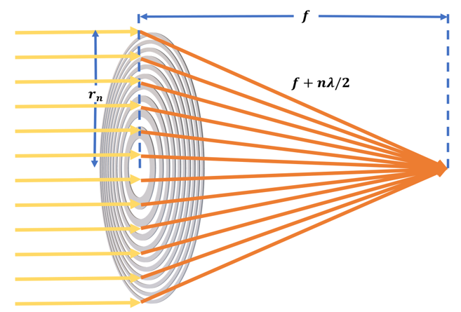
Supplementary Fig. 3. Schematic illustration of light focusing by a second-order FZP.

Supplementary Fig. 4. Simulation of the ESFZP’s modulation effect on the incident light field. a Two-dimensional simulation model of light field modulation by ESFZP. b Simulated electric field distribution of a proportionally scaled-down 100 mm² ESFZP. c, d Light intensity distribution at the solar cell under 0.8 µm wavelength illumination using a glass cover and ESFZP (Figures c and d correspond to solar cells with areas of 25 mm² and 100 mm², respectively). Due to the influence of the ESFZP, significant enhancement of the electric field is observed in the regions from −50-20 µm and from −100-70 µm. e Enhancement in light intensity across different wavelengths on the surface of the solar cell.

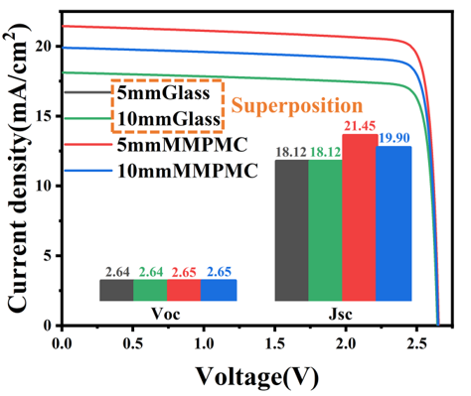
Supplementary Fig. 5. Simulated J-V curves of GaAs solar cells with MMPMC and glass cover plates, with areas of 25 mm² and 100 mm².The inset shows the open-circuit voltage and short-circuit current density for GaAs cells with different covers.

Supplementary Fig. 6. a J–V characteristics of the edge-surrounding Fresnel zone plate photovoltaic module (ESFZPPVM). The inset illustrates the efficiency enhancement mechanism of the ESFZPPVM. b J-V characteristics of the aluminum-reflector photovoltaic module (ARPVM). The inset illustrates the efficiency enhancement mechanism through reflection in the ARPVM.

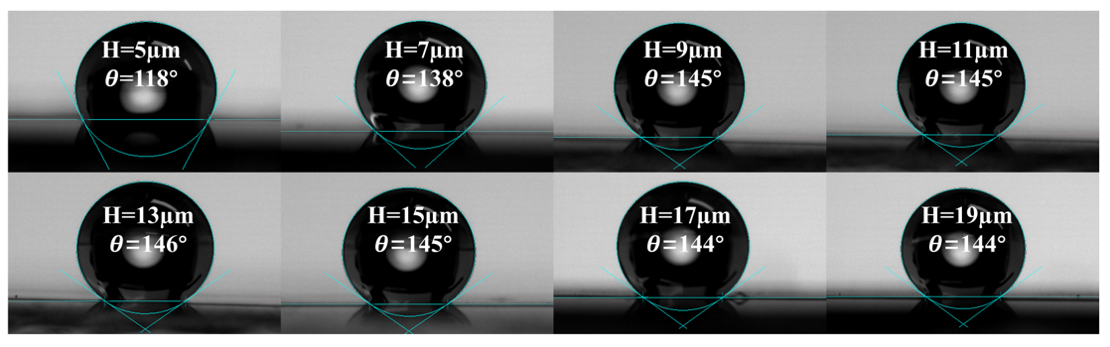
Supplementary Fig. 7. Contact angle photograph of a hollow cylindrical array with a radius of 12 µm, aperture of 6 µm, and height ranging from 5-19 µm.

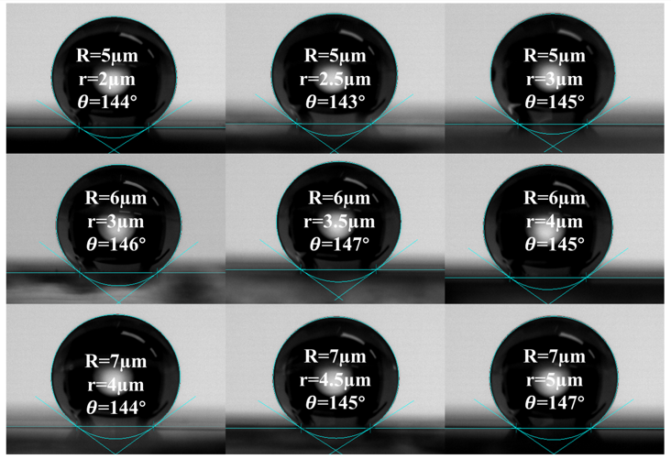
Supplementary Fig. 8. Contact angle photograph of a hollow cylindrical array with a height of 13 µm and varying radius (R) and apertures (r).

6
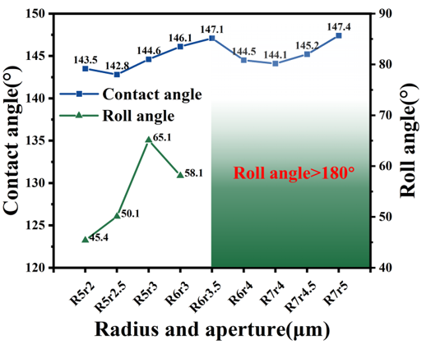
Supplementary Fig. 9. Contact angle and rolling angle of a hollow cylindrical array with a height of 13 µm and varying radius (R) and aperture (r). As the outer and inner radii increase, the rolling angle of the hollow cylindrical array increases. When the aperture reaches a certain size, the droplet adopts a Wenzel state of contact with the surface, at which point the droplet adheres firmly to the surface.

Supplementary Fig. 10. Contact angle photographs of arrays composed of alternating tall (H = 15 μm) and short (h = 10 μm) hollow cylindrical structures with varying radius (R) and apertures (r).

Supplementary Fig. 11. Optical properties of an ideal solar cell cover. Here, $τ$ represents transmittance and $ε$ represents emissivity. As a photovoltaic device, the solar cell aims to allow as much sunlight across various wavelengths as possible to enter the cell⁹⁻¹¹. At the same time, considering that high operating temperatures can reduce the efficiency of the cell, it is desirable for the solar cell cover to have a high emissivity for mid- to far-infrared wavelengths¹²⁻¹⁴.

Supplementary Fig. 12. a AM1.5G global standard spectrum. b Atmospheric transmittance in the mid- to far-infrared wavelength range.

Supplementary Fig. 13. Optical properties of epoxy resin glass cover plate (EGCP). a Optical properties of EGCP ($γ_{EGCP}$ is the reflectance, $τ_{EGCP}$ is the transmittance, and $ε_{EGCP}$ is the emissivity of EGCP). b Cross-sectional SEM image of EGCP. The transmittance and reflectance of EGCP in the visible range are nearly identical to those of the glass cover plate, indicating that the epoxy resin absorbs almost no light in the visible spectrum. Additionally, the inclusion of epoxy resin effectively fills the emissivity dip of the glass cover plate for light in the wavelength range of 8-13 μm.

Supplementary Fig. 14. Optical properties of MMPMC in the visible wavelength range. a Optical constants of epoxy resin in the visible wavelength range. b Simulation model and schematic of light propagation in MMPMC under total internal reflection conditions. c Simulation and experimental results of MMPMC under total internal reflection conditions. d Simulation model and schematic of light propagation in MMPMC without total internal reflection.

Supplementary Fig. 15. Optical properties and optical constants of epoxy resin at wavelengths of 8-13 μm. a Optical properties of epoxy resin with a ZnSe substrate at wavelengths of 8-13 μm (reflectance $γ$, transmittance $τ$, and absorption $ε$). b Optical constants of epoxy resin at 8-13 μm. Based on the optical properties of epoxy resin, the optical constants were calculated using the commercial software FilmWizard.

Supplementary Fig. 16. Simulation of the emissivity of MMPMC and glass cover plate for light at wavelengths of 8-13 μm under different incident angles. a FDTD Solutions simulation diagram. b Emissivity of MMPMC and glass cover plate at 8-13 μm under normal incidence. c Emissivity of the glass cover plate for TE-polarized light at wavelengths of 8-13 μm under incident angles of 10-70°. d Emissivity of the glass cover plate for TM-polarized light at wavelengths of 8-13 μm under incident angles of 10-70°. As the incident angle increases, the emissivity of the glass for light in the 8-13 μm range shows a significant decrease. e Emissivity of MMPMC for TE-polarized light at wavelengths of 8-13 μm under incident angles of 10-70°. f Emissivity of MMPMC for TM-polarized light at wavelengths of 8-13 μm under incident angles of 10°-70°. Compared to glass, the increase in the incident angle has a smaller effect on MMPMC. This is because epoxy resin itself is an excellent radiative material, and the addition of PHHCA effectively enhances the panel's ability to capture light in the 8-13 μm wavelength range, especially for obliquely incident light, where the improvement is more pronounced.

Supplementary Fig. 17. Radiative cooling power of MMPMC under high atmospheric relative humidity. a Comparison of atmospheric transmittance under high and normal relative humidity. Atmospheric transmittance data for the 4-25 μm wavelength range were generated using the MODTRAN simulation software. b Net cooling power of MMPMC at high relative humidity for different non-radiative heat coefficients (q). Under high relative humidity and ambient temperature, the radiative cooling power of MMPMC is 70 W/m². In the ideal case where non-radiative heat is zero, the MMPMC panel can theoretically cool by more than 15°C, and even with a non-radiative heat coefficient of q = 8 W/m²K, it can still achieve a cooling of approximately 6°C.

Supplementary Fig. 18. Schematic diagram of the radiative cooling test system.

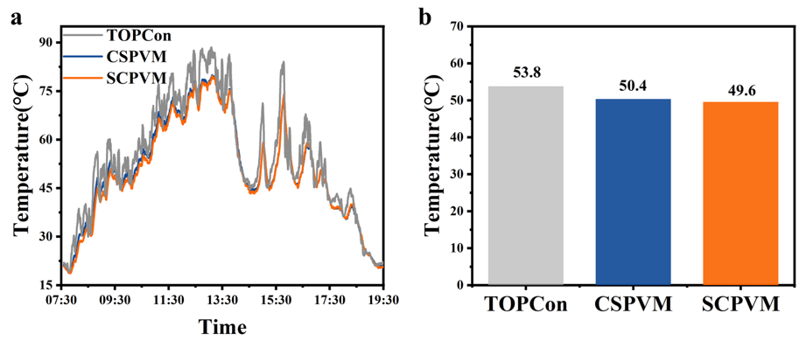
Supplementary Fig. 19. a Diurnal temperature variations of the TOPCon cell, CSPVM, and SCPVM under cloudy weather. b 12-hour average temperature of the TOPCon cell, CSPVM, and SCPVM under cloudy weather. Under cloudy weather, the temperatures of the CSPVM and SCPVM were reduced by 3.4°C and 4.2°C, respectively, compared to the TOPCon cell.

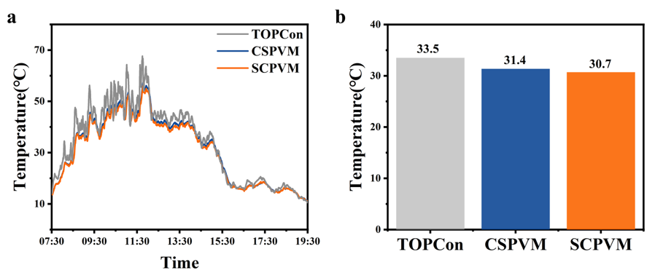
Supplementary Fig. 20. a Diurnal temperature variations of the TOPCon cell, CSPVM, and SCPVM under overcast weather. b 12-hour average temperature of the TOPCon cell, CSPVM, and SCPVM under overcast weather. Under overcast weather, the temperatures of the CSPVM and SCPVM were reduced by 2.1°C and 2.8°C, respectively, compared to the TOPCon cell.

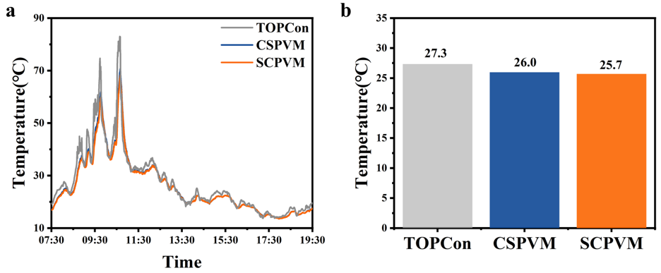
Supplementary Fig. 21. a Diurnal temperature variations of the TOPCon cell, CSPVM, and SCPVM under rainy weather. b 12-hour average temperature of the TOPCon cell, CSPVM, and SCPVM under rainy weather. Under rainy weather, the temperatures of the CSPVM and SCPVM were reduced by 1.3°C and 1.6°C, respectively, compared to the TOPCon cell.

Supplementary Table 1: Parameters of the GaAs solar cell from simulated calculations and experimental tests.
Symbol/Unit | Simulating calculation |  |  |  | Experimental measurement
Symbol/Unit | Glass cover  solar cells |  | MMPMC  solar cells |  | Glass cover  solar cells |  | MMPMC  solar cells
Size(mm²) | 25 | 100 | 25 | 100 | 25 | 100 | 25 | 100
V_{oc}(V) | 2.64 | 2.64 | 2.65 | 2.65 | 2.60 | 2.60 | 2.65 | 2.61
J_{sc}(mA/cm²) | 18.12 | 18.12 | 21.45 | 19.90 | 11.99 | 12.12 | 14.14 | 13.43
P_{density}(mW/ cm²) | 41.44 | 41.44 | 49.15 | 45.57 | 26.52 | 26.36 | 31.36 | 29.08
FF(%) | 86.62 | 86.62 | 86.47 | 86.41 | 85.07 | 83.65 | 83.69 | 82.96

Supplementary references
1. Zeng, S.J. et al. Ultraviolet photonconversion enhancement in crystalline Si solar cells via nanocrystalline ZnO. Opt. Mater. 154, 115766 (2024).
2. Wenzel, R.N. Resistance of solid surfaces to wetting by water. Industrial and Engineering Chemistry 28, 988-994 (1936).
3. Cassie, A.B.D. & Baxter, S. Wettability of porous surfaces. Trans. Faraday Soc. 40, 0546-0550 (1944).
4. Xie, C., Shi, J., Luo, Y., Chu, G. & Li, H. Velocity-dependent contact angle and energy dissipations of dynamic wetting nanodroplets on nanopillared surfaces. Langmuir 38, 9822-9832 (2022).
5. Jiang, Y. et al. Role of multi-scale hierarchical structures in regulating wetting state and wetting properties of structured surfaces. J. Bionic Eng. 21, 1347-1359 (2024).
6. He, B., Lee, J. & Patankar, N.A. Contact angle hysteresis on rough hydrophobic surfaces. Colloids Surf., A 248, 101-104 (2004).
7. Guan, C., Lv, X., Han, Z. & Chen, C. The wetting characteristics of aluminum droplets on rough surfaces with molecular dynamics simulations. PCCP 22, 2361-2371 (2020).
8. Miller, S., Ding, Y., Jiang, L., Tu, X. & Pau, S. Observation of elliptically polarized light from total internal reflection in bubbles. Sci. Rep. 10, 8725 (2020).
9. Kant, K. & Pitchumani, R. Fractal textured glass surface for enhanced performance and self-cleaning characteristics of photovoltaic panels. Energy Convers. Manage. 270, 116240 (2022).
10. Liu, S. et al. Multilayer anti-reflective coating with ultra-low refractive index SiO₂ nanopillars for high efficiency multi-junction GaAs solar cells. Sol. Energy Mater. Sol. Cells 266, 112679 (2024).
11. Zhao, C., Gong, X., Lin, X., Zhang, C. & Wang, Y. Regenerated cellulose/polyvinyl alcohol composite films with high transparency and ultrahigh haze for multifunctional light management. Carbohydr. Polym. 321, 121303 (2023).
12. Dai, Q. et al. Highly reliable anti-reflection radiative cooling glass applicable to thermal management of solar cells. Chem. Eng. J. 498, 155768 (2024).
13. Akerboom, E., Veeken, T., Hecker, C., van de Groep, J. & Polman, A. Passive radiative cooling of silicon solar modules with photonic silica microcylinders. ACS Photonics 9, 3831-3840 (2022).
14. Shanker, R. et al. Structurally colored cellulose nanocrystal films as transreflective radiative coolers. ACS Nano 16, 10156-10162 (2022).

