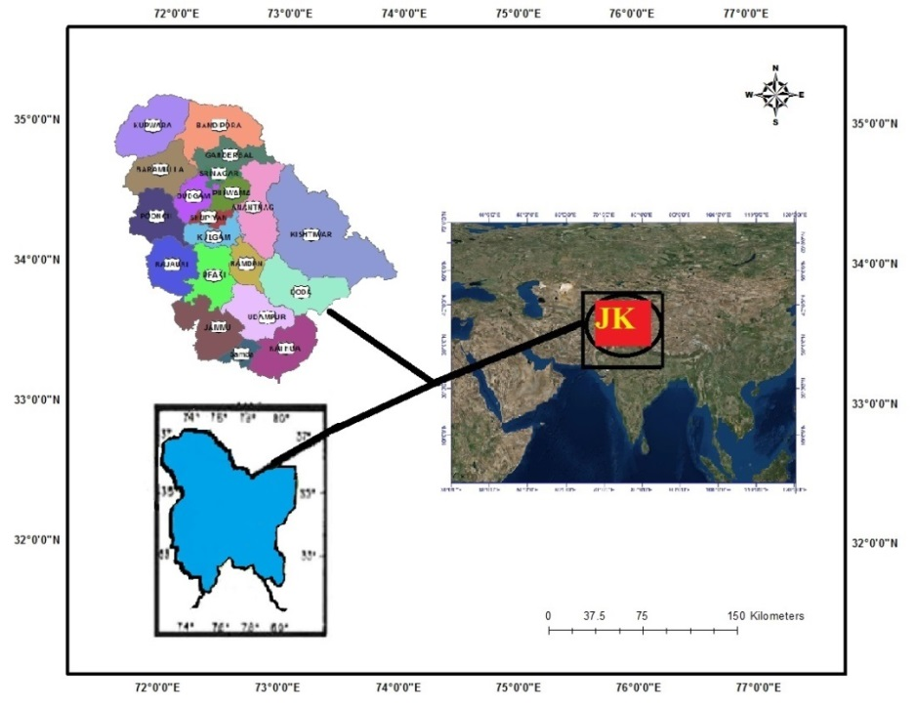
Fig SI: Study area map; Source: Google Earth, JK District boundary
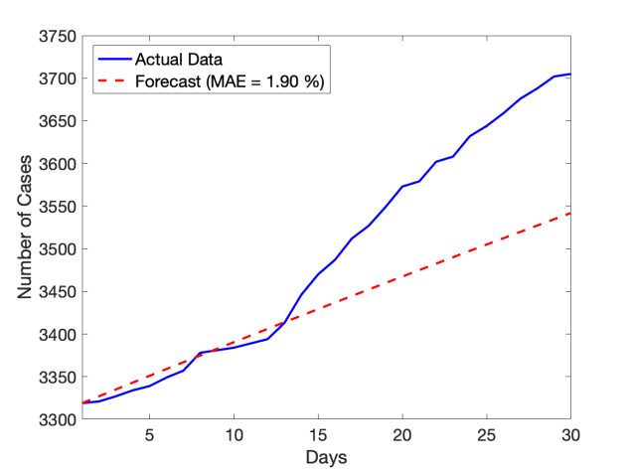
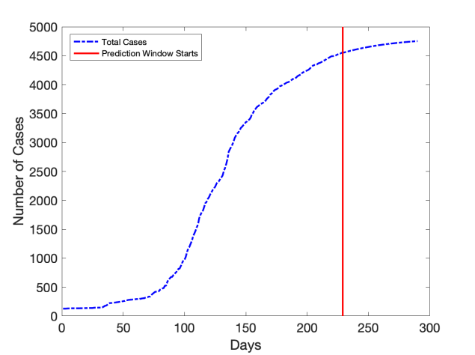
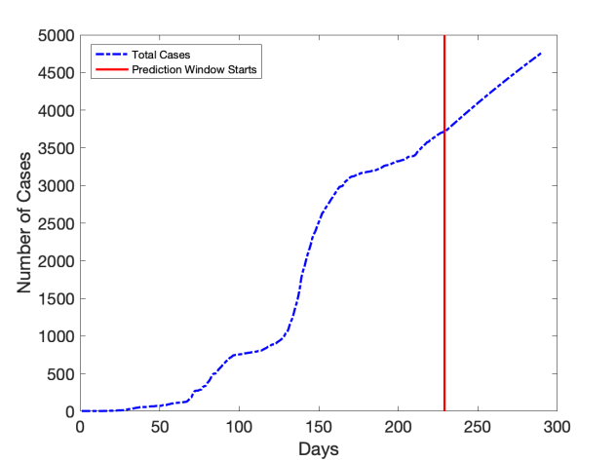
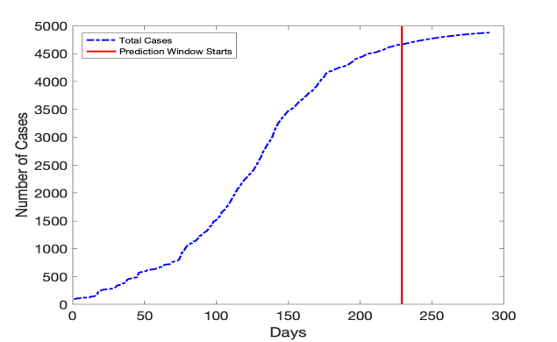
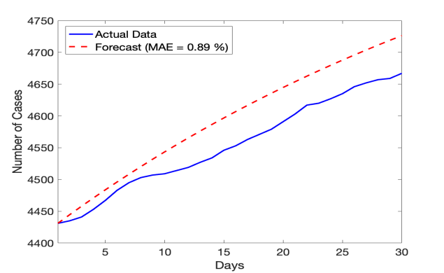
Fig SII: Prediction & data validation of COVID-19 cases in district Rajouri
Fig SIII: Prediction & data validation of COVID-19 cases in district Anantnag

Fig SIV: Prediction & data validation of COVID-1 9 cases in district Bandipora
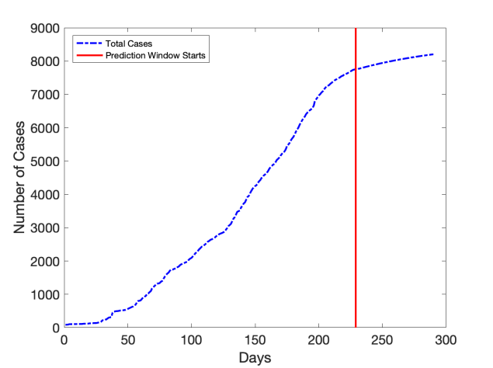
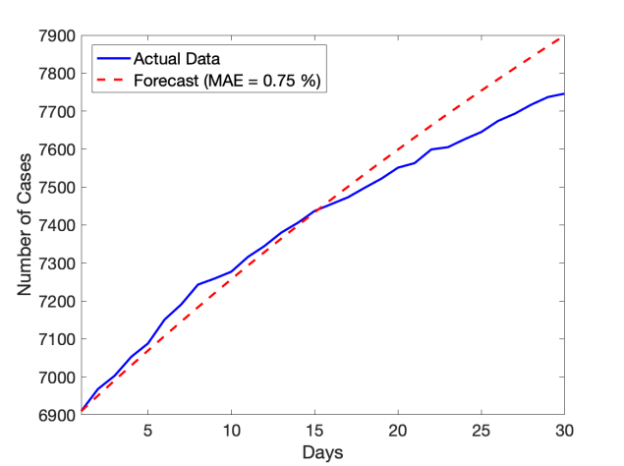
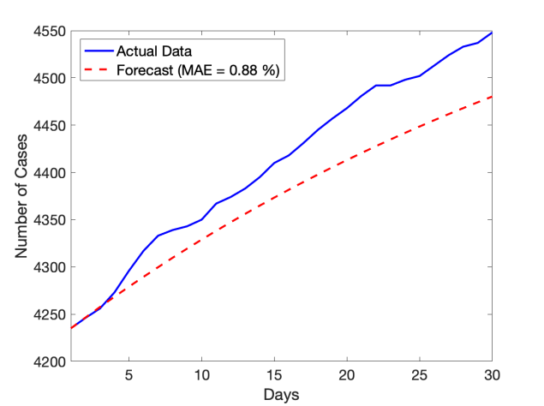
Fig SV: Prediction & data validation of COVID-1 9 cases in district Baramulla

\

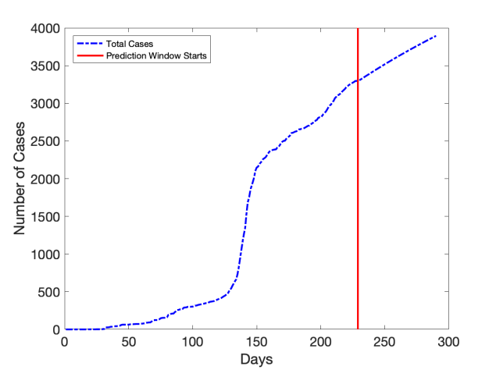
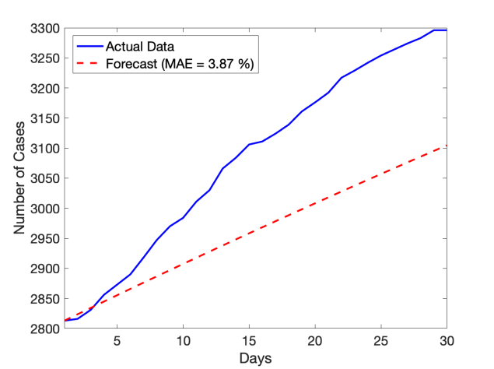
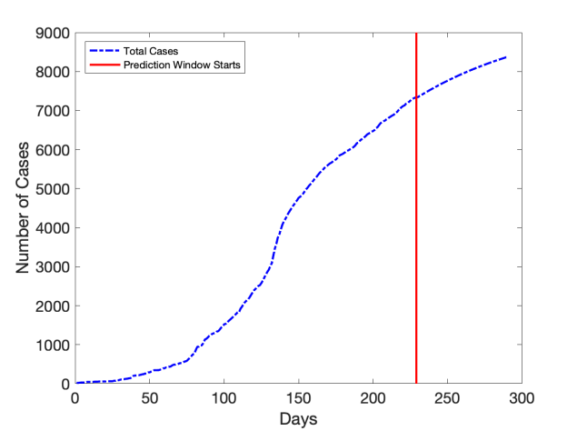
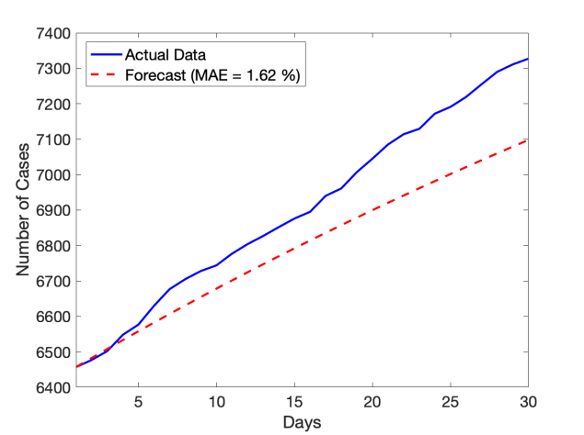
Fig SVI: Prediction & data validation of COVID-1 9 cases in district Budgam
Fig SVII: Prediction & data validation of COVID-1 9 cases in district Doda

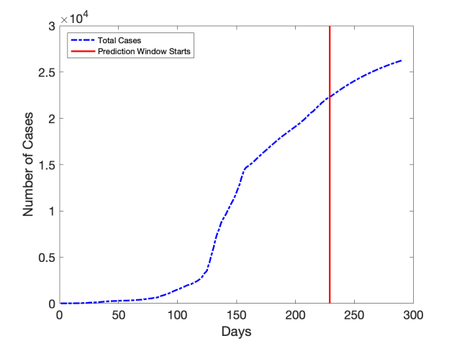
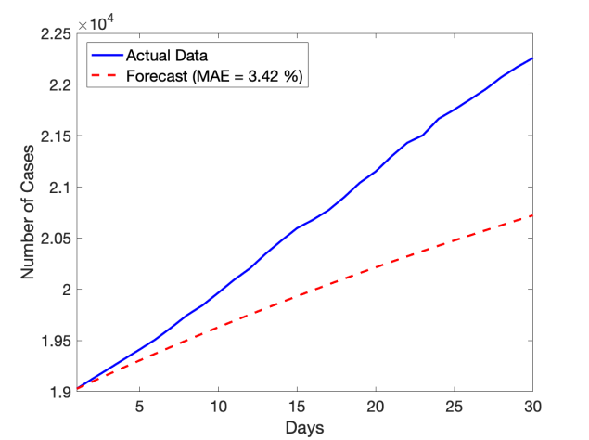
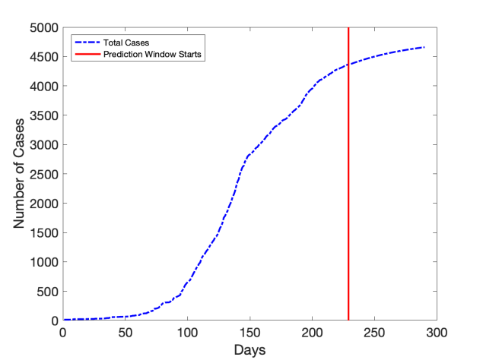
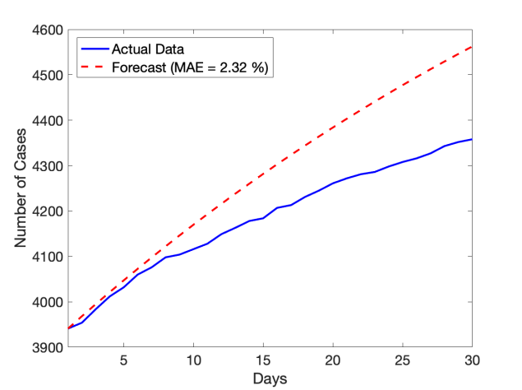
Fig SVIII: Prediction & data validation of COVID-1 9 cases in district Ganderbal
Fig SIX: Prediction & data validation of COVID-1 9 cases in district Jammu

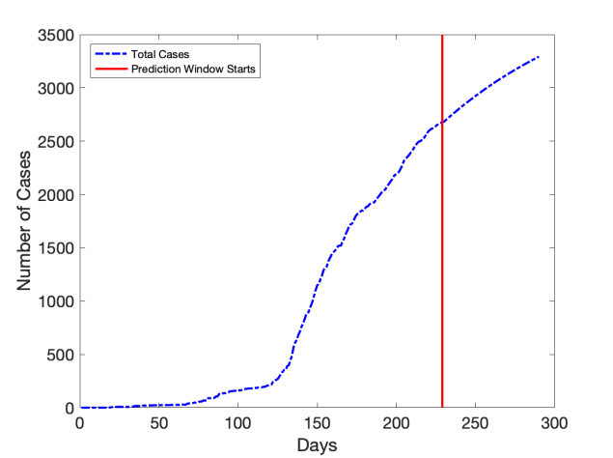
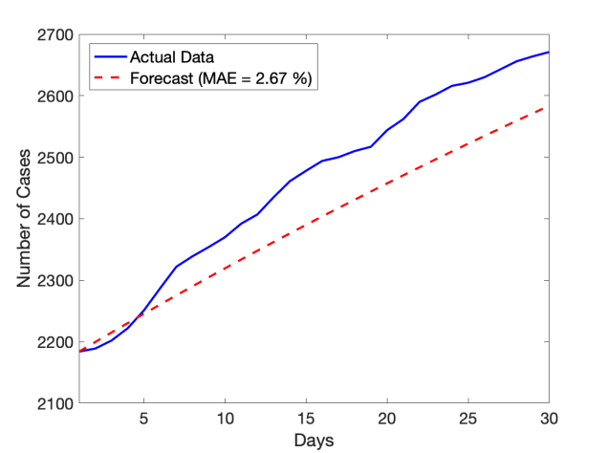
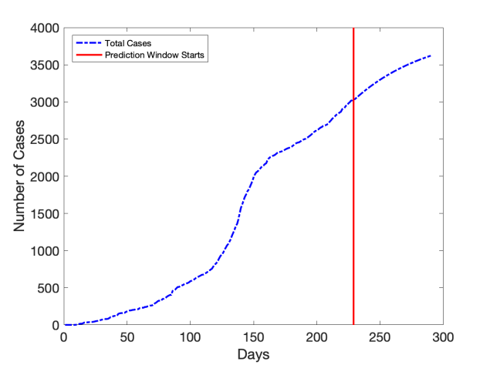
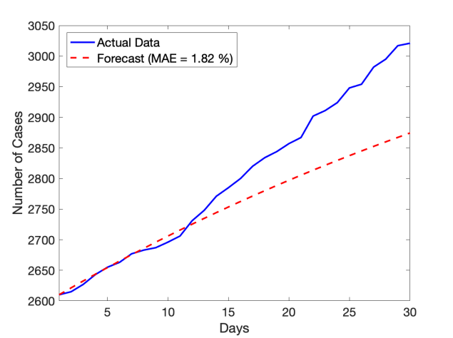
Fig SX: Prediction & data validation of COVID-1 9 cases in district Kathua
Fig SXI: Prediction & data validation of COVID-1 9 cases in district Kishtwar

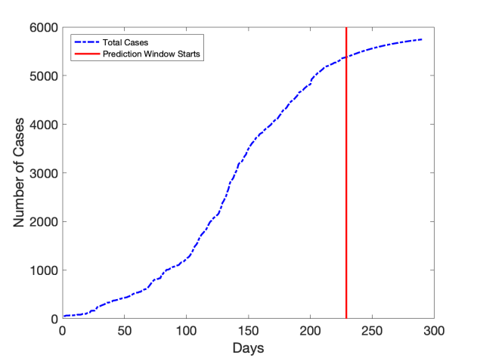
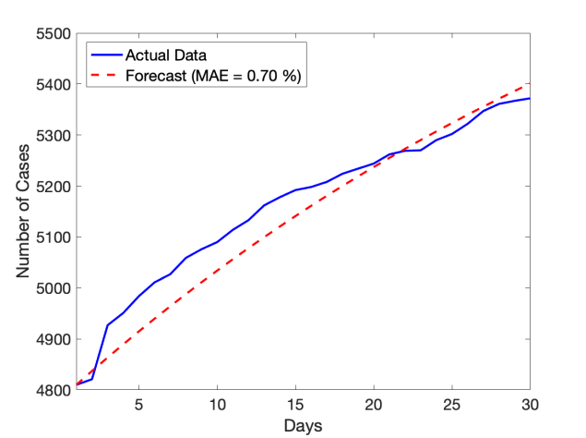
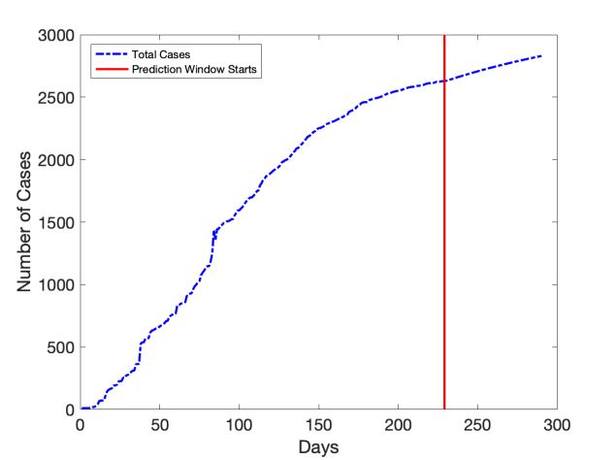
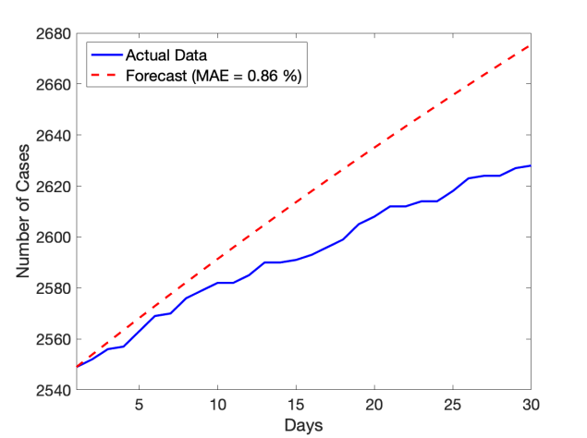
Fig SXII: Prediction & data validation of COVID-1 9 cases in district Kulgam
Fig SXIII: Prediction & data validation of COVID-1 9 cases in district Kupwara

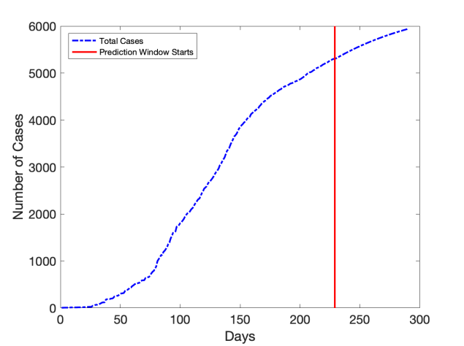
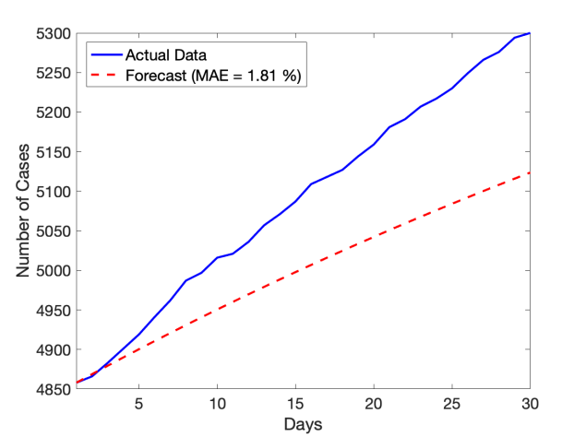
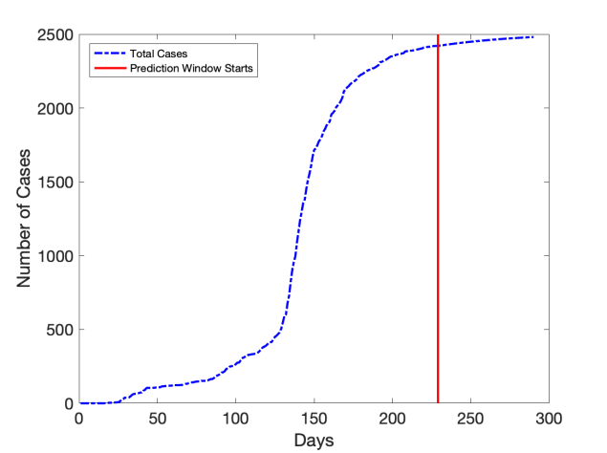
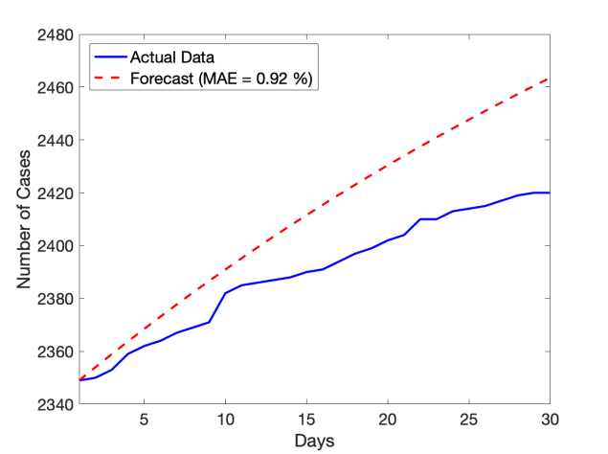
Fig SXIV: Prediction & data validation of COVID-1 9 cases in district Poonch
Fig SXV: Prediction & data validation of COVID-1 9 cases in district Pulwama

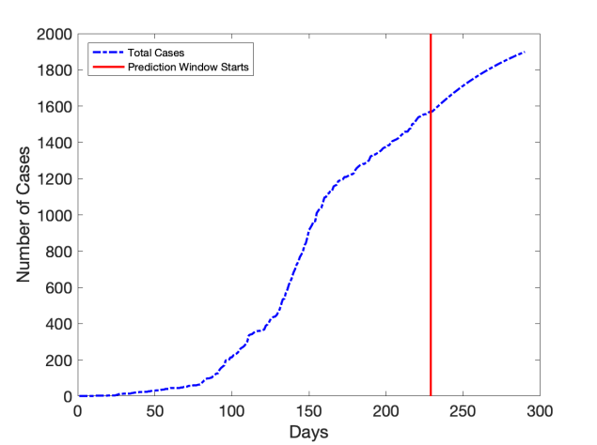
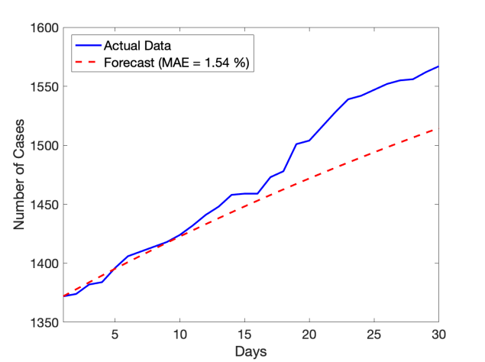
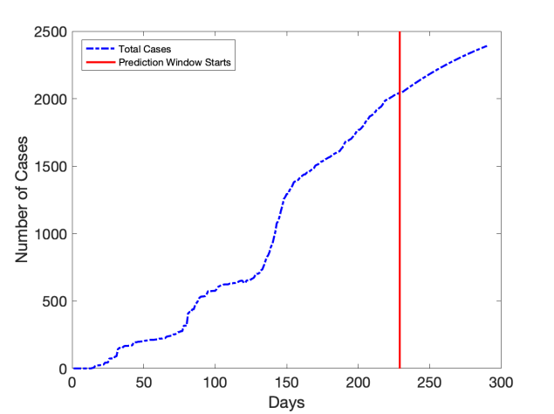
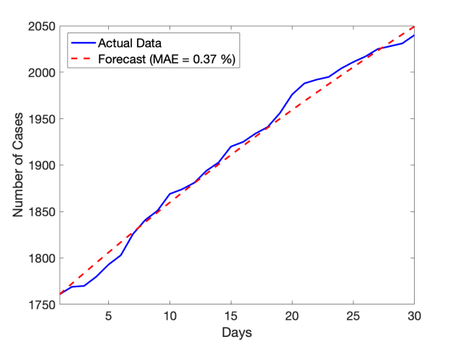
Fig SXVI: Prediction & data validation of COVID-1 9 cases in district Ramban
Fig SXVII: Prediction & data validation of COVID-1 9 cases in district Reasi

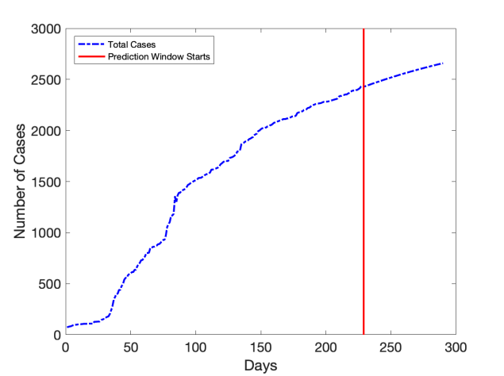
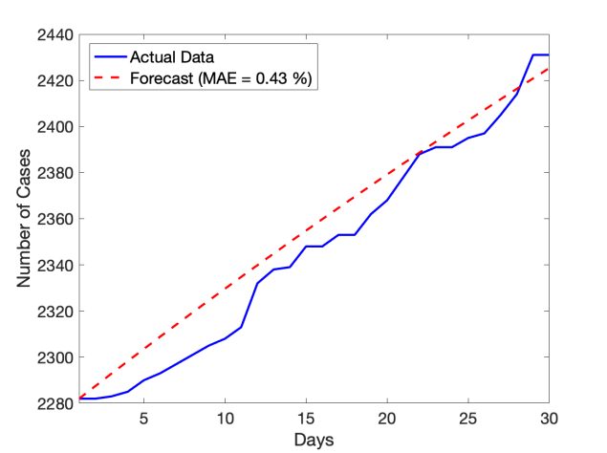
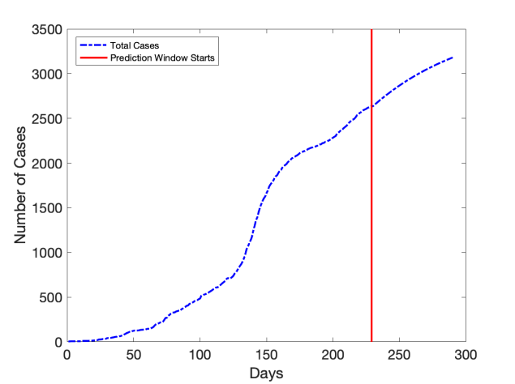
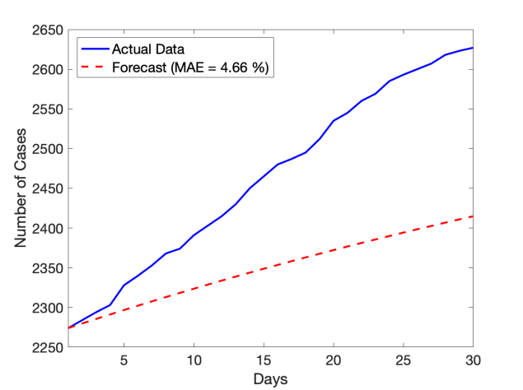
Fig SXVIII: Prediction & data validation of COVID-1 9 cases in district Samba
Fig SXIX: Prediction & data validation of COVID-1 9 cases in district Shopian

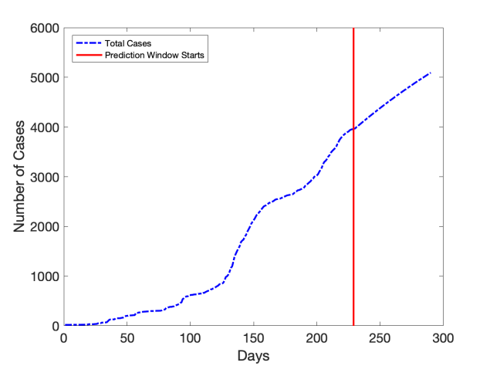
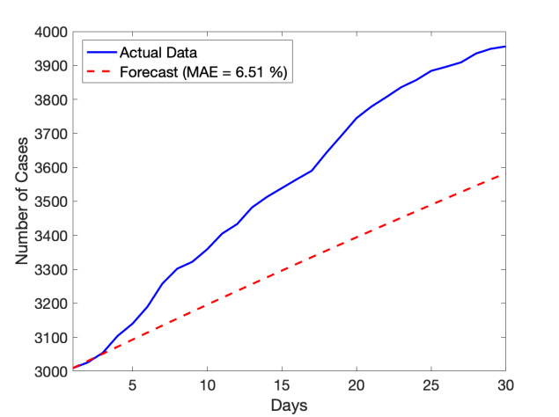
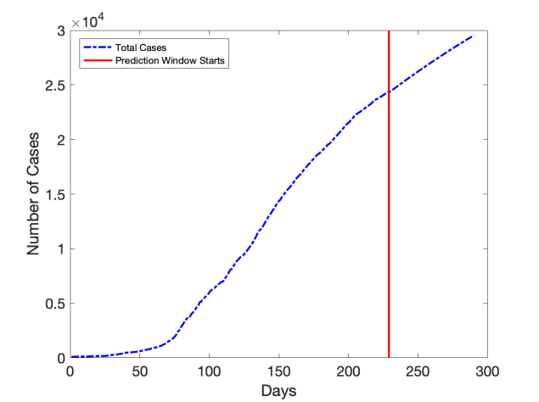
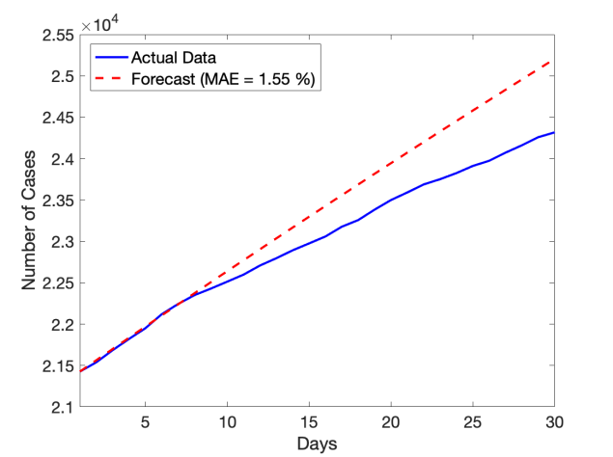
Fig SXX: Prediction & data validation of COVID-1 9 cases in district Srinagar
Fig SXXI: Prediction & data validation of COVID-1 9 cases in district Udhampur

Table SI: Socio-economic profile of Jammu & Kashmir
Districts | Population (lacs) | Sex ratio | Decadal growth rate (%age) | Population Density/Km2 | Urban population (%age) | Literacy rate (%age) | Female literacy (%age)
Anantnag | 10.7 | 927 | 38.5 | 302 | 26.2 | 62.6 | 52.1
Badgam | 7.5 | 894 | 24.1 | 554 | 12.9 | 56 | 44.8
Bandipora | 3.9 | 889 | 28.6 | 1137 | 16.6 | 56.2 | 44.3
Baramulla | 10.08 | 885 | 19.4 | 238 | 18.1 | 64.6 | 52.3
Doda | 4.09 | 919 | 28 | 46 | 7.9 | 64.6 | 49.6
Ganderbal | 2.9 | 874 | 36.5 | 1148 | 15.8 | 58 | 45.7
Jammu | 15.2 | 879 | 12.7 | 653 | 50 | 83.4 | 77.1
Kathua | 6.1 | 890 | 20.5 | 246 | 14.5 | 73 | 63.7
Kishtwar | 2.3 | 920 | 20.8 | 140 | 6.4 | 56.2 | 42.3
Kulgam | 4.2 | 951 | 7.7 | 1051 | 18.9 | 59.2 | 84.4
Kupwara | 8.7 | 835 | 33.8 | 366 | 12 | 64.5 | 50.9
Poonch | 4.7 | 893 | 27.9 | 1674 | 8.1 | 66.7 | 53.1
Pulwama | 5.6 | 912 | 27 | 516 | 14.3 | 63.4 | 51.8
Rajouri | 6.4 | 860 | 32.9 | 244 | 8.1 | 68.1 | 56.5
Ramban | 2.8 | 902 | 31.9 | 213 | 4.1 | 54.2 | 38.08
Reasi | 3.1 | 890 | 27 | 183 | 8.5 | 58.1 | 46.5
Samba | 3.1 | 886 | 17 | 353 | 16.8 | 81.4 | 73.6
Shupiyan | 2.6 | 951 | 25.9 | 853 | 6.1 | 60.7 | 50.9
Srinagar | 12.3 | 900 | 20.3 | 625 | 98.6 | 69.4 | 61.8
Udhampur | 6.4 | 696 | 19.5 | 210 | 6.4 | 87.9 | 57.1
Total | 122.7 | 889 | 29.5 | 289 | 26.3 | 67.5 | 48.25
Source: JK census -2011, JK Statistical Digest 2015-16

Table SII: COVID-19 health care infrastrure in Jammu & Kashmir
District Name | Active cases | Total Isolation beds (excluding ICU Beds)-Patients Ratio | Isolation beds –confirmed cases Ratio | Isolation beds for suspected cases | Patient-O2 Supported beds Ratio | Patient- ICU beds ratio | Patient-ventilators Ratio
Anantnag | 2332 | 1:3 | 1:3 | 50 | 1:18 | 1:194 | 1:333
Bandipora | 2180 | 1:2 | 1:10 | 680 | 1:22 | 0 | 0
Baramulla | 2826 | 1:2 | 1:2 | 0 | 1:28 | 1:202 | 1:257
Budgam | 2507 | 1:3 | 1:3 | 0 | 1:36 | 0 | 1:501
Doda | 424 | 1:1 | 1:1 | 0 | 1:9 | 1:30 | 1:35
Ganderbal | 1433 | 1:2 | 1:5 | 545 | 1:20 | 1:143 | 1:478
Jammu | 3288 | 1:3 | 1:5 | 550 | 1:14 | 1:183 | 1:411
Kathua | 904 | 1:1 | 1:2 | 332 | 1:45 | 1:181 | 1:90
Kishtwar | 250 | 1:1 | 0 | 740 | 1:3 | 0 | 0
Kulgam | 1925 | 1:2 | 1:2 | 0 | 1:32 | 1:193 | 1:962
Kupwara | 2094 | 1:2 | 1:2 | 0 | 1:42 | 1:209 | 1:698
Poonch | 416 | 1:1 | 1:1 | 50 | 1:12 | 1:104 | 0
Pulwama | 2643 | 1:3 | 1:3 | 0 | 1:26 | 1:264 | 1:1322
Rajouri | 901 | 1:1 | 1:1 | 440 | 1:45 | 1:90 | 1:90
Ramban | 654 | 1:1 | 1:1 | 0 | 1:33 | 1:327 | 1:164
Reasi | 395 | 1:1 | 1:1 | 0 | 1:26 | 0 | 0
Samba | 712 | 1:1 | 1:1 | 6 | 1:119 | 0 | 1:712
Shopian | 1704 | 1:2 | 1:4 | 306 | 1:17 | 1:426 | 1:568
Srinagar | 9273 | 1:6 | 1:6 | 0 | 1:87 | 1:773 | 1:1546
Udhampur | 837 | 1:1 | 1:1 | 0 | 200 (4) | 1:105 | 1:140
Total | 37698 | 1:2 | 1:3 | 3699 | 1:25 | 1:264 | 1:405
Source: Department of information and public relations, Govt. of Jammu Kashmir (DIPR)

