Supporting information
Engineering Cu/Cu⁺ interfaces to boost C–N coulping for urea electrosynthesis: from fundamental insights to efficient catalysis

Yinchao Yao^{1#}, Jiakang Yao^{2#}, Zezhou Li^{3#}, Zhiwei Zhao¹, Cao Wang², Jihan Zhou³, Liang Cao^{2*}, and Zhuo Chen^{1*}
¹Energy & Catalysis Center, Department of Materials Physics and Chemistry, School of Materials Science and Engineering, Beijing Institute of Technology, Beijing 100081, P. R. China
²Department of Chemistry, Zhejiang University, Hangzhou, Zhejiang 310058, P. R. China
³College of Chemistry and Molecular Engineering, Beijing National Laboratory for Molecular Sciences, Peking University, Beijing 100091, P. R. China.

#These authors contributed equally to this work.
*Corresponding authors: liangcao@zju.edu.cn and zchen@bit.edu.cn.

Computational methods
All Density functional theory (DFT)^{1,2} calculations were performed via Vienna Ab-initio Simulation Package (VASP),³ with the projector-augmented plane-wave (PAW)⁴ method to represent the ion-electron interaction. The electron exchange correlation energy was described by using a function of the revised Perdew-Burke-Ernzerhof (RPBE)⁵ at Generalized Gradient Approximation (GGA)⁶ level, and Van der Waals interactions were accounted for by using the DFT-D3 method.⁷ The plane-wave cut-off energy was set to be 434 eV. For geometry optimization, the Brillouin zone was sampled with a 3 × 3 × 1 k-points,⁸ and the convergence criteria for electronic energy and force were 10⁻⁶ eV and 0.03 eV/Å, respectively. Spin polarization was taken into account in the calculations. For metal surface, the Methfessel−Paxton method⁹ of order 2 with a smearing width of 0.2 eV was employed to determine the electron occupancies. For other surfaces, the Gaussian smearing scheme was used with a smearing width of 0.05 eV. The Hubbard U value in the Hamiltonian was set to be 5.2 eV for Cu₂O in order to improve the electronic structure calculations of transition metal compounds, as it removes the self-interaction in the metal d-orbitals, leading to strong charge localization and correction of ground-state structure.^{10,11} The transition states were searched by combining nudged elastic band (CI-NEB)¹² method with the dimer method¹³ and verified that there was only one virtual frequency.
Based on the experimental results (Fig. 3 a-c), two types of surface models, Cu/Cu⁺-co and Cu/Cu⁺-non-co, were established to model Cu/Cu⁺ interface (Figs. 3b, c and Supplementary Fig. 10). The Cu/Cu⁺-co slab was derived from a p(2 × 2) unit cell of Cu₂O(111) slab and half of the oxygen atoms were removed, which was similar to Xiao’s work.¹⁴ The Cu/Cu⁺-non-co slab was obtained by combining a p(5 × 2) unit cell of Cu(111) and a p(2 × 1) unit cell of Cu₂O(111). For interface models, the lattice parameters were the average of those of Cu and Cu₂O, which were determined due to the experimental observation that the lattice parameters of Cu region and Cu⁺ region at the interface had no significant change. For comparison, a p(2 × 2) unit cell of Cu(111) and a (√3 × √3)R30° unit cell of Cu₂O(111) slabs were also constructed. The Cu(111) slab contained 4 atomic layers and the bottom two layers were fixed to the optimized bulk positions to mimic the bulk crystal structure beneath the surface, while other three slabs were consisted of 3 atomic layers and the bottom layer was fixed. The slabs were separated by 20 Å of vacuum to avoid the interaction between layers.
The adsorption energies (Δ𝐸_{𝑎𝑑𝑠}) for adsorbates were calculated as the DFT-calculated energy of the slab after adsorption minus the DFT-calculated energy of the corresponding clean slab, with C atoms referenced to graphene, N atoms referenced to 1/2 N₂, H atoms referenced to 1/2 H₂, and O atoms referenced to (H₂O-H₂). Here is an example for *CONH₂:
$$\begin{aligned}\begin{aligned}{∆E}_{ads}\left({*CONH}_{2}\right)=&E_{DFT}\left({*CONH}_{2}\right)-E_{DFT}\left(*\right)-E\left(graphene\right) \\ &-E\left(N_{2}\right)/2-E\left(H_{2}\right)-\left(E\left(H_{2}O\right)-E\left(H_{2}\right)\right)\end{aligned}\#\left(1\right)\end{aligned}$$
The energies of gas-phase molecules of CO₂ and NO₂ were also calculated according to the above references.
The activation free energy barrier (G_{a}) and reaction free energy (ΔG_{r}) were calculated as following:
$G_{a}={∆G}_{TS}-{∆G}_{IS}$ (2)
${∆G}_{r}={∆G}_{FS}-{∆G}_{IS}$ (3)
where ΔG_{IS}, ΔG_{TS} and ΔG_{FS} are the Gibbs free energies of initial state, transition
state and final state, respectively.
The Gibbs free energies (Δ𝐺) of the adsorbed species were calculated as following:
$∆G={∆E}_{\text{ads}}+∆ZPE-T∆S+∆\int_{T^{'}=0}^{T}{C_{p}dT^{'}}$ (4)
where ΔZPE and ΔS are the differences in zero point energies and entropies between the adsorbed species and the gas phase molecules, respectively (Supplementary tables 6-10), and C_{p} is the heat capacities under constant pressure, which were obtained via computing the vibrational frequencies of the adsorbed species. All corrections of Δ𝐺 were obtained using VASPKIT (v.1.4.0) software.¹⁵ The initial state of free energy diagrams is the free energy of CO₂ (g) and 2NO₂ (g).

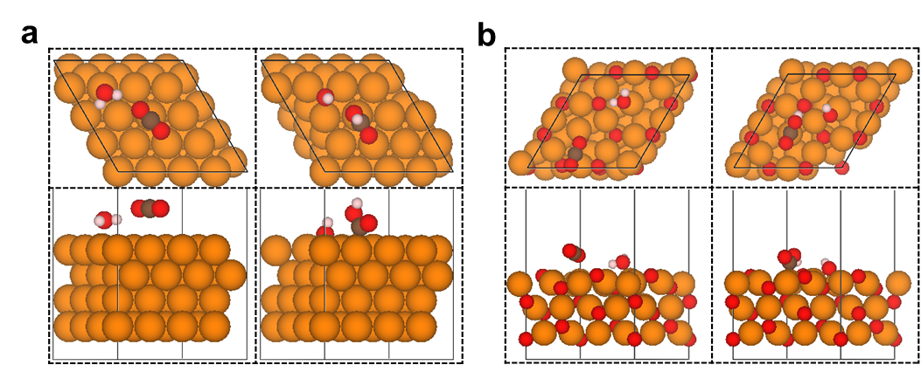Supplementary Figure 1. The top and side view of the optimized structures of the *CO₂ reduction to *COOH on the (a) Cu(111) and (b) Cu₂O(111) slabs. The surface adsorbed species are *CO₂ + *H₂O and *COOH + *OH, respectively. Orange, red, brown, pink spheres indicate copper atoms, oxygen atoms, carbon atoms and hydrogen atoms, respectively.

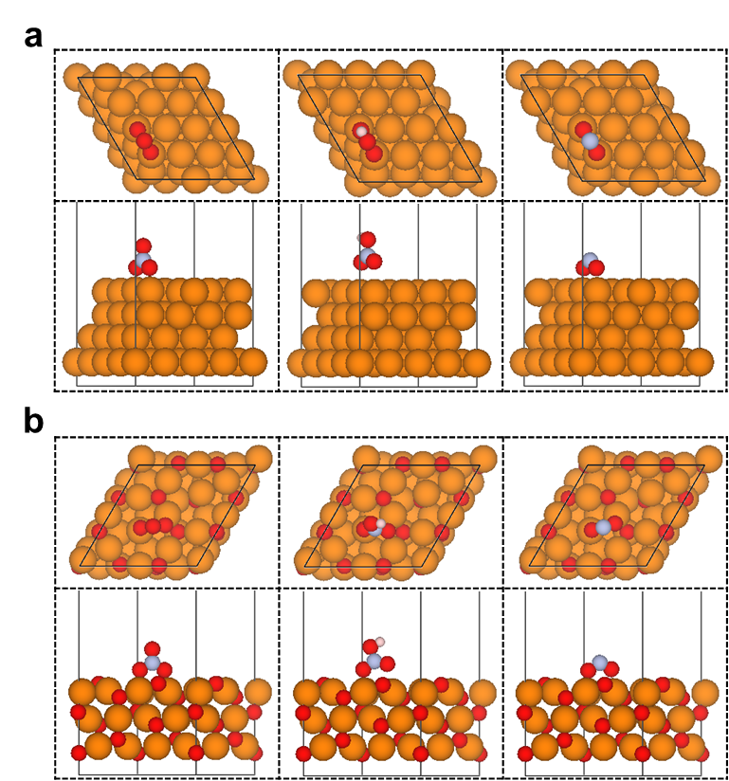
Supplementary Figure 2. The top and side view of the optimized structures of the *NO₃ reduction to *NO₂ on the (a) Cu(111) and (b) Cu₂O(111) slabs. The surface adsorbed species are *NO₃, *HNO₃ and *NO₂, respectively. Orange, red, grey, pink spheres indicate copper atoms, oxygen atoms, nitrogen atoms and hydrogen atoms, respectively.

Supplementary Table 1. The reaction energies (ΔE), reaction free energies (ΔG) of the CO₂ activated to *COOH on Cu₂O(111) and Cu(111) slabs. The initial state contains CO₂ and H₂O, and the final state is the co-adsorption of *COOH and *OH. The unit is eV.
Catalysts | ΔE | ΔG
Cu₂O(111) | 1.57 | 1.60
Cu(111) | 0.89 | 0.92

Supplementary Table 2. The reaction energies (ΔE), reaction free energies (ΔG) of the NO₃ reduction to NO₂ on Cu₂O(111) and Cu(111) slabs. The unit is eV.
Catalysts | *NO₃ + H⁺ + e⁻ → *HNO₃ |  | *HNO₃ + H⁺ + e⁻ → *NO₂ + H₂O
Catalysts | $$∆E$$ | $$∆G$$ | $$∆E$$ | $$∆G$$
Cu₂O(111) | -0.07 | 0.20 | -1.66 | -2.00
Cu(111) | 0.23 | 0.56 | -2.03 | -2.44

Supplementary Figure 3. XRD patterns of Bare Si crystal, Au deposited on Si crystal, Cu or Cu₂O subsequently deposited on Au-coated Si crystal. Depositing Cu or Cu₂O on Au-coated Si crystal was through electrodeposition. The Au-plated Si prism was then used as the working electrode in a custom-made electrochemical cell. A graphite rod and a Ag/AgCl electrode were used as the counter electrode and reference electrodes in all of the electrochemical experiments, respectively. For Cu₂O, the plating solution consisted of 0.4M copper sulfate pentahydrate in 50 mL of Millipore water. To maintain Cu²⁺ stability in the alkaline environment, 3M lactic acid was incorporated, followed by the addition of 3M NaOH until a pH of 12 was achieved. Cu₂O deposition occurred on the substrate over 2.5 hours at room temperature using a constant current density of −0.1 mAcm⁻² in a three-electrode setup. Post-deposition, samples underwent gentle rinsing with water and subsequent nitrogen drying. Copper electroplating was done via chronopotentiometry at 1.13 mA for 320 s in a 5 mM CuSO₄·5H₂O (≥99.9%,), 50 mM H₂SO₄ electrolyte.

Supplementary Figure 4. In-situ ATR-SEIRS of Cu and Cu₂O.

Supplementary Figure 5. Characterization results of CuO nanowires. (a-b) SEM images of CuO and (c) XRD results (d) Cu 2p spectrum and (e) O1s spectrum of CuO.

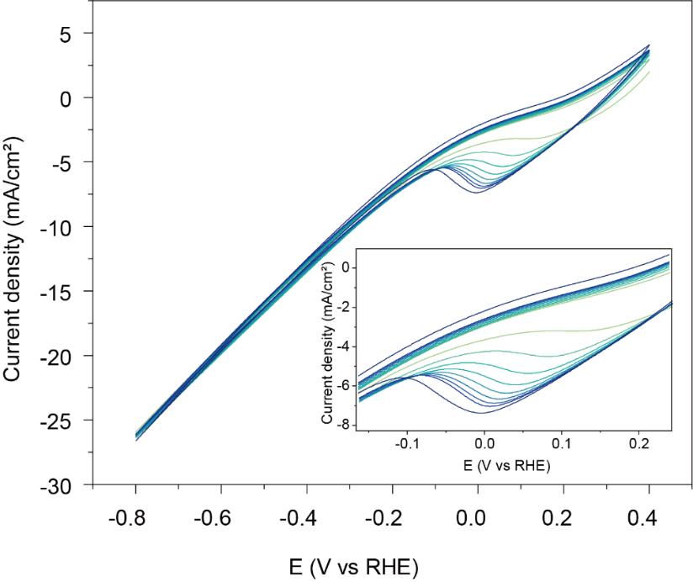
Supplementary Figure 6. Activation CV scanning curve of CuO nanowires.

Supplementary note: Based on thermodynamic equilibrium potentials (Cu²⁺/Cu⁺ = 0.64 V vs. RHE, Cu/Cu⁺ = 0.45 V vs. RHE, and CO₂ + NO₃⁻ + 3H₂O → CO₂ (NH₂)₂ + 4O₂ + 2OH⁻, E⁰ = 0.51 V vs. RHE), three key processes occur simultaneously during activation: (i) reduction of CO₂ and NO₃⁻, (ii) reduction of CuO and Cu₂O to Cu, and (iii) re-oxidation of Cu to Cu₂O. The CV profiles of CuO-NW revealed a positive oxidation current above 0.25 V, indicating the oxidation of Cu to Cu₂O. A pronounced reduction peak near 0 V was also observed, corresponding to the reduction of Cu₂O to Cu. These results suggest that during CV activation, the CuO-NW surface undergoes dynamic redox cycling between Cu and Cu₂O. By tuning the activation duration, the density of Cu/Cu⁺ interfaces could theoretically be modulated.

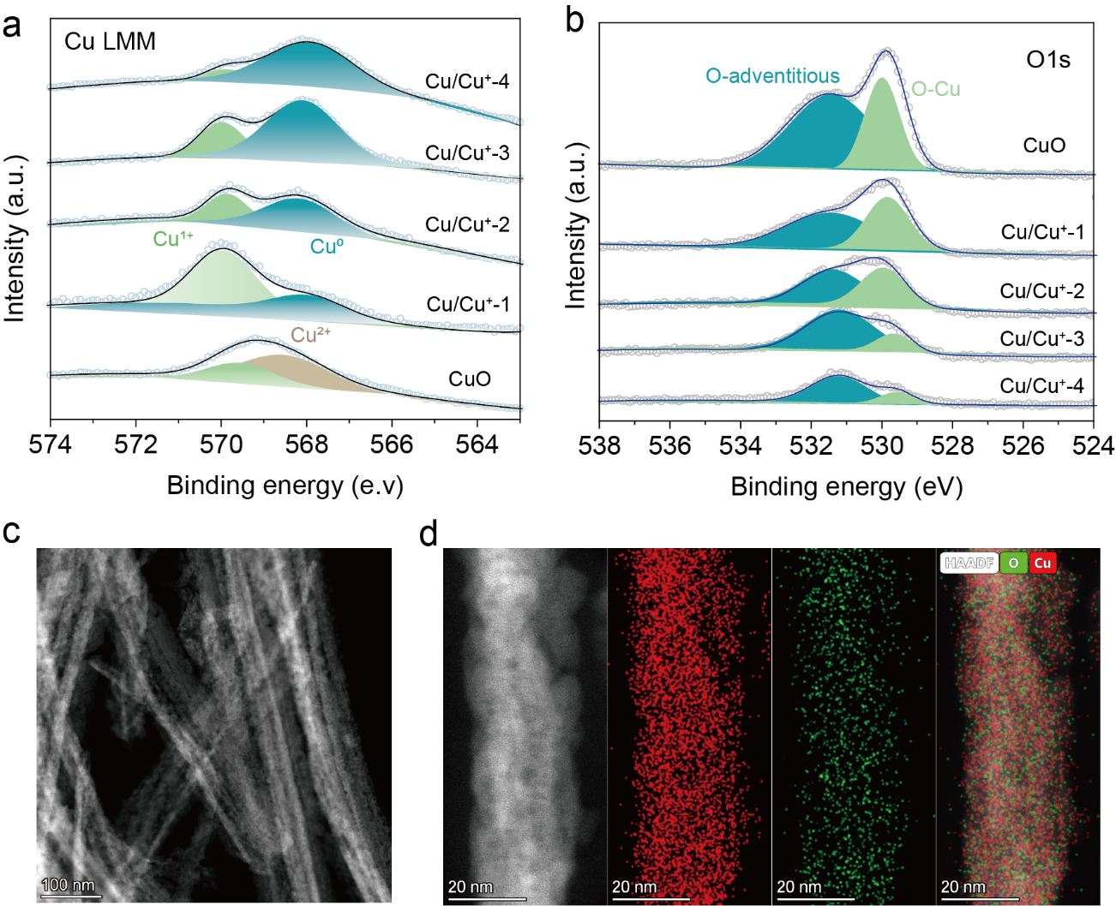Supplementary Figure 7. Characterization results of Cu/Cu⁺ and CuO catalysts. (a) Cu LMM Auger spectrum; (b) O 1s spectrum; (c) HAADF-STEM image and EDS mapping results of Cu/Cu⁺-2, where red represents Cu and green represents O.
Supplementary Figure 8. Cu LMM Auger spectrum of Cu/Cu⁺-IT. We prepared a Cu/Cu⁺-IT sample by potentiostatic reduction at -0.8 V vs RHE for 30 minutes in a 0.1 M KHCO₃ - 0.1 M KNO₃ solution.
Supplementary Figure 9. XRD pattern of Cu₂O nanowire, Cu nanowire and Cu/Cu⁺-IT nanowire. As a control experiment, we synthesized Cu₂O and Cu nanowires by annealing Cu(OH)₂ nanowire precursors in N₂ and Ar/H₂ atmospheres, respectively.

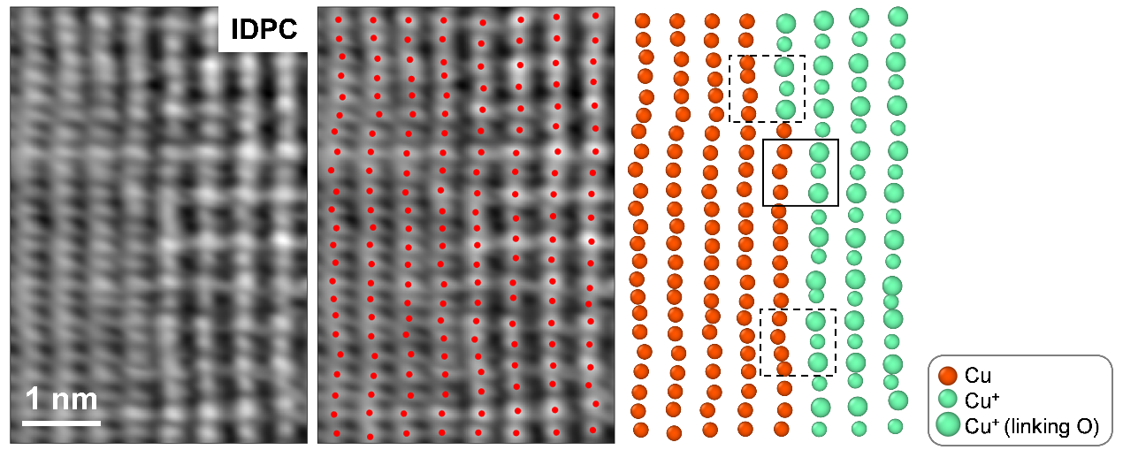
Supplementary Figure10. AC-TEM images of Cu/Cu⁺-2.

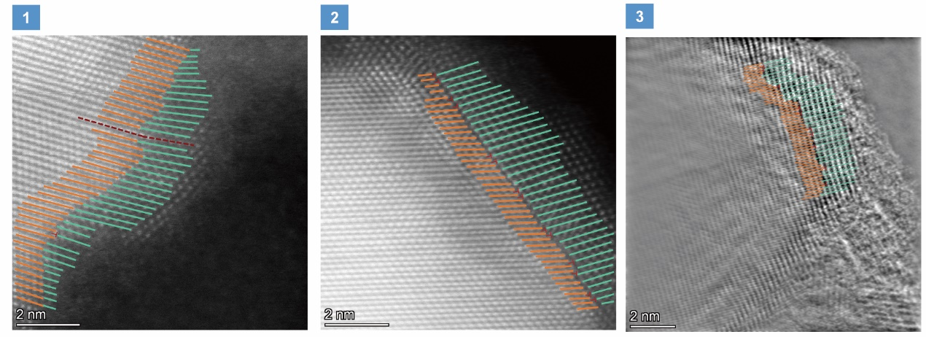
Supplementary Figure 11. AC-TEM images of Cu/Cu⁺-2.

Supplementary Table 3. The distribution of co-lattice and non-co-lattice on Cu/Cu⁺-2 catalyst.
area | co-lattice | non-co-lattice | Ratio of co-lattice (%)
1 | 40 | 1 | 97.6%
2 | 23 | 14 | 62.2%
3 | 39 | 10 | 79.6%

HRTEM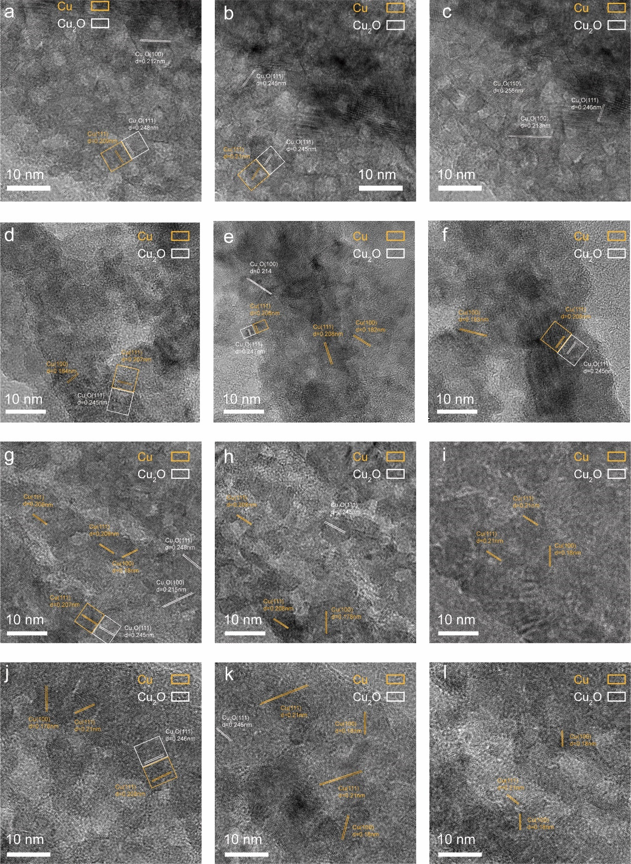
Supplementary Figure 12. High resolution transmission electron microscope (HRTEM) results of Cu/Cu⁺ catalysts. (a-c) HRTEM images of Cu/Cu⁺-1, (d-f) HRTEM images of Cu/Cu⁺-2, (g-i) HRTEM images of Cu/Cu⁺-3, (j-l) HRTEM images of Cu/Cu⁺-4.

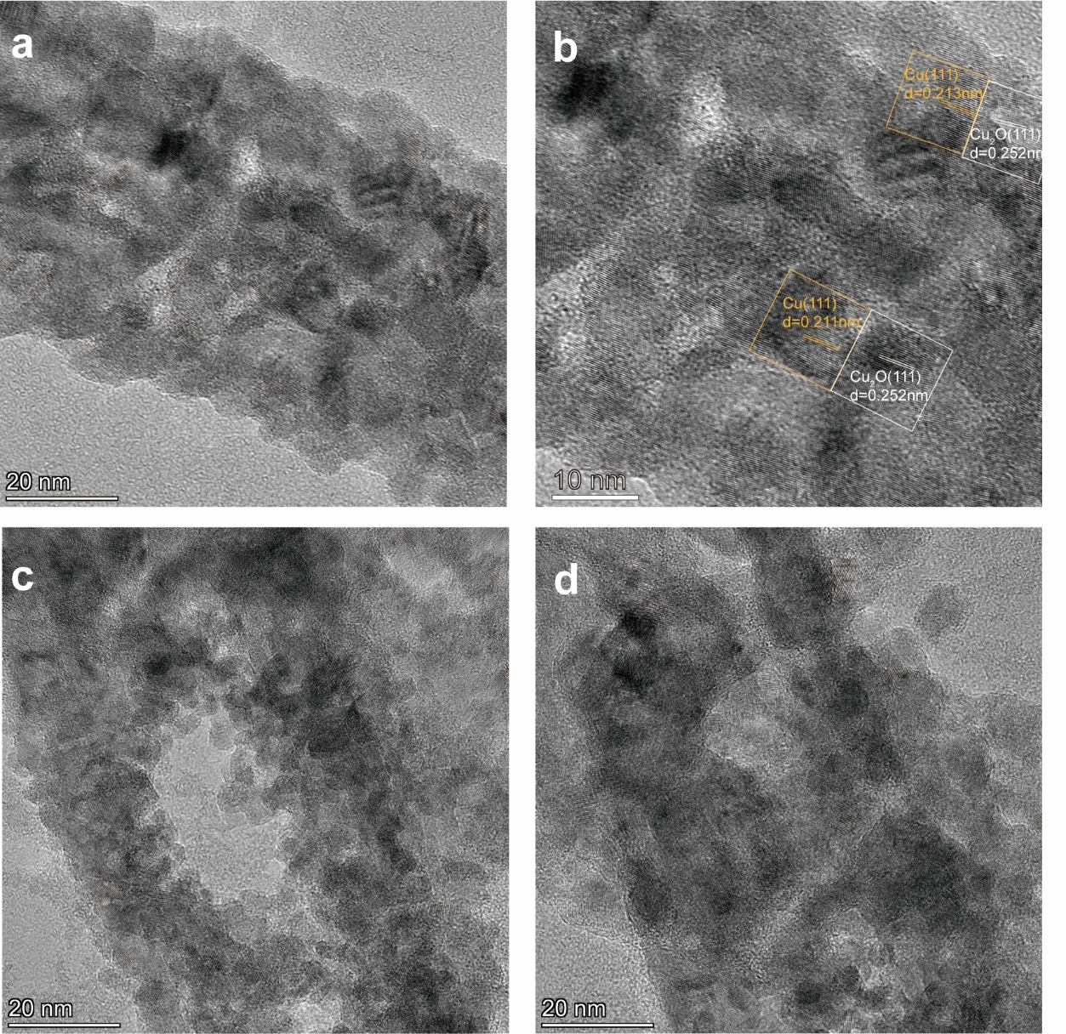
Supplementary Figure13. (a-b) HRTEM images of Cu/Cu⁺-IT, (c-d) HRTEM images of Cu/Cu⁺-2.
Supplementary Figure14. Cdl and CV results of Cu/Cu⁺ catalysts.

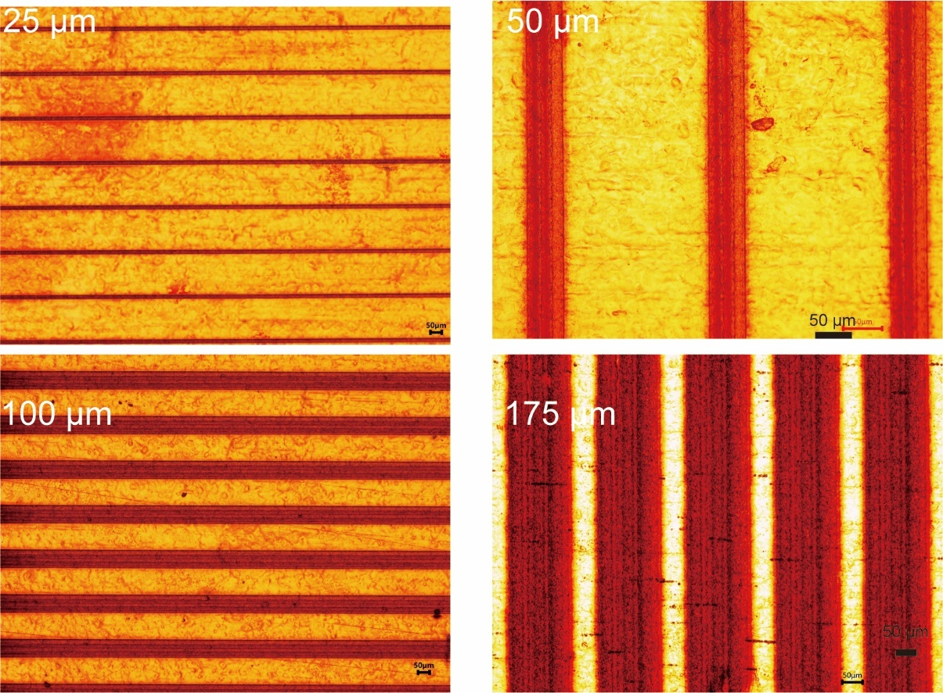
Supplementary Figure15. Optical images of Cu foil model catalysts with identical boundaries but varying overall valence states, where 25 μm, 50 μm, 100 μm, and 175 μm denote the widths of the fabricated Cu⁺ stripes within the model catalysts.

Supplementary Figure16. (a) Constant potential stability test results of Cu/Cu⁺-2 at 0V; (b) Cu LMM Auger spectrum results after stability test of Cu/Cu⁺-2 and Cu/Cu⁺-Zr, (c) Urea FE of Cu/Cu⁺-Zr, (d) CO₂-TPD results of CuO and CuO-ZrO₂; (e-f) STEM and EDS-mapping of CuO-ZrO₂ yellow represents Zr, green represents O, and red represents Cu.

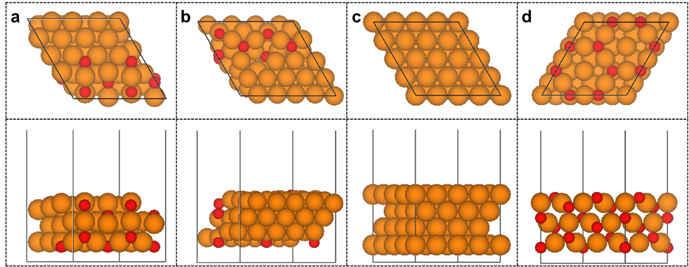
Supplementary Figure 17. The top and side view of (a) Cu/Cu⁺-co, (b) Cu/Cu⁺-non-co, (c) Cu(111) and (d) Cu₂O(111) slabs. Orange, red spheres indicate copper atoms and oxygen atoms respectively.

Supplementary Figure 18. The free energy diagram of the 2nd C-N coupling on Cu₂O(111), Cu/Cu⁺-co, Cu/Cu⁺-non-co and Cu(111) slabs.

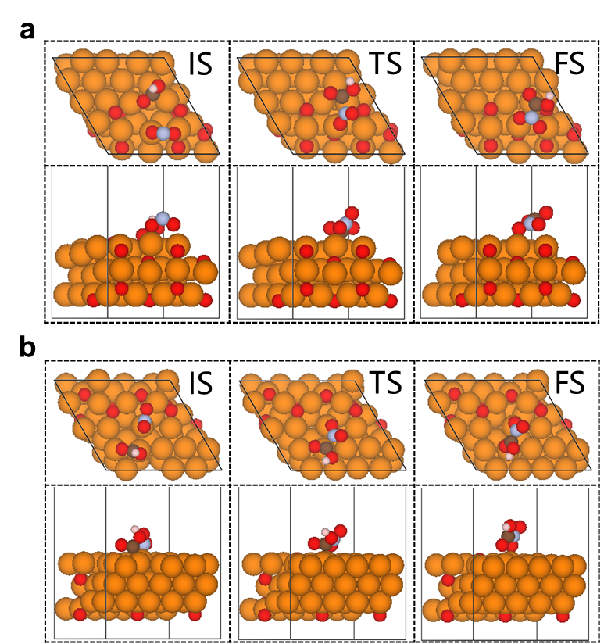
Supplementary Figure 19. The top and side view of the structures of the initial state, the transition state and the final state of the 1st C-N coupling on the (a) Cu/Cu⁺-co and (b) Cu/Cu⁺-non-co slabs. Orange, red, brown, grey, pink spheres indicate copper atoms, oxygen atoms, carbon atoms, nitrogen atoms and hydrogen atoms, respectively.

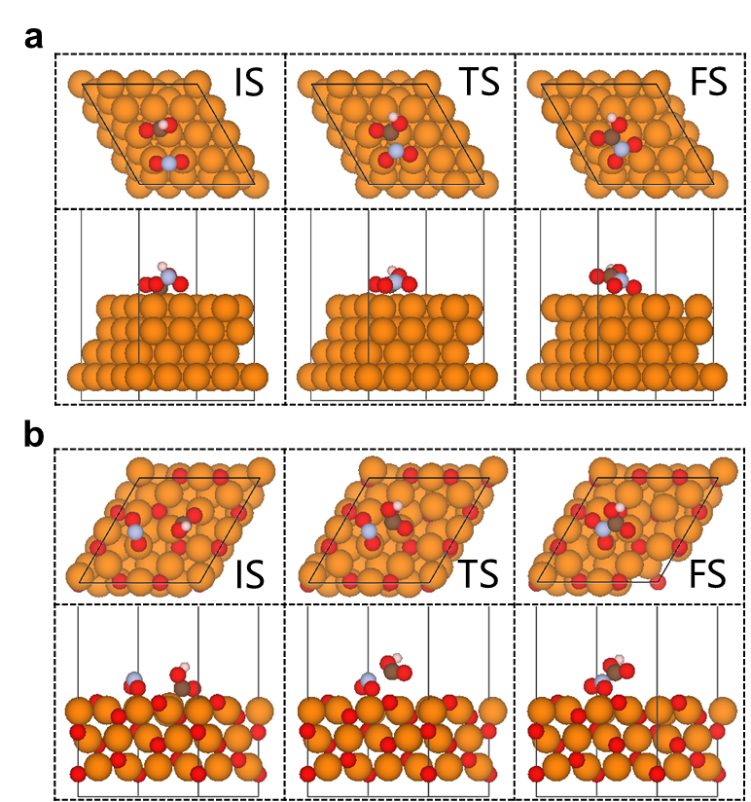
Supplementary Figure 20. The top and side view of the structures of the initial state, the transition state and the final state of the 1st C-N coupling on the (a) Cu(111) and (b) Cu₂O(111) slabs. Orange, red, brown, grey, pink spheres indicate copper atoms, oxygen atoms, carbon atoms, nitrogen atoms and hydrogen atoms, respectively.

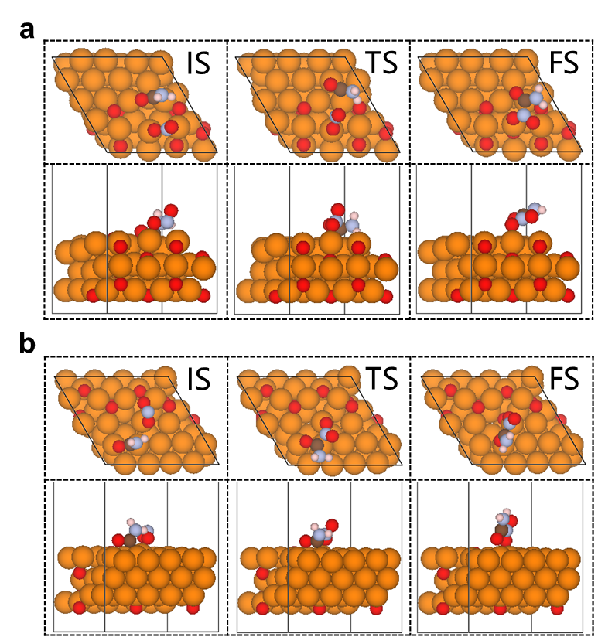
Supplementary Figure 21. The top and side view of the structures of the initial state, the transition state and the final state of the 2nd C-N coupling on the (a) Cu/Cu⁺-co and (b) Cu/Cu⁺-non-co slabs. Orange, red, brown, grey, pink spheres indicate copper atoms, oxygen atoms, carbon atoms, nitrogen atoms and hydrogen atoms, respectively.

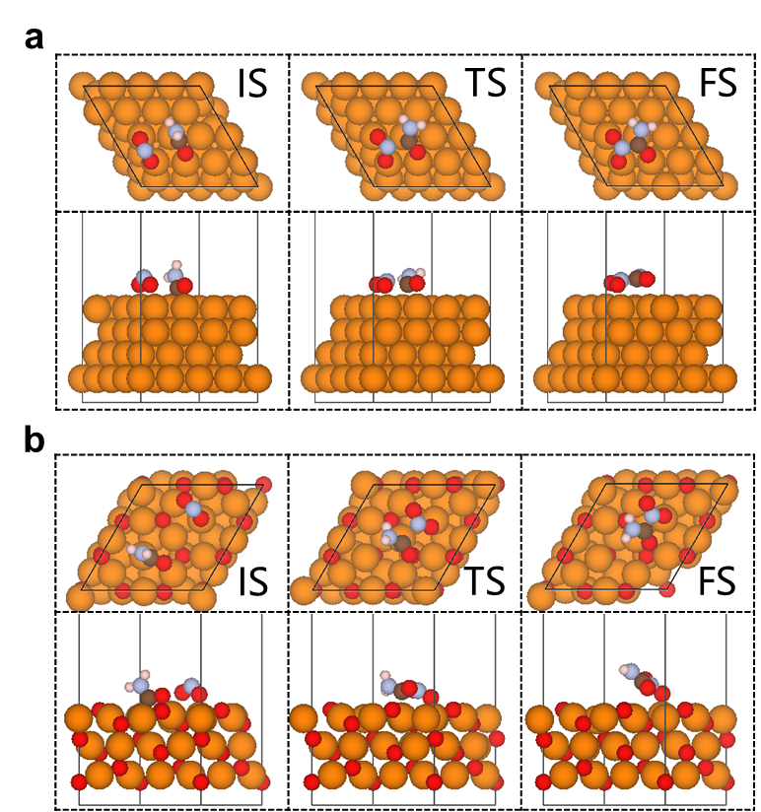
Supplementary Figure 22. The top and side view of the structures of the initial state, the transition state and the final state of the 2nd C-N coupling on the (a) Cu(111) and (b) Cu₂O(111) slabs. Orange, red, brown, grey, pink spheres indicate copper atoms, oxygen atoms, carbon atoms, nitrogen atoms and hydrogen atoms, respectively.

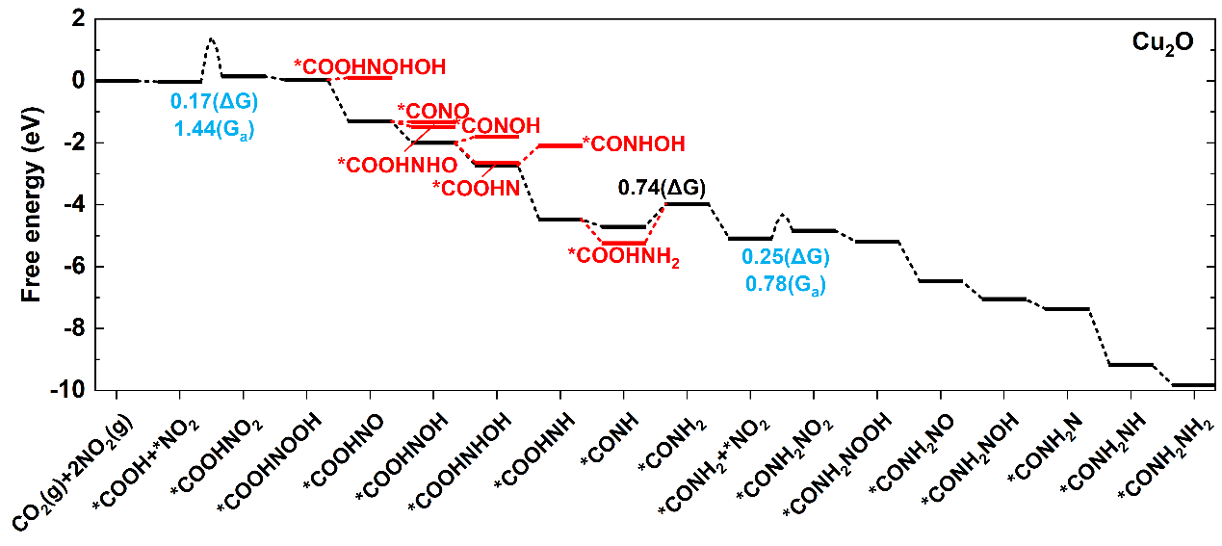
Supplementary Figure 23. Free energy diagram for urea synthesis on the Cu₂O(111) slab.

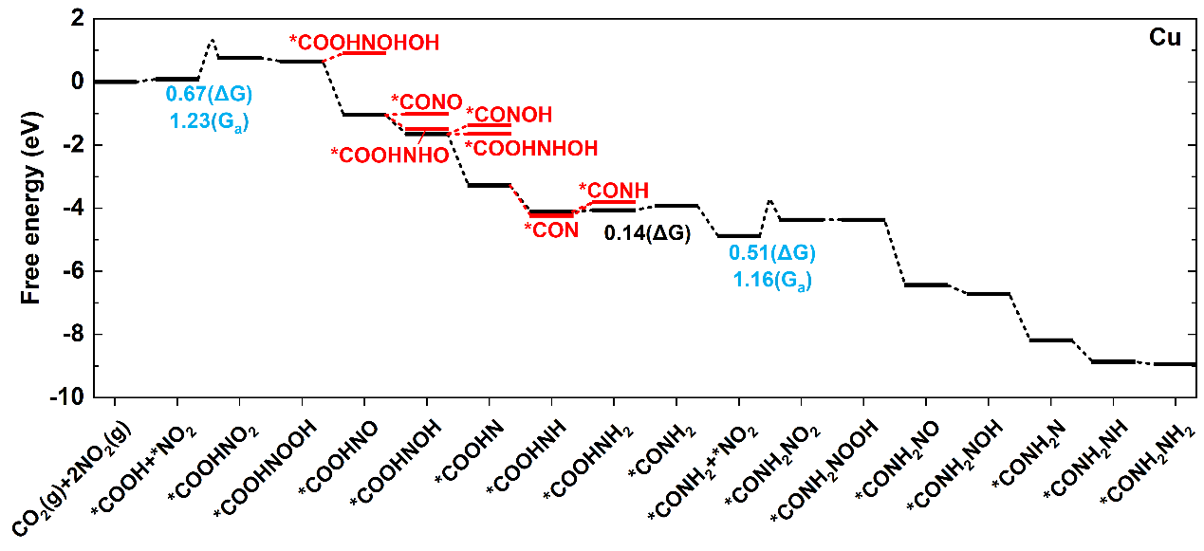
Supplementary Figure 24. Free energy diagram for urea synthesis on Cu(111) slab.

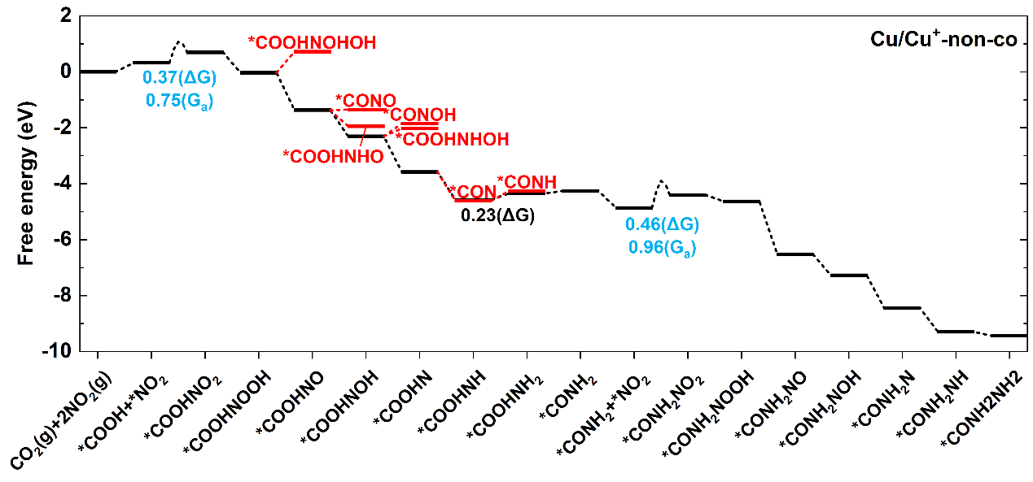
Supplementary Figure 25. Free energy diagram for urea synthesis on the Cu/Cu⁺-non-co slab.

Supplementary Table 4. The activation free energy barriers (G_{a}) of the two C-N couplings on Cu₂O(111), Cu/Cu⁺-co, Cu/Cu⁺-non-co and Cu(111) slabs. The unit is eV.
Catalysts | G_{a} (1st C-N coupling) | G_{a} (2nd C-N coupling)
Cu₂O(111) | 1.44 | 0.78
Cu/Cu⁺-co | 1.01 | 0.26
Cu/Cu⁺-non-co | 0.75 | 0.96
Cu(111) | 1.23 | 1.15

Supplementary Table 5. The reaction free energies (ΔG) of the two C-N couplings and the most difficult hydrogenation steps of urea synthesis on Cu₂O(111), Cu/Cu⁺-co, Cu/Cu⁺-non-co and Cu(111) slabs. The unit is eV.
Catalysts | ΔG (1st C-N coupling) | ΔG (2nd C-N coupling) | ΔG (maximum of hydrogenation)
Cu₂O(111) | 0.17 | 0.25 | 0.74
Cu/Cu⁺-co | 0.34 | 0.10 | 0.30
Cu/Cu⁺-non-co | 0.37 | 0.46 | 0.23
Cu(111) | 0.67 | 0.51 | 0.14

Supplementary Table 6. Correction terms of adsorbates utilized to transform energies into free energies on Cu₂O (111) slab. ZPE, $\int{C_{p}dT}$ and TS are zero-point energy corrections, enthalpic temperature corrections and entropy contributions, respectively. Temperature is set to 298.15 K. The unit is eV.
adsorbates | ZPE | $$\int{C_{p}dT}-TS$$ | $$ZPE+\int{C_{p}dT}-TS$$
*CO₂+*H₂O | 0.94 | -0.19 | 0.75
*COOH+*OH | 0.93 | -0.15 | 0.78
*NO₃ | 0.39 | -0.12 | 0.27
*HNO₃ | 0.68 | -0.11 | 0.57
*NO₂ | 0.26 | -0.12 | 0.14
*COOH+*NO₂ | 0.88 | -0.21 | 0.68
TS1 | 0.83 | -0.24 | 0.59
*COOHNO₂ | 0.96 | -0.21 | 0.75
*COOHNOOH | 1.18 | -0.20 | 0.98
*COOHNO | 0.84 | -0.13 | 0.70
*COOHNOHOH | 1.54 | -0.19 | 1.35
*COOHNOH | 1.14 | -0.18 | 0.97
*COOHNHO | 1.16 | -0.20 | 0.96
*CONO | 0.40 | -0.16 | 0.24
*COOHN | 0.73 | -0.14 | 0.60
*COOHNHOH | 1.46 | -0.18 | 1.28
*CONOH | 0.69 | -0.16 | 0.53
*COOHNH | 1.08 | -0.09 | 0.99
*CONHOH | 1.03 | -0.16 | 0.87
*COOHNH₂ | 1.39 | -0.14 | 1.24
*CONH | 0.62 | -0.13 | 0.49
*CONH₂ | 0.94 | -0.07 | 0.87
*CONH₂+*NO₂ | 1.22 | -0.21 | 1.00
TS2 | 1.19 | -0.22 | 0.97
*CONH₂NO₂ | 1.28 | -0.24 | 1.04
*CONH₂NOOH | 1.56 | -0.21 | 1.35
*CONH₂NO | 1.17 | -0.18 | 0.99
*CONH₂NOH | 1.50 | -0.16 | 1.33
*CONH₂N | 1.05 | -0.14 | 0.91
*CONH₂NH | 1.41 | -0.13 | 1.27
*CO(NH₂)₂ | 1.74 | -0.13 | 1.61
Note: TS1 and TS2 refer to the transition states of the first and second C-N coupling steps, respectively.

Supplementary Table 7. Correction terms of adsorbates utilized to transform energies into free energies on Cu(111) slab. ZPE, $\int{C_{p}dT}$ and TS are zero-point energy corrections, enthalpic temperature corrections and entropy contributions, respectively. Temperature is set to 298.15 K. The unit is eV.
adsorbates | ZPE | $$\int{C_{p}dT}-TS$$ | $$ZPE+\int{C_{p}dT}-TS$$
*CO₂+*H₂O | 1.00 | -0.22 | 0.78
*COOH+*OH | 0.97 | -0.16 | 0.80
*NO₃ | 0.41 | -0.14 | 0.27
*HNO₃ | 0.70 | -0.18 | 0.52
*NO₂ | 0.27 | -0.10 | 0.17
*COOH+*NO₂ | 0.86 | -0.23 | 0.63
TS1 | 0.84 | -0.18 | 0.65
*COOHNO₂ | 0.92 | -0.21 | 0.71
*COOHNOOH | 1.21 | -0.22 | 0.99
*COOHNO | 0.82 | -0.13 | 0.70
*COOHNOHOH | 1.51 | -0.23 | 1.28
*COOHNOH | 1.12 | -0.17 | 0.95
*COOHNHO | 1.14 | -0.20 | 0.95
*CONO | 0.39 | -0.11 | 0.28
*COOHN | 0.75 | -0.12 | 0.63
*COOHNHOH | 1.46 | -0.18 | 1.28
*CONOH | 0.67 | -0.11 | 0.56
*COOHNH | 1.08 | -0.13 | 0.95
*CON | 0.33 | -0.12 | 0.21
*COOHNH₂ | 1.37 | -0.16 | 1.20
*CONH | 0.58 | -0.12 | 0.46
*CONH₂ | 0.92 | -0.13 | 0.79
*CONH₂+*NO₂ | 1.19 | -0.23 | 0.96
TS2 | 1.16 | -0.21 | 0.95
*CONH₂NO₂ | 1.24 | -0.22 | 1.02
*CONH₂NOOH | 1.54 | -0.21 | 1.33
*CONH₂NO | 1.16 | -0.15 | 1.01
*CONH₂NOH | 1.47 | -0.17 | 1.29
*CONH₂N | 1.06 | -0.14 | 0.93
*CONH₂NH | 1.40 | -0.14 | 1.26
*CO(NH₂)₂ | 1.71 | -0.18 | 1.54
Note: TS1 and TS2 refer to the transition states of the first and second C-N coupling steps, respectively.

Supplementary Table 8. Correction terms of adsorbates utilized to transform energies into free energies on Cu/Cu⁺-co slab. ZPE, $\int{C_{p}dT}$ and TS are zero-point energy corrections, enthalpic temperature corrections and entropy contributions, respectively. Temperature is set to 298.15 K. The unit is eV.
adsorbates | ZPE | $$\int{C_{p}dT}-TS$$ | $$ZPE+\int{C_{p}dT}-TS$$
*COOH+*NO₂ | 0.86 | -0.22 | 0.65
TS1 | 0.87 | -0.22 | 0.66
*COOHNO₂ | 0.95 | -0.20 | 0.75
*COOHNOOH | 1.22 | -0.19 | 1.03
*COOHNO | 0.84 | -0.18 | 0.66
*COOHNOHOH | 1.51 | -0.19 | 1.32
*COOHNOH | 1.14 | -0.19 | 0.95
*COOHNHO | 1.15 | -0.18 | 0.97
*CONO | 0.39 | -0.16 | 0.23
*COOHNHOH | 1.47 | -0.21 | 1.27
*CONHO | 0.71 | -0.12 | 0.59
*COOHNH | 1.08 | -0.14 | 0.94
*CONHOH | 1.03 | -0.14 | 0.89
*COOHNH₂ | 1.41 | -0.13 | 1.28
*CONH | 0.61 | -0.12 | 0.49
*CONH₂ | 0.91 | -0.08 | 0.83
*CONH₂+*NO₂ | 1.22 | -0.21 | 1.00
TS2 | 1.05 | -0.25 | 0.80
*CONH₂NO₂ | 1.28 | -0.19 | 1.09
*CONH₂NOOH | 1.56 | -0.23 | 1.33
*CONH₂NO | 1.16 | -0.18 | 0.98
*CONH₂NOH | 1.48 | -0.18 | 1.30
*CONH₂N | 1.08 | -0.13 | 0.94
*CONH₂NH | 1.40 | -0.14 | 1.26
*CO(NH₂)₂ | 1.73 | -0.14 | 1.59
Note: TS1 and TS2 refer to the transition states of the first and second C-N coupling steps, respectively.

Supplementary Table 9. Correction terms of adsorbates utilized to transform energies into free energies on Cu/Cu⁺-non-co slab. ZPE, $\int{C_{p}dT}$ and TS are zero-point energy corrections, enthalpic temperature corrections and entropy contributions, respectively. Temperature is set to 298.15 K. The unit is eV.
adsorbates | ZPE | $$\int{C_{p}dT}-TS$$ | $$ZPE+\int{C_{p}dT}-TS$$
*COOH+*NO₂ | 0.87 | -0.24 | 0.63
TS1 | 0.87 | -0.20 | 0.68
*COOHNO₂ | 0.93 | -0.23 | 0.71
*COOHNOOH | 1.33 | -0.35 | 0.98
*COOHNO | 0.84 | -0.14 | 0.71
*COOHNOHOH | 1.52 | -0.22 | 1.30
*COOHNOH | 1.17 | -0.16 | 1.02
*COOHNHO | 1.16 | -0.15 | 1.01
*CONO | 0.40 | -0.15 | 0.25
*COOHN | 0.76 | -0.14 | 0.62
*COOHNHOH | 1.47 | -0.20 | 1.27
*CONOH | 0.68 | -0.16 | 0.52
*COOHNH | 1.08 | -0.14 | 0.94
*CON | 0.33 | -0.08 | 0.25
*COOHNH₂ | 1.40 | -0.14 | 1.26
*CONH | 0.60 | -0.13 | 0.47
*CONH₂ | 0.94 | -0.12 | 0.82
*CONH₂+*NO₂ | 1.20 | -0.24 | 0.96
TS2 | 1.21 | -0.18 | 1.03
*CONH₂NO₂ | 1.25 | -0.20 | 1.05
*CONH₂NOOH | 1.55 | -0.24 | 1.30
*CONH₂NO | 1.17 | -0.18 | 0.99
*CONH₂NOH | 1.50 | -0.16 | 1.34
*CONH₂N | 1.07 | -0.14 | 0.93
*CONH₂NH | 1.40 | -0.15 | 1.25
*CO(NH₂)₂ | 1.74 | -0.17 | 1.57
Note: TS1 and TS2 refer to the transition states of the first and second C-N coupling steps, respectively.

Supplementary Table S10. Correction terms of gas-phase molecules utilized to transform energies into free energies. ZPE, $\int{C_{p}dT}$ and TS are zero-point energy corrections, enthalpic temperature corrections and entropy contributions, respectively. Temperature is set to 298.15 K.
species | partial pressure (atm) | ZPE (eV) | $\int{C_{p}dT}-TS$ (eV) | $ZPE+\int{C_{p}dT}-TS$ (eV)
H₂ | 1 | 0.27 | -0.31 | -0.05
N₂ | 1 | 0.14 | -0.50 | -0.36
H₂O | 0.035¹⁶ | 0.56 | -0.57 | -0.01
CO₂ | 1 | 0.30 | -0.58 | -0.28
NO₂ | 1 | 0.23 | -0.64 | -0.41

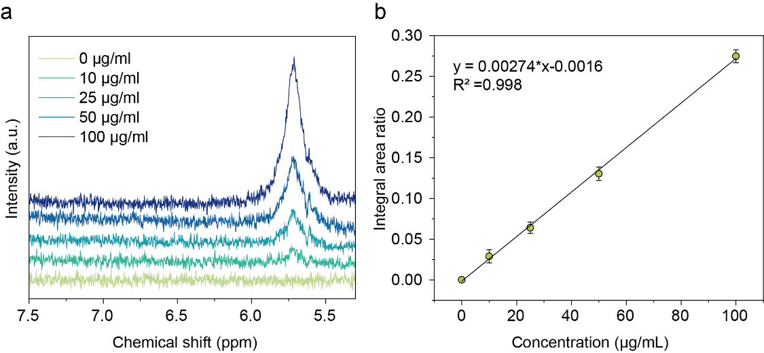
Supplementary Figure 26. Determination of urea concentration by 1H NMR spectroscopy. (a) 1H NMR spectra of urea standard solutions with different concentrations (0 ppm, 10 ppm, 25 ppm, 50 ppm, 100 ppm); (b) quantitative calibration curve of urea concentration.

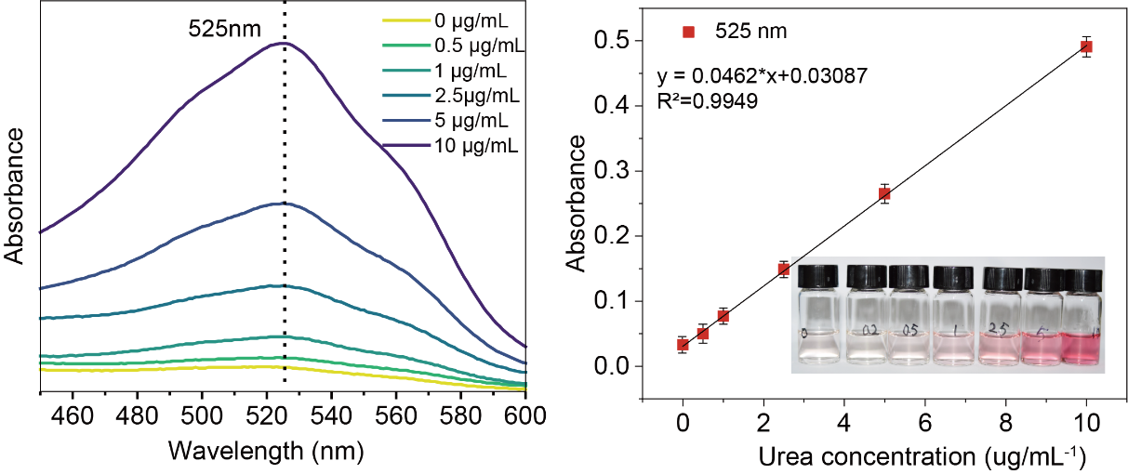
Supplementary Figure 27. Determination of urea concentration by UV-vis spectroscopy. (a) UV-vis spectra of urea standard solutions with different concentrations (0 μg/mL, 0.5 μg/mL, 1 μg/mL, 2 μg/mL, 2.5 μg/mL, 5 μg/mL, 10 μg/mL); (b) Quantitative calibration curve of urea concentration.

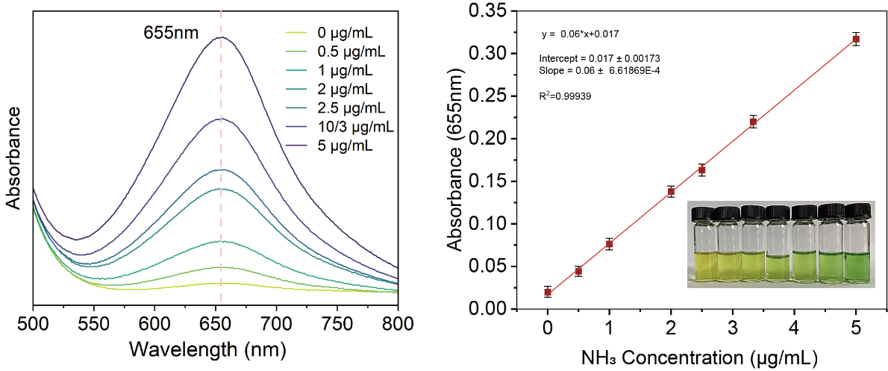
Supplementary Figure 28. Determination of NH3 concentration by UV-vis spectroscopy. (a) UV-vis spectra of ammonium chloride standard solutions with different concentrations (0 μg/mL, 0.5 μg/mL, 1 μg/mL, 2 μg/mL, 2.5 μg/mL, 3.33 μg/mL, 5 μg/mL); (b) Quantitative calibration curve of NH3 concentration.

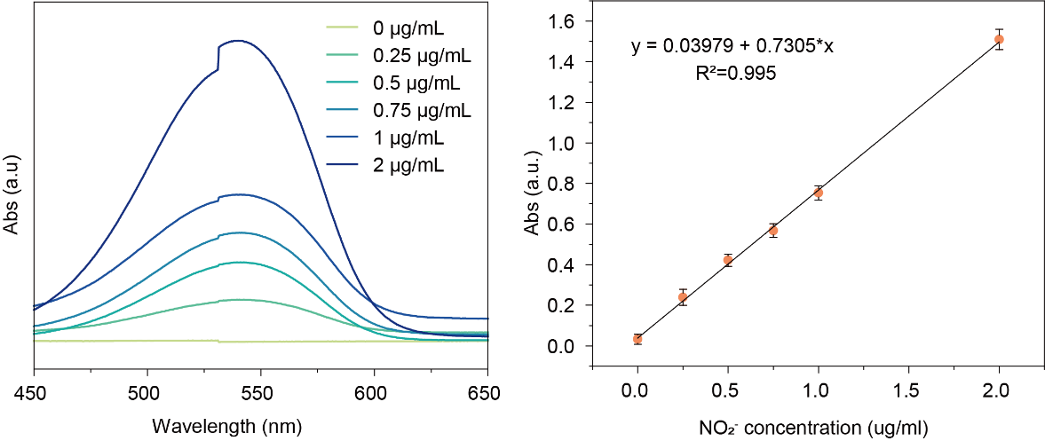
Supplementary Figure 29. Determination of nitrite concentration by UV-vis spectroscopy. (a) UV-vis spectra of potassium nitrite standard solutions with different concentrations (0 μg/mL, 0.25 μg/mL, 0.5 μg/mL, 0.75 μg/mL, 1 μg/mL, 2 μg/mL); (b) quantitative calibration curve of nitrite concentration.

References
1 Kohn, W. & Sham, L. J. Self-consistent equations including exchange and correlation effects. Phys. Rev. 140, A1133-A1138 (1965).
2 Hohenberg, P. & Kohn, W. Inhomogeneous Electron Gas. Physical Review. 136, B864-B871 (1964).
3 Kresse, G. & Furthmuller, J. Efficient iterative schemes for ab initio total-energy calculations using a plane-wave basis set. Phys. Rev. B. 54, 11169-11186 (1996).
4 Blöchl, P. E. Projector augmented-wave method. Phys. Rev. B. 50, 17953-17979 (1994).
5 Hammer, B., Hansen, L. B. & Nørskov, J. K. Improved adsorption energetics within density-functional theory using revised Perdew-Burke-Ernzerhof functionals. Physical Review B. 59, 7413-7421 (1999).
6 Perdew, J. P., Burke, K. & Ernzerhof, M. Generalized Gradient Approximation Made Simple. Physical Review Letters. 77, 3865-3868 (1996).
7 Grimme, S., Antony, J., Ehrlich, S. & Krieg, H. A consistent and accurate ab initio parametrization of density functional dispersion correction (DFT-D) for the 94 elements H-Pu. The Journal of Chemical Physics. 132, 154104 (2010).
8 Monkhorst, H. J. & Pack, J. D. Special points for Brillouin-zone integrations. Physical Review B. 13, 5188-5192 (1976).
9 Methfessel, M. & Paxton, A. T. High-precision sampling for Brillouin-zone integration in metals. Physical Review B. 40, 3616-3621 (1989).
10 Kulik, H. J., Cococcioni, M., Scherlis, D. A. & Marzari, N. Density Functional Theory in Transition-Metal Chemistry: A Self-Consistent Hubbard U Approach. Physical Review Letters. 97, 103001 (2006).
11 Zuo, Z., Ramírez, P. J., Senanayake, S. D., Liu, P. & Rodriguez, J. A. Low-Temperature Conversion of Methane to Methanol on CeO_{x}/Cu₂O Catalysts: Water Controlled Activation of the C–H Bond. Journal of the American Chemical Society. 138, 13810-13813 (2016).
12 Henkelman, G., Uberuaga, B. P. & Jónsson, H. A climbing image nudged elastic band method for finding saddle points and minimum energy paths. The Journal of Chemical Physics. 113, 9901-9904 (2000).
13 Henkelman, G. & Jónsson, H. Improved tangent estimate in the nudged elastic band method for finding minimum energy paths and saddle points. The Journal of Chemical Physics. 113, 9978-9985 (2000).
14 Xiao, H., Goddard, W. A., Cheng, T. & Liu, Y. Cu metal embedded in oxidized matrix catalyst to promote CO2 activation and CO dimerization for electrochemical reduction of CO2. Proceedings of the National Academy of Sciences. 114, 6685-6688 (2017).
15 Wang, V., Xu, N., Liu, J.-C., Tang, G. & Geng, W.-T. VASPKIT: A user-friendly interface facilitating high-throughput computing and analysis using VASP code. Computer Physics Communications. 267, 108033 (2021).
16 Peterson, A. A., Abild-Pedersen, F., Studt, F., Rossmeisl, J. & Norskov, J. K. How copper catalyzes the electroreduction of carbon dioxide into hydrocarbon fuels. Energy Environ. Sci. 3, 1311-1315 (2010).

