1.Where gels/blots are used in figures 2 authors should check their compliance with the digital image and integrity policies . The grouping of gels/blots cropped from different parts of the same gel, or from different gels, fields, or exposures must be made explicit (e.g., using clear delineation either with dividing lines or white space) and described in the figure legend. Where cropped gels/blots are displayed, we ask that full-length gels and blots are included in a Supplementary Information file wherever possible. High-contrast (overexposure) of gels/blots is discouraged. Where high-contrast is unavoidable authors should include multiple exposures in the Supplementary Information file.
Any supplementary information should be uploaded as a single PDF file (where possible) separate from the manuscript file. Please note that large supplementary datasets can be included as separate Excel documents and should be uploaded as ‘Supplementary Info File’/ ’Supplementary Dataset File’. Please note the Supplementary Information will be published as is, without modification or typesetting.

Responses:We thank the reviewer for this helpful suggestion. In the revised manuscript, we have clearly indicated any grouping and cropping of Western blot (WB) bands, in accordance with the journal’s digital image and integrity policies. Specifically, dividing lines have been added where non-adjacent lanes are juxtaposed, and the figure legends now explicitly describe the cropping and alignment procedures.

To ensure full transparency and compliance, we have included the original, uncropped, full-length WB images with visible membrane edges in the Supplementary Information file, labeled consistently with the main figures.

Figure 2B
TSEN15

β-Acting
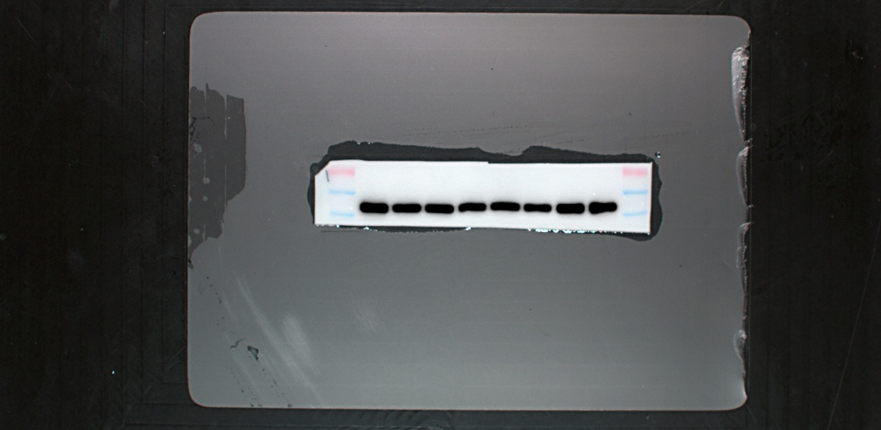

Figure 2G
HEP-G2 TSEN15
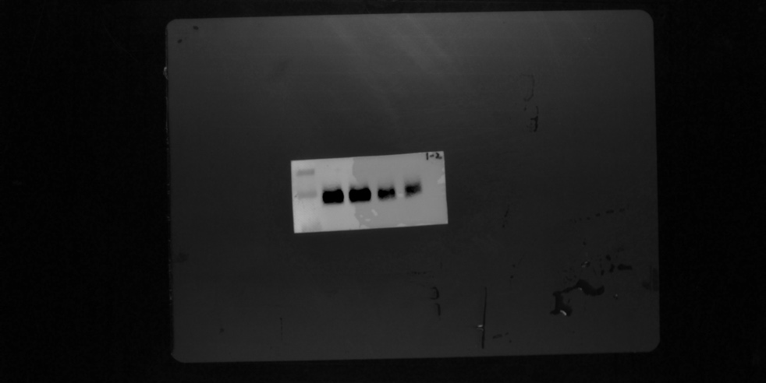

HEP-G2 β-Acting
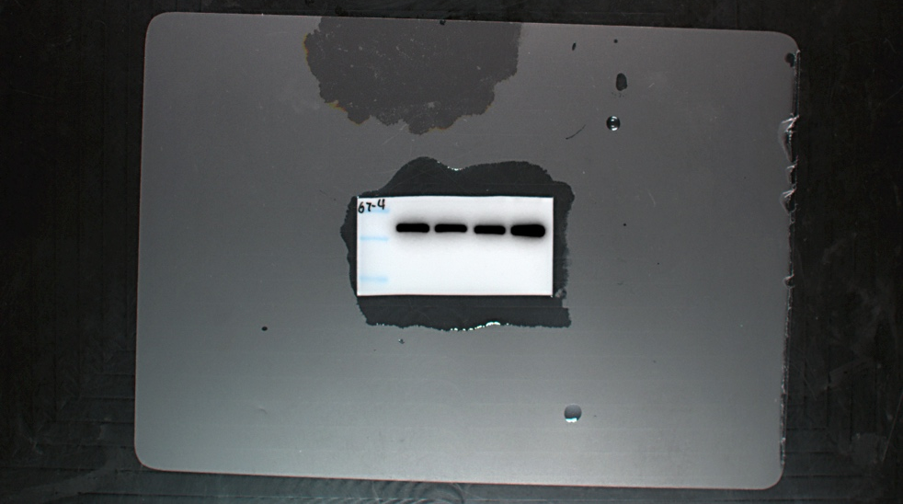

HEP-3B TSEN15

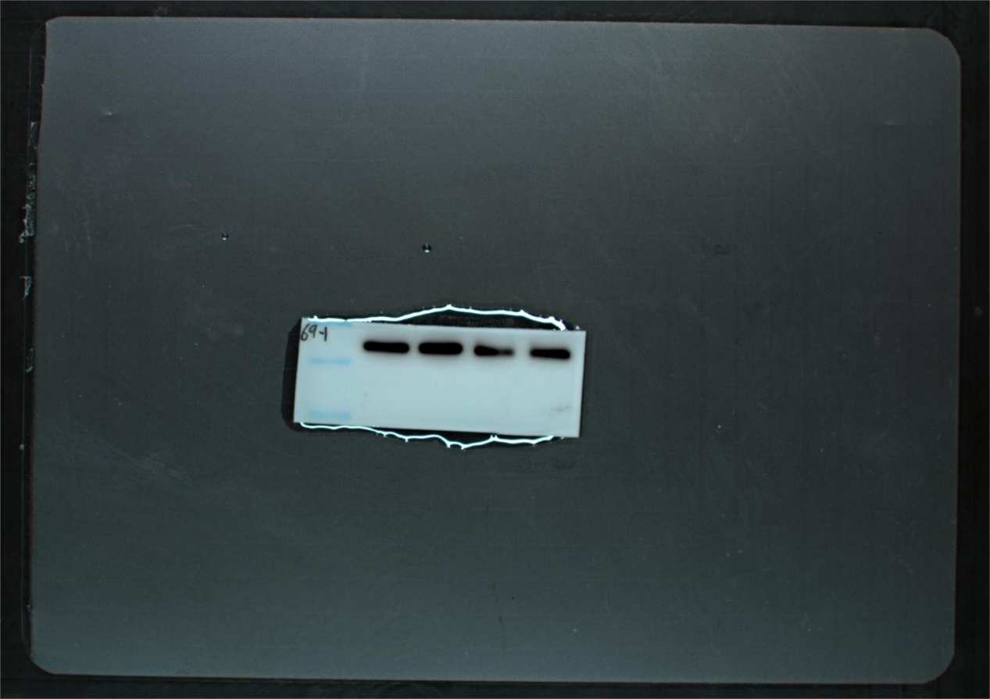

HEP-3B β-Acting

2.The KEGG pathway database is copyrighted by Kanehisa laboratories and we do require formal permission from them to publish this material commercially under an Open Access license. We would therefore be grateful if you could get permission to use the KEGG software from the Kanehisa laboratory. To obtain this permission please submit the form at the following URL: www.kegg.jp/feedback/copyright.html . Please make sure to select ‘Scientific Reports’ in the Publication Detail section.
When using KEGG imagery please ensure that you cite this source in the appropriate figure legend, as per the citation guidelines: www.kegg.jp/kegg/kegg1.html . For previous uses, the Kanehisa laboratory have happily provided permission.
Please send the permissions document to srep@nature.com
We recommend submitting all revisions within the mentioned deadline.

Responses:We thank the editorial office for the reminder regarding KEGG pathway copyright permission. We have obtained formal permission from the Kanehisa Laboratories to use the KEGG material under an Open Access license for publication in Scientific Reports. The permission confirmation document has been submitted via email to srep@nature.com as requested.

