Influence of Morning and Afternoon Exercise on Body Composition and Metabolic Health
Sports medicine
Jiayun Wang¹,Shi Chen²,Zhanjia Zhang¹,Bingqing Yang¹,Xiaoyuan Zhang¹
¹Department of Physical Education, Peking University, Beijing 100871, China
²Department of Cardiac Surgery, Fuwai Hospital, National Center for Cardiovascular Diseases, Chinese Academy of Medical Sciences and Peking Union Medical College, Beijing, China.

Corresponding author: Xiaoyuan Zhang
Email: xiaoyuanzhang@pku.edu.cn

Suppl Figure 1. Funnel plot of Body Weight
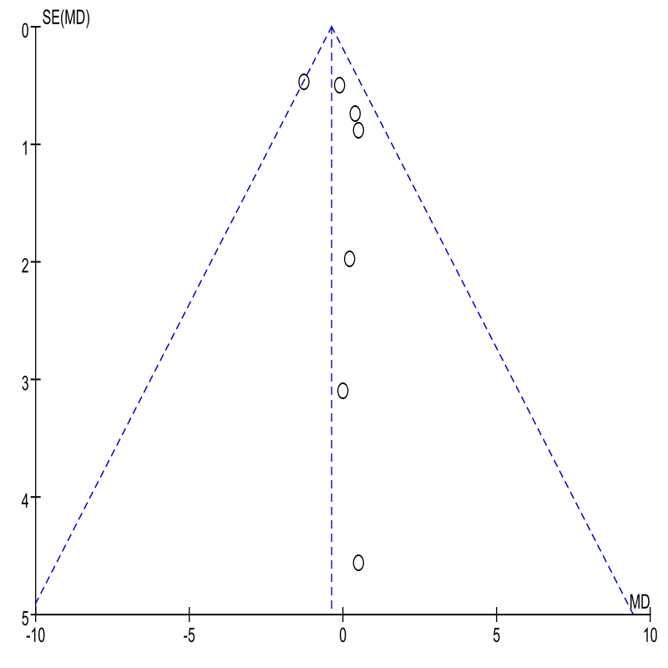
Suppl Figure 2. Funnel plot of BMI
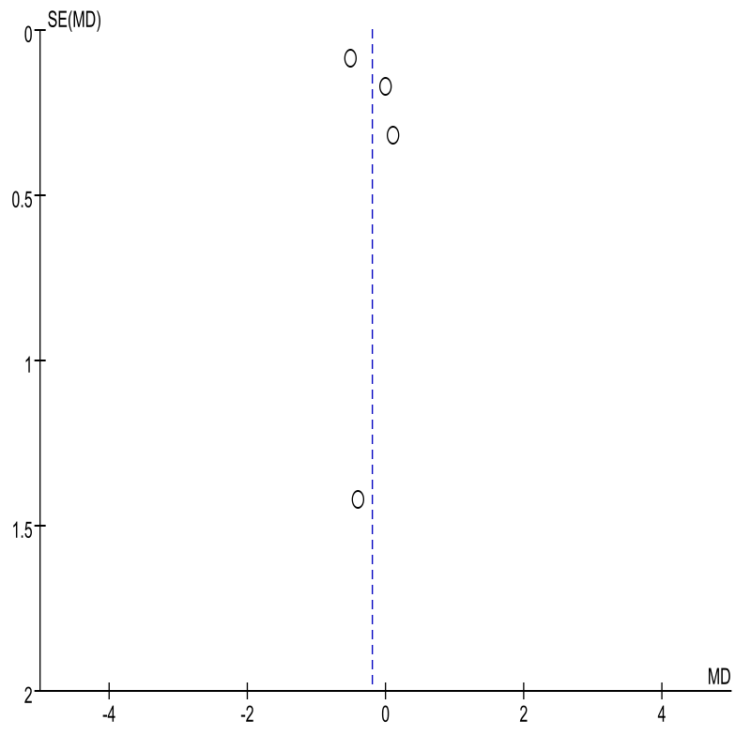
Suppl Figure 3. Funnel plot of Fat mass
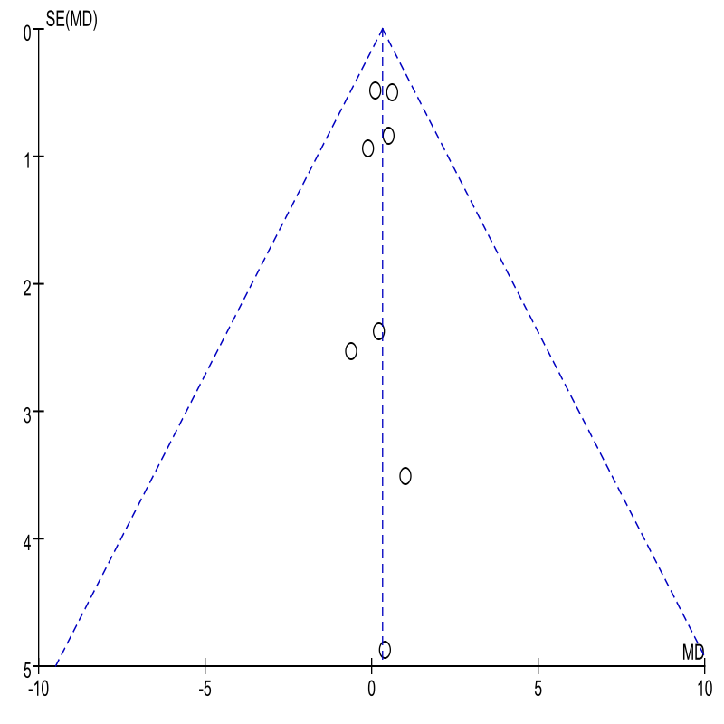
Suppl Figure 4. Funnel plot of Fat free mass
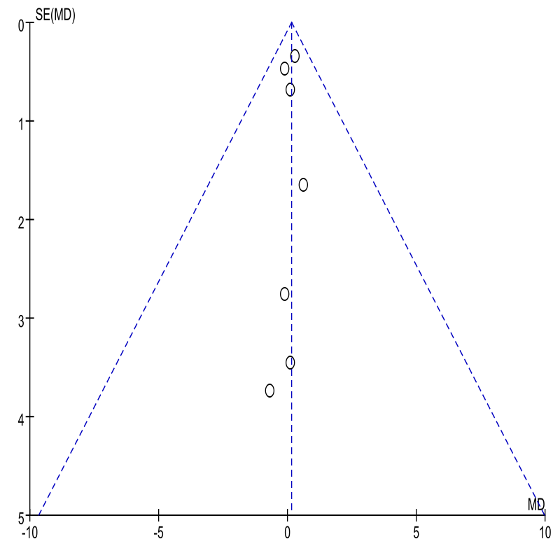
Suppl Figure 5. Funnel plot of Body fat
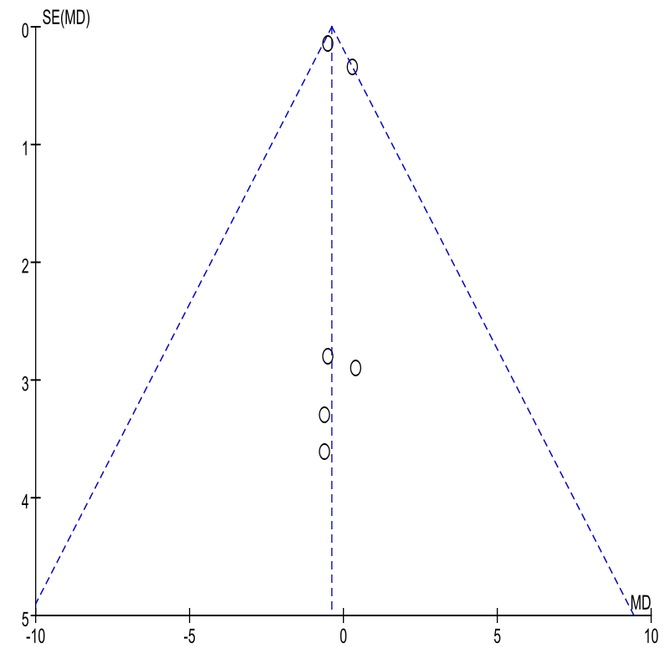
Suppl Figure 6. Funnel plot of Waist circumference
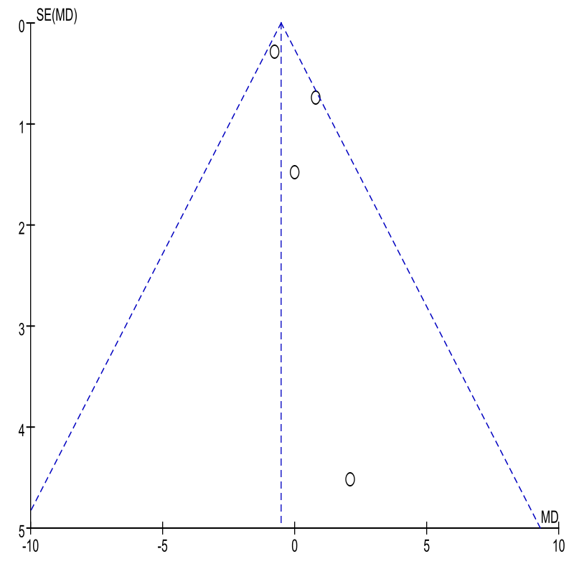
Suppl Figure 7. Funnel plot of Fasting Blood Glucose
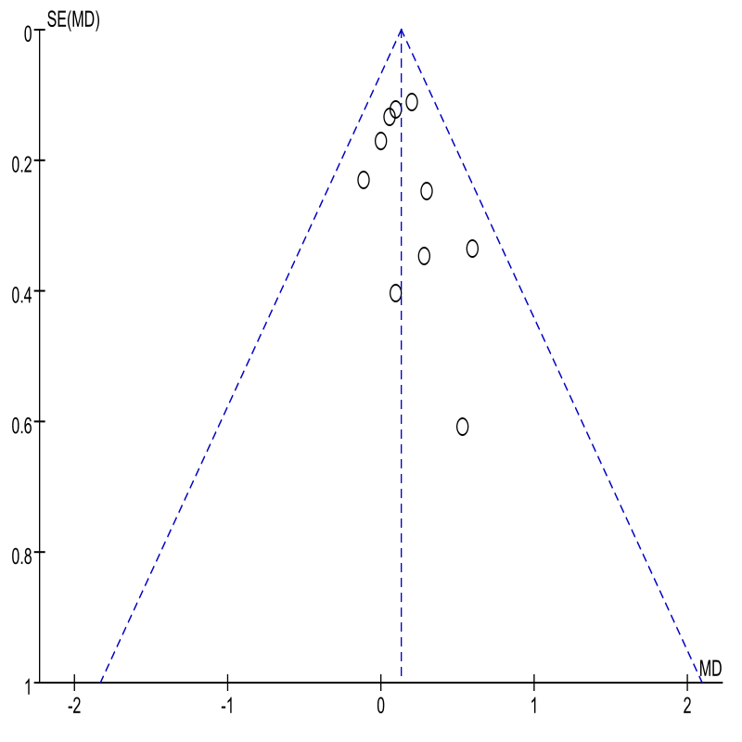
Suppl Figure 8. Funnel plot of Fasting Blood Glucose In the acute studies
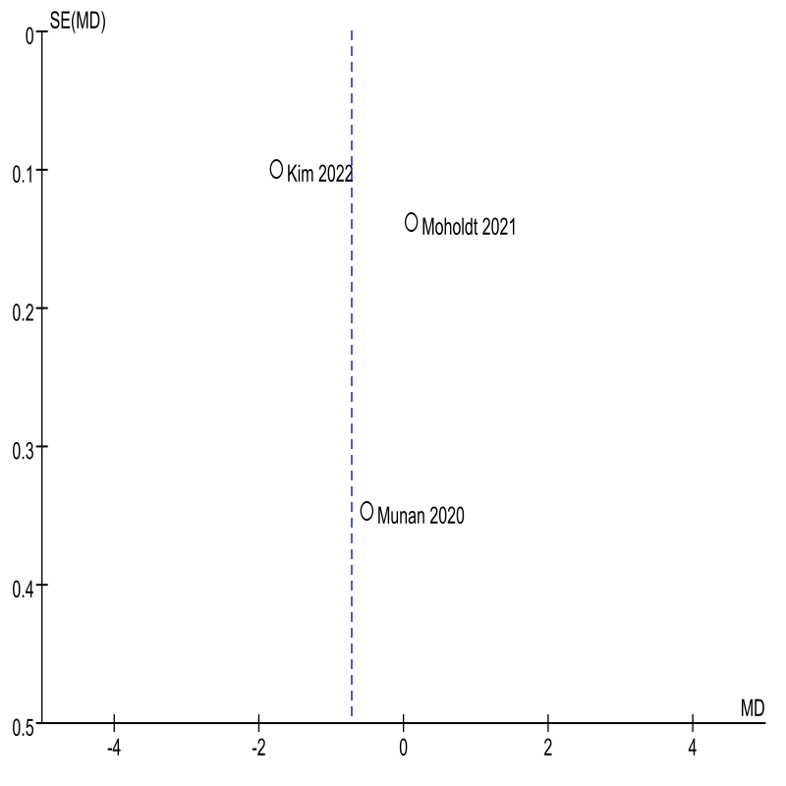
Suppl Figure 9. Funnel plot of Blood glucose before and after exercise In the acute studies
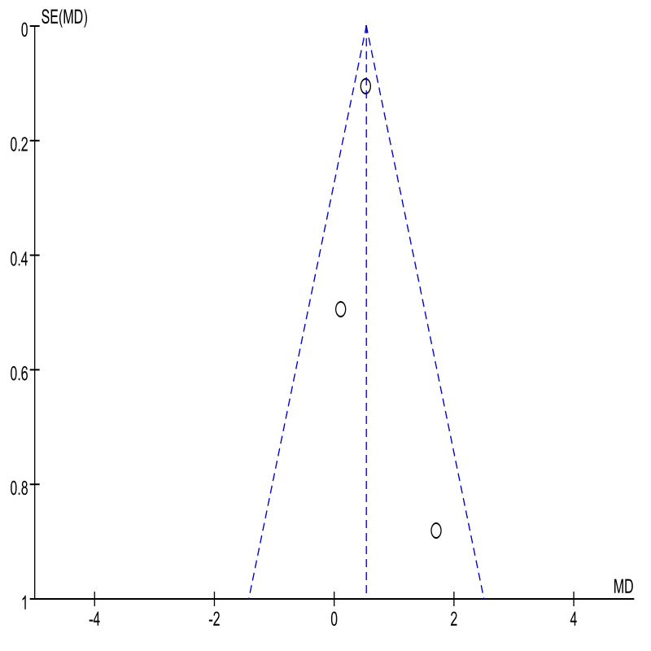
Suppl Figure 10. Funnel plot of HbAc1
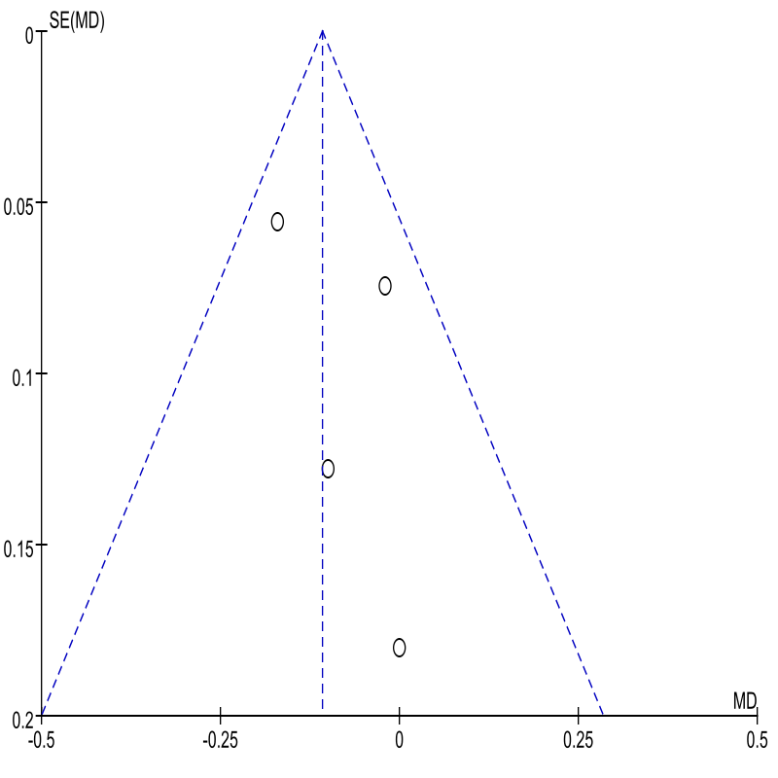
Suppl Figure 11. Funnel plot of Fasting insulin
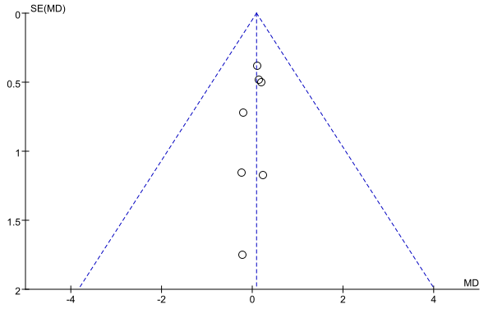
Suppl Figure 12. Funnel plot of HOMA-IR
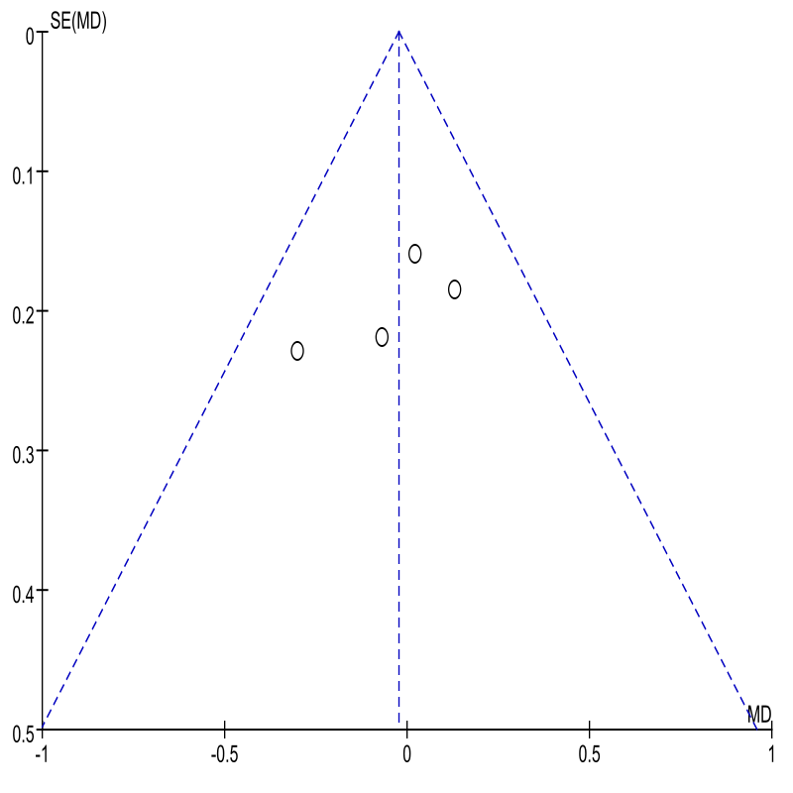
Suppl Figure 13. Funnel plot of TG
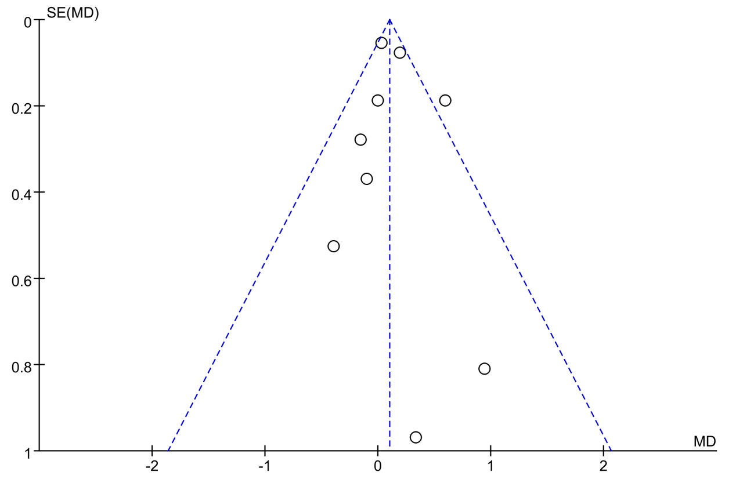
Suppl Figure 14. Funnel plot of TC
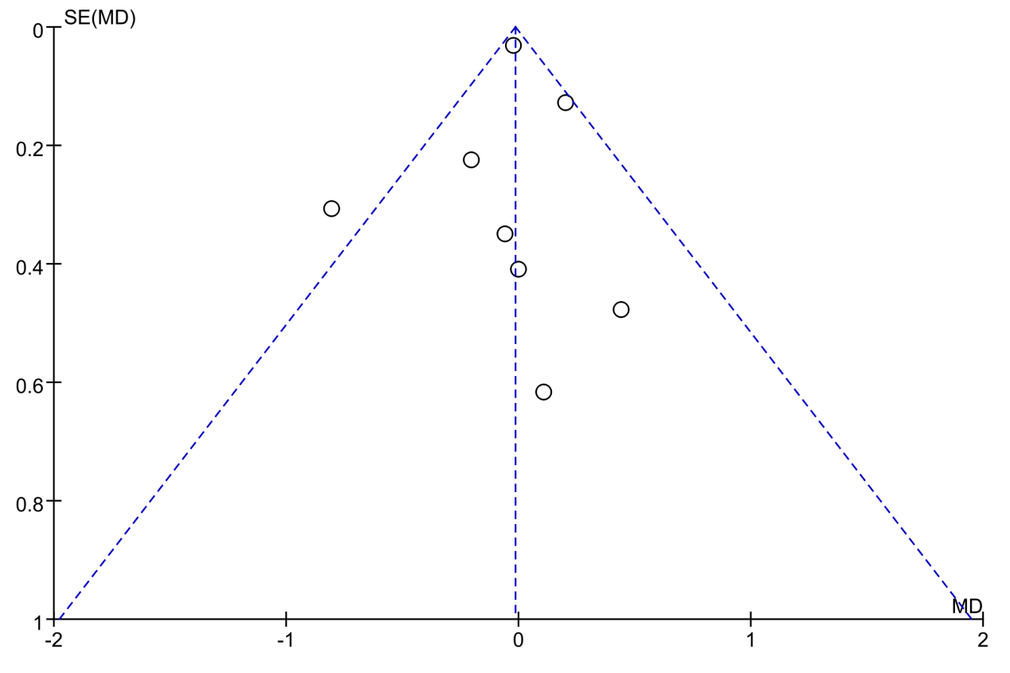
Suppl Figure 15. Funnel plot of HDL
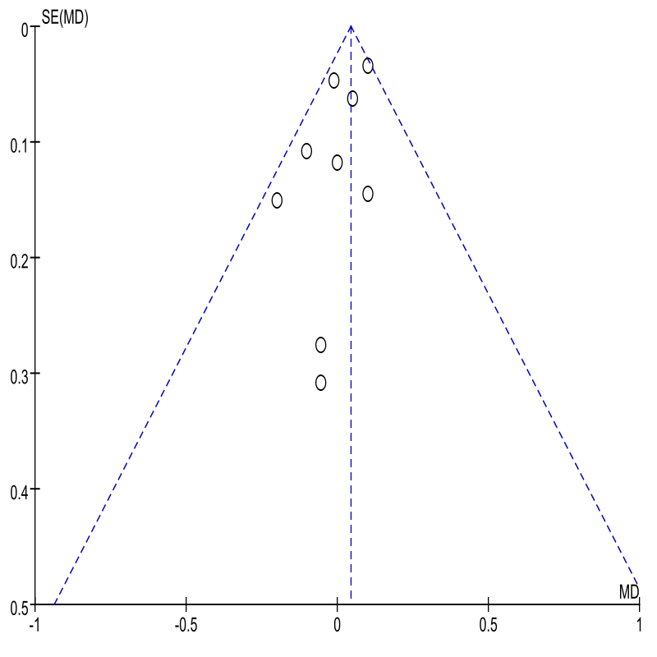
Suppl Figure 16. Funnel plot of LDL
