Supplementary material
- Supplementary Figures

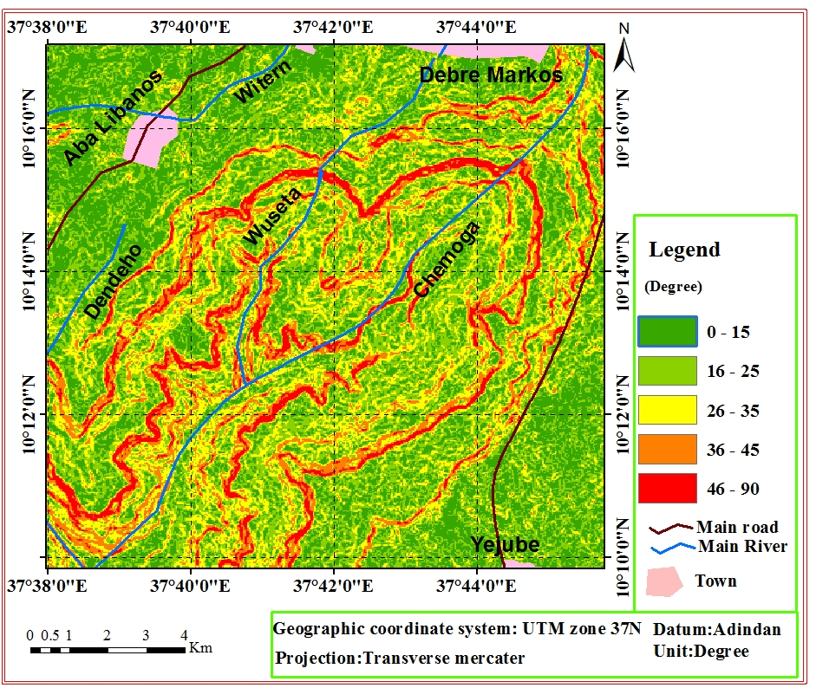
Figure 3 Slope map of the study area

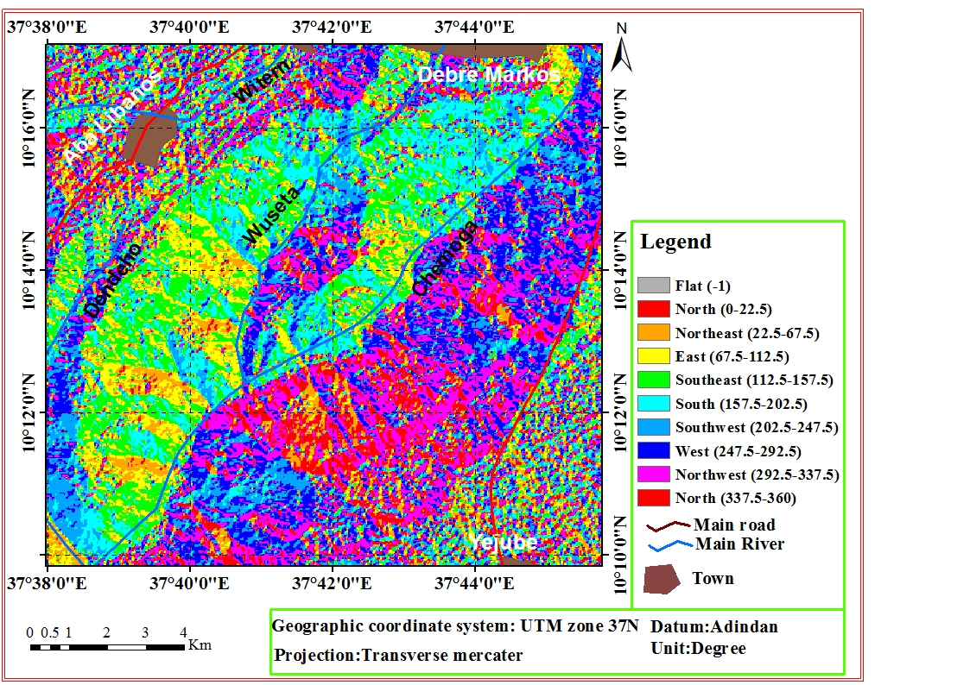
Figure 4 Aspect map of the study area

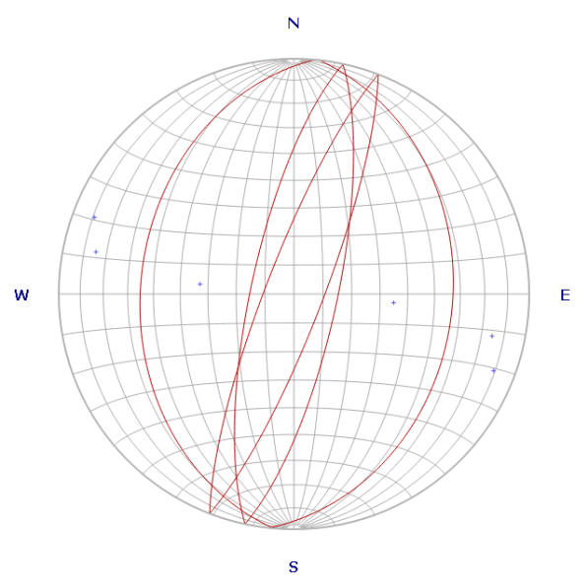
Figure 6: The six major normal faults plotted on Rose diagram and they illustrated a mirror reflection to each other
Figure7 The correlation of local geology (Fig b) to the generalized stratigraphic units of the Blue Nile Basin (Fig a), (Gani, et al., 2008)

Figure 8. The physiographic set up and potential areas of geomaterials (Google Map, 2019)

Figure 9 a Regional 3D view of the study area using surfer softwares

Figure 9b. Local 3D view of the study area using global mapper softwares with 1.5 times the vertical exaggeration

II. Supplementary Plates

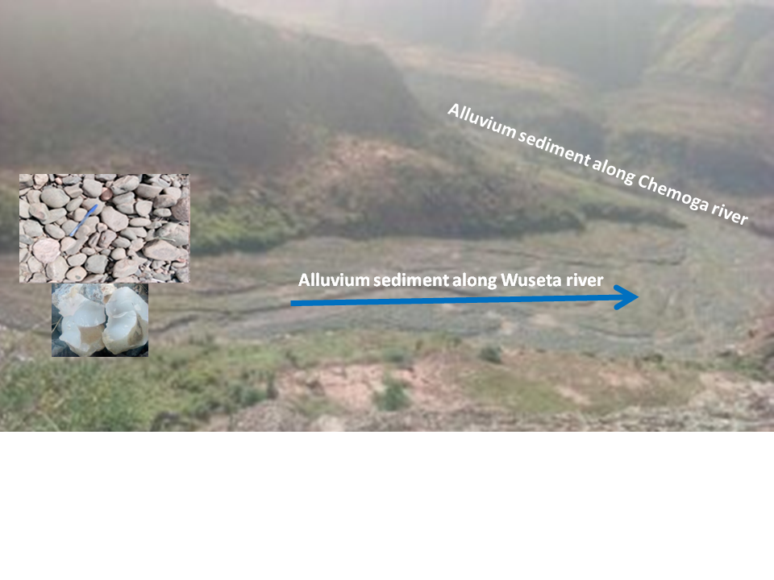
Plate 1 Different sizes and shapes of unconsolidated cataclastic sediments along Wuseta River

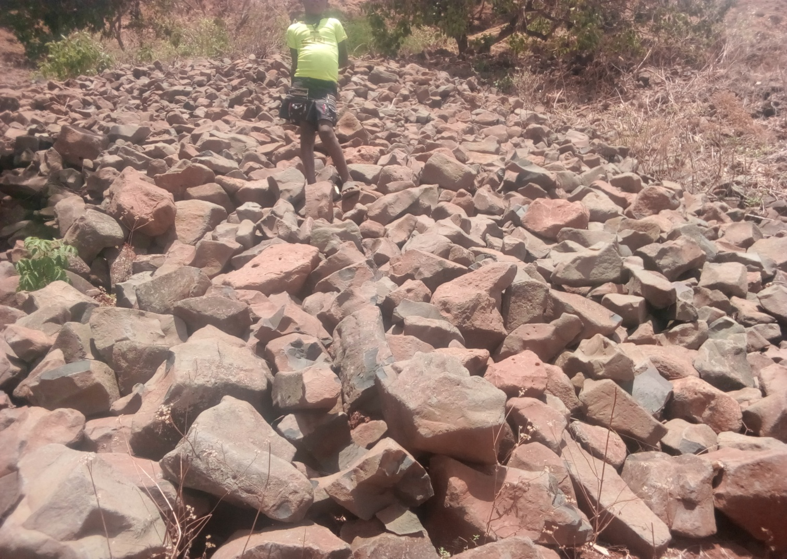
Plate 2 slightly weathered different sizes of colluviums rocks on the foot of cliff areas.
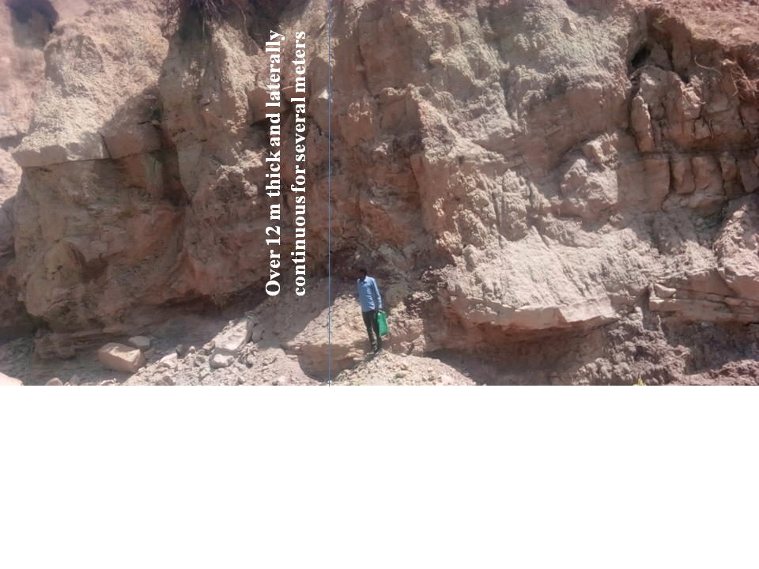
Plate 4 Light to reddish color of Mudstone well exposed on the local name of Argoshesh gorge at GPS reading of long. 37^{ο} 40׳ 40 ״, lat 10^{ο} 13 ׳ 30״ and alt. 1545 m.
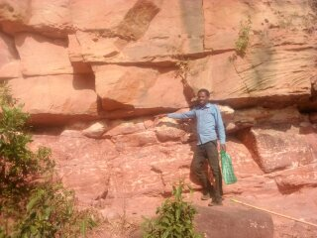
Plate 6 A horizontally interbedded two to three meters thick and laterally continuous fresh to slightly weathered brown and slight rusty red Siltstone is preserved on the cliff of Wuseta River.

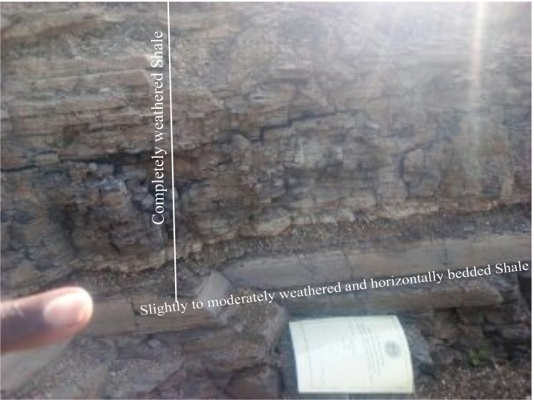
Plate 7 Stream cut exposures of horizontally bedded moderately to completely weathered Shale. The individual thin layers are easily split from its bed rock formation.at GPS reading of long. 37^{ο} 39 ׳ 58״, lat 10^{ο} 13 ׳ 89״ and alt. 2119 m.
Iv. Supplementary Tables

Table4. 1 structural measurements
Lithologic unit | Geologic structure | Strike | Dip direction | Dip amount
Aphanitic basalt | Fault | 006^{ο} | 096^{ο} | 33^{ο}
Aphanitic basalt | Fault | 012^{ο} | 102^{ο} | 75^{ο}
Aphanitic basalt | Fault | 021^{ο} | 111^{ο} | 80^{ο}
Aphanitic basalt | Fault | 005^{ο} | 275^{ο} | 35^{ο}
Aphanitic basalt | Fault | 012^{ο} | 282^{ο} | 75^{ο}
Aphanitic basalt | Fault | 021^{ο} | 291^{ο} | 80^{ο}
Aphanitic basalt | Joint  (columnar joint) | 025^{ο}
Aphanitic basalt | Joint  (columnar joint) | 011^{ο}
Aphanitic basalt | Joint  (columnar joint) | 008^{ο}
Aphanitic basalt | Joint  (columnar joint) | 022^{ο}
Sandstone | Joint | 042^{ο}
Sandstone | Joint | 010^{ο} | -
Sandstone | Bedding | 175^{ο} | - | 0^{ο}
Sandstone | Bedding | 005^{ο} | - | 0^{ο}
Shale | Bedding | 085^{ο} | - | 0^{ο}
Table 2 GPS reading field data to estimate the potentials exposures of different rock units
Location (Top of the cliff) |  |  | Location (Foot of the cliff) |  |  | dominant  rock units | Thickness  (m)
Long. | Latitude | Alt (m) | Long. | latitude | Alt.(m) | dominant  rock units | Thickness  (m)
37^{ο} 43’ 00” | 10 ^{ο} 13’ 36” | 1626 | 37^{ο} 42’ 51” | 10 ^{ο} 13’ 29” | 1518 | Sandstone | 108
37^{ο} 42’ 28” | 10 ^{ο} 13’ 20” | 1618 | 37^{ο} 42’ 32” | 10 ^{ο} 13’ 16” | 1505 | Sandstone | 113
37^{ο} 42’ 21” | 10 ^{ο} 13’ 10” | 1662 | 37^{ο} 42’ 26” | 10 ^{ο} 13’ 08” | 1549 | Sandstone | 113
37^{ο} 42’ 20” | 10 ^{ο} 13’ 04” | 1626 | 37^{ο} 42’ 23” | 10 ^{ο} 12’ 57” | 1485 | Sandstone | 141
37^{ο} 42’ 11” | 10 ^{ο} 13’ 01” | 1624 | 37^{ο} 42’ 11” | 10 ^{ο} 12’ 49” | 1474 | Sandstone | 151
37^{ο} 41’ 58” | 10 ^{ο} 13’ 01” | 1650 | 37^{ο} 41’ 56” | 10^{ο} 12’ 48” | 1463 | Sandstone | 187
37^{ο} 41’ 49” | 10 ^{ο} 13’ 04” | 1651 | 37^{ο} 41’ 42” | 10 ^{ο} 12’ 43” | 1456 | Sandstone | 195
37^{ο} 41’ 13” | 10 ^{ο} 12’ 59” | 1709 | 37^{ο} 41’ 13” | 10 ^{ο} 12’ 26” | 1442 | Sandstone | 267
37^{ο} 41’ 01” | 10 ^{ο} 13’ 00” | 1697 | 37^{ο} 40’ 45” | 10 ^{ο} 12’ 57” | 1491 | Sandstone | 206
37^{ο} 41’ 08” | 10 ^{ο} 13’ 27” | 1708 | 37^{ο} 40’ 52” | 10^{ο} 13’ 27” | 1523 | Sandstone | 186
37^{ο} 40’ 37” | 10 ^{ο} 13’ 29” | 1638 | 37^{ο} 40’ 52” | 10^{ο} 13’ 27” | 1519 | Sandstone | 120
37^{ο} 40’ 50” | 10 ^{ο} 13’ 46” | 1597 | 37^{ο} 41’ 00” | 10^{ο} 13’ 45” | 1545 | Sandstone | 52
37^{ο} 41’ 10” | 10 ^{ο} 13’ 40” | 1713 | 37^{ο} 41’ 00” | 10^{ο} 13’ 45” | 1544 | Sandstone | 169
37^{ο} 39’ 49” | 10 ^{ο} 12’ 05” | 1598 | 37^{ο} 40’ 06” | 10^{ο} 11’ 46” | 1399 | Sandstone | 199
37^{ο} 40’ 18” | 10 ^{ο} 12’ 36” | 1613 | 37^{ο} 40’ 20” | 10^{ο} 12’ 02” | 1413 | Sandstone | 201
37^{ο} 40’ 31” | 10 ^{ο} 13’ 04” | 1581 | 37^{ο} 40’ 42” | 10^{ο} 13’ 01” | 1499 | Sandstone | 82
37^{ο} 40’ 38” | 10 ^{ο} 13’ 26” | 1600 | 37^{ο} 40’ 47” | 10^{ο} 13’ 17” | 1515 | Sandstone | 84
37^{ο} 41’ 59” | 10 ^{ο} 12’ 25” | 1646 | 37^{ο} 41’ 51” | 10^{ο} 12’ 36” | 1497 | Sandstone | 149
37^{ο} 41’ 23” | 10 ^{ο} 12’ 16” | 1582 | 37^{ο} 41’ 21” | 10^{ο} 12’ 27” | 1469 | Sandstone | 114
37^{ο} 41’ 01” | 10 ^{ο} 12’00” | 1579 | 37^{ο} 40’ 55” | 10^{ο} 12’15” | 1454 | Sandstone | 125
37^{ο} 40’ 34” | 10 ^{ο} 11’ 47” | 1579 | 37^{ο} 40’ 18” | 10^{ο} 11’ 54” | 1424 | Sandstone | 156
37^{ο} 40’ 31” | 10 ^{ο} 11’ 36” | 1573 | 37^{ο} 40’ 07” | 10^{ο} 11’ 37” | 1408 | Sandstone | 165
37^{ο} 40’ 32” | 10 ^{ο} 12’ 78” | 1760 | 37^{ο} 40’ 64” | 10^{ο} 12’ 59” | 1510 | Sandstone | 250

