Vitex rotundifolia L. f. Engineered Microbial Interaction Reverse Desertification: Nitrogen-Fixing Consortia Drive Ecosystem Restoration in Sandy Wetlands of Poyang Lake
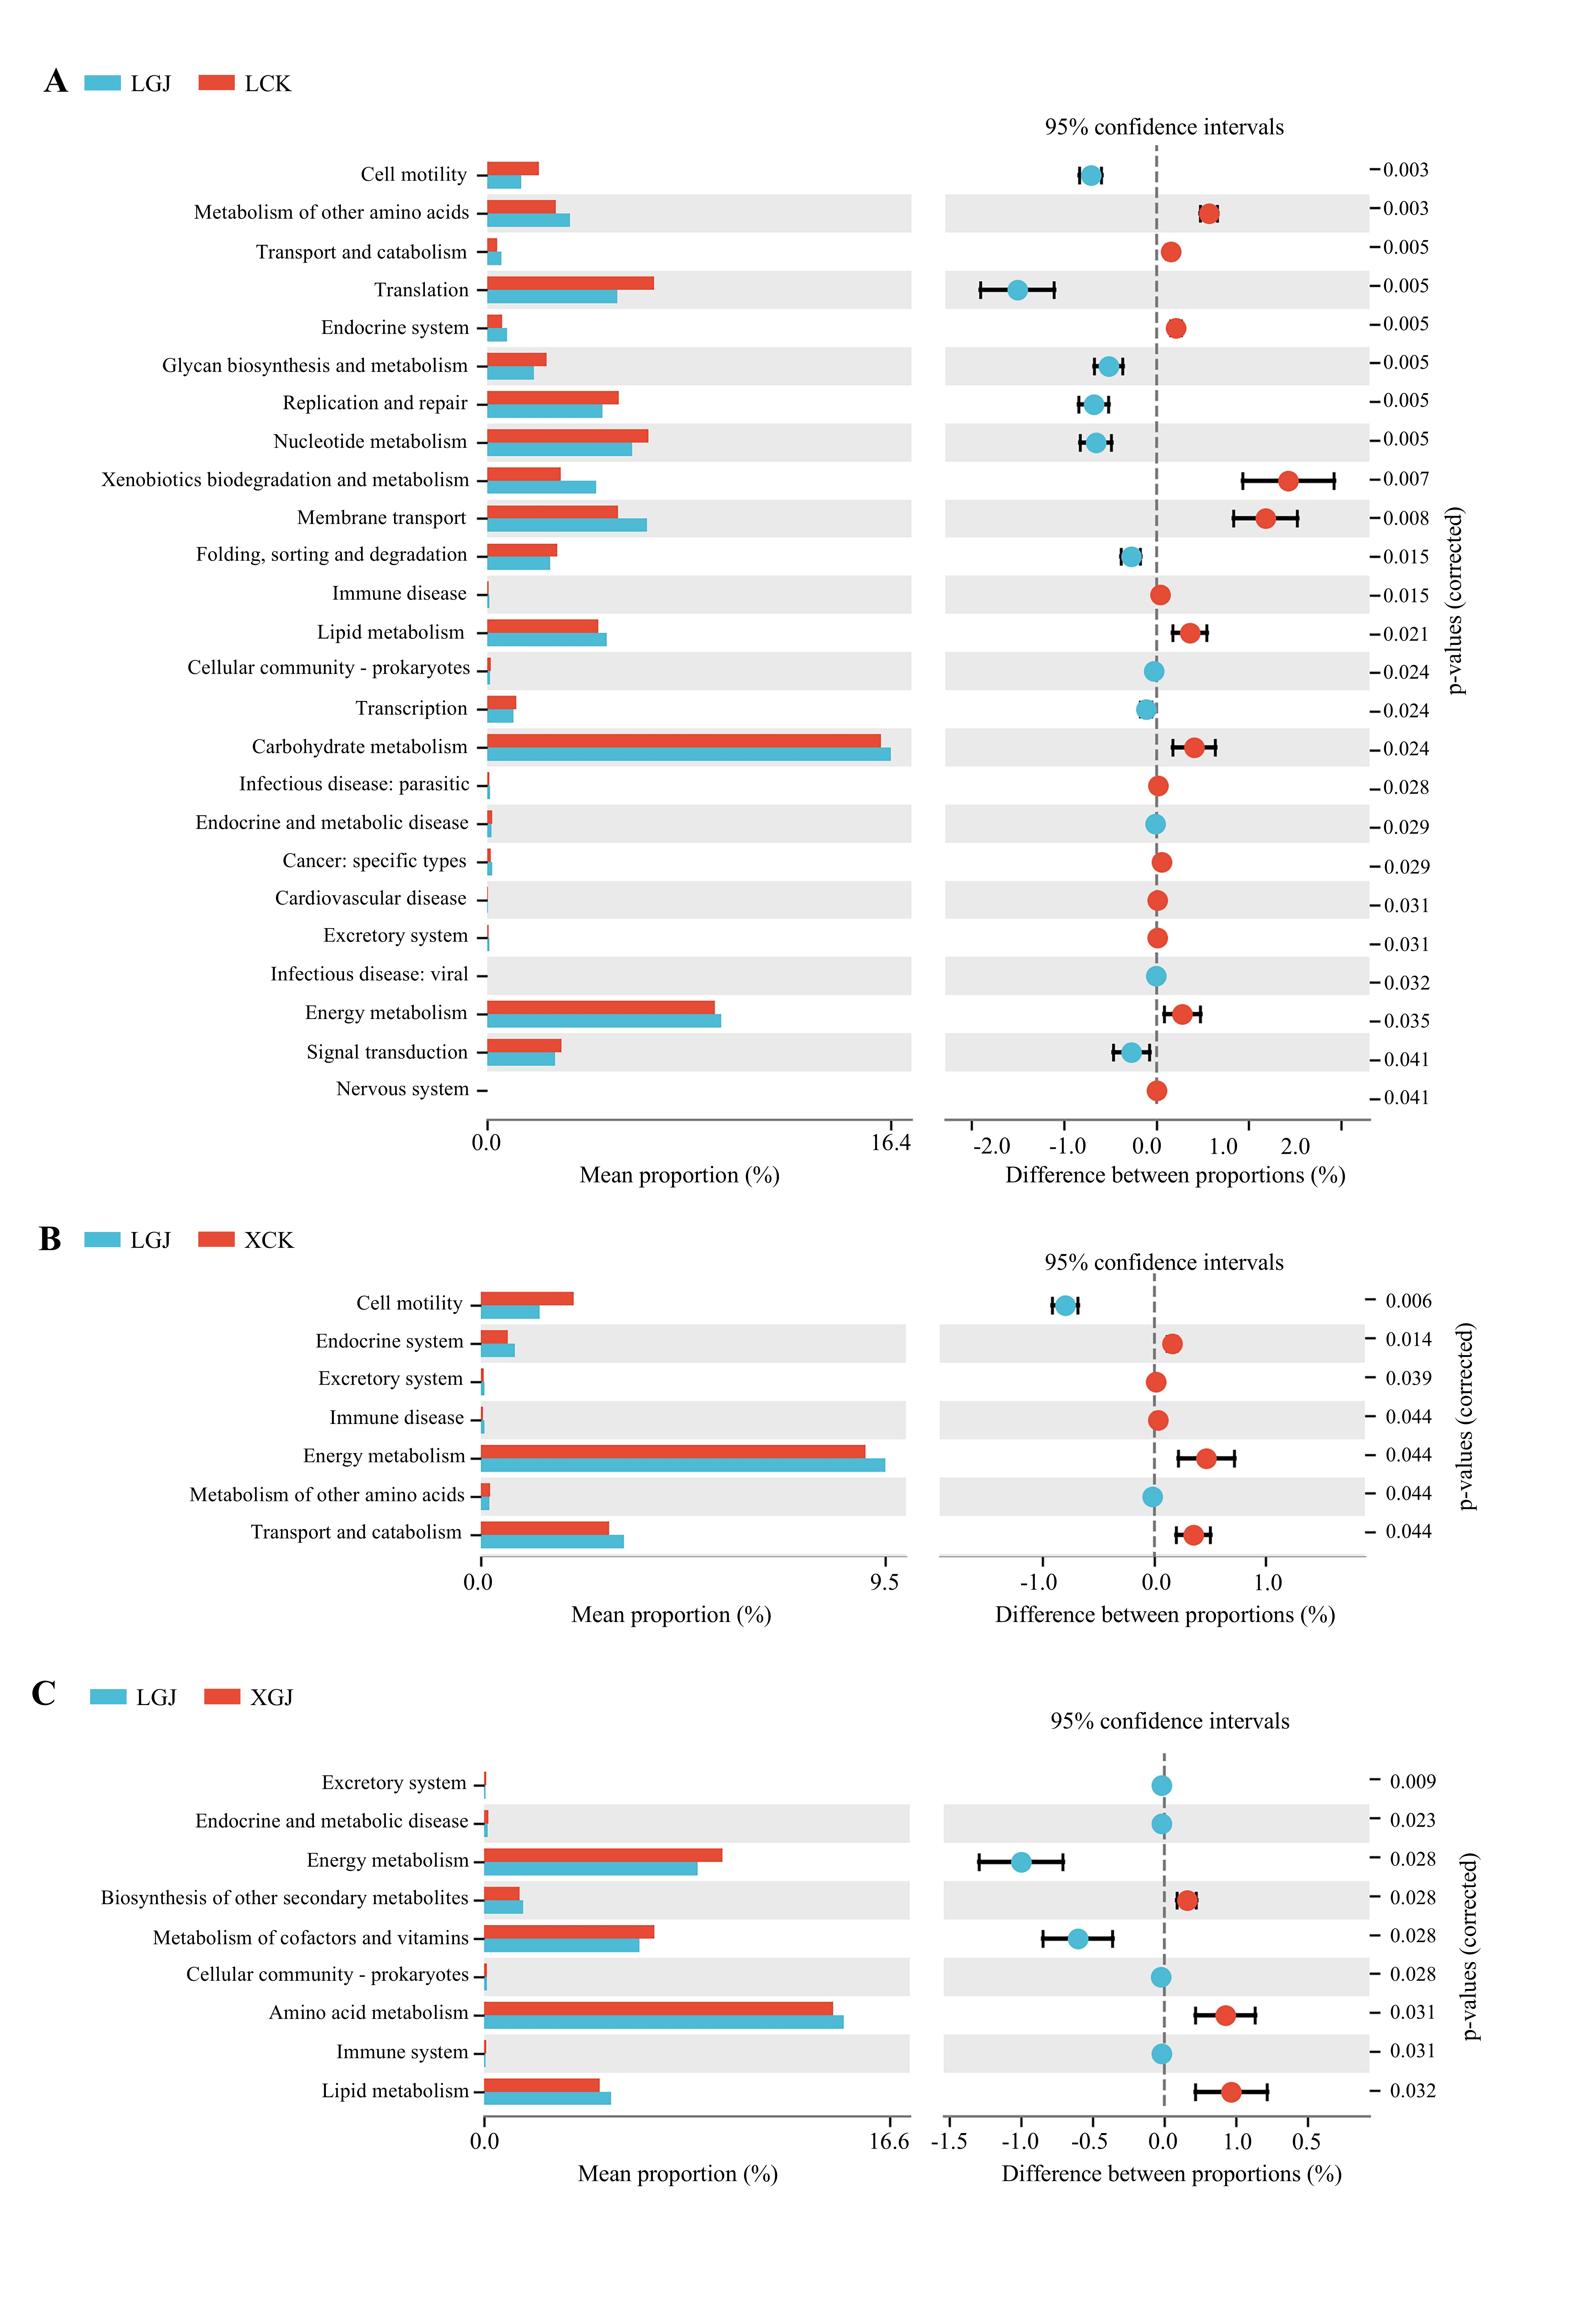
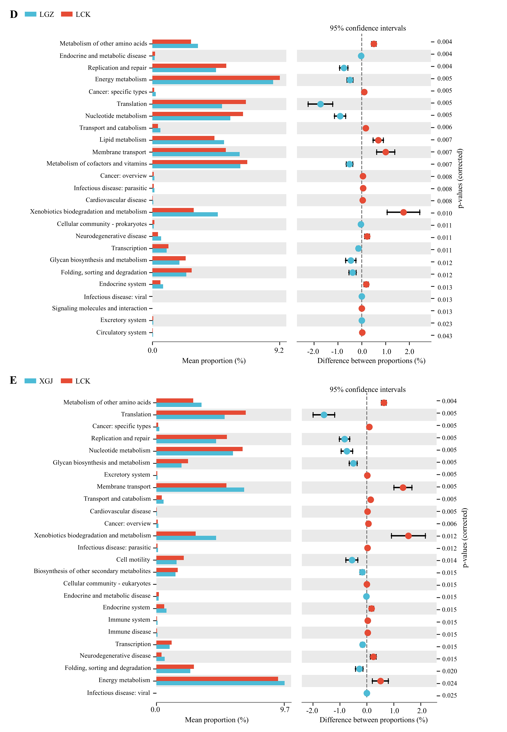
Supplementary Fig S1
Bar chart of functional differences (KEGG level 2). (A-E) Pairwise comparison. A p-value less than 0.05 indicates a significant difference, while a p-value less than 0.01 indicates an extremely significant difference.

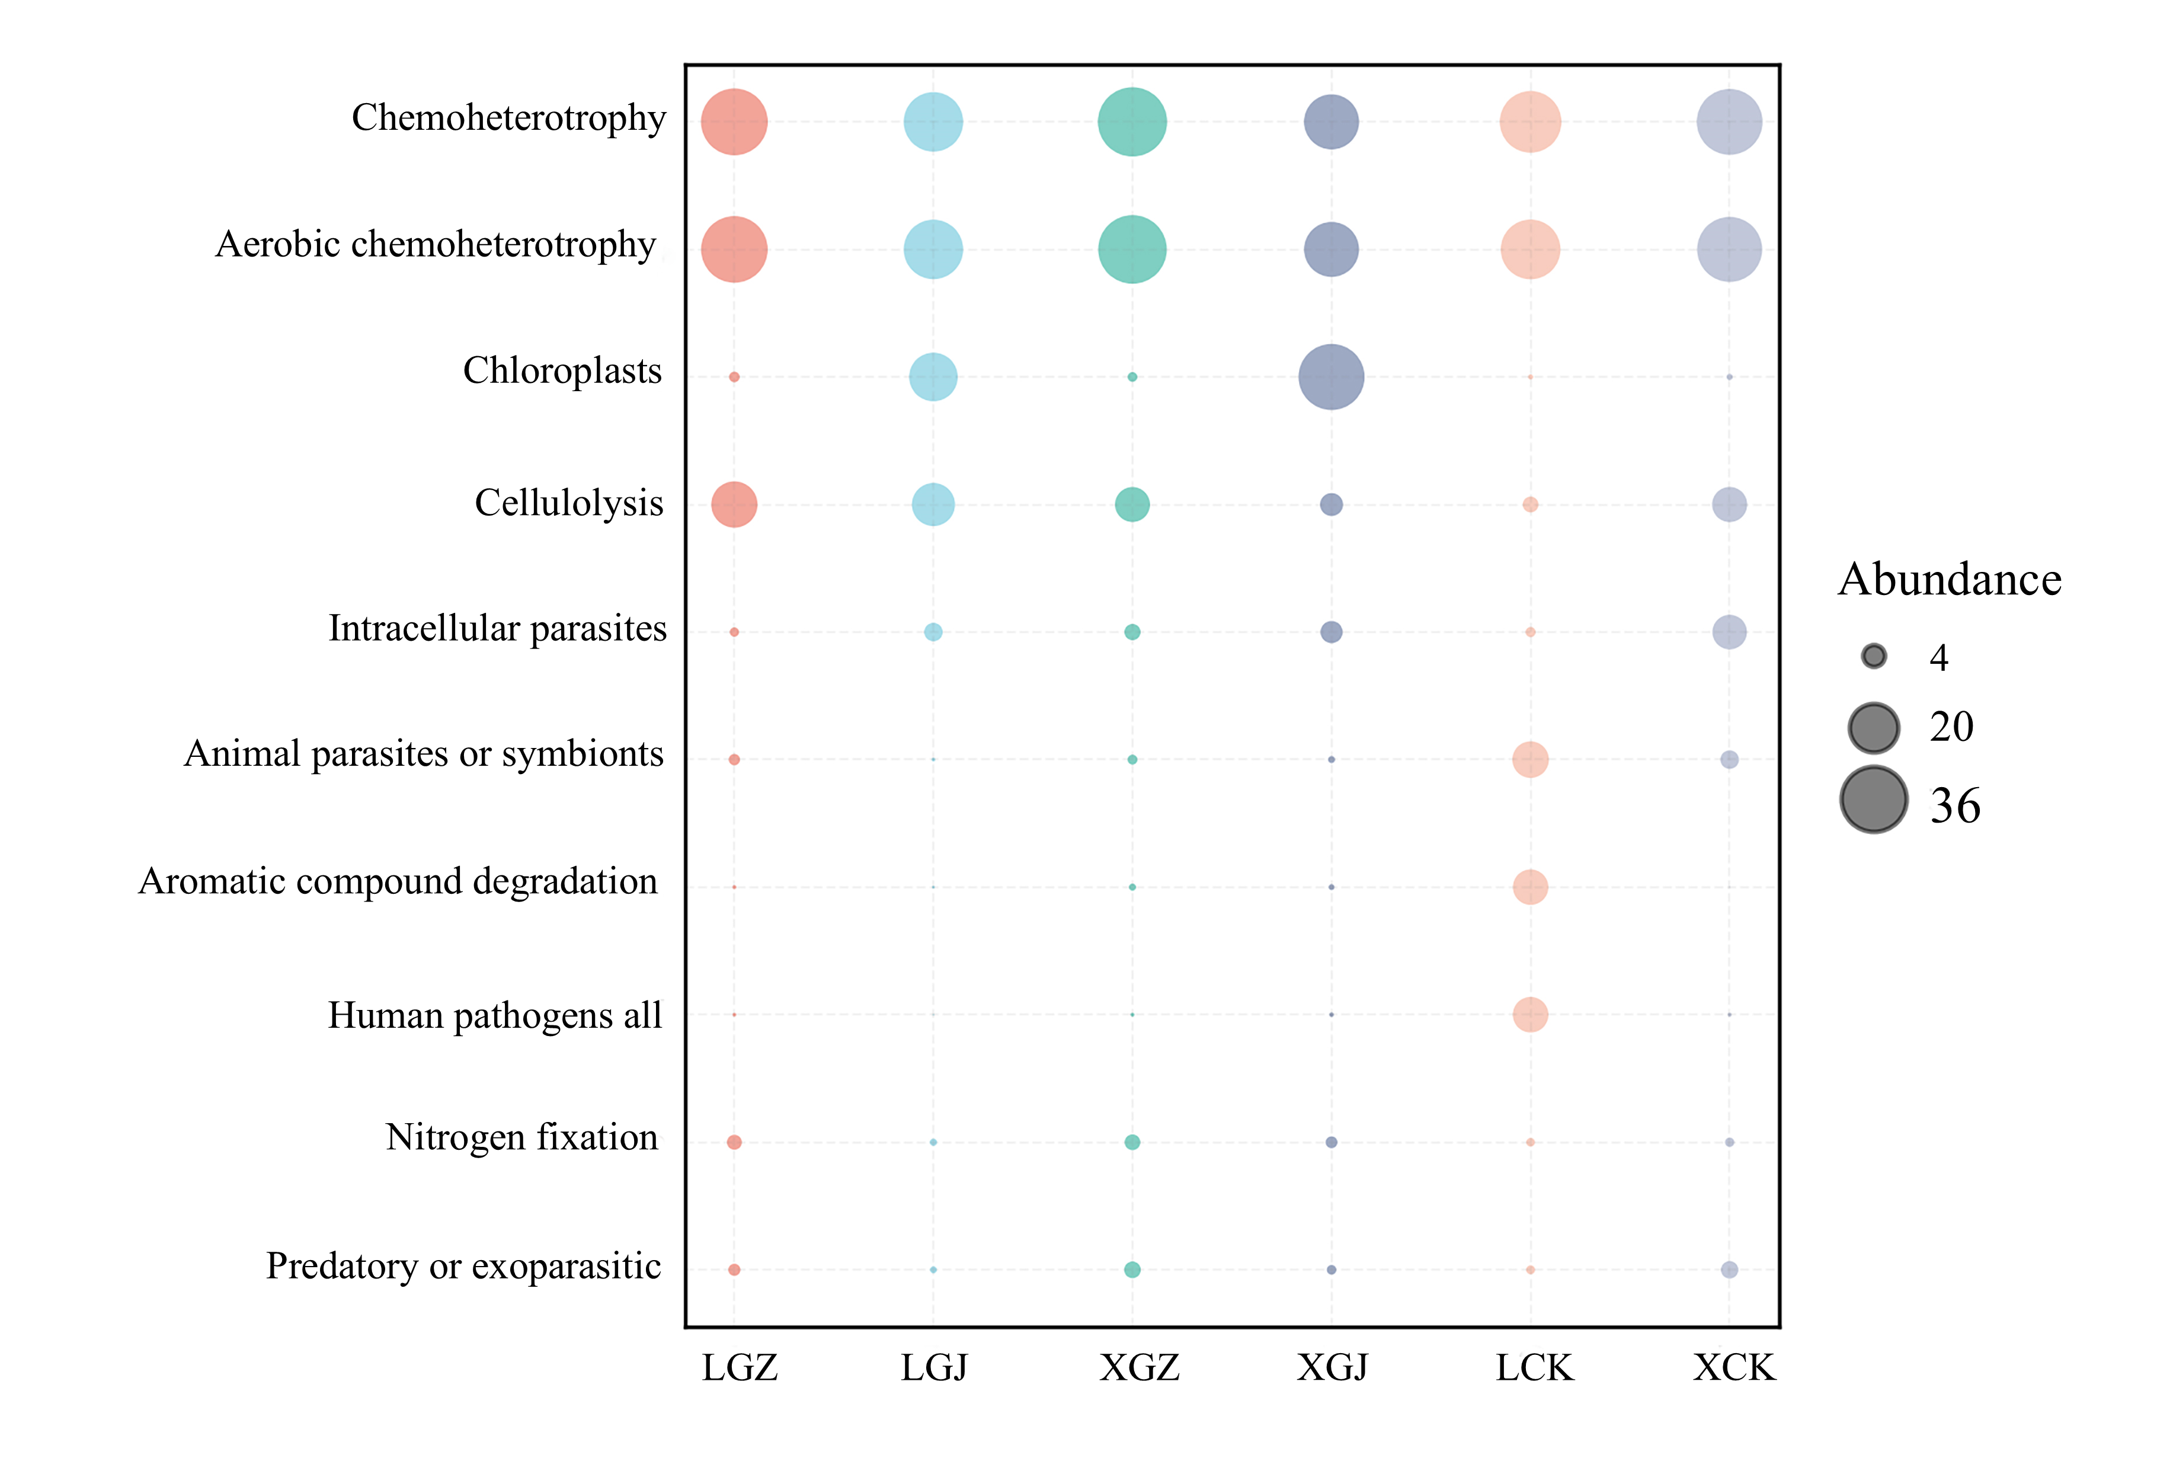
Supplementary Fig S2
Abundance bubble map. Bubble size and color indicate the abundance and classification of the genus, respectively

