Supplementary Information for

A heavy molybdenum reservoir in Neoarchean seawater tracks extensive iron oxidation

Geological Background
North China Craton
As the largest craton in China, the North China Craton (NCC) covers a total area of 1500,000 km². It consists of multiple Archean to Paleoproterozoic metamorphic basement terranes that are overlain by unmetamorphosed Mesoproterozoic to Cenozoic cover (e.g., Zhao and Cawood, 2012). The Precambrian basement is generally proposed to have formed by the amalgamation of the Eastern and the Western blocks along the Trans-North China Orogen (TNCO) in the Paleoproterozoic (Fig. 2; Zhao and Cawood, 2012). Unlike other cratons, the NCC records a long history of Archean magmatism from 3.8 to 2.5 Ga (Wan et al., 2023), but is dominated by Neoarchean igneous rocks that were formed during two magmatic events at 2.8–2.7 Ga and 2.6–2.5 Ga (Zhao and Zhai, 2013). In contrast to the limited exposure of 2.8–2.7 Ga rocks (Wan et al., 2023), the 2.6–2.5 Ga rocks comprise approximately 80% of the Archean basement in the NCC (Zhao and Cawood, 2012). This is consistent with the occurrence of significant tectonic-thermal events and U-Pb zircon age peaks around 2.5 Ga that differ from those typically found in most other cratons worldwide, where major events and age peaks typically occurred around 2.7 Ga (Liou et al., 2022; Wan et al., 2023). The lithotectonic assemblages from 2.6 to 2.5 Ga are dominated by tonalite-trondhjemite-granodiorite gneisses, ultramafic to mafic intrusive rocks, and ~2.5 Ga charnockite and granites, with lesser amounts of 2.6–2.5 Ga bimodal volcanic and sedimentary supracrustal rocks (e. g., Zhao and Cawood, 2012). These assemblages can be classified into high-grade gneiss complexes and low- to medium-grade granite-greenstone belts.
There are notable differences existing between the 2.6–2.5 Ga lithotectonic assemblages in the Eastern and Western blocks of the NCC and those in the TNCO regarding both the timing of metamorphism and structural patterns (Zhao et al., 2001). Late Archean rocks in the Eastern and Western blocks of the NCC are characterized by gneiss domes that have undergone polyphase deformation and greenschist- to granulite-facies metamorphism around 2.5 Ga (Zhao and Zhai, 2013). In contrast, the rocks in the TNCO occur as linear structural belts that experienced a regional metamorphic event at ~1.85 Ga (Zhao and Zhai, 2013). The tectonic setting of Neoarchean rocks in the Eastern Block of the NCC has long been debated, with one perspective advocating for a continental magmatic arc setting (e.g., Wan et al., 2012; Zhai, 2022), while the other preferring a mantle plume model (e.g., Zhao et al., 2001). Conversely, the 2.6–2.5 Ga high-grade gneiss terranes and low-grade granite-greenstone belts in the TNCO display structural and metamorphic characteristics similar to those of other Paleoproterozoic lithological elements typical of active continental margin arcs and continent-continent collisional belts (e.g., Zhao et al., 2001).

The 2565 Ma Xiaolaihe banded iron formation, Qingyuan greenstone belt
The Qingyuan greenstone belt is located on the northern margin of the North China Craton (NCC), covering an area of ~25,000 km². It consists dominantly of late Neoarchean (2.57-2.53 Ga) plutons, covering nearly 70% of the area, and supracrustal rocks. The supracrustal rocks are subdivided into three formations (from the bottom up): the Shipengzi, Hongtoushan, and Nantianmen formations. Banded iron formations (BIFs) are hosted in each, for instance, the Xiaolaihe and Yujiabu BIFs, the Taiyanggou BIF, and the Xiadianzi BIF, occur in the upper part of the Shipengzi Formation, the Hongtoushan and Nantianmen formations, respectively (Fig. S1). The Xiaolaihe BIF occurs in the upper part of the Shipengzi Formation and is interbedded with meta-volcanic rocks (meta-basalts and -dacites), which have undergone granulite-facies metamorphism (Peng et al., 2018, 2019). The Xiaolaihe BIF consists of alternating magnetite- and silicate-rich microbands (0.05–5 mm thick), among which individual microbands are straight and continuous. The mineral assemblage is composed of magnetite, quartz, pyroxene, cummingtonite, and minor calcite. The age of this BIF is constrained by SIMS U-Pb zircon dating of a biotite plagioclase gneiss (meta-dacite) interlayer to 2565 ± 8 Ma (Peng et al., 2019).

The 2560 Ma Nanfen banded iron formation, Anshan Group
The Anshan-Benxi area is situated in the northeastern part of the NCC and is one of a few documented localities worldwide that has preserved crustal remnants as old as 3.8 Ga (Liu et al., 1992). The region has seen approximately 20 billion tonnes of iron (Fe) ore, hosted in BIFs, produced from past and current mines (Zhang et al., 2012, 2016). This makes the Anshan-Benxi area the largest Fe metallogenic province in China. The Anshan-Benxi terrane covers an area of approximately ~7,500 km², extending from the Xi’anshan district in the west, through the Gongchangling district, to the Nanfen district in the east (Zhai et al., 1990). It comprises Eoarchean to Mesoarchean rocks and Neoarchean plutons and supracrustal rocks, many of which were unconformably covered by sediments of the Paleoproterozoic Liaohe Group. The Archean units include Eoarchean to Mesoarchean gneisses, granites, and supracrustal rocks (e.g., Liu et al., 1992, 2008; Song et al., 1996; Wan et al., 2012a; Wang et al., 2016) and Neoarchean (~2.56-2.51 Ga) metamorphosed volcanic and sedimentary rocks (Wang et al., 2017a; Guo et al., 2022), which are collectively assigned to the Anshan Group (Zhou, 1994). The Anshan Group is intruded by extensive and voluminous ~2.5 Ga granitoids (e.g., Wan et al., 2012b, 2015). The supracrustal rocks either are interlayered with the orthogneisses or occur as massive blocks of various dimensions. In places, a few occur as xenoliths within syn-tectonic plutonic gneisses. Geological relationships between lithotectonic assemblages and supracrustal sequences of diverse episodes suggest that they were tectonically assembled (Wang et al., 2017a).
The late Neoarchean supracrustal rocks consist primarily of metamorphosed basaltic rocks (amphibolites), BIFs (e.g., Dataigou, Waitoushan, and Qidashan), and siliciclastic and/or volcaniclastic sedimentary rocks (e.g., quartz-mica schists, biotite-chlorite-quartz schists, and biotite gneisses) (Zhou, 1994; Wang et al., 2017a; Guo et al., 2022) (Fig. S1). Patterns of regional deformation can be locally complex (e.g., polyphase folding and multiple stages of fault displacement), and the metamorphic grade typically ranges between upper greenschist and upper amphibolite facies. Previous geochemical investigations in the Anshan-Benxi region have shown that the Neoarchean metamorphosed volcanic and sedimentary rocks display geochemical characteristics that resemble those at Phanerozoic subduction zones, suggesting that they formed in a back-arc basin along the ancient continental margin (e.g., Wang et al., 2016, 2017a; Guo et al., 2022).
The Nanfen BIF is situated to the south of the Benxi city, covering an area of ca. 4.6 km². It is commonly interlayered with amphibolite (meta-basalt) and mica quartz schist (meta-arenite). The BIF, consisting of alternating quartz- and magnetite-rich microbands, is dominated by quartz and magnetite with various accessory Fe-rich silicate minerals (e.g., hornblende, chlorite, and biotite) due to amphibolite-facies metamorphism (Zhu et al., 2015). Results of LA-ICP-MS U-Pb dating on a group of igneous zircons separated from amphibolites that are spatially associated with the BIF yield a discordant line with an upper intercept of 2554 ± 14 Ma, interpreted to reflect the formation age of this BIF (Zhu et al., 2015).

The 2550 Ma Gongchangling banded iron formation, Anshan Group
The Gongchangling BIF is located in the middle part of the Anshan-Benxi area and also occurs in the Anshan Group. It is closely associated with a series of metamorphosed volcanic and sedimentary rocks that experienced amphibolite-facies metamorphism, and include from bottom up: (i) lower amphibolite (meta-basalts); (ii) mica quartz schist (meta-arenite); (iii) one BIF layer; (iv) mica quartz schist; (v) one BIF layer; (vi) biotite gneiss (meta-volcaniclastic rocks) interlayered with BIF layers; (vii) amphibolite interlayered with BIF layers; and (viii) siliceous rock (Sun et al., 2014). The BIF is mainly composed of alternating magnetite-rich and quartz-rich microbands. The magnetite-rich microbands consist of magnetite with lesser amounts of quartz, whereas the quartz-rich microbands are comprised of quartz and minor actinolite and magnetite.
Formation age of the BIF was constrained by Wan et al. (2012c) and Li et al. (2016). They reported zircon SHRIMP U-Pb ages of 2528 ± 10 Ma and 2539 ± 25 Ma for biotite gneiss interlayered with the BIF, respectively. Han et al. (2014) and Cui (2014) also conducted zircon U-Pb dating analyses on amphibolites that are spatially associated with the BIF applying SHRIMP and LA-ICP-MS methods, respectively. These U-Pb analyses yielded ages of 2554 ± 12 Ma and 2548 ± 12 Ma, respectively. Therefore, the Gongchangling BIF is proposed to have been deposited between 2554 and 2528 Ma.

The 2540 Ma Dong’anshan banded iron formation, Anshan Group
The Dong’anshan BIF is situated in the Anshan area and occurs in the upper part of metamorphosed volcanic and sedimentary rocks of the Anshan Group. The BIF is conformably interbedded with chlorite quartz schist (meta-shale) that is uncomformably overlain by the Paleoproterozoic Liaohe Group. Igneous rocks have a wide geographic distribution in the study area, consisting predominantly of the ~3.0 Ga Dong’anshan granite and Cretaceous granite porphyry. The Mesoarchean granite occurs on the footwall of the Neoarchean supracrustal sequence and contacts the BIF at a fault. Due to relatively low-grade metamorphism (upper greenschist to lower amphibolite facies), the Dong’anshan BIF preserves various types of Fe-rich minerals and is comprised mainly of magnetite, siderite, stilpnomelane, chlorite, and cummingtonite. Li et al. (2016) obtained a SHRIMP U-Pb zircon age of 2544 ± 8 Ma for the chlorite quartz schist interlayered with the BIF and interpreted it as the maximum depositional age of the BIF.

The 2540 Ma Sijiaying banded iron formation, Luanxian Group
A large number of BIFs are exposed in Eastern Hebei, such as Shuichang, Shirengou, Erma, Xingshan, Sijiaying, and Macheng BIFs. Collectively, these make Eastern Hebei the second largest Fe metallogenic province after Anshan-Benxi in the NCC (Wang et al., 2017b). The Sijiaying BIF is the largest and most laterally extensive in Eastern Hebei and occurs in the lower succession of the Luanxian Group. This group comprises upper greenschist- to lower amphibolite-facies metamorphosed volcanic and sedimentary rocks. They are dominated by biotite plagioclase gneiss (meta-andesite), biotite leptynite (meta-dacitic tuffaceous rock), amphibolite (meta-basalt), and minor garnet hornblende leptynite (meta-dacite) (Fig. S1). The intermediate-felsic meta-volcanic rocks are up to hundreds of meters thick and are intercalated with the Sijiaying BIF of various thickness, from less than 10 m to hundreds of meters (Wang et al., 2017b). The BIF consists of successive quartz-rich (white) and magnetite-rich (black) bands of between <1 and 50 mm thickness. A few centimeter-scale mesobands are composed of several millimeter-scale microbands. The mineral assemblage is simple, consisting predominantly of quartz and magnetite with lesser amounts of actinolite and hornblende.
Cui et al. (2014) reported three SIMS U-Pb zircon dates for meta-volcanic rocks associated with the BIF that constrain the depositional age. These include a meta-dacitic flow (hornblende plagioclase gneiss) at the base of the BIF sequence which yielded an age of 2543 ± 14 Ma, a 2537 ± 13 Ma meta-dacitic tuffaceous rock (biotite leptynite) interlayered with the BIF further up, and a 2535 ± 8 Ma meta-andesite lava flow (biotite plagioclase gneiss) within the upper part of the sedimentary succession.

The 2530 Ma Ekou banded iron formation, Wutai greenstone belt
The Wutai greenstone belt is situated in the middle part of the NCC and consists of Neoarchean granitic plutons and metamorphosed volcanic and sedimentary rocks, traditionally named the Wutai Group. Based on lithologies and metamorphic grades, the Wutai Group is divided into three subgroups. From bottom up, these are the Shizui, Taihuai, and Gaofan subgroups (Fig. S1). The Shizui Subgroup consists of peridotite, oceanic tholeiite, dacite, rhyolite, chert, BIFs, sandstone, siltstone, and minor limestone that have experienced amphibolite-facies metamorphism (Zhao et al., 2007). The Taihuai Subgroup comprises felsic volcanic rocks, BIFs and tholeiites that have experienced metamorphosed to greenschist facies. The Gaofan Subgroup contains conglomerates, quartz greywackes, siltstones, limestones, and minor mafic to felsic volcanic rocks that have experienced subgreenschist-facies metamorphism. The Ekou BIF occurs in the upper Baizhiyan Formation of the Taihuai Subgroup and is closely associated with chlorite quartz schist (meta-shale), mica quartz schist (meta-arenite), and amphibolite (meta-basalt). Based on the mineral assemblage, the BIF can be divided into two facies: oxide and silicate facies. The oxide facies is dominant in the Ekou BIF and comprises magnetite-rich microbands alternating with quartz-rich microbands. In contrast to the oxide facies, the silicate facies contains various types of silicate minerals (e.g., cummingtonite and actinolite) other than magnetite and quartz. In addition, there are some carbonate minerals (e.g., ankerite and siderite) within the BIF (Men et al., 2020). Wilde et al. (2004) obtained a SHRIMP U-Pb zircon age of 2524 ± 10 Ma for meta-andesite overlain by amphibolite and BIF in the Ekou area, representing the formation age of the Ekou BIF.

The 2530-2510 Ma Qidashan banded iron formation, Anshan Group
The Qidashan BIF is located in the Anshan area of the NCC and occurs in the upper part of the Anshan Group. Individual layers of the BIF vary commonly from less than 10 m to greater than 50 m. The BIF is closely associated with meta-sedimentary rocks (e.g., biotite-chlorite-quartz schist) with minor meta-volcaniclastic (i.e., biotite gneiss) and meta-mafic volcanic rocks (i.e., amphibolite), which have undergone lower amphibolite-facies metamorphism. These clastic metasediments are commonly interbedded with, underlain, and capped by the BIF layer. Contacts are sharp and well-defined with no sign of grading, erosion, or intermixing. The biotite gneisses commonly occur at the base of the total BIF sequence, varying in thickness from 1.5 to 10 m. These clastic metasedimentary rocks and BIF transition upward into amphibolites, which then grade upward into the BIF and interbedded meta-sedimentary rocks. The mineralogy of the BIF is dominated by quartz and magnetite with variable amounts of calcite and silicate minerals (e.g., grunerite, cummingtonite, tremolite, and minor actinolite and chlorite).
There are several important geochronological constraints on the Qidashan BIF. The youngest group of detrital zircons from both biotite gneiss and biotite-chlorite-quartz schist associated with the BIF constrains their maximum depositional age at ~2.53 Ga (Wang and Zhang, 1995; Li et al., 2016; Wang et al., 2017a). In combination with the oldest metamorphic age of ~2.51 Ga for these supracrustal rocks (Wang et al., 2017a), the depositional age of the Qidashan BIF can be constrained between 2.53 and 2.51 Ga.

Potential challenges for reconstructing the Neoarchean marine molybdenum isotope composition
It is challenging to determine whether much of the current molybdenum isotope (δ⁹⁸Mo) record tracks an ancient seawater signature. Transfer of the seawater δ⁹⁸Mo value to marine sediments today is dependent on local redox conditions and bottom water Mo availability (Kendall, 2021). Under euxinic conditions with dissolved H₂S concentrations above 11 µM, MoO₄²⁻ is almost quantitatively transformed to thiomolybdate (MoS₄²⁻) (Helz et al., 2011), which, assuming a constant pH and without substantial deep-water renewal, is readily removed from solution either by adsorption onto organic matter (Dahl et al., 2010) or by the formation of authigenic Fe-Mo-sulfides (Helz et al., 2011). Consequently, the δ⁹⁸Mo in black shales deposited below such a strongly euxinic water column should mirror the isotopic composition of coeval seawater (Nägler et al., 2011). Below this threshold value of 11 µM the incomplete transformation of MoO₄²⁻ favors the lighter Mo to be incorporated within the MoS₄²⁻ of sediments (Nägler et al., 2011). Between these two redox scenarios (oxic and euxinic), authigenic Mo enrichments in sediments show a broad range in their isotopic composition and are mainly controlled by redox gradients in the sediment pore fluids, induced by early diagenesis (e.g., Dahl et al., 2010; Nägler et al., 2011; Romaniello et al., 2016).
Accordingly, the majority of the seawater δ⁹⁸Mo record has been generated using black shales deposited under euxinic conditions. However, suitable shales are not ubiquitous throughout the geologic record. Furthermore, while Fe speciation analyses may be used to indicate euxinic depositional conditions, it is difficult to prove that any particular threshold guarantees sufficient H₂S to quantitatively scavenge Mo (Voegelin et al., 2010; Romaniello et al., 2016). Hence, the maximum δ⁹⁸Mo value recorded in black shales may only be taken as a minimum estimate for the composition of ancient seawater, which may have been isotopically heavier.
Non-skeletal carbonates may directly record the Mo isotope composition of seawater, therefore avoiding the need to demonstrate highly euxinic depositional conditions in shales (Voegelin et al., 2010). However, application of the δ⁹⁸Mo values in carbonates is complicated by significantly lower Mo contents (generally <200 ppb; Thoby et al., 2019), which make them susceptible to diagenetic resetting or dilution by detrital materials, the presence of organic matter, Fe-Mn oxides, or pore-water sulfide during diagenesis (Romaniello et al., 2016; Chen et al., 2021). These factors may lead to a lighter Mo isotope composition than coeval seawater.

References
Chen, X., Romaniello, S.J., Anbar, A.D., 2021. Preliminary exploration of molybdenum isotope fractionation during coprecipitation of molybdate with abiotic and microbial calcite. Chemical Geology 566, 120102.
Cui, M.L., Zhang, L.C., Wu, H.Y., Xu, Y.X., Li, W.J., 2014. Timing and tectonic setting of the Sijiaying banded iron deposit in the eastern Hebei province, North China Craton: Constraints from geochemistry and SIMS zircon U–Pb dating. Journal of Asian Earth Sciences 94, 240–251.
Cui, P.L., 2014. Metallogenic Tectonic Setting, Metallogenic and Prospecting Models for Precambrian Iron-Formation in the Anshan-Benxi Area. Ph.D. thesis, Jilin University, 1-145.
Dahl, T.W., Anbar, A.D., Gordon, G.W., Rosing, M.T., Frei, R., Canfield, D.E., 2010. The behavior of molybdenum and its isotopes across the chemocline and in the sediments of sulfidic Lake Cadagno, Switzerland. Geochimica et Cosmochimica Acta 74(1), 144-163.
Guo, R.R., Li, Z.H., Liu, S.W., Wang, M.J., Bao, H., Wang, W., Huang, X., Dou, Y.X., 2022. Late Neoarchean geodynamic regime of the northeastern North China Craton: Constraints from metamorphosed volcanic rocks of the Anshan-Benxi greenstone belt. Precambrian Research 371, 106583.
Han, C.M., Xiao, W.J., Su, B.X., Sakyi, P. A., Chen, Z.L., Zhang, X.H., Ao, S.J., Zhang, J.E., Wan, B., Zhang, Z.Y., Wang, Z.M., Ding, J.X., 2014. Formation age and genesis of the Gongchangling Neoarchean banded iron deposit in eastern Liaoning Province: Constraints from geochemistry and SHRIMP zircon U-Pb dating. Precambrian Research 254, 306-322.
Helz, G.R., Bura-Nakić, E., Mikac, N., Ciglenečki, I., 2011. New model for molybdenum behavior in euxinic waters. Chemical Geology 284(3-4), 323-332.
Kendall, B., 2021. Recent advances in geochemical paleo-oxybarometers. Annual Review of Earth and Planetary Sciences 49(1), 399-433.
Li, L.X., Li, H.M., Liu, M.J., Yang, X.Q., Meng, J., 2016. Timing of deposition and tectonothermal events of banded iron formations in the Anshan-Benxi area, Liaoning Province, China: Evidence from SHRIMP U-Pb zircon geochronology of the wall rocks. Journal of Asian Earth Sciences 129, 276-293.
Liou, P., Guo, J., Peng, P., Mitchell, R. N., Mao, M., Jiang, N., Zhai, M., 2022. Crustal growth of the North China Craton at ca. 2.5 Ga. Science Bulletin 67(15), 1553-1555.
Liu, D.Y., Nutman, A.P., Compston, W., Wu, J.S., Shen, Q.H., 1992. Remnants of ≥ 3800 Ma crust in the Chinese part of the Sino-Korean craton. Geology 20(4), 339-342.
Liu, D.Y., Wilde, S.A., Wan, Y.S., Wu, J.S., Zhou, H.Y., Dong, C.Y., Yin, X.Y., 2008. New U-Pb and Hf isotopic data confirm Anshan as the oldest preserved segment of the North China Craton. American Journal of Science 308(3), 200-231.
Men, Y.K., Wang, E.D., Fu, J.F., Jia, S.S., You, X.W., He, Q.W., 2020. Geochemical constraints on the genesis of the Ekou banded iron formation, Shanxi Province, North China. International Journal of Earth Sciences 109, 2851-2868.
Nägler, T.F., Neubert, N., Böttcher, M.E., Dellwig, O., Schnetger, B., 2011. Molybdenum isotope fractionation in pelagic euxinia: Evidence from the modern Black and Baltic Seas. Chemical Geology 289(1-2), 1-11.
Peng, Z.D., Wang, C.L., Tong, X.X., Zhang, L.C., Zhang, B.L., 2018. Element geochemistry and neodymium isotope systematics of the Neoarchean banded iron formations in the Qingyuan greenstone belt, North China Craton. Ore Geology Reviews 102, 562-584.
Peng, Z.D., Wang, C.L., Zhang, L.C., Zhu, M.T., Tong, X.X., 2019. Geochemistry of metamorphosed volcanic rocks in the Neoarchean Qingyuan greenstone belt, North China Craton: Implications for geodynamic evolution and VMS mineralization. Precambrian Research 326, 196-221.
Romaniello, S.J., Herrmann, A.D., Anbar, A.D., 2016. Syndepositional diagenetic control of molybdenum isotope variations in carbonate sediments from the Bahamas. Chemical Geology 438, 84-90.
Song, B., Nutman, A.P., Liu, D.Y., Wu, J.S., 1996. 3800 to 2500 Ma crustal evolution in the Anshan area of Liaoning Province, northeastern China: Precambrian Research 78, 79-94.
Sun, X.H., Zhu, X.Q., Tang, H.S., Zhang, Q., Luo, T.Y., 2014. The Gongchangling BIFs from the Anshan–Benxi area, NE China: petrological–geochemical characteristics and genesis of high-grade iron ores. Ore Geology Reviews 60, 112-125.
Thoby, M., Konhauser, K.O., Fralick, P.W., Altermann, W., Visscher, P.T., Lalonde, S.V., 2019. Global importance of oxic molybdenum sinks prior to 2.6 Ga revealed by the Mo isotope composition of Precambrian carbonates. Geology 47(6), 559-562.
Voegelin, A.R., Nägler, T.F., Beukes, N.J., Lacassie, J.P., 2010. Molybdenum isotopes in late Archean carbonate rocks: implications for early Earth oxygenation. Precambrian Research 182(1-2), 70-82.
Wan, Y., Ma, M., Dong, C., Xie, H., Xie, S., Ren, P., Liu, D., 2015. Widespread late Neoarchean reworking of Meso- to Paleoarchean continental crust in the Anshan-Benxi area, North China Craton, as documented by U-Pb-Nd-Hf-O isotopes: American Journal of Science 315, 620-670.
Wan, Y.S., Dong, C., Liu, D., Kröner, A., Yang, C., Wang, W., Du, L.L., Xie, H. Q., Ma, M., 2012b. Zircon ages and geochemistry of late Neoarchean syenogranites in the North China Craton: a review: Precambrian Research 222, 265-289.
Wan, Y.S., Dong, C.Y., Xie, H.Q., Wang, S.J., Song, M.C., Xu, Z.Y., Wang, S.Y., Zhou, H.Y., Ma, M.Z., Liu, D.Y., 2012c. Formation Ages of Early Precambrian BIFs in the North China Craton: SHRIMP Zircon U-Pb Dating: Acta Geologica Sinica 86, 1447-1478.
Wan, Y.S., Dong, C.Y., Xie, H.Q., Wilde, S.A., Liu, S.J., Li, P.C., Ma, M.Z., Li, Y., Wang, Y.Q., Wang, K.L., Liu, D.Y., 2023. Hadean to early Mesoarchean rocks and zircons in the North China Craton: A review. Earth-Science Reviews 243, 104489.
Wan, Y.S., Liu, D., Nutman, A., Zhou, H., Dong, C., Yin, X., Ma, M., 2012a. Multiple 3.8-3.1 Ga tectono-magmatic events in a newly discovered area of ancient rocks (the Shengousi Complex), Anshan, North China Craton: Journal of Asian Earth Sciences 54-55, 18-30.
Wan, Y.S., Wang, S.J., Liu, D.Y., Wang, W., Kröner, A., Dong, C.Y., Yang, E.X., Zhou, H.Y., Xie, H.Q., Ma, M.Z., 2012. Redefinition of depositional ages of Neoarchean supracrustal rocks in western Shandong Province, China: SHRIMP U–Pb zircon dating. Gondwana Research 21(4), 768-784.
Wang, C.L., Huang, H., Tong, X., Zheng, M., Peng, Z., Nan, J., Zhang, L., Zhai, M., 2016. Changing provenance of late Neoarchean metasedimentary rocks in the Anshan-Benxi area, North China Craton: Implications for the tectonic setting of the world-class Dataigou banded iron formation: Gondwana Research 40, 107-123.
Wang, C.L., Peng, Z.D., Tong, X.X., Huang, H., Zheng, M.T., Zhang, L.C., Zhai, M.G., 2017a. Late Neoarchean supracrustal rocks from the Anshan-Benxi terrane, North China craton: New geodynamic implications from the geochemical record. American Journal of Science 317(10), 1095-1148.
Wang, C.L., Wu, H.Y., Li, W.J., Peng, Z.D., Zhang, L.C., Zhai, M.G., 2017b. Changes of Ge/Si, REE+Y and Sm-Nd isotopes in alternating Fe- and Si-rich mesobands reveal source heterogeneity of the ~2.54 Ga Sijiaying banded iron formation in Eastern Hebei, China. Ore Geology Reviews 80, 363-376.
Wang, C.L., Dong, Z.G., Robbins, L., Zhang, B.L., Peng, Z.D., Tong, X.X., Zhang, L.C., Konhauser, K., 2024. A craton-wide geochemical survey of late Archean banded iron formations in China. Earth and Planetary Science Letters 642, 118879.
Wang, S.L., Zhang, R.H., 1995. U-Pb isotope age of individual zircon from biotite leptynite in the Qidashan iron deposit and its significance. Mineral Deposits 3, 216-219.
Wilde, S.A., Cawood, P.A., Wang, K.Y., Nemchin, A., Zhao, G.C., 2004. Determining Precambrian crustal evolution in China: a case-study from Wutaishan, Shanxi Province, demonstrating the application of precise SHRIMPU–Pb geochronology. In: Malpas, J., Fletcher, C.J.N., Ali, J.R., and Aichison, J.C. (Eds.), Aspects of the Tectonic Evolution of China: Geological Society of London, Special Publication 226, pp. 5–26.
Zhai, M.G., 2022. Radical change in tectonic regime and paleo-environment at the end of Neoarchean evidenced by a unique metal co-existing deposit. Science Bulletin 67, 2438-2448.
Zhai, M.G., Windley, B.F., Sills, J.D., 1990. Archaean gneisses, amphibolites and banded iron-formations from the Anshan area of Liaoning Province, NE China: Their geochemistry, metamorphism and petrogenesis. Precambrian Research 46(3), 195-216.
Zhang, L.C., Wang, C.L., Zhu, M.T., Huang, H., Peng, Z.D., 2016. Neoarchean Banded Iron Formations in the North China Craton: Geology, Geochemistry, and Its Implications. In MG Zhai, Y Zhao and TP Zhao (ed.) Main Tectonic Events and Metallogeny of the North China Craton. Springer Singapore, 85-103.
Zhang, L.C., Zhai, M.G., Wan, Y.S., Guo, J.H., Dai, Y.P., Wang, C.L., Liu, L., 2012. Study of the Precambrian BIF-iron deposits in the North China Craton: Progresses and questions: Acta Petrologica Sinica 28, 3431-3445.
Zhao, G.C., Cawood, P.A., 2012. Precambrian geology of China. Precambrian Research 222, 13-54.
Zhao, G.C., Kröner, A., Wilde, S.A., Sun, M., Li, S.Z., Li, X.P., Zhang, J., Xia, X.P., He, Y.H., 2007. Lithotectonic elements and geological events in the Hengshan–Wutai–Fuping belt: a synthesis and implications for the evolution of the Trans-North China Orogen. Geological Magazine 144(5), 753-775.
Zhao, G.C., Wilde, S.A., Cawood, P.A., Sun, M., 2001. Archean blocks and their boundaries in the North China Craton: lithological, geochemical, structural and P–T path constrains and tectonic evolution. Precambrian Research 107, 45-73.
Zhao, G.C., Zhai, M.G., 2013. Lithotectonic elements of Precambrian basement in the North China Craton: review and tectonic implications. Gondwana Research 23, 1207-1240.
Zhou, S.T., 1994. Geology of the BIF in Anshan-Benxi area: Beijing, Geological Publishing House, 277 p.
Zhu, M.T., Dai, Y.P., Zhang, L.C., Wang, C.L., Liu, L., 2015. Geochronology and geochemistry of the Nanfen iron deposit in the Anshan-Benxi area, North China Craton: Implications for ∼2.55 Ga crustal growth and the genesis of high-grade iron ores. Precambrian Research 260, 23-38.

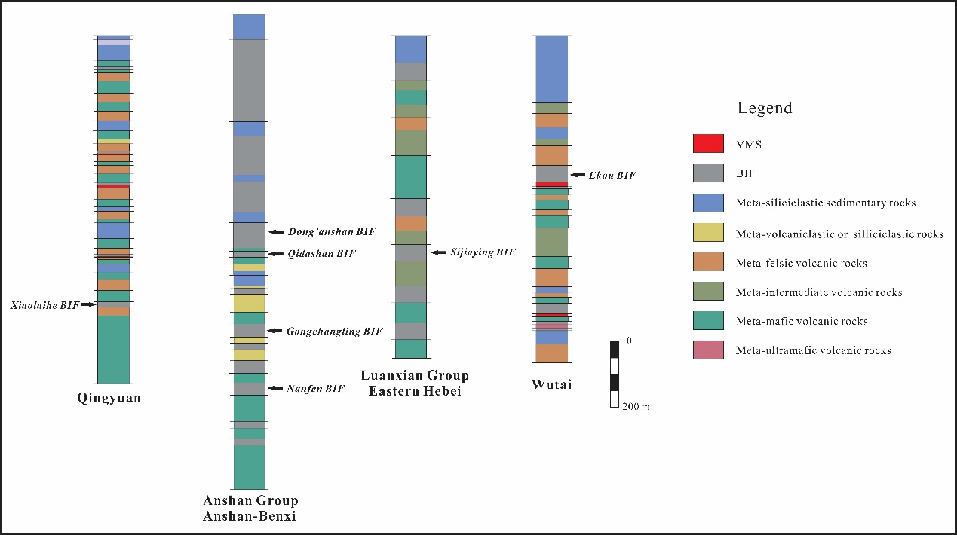
Fig. S1. Stratigraphic synthesis from the studied locations across the NCC showing stratigraphic variations of four different lithotectonic assemblages and the relationship of the studied seven BIFs to other stratigraphic units.

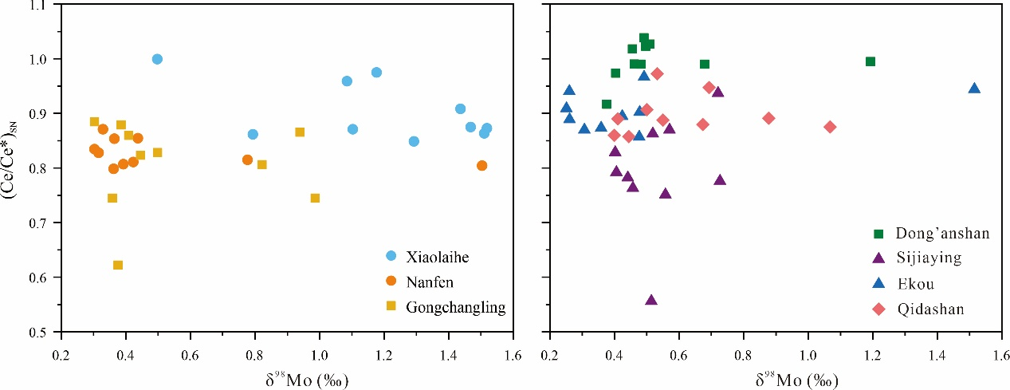
Fig. S2. Bulk δ⁹⁸Mo values plotted against shale-normalized Ce anomalies for the NCC BIFs. Note that Ce anomaly data is from Wang et al. (2024).

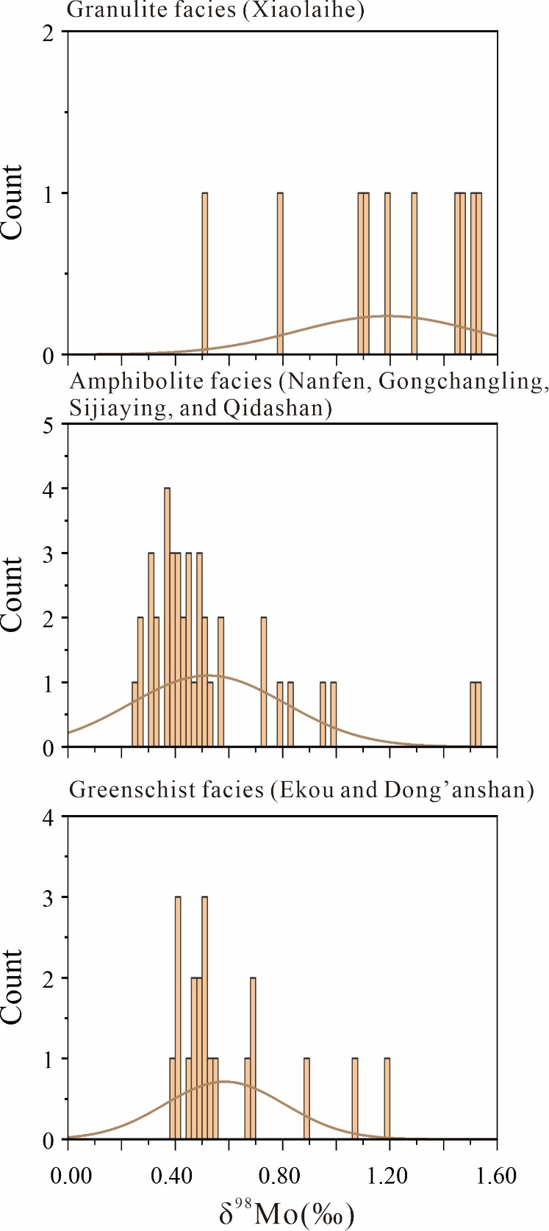
Fig. S3. Molybdenum isotope compositions of the studied NCC BIFs that have undergone different grades of metamorphism.

