List of Supplementary Tables:
Supplementary Table 1 Major soils for Burkina Faso used in this simulation study.

Type | Soil depth | LL | DUL | SAT | Bulk density
 | (cm) | (mm/mm) | (mm/mm) | (mm/mm) | (g/cm³)
Loam | 5 | 0.18 | 0.36 | 0.47 | 1.31
 | 15 | 0.18 | 0.36 | 0.44 | 1.39
 | 30 | 0.18 | 0.36 | 0.45 | 1.35
 | 45 | 0.18 | 0.36 | 0.46 | 1.33
 | 60 | 0.18 | 0.36 | 0.45 | 1.35
 | 75 | 0.18 | 0.36 | 0.46 | 1.33
 | 90 | 0.18 | 0.36 | 0.46 | 1.33
 | 105 | 0.16 | 0.33 | 0.43 | 1.40
 | 120 | 0.16 | 0.33 | 0.41 | 1.47
Sandy loam | 5 | 0.13 | 0.20 | 0.29 | 1.49
 | 15 | 0.13 | 0.20 | 0.29 | 1.49
 | 25 | 0.13 | 0.20 | 0.29 | 1.49
 | 34 | 0.12 | 0.23 | 0.32 | 1.41
 | 43 | 0.12 | 0.23 | 0.32 | 1.41
 | 53 | 0.14 | 0.25 | 0.33 | 1.44
 | 64 | 0.14 | 0.25 | 0.33 | 1.44
 | 83 | 0.17 | 0.28 | 0.33 | 1.57
 | 102 | 0.17 | 0.28 | 0.33 | 1.57
 | 123 | 0.18 | 0.29 | 0.33 | 1.59
 | 145 | 0.18 | 0.29 | 0.33 | 1.59
Sandy clay loam | 5 | 0.04 | 0.17 | 0.39 | 1.20
 | 15 | 0.04 | 0.17 | 0.39 | 1.20
 | 25 | 0.04 | 0.17 | 0.39 | 1.20
 | 33 | 0.04 | 0.18 | 0.36 | 1.20
 | 46 | 0.06 | 0.17 | 0.40 | 1.20
 | 61 | 0.15 | 0.29 | 0.38 | 1.20
 | 76 | 0.15 | 0.29 | 0.38 | 1.20
 | 106 | 0.15 | 0.29 | 0.38 | 1.20
 | 136 | 0.15 | 0.29 | 0.38 | 1.20
LL, lower limit; DUL, drainage upper limit; SAT, water content at saturation;

Supplementary Table 2 Soil profile used for Senegal in this simulation study.
Type | Soil depth | LL | DUL | SAT | Bulk density
 | (cm) | (mm/mm) | (mm/mm) | (mm/mm) | (g/cm³)
Sand | 5 | 0.031 | 0.097 | 0.32 | 1.61
 | 15 | 0.031 | 0.097 | 0.32 | 1.61
 | 30 | 0.037 | 0.119 | 0.331 | 1.66
 | 45 | 0.037 | 0.117 | 0.332 | 1.54
 | 60 | 0.037 | 0.117 | 0.332 | 1.54
 | 90 | 0.04 | 0.126 | 0.331 | 1.57
 | 120 | 0.037 | 0.117 | 0.331 | 1.55
 | 150 | 0.037 | 0.119 | 0.33 | 1.64
 | 180 | 0.037 | 0.119 | 0.331 | 1.58
 | 210 | 0.034 | 0.108 | 0.324 | 1.6
LL, lower limit; DUL, drainage upper limit; SAT, water content at saturation

List of supplementary Figures

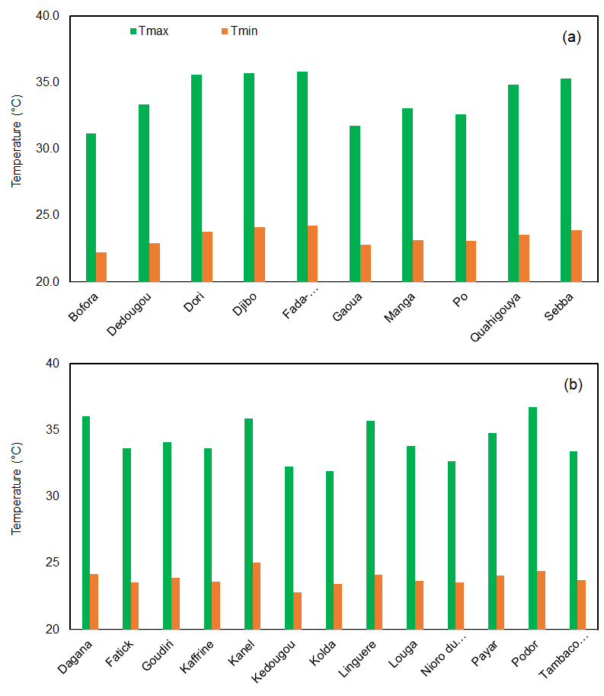
Supplementary Fig. 1. Average maximum and minimum temperatures under the baseline climate (1981 – 2020) for different locations in (a) Burkina Faso and (b) Senegal.

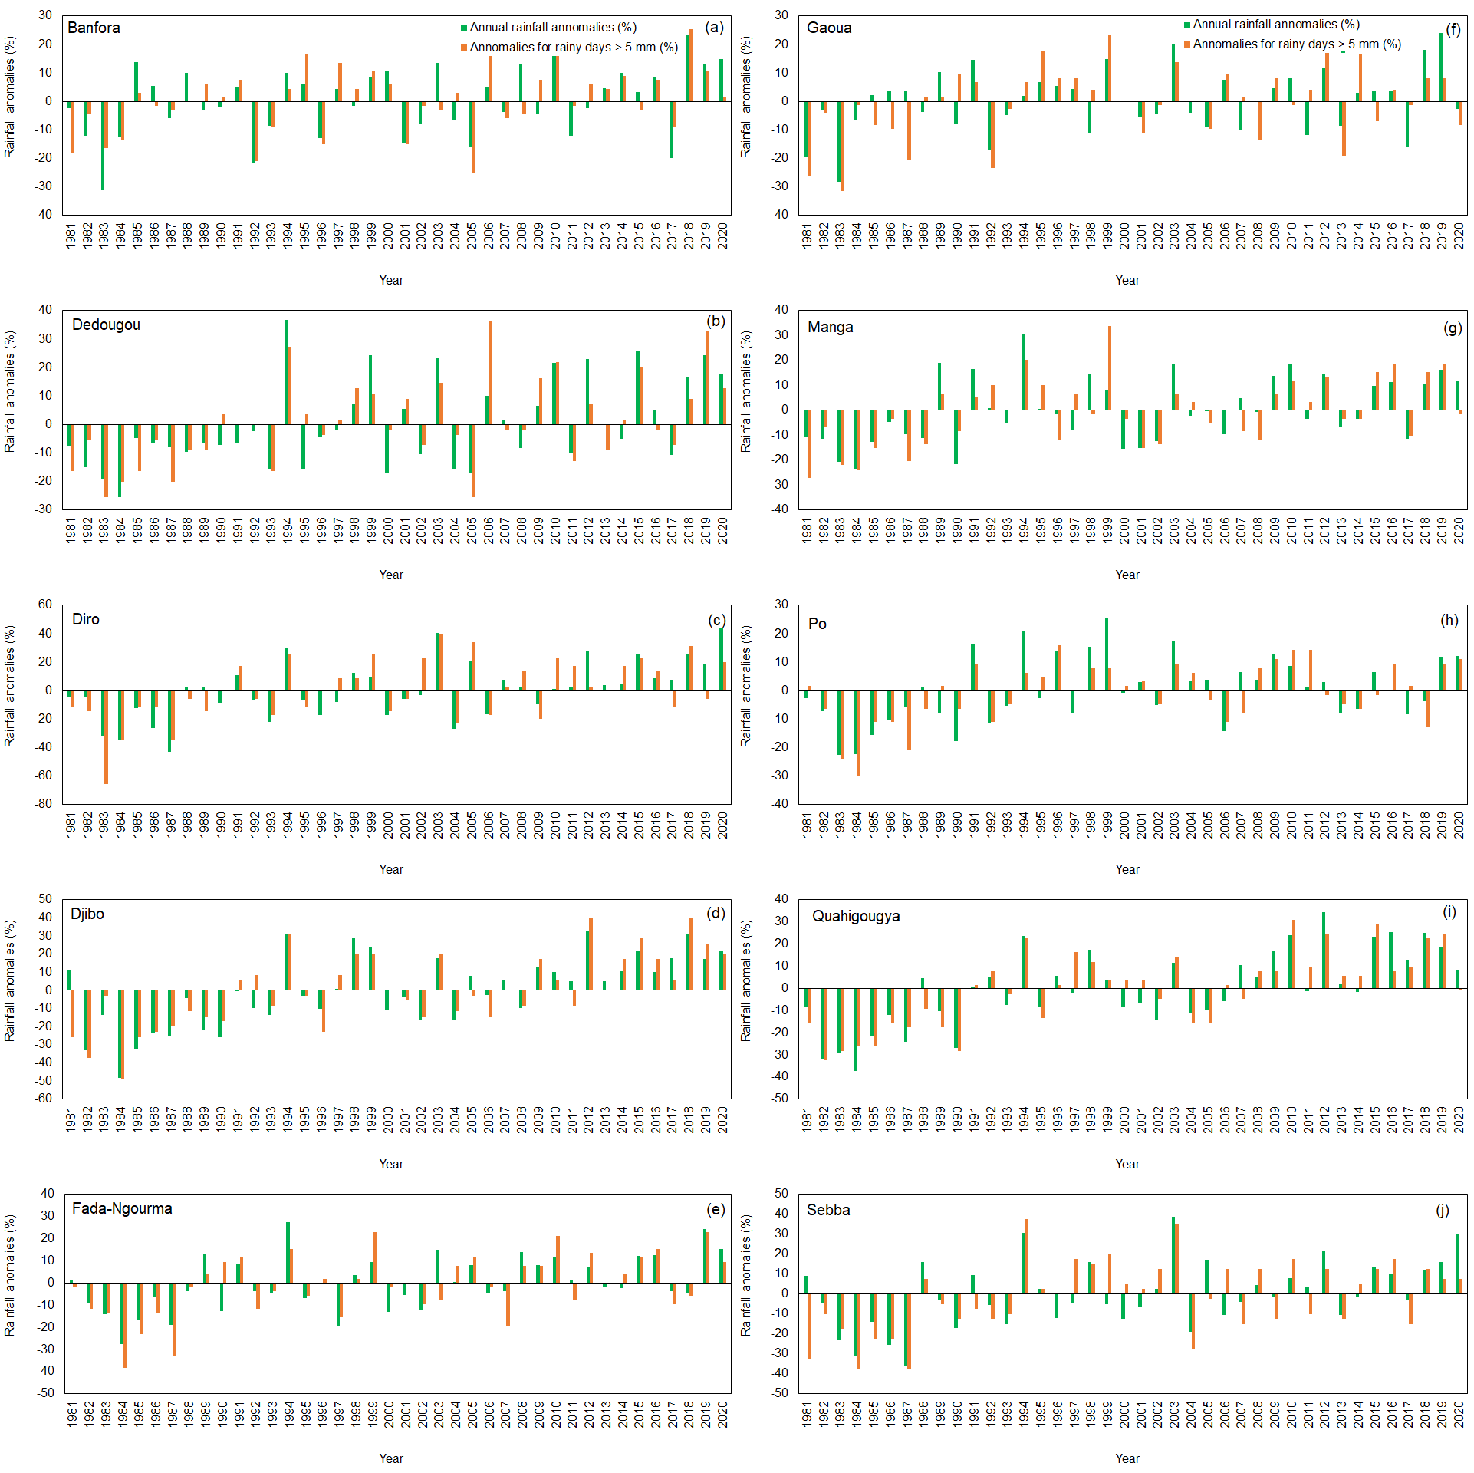
Supplementary Fig. 2. Annual rainfall and rainy days above 5 mm rainfall variabilities for different locations in Burkina Faso for the period of 1981–2020.

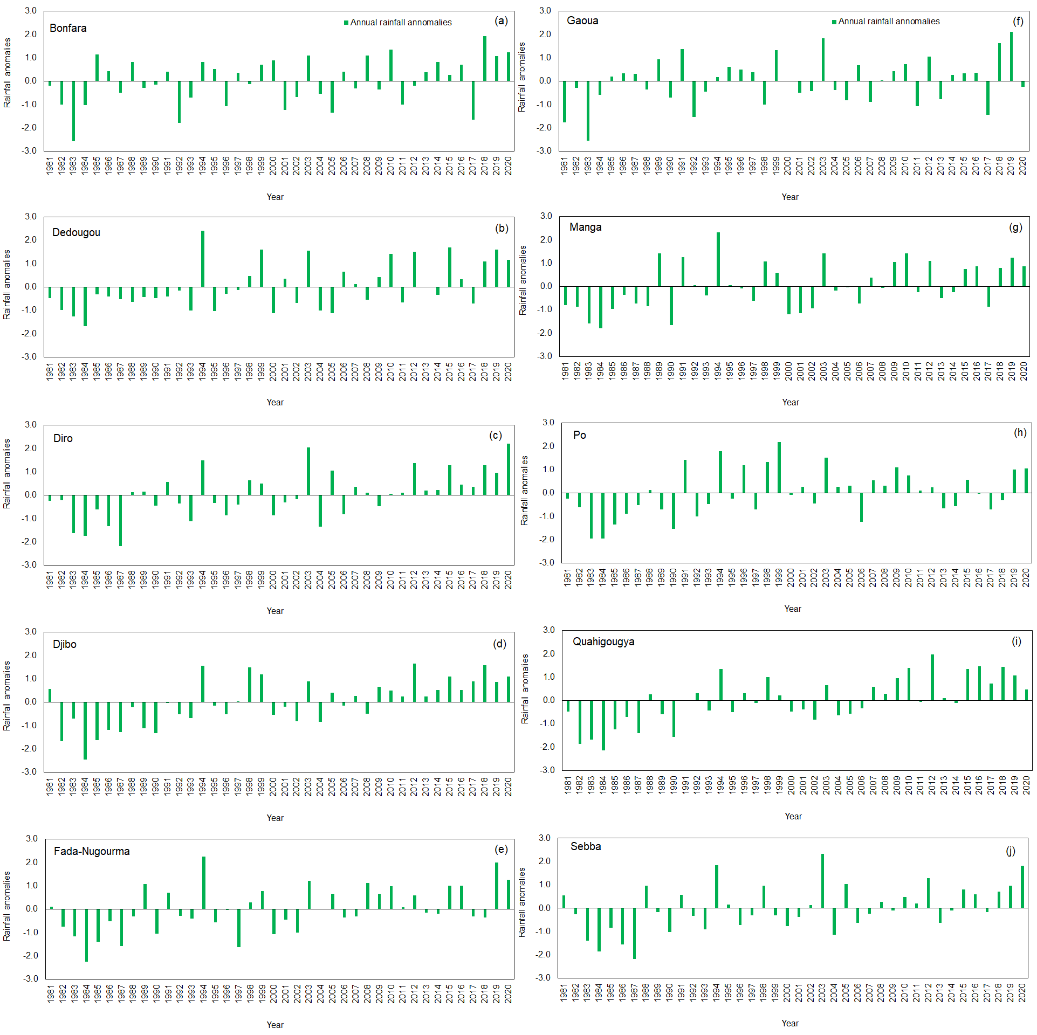
Supplementary Fig. 3. Standardized annual rainfall anomalies for different locations in Burkina Faso for the period of 1981–2020.

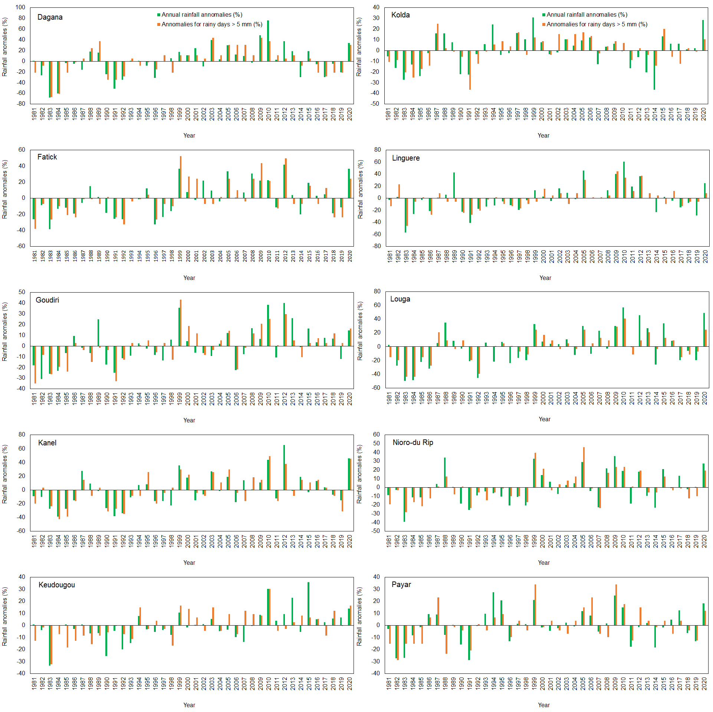
Supplementary Fig. 4. Annual rainfall and rainy days above 5 mm rainfall variabilities for different locations in Senegal for the period of 1981–2020.

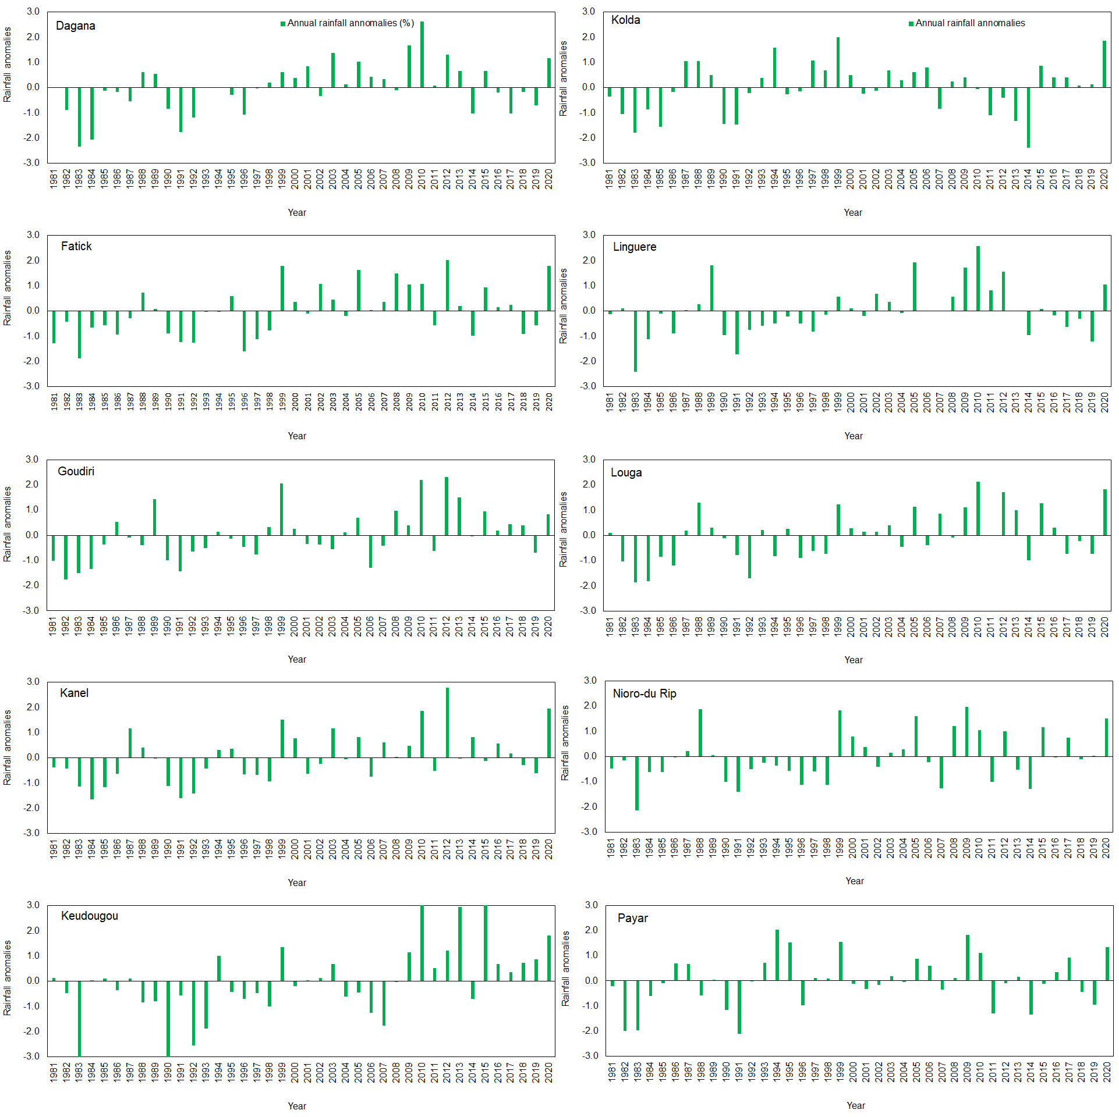
Supplementary Fig. 5. Standardized annual rainfall anomalies for different locations in Senegal for the period of 1981–2020.

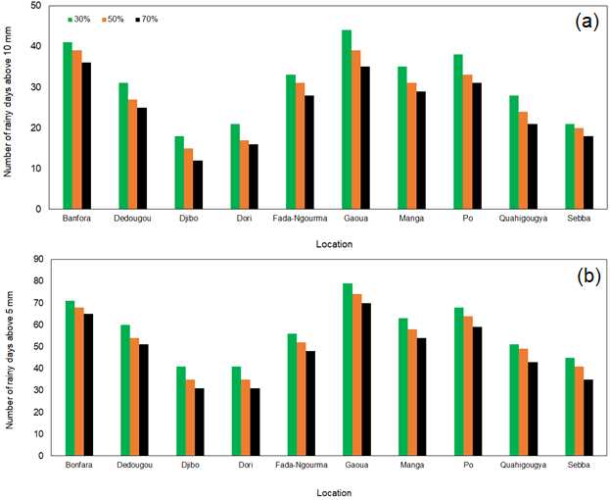
Supplementary Fig. 6. The 30%, 50% and 70% probabilities of exceedance of number of rainy days equal or above 10 mm (a) and 5 mm (b) for selected locations in Burkina Faso for the growing seasons of 1981–2020.

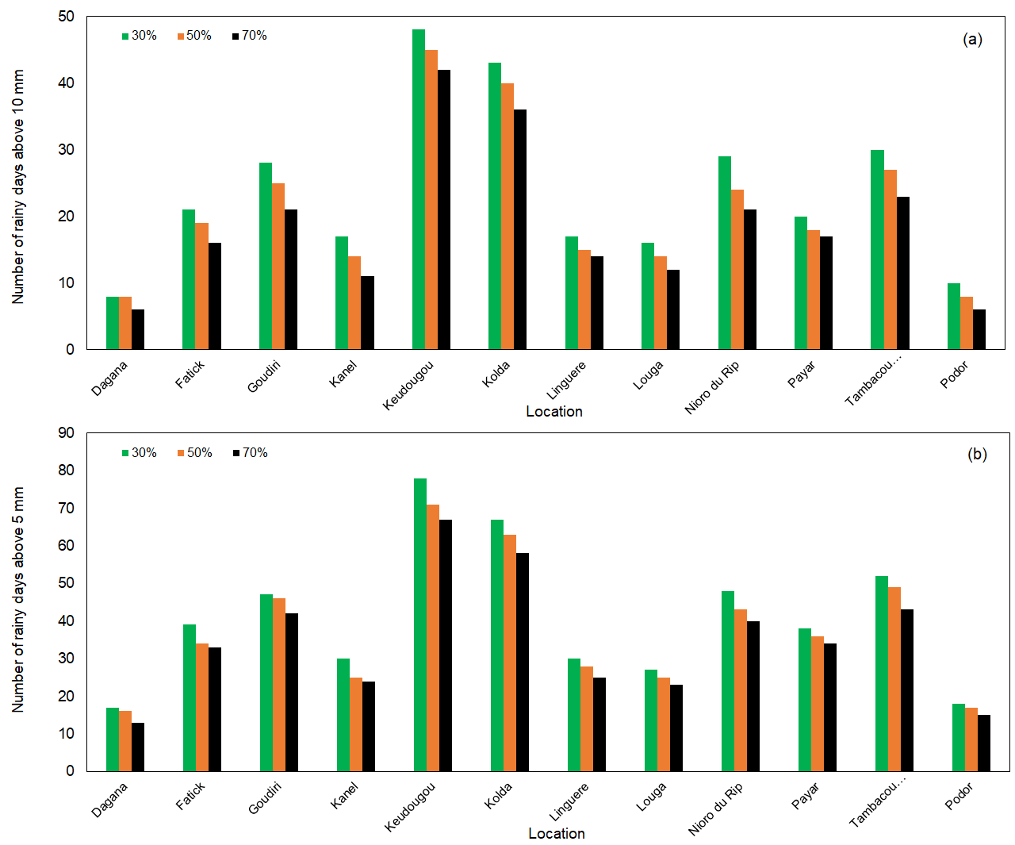
Supplementary Fig. 7. The 30%, 50% and 70% probabilities of exceedance of number of rainy days equal or above 10 mm (a) and 5 mm (b) for selected locations in Senegal for the growing season periods of 1981–2020.

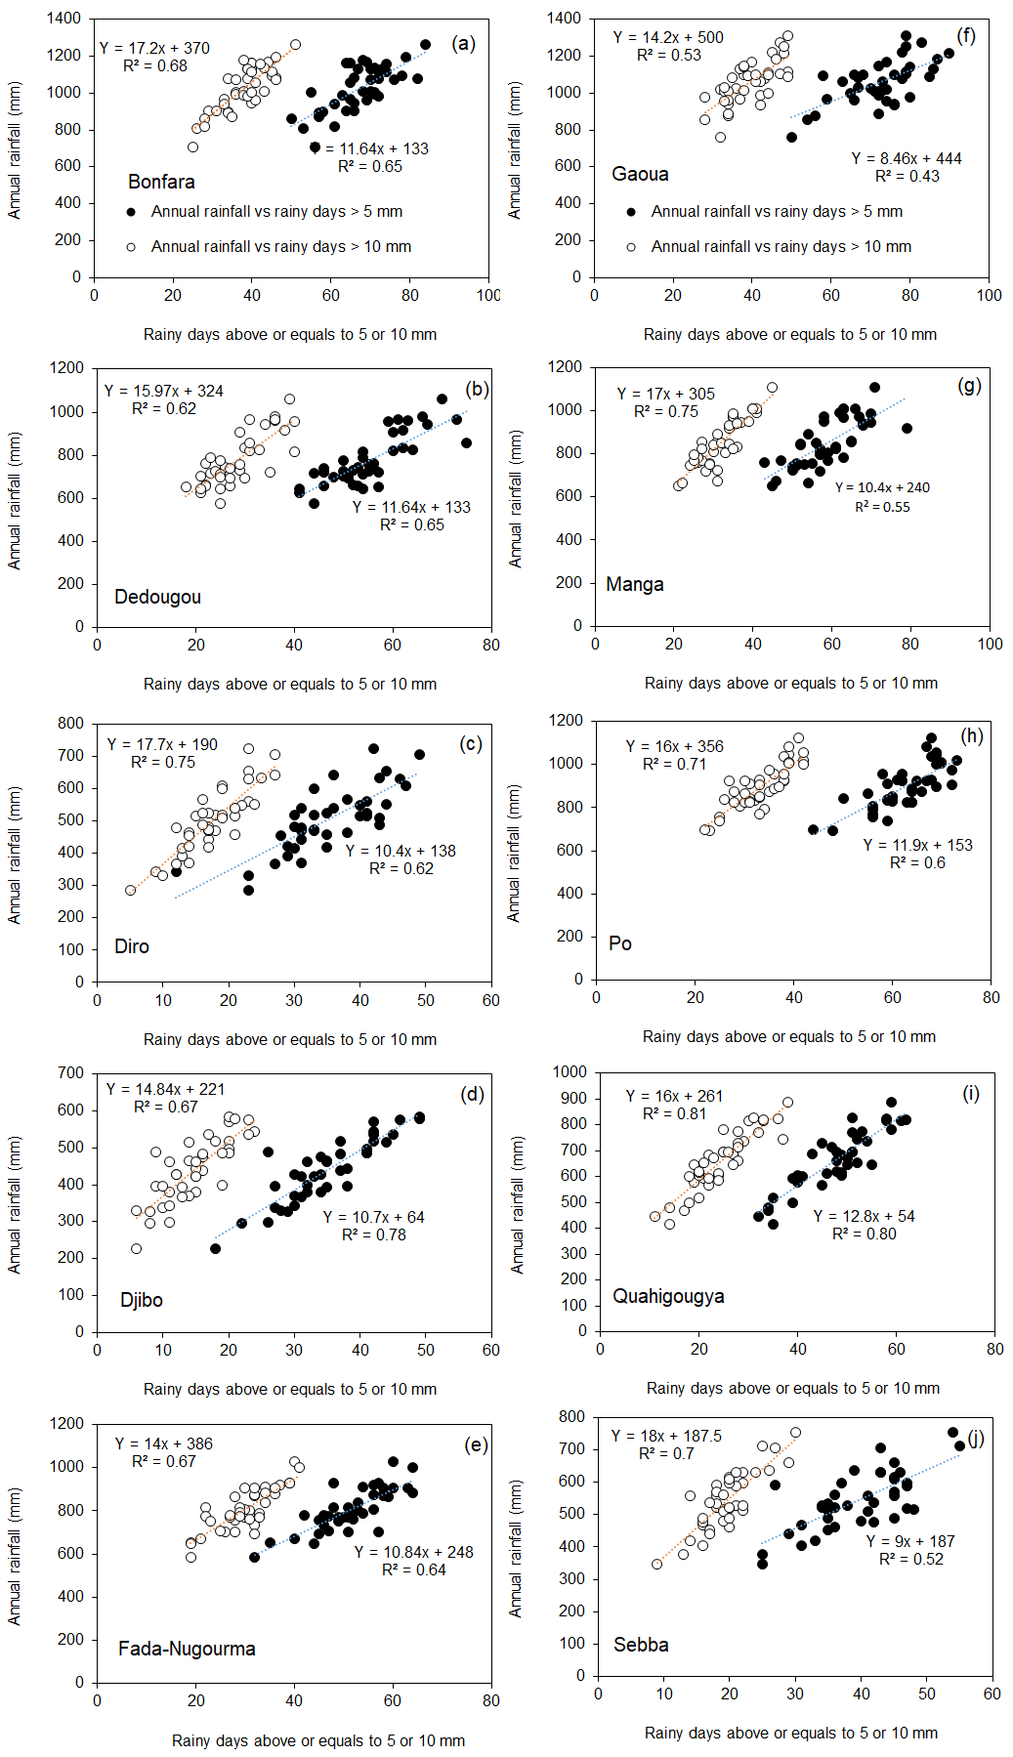
Supplementary Fig. 8. The relationship between annual rainfall and number of rainy days above 10 or 5 mm for different locations in Burkina Faso.

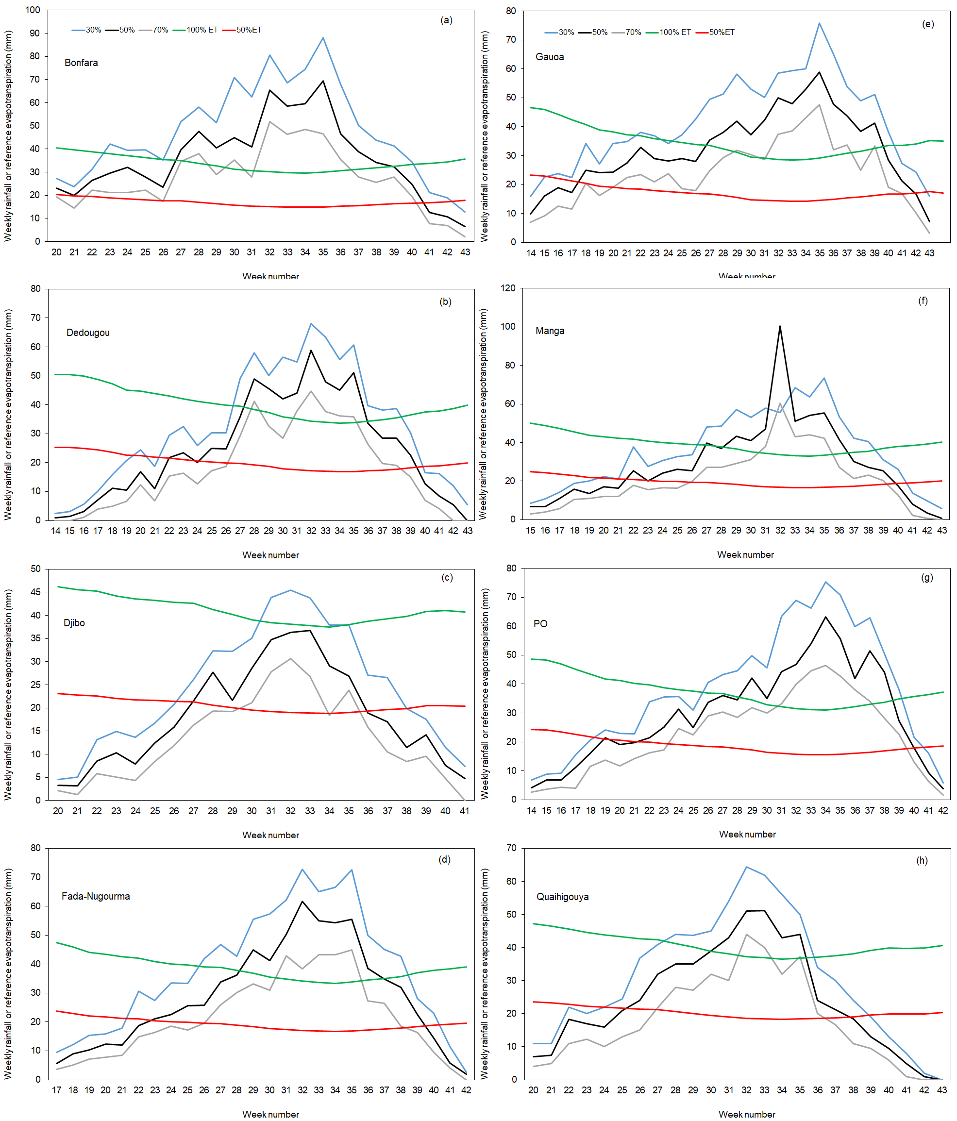
Supplementary Fig. 9. Rain onset, cessation and length of growing period (LGP) based on weekly rainfall versus weekly reference evapotranspiration for different locations in Burkina Faso.

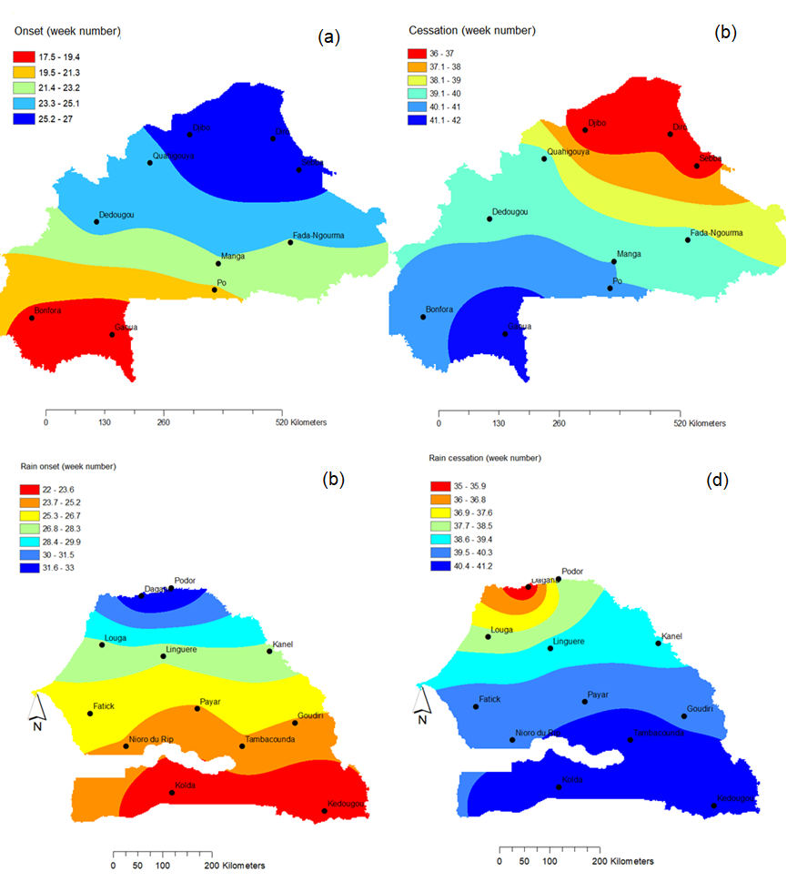

Supplementary Fig. 10. Average onset based on 50% rain onset (P2) (a) and cessation (b) for Burkina Faso locations; P2 (c) and cessation (d) for Senegal based on climate data for the period of 1981–2020.

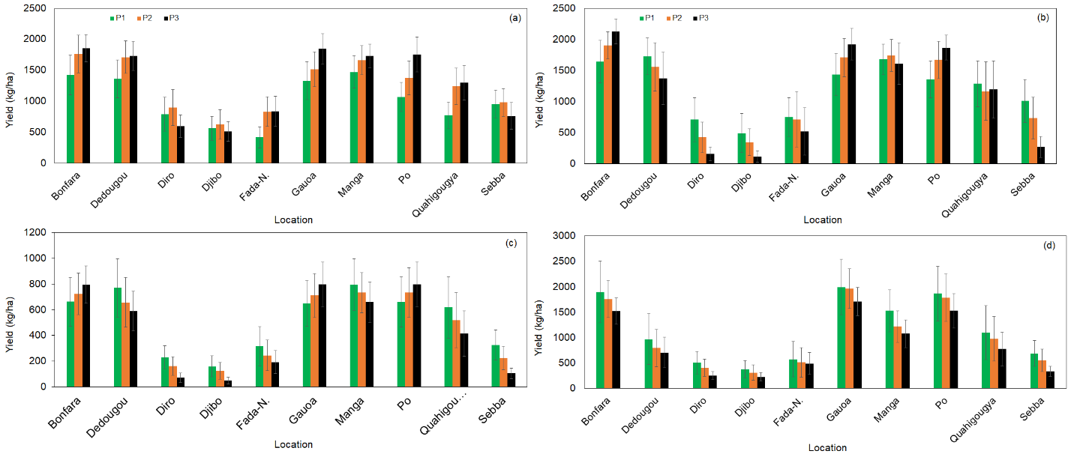
Supplementary Fig. 11. Simulated yield of maize (a), millet (b), peanut (c), and sorghum (d) for selected Burkina Faso locations for the period of 1981–2005.

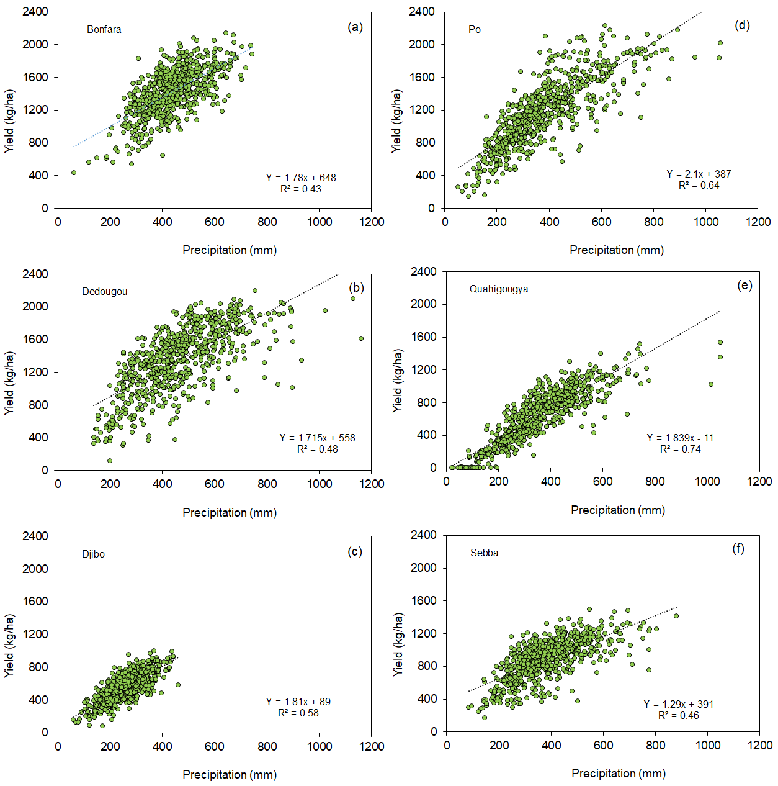

Supplementary Fig. 12. The relationship between seasonal precipitation and yield of maize for selected locations in Burkina Faso during the period of 1981–2005

