Supplementary Materials for the Paper titled: "Diagnostic Performance of Deep Learning Models for Diabetic Retinopathy: A Systematic Review and Meta-Analysis of Clinical Studies

Supplementary Figure S1: Sensitivity and Specificity by Model Type: Ensemble Models vs. Standard CNNs
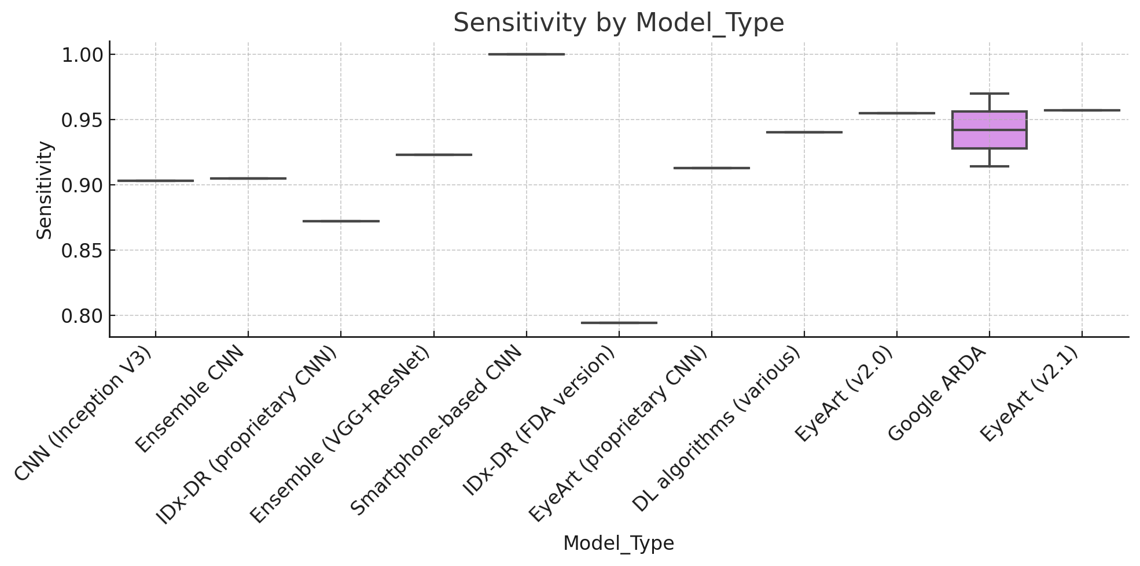
Supplementary Figure S2: Sensitivity and Specificity by Validation Type: External/Prospective vs. Internal
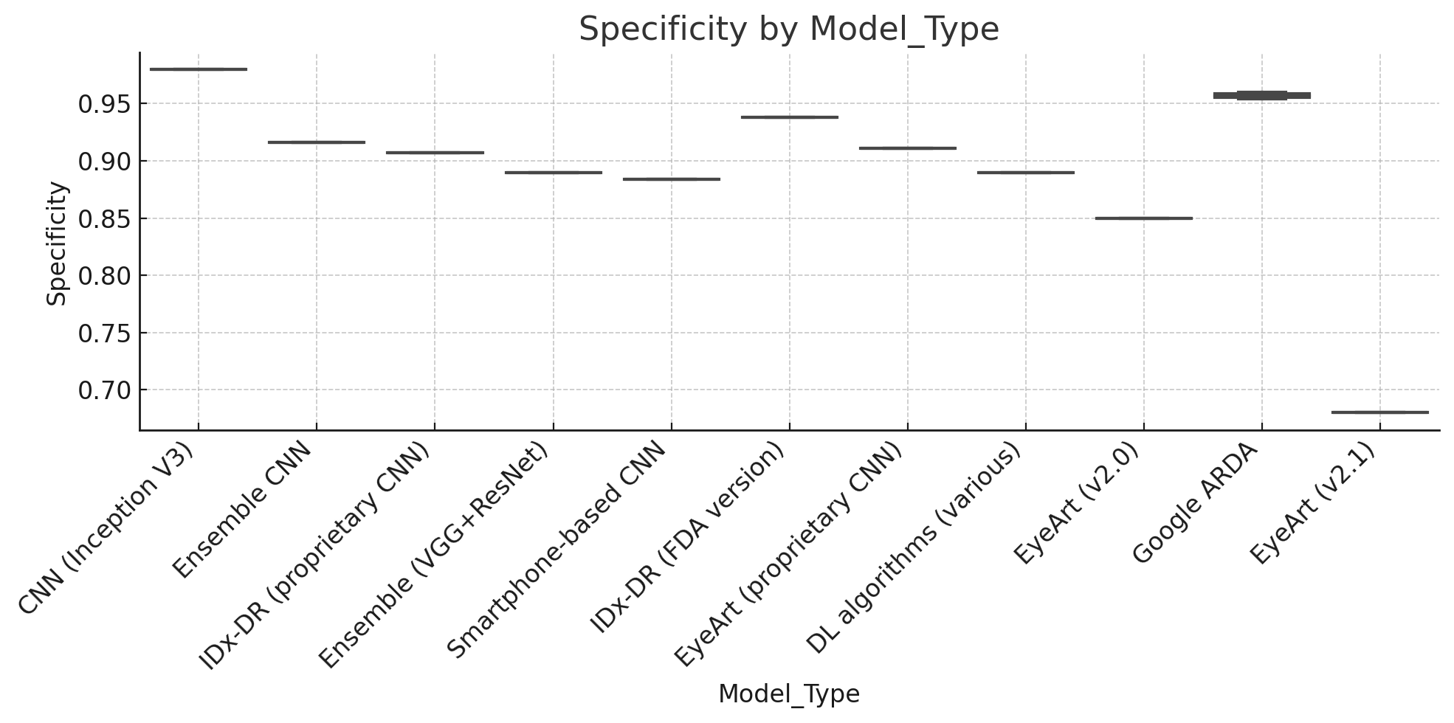
Supplementary Figure S3: Sensitivity by Geography (Country): Comparison of High-Income vs. Low-Middle Income Countries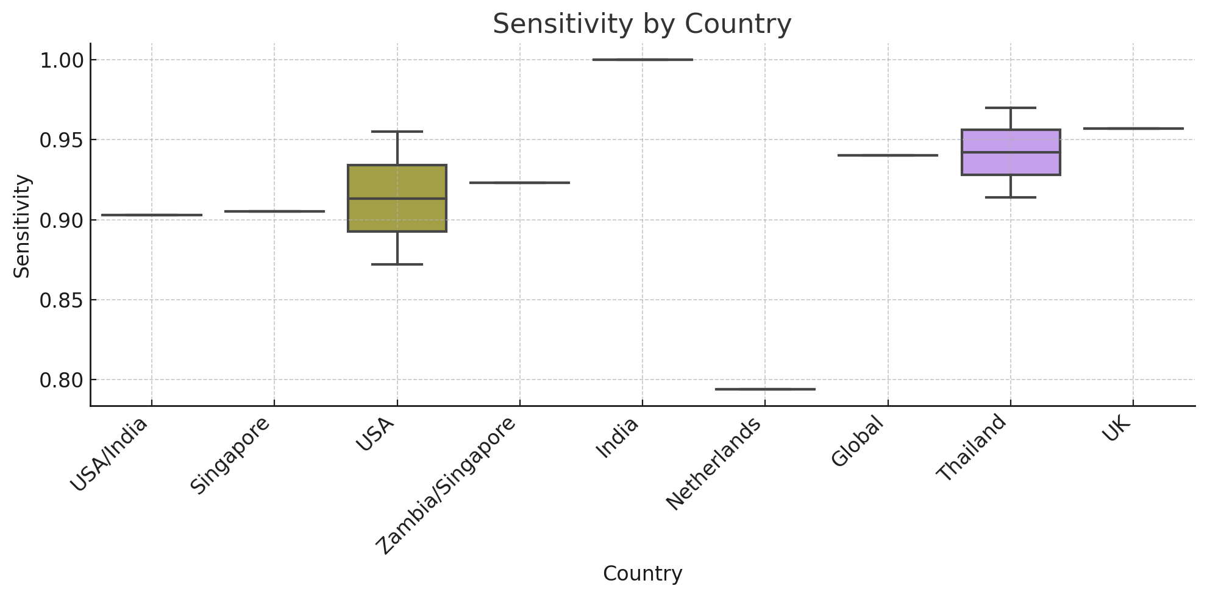
Supplementary Figure S4: Specificity by Geography (Country): Performance in Different Geographical Regions
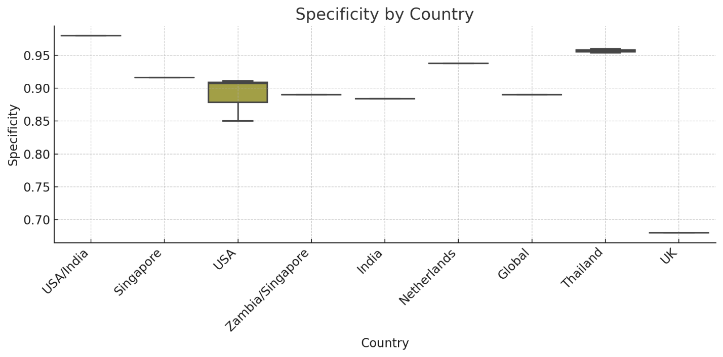

Supplementary Figure S5: Sensitivity by Image Quality Handling: Excluding, Retaining, or Referring Ungradable Images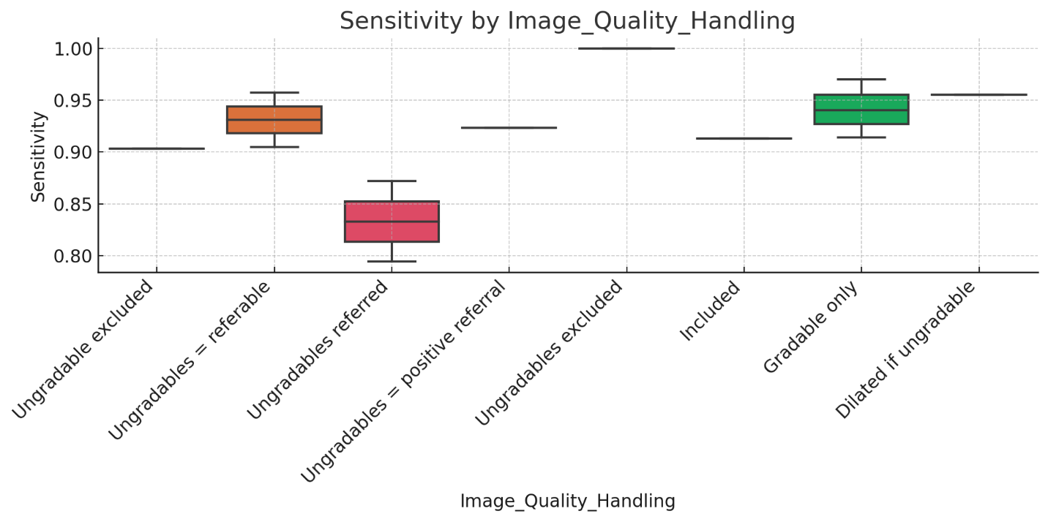
Supplementary Figure S6: Specificity by Image Quality Handling: Excluding, Retaining, or Referring Ungradable Images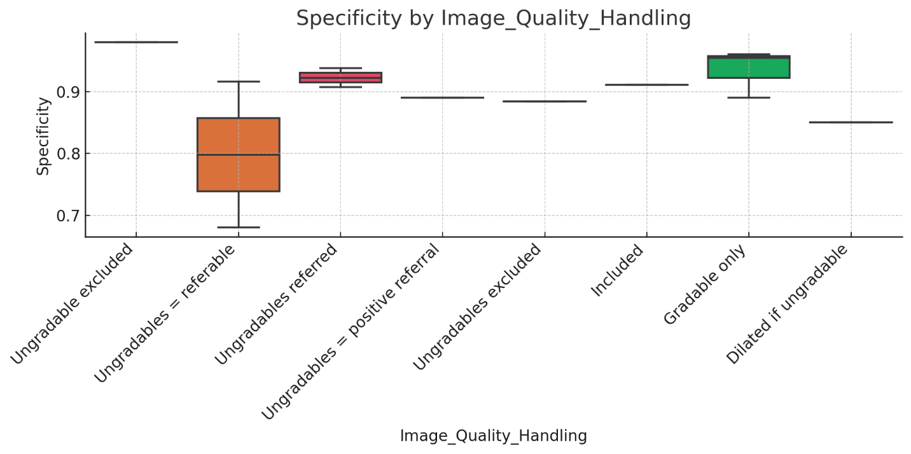

Supplementary Figure S7: Sensitivity by DR Severity Threshold: Performance of Models Targeting Vision-Threatening DR vs. Any DR
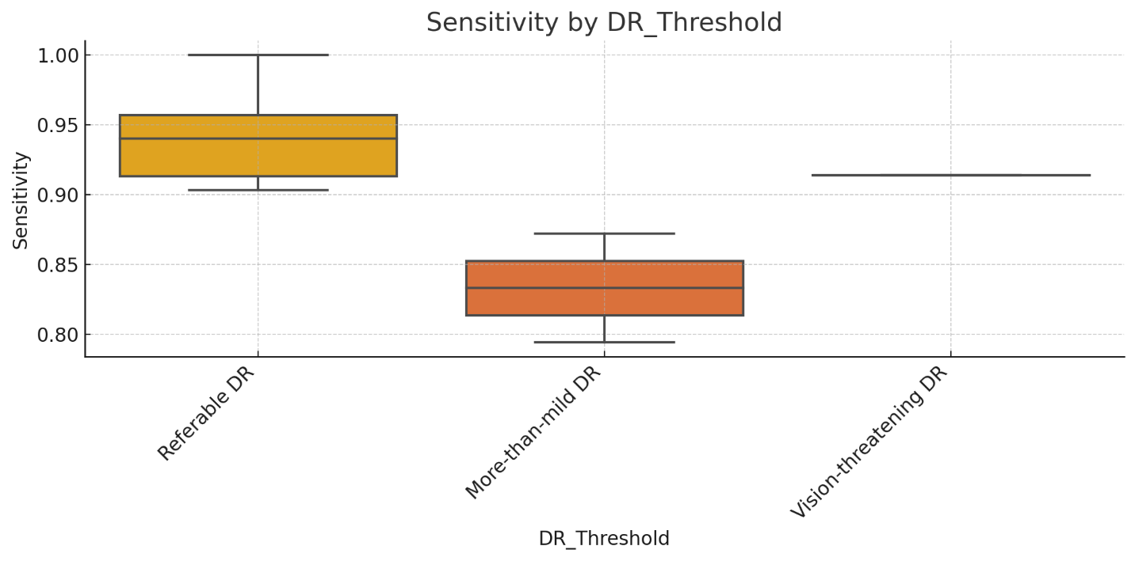

Supplementary Figure S8: Specificity by DR Severity Threshold: Performance of Models Targeting Vision-Threatening DR vs. Any DR
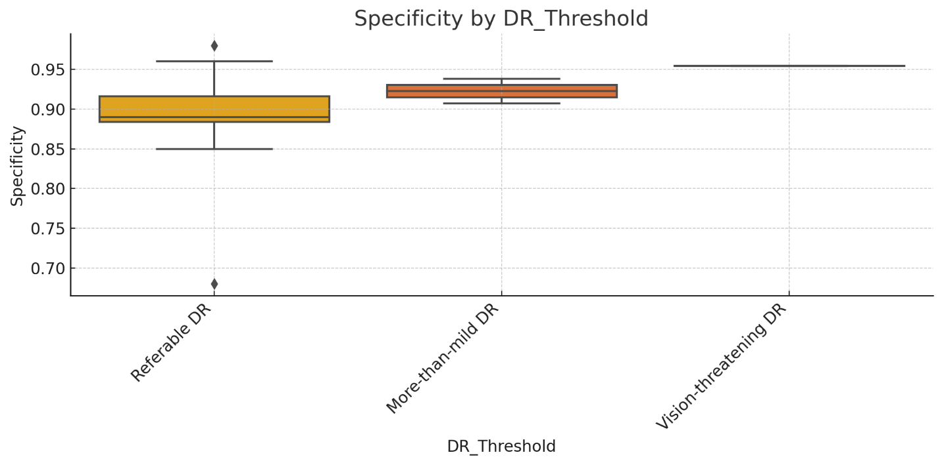

Supplementary Figure S11: Scatter Plot – Sensitivity vs. Year: Meta-Regression Analysis
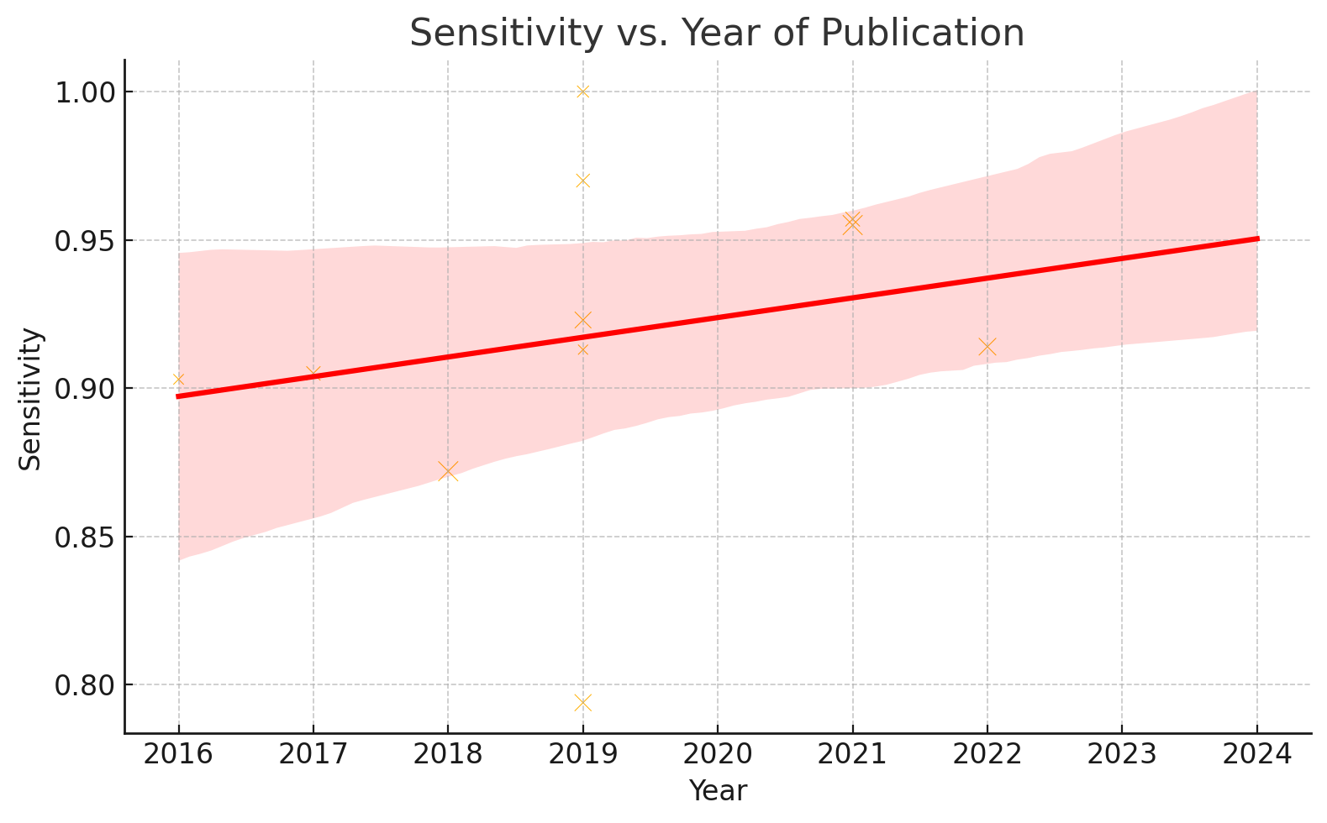
Supplementary Figure S12: Scatter Plot – Specificity vs. Year: Meta-Regression Analysis
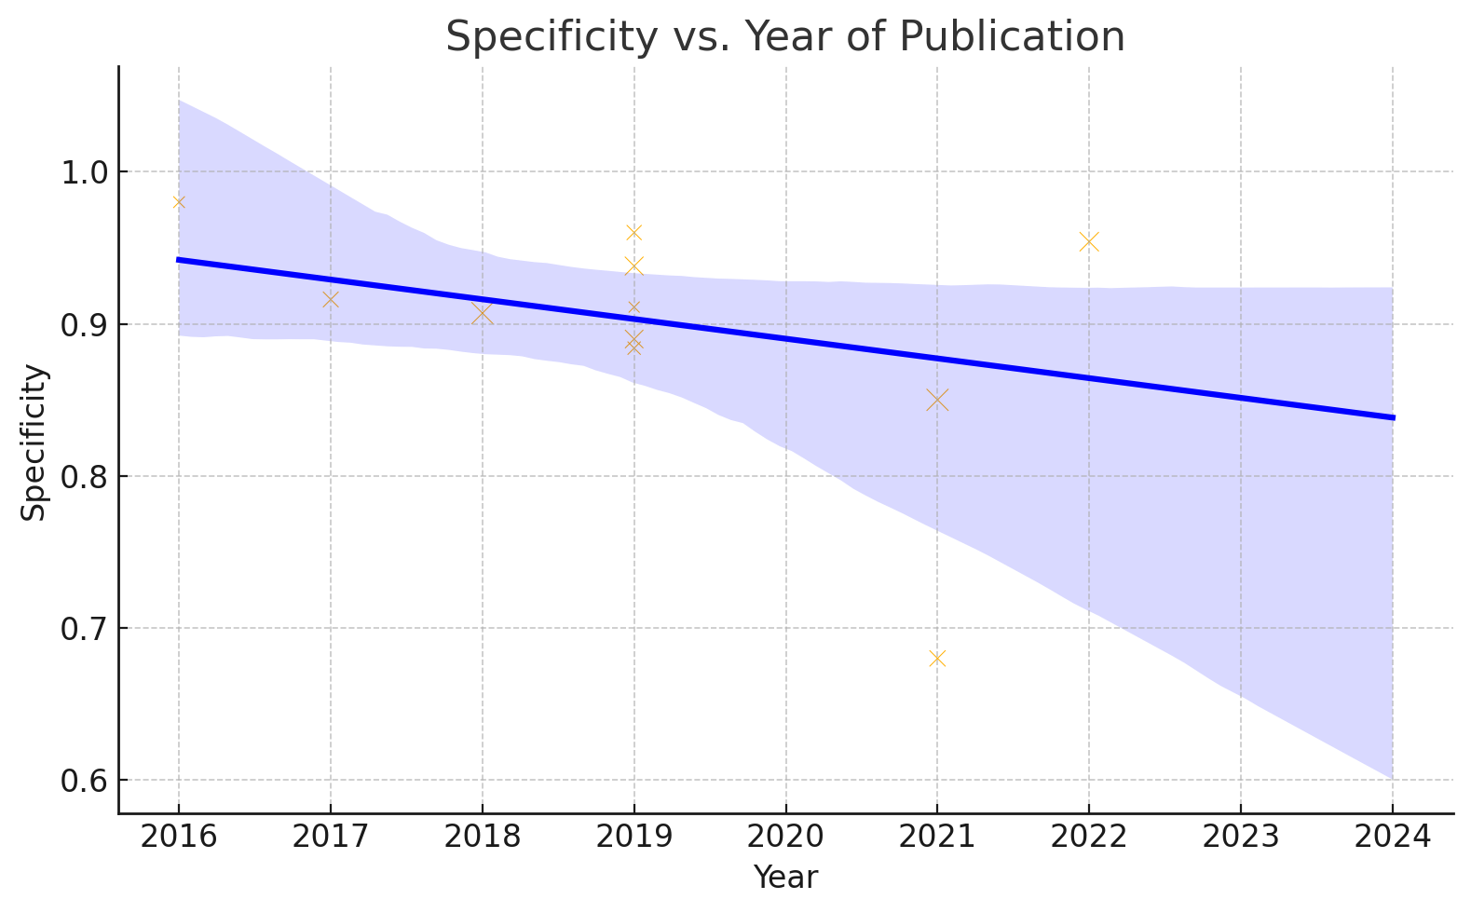

Supplementary Figure S13: Scatter Plot – Sensitivity vs. Sample Size: Meta-Regression Analysis
