Supplementary Material for “Impact of cropland-urbanization dynamics on crop production in the United States” by Zhou et al.

INDEX FOR SUPPLEMENTARY FIGURES AND TABLES

Supplementary Figure S1 …………………………………………………………………………………… 2

Supplementary Figure S2 …………………………………………………………………………………… 3

Supplementary Figure S3 …………………………………………………………………………………… 4

Supplementary Table S1 ……...…………………………………………………………………….……… 5

Supplementary Table S2 ……...…………………………………………………………………….……… 6

Supplementary Table S3 ……...…………………………………………………………………….……… 7

Supplementary Table S4 ……...…………………………………………………………………….……… 8

Supplementary Table S5 ……...…………………………………………………………………….……… 9

Additional References ……......…………………………………………………………………….……… 10

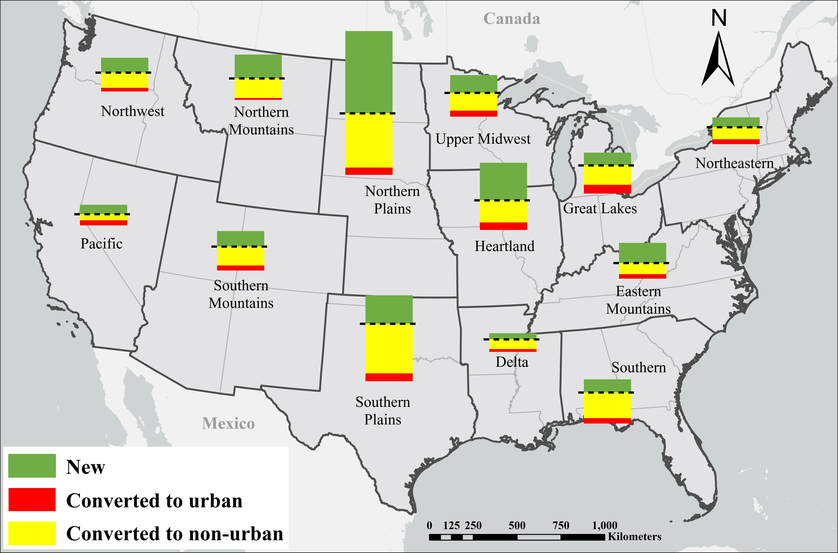

Supplementary Figure S1. Spatial patterns of cropland changes across the conterminous United States from 2000 to 2023. For each region, the size of the bars represents the change in cropland due to urbanization, expansion, or loss into other uses based on National Land Cover Database (USGS, 2024).

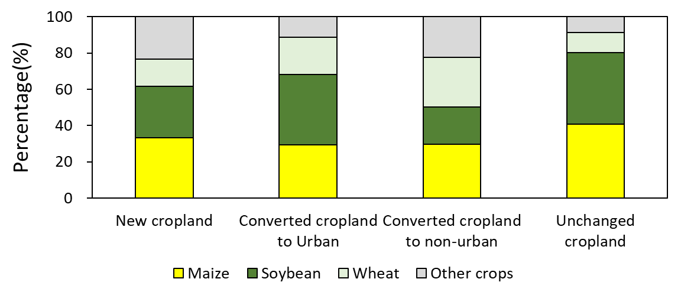

Supplementary Figure S2. Percentage of areas sown with maize, soybean, wheat, and other crops in the new, unchanged, and converted cropland into urban and to non-urban. Estimated were derived from the Cropland Data Layer (USDA, 2024).

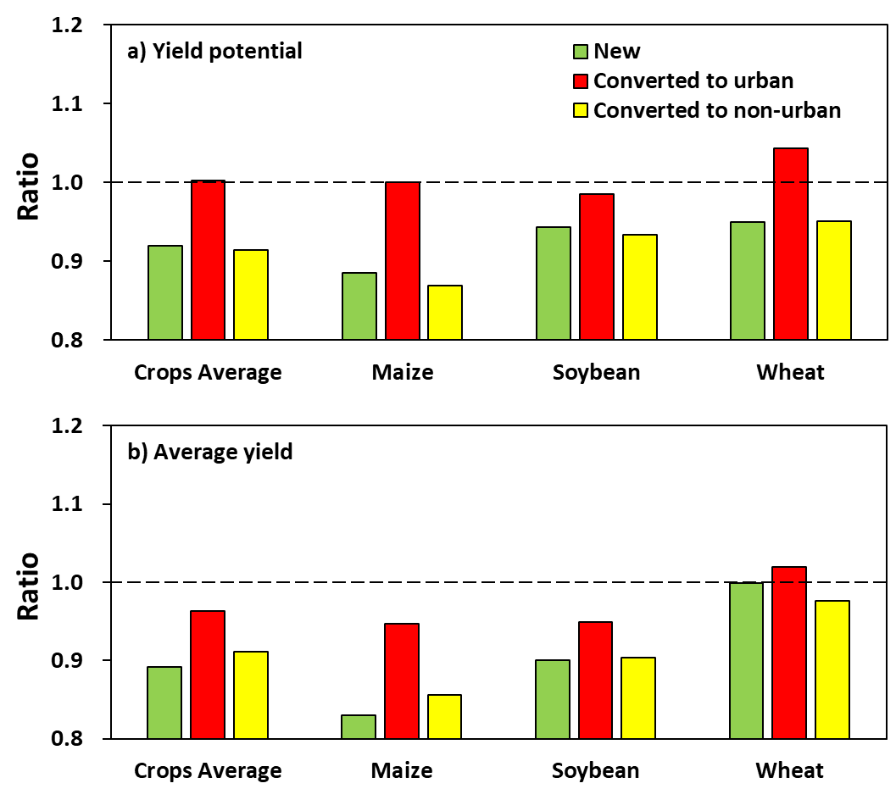

Supplementary Figure S3. Comparison of cropland productivity among new and converted cropland to urban and non-urban relative to unchanged cropland by crop type. The ratio between each cropland class and the unchanged cropland was calculated for (a) water-limited yield potential and (b) average farmer yield for maize, soybean, and wheat. Also shown is the weighted average based on the cropland fraction associated with each crop. See Methods for calculations and Supplementary Table S5 for associated data sources.

Supplementary Table S1. Summary of previous literature on US urbanization-cropland interactions over time and impact on crop production.
Study | Spatial scope ª | Temporal scope ^{b} | Temporal resolution | Focus ^{c} | Approach to estimate LUC, LP and/or E | Crop specificity ^{d} | LUC type analyzed ^{e}
Our study (Zuo et al.) | National  (30 m) | R (2000-2022) | Each year | LUC, LP, E | Satellite imagery (LUC), crop model & yield, soil, and weather data (LP, E) | Individual crops | C-U, C-NU, NU-C, N, U
Yu and Lu (2018) | National  (1 km) | R (1850- 2016) | Six sub-periods (6-58 yrs each) | LUC | Official statistics & satellite imagery (LUC) | Pooled crops | C-NU, NU-C, N
Xie et al (2024) | National  (30 m) | R (1991-2014) | Each year | LUC | Satellite imagery (LUC) to assess cropland abandonment | Pooled crops | C-NU
Xie et al (2023) | National  (30 m) | RP (2001-2040) | Two sub periods (20 yr) | LUC | Satellite imagery & machine learning (ML) coupled with auxiliary databases (LUC) | Pooled crops | C-U
Lark et al (2020) | National  (30 m) | R (2008-2016) | Each year | LUC, LP, E | Satellite imagery (LUC), environmental and biophysical data & ML model (LP & E) | Individual crops | C-NU, N
Smidt et al (2018) | Sub-national (not reported) | P (1992-  2050) | Every 5 yrs | LUC, LP | Land transformation model (LUC) & soil water storage (LP) | Individual crops | C-U
Islam et al (2024) | Sub-national (30 m) | R (2001-2021) | No sub-periods | LUC | Satellite imagery (LUC) | Pooled crops | C-U
Freedgood et al (2020) | National  (30 m) | R (2001-2016) | No sub-periods | LUC, LP | Satellite imagery (LUC) & qualitative land suitability indexes (LP) | Pooled farmland | C-U
Huang et al (2020) | Global  (1 km) | R (1992-2016) | No sub-periods | LUC, LP | Satellite-based urban & cropland (LUC) and net primary productivity (LP) | Pooled crops | C-U
d’Amour et al (2016) | Global  (5 km) | P (2000-2030) | No sub-periods | LUC, LP | Data on area expansion probability (LUC) & current gridded cropland and yield (LP) | Pooled crops | C-U
Van Vliet (2019) | Global  (300 m) | P (1992-2015) | No sub-periods | LUC, LP | Satellite imagery (LUC) & actual and potential yields (LP) | Pooled crops | C-U, N
ª Sub-national, national, or global (and resolution). ^{b} Retrospective (R) or projection (P) and period. ^{c} Land-use change (LUC), productivity (LP), and/or environment (E). ^{d} Individual crops, pooled crops using calories equivalents (d’Amour et al., 2016) or net primary productivity (Van Vilet, 2016), or pooled farmland (including cropland, rangeland, and woodlands). ^{d} Converted cropland to urban (C-U) or non-urban (C-NU) & new (N) or unchanged (U) cropland.
Supplementary Table S2. Historical yield gain and required yield gain on existing cropland to offset the crop production loss due to cropland conversion to urban. Parenthetic values indicate the required yield gain as percentage of the historical yield gain. Production loss was estimated based on the cropland converted to urban and associated water-limited yield potential.

 | Production loss  (Mt) | Historical (1970-2023) yield gain  (kg ha⁻¹ y⁻¹) | Yield gain to offset production loss due to urbanization  (kg ha⁻¹ y⁻¹)
Maize | 7.9 | 119 | 7 (6%)
Soybean | 4.1 | 33 | 4 (12%)
Wheat | 2.9 | 24 | 10 (40%)

Supplementary Table S3. Reclassification scheme of NLCD (USGS, 2024) data for the purpose of this research

Reclassified types | Types in NLCD classification
Reclassified types | First level class | Second level class
Water | Water | Open Water
Water | Water | Perennial Ice/Snow
Urban land | Developed | Developed, Open Space
Urban land | Developed | Developed, Low Intensity
Urban land | Developed | Developed, Medium Intensity
Urban land | Developed | Developed High Intensity
Unused land | Barren | Barren Land (Rock/Sand/Clay)
Woodland | Forest | Deciduous Forest
Woodland | Forest | Evergreen Forest
Woodland | Forest | Mixed Forest
Woodland | Shrubland | Dwarf Scrub
Woodland | Shrubland | Shrub/Scrub
Grassland | Herbaceous | Grassland/Herbaceous
Grassland | Herbaceous | Sedge/Herbaceous
Grassland | Herbaceous | Lichens
Grassland | Herbaceous | Moss
Grassland | Planted/ Cultivated | Pasture/Hay
Cropland | Planted/ Cultivated | Cultivated Crops
Wetland | Wetland | Woody Wetlands
Wetland | Wetland | Emergent Herbaceous Wetlands

Supplementary Table S4. Reclassification scheme of CDL data (USDA, 2024) for the purpose of this research

Crop types | Details | Crop types | Details
Corn | Corn  Dbl Crop Barley/Corn  Dbl Crop Corn/Soybeans  Dbl Crop Oats/Corn  Dbl Crop WinWht/Corn  Pop or Orn Corn  Sweet Corn | Other crops | Barley, Buckwheat, Camelina,  Canola, Chickpeas, Cotton,  Dbl Crop Barley/Sorghum,  Dbl Crop Lettuce/Barley,  Dbl Crop Lettuce/Cantaloupe,  Dbl Crop Lettuce/Cotton, Dbl Crop WinWht/Cotton,  Dbl Crop WinWht/Sorghum,  Dry Beans, Flaxseed, Lentils,  Millet, Mint, Mustard, Oats,  Other Small Grains, Peanuts, Peas, Potatoes, Rape Seed, Rice, Rye,  Safflower, Sorghum, Speltz,  Sugarbeets, Sugarcane, Sunflower,  Sweet Potatoes, Tobacco
Soybean | Dbl Crop Barley/Soybeans  Dbl Crop Corn/Soybeans  Dbl Crop Soybeans/Cotton  Dbl Crop Soybeans/Oats  Dbl Crop WinWht/Soybeans  Soybeans | Other crops
Wheat | Dbl Crop Durum Wht/Sorghum  Dbl Crop Lettuce/Durum Wht  Dbl Crop WinWht/Corn  Dbl Crop WinWht/Soybeans  Durum Wheat  Spring Wheat  Winter Wheat | Other crops

Supplementary Table S5. Variables used to assess the impact of urbanization on cropland productivity.
Variable | Description | Years | Resolution | Source
Average yield (Ya) | Average yield for rainfed maize, soybean and wheat | 2008-2023 | County | USDA-NASS Quick Stats https://www.nass.usda.gov/Quick_Stats/
Yield potential (Yw) | Rainfed yield potential for maize, soybean and wheat | 2000-2022 | 30 arc-second | Aramburu-Merlos et al. (2024)  https://doi.org/10.5281/zenodo.12209709
Yield fluctuation (YwCV) | Temporal coefficient of variation of rainfed yield potential for maize, soybean and wheat | 2000-2022 | Climate zone | www.yieldgap.org
Risk | Semi deviation (values below the mean) of the rainfed yield potential of each crop. | 2000-2022 | Climate zone | www.yieldgap.org
Water limitation index (WLI) | One minus the ratio of rainfed versus irrigated yield potential for each crop | 2000-2022 | Climate zone | www.yieldgap.org
TWI | Topographic wetness index | - | 1 arc-second | Calculated from the National Elevation Dataset using SAGA-GIS.
Kw | Soil erodibility factor | - | 30 meters | gSSURGO (USDA-NRCS) https://gdg.sc.egov.usda.gov/
PAWHC | Soil plant available water holding capacity | - | 30 meters | gSSURGO (USDA-NRCS)
pH | Average soil pH |  | 30 meters | gSSURGO (USDA-NRCS)
SOM | Soil organic matter in the first 20 cm of soil depth |  | 30 meters | gSSURGO (USDA-NRCS)

Additional references associated with Supplementary Information

d’Amour, C. B., Reitsma, F. & Baiocchi, G. Future urban land expansion and implications for global croplands. PNAS 114, 105346 (2016).
Aramburu-Merlos, F., van Loon, M. P., van Ittersum, M. K. & Grassini, P. High-resolution global maps of yield potential with local relevance for targeted crop production improvement. Nature Food 5 (2024).
Freedgood, J., Hunter, M., Dempsey, J. & Sorensen, A. Farms Under Threat: The State of the States. Washington, DC: American Farmland Trust (2020).
Huang, Q., Liu, Z., He, C., Gou, S., Bai, Y., Wang, Y. & Shen, M. The occupation of cropland by global urban expansion from 1992 to 2016 and its implications. Environmental Research Letters 15, 084037 (2020).
Islam, M., Katchova, A. & Zulauf, C. Agricultural Land Lost to Development in the Midwest. Farmdoc daily (14):144, Department of Agricultural and Consumer Economics, University of Illinois at Urbana-Champaign (2024).
Lark, T. J., Spawn S. A., Bougie M., et al. Cropland expansion in the United States produces marginal yields at high costs to wildlife. Nat. Commun. 11, 4295 (2020).
Smidt, S. J., Tayyebi, A., Kendall, A. D., Pijanowski, B. C. & Hyndman, D. W. Agricultural implications of providing soil-based constraints on urban expansion: Land use forecasts to 2050. Journal of Environmental Management, 217, 677-689 (2018).
U.S. Department of Agriculture, National Agricultural Statistics Service Quick Stats, 2024. https://quickstats.nass.usda.gov/
U.S. Geological Survey, National Land Cover Database, 2024. https://www.usgs.gov/centers/eros/science/national-land-cover-database
Xie, Y., Hunter, M., Sorensen, A., Nogeire-McRae, T., Murphy, R., Suraci, J.P., Lischka, S. & Lark T.J. US farmland under threat of urbanization: Future development scenarios to 2040. Land 12 574 (2023).
Xie, Y., Spawn-Lee, S. A., Radeloff, V. C., Yin, H., Robertson, G. P. & Lark T. J. Cropland abandonment between 1986 and 2018 across the United States: spatiotemporal patterns and current land uses. Environmental Research Letters 19, 044009 (2024)
Yu, Z. & Lu, C. Historical cropland expansion and abandonment in the continental US during 1850 to 2016. Global Ecology and Biogeography 27, 322-333 (2018).
van Vliet, J. Direct and indirect loss of natural area from urban expansion. Nat Sustain 2, 755–763 (2019).

