Supplementary Information for
Giant Photostriction Rate for Remote Opto-ultrasonic Structural Health Monitoring

- Methods
  - Sample Fabrication
(K_{0.47}Na_{0.47}Li_{0.06})(Nb_{0.97}Bi_{0.03})O₃-xTb (KNN-xTb, x=0, 0.01, 0.02, 0.03, 0.04) ceramic samples were fabricated through a solid-state reaction method with Nb₂O₅ (99.99%), Na₂CO₃ (99.99%), K₂CO₃ (99.99%), Li₂CO₃ (99.99%), Bi₂O₃ (99.99%), and Tb₄O₇ (99.99%) as raw materials. The raw materials were weighed in stoichiometric proportions and then ball-milled for 24 hours using yttrium-stabilized zirconia balls and ethyl alcohol as the milling media. The resulting slurry was dried and subsequently calcined at 850 °C for 4 hours. The calcined powders were then mixed with 6 wt% polyvinyl alcohol (PVA) and pressed into pellets (uniaxial pressure: 10 MPa, diameter: 10.0 mm, thickness: 1.0 mm). These pellets were heated to 800 °C to remove the PVA, followed by sintering at 1140−1150 °C in air. The optical transmittance of the compositions was measured using two types of spectrophotometers (PerkinElmer Lambda 950 and the Ocean Optics USB 4000, USA). To facilitate poling treatment, the ceramics were coated with a gold electrode. To fabricate the KNN-xTb cantilever sample, the pellet sample was cut into dimensions of 0.25 mm × 0.50 mm × 3.00 mm (width × height × length) using the dicing saw method. The poling direction is aligned along the height direction of the cantilever. To assess the water resistance of the KNN-0.02Tb sample, it was immersed in deionized water for 30 days. Subsequently, the sample was removed and cut into cantilevers measuring 0.25 mm × 0.50 mm × 3.00 mm (width × height × length) using the dicing saw method.
1.2 Electrical Property Measurement
Poling treatment was applied by using a D.C. (direct current) electric field (E-field: 4 kV/mm) in a silicon oil bath. Berlin-court method (piezo-meter, ZJ-3A, China) was used to measure the quasi-static d₃₃ values. The photostrictive displacement of KNN-xTb cantilever samples were measured using the laser scanning vibrometer (Polytec GmbH PSV 400, Germany), which is triggered by an intensity-modulated excitation light from the laser diode kit (Thorlabs Inc. LTC56A with an LP405-MF300 laser diode, USA) with a wavelength of 400 nm. The open-circuit bulk photovoltaic effect (BPVE) photovoltage was recorded with an oscilloscope (Tektronix TBS 1072B, USA), connected to the top and bottom electrodes of the KNN-xTb cantilever.
An intensity-modulated excitation light, with a power density of 65 W/cm², was focused into a line projection on the lower half of the KNN-xTb to actuate the cantilever's movement. The mechanical resonance frequency of the KNN-xTb cantilever was established by sweeping the electrical voltage and recording the frequency-dependent displacement. Subsequently, the resonance frequency was utilized as the modulation frequency for the intensity-modulated excitation light, enabling a comparison of the photostrictive displacement in KNN-xTb cantilevers. The bulk photovoltaic effect (BPVE) induced photovoltage and photostrictive displacement were recorded across a frequency spectrum of 5–13 kHz by subjecting the KNN-0.02Tb cantilever to this modulated excitation light. Polarization-electric field (P-E) hysteresis loops were characterized by a standard ferroelectric testing unit (Precision Premier II; Radiant Technologies Inc) at 10 Hz.
1.3 Structural Characterization
1.3.1 Piezo-force Microscopy (PFM)
Prior to polishing, the sintered samples were ground to a thickness of 400 μm. Subsequently, the samples underwent polishing using polycrystalline diamond paste with gradations of 9 μm, 3 μm, and 1 μm to achieve a flat surface. Domain morphology and switching spectroscopy were characterized using an atomic force microscope (AFM) equipped with piezoresponse force microscopy (PFM) functions (MFP-3D, Asylum Research, USA). A driving voltage of 3 V was applied via a platinum- and iridium-coated cantilever (NanoWorld EFM, force constant: 2.8 N/m, resonance frequency: 75 kHz) to visualize the domain structure on a 3 μm × 3 μm area region.
1.3.2 (Scanning) Transmission Electron Microscopy (TEM/STEM)
Samples used for (S)TEM investigation were prepared by slicing, polishing, and then ion milling with liquid N₂ cooling (Fischione M1051 TEM Mill). Aberration-corrected STEM characterization was conducted with JEOL ARM200F equipped with a cold field emission gun and ASCOR probe corrector.
Quantifying the projected polarization and local domain structures
For [001]_{p} projected STEM images, the overlapping effect of A-site cations and oxygen is required to be discussed². According to Kumar et al.’s work², the captured positions for A-site cations are dominated by the displacement of A-site cations, validating the feasibility of analyzing the details of A-site cations by using the position and intensity data detected from ADF STEM. Then, the local polarization vectors are evaluated from the displacement between the B-site cations and the center of A-site cations^{4,5}. For each B-site cation, the center of the four nearest A-site atom cations is used. This is a generally accepted method to evaluate the polarization in displacive ferroelectrics, like PbTiO₃⁶, Pb(Zr, Ti)O₃⁷, BiFeO₃⁸, SrTiO₃⁹, BaTiO₃¹⁰, (K, Na)NbO₃¹¹, (La, Sr)MnO₃¹². Polarization angle P_{ang} is determined by the orientation of polarization vectors. Polarization magnitude P_{mag} is defined by the vector length, P_{mag}=|P|=$\sqrt{{dx}^{2}+{dy}^{2}}$. The atomic positions of the atomically resolved STEM images are located accurately by fitting them as 2D Gaussian peaks. The visualization of the two-dimensional polar displacement vectors with the information of magnitude and direction was carried out using Matlab.
Capturing the data of atomic position and intensity of cations and anions
Due to its sensitivity to chemical distribution, annular dark-field scanning transmission electron microscopy (ADF STEM) is used to capture the position and intensity of cations. The light element, oxygen, is captured by the annular bright-field (ABF) and integrated differential phase contrast (iDPC) STEM. By simultaneously capturing ADF and ABF-iDPC STEM images, the position and intensity of cations and anions in their corresponding sublattices can be technically detected, which enables the atomic-scale point-to-point correlation analysis. The oxygen octahedra tilt (OT) pattern is described by the rotation angle θ along the pseudo-cubic <110>_{pc} axis³. The oxygen octahedra distortion (OD) pattern is described by the distortion magnitude compared to the average distance of two oxygen atoms near the B-site atom, along the pseudo-cubic <110>_{pc} axis³. By choosing the [110] direction as the zone axis, the correlation between the bond length, local octahedral structure, local polarization, and material properties can be established in K_{0.5}Na_{0.5}NbO₃-based ferroelectrics.

- Phase-field simulations
Phase-field simulations of KNN-based ceramics provide insights into how composition affects the evolution of domain structures, material performance, and underlying mechanisms. In this study, domain structures are represented by the spatial distribution of spontaneous polarization components, P (P₁, P₂, P₃). The time evolution of polarization follows the time-dependent Ginzburg-Landau (TDGL) equation, while the displacement field u satisfies the stress equilibrium equation¹⁹⁻²¹:
(1)
Here, L is the kinetic coefficient associated with domain wall mobility, F is the total free energy, is the thermodynamic force driving polarization evolution, σ_{ij} is the stress tensor, and r and t are the spatial coordinate and time, respectively. The total free energy of a bulk system can be defined as:
(2)
Here, F includes the bulk free energy , domain-wall energy , elastic energy , and electrostatic energy , where E is the applied static electric field.
The bulk free energy density for zero strain is expressed as a sixth-order polynomial:
f_{bulk} = α₁(P₁² + P₂² + P₃²) + α₁₁(P₁⁴ + P₂⁴ + P₃⁴) + α₁₂(P₁²P₂² + P₂²P₃² + P₁²P₃²) + α₁₁₁(P₁⁶ + P₂⁶ + P₃⁶) + α₁₁₂[P₁⁴(P₂² + P₃²) + P₂⁴(P₁² + P₃²) + P₃⁴(P₁² + P₂²)] + α₁₂₃P₁²P₂²P₃² (3)
where α_{i}, α_{ij}, α_{ijk} are experimentally obtained Landau parameters. The elastic energy density is given by f_{elas} = $\frac{1}{2}$C_{ijkl}(ε_{ij}-ε_{ij}⁰)(ε_{kl}-ε_{kl}⁰), where C_{ijkl} is the elastic stiffness tensor, ε_{ij} is the total strain and ε_{ij}⁰ is the spontaneous strain during the phase transformation. The spontaneous strain is polarization-dependent and related through the electrostrictive coefficient Q_{ijkl} as ε_{ij}⁰ = Q_{ijkl}P_{k}P_{l}, with the anisotropy factor A = C₄₄/C₁₁. Gradient energy density is given by f_{grad} = $\frac{1}{2}$G_{ijkl} P_{i,j} P_{k,l}, where G_{ijkl} is the gradient coefficient.
The electrostatic energy density $f_{elec}=-E_{i}P_{i}-\frac{1}{2}E_{i}^{d}P_{i}$, where E_{i} is the applied electric field, and $E_{i}^{d}$ is the depolarizing electric field.
In our simulation, hole and electron are major transports of charged defects. The hole and electron drift-diffusion equation can be represented as:
$\begin{aligned}&J_{p}=-D_{p}∇n_{p}-μ_{p}n_{p}E \\ &\frac{∂n_{p}}{∂t}=-∇⋅J_{p} \\ &D_{p}=\frac{k_{B}T}{q_{0}}μ_{p}\end{aligned}$ (4)
where $n_{p}$ is the hole concentration, $J_{p}$is the flux of the hole, $D_{p}$and $μ_{p}$are the diffusivity and mobility of hole, respectively. $n$ is the electron concentration, $J$is the flux of the electron, $D_{n}$and $μ_{n}$are the diffusivity and mobility of electron, respectively. k_{B} is the Boltzmann constant, T is the absolute temperature, q₀ is the unit charge. A blocking boundary condition was employed for hole migration:
${\left.J_{p}\right|}_{z=0,L}=0$ (5)
The parameters (all in SI units) in detail are $a_{1}=4.29(Coth\left[\frac{140}{T}\right]-Coth[\frac{140}{657}])×{10}^{7}$,$a_{11}=-2.73×{10}^{8}$,$a_{12}=1.0861×{10}^{9}$,$a_{111}=3.04×{10}^{9}$,$a_{112}=-2.73×{10}^{9}$, $a_{123}=1.55×{10}^{10}$,$a_{1111}=2.4×{10}^{10}$,$a_{1112}=3.73×{10}^{9}$,$a_{1122}=3.34×{10}^{10}$,$a_{1123}=-6.2×{10}^{10}$,$Q_{11}=0.13$,$Q_{12}=-0.047$,$Q_{44}=0.052$,$s_{11}=5.5×{10}^{-11}$, $s_{12}=-1.6×{10}^{-10}$,$s_{44}=1.3×{10}^{-9}$. Here, s is the Compliance coefficient and Q is the electrostrictive coefficient. For the hole and electron migration process, T=300 K，$μ_{p}=0.35$ cm²/(Vs), $μ_{n}=0.67$ cm²/(Vs) [3] and the initial concentration is set as 1.0$×{10}^{18}$cm⁻³. The simulation scale is 256dx×256dz. The grid scales dx and dz are 10 nm. The Fourier method was used for solving the equations. The open circuit electrical boundary condition and the bulk mechanical boundary conditions are adopted in the calculations.

- Supplementary Notes
  - Supplementary Note 1: Calculating the strain rate of KNN-xTb cantilever
The photostrictive strain of the KNN-xTb (x = 0.02) cantilever upon illumination with modulated excitation light is schematically illustrated in Figure S2. The bending of the cantilever results from the in-plane contraction of the lower portion, which is separated from the lower portion by a neutral line (Figure S2a and S2b).
The maximum strain magnitude occurs at the top and bottom surfaces of the cantilever. Therefore, the maximum strain, ε₀, can be expressed as ΔL/L, where ΔL represents the change in length, and L is the original length of the cantilever, as shown in Figure S2c. ΔL/L is derived from the relationship:
​ ε₀ = ΔL/L = h/2R (6)
where h is the cantilever’s height and R is the radius of curvature of the bend. R is determined from the equation incorporating δ, the maximum deflected displacement of the cantilever, which is measured to be 202 nm, as follows:
R = (L² + δ²)/2δ (7)
Consequently, the maximum strain, ε₀, of the KNN-xTb (x = 0.02) cantilever can be calculated as 1.12 × 10⁻⁵.
The maximum strain rate at the frequency of 9.1 kHz,
(dε/dt)_{max} = 2πfε₀ (8)
is calculated to be 6.413 × 10⁻¹ s⁻¹.

3.2 Supplementary Note 2: Concurrently measure the BPVE voltage and photostrictive strain
A schematic diagram shows the experimental setup used to concurrently measure BPVE and photostriction of the KNN-xTb (x=0.02) sample, as shown in Figure S1a. The cantilever was illuminated by an intensity-modulated excitation light at a modulation frequency of 9.1 kHz, matching the cantilever’s resonance frequency, and the setup can simultaneously acquire the photovoltage and photostrictive displacement data. Photovoltage and photostrictive displacement data were captured concurrently in the time domain, as the KNN-xTb (x=0.02) cantilever was illuminated and subsequently when the light was switched off, as shown in Figure S1b. Baseline correction was applied to the photovoltage data, revealing the net responses for both BPVE and photostrictive displacement, as shown in Figure S1c. The poled KNN-xTb (x=0.02) exhibited the obvious photovoltage when the light was on, and the photovoltage decreased obviously when the light was off. However, the non-poled KNN-xTb (x=0.02) exhibited a negligible photovoltage, as shown in Figure S1d. This methodology provided a simultaneous assessment method of photovoltage and photostrictive displacement, offering deep insights into the photostrictive behavior of KNN-xTb ceramics.

3.3 Supplementary Note 3: Frequency-dependent photostrictive displacement, photovoltage, and electrical impedance and phase angle
As depicted in Figure S5a, the photovoltage of the KNN-xTb (x=0.02) cantilever exhibited a significant decrease with increasing frequency, except for a moderate enhancement at 9.1 kHz. In contrast, the photostrictive displacement remained consistent across the frequency range and showed a substantial increase, by at least one order of magnitude, at 9.1 kHz. This indicates that an apparent high photovoltage across the entire bulk material is not essential for a pronounced photostrictive response. Figure S5b presents the electrical impedance spectrum of the KNN-xTb (x=0.02) cantilever, indicating an electromechanical resonance peak at 9.1 kHz. The corresponding high loss tangent at this frequency suggests the highest energy conversion efficiency from electrical to mechanical energy. Thus, the enhanced photostrictive response at this frequency can be primarily attributed to the significantly increased energy conversion efficiency from electrical to mechanical energy.
For non-poled KNN-xTb ceramics, variations in total photostrictive displacement at resonance frequencies arise from differential accumulation of local photostrictive strains. Enhanced optical transmittance facilitates deeper light penetration, interacting with increasing lattice sites and improving the overall photostrictive strain via summation of local contributions.

3.4 Supplementary Note 4: Eliminate the light-induced thermal expansion effect
The strain induced by photothermal expansion due to heating from excitation light in KNN-xTb can be analyzed using the rate of temperature change and the material's thermal expansion coefficient.
A thermocouple is attached to the KNN-xTb cantilever, as shown in Fig S6a, which measures the temperature change upon light illumination. The maximum rate of temperature change, derived from the gradient of the curves in Fig S6b, is 6 °C s⁻¹. Given the modulated excitation light’s period of 1.1 × 10⁻⁴ s, the maximum temperature change is calculated to be 6.6 × 10⁻⁴ °C.
With a thermal expansion coefficient of KNN ceramics¹ in the range of 2 × 10⁻⁶ °C⁻¹ to 8 × 10⁻⁶ °C⁻¹, the maximum strain induced by photothermal expansion due to the excitation light heating is calculated to be 5.28 × 10⁻⁹. This value is negligible compared to the observed photostrictive strain of 1.12 × 10⁻⁵.

3.5 Supplementary Note 5: Calculation of power conversion efficiencies of BPVE and photostrictive effects
To determine the power conversion efficiency of the bulk photovoltaic effect (BPVE), we measured the photovoltage output from the KNN-xTb (x = 0.02) cantilever when illuminated with an intensity-modulated excitation light at a modulation frequency of 9.1 kHz, matching the cantilever’s resonance frequency, as depicted in Fig S8. Measurements were conducted using an oscilloscope with an input impedance (Z) of 1 MΩ. The BPVE power output, 𝑃_{BPVE}, is calculated using the formula 𝑃_{BPVE} = 𝑉_{rms}²/𝑍, where 𝑉_{rms} is the root-mean-square voltage output. Based on the data shown in Figure S8a, the calculated 𝑉_{rms} was 1.312 mV, yielding a 𝑃_{BPVE} of 1.721×10⁻¹² W. Given that the average power of the incident excitation light was 20 ×10⁻³ W, the resulting power conversion efficiency of the BPVE is 8.6 ×10⁻¹¹.
The power conversion efficiency of the oscillating photostrictive effect in a KNN-xTb (x = 0.02) cantilever is determined by calculating the strain energy, generated by the deflection of the cantilever under uniform load. This strain energy can be estimated using the following equation:
$U=\int_{0}^{L}{\left(\frac{8EIδ^{2}x^{4}}{L^{8}}\right)dx}$ (9)
where E is the modulus of elasticity (122 GPa)², I represents the moment of inertia (here is I=bh³/12=0.25×0.5³/12 mm⁴, b is the width, h is the height of the cantilever), δ denotes the maximum cantilever deflection (202 nm), L is the length (3 mm), and x is the position along the cantilever. The photostrictive power output, 𝑃_{photostrictive}, is calculated from the rate of strain energy change with time, ΔU/Δt, where Δt is the oscillation period.
Figure S8b illustrates the mechanical power outputs for varying levels of optical input. Since the mechanical output is proportional to the optical input, the power conversion efficiency of the photostrictive effect, η_{photostrictive}, is estimated from the ratio of the change in mechanical power output to optical power input. Consequently, the power conversion efficiency for the KNN-xTb (x = 0.02) cantilever is calculated to be 1.48×10⁻⁴.

3.6 Supplementary Note 6: Damage Index Calculation
The calculation of damage index DI is based on a residual signal energy method, which measures the energy ratio between different signals using Equation X:
𝐷𝐼 = ($\int_{t1}^{t2}{A^{2}dt}$ - $\int_{t1}^{t2}{B^{2}dt}$) / $\int_{t1}^{t2}{A^{2}dt}$ (10)
where DI is the damage index, A is the ultrasonic signal amplitude in pristine stage, B is the ultrasonic signal amplitude with the defect of a particular size, t1 and t2 are the start and end of the A0 wave mode signal at 105.5 µs and 225.5 µs, respectively.

3.7 Supplementary Note 7: Engineering Structure Selected for Demonstration
For our demonstration, a 1.6 mm-thick aluminum plate was selected, chosen for its prevalent use in diverse applications including kit cars, model cladding, and architectural flashings.

Supplementary Table 1: Photovoltage testing results (unit: V)
Composition | x=0.01 |  | x=0.02 |  | x=0.03
Photovoltage (V) | U_{Max} | U_{Min} | U_{Max} | U_{Min} | U_{Max} | U_{Min}
Cycle 1 | 9.01 | 4.93 | 26.47 | 5.77 | 10.28 | 4.67
Cycle 2 | 8.29 | 4.17 | 26.56 | 3.54 | 10.32 | 3.99
Cycle 3 | 8.98 | 3.95 | 27.37 | 3.18 | 10.59 | 4.13
Average of  U_{Max} - U_{Min} (V) | 4.41 |  | 22.64 |  | 6.13
Error bar (V) | 0.31 |  | 1.03 |  | 0.26

Supplementary Table 2: Photostrictive displacement testing results (unit: m)
Composition | x=0.01 |  | x=0.02 |  | x=0.03
Poling | Poled | Non-poled | Poled | Non-poled | Poled | Non-poled
S1 (m) | 1.64E-08 | 1.30E-08 | 0.96E-07 | 1.85E-07 | 5.04E-08 | 3.84E-08
S2 (m) | 2.51E-08 | 1.16E-08 | 1.40E-07 | 1.94E-07 | 5.03E-08 | 4.11E-08
S3 (m) | 2.98E-08 | 1.83E-08 | 1.66E-07 | 2.27E-07 | 6.01E-08 | 4.77E-08
Average (m) | 2.38E-08 | 1.43E-08 | 1.34E-07 | 2.02E-07 | 5.36E-08 | 4.24E-08
Error bar (m) | 3.93E-09 | 2.04E-09 | 2.04E-08 | 1.99E-08 | 5.37E-09 | 2.75E-09

Supplementary Table 3: Local piezoelectricity testing results (unit: pm/V)
Composition | x=0 |  | x=0.01 |  | x=0.02 |  | x=0.04
Electric signal (V) | 5 | 20 | 5 | 20 | 5 | 20 | 5 | 20
1 | 7.54 | 18.85 | 43.32 | 21.53 | 59.63 | 27.22 | 14.58 | 7.20
2 | 9.14 | 17.24 | 38.84 | 21.79 | 37.74 | 19.83 | 20.94 | 9.94
3 | 30.38 | 9.77 | 34.75 | 19.97 | 64.23 | 19.87 | 5.21 | 7.23
4 | 1.54 | 13.49 | 29.84 | 17.78 | 36.89 | 18.28 | 2.41 | 2.28
5 | 26.53 | 14.86 | 28.44 | 16.32 | 45.09 | 18.76 | 4.37 | 8.86
6 | 21.93 | 12.11 | 27.22 | 16.57 | 50.98 | 19.85 | 1.74 | 8.90
7 | 15.82 | 11.81 | 28.38 | 22.41 | 61.93 | 23.55 | 6.49 | 8.64
8 | 19.63 | 9.80 | 22.48 | 14.50 | 58.65 | 22.44 | 7.52 | 6.11
9 | 13.93 | 9.45 | 27.03 | 14.87 | 50.28 | 21.40 | 19.75 | 10.69
10 | 33.39 | 9.60 | 26.41 | 16.74 | 42.25 | 19.53 | 1.60 | 7.22
Average | 17.98 | 12.70 | 30.67 | 18.03 | 50.77 | 21.07 | 8.46 | 7.71
Error bar | 3.27 | 1.06 | 2.01 | 0.84 | 3.19 | 0.86 | 2.31 | 0.75

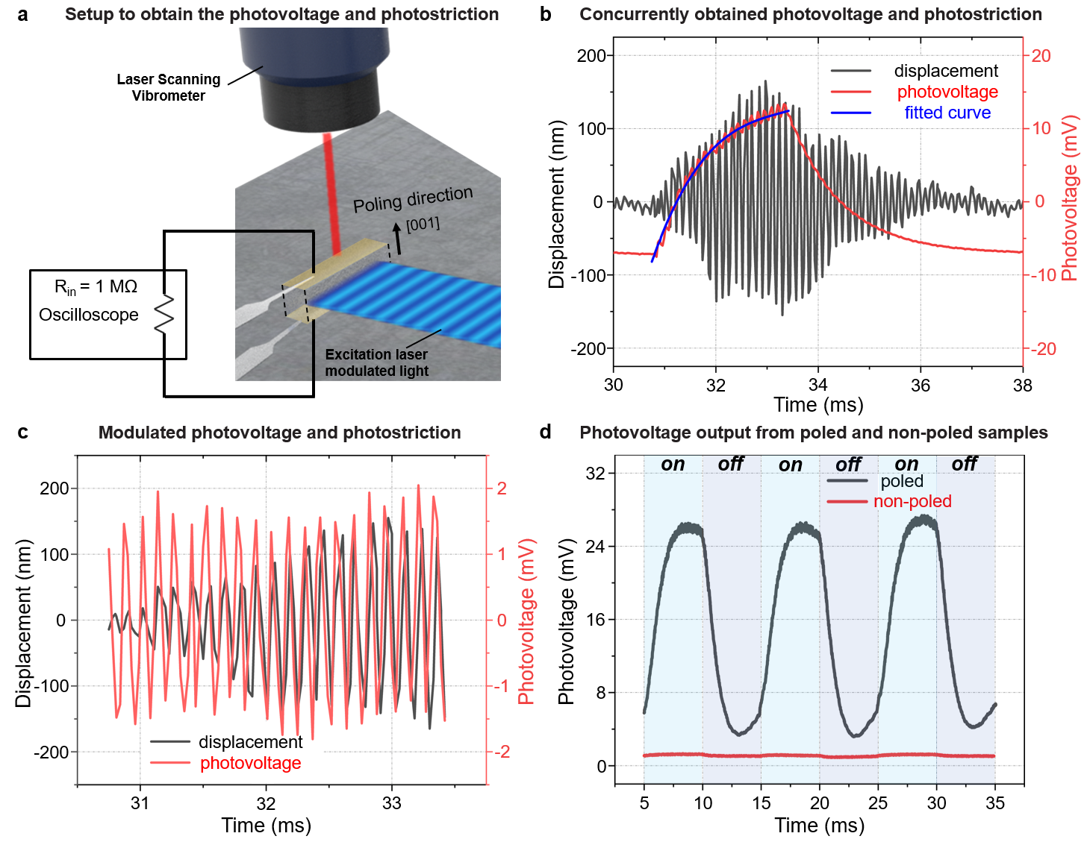
Supplementary Fig. 1 | Concurrent measurements for the BPVE and photostriction of KNN-xTb (x=0.02) ceramic samples. (a) Schematic diagram of the experimental setup to measure the BPVE and photostriction concurrently when the KNN-xTb (x=0.02) cantilever is illuminated by an intensity-modulated excitation light. (b) Concurrently obtained photovoltage and photostriction results of KNN-xTb (x=0.02) cantilever in the time domain when the KNN-xTb (x=0.02) cantilever is illuminated by an intensity-modulated excitation light, followed by switch-off of the light. (c) Concurrently obtained photovoltage and photostriction results of KNN-xTb (x=0.02) cantilever in the time domain by subtracting the fitted baseline of the photovoltage. (d) Comparison of photovoltage output from the poled and non-poled KNN-xTb (x=0.02) cantilevers.

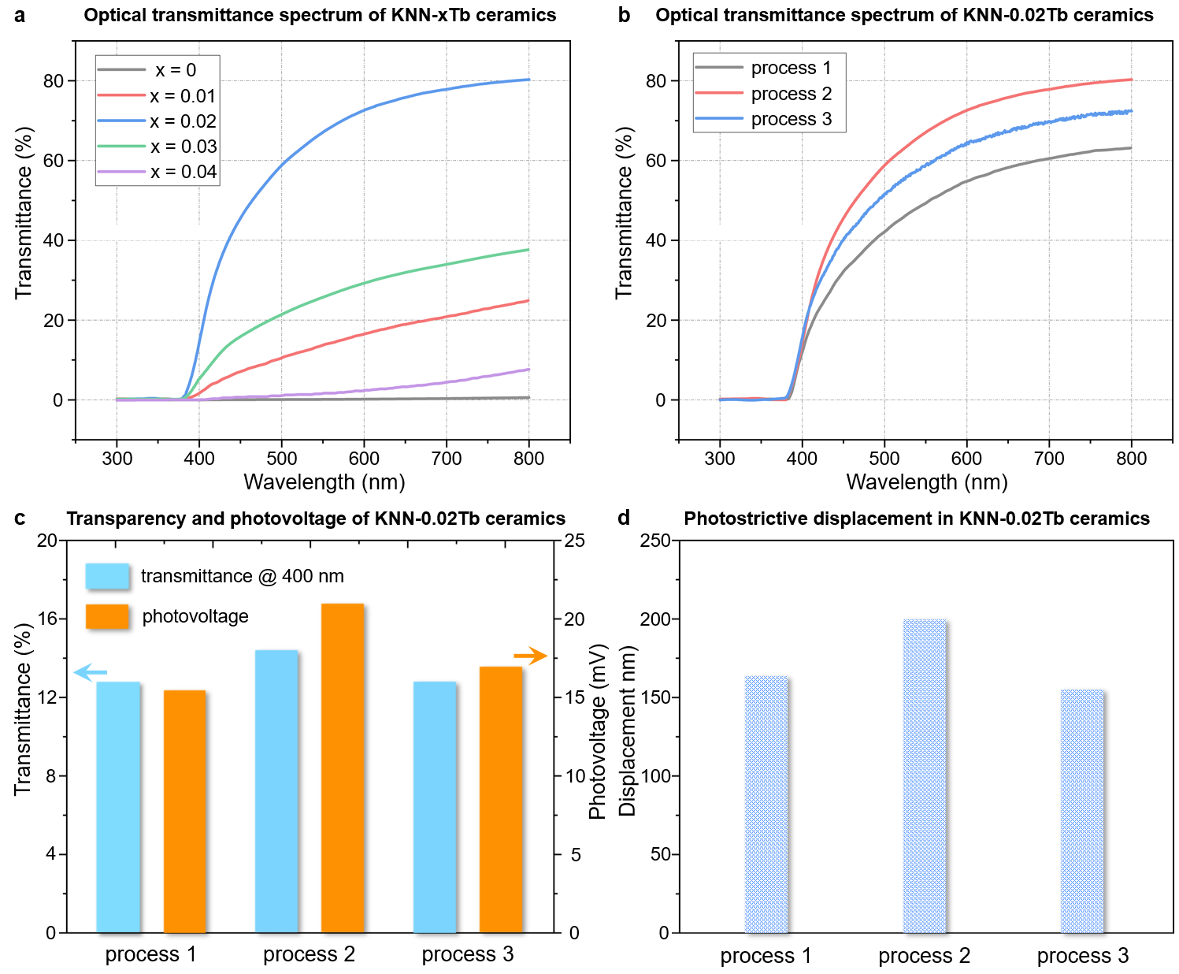
Supplementary Fig. 2 | Comparison of composition and process-dependent transmittance, and the effects of different processes on transmittance, photovoltage, and photostrictive displacement. (a) Comparison of transmittance in KNN-xTb (x = 0-0.04) samples, revealing composition-dependent transmittance. (b) Transmittance variations according to different processing methods on KNN-0.02Tb sample. (c) Transmittance and photovoltage comparison for KNN-0.02Tb samples produced via different methods under modulated excitation light with the wavelength of 400 nm. (d) Photostrictive displacement comparison for KNN-0.02Tb samples produced using different processing methods under modulated excitation light with the wavelength of 400 nm.

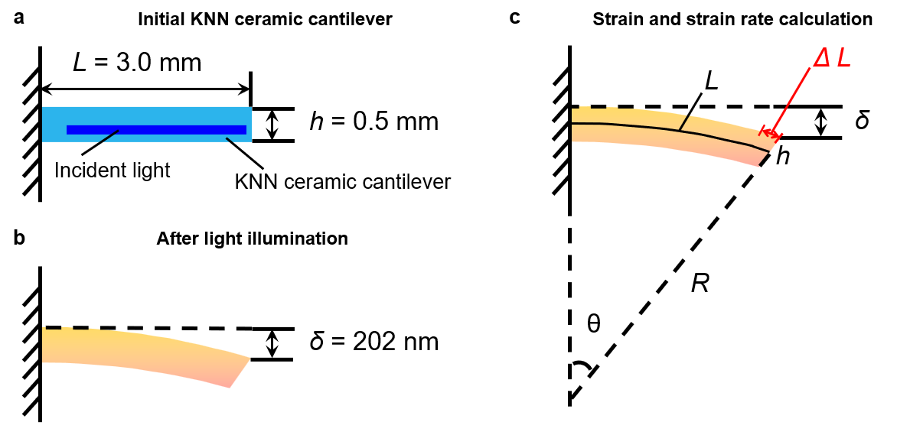
Supplementary Fig. 3 | Schematic illustration of the calculation of maximum strain in the cantilever. (a) Dimensions of the KNN-xTb cantilever and the incident light. (b) Bending of the cantilever upon illumination of excitation light on the lower half. (c) Geometrical analysis used to calculate the strain resulting from the cantilever’s bending.

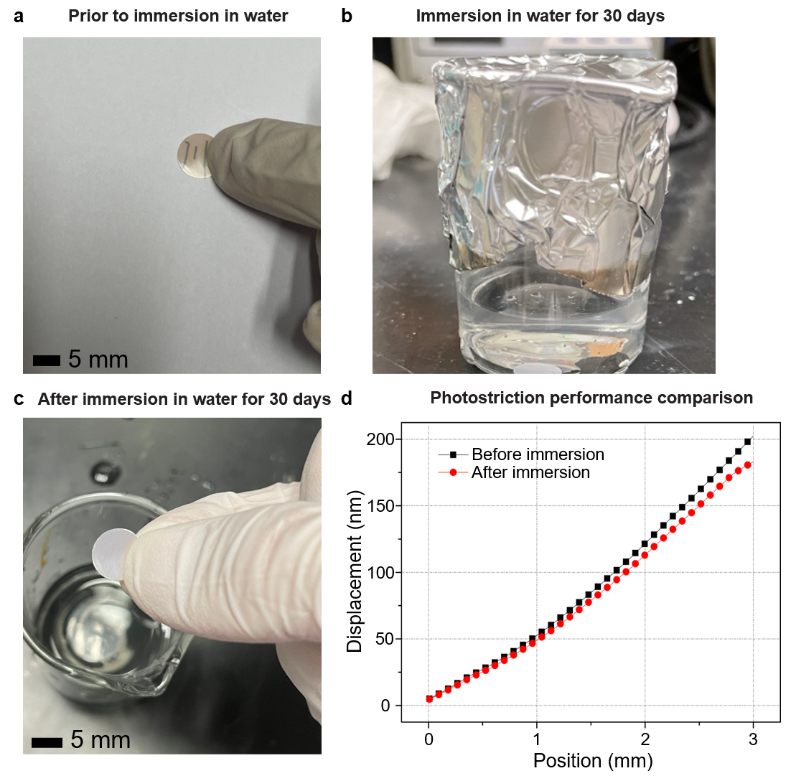
Supplementary Fig. 4 | Water resistance test of KNN-0.02Tb ceramic samples. (a) KNN-0.02Tb ceramic sample prior to immersion in water. (b) KNN-0.02Tb ceramic sample immersed in water. (c) KNN-0.02Tb ceramic sample after 30-day water immersion period. (d) Comparison of photostrictive displacement in unpoled KNN-0.02Tb ceramic cantilevers before and after water immersion.

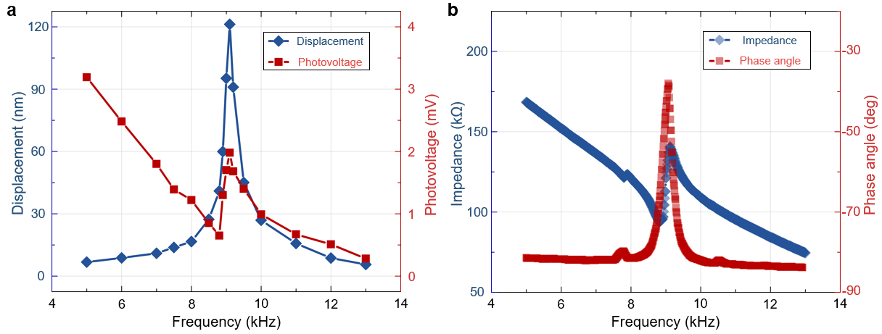
Supplementary Fig. 5 | Resonance-driven photostriction enhancement. a, Photovoltage and photostrictive displacement measured at different frequencies for the KNN-xTb (x=0.02) cantilever, showing the maximum strain at 9.1 kHz. b, Frequency-dependent electrical impedance and phase angle of the KNN-xTb (x=0.02) cantilever, highlighting the resonance peak at 9.1 kHz.

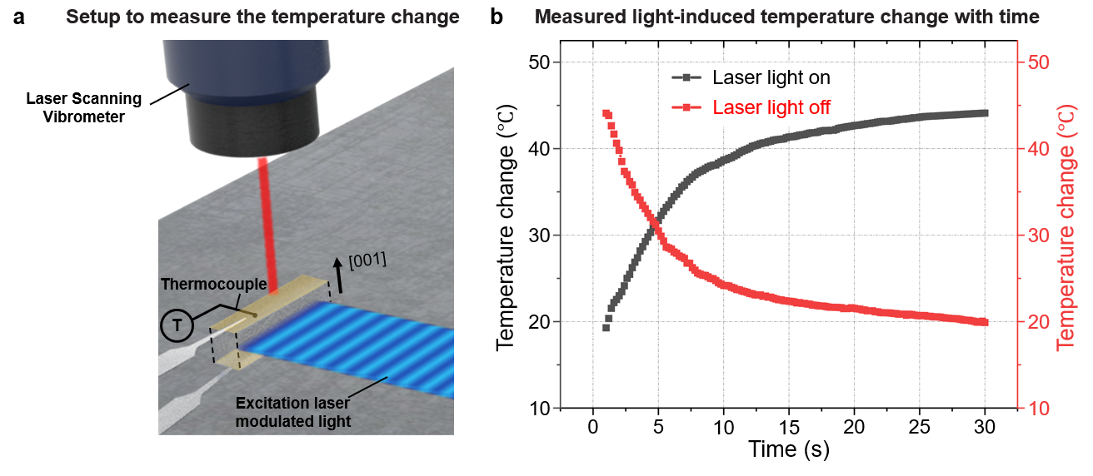
Supplementary Fig. 6 | Effect of light-induced thermal expansion on KNN-xTb (x=0.02) ceramic cantilever. (a) Schematic of the experimental setup used to measure the temperature change of the PMN-PT cantilever under the excitation light. (b) Temperature variation over time as the excitation light is switched on and off.

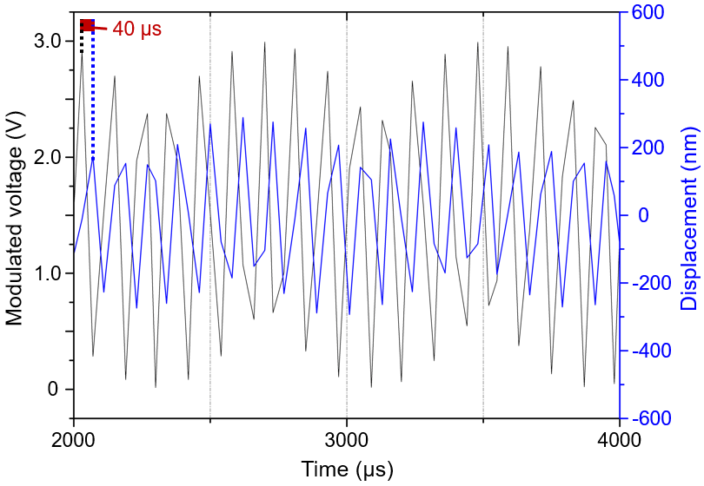
Supplementary Fig. 7 | Microsecond-scale delay between peak illumination and maximum strain.

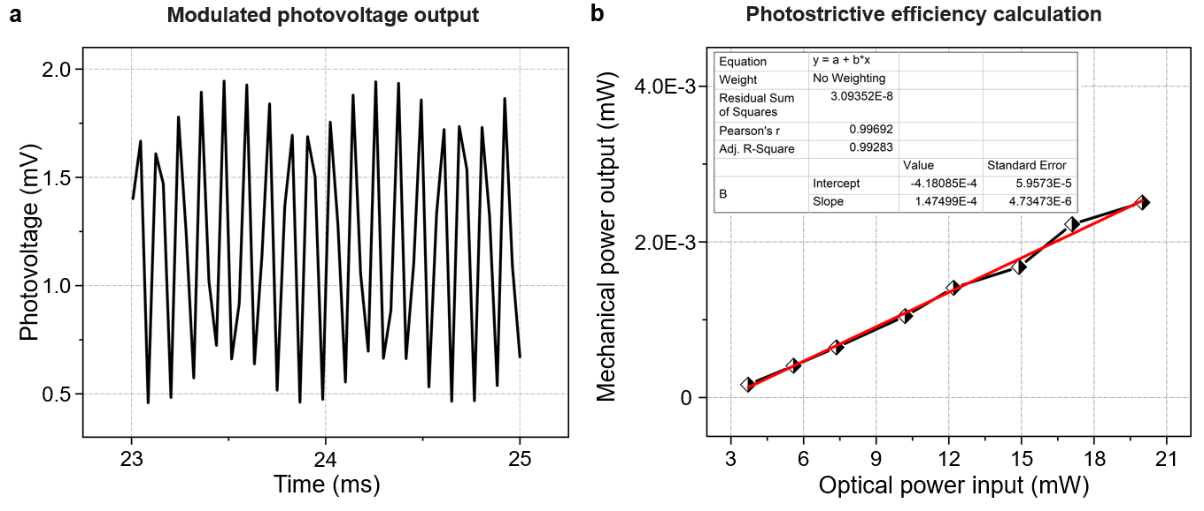
Supplementary Fig. 8 | Evaluation of the photovoltage efficiency and photostrictive efficiency. (a) Photovoltage output under illumination by intensity-modulated light with a 9.1 kHz-modulation frequency. (b) The mechanical power output of the KNN-xTb cantilever scales in proportion with the optical power input. The photostrictive power conversion efficiency, given by the slope of the linear fit, is 1.47×10⁻⁴.

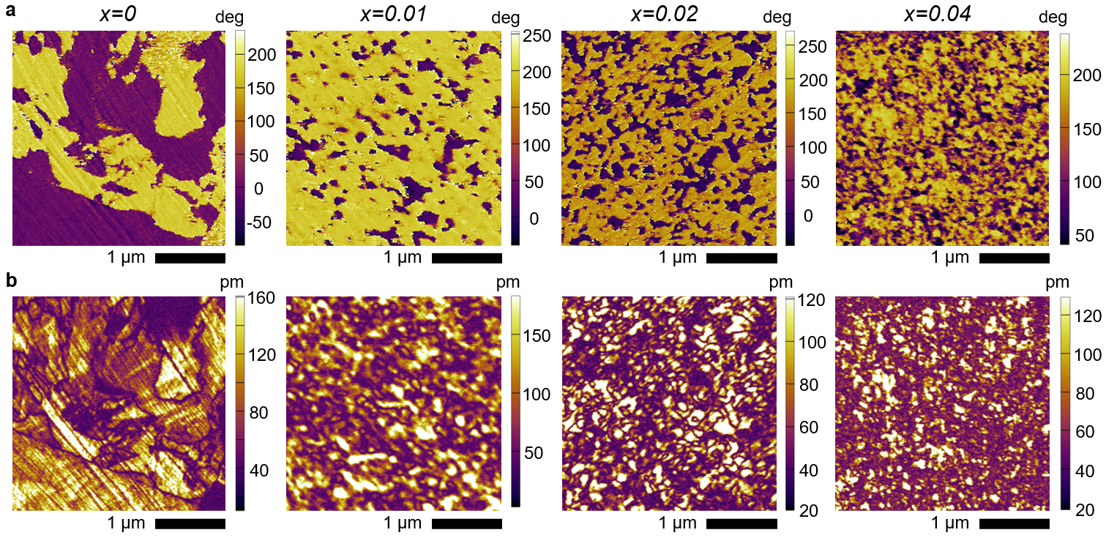
Supplementary Fig. 9 | Composition-dependent domain morphology of KNN-xTb samples. (a) PFM-phase images depicting composition-dependent domain morphology in KNN-xTb (x = 0-0.04) samples. (b) PFM-amplitude images depicting composition-dependent domain morphology in KNN-xTb (x = 0-0.04) samples.

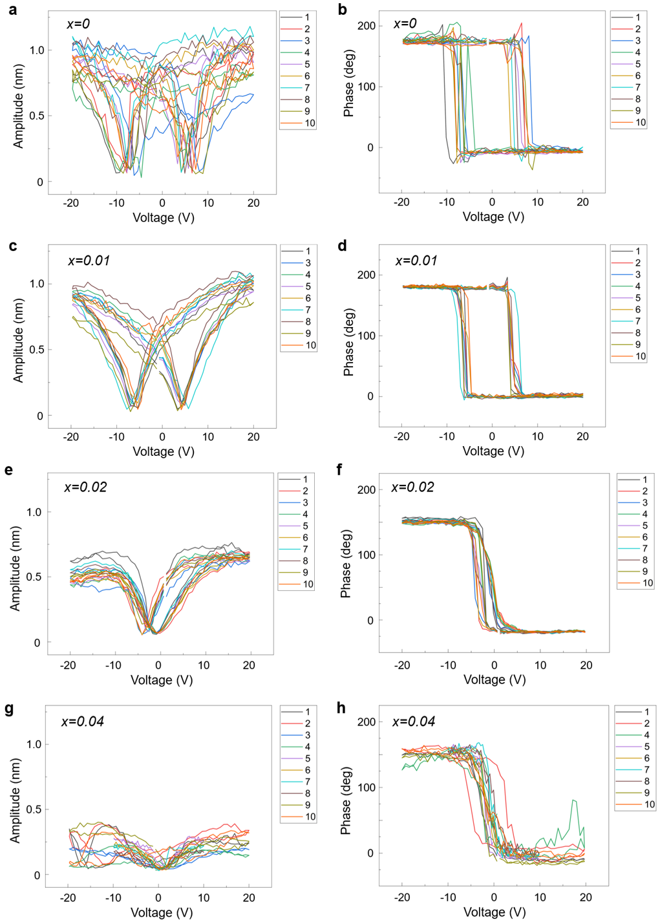
Supplementary Fig. 10 | Local piezoelectric response of KNN-xTb ceramics. (a, c, e, g) Amplitude of the local voltage-induced deflection change of the sample, and (b, d, f, h) corresponding local voltage-induced phase change of the sample.

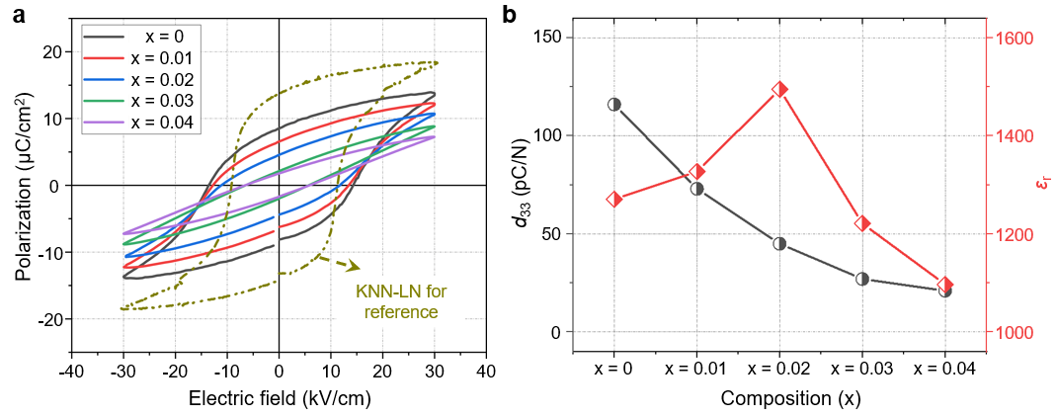
Supplementary Fig. 11 | Composition-dependent PE loops and piezoelectric and dielectric property of KNN-xTb samples. (a) Comparison of PE loops in KNN-xTb (x = 0-0.04) samples, and the PE loop of a KNN-LN sample is also introduced as a reference. (b) Piezoelectric strain coefficient d₃₃ and dielectric constant ε_{r} variations of KNN- xTb samples with different compositions (x = 0-0.04).

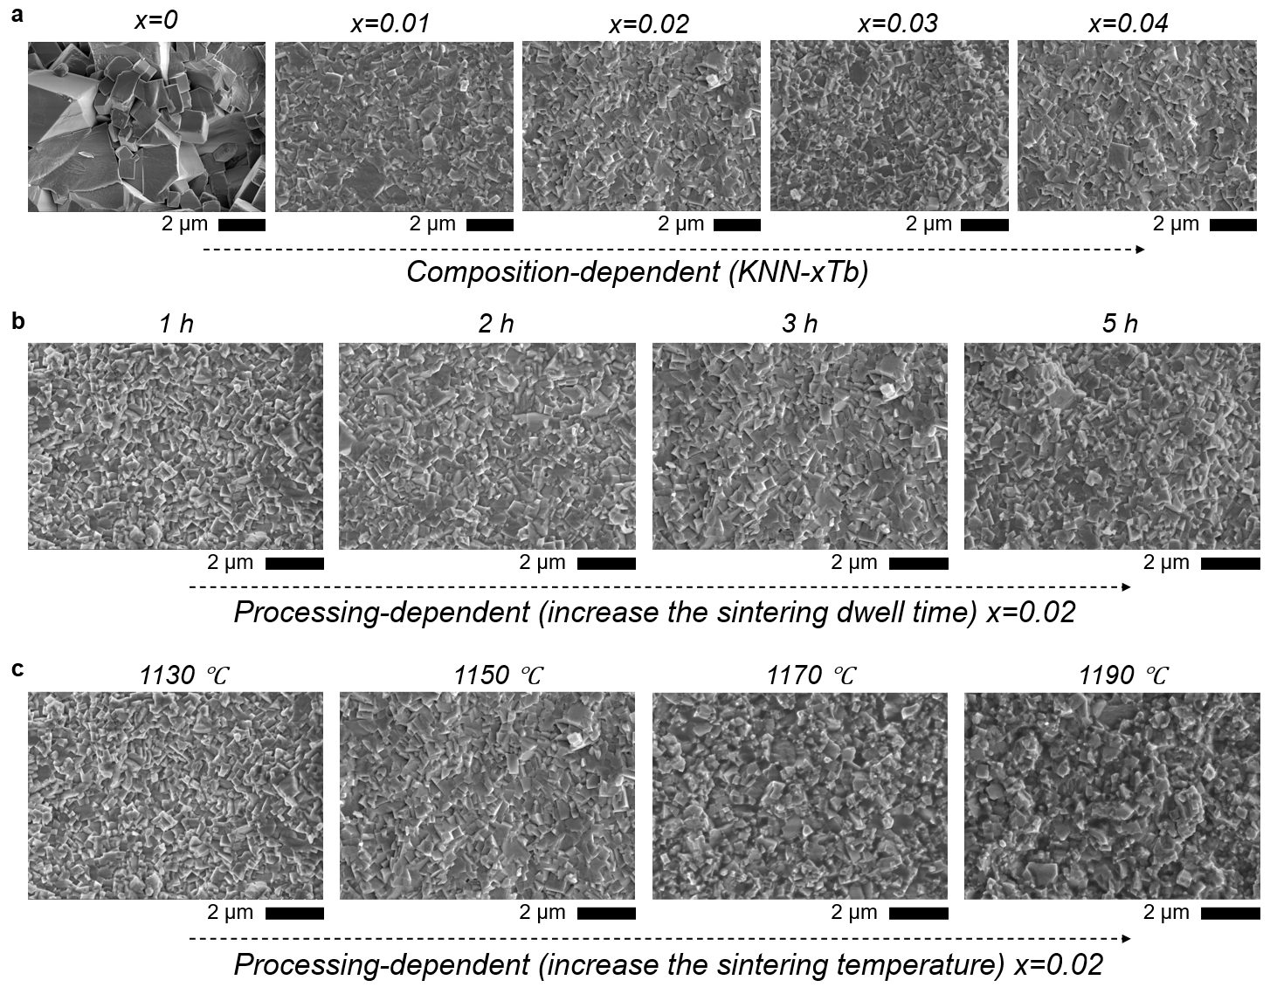
Supplementary Fig. 12 | SEM images showing composition and process-dependent microstructure morphology. (a) SEM images depicting composition-dependent microstructure morphology in KNN-xTb (x = 0-0.04) samples. (b) Processing-dependent SEM images of KNN-0.02Tb under different dwell times. (c) Processing-dependent SEM images of KNN-0.02Tb under different sintering temperatures, showing the processing-dependent microstructure morphology of KNN-0.02Tb samples.

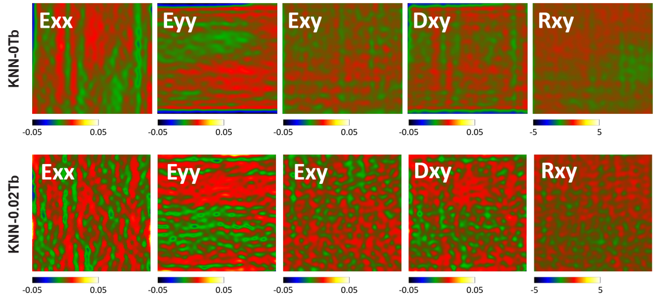
Supplementary Fig. 13 | Internal stress within the grain. Local strain fields of KNN-0Tb and KNN-0.02Tb, derived from Geometric Phase Analysis (GPA), showing E_{xx} (normal strain along the x-direction), E_{yy} (normal strain along the y-direction), E_{xy} (shear strain in the xy-plane), D_{xy} (displacement gradient), and R_{xy} (rotation field in the xy-plane).

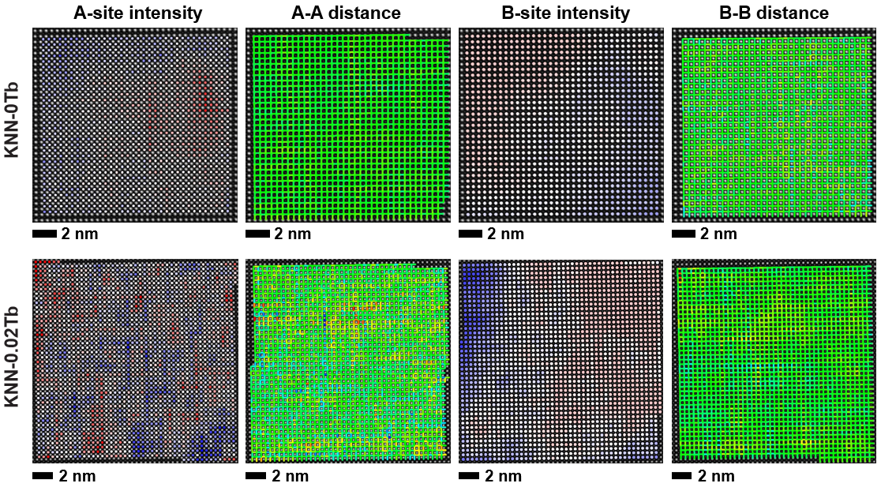
Supplementary Fig. 14 | Doping site analysis of Tb doping in KNN ceramics. Using aberration-corrected STEM along [100] zone axis, the relative intensities and positions of A-site and B-site atoms were determined in KNN-xTb sample. The A-A and B-B distances were then calculated to evaluate whether Tb atoms occupy the A-site or B-site within the crystal lattice. This analysis reveals that Tb is doped into the A-site of the KNN lattice, leading to changes in the relative intensity of A-site atoms and inducing structural distortions in the spatial arrangement of A-site atoms.

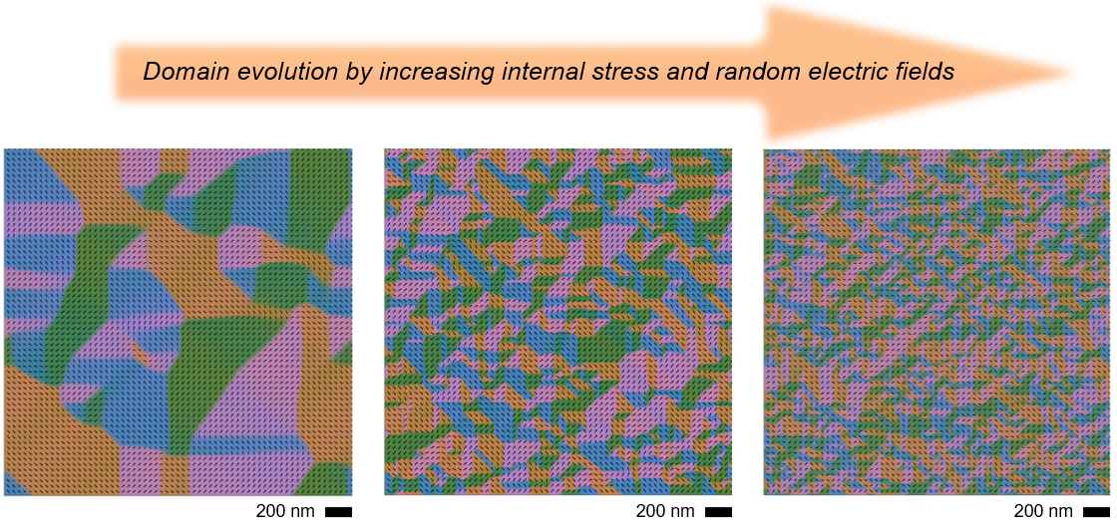
Supplementary Fig. 15 | Domain structures evolution through phase-field simulations. The evolution of domain structures was successfully replicated through phase-field simulations, guided by experimental observations, by accounting for internal stresses and random electric fields. As the internal stresses and random electric fields increased, the domain structures progressively transitioned from a micrometer size to tens of nanometer size and eventually to just a few nanometer size.

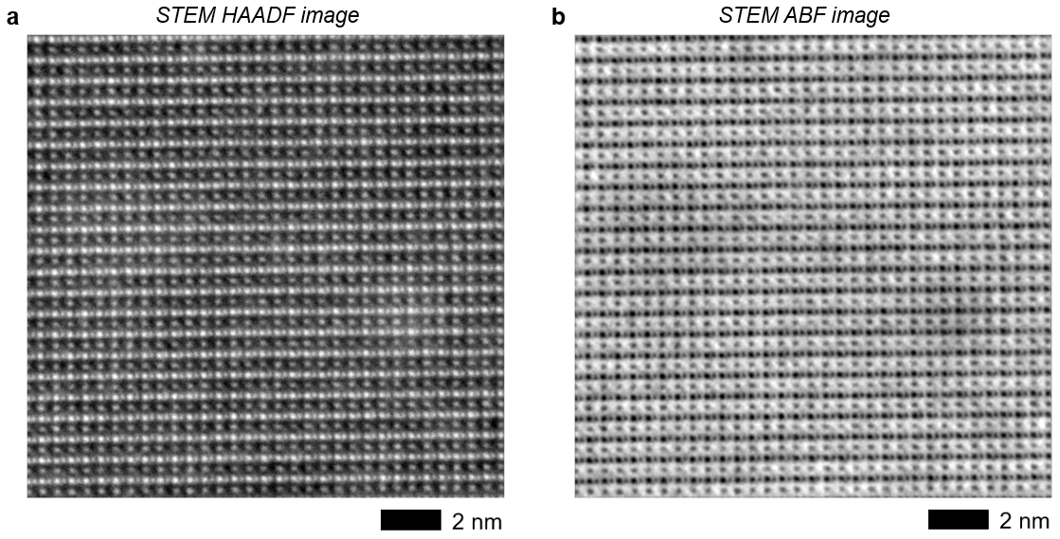
Supplementary Fig. 16 | STEM images used for point-to-point correlation analysis. (a) and (b) Simultaneously acquired STEM HAADF and ABF images of KNN-0.02Tb sample along [110] zone axis.

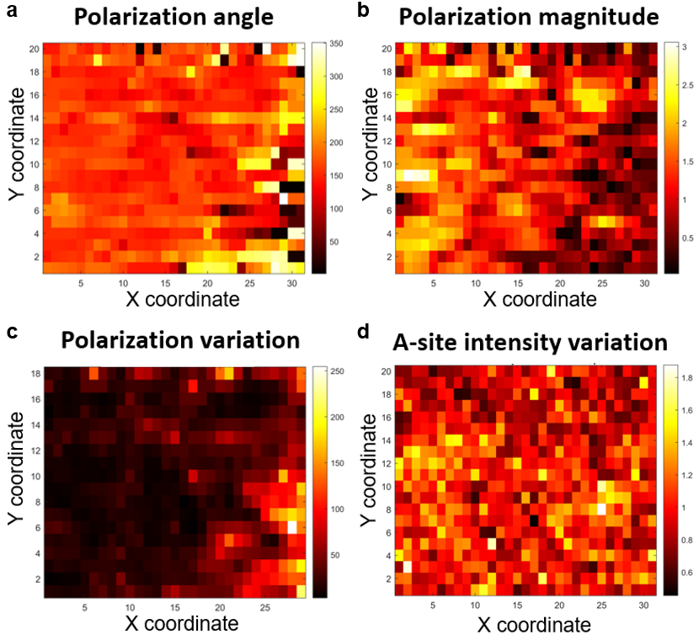
Supplementary Fig. 17 | Polarization analysis and corresponding local structural factor mappings. (a) Polarization angle P_{ang} is determined by the orientation of polarization vectors. (b) Polarization magnitude P_{mag} is defined by the vector length. (c) The polarization variation is characterized by the deviated polarization angle (θ_{DP}), calculated as θ_{DP} = ∑_{i} |θ_{i} - θ₀|/8, where θ₀ is the polarization angle of the central unit cell and θ_{i} are those of the surrounding unit cells³. (d) A-site intensity variation map obtained by subtracting the average A-site intensity from each individual A-site column and plotting the absolute value of the relative change.

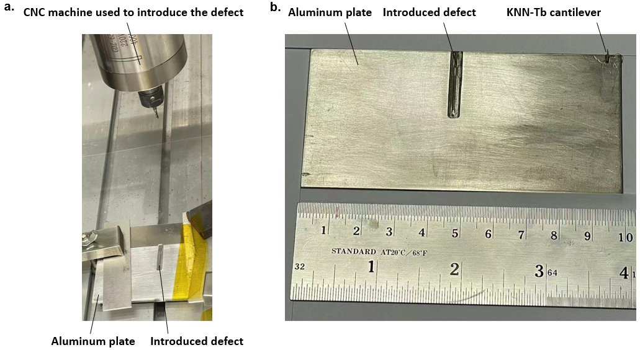
Supplementary Fig. 18 | Experimental details for introducing the machined defect. (a) Experimental setup of using the CNS to introduce machined defects with different depths on aluminum plate, and (b) a photo to show more details for the sizes of the aluminum plate and the introduced defect.

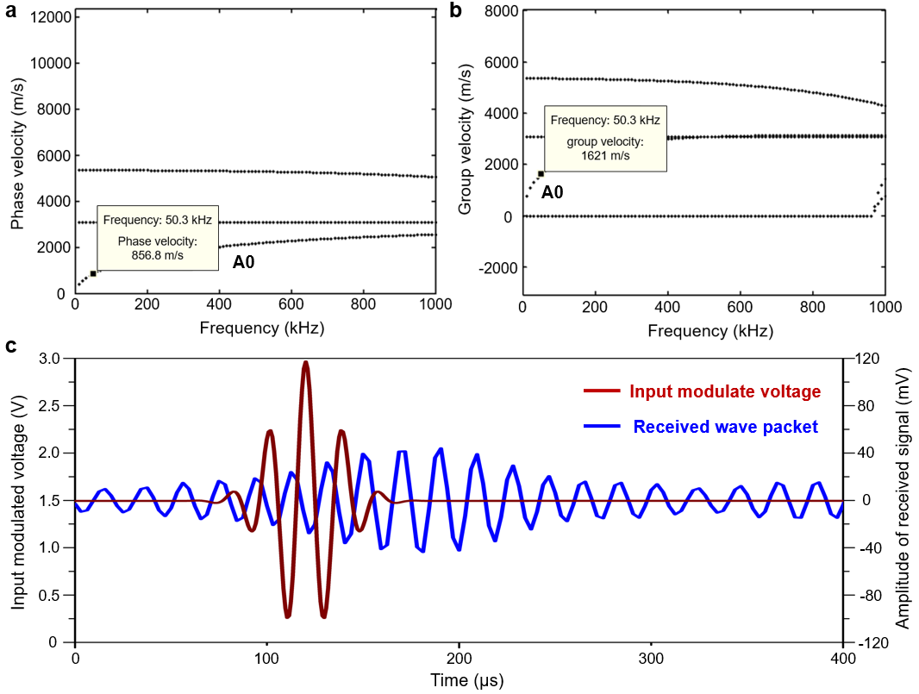
Supplementary Fig. 19 | Determination of A0 Ultrasonic Lamb wave in a 1.6 mm-thick aluminum plate. (a) Phase velocity as a function of frequency. (b) Group velocity as a function of frequency. The dispersion curves provide phase and group velocities of acoustic waves at specific frequencies. (c) Modulated input voltage (dark red) used to modulate light to excite the KNN-xTb cantilever, which acts as an opto-ultrasonic transmitter, generating vibrations for exciting the ultrasound in the aluminum plate, together with the corresponding received ultrasonic wave packet (blue).

Reference
1. Malič, B.; Razpotnik, H.; Koruza, J.; Kokalj, S.; Cilenšek, J.; Kosec, M. J. J. o. t. A. C. S., Linear thermal expansion of lead‐free piezoelectric K_{0.5}Na_{0.5}NbO₃ ceramics in a wide temperature range. Journal of the American Ceramic Society 2011, 94 (8), 2273-2275.
2. Pinho, R.; Tkach, A.; Carpenter, M. A.; Noudem, J.; Costa, M. E.; Vilarinho, P. M. J. S. M., Elastic moduli of potassium sodium niobate ceramics: Impact of spark plasma texturing. Scripta Materialia 2022, 218, 114837.
3. Yin, J.; Shi, X.; Tao, H.; Tan, Z.; Lv, X.; Ding, X.; Sun, J.; Zhang, Y.; Zhang, X.; Yao, K. J. N. C., Deciphering the atomic-scale structural origin for large dynamic electromechanical response in lead-free Bi_{0.5}Na_{0.5}TiO₃-based relaxor ferroelectrics. Nature Communications 2022, 13 (1), 6333.

