Supplementary Information
Article Title: Structural MRI Biomarkers of Intracranial Pressure in IIH: Linking Optic Nerve Sheath, Pituitary Morphology, and Hormonal Changes
Journal: Clinical Neuroradiology
Authors: Zeynep Bendella, Barbara Daria Wichtmann, Ralf Clauberg, Wiebke Fenske, Charlotte Fries, Monika Jeub, Martina Minnerop, Arndt-Hendrik Schievelkamp, Franziskus M. Schützeichel, Bettina Wabbels, Christina Schaub, Max Witry, Berkan Koyak, Alexander Radbruch, Jennifer Linder, Ullrich Wüllner, Christine Kindler
Corresponding Author: Zeynep Bendella, MD
Affiliation: Department of Neuroradiology, University Hospital of Bonn, Bonn, Germany
E-Mail : zeynep.bendella@ukbonn.de

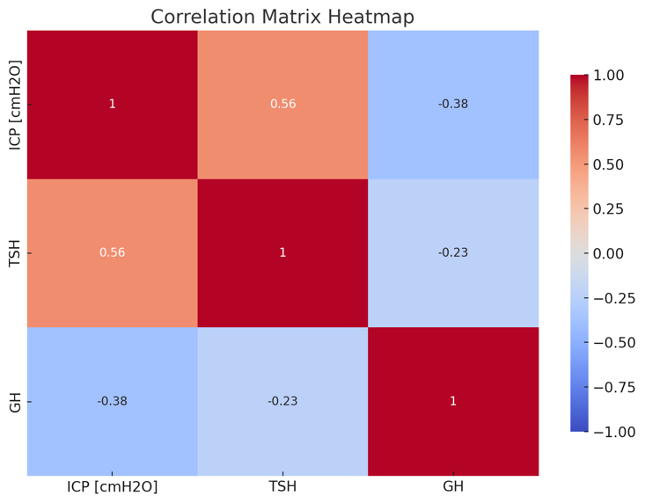

Fig. S1 Correlation Matrix Heatmap. The heatmap illustrates the correlation coefficients between various parameters: ICP (Intracranial Pressure), TSH (Thyroid-Stimulating Hormone), fT4 (Free Thyroxine), and GH (Growth Hormone). The colors represent the strength and direction of the correlations, with red indicating positive correlations and blue indicating negative correlations. The numbers within the cells indicate the exact correlation coefficients. The data shows notable positive correlations between TSH and ICP (0.56), and between fT4 and GH (0.69), while showing negative correlations between ICP and GH (-0.38) and ICP and fT4 (-0.3)

