Supplementary material

Journal name: Plant Molecular Biology

Introgression of barley chromosome arms 4H and 6H into wheat via Robertsonian translocations: GBS-assisted structural analysis and impact on grain nutrient composition

László Ivanizs^{1a}, Eszter Gaál^{1a}*, Klaudia Kruppa^{1a}, András Farkas¹, Péter Mikó¹, Edina Türkösi¹, Marianna Rakszegi¹, Péter Kovács¹, Balázs Kalapos¹, Andrea Gulyás¹, Norbert Hídvégi¹, Kitti Szőke-Pázsi¹, Márta Molnár-Láng¹, Éva Szakács¹, Mahmoud Said², Jan Bartoš², Tünde Pusztahelyi³, Dimitar Douchkov⁴, István Molnár¹
¹Agricultural Institute, Centre for Agricultural Research, Martonvásár, Hungary
² Institute for Experimental Botany, Centre of Plant Structural and Functional Genomics, Olomouc 779 00, Czech Republic
³ Central Laboratory of Agricultural and Food Products, Faculty of Agricultural and Food Sciences and Environmental Management, University of Debrecen, Debrecen, Hungary
⁴ Research Group Biotrophy and Immunity, Leibniz Institute of Plant Genetics and Crop Plant Research (IPK), Gatersleben, Germany

ªThese authors are equal first authors
*Corresponding author: gaal.eszter@atk.hun-ren.hu

Following supplementary informations are involved in these files:
Four tables are included separately in four additional Excel files-
Supplementary Table 1. Data on primer pairs used to detect barley chromosome arms.
Supplementary Table 2. Results of selection for the plants carrying 6BS.6HL or 6HS.6BL translocation.
Supplementary Table 3. Results of selection for the plants carrying 4BS.4HL translocation.
Supplementary Table 4. Number of reads, number of average reads per 1Mb bin and average of normalized read values per 1 Mb bin data of Asakaze wheat, Manas barley and 6HS.6BL, 6BS.6HL and 4BS.4HL translocation lines mapped onto the T. aestivum-H. vulgare in silico hybrid.

Seven inline figures are inserted in this file-
Supplementary Figure S1. Digital capillary electrophoretic pattern of molecular markers specific to barley chromosome 4H.
Supplementary Figure S2. Normalized GBS read coverage of the Asakaze parental wheat variety along the 1-7 chromosomes of wheat subgenomes A, B, and D, and the barley genome H used as reference.
Supplementary Figure S3. Normalized GBS read coverage of the Manas parental barley variety along the 1-7 chromosomes of wheat subgenomes A, B, and D, and the barley genome H used as reference.
Supplementary Figure S4. Normalized GBS read coverage of the 6HS.6BL centric fusion line along the 1-7 chromosomes of wheat subgenomes A, B, and D, and the barley genome H used as reference.
Supplementary Figure S5. Normalized GBS read coverage of the 6BS.6HL centric fusion line along the 1-7 chromosomes of wheat subgenomes A, B, and D, and the barley genome H used as reference.
Supplementary Figure S6. Normalized GBS read coverage of the 4HS.4BL centric fusion line along the 1-7 chromosomes of wheat subgenomes A, B, and D, and the barley genome H used as reference.
Supplementary Figure S7. Spike morphology of the wheat cultivars Rannaja and Asakaze, the barley cultivar Manas and the wheat-barley translocation lines.

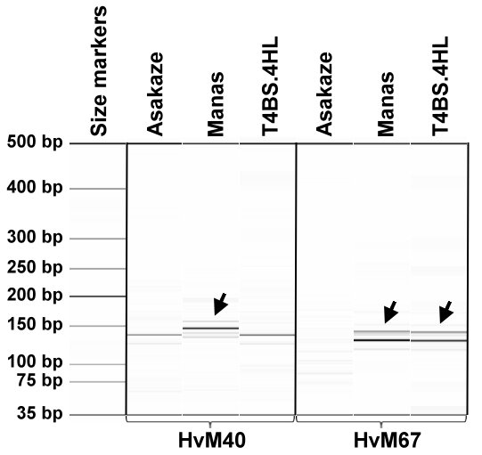
Supplementary Figure S1. Digital capillary electrophoretic pattern of molecular markers specific to barley chromosome 4H. The HvM40 marker, located on the short arm (4HS), and the HvM67 marker, mapped to the long arm (4HL) of chromosome 4H, were tested on wheat cultivar Asakaze, and barley cultivar Manas and the translocation line 4BS.4HL/Asakaze. The arrow indicates the presence of barley-specific PCR products in the tested samples. A 35-500 bp DNA ladder was used as a molecular-weight size standard to estimate the fragment size.

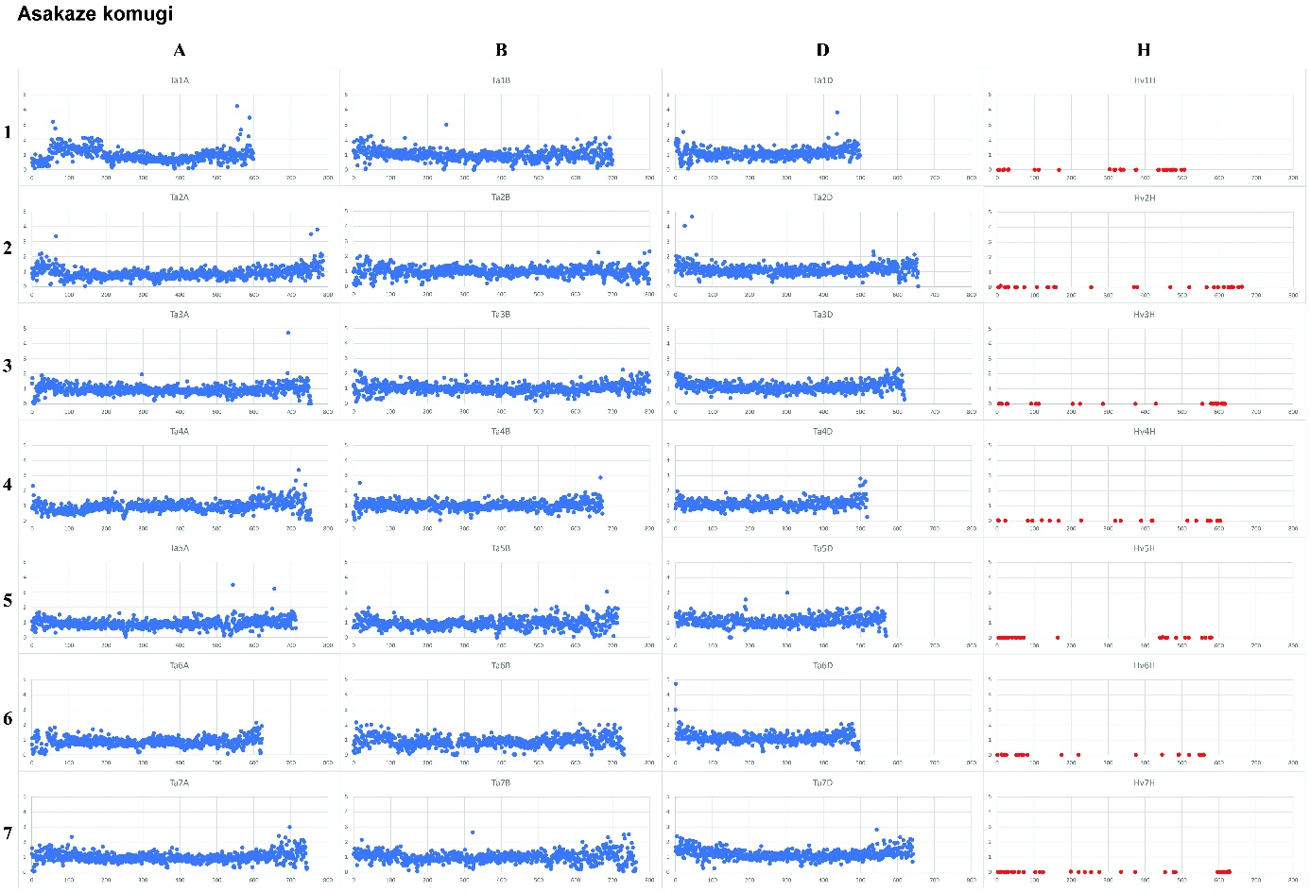
Supplementary Figure S2. Normalized GBS read coverage of the Asakaze parental wheat variety along the 1-7 chromosomes of wheat subgenomes A, B, and D, and the barley genome H used as reference. The x-axis represents the genomic position within the chromosome in Mb, while the y-axis shows the normalized read coverage values.

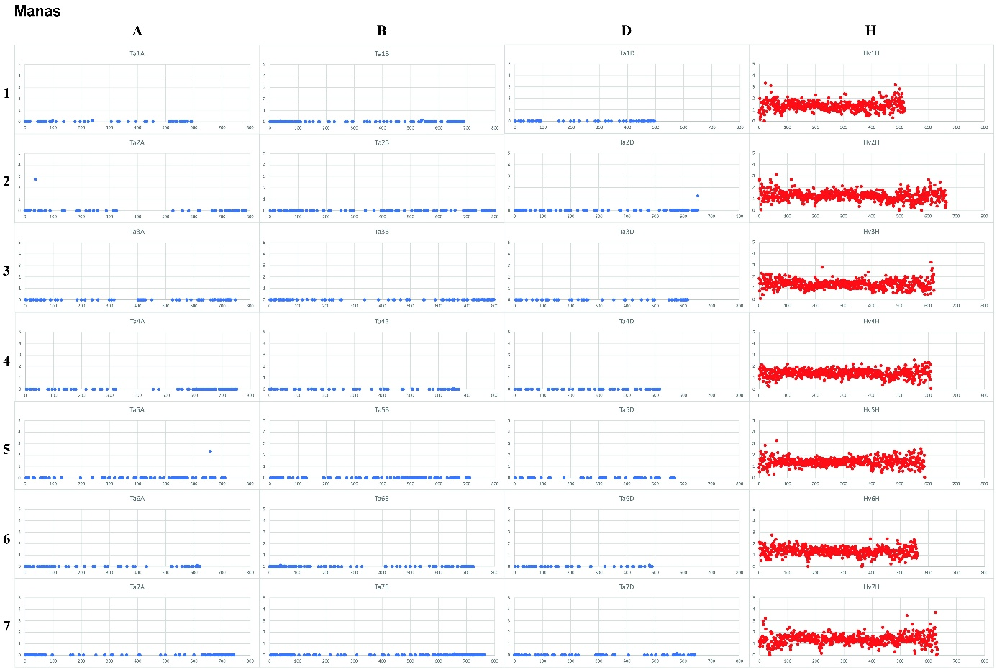
Supplementary Figure S3. Normalized GBS read coverage of the Manas parental barley variety along the 1-7 chromosomes of wheat subgenomes A, B, and D, and the barley genome H used as reference. The x-axis represents the genomic position within the chromosome in Mb, while the y-axis shows the normalized read coverage values.

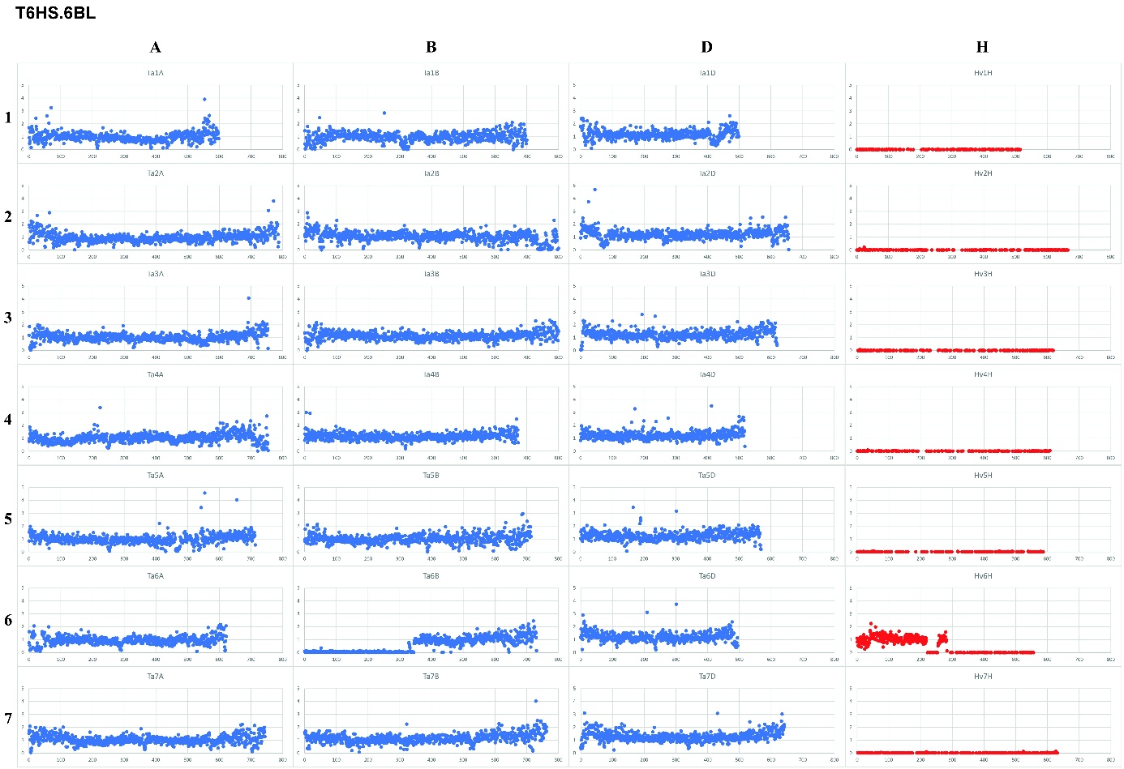
Supplementary Figure S4. Normalized GBS read coverage of the 6HS.6BL centric fusion line along the 1-7 chromosomes of wheat subgenomes A, B, and D, and the barley genome H used as reference. The x-axis represents the genomic position within the chromosome in Mb, while the y-axis shows the normalized read coverage values.

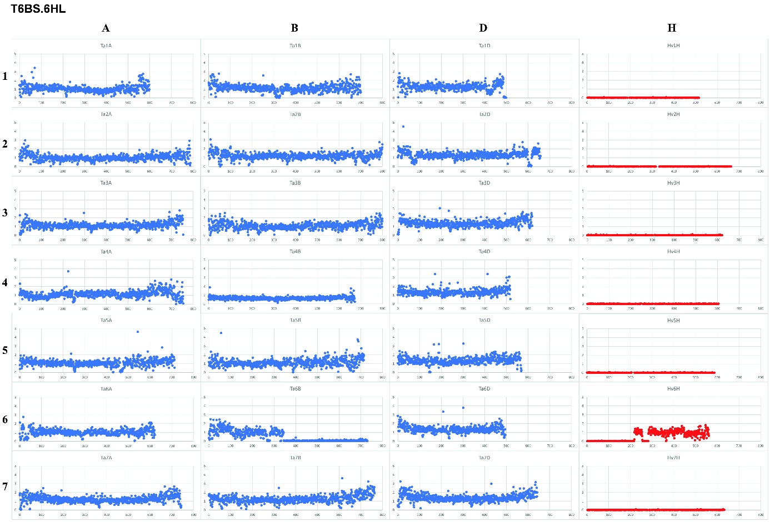
Supplementary Figure S5. Normalized GBS read coverage of the 6BS.6HL centric fusion line along the 1-7 chromosomes of wheat subgenomes A, B, and D, and the barley genome H used as reference. The x-axis represents the genomic position within the chromosome in Mb, while the y-axis shows the normalized read coverage values.

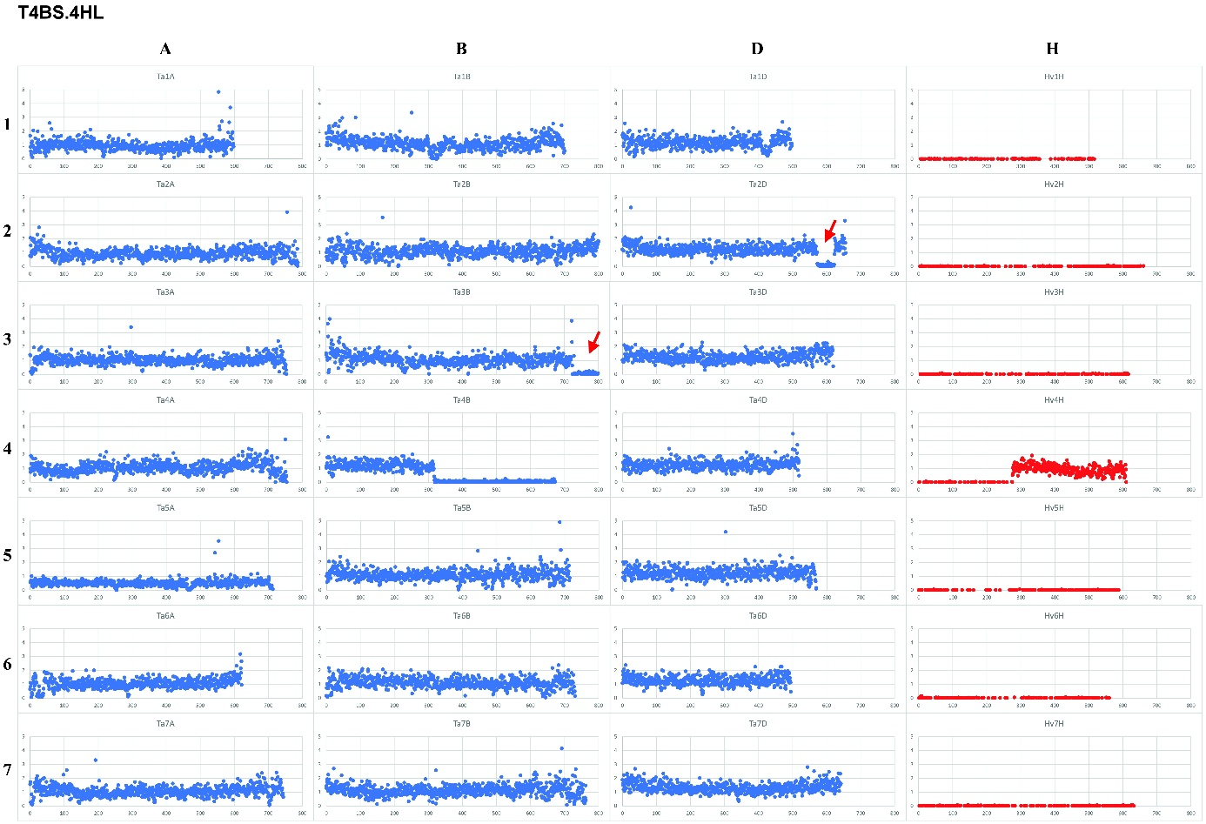
Supplementary Figure S6. Normalized GBS read coverage of the 4BS.4HL centric fusion line along the 1-7 chromosomes of wheat subgenomes A, B, and D, and the barley genome H used as reference. The x-axis represents the genomic position within the chromosome in Mb, while the y-axis shows the normalized read coverage values. Red arrows indicate the two regions (49 and 127 Mb) that are missing from wheat chromosomes 2D (573-622 Mb) and 3B (724-851 Mb).

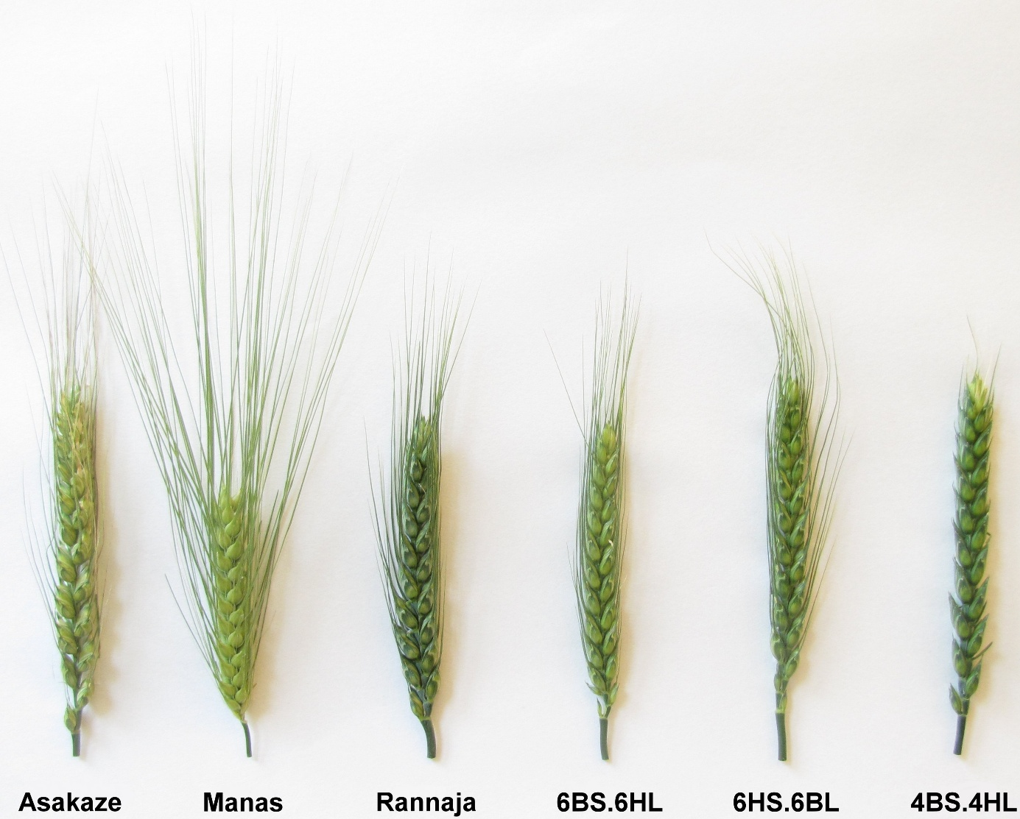
Supplementary Figure S7. Spike morphology of the wheat cultivars Rannaja and Asakaze, the barley cultivar Manas and the wheat-barley translocation lines. The plants were grown in the Organic Nursery (Tükrös) in Martonvásár, Hungary in the 2023-24 growing season.

