Supplementary material

Supplementary Figure 1: Placement of CC mask

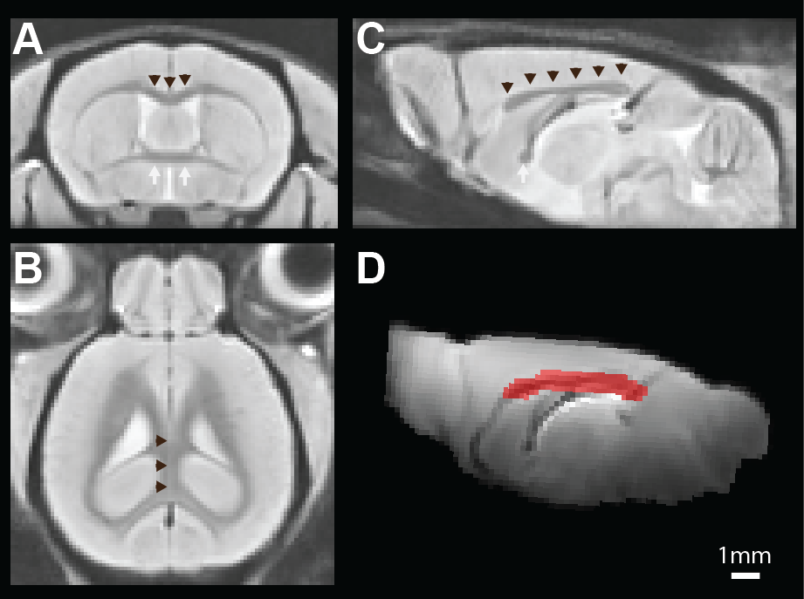
A-C: Shows the T1 study-specific template with coronal (A), axial/horizontal (B), and sagittal (C) views. Black arrowheads delineate CC, and white arrows the anterior commissure. The CC mask was manually delineated on the nodif template (D) with a loosely placed border to include surrounding tissue (red ROI in D). The area delineated on the nodif template was 4mm² compared to the CC area on the T1 template with 2mm².

Supplementary Figure 2:
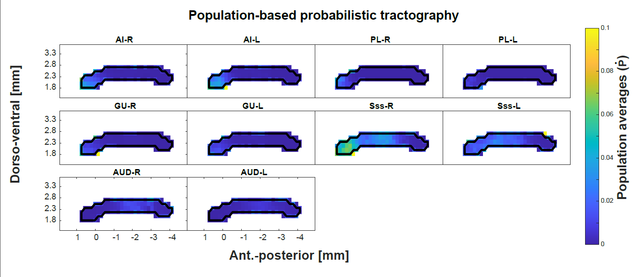
Plot shows population based probabilistic tractography of five ROIs with weaker CC tracts (ROIs not included in Figs 2 and 3).

