Table 1: Comparison of Menstrual and Non-Menstrual Bloodstain Images Across Time Intervals using Stereo Microscope at 1x
Time Intervals | 10 min | 1 hr | 2 hr | 24 hr | 72 hr | 120 hr
Reference/Sample Type | Menstrual Bloodstain
Reference 1 | 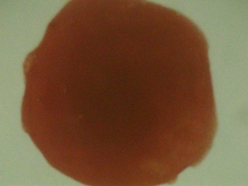 | 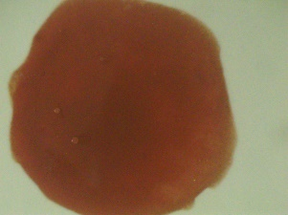 | 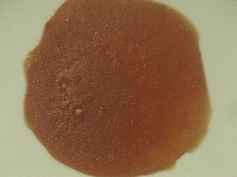 | 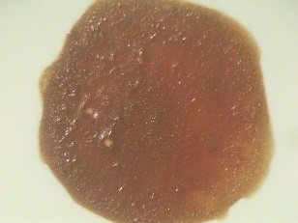 | 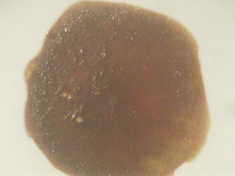 | 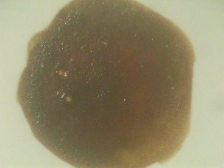
+  +Reference 2 | 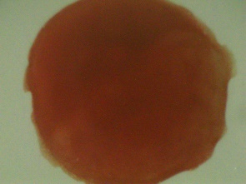 | 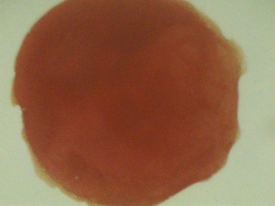 | 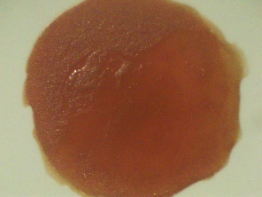 | 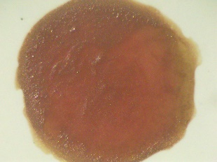 | 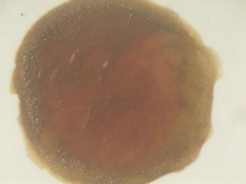 | 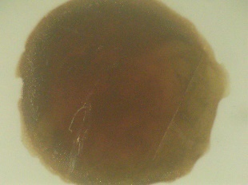
Reference 3 | 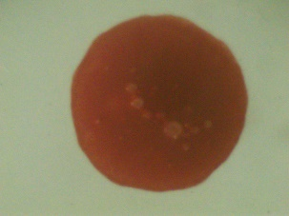 | 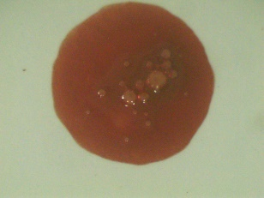 | 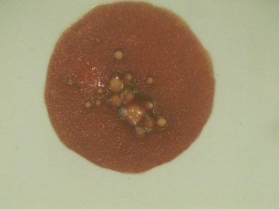 | 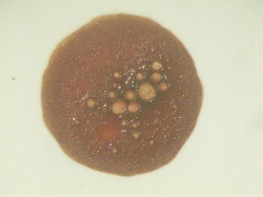 | 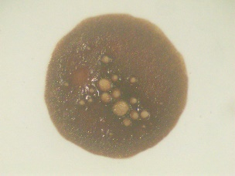 | 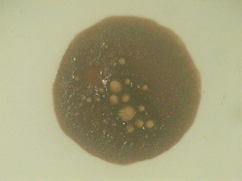
Reference/Sample Type | Non-Menstrual Bloodstain
Reference 1 | 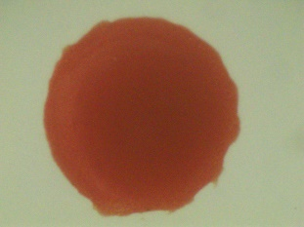 | 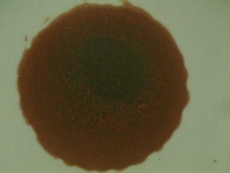 | 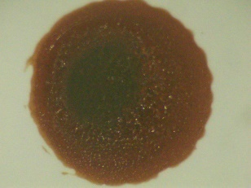 | 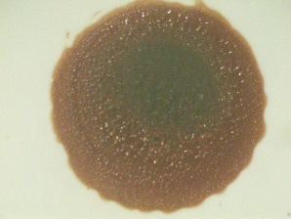 | 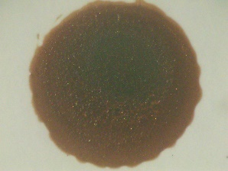 | 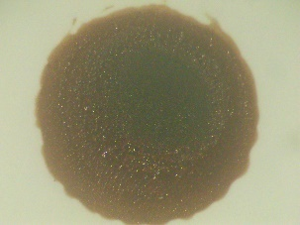
Reference 2 | 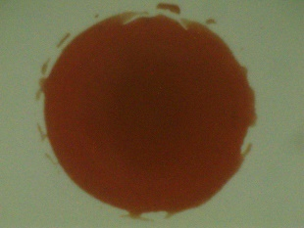 | 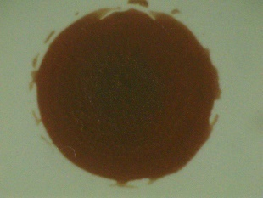 | 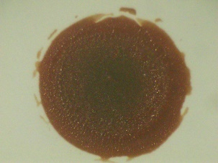 | 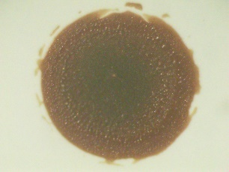 | 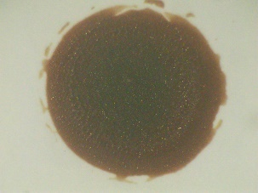 | 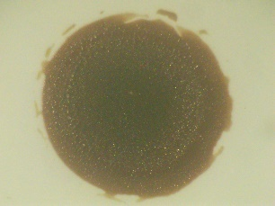
Reference 3 | 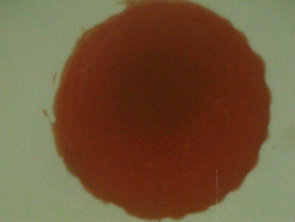 | 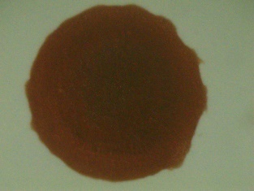 | 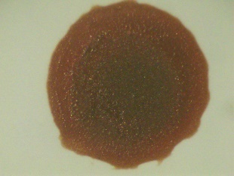 | 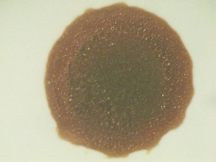 | 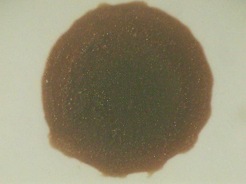 | 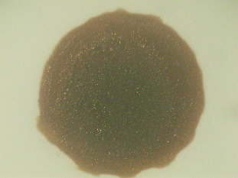

The bloodstains (menstrual ones and the rest) are depicted in Table 1 measured at separate time points after they have been deposited: 10 minutes, 1 hour, 2 hours, 24 hours, 72 hours, and 120 hours. The aim of monitoring such measurements is to determine the variation of the diameter of the stains with time so as to understand the nature of menstrual and non-menstrual bloodstain behaviour and consistency of bloodstains with time.

Table 2: Comparison of Menstrual and Non-Menstrual Bloodstain Images Across Time Intervals using Stereo Microscope at 0.65x with ABFO scale
Time Intervals | 10 min | 1 hr | 2 hr | 24 hr | 72 hr | 120 hr
Reference/Sample Type | Menstrual Bloodstain
Reference 1 | 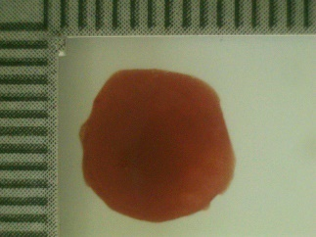 | 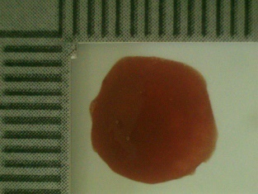 | 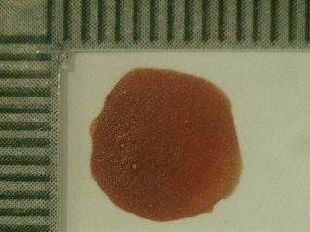 | 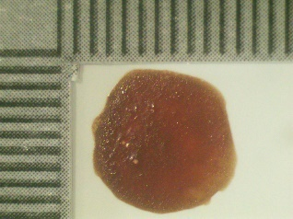 | 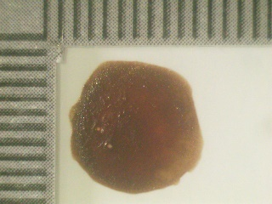 | 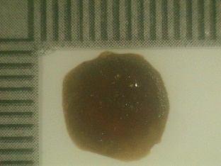
Reference 2 | 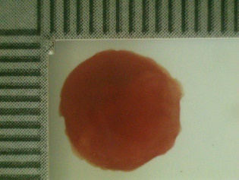 | 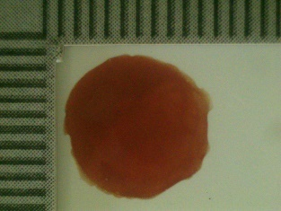 | 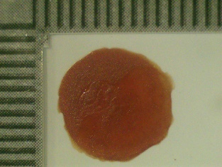 | 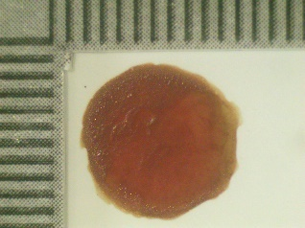 | 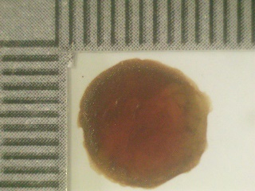 | 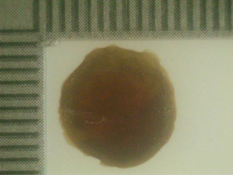
Reference 3 | 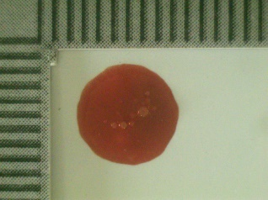 | 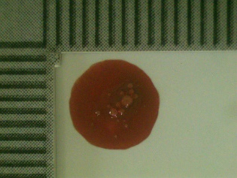 | 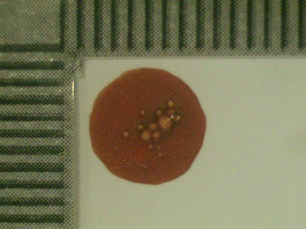 | 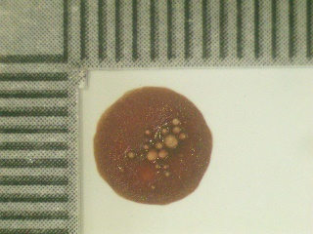 | 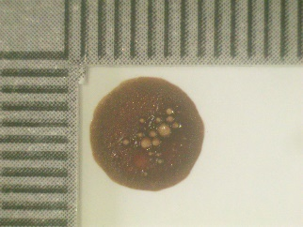 | 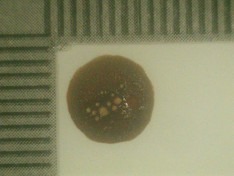
Reference/Sample Type | Non-Menstrual Bloodstain
Reference 1 | 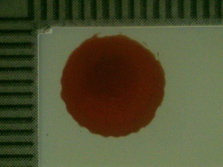 | 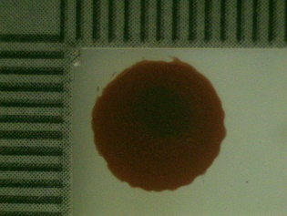 | 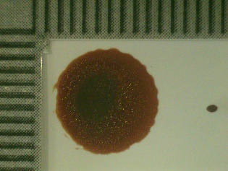 | 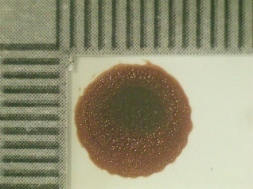 | 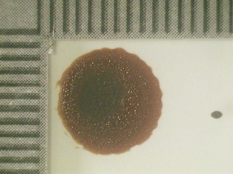 | 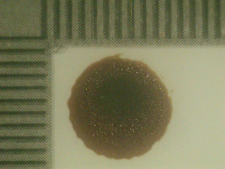
Reference 2 | 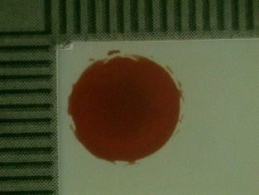 | 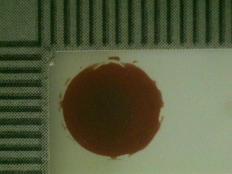 | 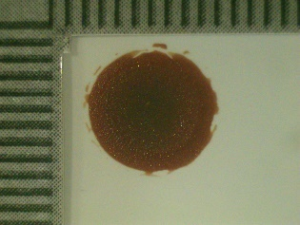 | 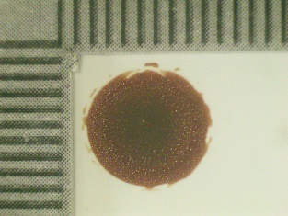 | 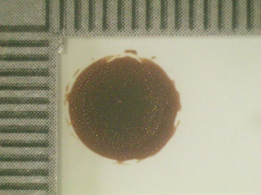 | 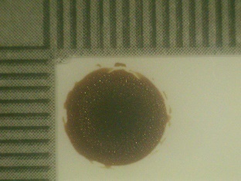
Reference 3 | 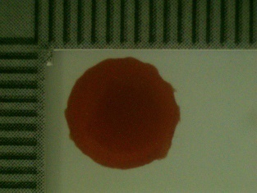 | 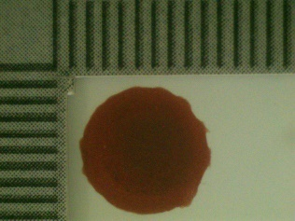 | 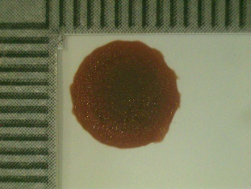 | 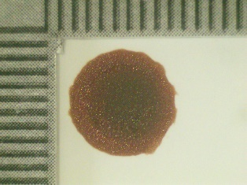 | 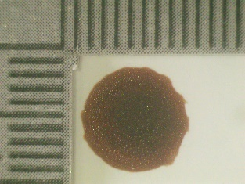 | 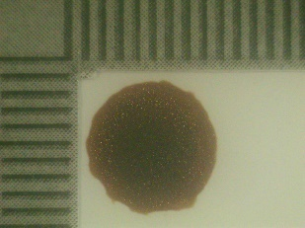

Table 2 presents the comparison of the images of menstrual and non-menstrual bloodstains looked through a stereo microscope at the magnification of 0.65x, comparing the time intervals (10 minutes, 1, 2, 24, 72 and 120 hours) with the help of an ABFO scale. The most important observation that can be made is that, the non-menstrual bloodstains exhibit a successive loss of diameter in these time intervals which appear as a consistent, predictable loss of size as they dry and shrink. The changes in diameter with diameter are probably less regular in menstrual bloodstains, because of the complexity of their composition (blood, endometrial tissue, mucus). This is because the ABFO scale guarantees high levels of accuracy in measuring it, and as time goes by, the microscope shows specific difference in visual appearance, e.g. the texture of the stain or edges.

Table 3: Comparison of Menstrual and Non-Menstrual Bloodstain Images Across Time Intervals using Stereo Microscope at 2x
Time Intervals | 24 hr | 72 hr | 120 hr
Reference/Sample Type | Menstrual Bloodstain
Reference 1 | 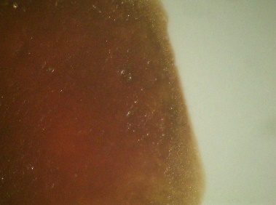 | 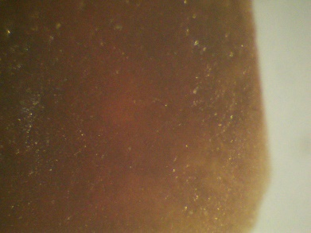 | 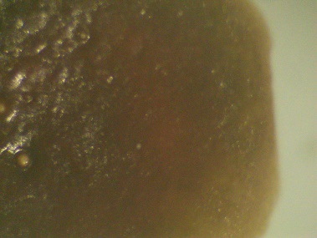
Reference 2 | 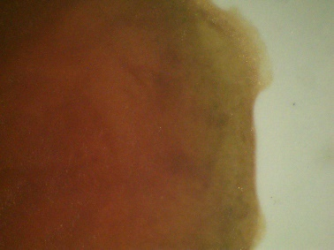 | 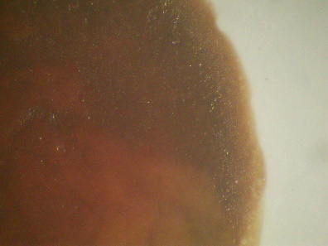 | 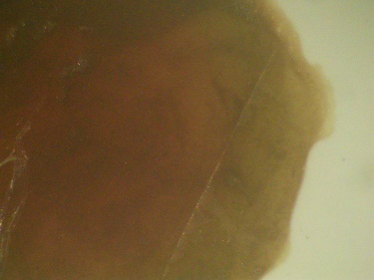
Reference 3 | 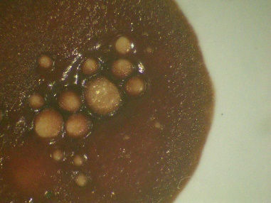 | 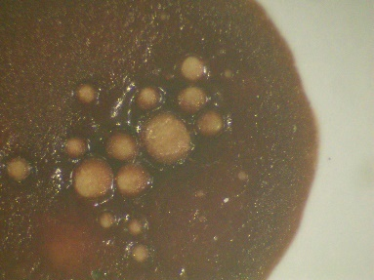 | 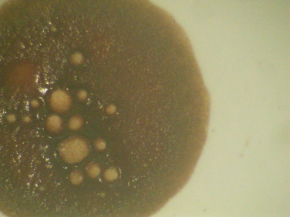
Reference/Sample Type | Non-Menstrual Bloodstain
Reference 1 | 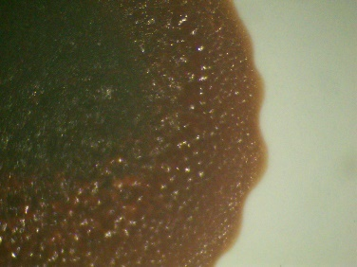 | 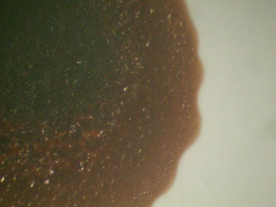 | 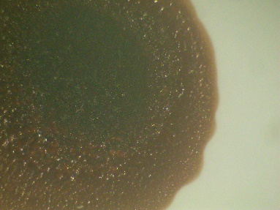
Reference 2 | 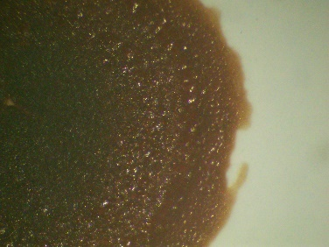 | 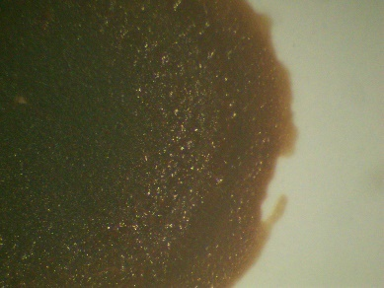 | 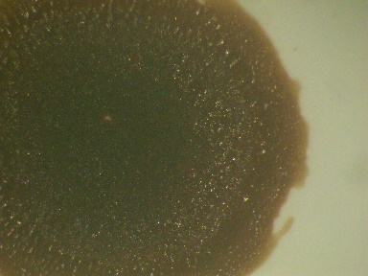
Reference 3 | 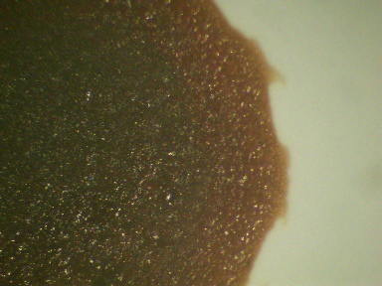 | 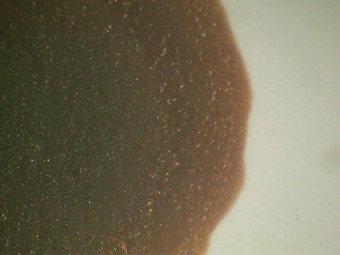 | 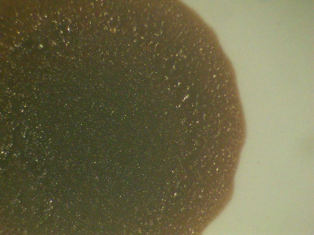

Table 3 gives a comparison of the side profiles (the edge aspects, thickness, or cross-sectional morphology) between menstrual and non-menstrual blood stains viewed using a stereo microscope at 2x magnification after specified intervals of time (24 hours, 72 hours, and 120 hours as in earlier tables). The emphasis is put on the change of these parallel side profiles with time, giving an idea of the physical and structural development of the bloodstains.

The visual comparison of menstrual and non-menstrual bloodstains is provided in Table 4: bloodstains were photographed with a Nikon 750 camera and an ABFO scale to provide proper size reference, at different time points (10 minutes, 1 hour, 2 hours, 24 hours, 72 hours, and 120 hours). These high-resolution images are used to document alterations in stain as well as in diameter, color, texture, and edge perception in order to bring variations in the way these blood types change with time to notice.

Table 4: Comparison of Menstrual and Non-Menstrual Bloodstain Images Across Time Intervals using Nikon 750 Camera with ABFO Scale
Time Intervals | 10 min | 1 hr | 2 hr | 24 hr | 72 hr | 120 hr
Reference/Sample Type | Menstrual Bloodstain
Reference 1 | 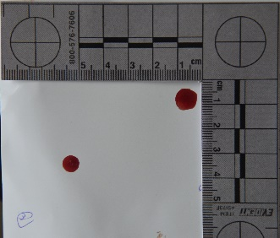 | 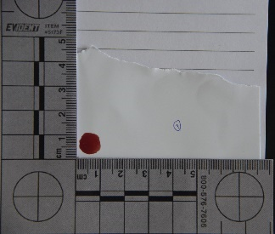 | 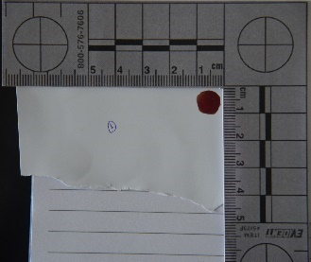 | 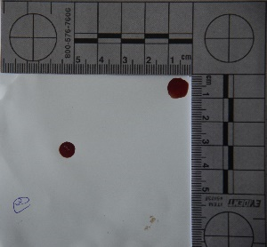 | 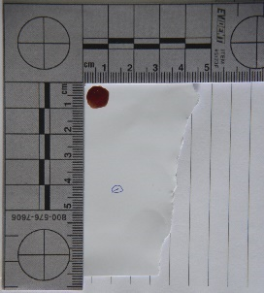 | 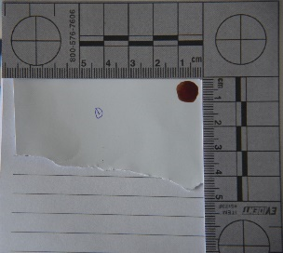
Reference 2 | 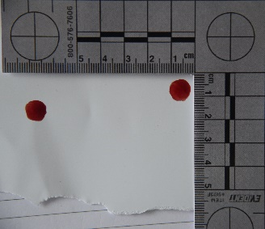 | 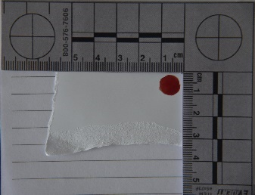 | 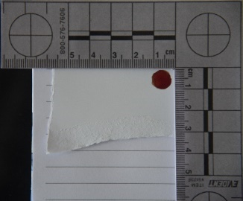 | 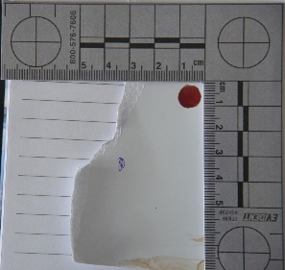 | 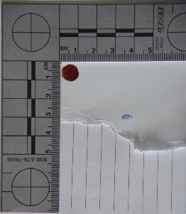 | 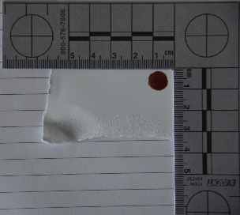
Reference 3 | 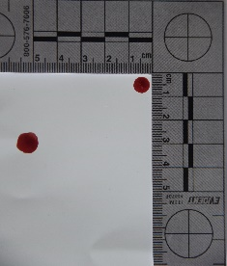 | 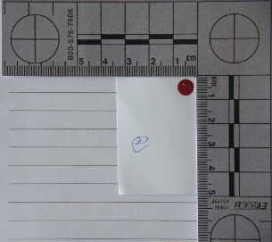 | 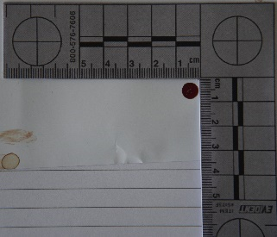 | 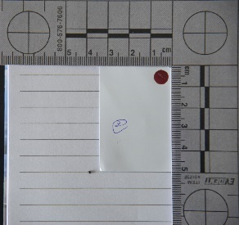 | 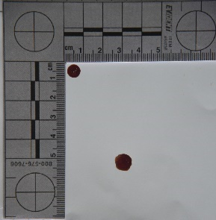 | 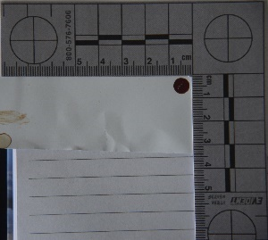
Reference/Sample Type | Non-Menstrual Bloodstain
Reference 1 | 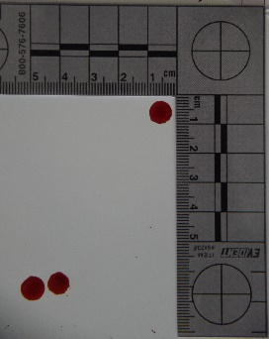 | 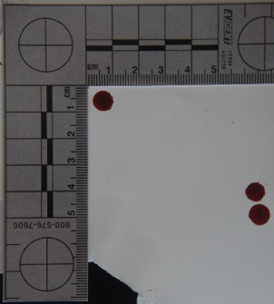 | 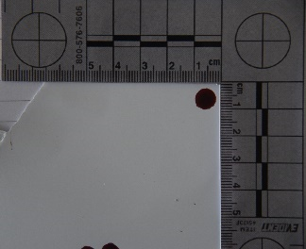 | 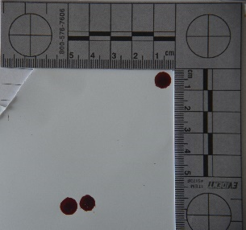 | 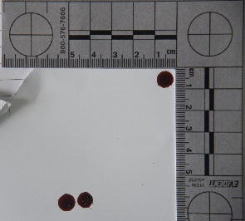 | 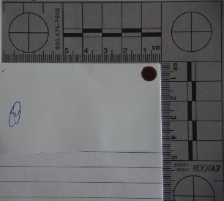
Reference 2 | 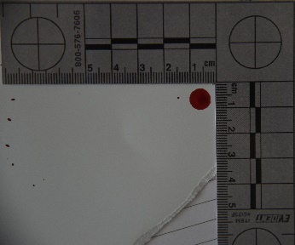 | 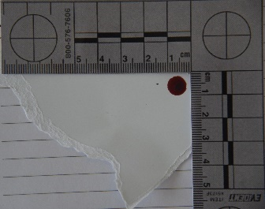 | 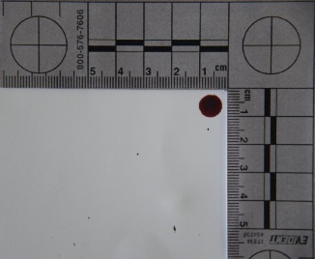 | 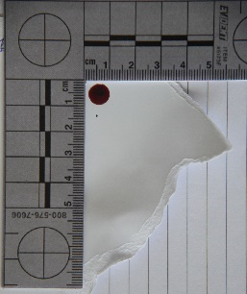 | 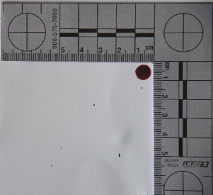 | 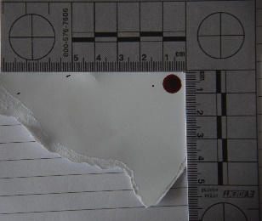
Reference 3 | 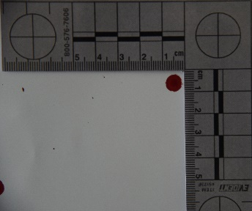 | 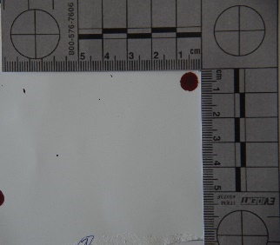 | 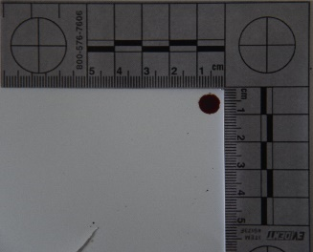 | 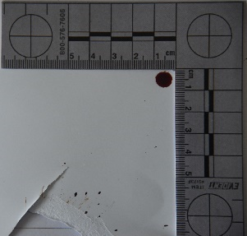 | 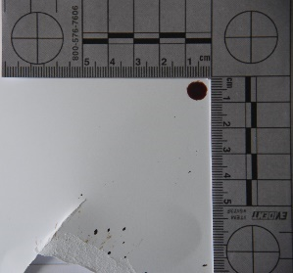 | 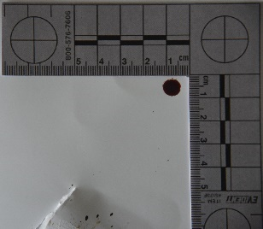

Table 5: Average Diameter of Menstrual and Non-Menstrual Bloodstains Across Time Intervals in Centimetres
 | Type of Sample | Time Interval | Mean | SD
Diameter | Menstrual Blood | 10 Min | 8.83 | 1.258
Diameter | Menstrual Blood | 1 hr. | 8.83 | 1.258
Diameter | Menstrual Blood | 2 hr. | 8.50 | 0.866
Diameter | Menstrual Blood | 24 hr. | 8.33 | 1.155
Diameter | Menstrual Blood | 72 hr. | 8.33 | 1.155
Diameter | Menstrual Blood | 120 hr. | 8.33 | 1.155
Diameter | Non-Menstrual Blood | 10 Min | 8.67 | 0.764
Diameter | Non-Menstrual Blood | 1 hr. | 8.67 | 0.764
Diameter | Non-Menstrual Blood | 2 hr. | 8.50 | 0.866
Diameter | Non-Menstrual Blood | 24 hr. | 8.33 | 0.577
Diameter | Non-Menstrual Blood | 72 hr. | 8.17 | 0.289
Diameter | Non-Menstrual Blood | 120 hr. | 8.00 | 0.000
Table 5 represents the average circular diameter of non-menstrual and menstrual bloodstains measured in centimeters at various timed periods after deposition (10 minutes, 1 hour, 2 hours, 24 hours, 72 hours, and 120 hours). The data summarizes how stain size evolves over time, highlighting differences between menstrual blood and non-menstrual blood. This builds on Table 1’s observation that non-menstrual bloodstains decrease consecutively in diameter, indicating consistent behavior, while menstrual bloodstains likely show more variability.

