Supplementary Information for

Q-Switching Nanophotonic Biosensing
Jiacheng Sun^{1,2}†, Fajun Li^{4,6}†, Xudong Wang³, Sisi Yan², Jing He², Dangwu Ni², Lang Wang², Shaowei Lin⁵, Min Qiu^{2,3}, Jinfeng Zhu⁴*, Liaoyong Wen^{2,3}*.
¹College of Information Science and Electronic Engineering, Zhejiang University, Hangzhou, 310027, China
²Zhejiang Key Laboratory of 3D Micro/Nano Fabrication and Characterization, School of Engineering, Westlake University, Hangzhou, Zhejiang 310030, China
³Westlake Institute for Optoelectronics, Fuyang, Hangzhou, Zhejiang 311421, China.
⁴Institute of Electromagnetics and Acoustics and Key Laboratory of Electromagnetic Wave Science and Detection Technology, Xiamen University, Xiamen, 361005, China
⁵Department of Nuclear Medicine, the First Affiliated Hospital of Xiamen University, School of Medicine, Xiamen University, Xiamen, 361003, China
⁶Department of Pulmonary and Critical Care Medicine, Shanghai Respiratory Research Institute, Zhongshan Hospital, Fudan University, Shanghai 200032, China.
†These authors contributed equally.
*Corresponding author. E-mail: jfzhu@xmu.edu.cn; wenliaoyong@westlake.edu.cn

The PDF file includes:

Supplementary Text
Figs. S1 to S27
Tables S1 to S2
References (65-73)

Supplementary Text
Note S1. Mechanism of Q-switching sensing
The eigenmodes of two oscillators in a strong coupling system are typically described by a 2×2 Hamiltonian matrix⁶⁵:
$H=\left(\begin{matrix}ω_{1}+iγ_{1} & g \\ g & ω_{2}+iγ_{2}\end{matrix}\right)$ (E1)
where $γ_{1}$ and $γ_{2}$ represent the damping rates of the oscillators, $ω_{1}$ and $ω_{2}$ represent the frequncies of the oscillators and $g$ is the coupling strength. The eigen-energies can be derived from the 2×2 Hamiltonian from equation 1:
$ω_{±}=\frac{ω_{1}+ω_{2}}{2}+\frac{{i(γ}_{1}+γ_{2})}{2}±\sqrt{g^{2}-\frac{1}{4}(γ_{1}-γ_{2}+i(ω_{1}-ω_{2}))^{2}}$ (E2)
when $ω_{1}$=${ ω}_{2}$, the Rabi splitting is given by:
$Ω_{R}=2\sqrt{g^{2}-(γ_{1}-γ_{2})^{2}/4}$ (E3)
This splitting should be larger than zero to indicate the presence of a strong coupling regime. When the detuning is non-zero, perturbed by a change in the ambient refractive index $∆n$, it causes a frequency shift in the two energy branches ${∆ω}_{1}$ and ${∆ω}_{2}$, modifying equation (E3) to (E7):
${∆ω}_{1}=S_{1}∆n$; ${∆ω}_{2}=S_{2}∆n$ (E4)
$∆∆ω$ = $∆n$ ($S_{1}$ - $S_{2}$) (E5)
$∆∆γ$ = ${∆γ}_{1}-{∆γ}_{2}$ (E6)
$Ω_{R}+∆∆ω=2\sqrt{g^{2}-(γ_{1}^{'}-γ_{2}^{'}+∆∆γ+i(ω_{1}-ω_{2}))^{2}/4}v$ (E7)
where $S_{1}$ and $S_{2}$ represent the frequency sensitivities of the two oscillators, $∆∆ω$ (${∆ω}_{1}-{∆ω}_{2}$) is the resonance frequency detuning induced by $∆n$. $γ_{1}^{'}$ and $γ_{2}^{'}$ are the damping rates of the two oscillators at zero detuning. For a small $∆n$, the coupling strength $g$ is negligibly perturbed. In case that the $ω_{1}$ experiences a significant redshift while the $ω_{2}$ changes slightly ($S_{1}$>>$S_{2}$), $∆∆ω$ is positive. The change in $∆∆γ$ can be expressed as the following, where $γ_{1}^{'}-γ_{2}^{'}$ = $\sqrt{4g^{2}-Ω_{R}^{2}}$:
$∆∆γ$ = $\sqrt{4g^{2}-(Ω_{R}+∆∆ω)^{2}}-\left(γ_{1}^{'}-γ_{2}^{'}\right)-i\left(ω_{1}-ω_{2}\right)$ (E8)
To maintain the balance in equation (E8), $∆∆γ$ must be negative. In the scenario of $∆∆ω$ >> 0 and ${∆γ}_{1}$ is close to zero after the mode transition, ${∆γ}_{2}$ have to be significantly positive ($∆∆γ$ << 0), preserving the equation's balance. Therefore, two oscillators in a strong coupling system must meet the following conditions in response to $∆n$ inducing a significant $∆γ$:
$∆∆ω$ >> 0 (E9)
$∆∆γ$ << 0 (E10)
A metasurface should be designed to support two strongly coupled modes with contrasting field distributions, such as one predominantly in the superstrate and the other in the substrate, resulting in significantly different frequency shifts (${∆ω}_{1}$ >> ${∆ω}_{2}$) and linewidths ($γ_{1}$ >> $γ_{2}$). This configuration satisfies conditions (E9) and (E10), enabling efficient conversion of refractive index changes ($∆n$) into damping rate modulation ($∆γ$). The total damping rate $γ$ is composed of radiative and nonradiative components $γ_{r}$ and $γ_{n}$ ⁶⁶:
$γ$ = $γ_{r}$ + $γ_{n}$ (E11)
Since $γ_{n}$ is determined by the intrinsic material properties, it remains theoretically invariant under perturbations from the ambient environment. Therefore, in the described process, variations in the ambient refractive index ($∆n$) primarily modulate the radiative loss rate (${∆γ}_{r}$). If the radiative linewidth change for oscillator 1 is negligible (i.e., ${∆γ}_{1}$ ≈ 0), then the total linewidth variation satisfies $∆∆γ$ = -${∆γ}_{2}$. For oscillator 2, the relationship is expressed as:
$γ_{2}^{'}+{∆γ}_{2}$ = $γ_{r}$ + $γ_{n}$ (E12)
Given that the damping rate is related to the quality factor $Q_{r}$= $ω$/2$γ_{r}$, it can be written in terms of the radiative quality factor $Q_{r}$:
$Q_{r}$ = $\frac{ω}{2{(γ}_{2}^{'}-(∆∆γ)-γ_{n})}$ (E13)
Thus, we can relate the $∆n$ with the $Q_{r}$ as follows:
$Q_{r}$ = $\frac{ω}{2{(γ}_{2}^{'}-\left(\sqrt{4g^{2}-(Ω_{R}+∆n (S_{1} - S_{2}))^{2}}-\sqrt{4g^{2}-Ω_{R}^{2}}-i\left(ω_{1}-ω_{2}\right)\right)-γ_{n})}$ (E14)
This mechanism introduces a refractometric Q-switching sensing approach. To amplify the signal response, the Q-switching process should operate near the critical coupling region, where absorption is maximized⁶⁷:
$Abs= \frac{4xQ_{r}Q_{n}}{(ω-ω_{r})^{2}+(Q_{r}+Q_{n})^{2}}$ (E15)
When the radiative and nonradiative quality factors are matched, i.e., under critical coupling conditions, the system's absorption reaches its maximum value, determined by the number of available energy leakage channels. This value, denoted as x, depends on whether the system behaves as a one-port or two-port structure. In a two-port system, where energy can leak through both forward and backward directions, the maximum achievable absorption is limited to 0.5. In contrast, a one-port system, which supports only a single radiative channel, can achieve unity absorption (x = 1.0), a condition referred to as perfect absorption under critical coupling⁶⁸.
The entire process described above is summarized as a Q-switching sensing mechanism. To intuitively illustrate the behavior of this mechanism, we plot the evolution of the radiative quality factor $Q_{r}$ and absorption as a function of $∆n$, according to equations (E14) and (E15). The parameters are set according to the expermental measurement, $γ_{n}$ = 4.25 meV, $ω$ = 977.6 meV, x = 1, $γ_{2}^{'}$ = 4.25, 4.45, 4.65, 4.85, 5.05 and 5.25 meV (the coresponding initial radiative damping rate $γ_{r0}$ = 0, 0.2, 0.4, 0.6, 0.6, 0.8 and 1.0 meV, when the $γ_{r0}$ = 0 means the system is originated from a BIC state), $g$ = 30.4 meV, $Ω_{R}$ = 46.7 meV, $S_{1}$ = 248 meV/RIU, $S_{2}$ = 21.8 meV/RIU.
As shown in Fig. 1d, an increase in $∆n$ causes an overall decrease in $Q_{r}$​. When the system’s radiative loss is constrained, resulting in a smaller $γ_{r0}$​, a distinct rising trend in $Q_{r}$ is observed. Since $γ_{2}^{'}$ = $γ_{n}$​, the initial $γ_{r0}$​ is zero, leading to an infinite initial Q_{r}​, which is characteristic of the bound state in the continuum (BIC). The advantage of employing BIC-enhanced methods is clearly demonstrated in Fig. S1. By introducing constrained initial radiative loss to suppress energy leakage, the system exhibits a lower initial absorption intensity, a broader tunable range, and a significantly enhanced intensity response. In contrast, a system with a large initial $γ_{r0}$​ experiences a rapid decay of Q_{r}​ as it crosses the critical coupling point, resulting in “pulse”-type intensity responses that are unsuitable for sensing applications.
To account for a more realistic scenario as shown in Fig. S2a, the coupling strength $g$ should also be related to $∆n$, denoted as $g_{n}=g+∆n (S_{1} - S_{2})$. Additionally, due to the presence of other radiative energy channels, $∆∆γ$ may not fully contribute to the Q-switching sensing process. To model a noticeable energy transfer in a strong coupling system under relatively large environmental perturbations, we introduce a conversion rate factor m for $∆∆γ$, which is also related to $∆n$, and can be expressed as m = $1/(5∆n \left(S_{1} - S_{2}\right)+1)$. Consequently, the corrected refractometric Q-switching equation is written as:
$Q_{r}$ = $\frac{ω}{2{(γ}_{2}^{'}-m\left(\sqrt{4g_{n}^{2}-(Ω_{R}+∆n (S_{1} - S_{2}))^{2}}-\sqrt{4g_{n}^{2}-Ω_{R}^{2}}-i\left(ω_{1}-ω_{2}\right)\right)-γ_{n})}$ (E16)
According to equation E16, calculated Q-switching sensing and intensity response are shown in Fig. S2b and S2c, respectively. To match the performance in the experiment, we set the $g_{n}$ = $g$ + 0.29×$∆n (S_{1} - S_{2})$ and m = 1/(800$∆n (S_{1} - S_{2})$+1). The increase of $∆n$ calculated by the corrected refractometric Q-switching equation aligns more closely with the simulation and experimental performance.
To validate and generalize the universality of the Q-switching sensing mechanism, we investigated its applicability in a widely used quasi-BIC system constructed on a gold film (Fig. S3). In this asymmetric quasi-BIC configuration, the radiative quality factor Q_{r} can be efficiently tuned by adjusting the coupling between two resonators. Accordingly, we evaluated the Q-switching sensing performance in such quasi-BIC systems, as shown in Fig. S4.
Initially, the metasurface composed of two distinct nanoparticles (with diameters d_{a} = 150 nm and d_{b} = 130 nm) on a gold film achieves perfect absorption under the condition Q_{r} = Q_{n}, as illustrated in Fig. S4a. When the bulk refractive index of the surrounding environment is varied, the resonance exhibits a spectral shift without a change in peak intensity, indicating that the critical coupling condition remains intact. A similar trend is observed in Fig. S4b for a structure with d_{a} = 150 nm and d_{b} = 100 nm, where the system deviates from critical coupling (Q_{r} = Q_{n}), resulting in reduced absorption. These results confirm that under bulk sensing conditions, the coupling between the two nanoparticles remains unaffected, meaning that Q_{r} in the quasi-BIC system remains constant. Therefore, variations in the bulk refractive index (Δn) lead exclusively to resonance shifts (Δω) without affecting the resonance linewidth (Δγ).
However, when a SiO₂ layer is selectively coated only on NP-a, the absorption intensity decreases significantly, as shown in Fig. S4c and S4d. This indicates a variation in the inherent coupling between the nanoparticles, resulting in changes to the radiative quality factor, Q_{r} Due to the larger polarizability difference between NP-a and NP-b, the quasi-BIC system deviates from the ideal BIC condition, increasing the asymmetry factor α. According to the radiative quality factor law for asymmetric BIC metasurfaces³⁶:
$Q_{r}∝ α^{-2}$ (E17)
As $α$ increases, Q_{r} ​inevitably decreases, moving the system away from the critical coupling region, which aligns with the observed decrease in absorption intensity. In combination with the gold film, this system effectively behaves as a one-port system, establishing a relationship between the refractive index change Δn and Q_{r}​ via modulation of α in a selectively functionalized BIC system.
Conversely, when the SiO₂ layer is applied only to NP-b, the smaller polarizability difference between the nanoparticles suppresses α, causing Q_{r} to initially increase away from the critical coupling condition, as shown in Fig. S4e. This leads to a rapid decrease in absorption, followed by an increase after Q_{r}​ reaches a maximum value and then begins to decrease again. In Fig. S4f, as Q_{r}​ increases (with Q_{r} < Q_{n}​) and approaches the critical coupling region, absorption correspondingly increases.
To eliminate the effects of inherent material loss present in plasmonic BIC systems, we further validated the Q-switching sensing mechanism using a dielectric BIC metasurface on a gold film. As shown in Fig. S5a, changes in the bulk refractive index induce a redshift in the resonance wavelength with only minimal changes in peak absorption. A slight increase in Q_{r}​​ is attributed to modifications in the effective refractive index of the resonator. When the SiO₂ layer is selectively bound to NP-a, as in Fig. S5b, a similar effect is observed: the larger refractive index difference between the nanoparticles (larger asymmetry factor $α$) causes Q_{r}​​ to decrease towards the critical coupling region, resulting in enhanced absorption. Conversely, when SiO₂ is bound to NP-b (Fig. S5c), the smaller $α$ suppresses the asymmetry, causing Q_{r}​ to increase and absorption to decrease.
Thus, the effectiveness of the Q-switching sensing mechanism is reconfirmed in a selectively functionalized quasi-BIC system where the surface refractive index of the two different nanoparticles is independently controlled⁶⁹.

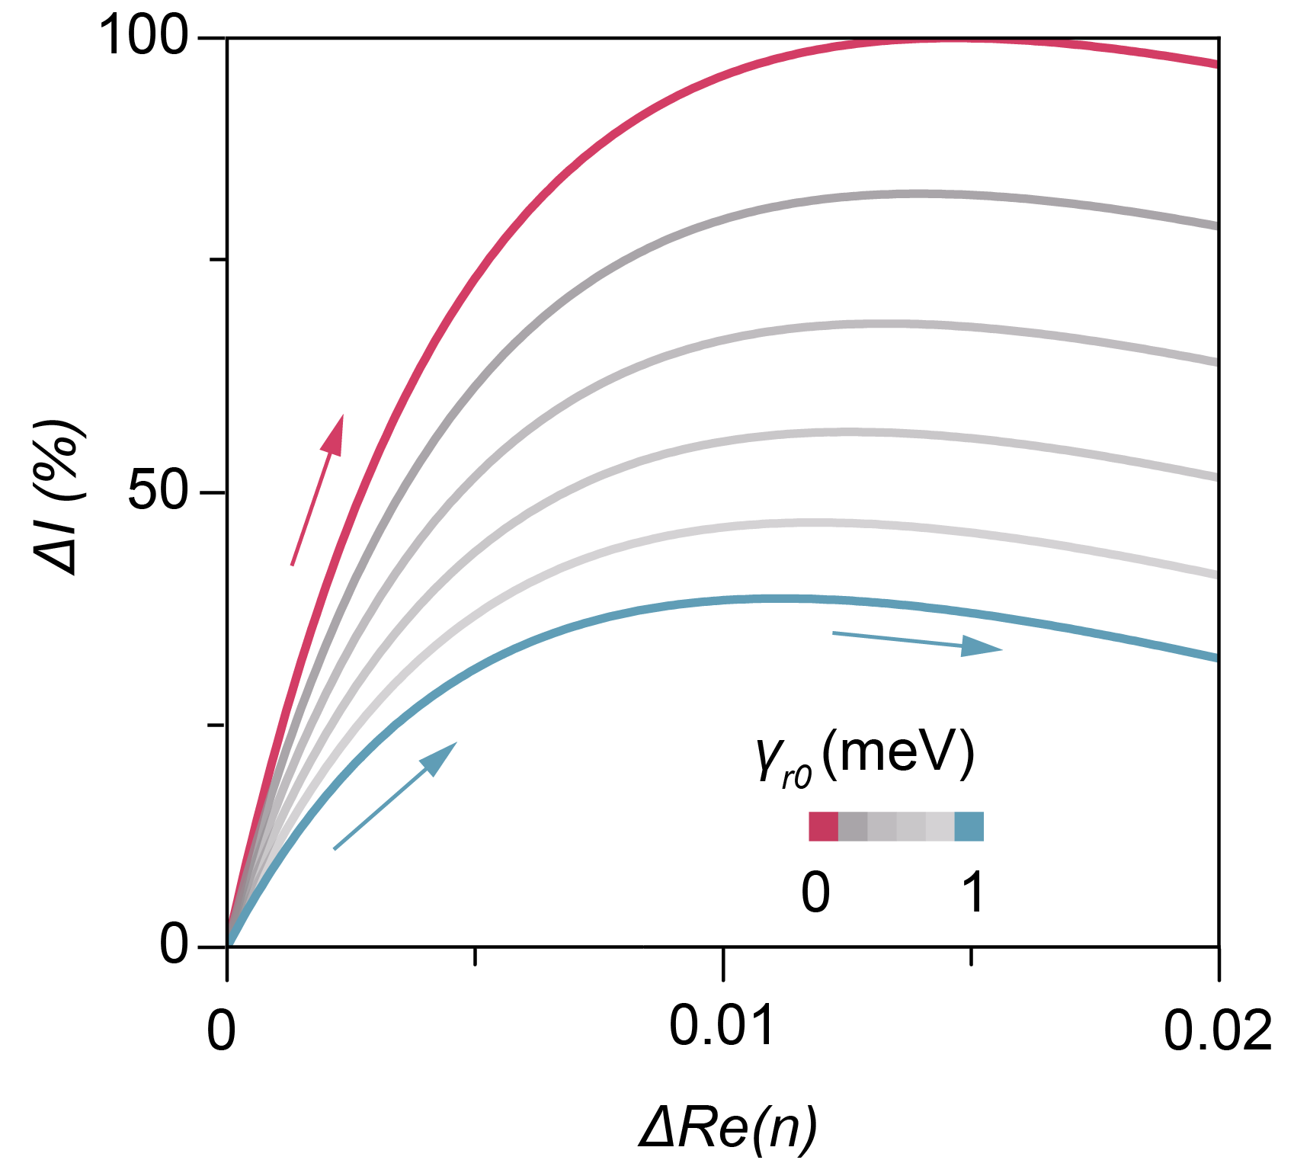

Fig. S1.
Intensity response of Q-switching sensing in equation E14. Analytical calculations of system energy responses to Δn in Q-switching sensing, highlighting the effects of different initial γ_{r}₀ values.

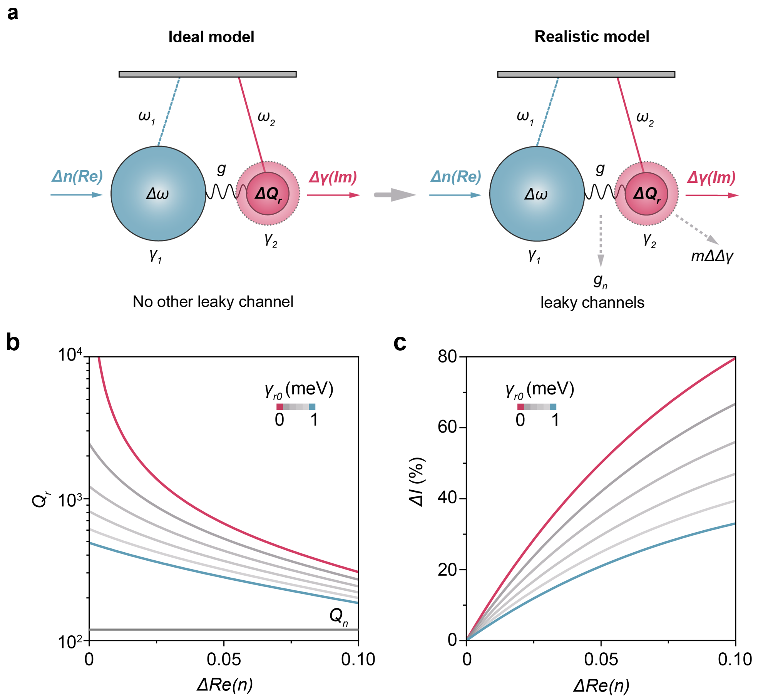

Fig. S2.
Analytical model and calculation of the ideal and realistic Q-switching sensing equation. (a) Schematics illustrate the ideal case and realistic case, including leaky channels from inter-coupling and output damping. (b) $Q_{r}$ of oscillator 2 as a function of $∆n$ with initial radiative gamma $γ_{r0}$ from 0 to 1 meV. (c) Resonance absorption evolution as a function of $∆n$ with $γ_{r0}$ from 0 to 1 meV.
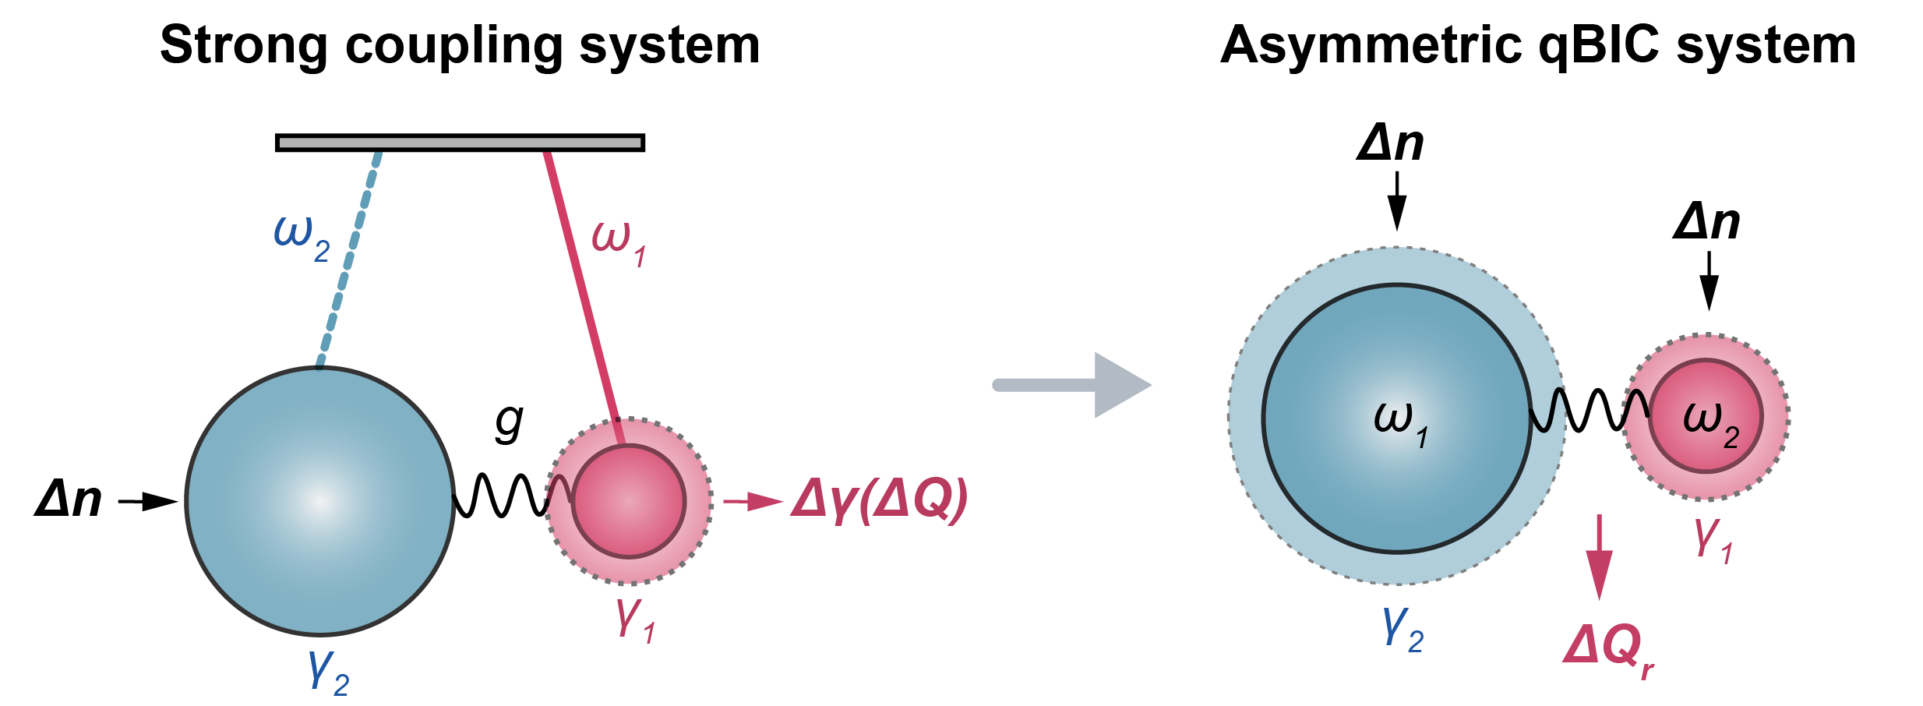

Fig. S3.
Extended Q-switching sensing model. Q-switching sensing mechanism based on a strong coupling system in this work can be extended to other coupled-oscillators, such as selective binding at an asymmetric qBIC system. This can be implemented using hybrid material configuration.

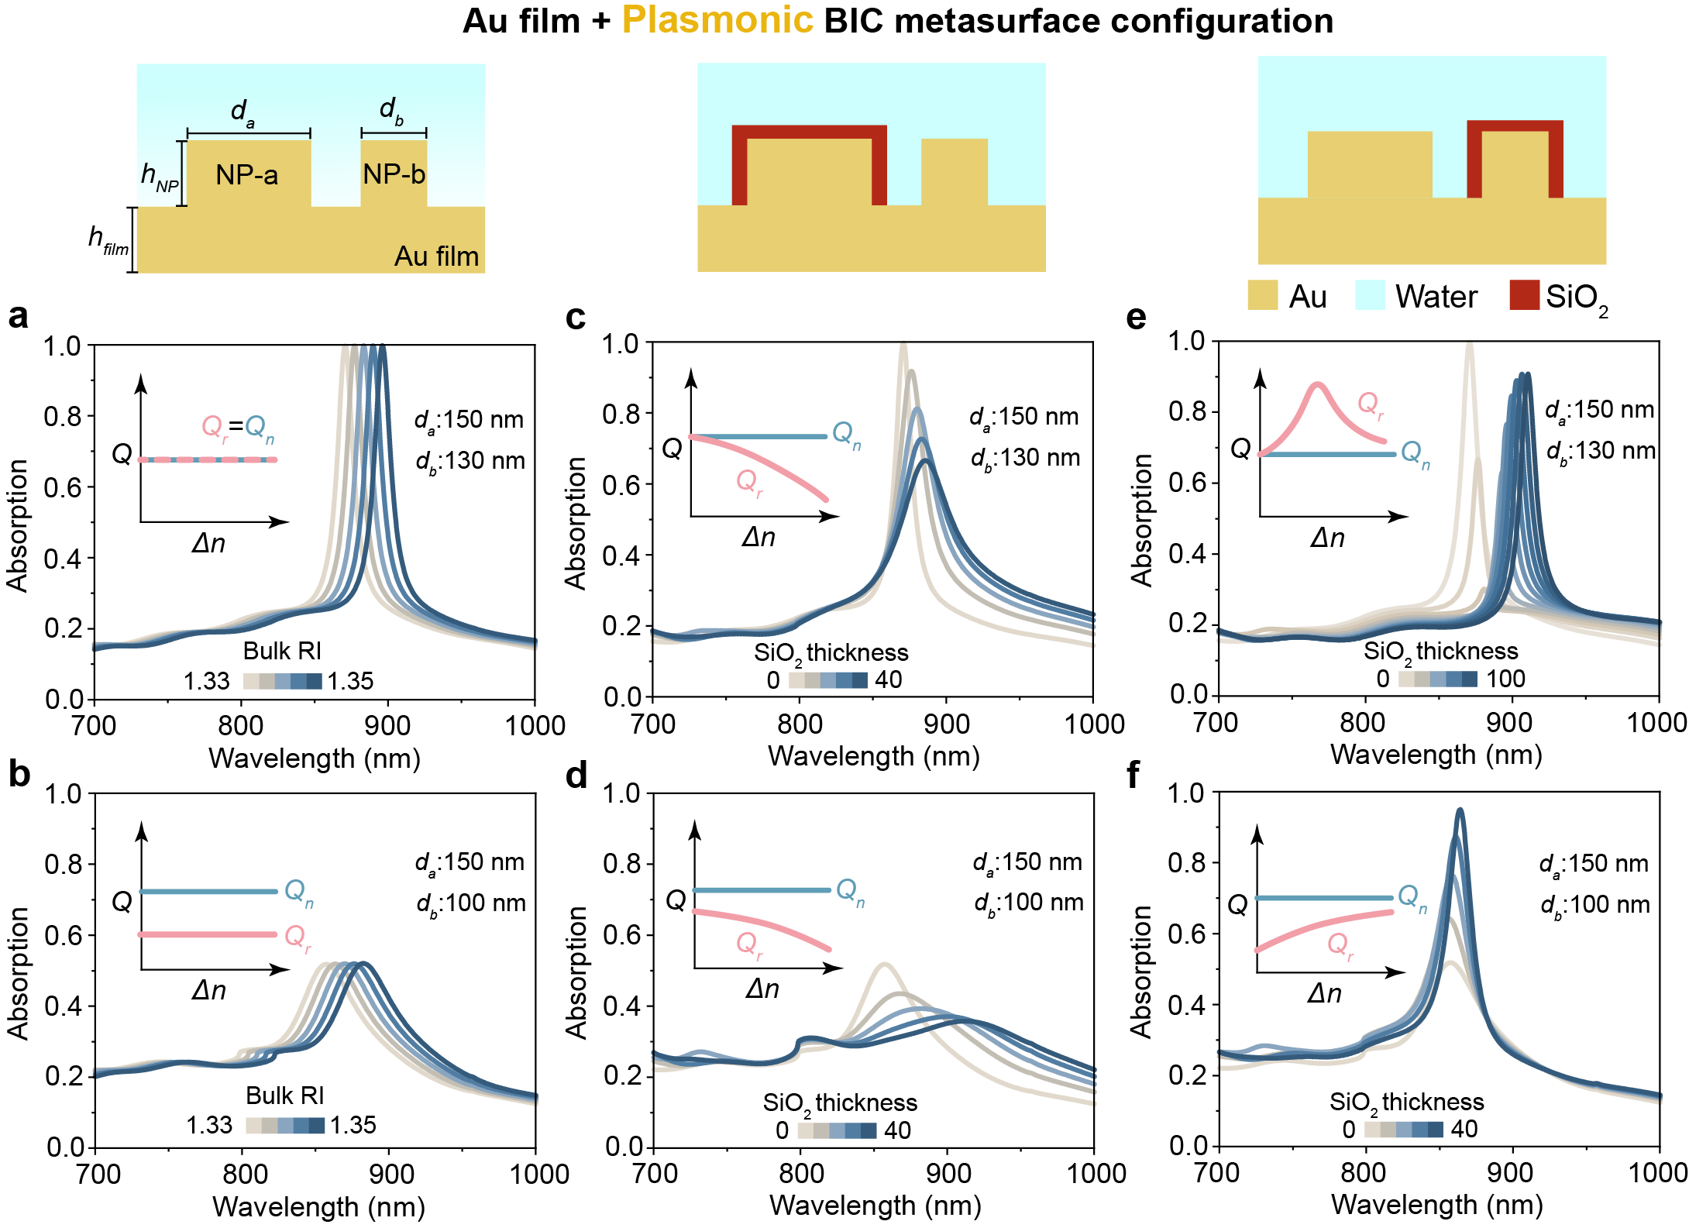

Fig. S4.
Extended Q-switching sensing in asymmetric plasmonic qBIC system. (a), (b) Spectral variation in bulk sensing for plasmonic BIC metasurface on the Au film with different particle diameters (d_{a} = 150 nm/d_{b} = 130 nm; d_{a} = 150 nm/d_{b} = 100 nm). (c), (d) The SiO₂ layer is only coated on the NP-a to change the Q_{r} of the quasi-BIC system with different nanoparticle diameters (d_{a} = 150 nm/d_{b} = 130 nm; d_{a} = 150 nm/d_{b} = 100 nm). (e), (f) The SiO₂ layer is only coated on the NP-b to change the Q_{r} of the quasi-BIC system with different nanoparticle diameters (d_{a} = 150 nm/d_{b} = 130 nm; d_{a} = 150 nm/d_{b} = 100 nm).
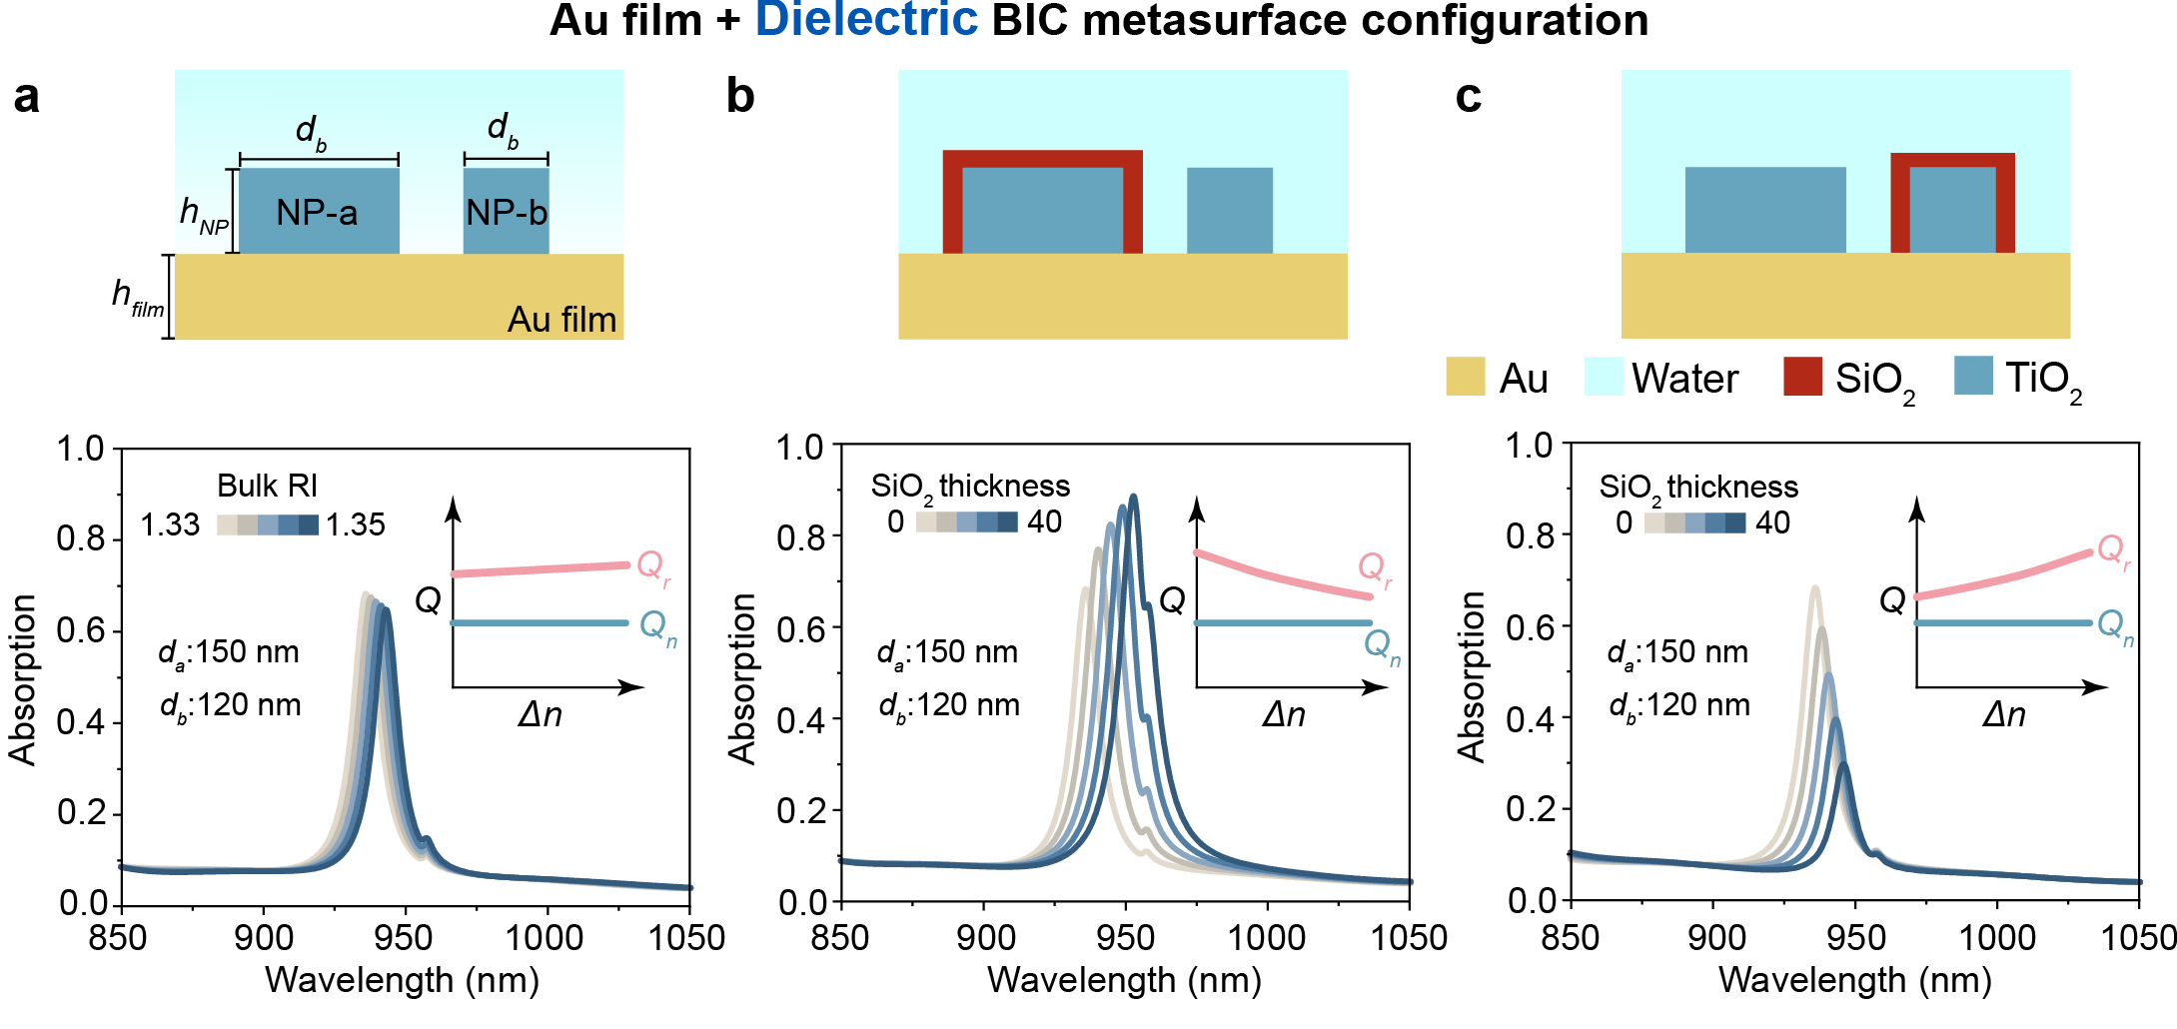

Fig. S5.
Extended Q-switching sensing in asymmetric plasmonic-dielectric hybrid qBIC system. (a) Spectral variation in bulk sensing for dielectric BIC metasurface on the Au film with different nanoparticle diameters (d_{a} = 150 nm/d_{b} = 120 nm). (b) The SiO₂ layer is only coated on the NP-a to change the Q_{r} of the quasi-BIC system with different nanoparticle diameters (d_{a} = 150 nm/d_{b} = 120 nm). (c) The SiO₂ layer is only coated on the NP-b to change the Q_{r} of the quasi-BIC system with different nanoparticle diameters (d_{a} = 150 nm/d_{b} = 120 nm).

Note. S2 Mode analysis
Simultaneously varying the diameters of both the nanoparticles and nanoholes induces a significant shift in the lowest-energy resonance wavelength (dotted line, Fig. S6a). To decouple the influence of diameter changes, we computed resonances for an isolated nanoparticle array (no nanoholes) with an effective refractive index of 1.8 for the background environment. The rapid blue shift observed with decreasing diameter (Figs. S6a and S6b) confirms this mode as a surface lattice resonance (SLR), arising from collective nanoparticle oscillations governed by polarizability α. The absorption cross-section of the nanoparticle is given by:
$C_{abs}=4πkIm(α)$ (E18)
$α= abc\frac{ϵ_{m}-ϵ_{s}}{3ϵ_{s}+3L(ϵ_{m}-ϵ_{s})}$ (E19)
Here, k is the wavevector, a, b, and c are semiaxes of particle, $ϵ_{s}$ and $ϵ_{m}$ are relative permittivity of surrounding medium and metal, respectively, and L is a shape factor⁷⁰.
On the contrary, the geometric variation of the nanoparticle has relatively less impact on frequencies of two SPP-Bloch modes (SPP_{UB} at shorter wavelength and SPP_{LB} at longer wavelength). This is because, at normal incidence, the resonance wavelength of SPP-Bloch modes is determined by:
$λ_{max}\left(i,j\right)= \frac{d_{0}}{\sqrt{i^{2}+j^{2}}}\sqrt{\frac{ϵ_{m}ϵ_{s}}{ϵ_{m}+ϵ_{s}}}$ (E20)
where d₀ is the lattice constant of the nanohole array; i and j are integer mode indices⁷¹. This equation shows that the resonance wavelength is primarily dependent on the lattice constant, explaining why changes in diameter D do not significantly shift SPP_{LB} and SPP_{UB} modes.
However, the shift of SLR due to changes in D significantly influences the SPP-Bloch modes because of the unavoidable coupling between multiple resonances in this hybrid plasmonic configuration. This demonstrates the limitations of traditional BIC manipulation using a 2D asymmetric geometry configuration as shown in Fig. 2a.

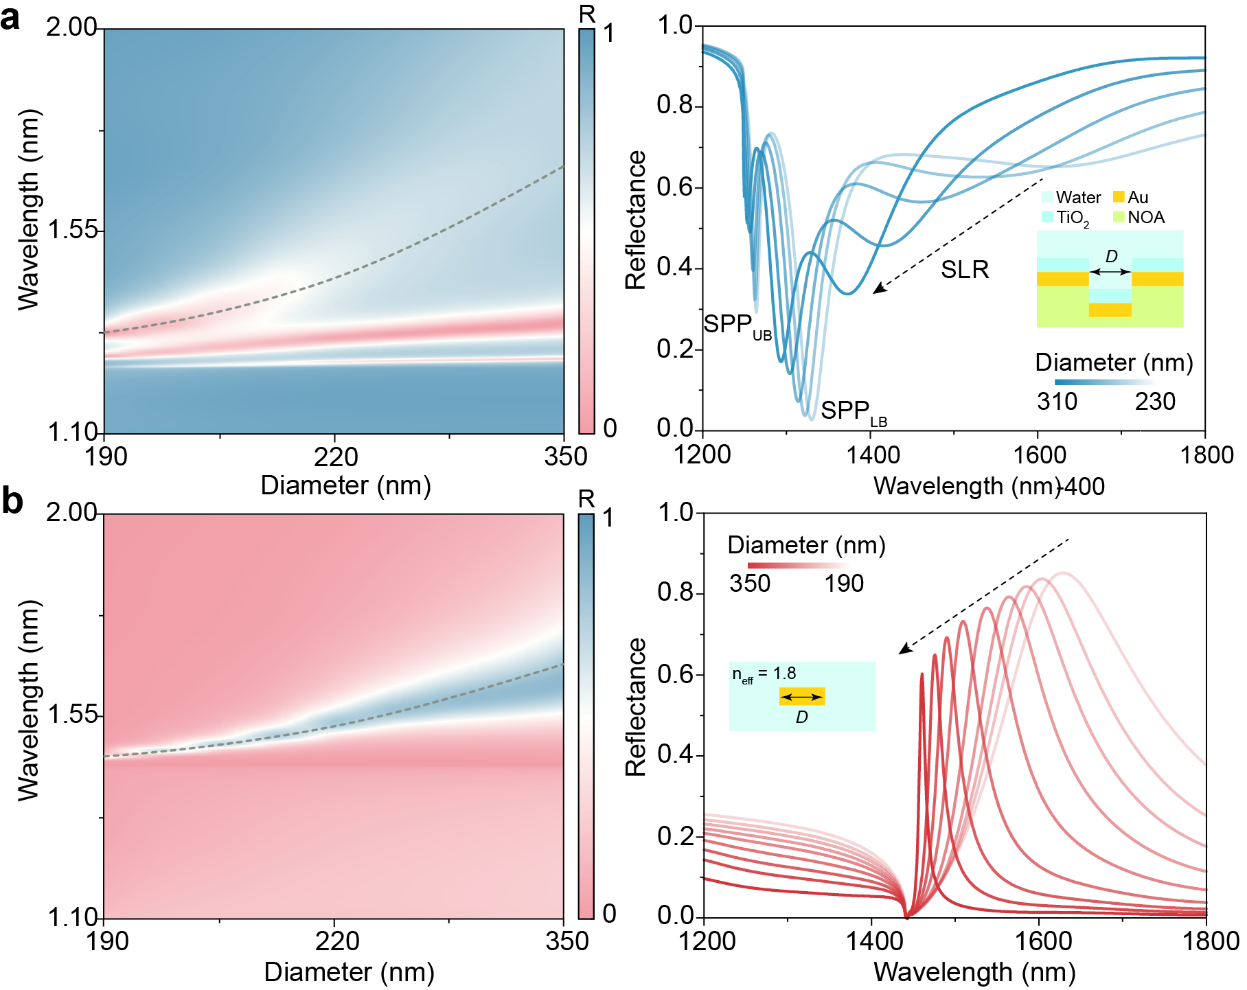

Fig. S6.
Mode analysis of 2D BIC manipulation failure in hybrid plasmonic configuration. (a) Reflectance spectra and spectral mapping of a single-layer nanoparticle array coupled to a nanohole array, plotted as a function of nanoparticle diameter. Distinct surface plasmon polariton (SPP) modes are identified at upper branch (SPP_{UB}) and lower branch (SPP_{LB}) (b) Reflectance spectra and spectral mapping of an isolated single-layer nanoparticle array embedded in a homogeneous effective medium (n = 1.8).

Note. S3 Strong coupling system tailored by 3D BIC metasurface
As discussed above, the change of nanoparticle geometry can significantly shift the resonance frequency of the SLR, which can disrupt the coupling between two SPP-Bloch modes. As shown in Fig. S7a, with the increase of ΔR, the frequency of qBIC_{U} initially blueshifts, accompanied by a normal decay in the Q factor. When ΔR reaches 55 nm, interference from the SLR, which features a more localized electric field and a larger damping coefficient, causes qBIC_{U} to split into two branches. This results in abrupt changes in both frequency and Q factor. Beyond a ΔR of 80 nm, these two branches merge again, exhibiting a low Q factor and rapid blueshift. The observed behavior stems from the weak intermodal coupling between SPP-like modes, characteristic of their light-like dispersion. As these modes approach, their coupling strength to SLR becomes increasingly dominant⁷². The interference from SLR aligns with the common definition of coupling strength⁷³:
$g≈μ·E≈\sqrt{\frac{N}{V_{eff}}}$ (S21)
where µ is the collective dipole moment of the exciton, E is the local electric field strength, N is the number of excitons participating in the coupling process, and V_{eff} is the effective mode volume. The SLR mode, with its smaller effective mode volume and larger electric field enhancement, can create stronger coupling with SPP-Bloch modes, thereby disrupting their coupling. On the contrary, geometry-invariant 3D BIC manipulation in Fig. S7b exhibits normal qBIC tailoring behavior with slow decay of both qBIC_{U} and qBIC_{L}. The frequencies of both qBIC modes remain very stable with minimal peak shift. The slight redshift in qBIC_{L} as it approaches the BIC is associated with larger detuning.
As qBIC modes approaching the BIC state, both damping rates γ₊ and γ₋ become smaller (Fig. S7c). Notebly, the γ₋ decays faster than γ₋ with decreasing ΔZ. Therefore, it results in a smaller damping difference between the upper branch (UB) and lower branch (LB) compared to the coupling strength, leading to an enlarged frequency difference between UB and LB. Furthermore, by removing the material loss, the calculated radiative Q factor in Fig. S7d matches well with Q_{r} ~ α⁻² rule, proving the 3D qBIC tailoring effectiveness.
To further control the coupling dynamics, a TiO₂ film is deposited atop the metasurface, introducing controlled detuning between the eigenmodes. This enables Rabi splitting and mode exchange as a function of the film thickness t_{TiO₂} (Fig. S8a). As t_{TiO₂} increases, the intensity of the upper branch initially remains weak but sharply rises once the “threshold” (t_{TiO₂} = 75 nm, I₀) is reached. However, it then rapidly decays at t_{TiO₂} = 85 nm, producing a ‘pulse’-like peak intensity response with the out-of-plane asymmetry set at ΔZ = 200 nm. While this response generates a pronounced signal, its non-monotonic nature renders it unsuitable for precise sensing applications. By optimizing the ΔZ to 140 nm, excessive radiative losses are effectively suppressed, resulting in stabilized peak intensity output. As shown in Fig. S8b, this adjustment led to a monotonic increase in upper branch intensity, beginning at t_{TiO₂} = 80 nm. This transition reflects the successful optimization of Q-switching performance through the 3D BIC metasurface.
At low Qᵣ, rapid decay across the Qₙ causes the system to shift swiftly from under-coupling to over-coupling regimes. In contrast, reducing ΔZ toward the BIC condition elevates Qᵣ and broadens the tunable range above Qₙ (Fig. S8c). As a result, the initial ‘pulse’ response is transformed into a monotonic, high dynamic-range signal, making it ideal for sensing applications (Fig. S8d).
Detailed analysis of SPP modes in a strong-coupling system is presented in Fig. S9. With the deposited thickness t of the TiO₂ layer increasing, significant energy exchange occurs between the two SPP modes at the substrate (SPP_{sub}) and superstrate (SPP_{sub}). Initially, the qBIC_{U} is predominantly influenced by SPP_{sup}, while the qBIC_{L} is mainly governed by SPP_{sub}. As the t further increases, the modes of the upper and lower branches are interchanged.
In the case of a continuous Au film, the dual SPP-Bloch modes exhibit weak coupling, as shown in Fig. S10a. Here, the SPP_{sup} mode undergoes rapid redshift with increasing TiO₂ thickness t, crossing the invariant SPP_{sub} mode. This behavior is characteristic of weak coupling, as the two SPP-Bloch modes, propagating on opposite sides of the structure, exhibit limited interaction and coupling strength.
Conversely, the introduction of a nanohole significantly enhances the interaction between the modes on both sides, resulting in clear energy splitting, as depicted in Fig. S10b. With an increase in the nanoparticle depth Z_{1,} shown in Figs. S10b-d, the Rabi splitting becomes more pronounced. However, the linewidths of both the upper branch (UB) and lower branch (LB) also broaden, indicating increased damping rates. This broadening is attributed to the more localized mode profile associated with deeper nanoparticles, resulting in greater energy loss.
In Figs. S10e-h, with the 3D BIC configuration, the overall damping rates are suppressed and the Rabi splitting is enhanced. This improvement is attributed to enhanced coupling strength and constrained radiative loss.
The BIC-enhanced strong coupling phenomenon has been documented in previous studies^{37,38}. However, direct evidence of radiative loss restriction in a strong coupling system remains limited. Notably, our Q-switching sensing mechanism provides an intuitive demonstration of radiative loss constriction through the resonance intensity variation observed with or without 3D BIC configurations (w/o BIC).
As illustrated in Fig. S11, though coupling strengths in structures w/o BIC increase from weak to strong, the intensity variation of UB exhibits a marked springback after reaching a minimum. This behavior, caused by the rapid decay of Q_{r} and crossing of the critical coupling condition. However, in 3D BIC configuration, with the decrease of ΔZ, the springback behavior diminishes, resulting in a smoother intensity variation. Notably, an FW-BIC is observed with smaller ΔZ. These observations strongly suggest the effective constraining of radiative loss and an enhancement of Q_{r}.
The 3D BIC-tailored Q-switching sensing mechanism is further validated by stereoscopic spectral mapping of absorption, transmission, and reflection, as presented in Fig. S12. For metasurfaces without BIC, noticeable intensity fluctuations in the upper branch (UB) are observed across all spectra (absorption, transmission, and reflection). In contrast, these fluctuations are significantly reduced in the 3D BIC metasurface, resulting in a smoother and more linear spectral response. Consequently, at the sensing threshold, the resonance exhibits a higher Q factor accompanied by a lower peak amplitude, as demonstrated by both simulations and experiments in Fig. S13a and S13b. Furthermore, the 3D BIC metasurface shows polarization independence, which enhances its versatility for various application scenarios, as shown in Fig. S13c.

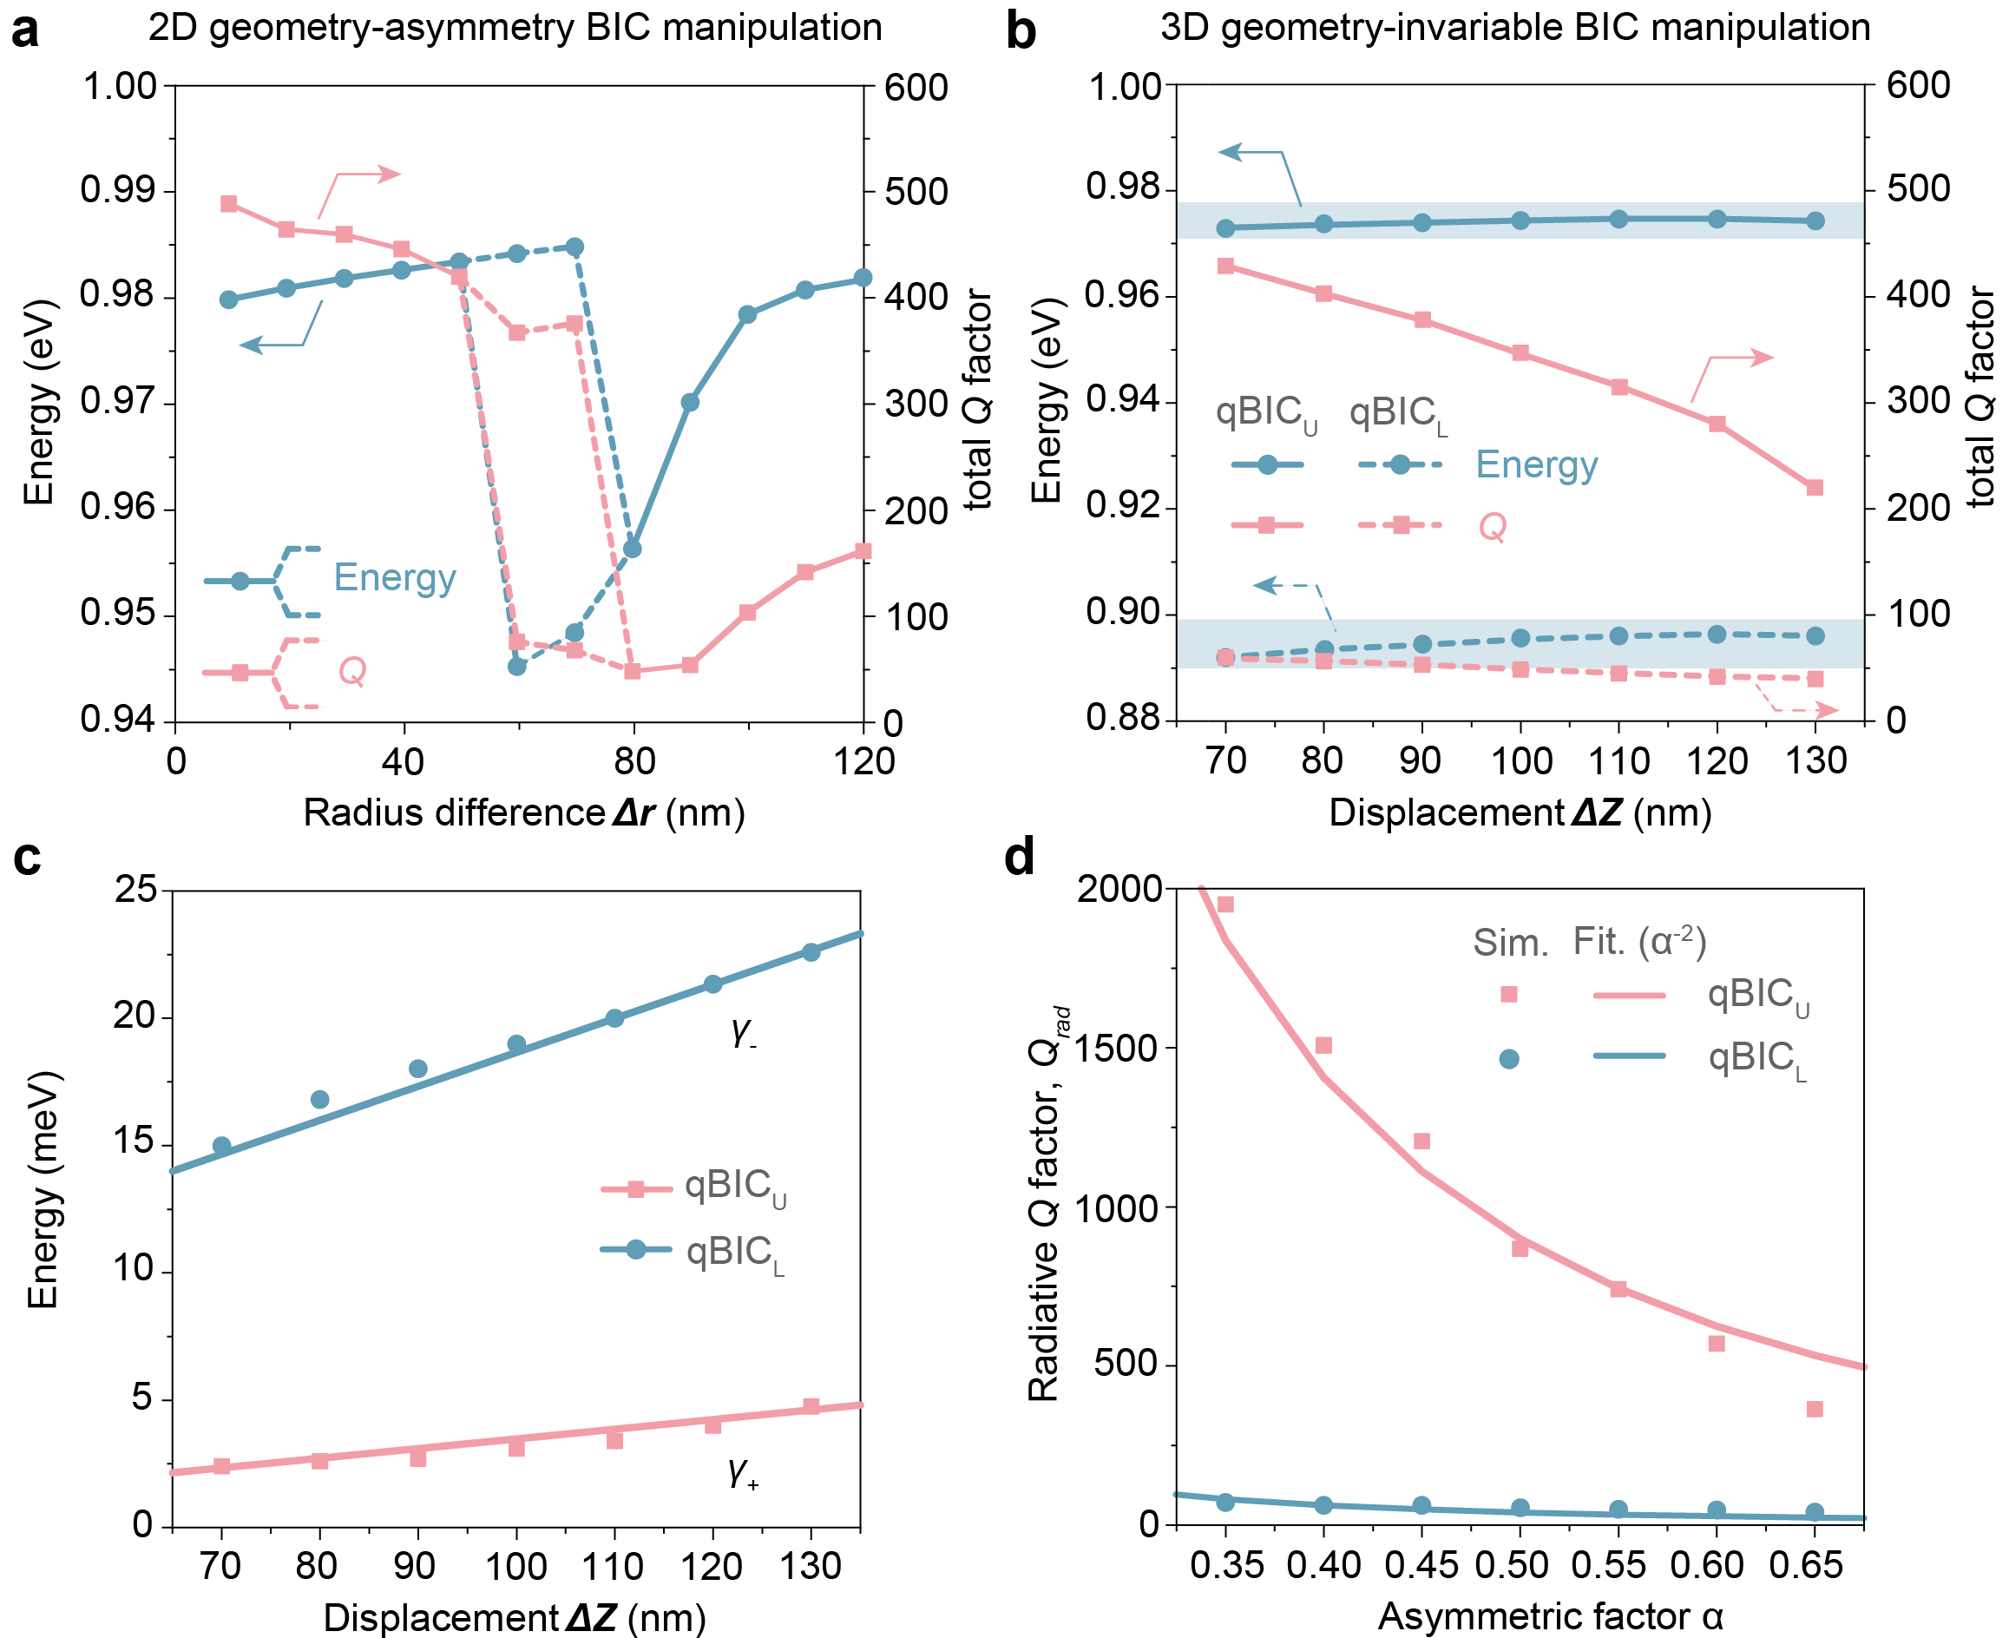

Fig. S7.
Analysis of in-plane and out-of-plane BIC manipulation with strongly coupled oscillators. (a) Frequency and total Q factor variation of qBIC₂ using 2D geometry-asymmetric BIC manipulation. (b) Frequency and total Q factor variation using 3D geometry-invariable BIC manipulation for qBIC resonance at UB and LB. (c) Damping rate γ₊ and γ₋ as a function of 3D displacement ΔZ for qBIC₂ and qBIC₁. (d) Simulated and fitted radiative Q factor of qBIC₂ and qBIC₁ as a function of asymmetric factor (α = ΔZ/Z). The fitting equation for qBIC₂ and qBIC₁ are Q_{rad} = 225α⁻² and Q_{rad} = 10α⁻².

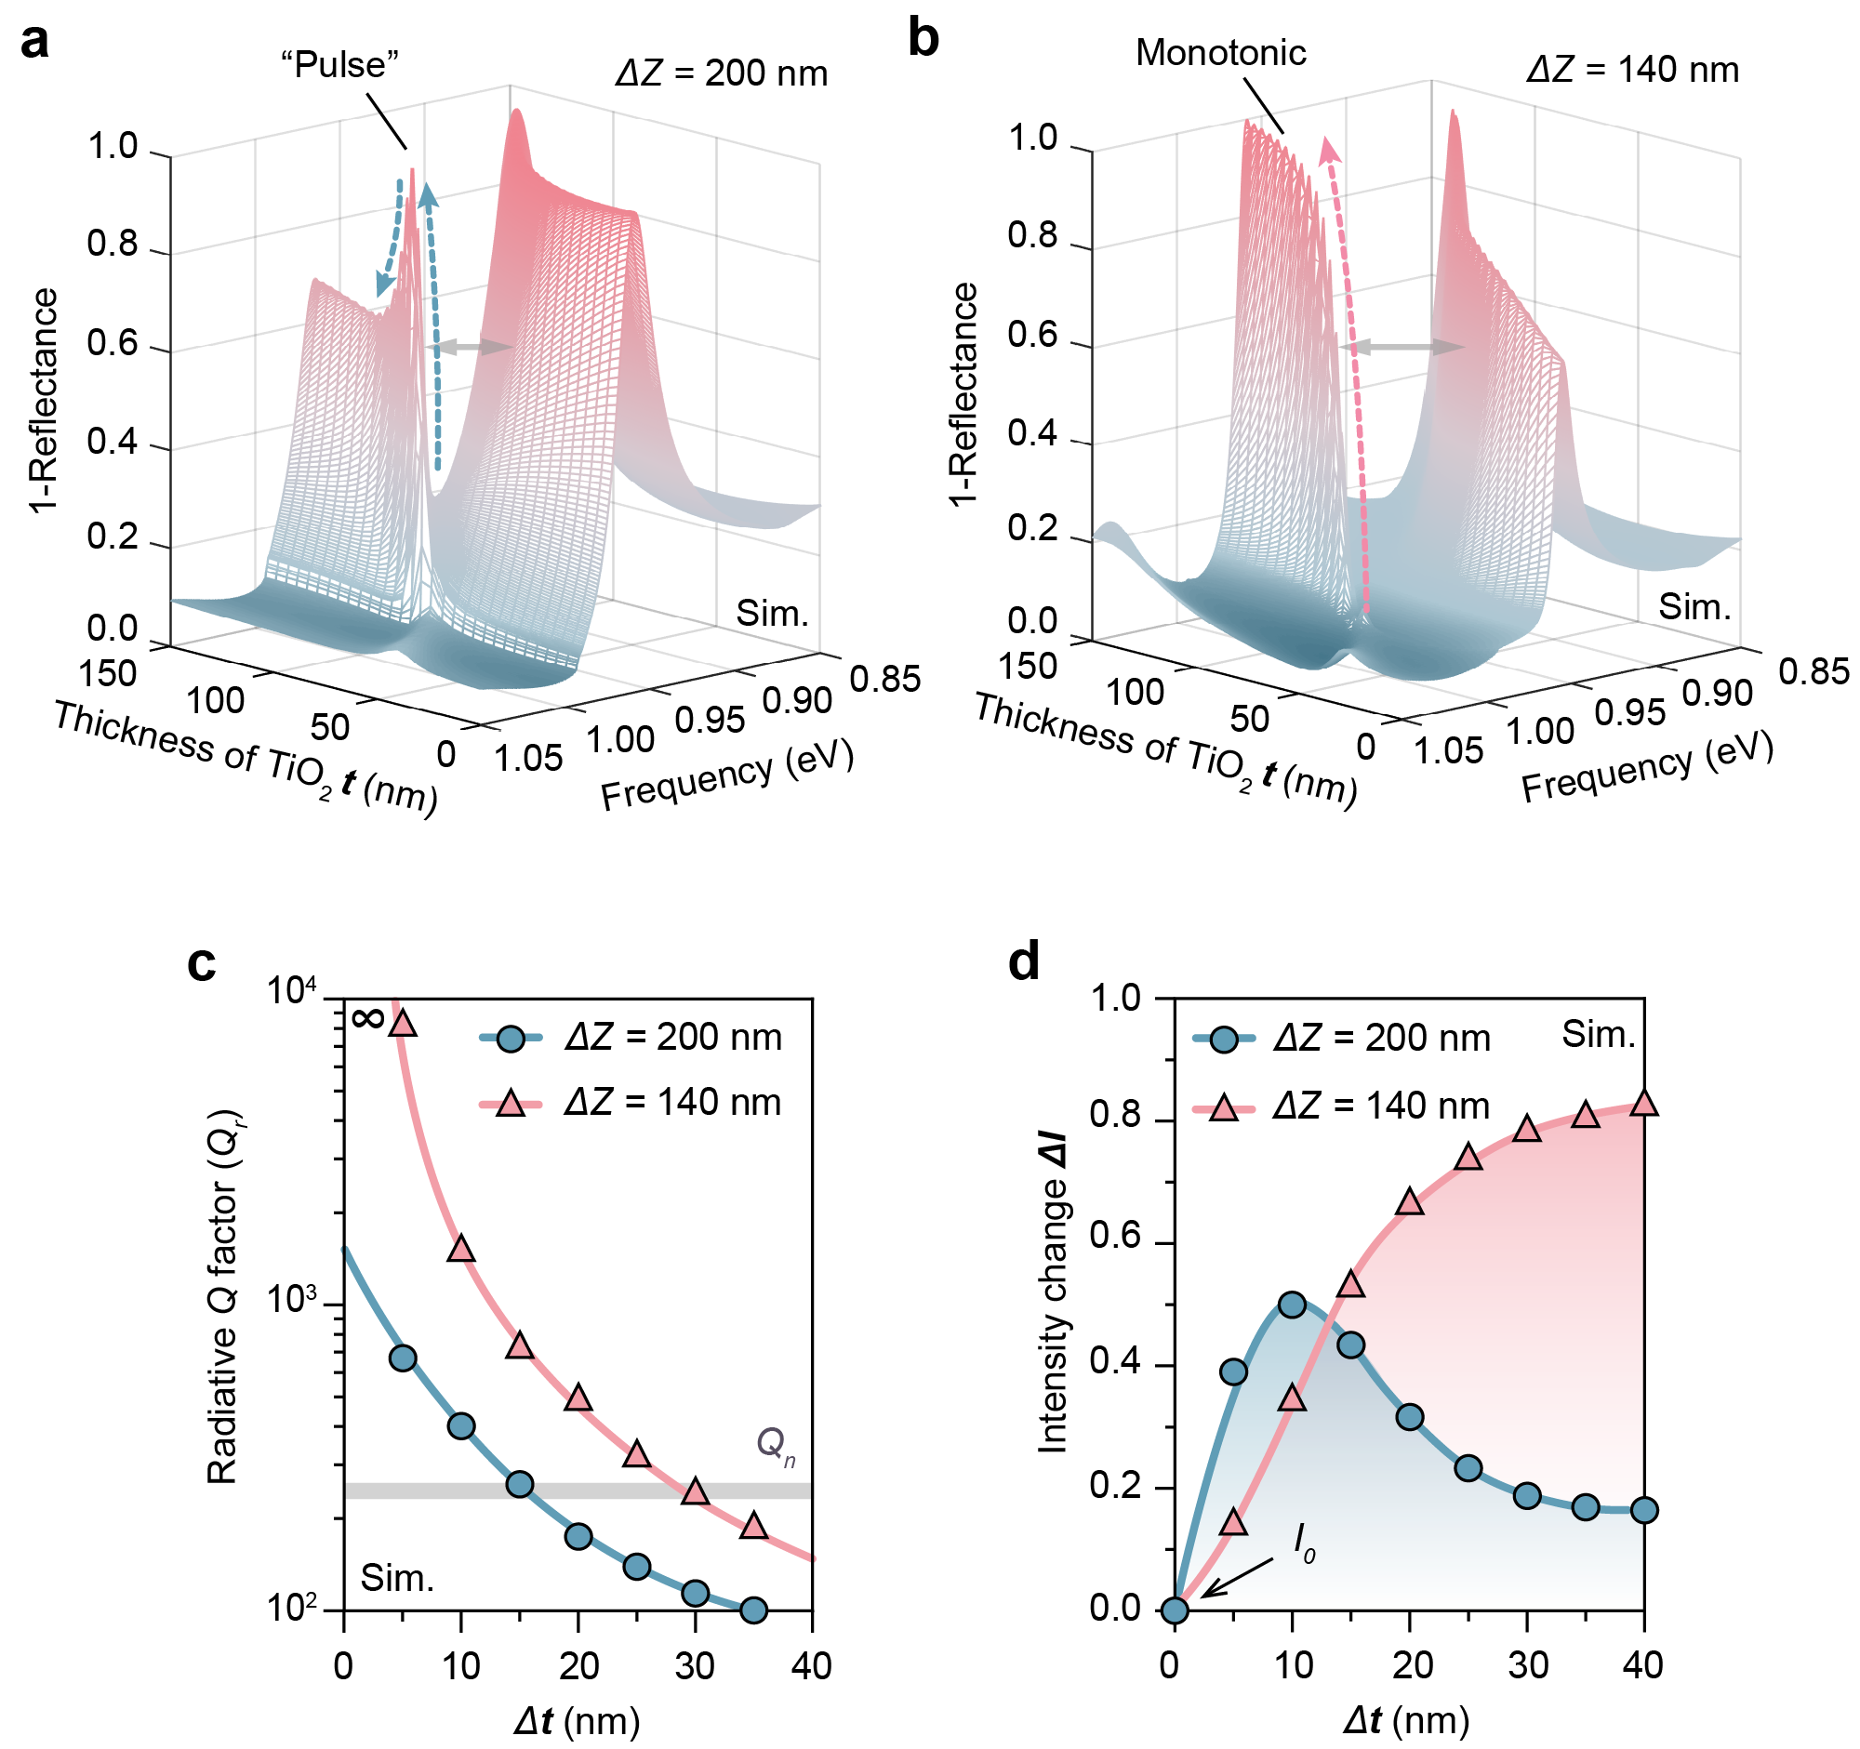

Fig. S8.
Optimization of 3D BIC metasurface in Q-switching sensing performance. (a, b) Simulated reflectance spectral mappings illustrating energy splitting in a strong coupling system (indicated by gray arrows) as a function of TiO₂ film thickness (t_{TiO2}) with fixed ΔZ values of 200 nm (C) and 140 nm (D). (c) Calculated Q_{r} of the upper branch (UB) mode as a function of TiO₂ film thickness for ΔZ values of 200 nm (Δt_{TiO2} = t_{TiO2} − 75 nm) and 140 nm (Δt_{TiO2} = t_{TiO2} − 80 nm). (d) Simulated peak reflectance intensity of the UB mode corresponding to varying TiO₂ film thicknesses under the same ΔZ conditions.
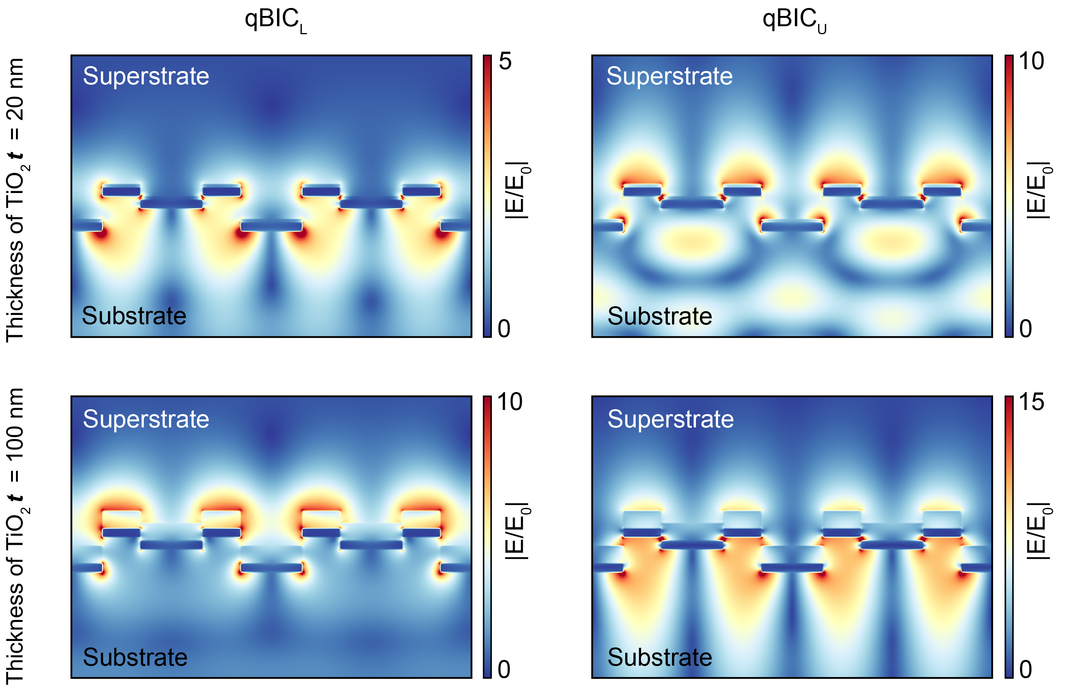

Fig. S9.
Mode transition in a strong-coupling process. The mode feature of qBIC_{L} and qBIC_{U} interchanged with the increase of TiO₂ thickness t from substrate (superstrate) to superstrate (substrate).

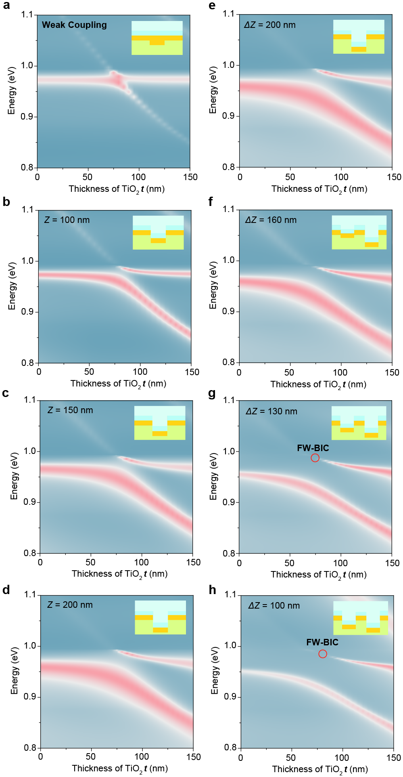

Fig. S10.
Evolution of coupling strength with structural parameter variation. (a) Reflectance spectral mapping of nanoparticle array on a continuous Au film as a function of TiO₂ thickness t. (b)-(d) Reflectance spectral mappings of a nanohole array with a 2D single-layer nanoparticle array with the nanoparticle depth Z₁ varying from 100 to 200 nm. (e)-(h) Reflectance spectral mappings of 3D BIC metasurface configuration with second nanoparticle layer with depth Z₂. The displacement between two nanoparticle layers is ΔZ = Z₁ – Z₂.
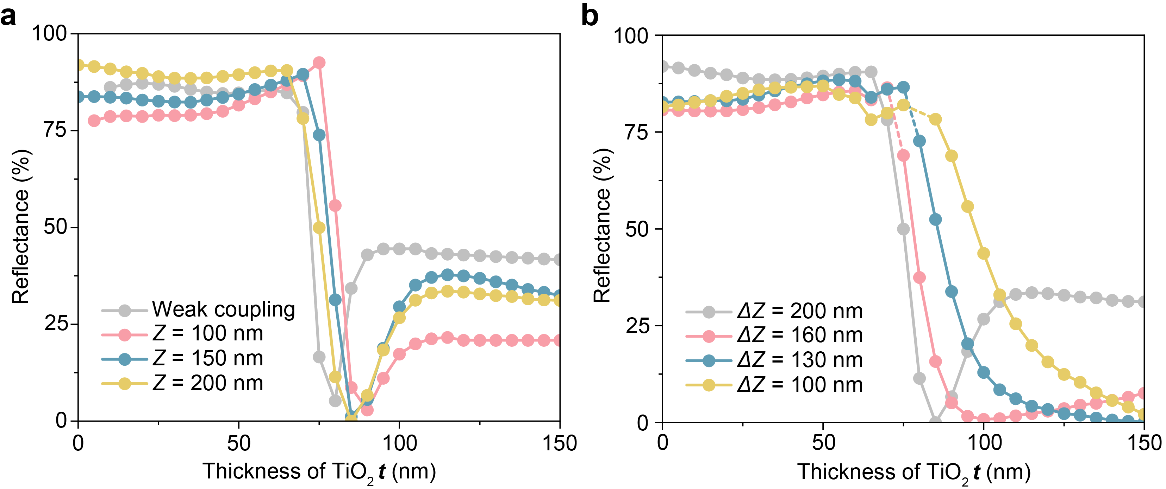

Fig. S11.
Evolution of peak reflectance intensity w/ and w/o 3D BIC configuration. (A) Peak reflectance variation of the upper branch (UB) for a nanohole array w/o BIC in different Z₁. (B) Peak reflectance variation of the upper branch (UB) for nanohole array with a 3D BIC metasurface configuration in different ΔZ.
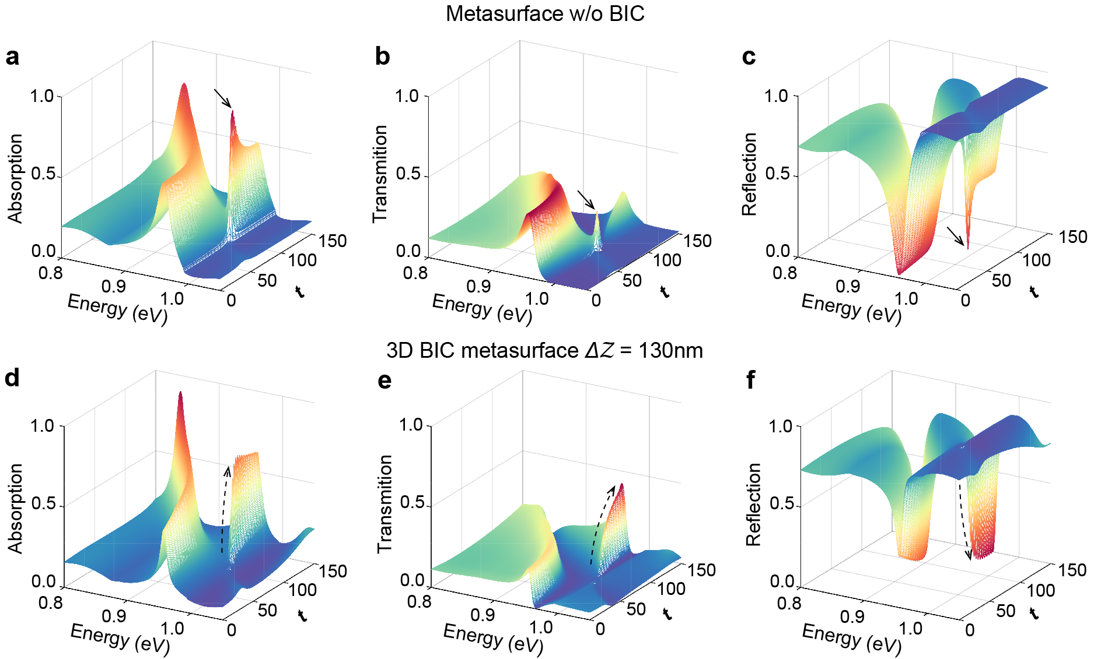

Fig. S12.
Spectral evolution comparison of metasurface w/o BIC and 3D BIC metasurface. (a)-(c) Absorption, transmittance, and reflectance spectral evolution of single nanoparticle layer metasurface as a function of TiO₂ thickness t. (d)-(f) Absorption, transmittance, and reflectance spectral evolution of 3D BIC metasurface as a function of TiO₂ thickness t.
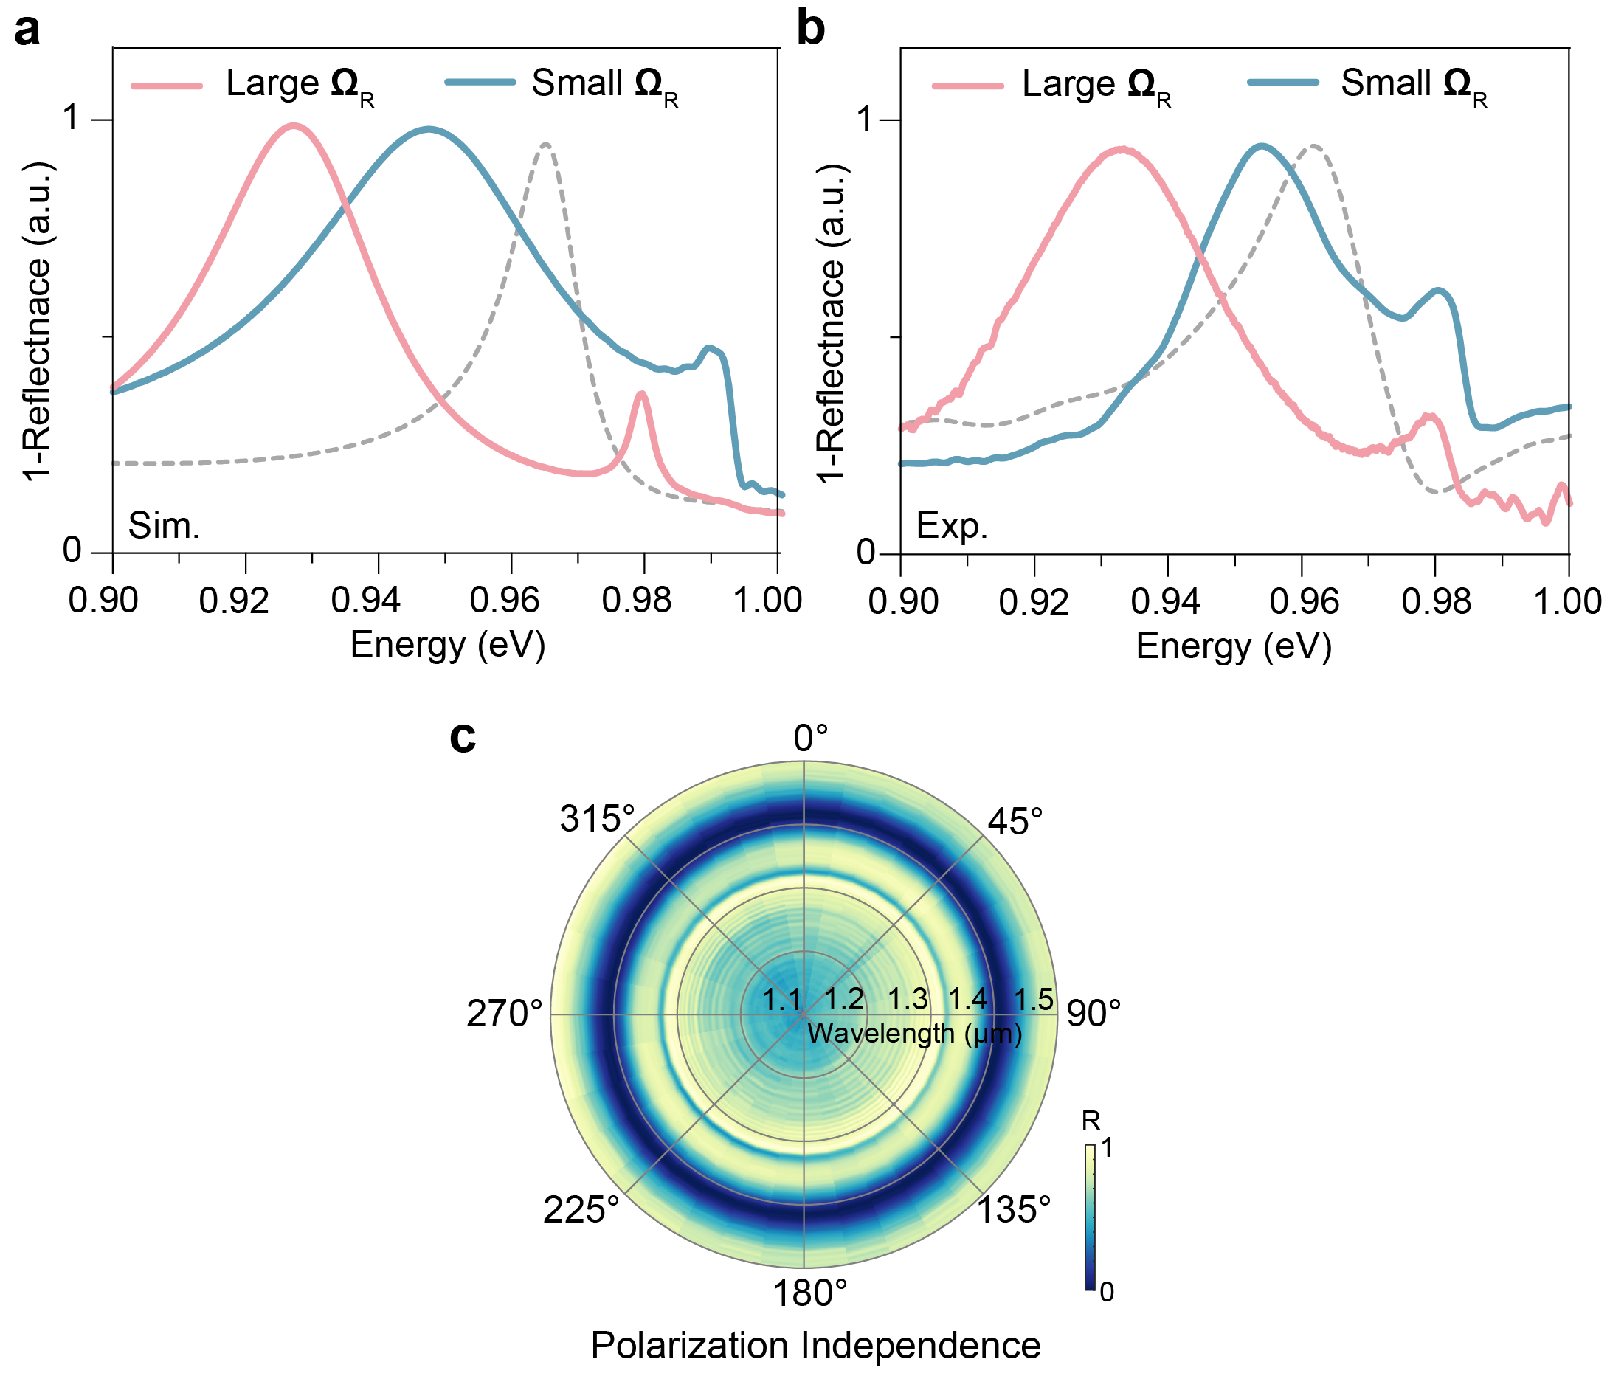

Fig. S13.
BIC enhanced Rabi splitting and polarization independence. (a) Comparison of simulation spectra between ΔZ = 200 nm (small detuning, red) and ΔZ = 130 nm (large detuning, blue). The gray dotted line is the resonance at zero detuning with no TiO₂ layer. (b) Corresponding experimental spectra show a good match with the simulation results. We can observe that qBIC_{U} with BIC-enhanced Rabi splitting has less overlap with qBIC_{L} and lower initial intensity, so it can provide a larger intensity tunable range in sensing applications. (c) Reflectance spectrum with the rotation of the incident polarization.

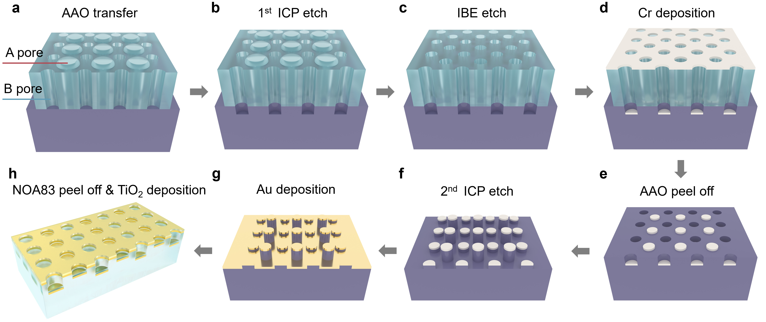

Fig. S14.
Fabrication of 3D BIC metasurface using BP-AAO template. (a) The BP-AAO template is transferred onto a silicon substrate, aligning with the B-pore openings. (b) The first step involves ICP etching to create the B-pores on the silicon substrate. (c) The A-pores of the BP-AAO template are then opened using ion beam milling. (d) A sacrificial Cr layer is deposited onto the silicon substrate through both the A- and B-pores of the BP-AAO template. (e) The BP-AAO template is removed from the silicon substrate. (f) The second step of ICP etching is performed to create an out-of-plane silicon nanostructure. (g) A gold layer is deposited onto the out-of-plane silicon nanostructure. (h) The out-of-plane nanostructure is transferred from the silicon substrate using NOA83, and a TiO₂ film is subsequently deposited to form the 3D BIC metasurface.

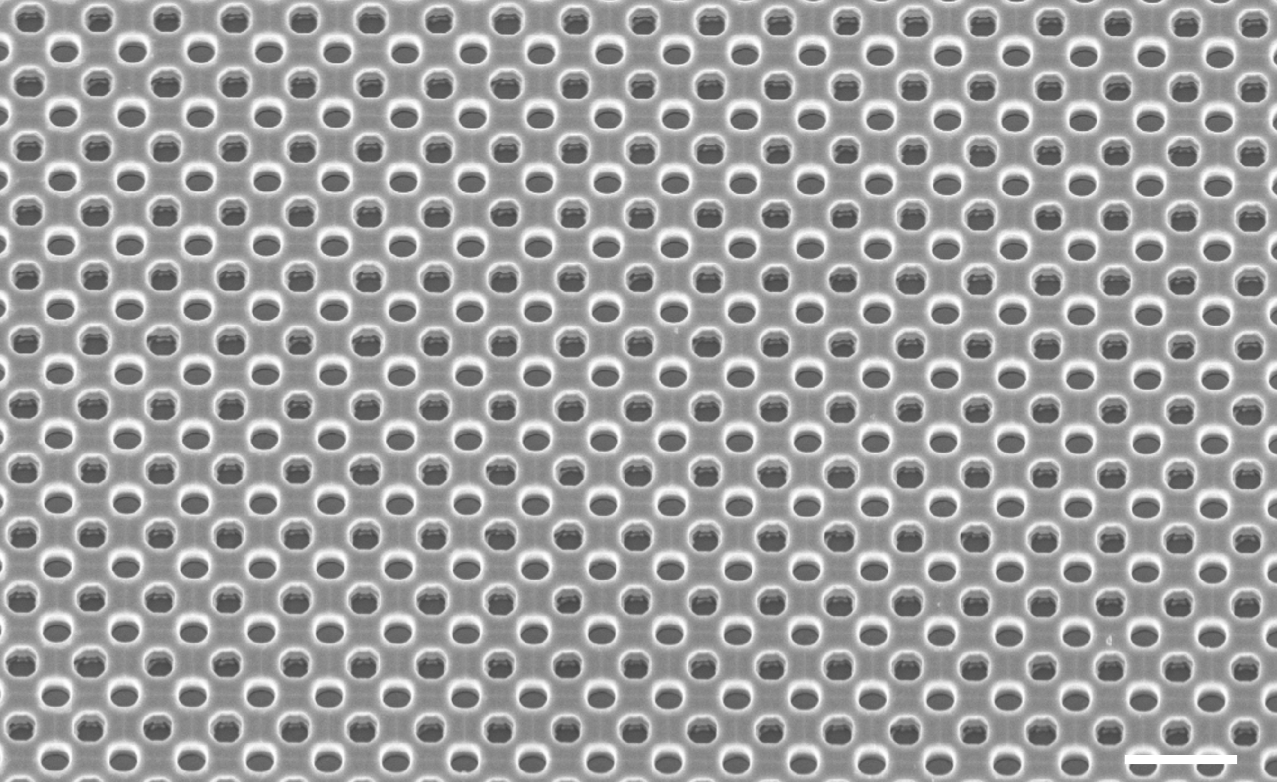

Fig. S15.
Morphology characterization of a representative BP-AAO template on the silicon substrate before peeling off after the 2nd ICP etch. This scanning electron microscope (SEM) corresponds to the step in Fig. S12D. Scale bar, 1 μm.

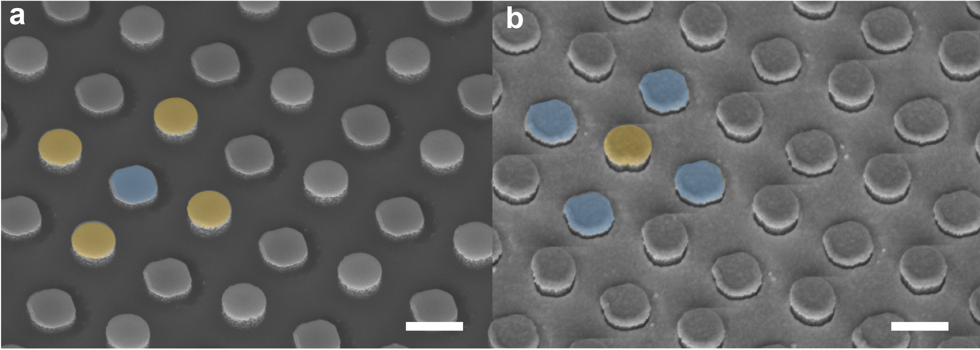

Fig. S16.
Morphology characterization of a representative out-of-plane nanostructure transferred from the silicon substrate. SEM of the silicon substrate corresponds to the different steps: (a) Fig. S12F and (b) Fig. S12G. The yellow block represents the production of higher silicon nanoparticles using A-pores; the blue block represents the production of lower silicon nanoparticles using B-pores, respectively. Scale bar, 300 nm.
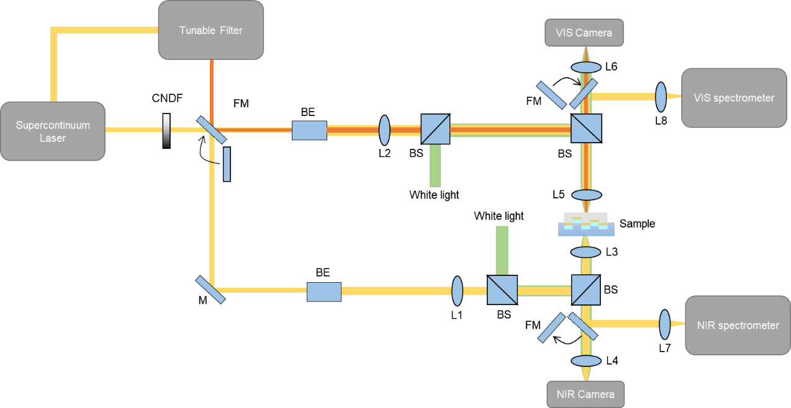

Fig. S17.
Schematic of the microscopy spectral measurement and hyperspectral imaging system.

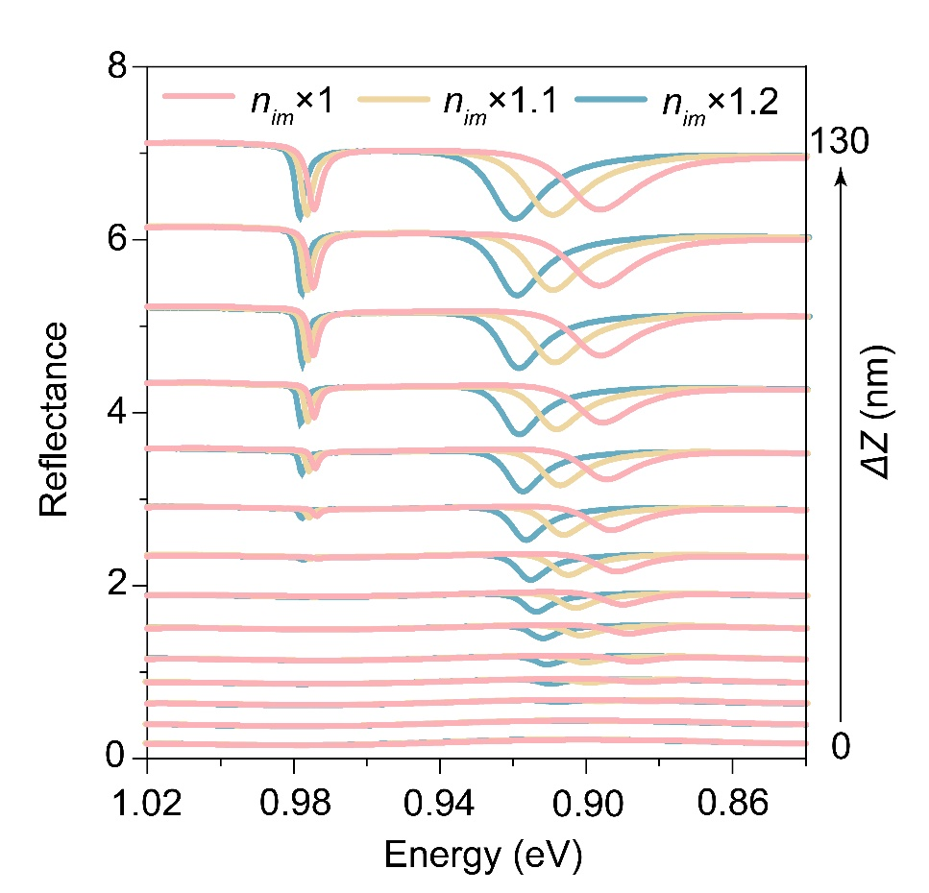

Fig. S18.
Robustness of the qBIC_{U} mode to material loss. To evaluate the impact of intrinsic material absorption, the imaginary part of the refractive index of gold, Im(n_{Au}), was incorporated into full-wave simulations. As Im(n_{Au}) increases, reflecting greater material loss, the energy splitting between the upper (qBIC_{U}) and lower (qBIC_{L}) resonance branches narrows, primarily due to a progressive blueshift in the qBIC_{L} mode. This behavior is consistent with the analytical framework described in Supplementary Equation E22, where increased absorption leads to a reduction in the effective exciton number N participating in the coupling process, thereby weakening the overall coupling strength. Notably, while the qBIC_{L} mode is highly sensitive to material loss and compensates for the majority of energy dissipation, the qBIC_{U} mode remains spectrally stable and retains a high Q-factor. This intrinsic robustness under lossy conditions underscores the practical reliability of the qBIC_{U} mode for biosensing applications.

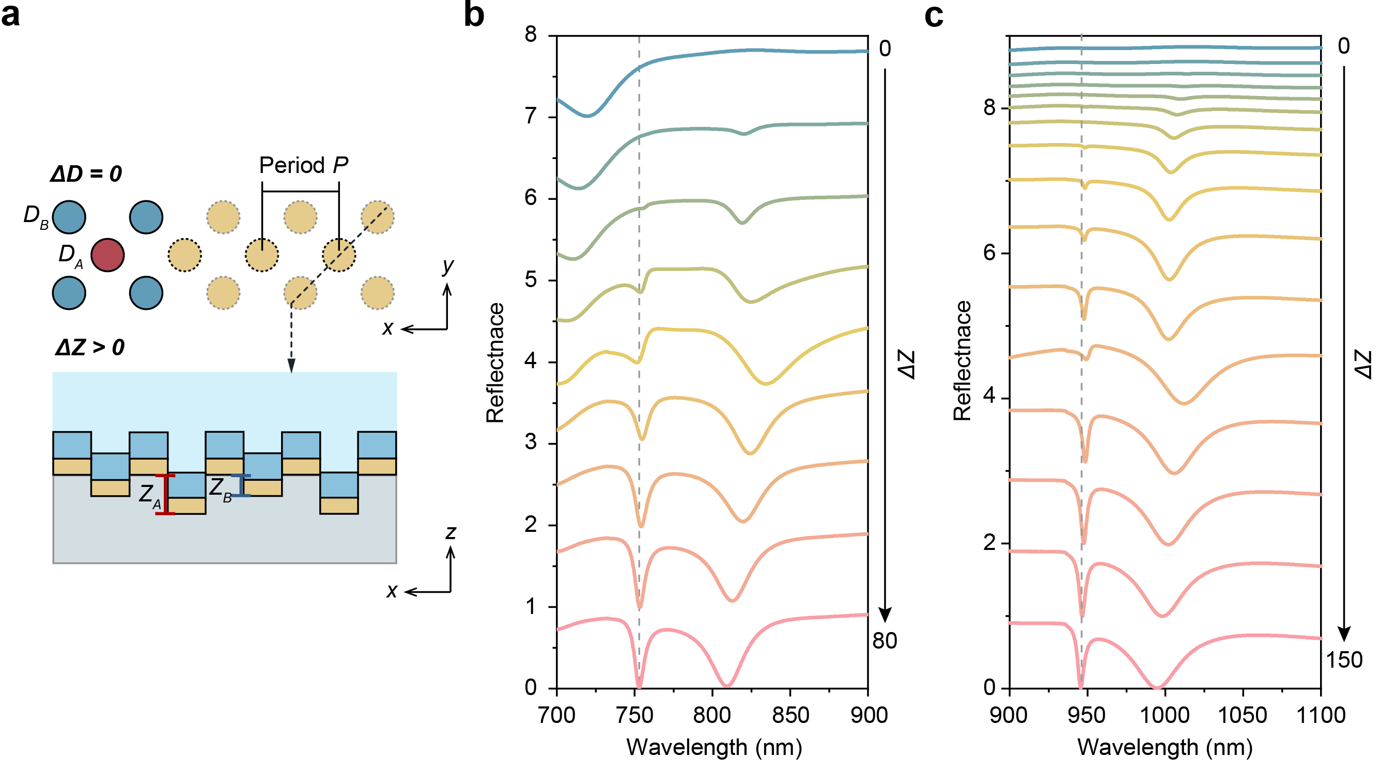

Fig. S19.
Simulation of 3D BIC manipulation for Q-switching sensing chip operating in the visible and near-infrared (VIS–NIR) wavelength regimes. (a) Schematic of the 3D BIC metasurface design, illustrating the unit cell architecture and key geometrical parameters, including lateral dimensions and out-of-plane displacement. (b) Simulated reflectance spectra for a metasurface with a lattice period of 470 nm, D_{A} = D_{B} = 150 nm, vertical position Z_{A} = Z_{B} = 80 nm, and out-of-plane offset ΔZ varied from 0 to 80 nm. The thickness of the top TiO₂ layer is set as 30 nm. (c) Simulated reflectance spectra for a metasurface with a lattice period of 600 nm, D_{A} = D_{B} = 200 nm, vertical position Z_{A} = Z_{B} =150 nm, and out-of-plane offset ΔZ varied from 0 to 150 nm. The thickness of the top TiO₂ layer is set as 55 nm. In both cases, increasing ΔZ induces a controlled symmetry breaking, enabling the transition from an ideal BIC to a qBIC resonance. The evolution of the qBIC_{U} mode is traced by the gray dotted line, highlighting the emergence of a high-Q resonance with well-defined wavelength stability.

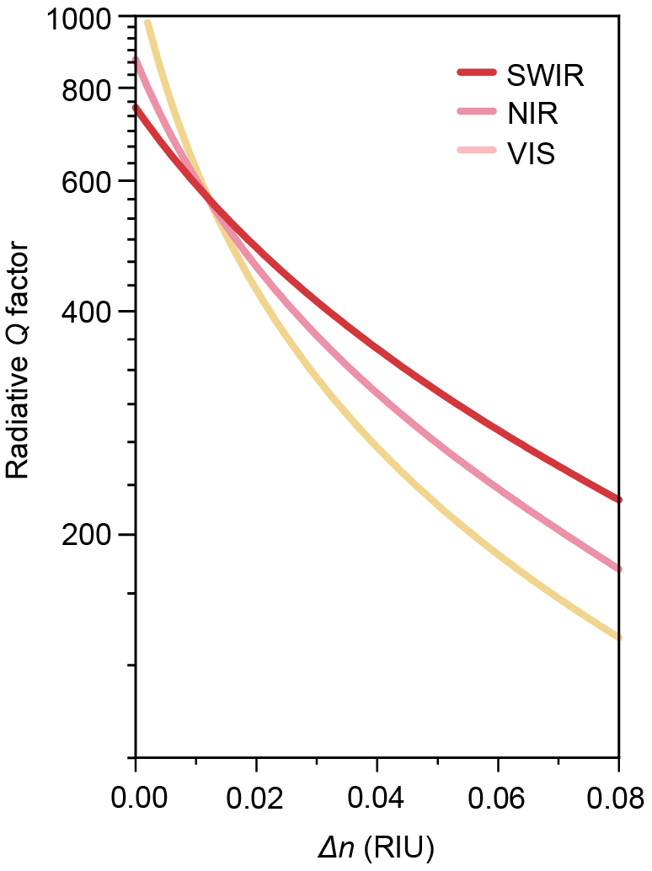

Fig. S20.
Analytical calculation of Q-switching sensing at different wavelength bands. The parameter settings for the three different bands are presented as follows, according to the experimental results. The Q_{n} is calculated from qBIC_{U} at the saturated absorption peak.
VIS: Q_{n} = 58.6, w = 1.67 eV, $γ_{1}^{'}$ = 0.0693 eV, $γ_{2}^{'}$ = 0.015 eV, $Ω_{R}$ = 0.1130, S₁ = 0.375 eV/RIU, S₂ = 0.209 eV/RIU, m = 1/(350Δn(S₁- S₂)+1), x = 0.5;
NIR: Q_{n} = 64.2, w = 1.327 eV, $γ_{1}^{'}$ = 0.0552 eV, $γ_{2}^{'}$ = 0.0111 eV, $Ω_{R}$ = 0.105, S₁ = 0.32 eV/RIU, S₂ = 0.13345 eV/RIU, m = 1/(800Δn(S₁- S₂)+1), x = 0.54;
SWIR: Q_{n} = 115, w = 0.9776 eV, $γ_{1}^{'}$ = 0.0442 eV, $γ_{2}^{'}$ = 0.005 eV, $Ω_{R}$ = 0.0467, S₁ = 0.248 eV/RIU, S₂ = 0.0218 eV/RIU, m = 1/(800Δn(S₁- S₂)+1), x = 0.65.

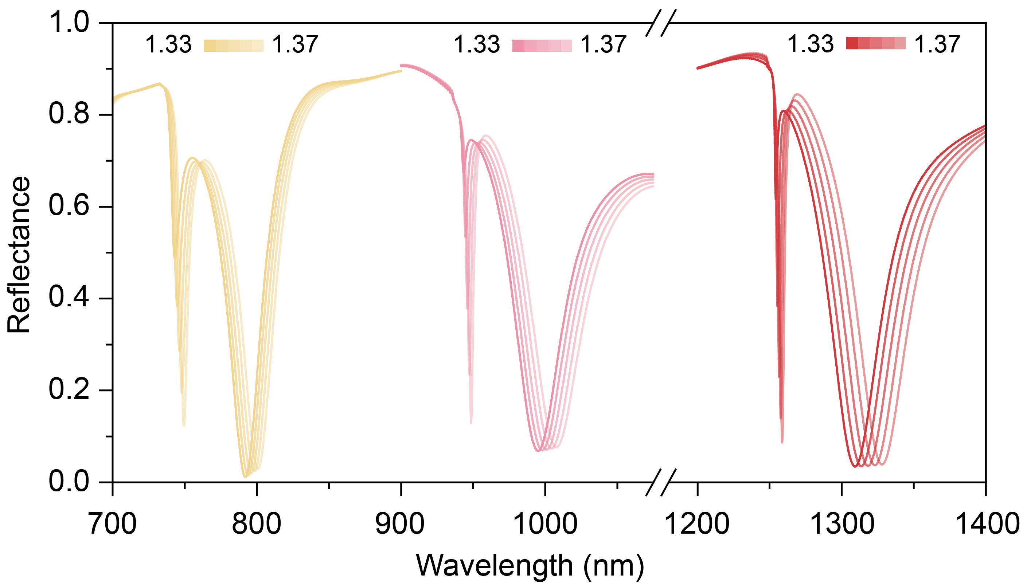

Fig. S21.
Simulation of bulk sensing performance using the 3D BIC metasurface with lattice periods of 470, 600, and 800 nm. These periods were chosen to span across visible and near-infrared spectral regions, enabling assessment of the Q-switching sensing mechanism across a broad optical bandwidth. The surrounding bulk refractive index systematically varied from 1.33 to 1.37, encompassing the physiologically relevant range for aqueous and biological environments. Notably, the results demonstrate the broadband compatibility of the Q-switching sensing in coupled-oscillators, with effective performance observed across visible and near-infrared regimes. These findings validate the underlying physical principle that the Q-switching resonance can be efficiently excited and tuned over a wide wavelength range by appropriate lattice design. The broadband Q-switching response observed in simulation is further corroborated by experimental measurements, establishing the architecture as a versatile platform for high-performance biosensing across diverse optical domains.

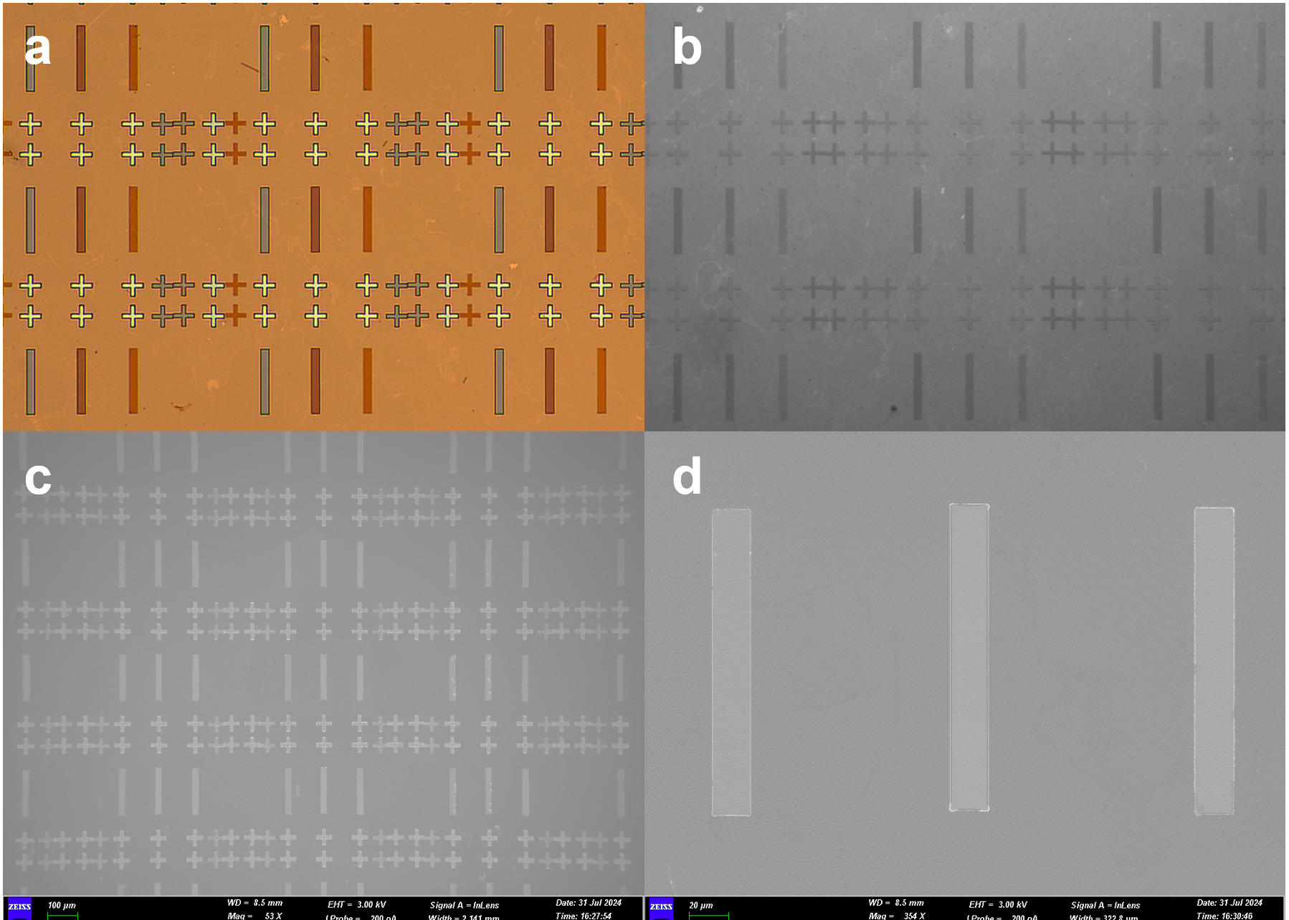

Fig. S22.
Large-scale uniformity and consistency for hyperspectral image construction. (a) Micrograph of gradient patterns. (b) Hyperspectral reconstruction of gradient patterns with illumination of 25 nm bandwidth light source. (c) SEM image of large-scale overlay SiO₂ strips deposited on the metasurface substrate. (d) Zoom in SEM image of a single overlay SiO₂ pattern.

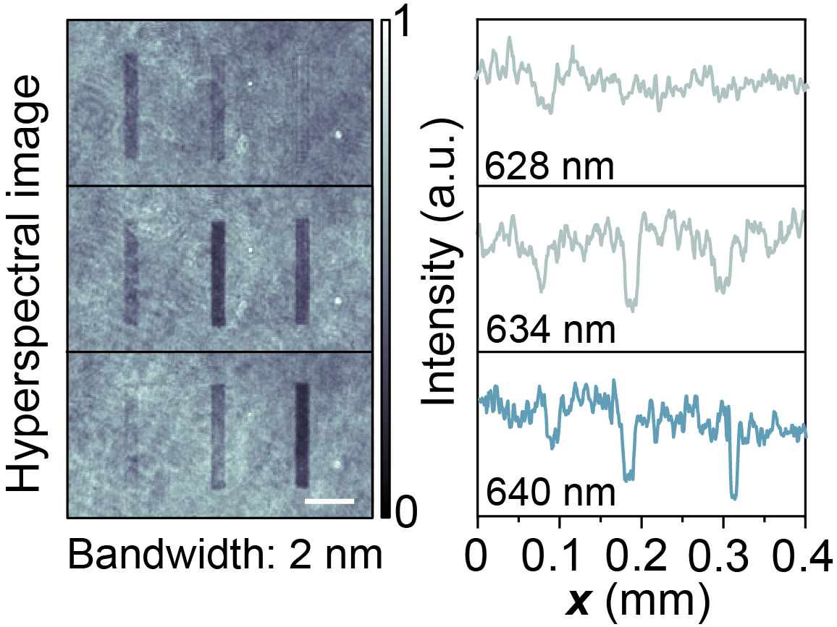

Fig. S23.
Hyperspectral image and line profiles of gradient pattern illuminated by a 2 nm bandwidth light source at 628, 634, and 640 nm. To ensure compatibility with various bandwidth light sources, we implemented a Q-switching sensor with a 400 nm period, which excites the Q-switching sensing mode at 640 nm. The center wavelength of the broadband filter and LED was set to 650 nm, effectively covering the sensor’s response band. Scale bar, 50 µm.

Facility | Supplier | Price
Q-switching sensing chip | Westlake University, Liaoyong Wen’s Lab | ~5 USD
Photo diode (PD) | Shenzhen Chaoyue Optoelectronics Co., LTD | ~5 USD
Light-emitting diode (LED) | Shenzhen Supernatural Technology Co., LTD | ~1 USD
Beam splitter  (BS2155-B) | Changsha Lubang Optoelectronic Technology Co., LTD (LBTEK) | ~100 USD
Bandpass filter  (MBF10-940-10) | Changsha Lubang Optoelectronic Technology Co., LTD (LBTEK) | ~100 USD
Total Cost |  | ~210 USD

Table S1 Cost of Q-switching sensing system.

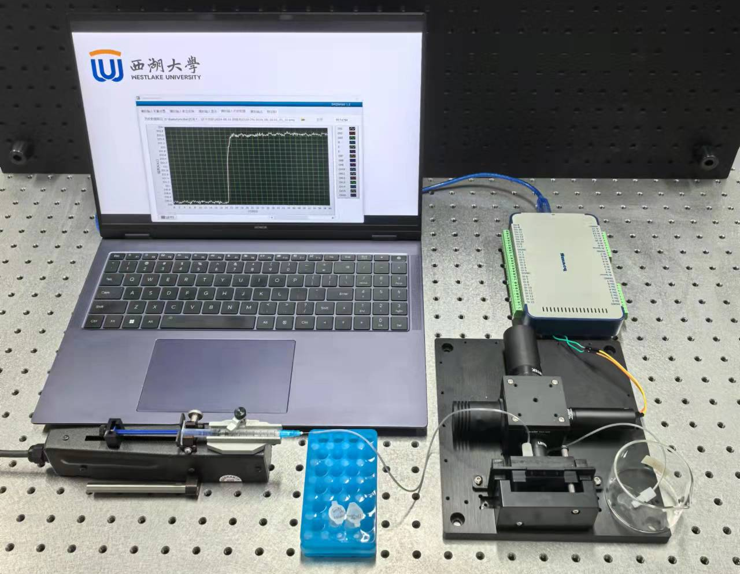

Fig. S24.
Photograph of the miniaturized testing system alongside its real-time software interface, illustrating the operational testing scenario. Integrated with a custom-designed real-time software interface, illustrating the complete operational configuration. The image captures both the physical assembly of the compact sensing unit and the synchronized live display of real-time biosensing data, highlighting the system’s capacity for continuous data acquisition, signal processing, and immediate analysis. To optimize optical excitation while ensuring biocompatibility, a 940 nm near-infrared (NIR) light source was employed. This wavelength was selected not only for its spectral compatibility with the Q-switching sensing architecture featuring a 600 nm grating period, but also for its superior performance in biological contexts. Specifically, the lower photon energy of 940 nm light minimizes adverse photophysical effects such as photodamage, photobleaching, and thermal degradation of fragile biomolecules, thereby enhancing measurement reliability and enabling prolonged monitoring. Furthermore, relative to conventional 850 nm sources, 940 nm illumination effectively suppresses red leakage arising from imperfect optical filtering, a critical factor that significantly improves spectral purity, detection fidelity, and long-term stability of the miniaturized biosensing platform. This optimized optical configuration ensures robust operation across a broad range of experimental and clinical conditions.

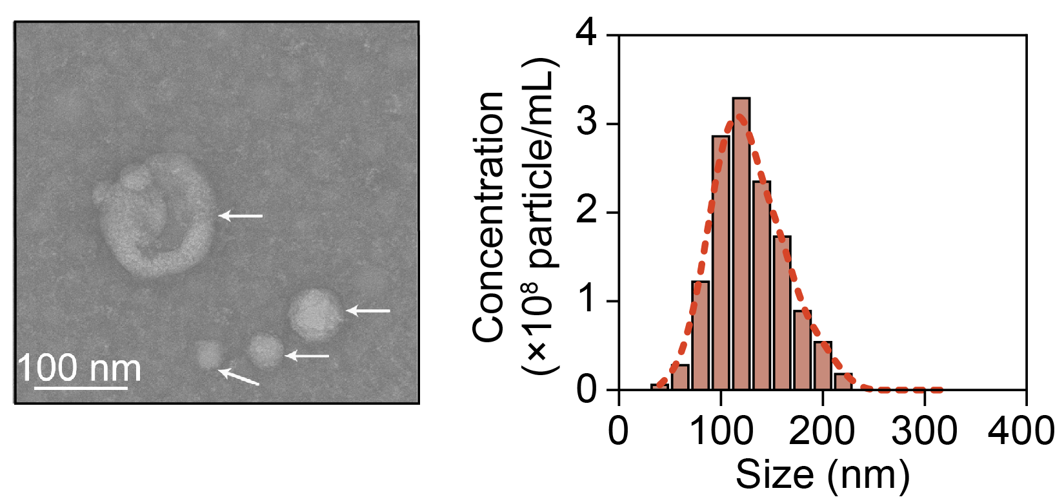

Fig. S25.
Molecular characterization and nanoparticle tracking analysis (NTA) of small extracellular vesicles (sEVs). NTA measurements revealed a unimodal size distribution of isolated sEVs, with a peak centered around ~120 nm in diameter, consistent with the expected size range for exosomes. This size profile confirms the successful enrichment of sEVs and supports their identity as membrane-bound nanovesicles of endosomal origin.

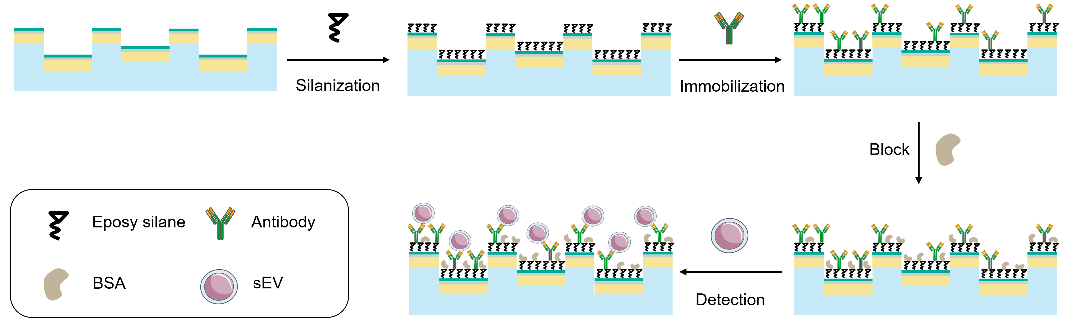

Fig. S26.
Schematic illustration of the bio-functionalization protocol for sEV detection. The device surface was first modified with (3-glycidoxypropyl) trimethoxysilane (3-GPS) to establish a uniform silanized monolayer via covalent surface chemistry. This epoxide-functionalized layer provides reactive sites for subsequent biomolecule attachment. Monoclonal antibodies specific to exosomal surface markers (e.g., anti-CD63 or anti-CD151) were then covalently conjugated to the silanized surface to enable selective recognition of small extracellular vesicles (sEVs). To minimize nonspecific adsorption and improve selectivity, the remaining active sites were passivated with bovine serum albumin (BSA). This stepwise functionalization strategy ensures robust and specific capture of target exosomes from complex biological media.

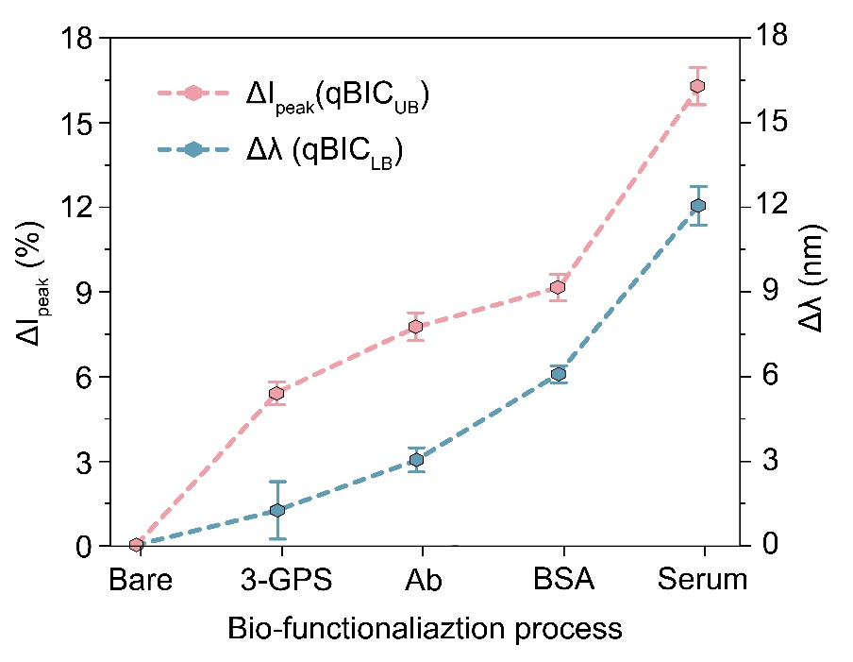

Fig. S27.
Experimentally measured peak intensity response and resonance wavelength shift. The qBIC_{U} mode exhibits pronounced intensity modulation in response to the spectral shifts of the qBIC_{L} mode. This coupling effect indicates that the qBIC_{U} intensity serves as a sensitive transduction signal, amplifying subtle refractive index–induced changes manifested as wavelength shifts in the qBIC_{L} resonance.

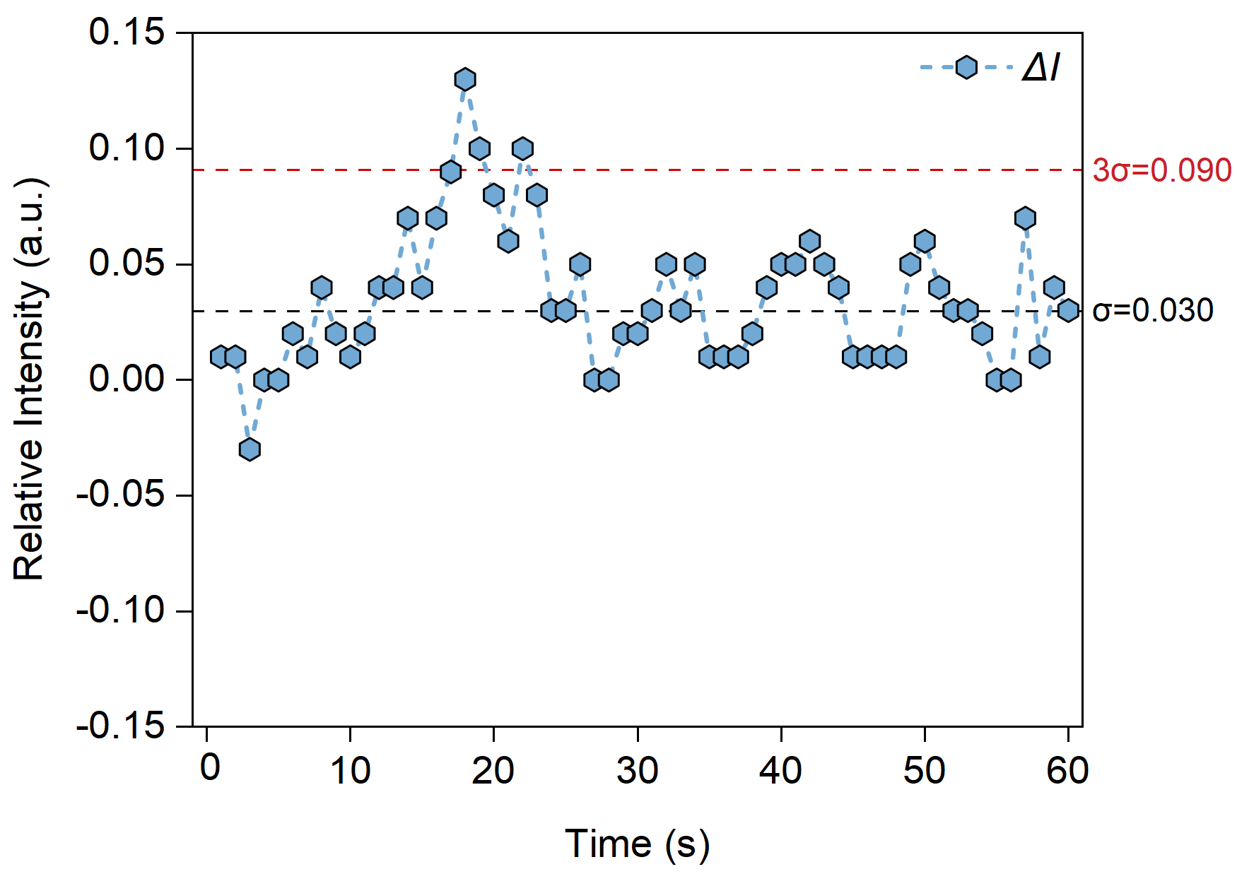

Fig. S28.
Time-domain evaluation of Q-switching sensing system stability. The relative intensity of the qBIC_{U} resonance is continuously monitored to assess signal fluctuations over time. The standard deviation (σ) of the intensity variation is calculated to quantify the intrinsic noise level of the system, providing a measure of operational stability and detection reliability under static environmental conditions.

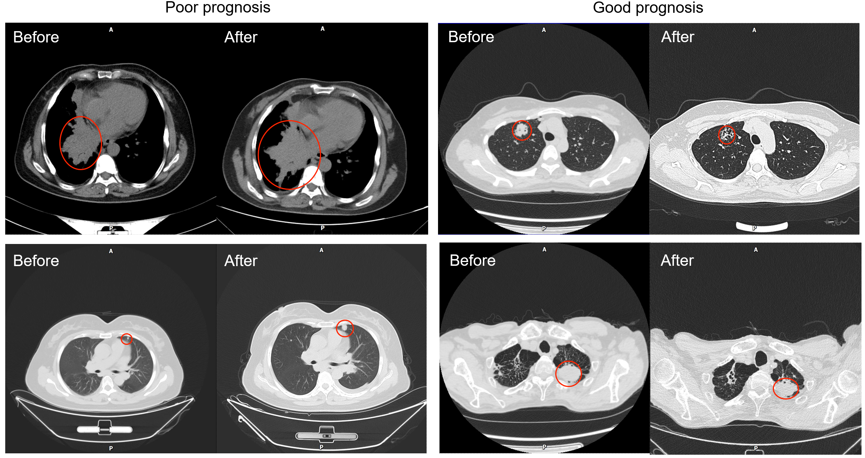

Fig. S29.
MRI scans obtained pre- and post-treatment, illustrating differential therapeutic outcomes. In the poor prognosis group, tumor progression is evident, with lesions enlarging following surgical intervention. In contrast, the good prognosis group exhibits significant tumor regression postoperatively, indicating a favorable therapeutic response. Tumor regions are delineated by red circles for visual clarity. These imaging results highlight the variability in treatment efficacy and underscore the importance of prognostic stratification in clinical decision-making.

Characteristics | Diagnostic assessment (Fig.5f)  Number (%) |  | Treatment monitoring (Fig.5h)  Number (%)
Characteristics | Lung cancer patients | Healthy controls | Good prognosis | Poor prognosis
Individuals | 34 | 22 | 16 | 12
Gender  Male  Female | 20 (58.8%)  14 (41.2%) | 13 (59.1%)  9 (40.9%) | 9 (56.2%)  7 (43.8%) | 7 (58.3%)  5 (41.7%)
Age  Median  Range | 56  40-82 | 61  41-84 | 57  46-83 | 59  48-75
Stage
Ⅰ | 1 (2.9%) | NA | - | -
Ⅱ | 4 (11.8%) | NA | - | -
Ⅲ | 7 (20.6%) | NA | 5 (31.2%) | 2 (16.7%)
Ⅳ | 22 (64.7%) | NA | 11 (68.8%) | 10 (83.3%)
Histology subtype
Adenocarcinoma | 24 (70.6%) | NA | 12 (75.0%) | 9 (75.0%)
Squamous cell carcinoma | 4 (11.8%) | NA | 1 (6.2%) | 1 (8.3%)
Small cell carcinoma | 6 (17.6%) | NA | 3 (18.8%) | 2 (16.7%)

Table S2 Clinical Information.

References
- I. I. Rabi, On the Process of Space Quantization. Physical Review 49, 324 (1936).
- A. Brandstetter-Kunc, G. Weick, C. A. Downing, D. Weinmann, R. A. Jalabert, Nonradiative limitations to plasmon propagation in chains of metallic nanoparticles. Physical Review B 94, 205432 (2016).
- A. C. Overvig, S. A. Mann, A. Alù, Thermal Metasurfaces: Complete Emission Control by Combining Local and Nonlocal Light-Matter Interactions. Physical Review X 11, 021050 (2021).
- J. R. Piper, S. Fan, Total Absorption in a Graphene Monolayer in the Optical Regime by Critical Coupling with a Photonic Crystal Guided Resonance. ACS Photonics 1, 347–353 (2014).
- R. Berté et al., Permittivity-Asymmetric Quasi-Bound States in the Continuum. Nano Letters 23, 2651–2658 (2023).
- A. D. Humphrey, W. L. Barnes, Plasmonic surface lattice resonances on arrays of different lattice symmetry. Physical Review B 90, 075404 (2014).
- A. Krishnan et al., Evanescently coupled resonance in surface plasmon enhanced transmission. Optics Communications 200, 1-7 (2001).
- C.-Y. Wang et al., Engineering Giant Rabi Splitting via Strong Coupling between Localized and Propagating Plasmon Modes on Metal Surface Lattices: Observation of √N Scaling Rule. Nano Letters 21, 605–611 (2020).
- D. S. Dovzhenko, S. V. Ryabchuk, Y. P. Rakovich, I. R. Nabiev, Light–matter interaction in the strong coupling regime: configurations, conditions, and applications. Nanoscale 10, 3589-3605 (2018).

