Supplementary Materials for
A dynamic urban waterlogging risk assessment framework integrating RAGA-optimized projection pursuit and scenario simulation for targeted flood mitigation

Table S1 Calibration results of relevant parameters
Parameters | Building | Road | Green space | Water body | Others
Runoff type | Fixed | Fixed | Horton | Fixed | Horton
Fixed runoff coefficient | 0.8 | 0.8 | - | 0 | -
Routing type | Rel | Rel | Rel | Rel | Rel
Routing model | SWMM | SWMM | SWMM | SWMM | SWMM
Routing parameters | 0.015 | 0.013 | 0.5 | 1 | 0.016
Surface type | Impervious | Impervious | Pervious | Impervious | Pervious
Initial infiltration rate (mm/h) | - | - | 90 | - | 71
Stable infiltration rate (mm/h) | - | - | 3.8 | - | 2.6
Decay factor (1/h) | - | - | 2.5 | - | 2.5

Table S2 Validation metrics for ponding depth simulations
Ponding point ID | Measured depth (m) | Simulated depth (m) | Relative error (R_{E}) (%)
a | 0.19 | 0.21 | 10.53
b | 0.16 | 0.18 | 12.50
c | 0.18 | 0.16 | 11.11

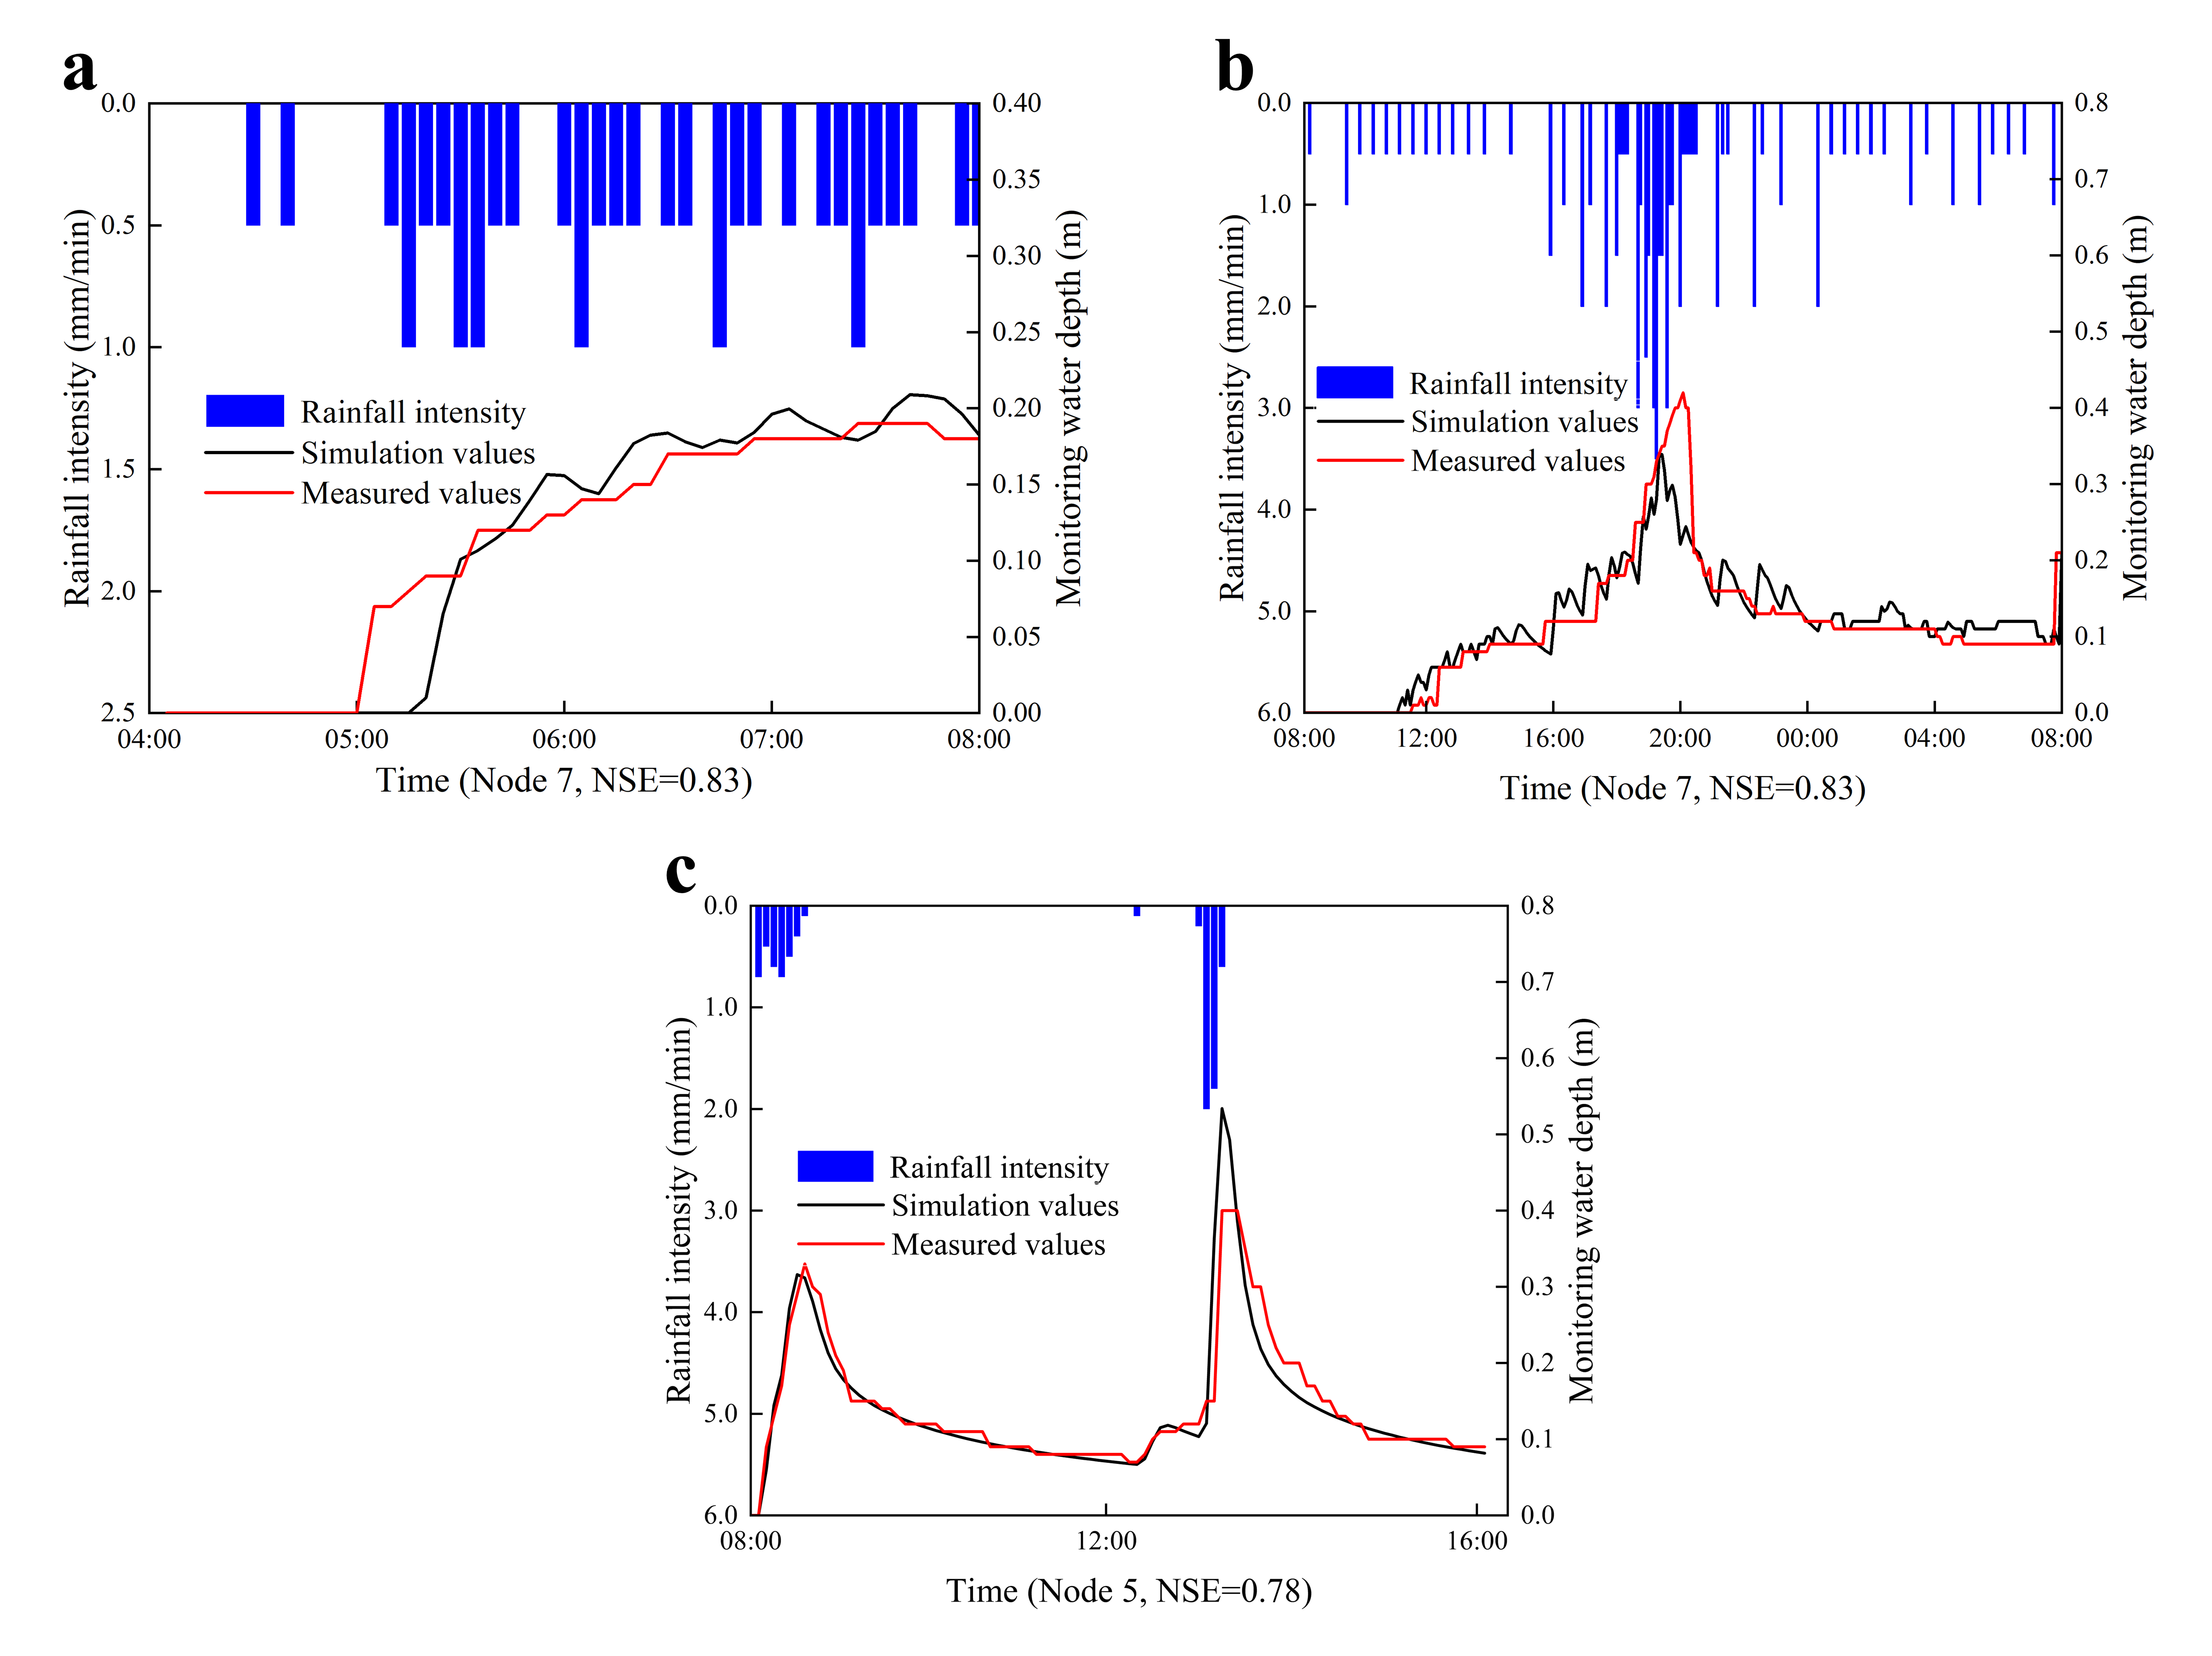
Fig. S1 Results of model parameter calibration and rainfall runoff process validation results: a Rainstorm event on October 22, 2019 b Extremely heavy rainstorm event on October 10, 2019 and c Rainstorm event on September 12, 2019

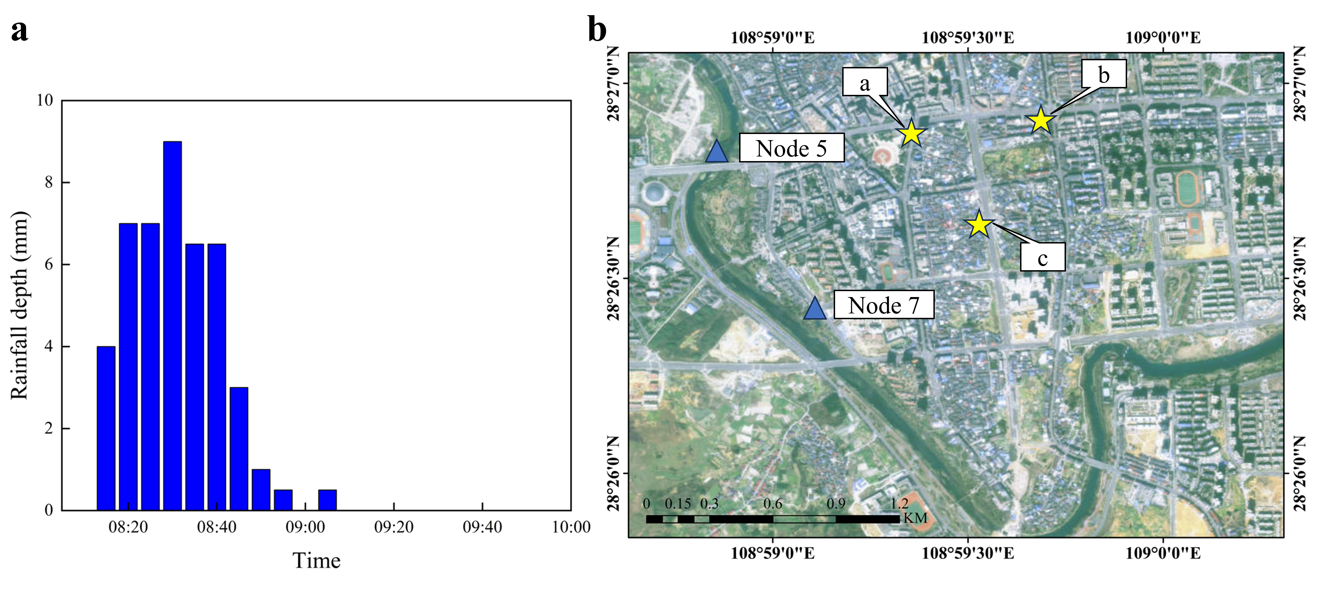
Fig. S2 Hydrological modeling inputs and validation framework: a Precipitation distribution during the August 11, 2020 rainfall event b Geographic distribution of calibration and validation points for the 1D-2D coupled hydrodynamic model

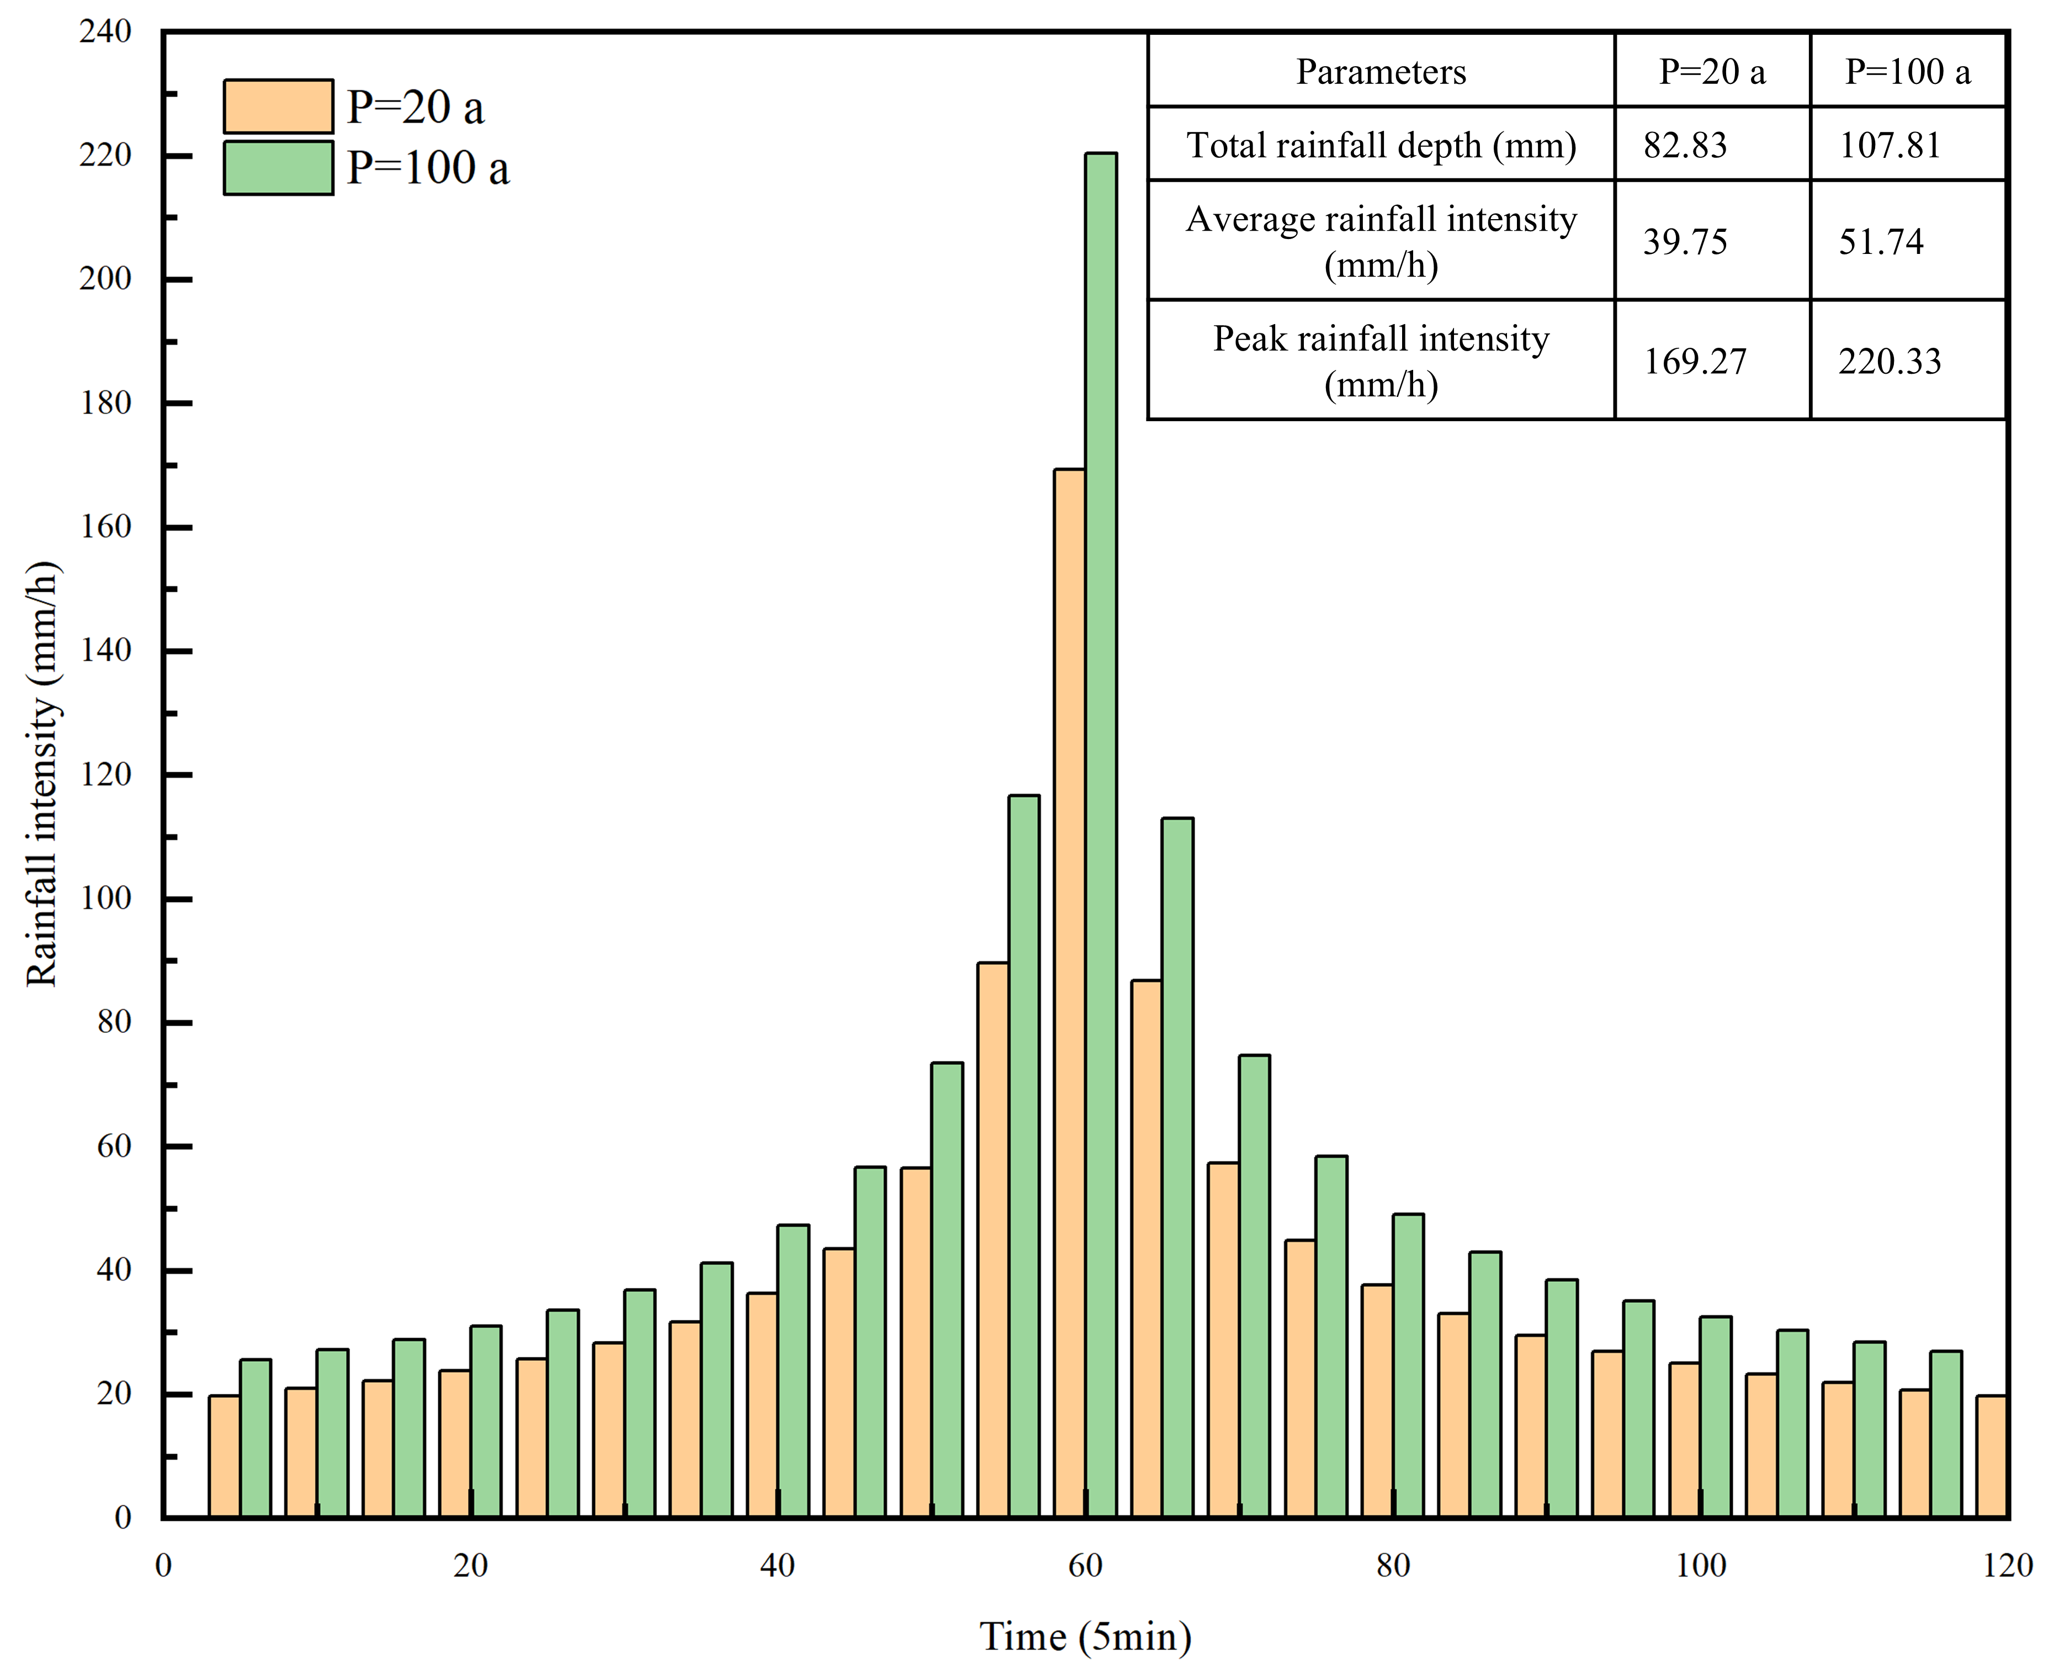
Fig. S3 Synthetic hyetograph of design rainfalls with two recurrence intervals and corresponding rainfall data

