Supplementary information
A facile preparation of multicolor carbon dots
Risheng Yu, Sen Liang, Yi Ru, Lu Li, Zhikun Wang, Junlang Chen, Liang Chen *
Department of Optical Engineering, Zhejiang Prov Key Lab Carbon Cycling Forest Ecosy, College of Environmental and Resource Sciences, Zhejiang Provincial Key Laboratory of Chemical Utilization of Forestry Biomass, Zhejiang A&F University, Hangzhou 311300, China

*Corresponding author. E-mail: liangchen@zafu.edu.cn (L.C.).

Contents
PS1 Materials and methods 2
PS2 Characterizations methods 2
PS3 XPS Data analysis 3
PS4 PL emission spectra 4

PS1 Materials and methods
Materials:
Hydrated critic acidic (C₆H₁₀O₈), Thiourea (CH₄N₂S), N,N-Dimethylformamide (DMF,C₃H₇NO), Ethyl acetate (C₄H₈O₂), Petroleum ether 30～60 ℃. All these chemical agents were obtained from Shanghai Aladdin Biochemical Technology Co., Ltd. Deionized water was used with 18.2 MΩ•cm⁻¹ in all experiments.

Synthesis of multi-colored CDs
Multiple color emission CDs were prepared by using different volume ratio of water and DMF in a one-spot solvothermal process. Firstly,1.26g (0.2mol/L) hydrated critic acidic and 1.37g (0.6mol/L) thiourea were dissolved in 30ml water ,30ml DMF for synthesis of blue emission CDs, red emission CDs, respectively. And from green to orange emitting CDs, 1.26g (0.2mol/L) hydrated critic acidic and 1.37g (0.6mol/L) thiourea were dissolved in one kind of mixed solvents (30ml in total). Such mixed solvents were gotten by mixing water and DMF with volume ratio of 1:1, 1:5, and 1:9, respectively. Secondly, each solution was translated into a Teflon-lined stainless-steel autoclave and heated at 160 ℃ for 4h. After reaction finished, each resulting CDs was cooled at the room temperature. The reaction liquid was filtrated with 0.22 μm membranes to further purify. And then the CDs solution of purification were added into the mixed solvent of petroleum ether and ethyl acetate to remove a great number of DMF. The volume ratio of petroleum ether and ethyl acetate varies with different CDs. Generally speaking, the volume ratio of petroleum ether and ethyl acetate is 2:3 for green emissive CDs to delete DMF; 4:1 for red emissive CDs to remove DMF, respectively. Finally, the blue emission CDs was freeze-vacuum dried and the green and red emission CDs were heated in the oven overnight to obtained the solid so that they were charactered at the next step.

PS2 Characterizations methods
Multiply colored CDs were analyzed with a Shimadzu UV-25500 PC UV/Vis absorption spectrometer. The chemical functional groups of the kinds of CDs were measured by Fourier transform infrared (FT-IR, Thermo Scientific Nicolet iS50, America) over the range of 800~4000 cm⁻¹.All fluorescence spectra were performed by a fluorescence spectrophotometer (F-4600, Hong Kong Tian mei Co., Ltd.). Raman spectra were measured by a HORIBA Scientific LabRAM HR Evolution high resolution Raman spectrometer with laser frequency of 785 nm as an excitation source. The XPS results of CDs were charactered by the ThermoFisher ESCALAB 250Xi spectrometer. The Atomic Force Microscopy (AFM, Bruker, Multimode-8) was used to gained height and sizes of CDs.

PS3 XPS Data analysis
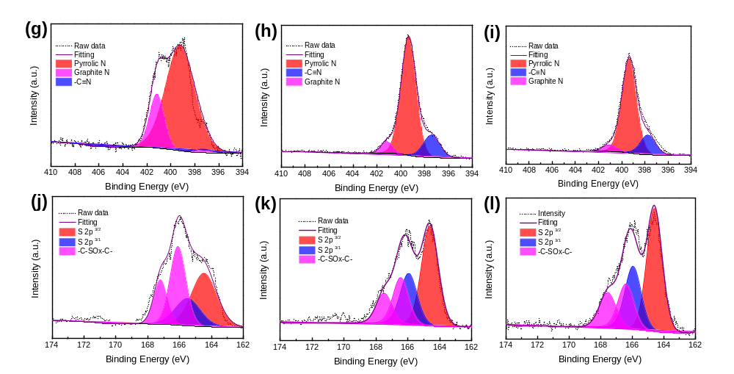
Figure S1. N 1s high-revolution level spectra (g) of B-CDs, (h) of G-CDs, (i) of R-CDs and S 2p high-revolution level spectra (j) of B-CDs, (k) of G-CDs, (l) of R-CDs.

Table S1. XPS Data Analyses of the C 1s, N 1s and S 2p Spectra of three typical CD Samples.

 | C=C/C-C (%) | C=O (%) | C-N/C-S (%) | C-OH (%) | COOH (%)
B-CDs | 37.09 | 35.04 | 11.26 | 10.97 | 5.59
G-CDs | 49.24 | 26.93 | 14.34 | 6.38 | 2.70
R-CDs | 49.11 | 27.28 | 17.34 | 3.64 | 2.63

 | Pyrrolic N (%) | Graphite N (%) | -C≡N (%)
B-CDs | 78.43 | 20.15 | 1.42
G-CDs | 77.88 | 5.88 | 16.24
R-CDs | 77.70 | 5.20 | 17.10

 | S 2p 3/2 S 2p 3/1 (%) | -C-SOx-C- (%)
B-CDs | 36.54 | 63.48
G-CDs | 51.93 | 48.07
R-CDs | 54.18 | 45.82

PS4 PL emission spectra
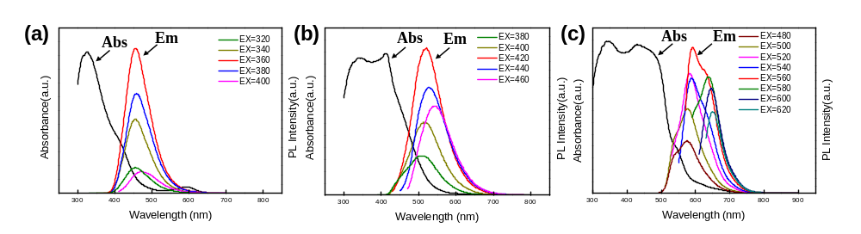
Figure S2. The (a) of B-CDs, (b) of G-CDs, (c) of R-CDs show their absorption curves (Abs) and their PL emission spectra (Em) under excitation with light of different wavelengths (see the inset legends).

