Polystyrene micro- and nanoplastics in a colitis mouse model – effects on biodistribution, macrophage polarization, and gut microbiome.
Verena Kopatz,^{1,2,3,4,#} Ulrike Resch,^{5,6,#} Kristina Draganic,¹ Angela Horvath,^{3,7} Janette Pfneissl,¹ Julijan Kabiljo,^{8,9} Bernadette Mödl,¹⁰ Gerald Timelthaler,¹⁰ Julia Wallner,¹ Zeynab Mirzaei,^{11,12} Saule Beratlyte,¹ Michaela Schlederer,¹ Stefan Sarbu,¹³ Simina Laslau,¹⁴ Oldamur Hollóczki,¹⁵ Martin Raigel,^{1,16} Elisabeth S. Gruber,¹⁷ Joachim Widder,^{2,4} Iris Kufferath,¹⁸ Marion Pollheimer,¹⁸ Wolfgang Wadsak,³ George Sarau,^{11,12,19} Silke Christiansen,^{11,12,19,20} Nikola Zlatkov Kolev,²¹ Marcus Krueger,⁶ Robert Eferl,¹⁰ Gerda Egger,^{1,4} Vanessa Stadlbauer,^{3,7} Verena Pichler,^{3,22}* Lukas Kenner^{1,3,4,16,21,23}*

¹ Medical University of Vienna, Department of Pathology, Vienna, Austria
² Medical University of Vienna, Department for Radiation Oncology, Vienna, Austria
³ CBmed GmbH – Center for Biomarker Research in Medicine, Graz, Styria, Austria
⁴ CCC – Comprehensive Cancer Center, Vienna, Austria
⁵ Medical University of Vienna, Department of Vascular Biology and Thrombosis Research, Vienna, Austria
⁶ Institute for Genetics, Cologne Excellence Cluster of Cellular Stress Responses in Aging-Associated Diseases (CECAD), Cologne, Germany
⁷ Department of Gastroenterology and Hepatology, Medical University of Graz, Graz, Austria
⁸ Medical University of Vienna, Division of Visceral Surgery, Department of General Surgery, Comprehensive Cancer Center Vienna, Vienna, Austria
⁹ Ludwig Boltzmann Institute Applied Diagnostics, Medical University of Vienna, Vienna, Austria
¹⁰ Medical University of Vienna, Center for Cancer Research, Vienna, Austria
¹¹ Fraunhofer Institute for Ceramic Technologies and Systems IKTS, Correlative Microscopy and Materials Data, Forchheim, Germany
¹² Institute for Nanotechnology and Correlative Microscopy eV INAM, Forchheim, Germany
¹³ TissueGnostics GmbH, Vienna, Austria
¹⁴ TissueGnostics Romania SRL, Iasi, Romania
¹⁵ Department of Physical Chemistry, University of Debrecen, Egyetem tér 1, 4032 Debrecen, Hungary
¹⁶ University of Veterinary Medicine, Unit of Laboratory Animal Pathology, Vienna, Austria
¹⁷ Medical University of Vienna, Department of Visceral Surgery, University Clinical for General Surgery, Vienna, Austria
¹⁸ Medical University of Graz, Department of Pathology, Graz, Austria
¹⁹ Max Planck Institute for the Science of Light, Leuchs Emeritus Group, Erlangen, Germany
²⁰ Freie Universität Berlin, Physics Department, Berlin, Germany
²¹ Department of Molecular Biology, Umeå University, Umeå, Sweden
²² University of Vienna, Department of Pharmaceutical Sciences, Division of Pharmaceutical Chemistry, Vienna, Austria
²³ Christian Doppler Laboratory for Applied Metabolomics, Medical University of Vienna, Vienna, Austria

Keywords: Micro- and nanoplastic, polystyrene, colitis mouse model, gut microbiome
# joint first authorhip
* Shared correspondence: Lukas.kenner@meduniwien.ac.at; verena.pichler@univie.ac.at

Supporting Information

SI Table 1: Particle characterization. Commercially available polystyrene (PS) particles were analyzed for their $ζ$-potential, size distribution and polydispersity index (PDI) in different media.
particles | particle sizeª / µm | DI water |  |  | 1 mM KCl
particles | particle sizeª / µm | $ζ$ potential / mV | Measured size / nm | PDI | $ζ$ potential / mV | Measured size / nm | PDI
Fluo-PS | 1.140 | -67.81 ± 29.92 | 1206.0 | 0.010 | -75.68 ± 11.27 | 1462.0 | 0.192
Fluo-PS | 0.29 | -66.8 ± 0.711 | 432.3 | 0.279 | -72.49 ± 0.805 | 417.9 | 0.272
Blue-PS | 9.550 | -11.66 ± 12.28 | 14670.0^{b} | 0.664 ^{b} | -13.34 ± 3.07 | 10200.0 ^{b} | 0.487 ^{b}
ª particle sizes as provided by the commercial source, ^{b} particle size and PDI not validated due to measurement limitation of the zetasizer Pro.

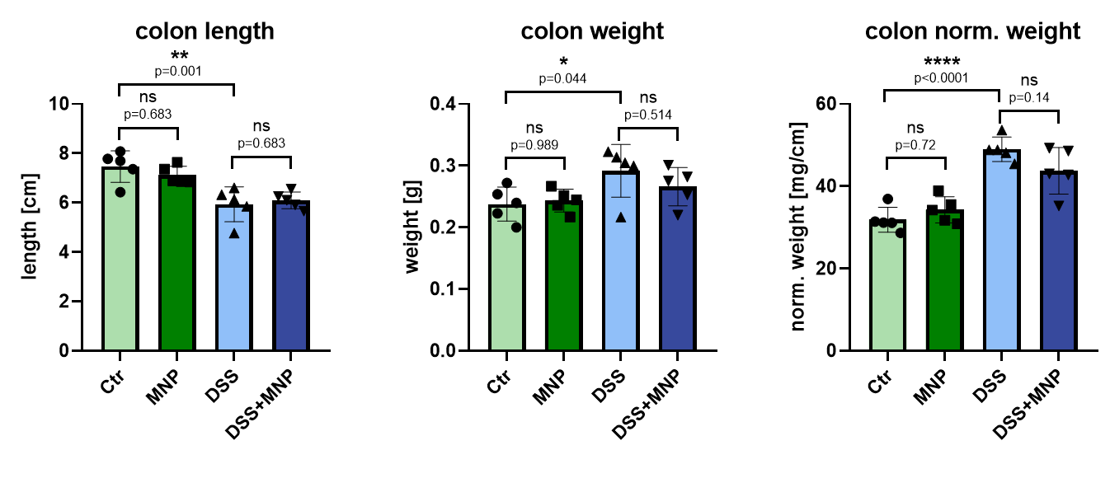
Supplementary Figure 1: Measurement of DSS-associated physiological colon parameters. Colon length, weight and normalized weight were assessed in all four treatment groups. Significant changes associated with DSS application (colitis) – reduced colon length, increased colon weight and normalized colon weight - were observed in both DSS treated groups. No significant changes for these parameters were observed between Ctr vs MNP or DSS vs DSS+MNP. n=5/group.

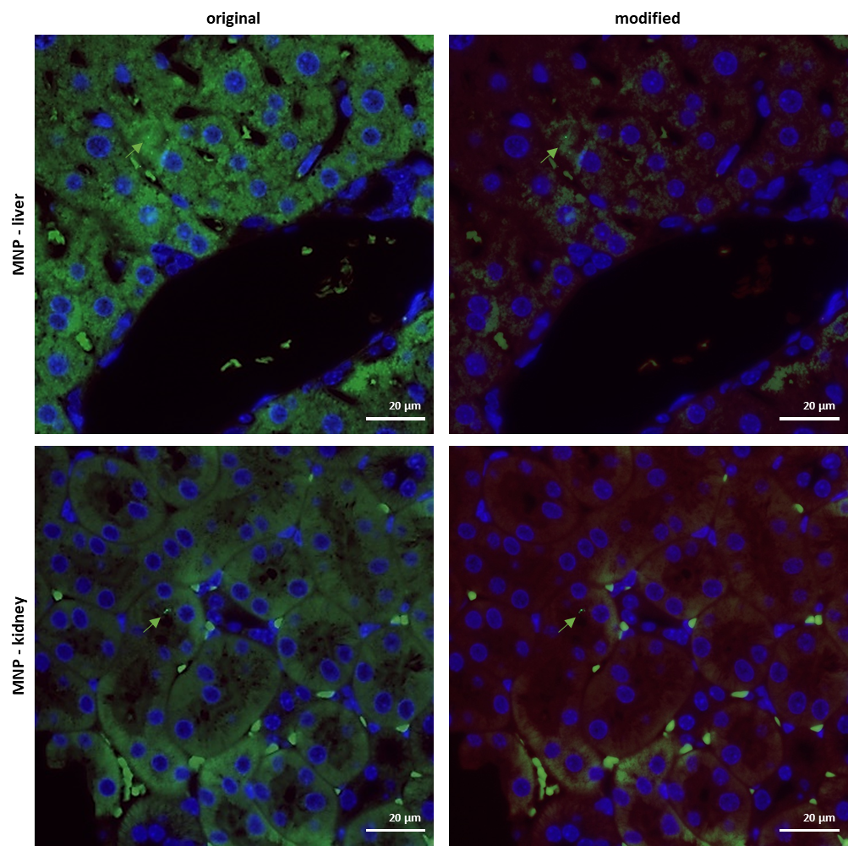
Supplementary Figure 2a: MNP uptake into liver and kidney for wildtype mice treated with MNP (modified from Figure 3E). Fluorescence images of liver and kidney after 10 days of treatment with MNP. Left panel shows a magnification of the fluorescence images as depicted for the respective treatment group in Figure 3E, right panel shows a modified version of the same fluorescence image with enhanced contrast (autofluorescence structures reduced in green channel and overamplified in red channel) to better discriminate nanoplastic particles. Nuclear counterstain: DAPI. Green arrows point at 0.29 µm PS particles. Scale bar 20 µm.

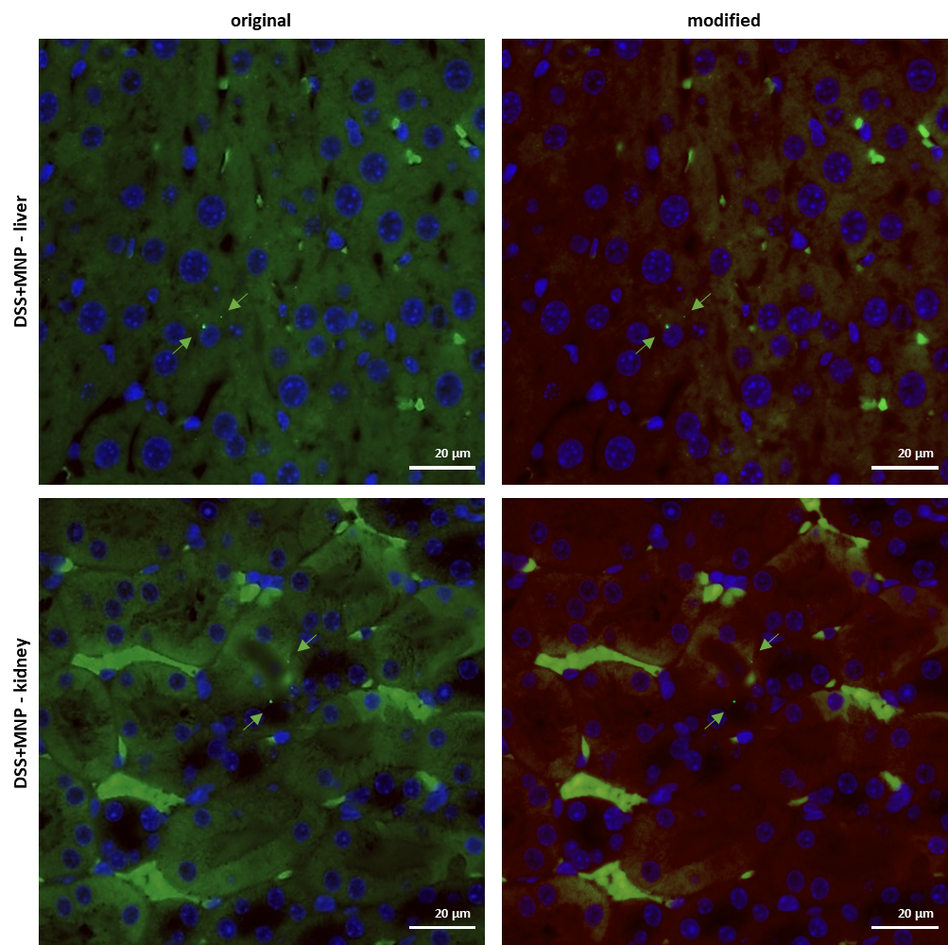
Supplementary Figure 2b: MNP uptake into liver and kidney for DSS-induced colitis mice treated with MNP (modified from Figure 3E). Fluorescence images of liver and kidney after 10 days of treatment with DSS+MNP. Left panel shows a magnification of the fluorescence images as depicted for the respective treatment group in Figure 3E, right panel shows a modified version of the same fluorescence image with enhanced contrast (autofluorescence structures reduced in green channel and overamplified in red channel) to better discriminate nanoplastic particles. Nuclear counterstain: DAPI. Green arrows point at 0.29 µm PS particles. Scale bar 20 µm.

Supplementary Figure 3: RT-qPCR analysis of immune and stress response markers.
Innate immune-, inflammatory and oxidative stress induced transcriptional response in FFPE-colon sections. RT-qPCR mRNA expression levels of Ifit1, Il-1, Nqo1 and Ifi205a in FFPE tissue sections extracted from control (ctrl), MNP, DSS or DSS+MNP mice (n=5 for each). Target gene expression levels (Ct-values) were normalized to housekeeping gene Hprt. The 2^{−ΔΔCt} method was used to calculate the relative expression of each gene. Statistical significance was evaluated by one-way-ANOVA with * p<0.05 and *** p<0.001. n=5/group (two outliers were excluded from MNP group for Ifit1 and Nqo1)

Supplementary Materials and Methods for RT-qPCR data (Supplementary Figure 3):
Total RNA extraction and RT-qPCR analysis
For RNA isolations from paraffin-embedded colon (n=5/group), two consecutive sections (2x40 μm) from the interior of the paraffin block were manually separated from excess of paraffin, placed into 1.5ml tubes, dewaxed by adding 1 ml 100% xylene, incubated at 50 °C for 3 min and centrifuged for 1 min at 12000g to pellet the tissue. Xylene was removed, pellets washed once with xylene and dehydrated twice with 100% ethanol and air-dried. RNA was extracted by the addition of 1ml of TRIzol (Life Technologies, Invitrogen), incubation at RT for 5 min with resuspension by pipetting and repeated incubation at 5 min to completely dissociate nucleoproteins complexes. After addition of 0.2 ml chloroform and vortex for 15 sec, tubes were incubated for 2 min at RT followed by centrifugation at 12000g for 10 min at 4 °C. Two-third of the upper aqueous phase were transferred to a fresh tube containing 10 μg glycogen (Thermo Scientific) as carrier to increase recovery of RNA by alcohol precipitation (0.6 ml of isopropyl alcohol). Tubes were placed for 1hr at -80 °C and centrifuged for 15 min at 12000g at 4 °C. The RNA pellet was washed twice with 100% ethanol and once with 70% ethanol, air-dried and dissolved in RNase-free water (Promega). Samples were incubated for 5 min at 55 °C to denature possible secondary structures, placed on ice and 1 μg RNA (Nanodrop, A 260/280 nm) was used for cDNA synthesis in a final volume of 20 μl containing MgCl₂, dNTPs (each 0.8 mM), Oligo(dT) primers (0.4 μM), 10x RT-buffer and 25 U MulV reverse transcriptase (all Thermo Scientific). RT was performed at 25 °C for 5 min, 42 °C for 1 h and 10 min 95 °C in a thermocycler. qPCR reactions were preformed from 1/5 dilutions of cDNA using the Luna Universal qPCR Master Mix (New England Biolabs) with forward and reverse primers (0.25 μM final concentration), 2 μl diluted cDNA (40 ng) in a final volume of 10 μl on a Biorad-CFX connect Thermocycler with 10 min initial denaturation at 95 °C, followed by 40 cycles of 95 °C (3 min), 60 °C (15 sec) and melting curve at 60-95 °C. Target-expression Ct-values were normalized to Hprt ΔCt with fold changes calculated to control samples using the 2^{−ΔΔCt} method.[1] Validated specific qPCR primer sequences (Origene) with following sequences were used:
mmHprt fwd: CTGGTGAAAAGGACCTCTCGAAG; rev: CCAGTTTCACTAATGACACAAACG
mmIfit1 fwd: TACAGGCTGGAGTGTGCTGAGA; rev: CTCCACTTTCAGAGCCTTCGCA
mmNqo1 fwd: GCCGAACACAAGAAGCTGGAAG; rev: GGCAAATCCTGCTACGAGCACT
mmIl1b for: TGGACCTTCCAGGATGAGGACA; rev: GTTCATCTCGGAGCCTGTAGTG
mmIfit205a fwd: TATCCCAGGTCTCATCTTCGGC; rev: CTCTGAGTGGAGAACAGCACCT

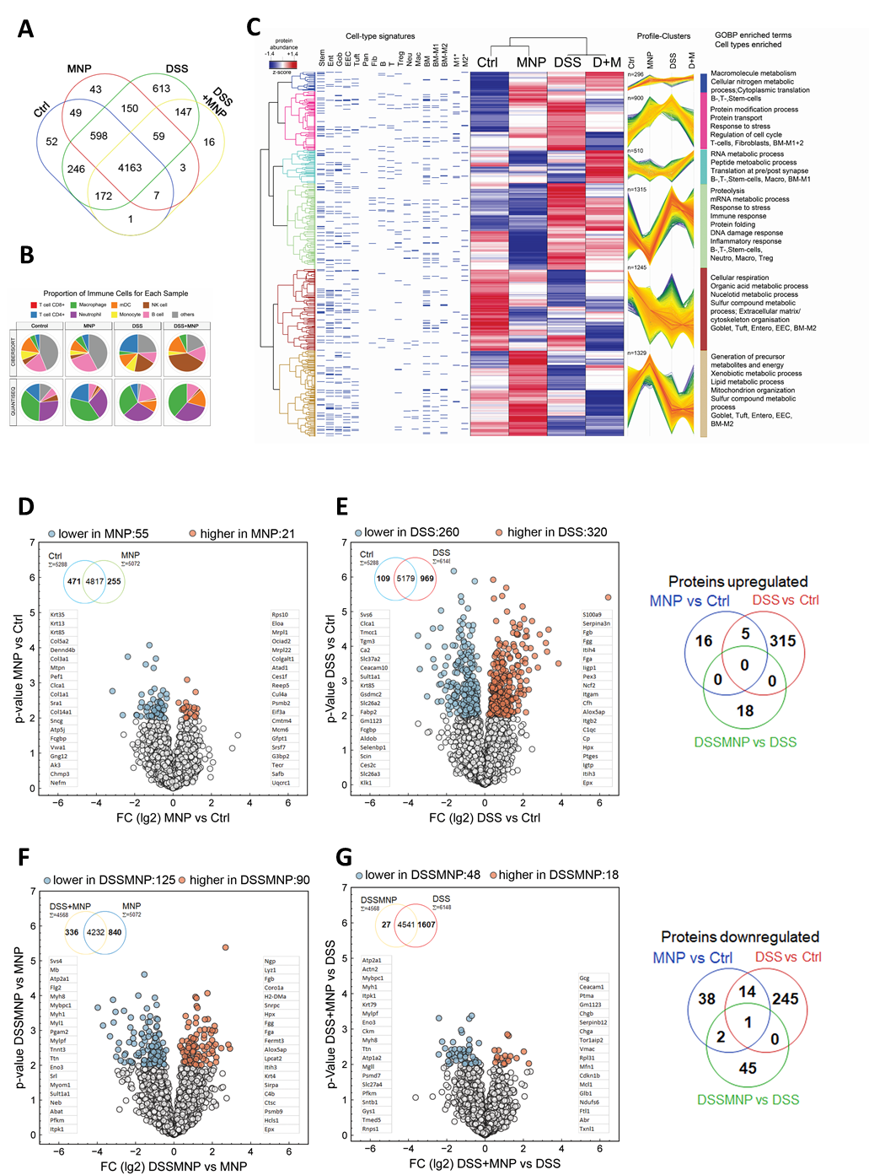
Supplementary Figure 4: Unbiased proteome profiling of colon tissue and pairwise comparisons of protein abundances in each sample type.
(A) Venn diagram showing overlaps proteins identified at least 3 times in respective sample types (ctrl= control, MNP=micro- and nanoplastic, DSS=dextran sulfate sodium, D+M= DSS and MNP). each sample types. B) Immune cell infiltration analysis of colon proteomes using the TIMER2.0 tool. Based on similarities to TCGA cancer types, the proteomic dataset (ctrl, MNP, DSS, DSS+MNP) was scored as COAD (colon adenocarcinoma) tumor with varying immune cell infiltration signatures based on CIBERSORT and QUANTISEQ. C) Heatmap on unsupervised hierarchical clustered (Euclidian distance on rows, k-means, 300clusters, 10 iterations) of mean (lg2) and z-scored (row) normalized protein abundance values with missing values replaced by zero (white) with cell-type signatures indicated as barcode. Protein abundance profiles for each sample type in denoted clusters are color coded by distance from center (maximal distance green). Enriched GOBP-terms and cell-type signatures in respective clusters based on Fisher´s exact test with BJH-FDR p<0.05 are shown. Source data are provided in Supplementary table 01. Volcano plots of pairwise comparisons for D) MNP vs Control, F) DSS vs Control, G) DSS+MNP vs DSS and H) DSS+MNP vs MNP showing lg(2) fold change (FC) on x-axis and respective p-value (-lg10) on y-axis and significant hits (-lg(10)>2 corresponding to p<0.01) color coded. Venn diagrams inscribed specifying the number of common proteins valid for comparative statistics. Top 20 downregulated (left) or up-regulated proteins (right) are shown. Overlaps of up- or down-regulated proteins are summarized in Venn diagrams. Source data are provided in Supplementary table 02.
Supplementary Results for Supplementary Fig 4
Differential protein abundance analysis of colonic tissue from MNP versus control (Ctrl) treated mice revealed that among 4817 proteins identified in common, 21 were upregulated and 55 were downregulated, with 471 and 255 proteins only identified in Ctrl or MNP, respectively as shown in A). Thus, we conclude that MNP exposure affects 5-10% of the colon proteome abundance. Comparisons among DSS versus Ctrl mice caused a massive disturbance of the colon proteome as expected and illustrated in B). Of the 5179 proteins accessible to differential expression analysis, 320 proteins were higher and 260 proteins were lower following DSS challenge. Remarkably, 1/6th of all proteins identified in DSS samples (969) were not detected in control samples, and among the 5179 commonly detected proteins, 320 proteins were up- and 260 proteins were downregulated, collaborating the massive inflammation along with immune cell infiltration and thus “non-resident” colonic proteins described for this model of ulcerative colitis. To dissect the impact of MNP in this acute inflammatory setting, we compared DSS+MNP versus DSS treatments as shown in C). Among the 4541 proteins commonly detected, we found 18 or 48 proteins up- or downregulated while the 1/5th of the proteins (1607 proteins) were detected only DSS samples and 27 were detected only in DSSMNP samples. This “imbalance” was less pronounced in comparisons among DSSMNP versus MNP as shown in D), with 336 or 840 proteins only detected in DSS+MNP or MNP, respectively and of the 4232 common proteins 90 were higher and 125 were lower expressed in DSS+MNP as compared to MNP. Together, we conclude that proteins detected “only” in one or another condition (depicted in Venn diagrams inscribed in Volcano-plots) or overall (Venn diagram in Figure 5A) may give a better insight into pleiotropic effects of MNPs during acute inflammatory settings. Our data should provide a resource for future investigations aimed to uncover how MNP may rewire diverse molecular mechanisms towards disease.

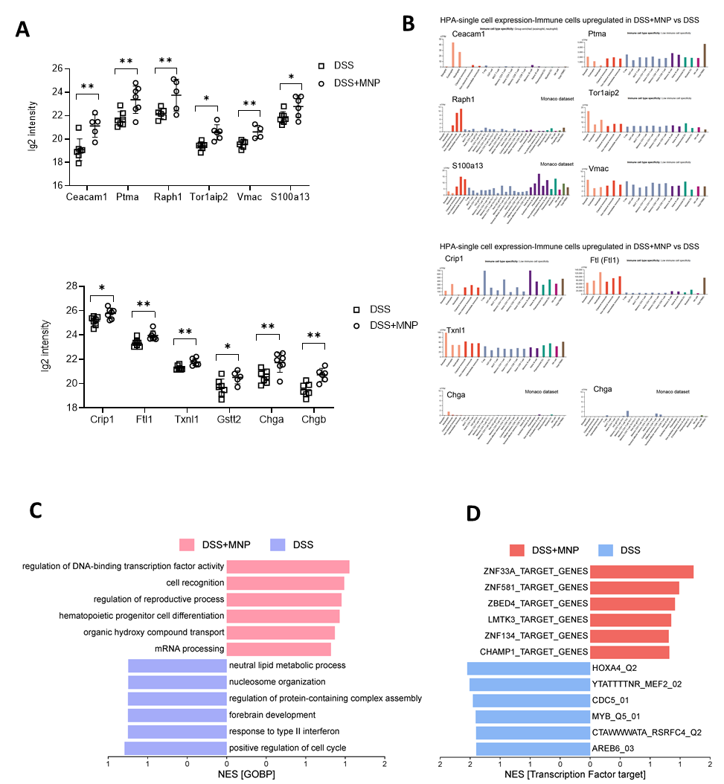
Supplementary Figure 5:
A, B) Boxplot showing increased abundance of proteins (left) expressed in immune cells (Human proteome Atlas, single cell sequencing data, right) in FFPE sections from mice treated with DSS+MNP as compared to DSS alone with functions in cancer (A) and oxidative stress (B). C, D) Enriched pathways (KEGG and Panther) and cell types based on ranks (T-statistics), source data are provided in Supplementary table 04.
Supplementary Results for Supplementary Fig 5
The impact of MNP on colitis analysed in 2-steps. The subset of 487 proteins with a significant interaction (2-way ANOVA, group 1: -/+MNP, group 2: -/+ DSS across all samples) were further analysed comparing DSS+MNP vs DSS samples only. A,B) Boxplots of candidates showing individual values with single-cell expression levels of immune cells based on Human Proteome Atlas in bargraphs. C, D) Rank-based enrichment in GOBP and transcription factor targets (www.webgestalt.org).

Supplementary Figure 6: Viability of MP and NP treated human PBMC-derived macrophages.
Macrophage viability of MP or NP treated human PBMC-derived macrophages (5 µg/ml for 24h) as assed during FACS gating for viable cell population. Percentage of zombie violet negative cells (viable cells) relative to total gated cell population from 3 different treatment groups is shown. Bars indicate mean values ± SD from 3 different PBMC donors (n=3/treatment group).

Supplementary Figure 7: Differences and changes in microbiome composition between groups and over time. (A) Network analysis based on Bray-Curtis dissimilarities; (B) Redundancy analysis (RDA) exploring the interaction between DSS-treatment, MNP ingestion and time while correcting for non-independence; (C) Principal coordinate analysis visualizing distances between treatment groups at different timepoints; (D) distance-based RDA on changes in the microbiome over time, exploring the effect of DSS-treatment and MNP ingestion.

Supplementary Results for Supplementary Fig 7:
An exploratory network analysis showed that the microbiome of DSS-treated mice with and without ingestion of MNPs differ from the microbiome compositions before treatment and microbiomes of mice not treated with DSS (see Supplementary Figure 7A). Redundancy analysis confirmed that DSS-treatment but not the ingestion of MNPs were significantly associated with changes in the microbiome over time (DSS: p=0.001; MNPs: p=0.268), as shown in Supplementary Figure 7B. Moreover, PCoA showed that 45.1% of variance in the microbiome composition can be explained by the first principal coordinate which most prominently separates DSS-mice after treatment from the remaining groups; however adonis could not confirm a statistically significant change in microbiome compositions over time (see Supplementary Figure 7C). Since the intra-individual variance was relatively high, as seen in the second principal coordinate in Figure 7C, intra-individual change of each genus over time were calculated. Adonis on the Bray-Curtis distance matrix could now detect the significant change in microbiome composition associated with DSS treatment (p=0.001), but no significant effect on the microbiome composition due to MNP ingestion (p=0.300). Similar results were obtained by RDA (see Supplementary Figure 7D).

SI Table 2: Bacterial taxa detected only in a particular mouse group(s).
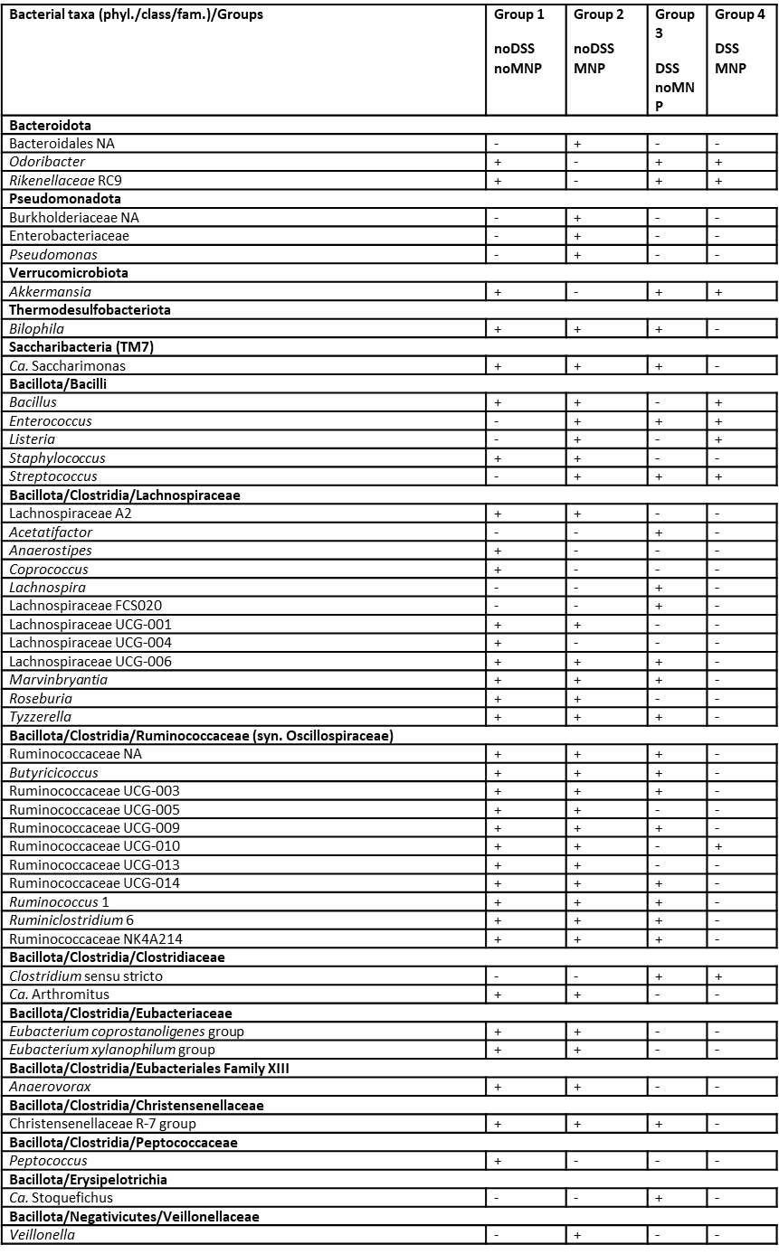
Supplementary References:
[1] Livak KJ, Schmittgen TD. Analysis of relative gene expression data using real-time quantitative PCR and the 2-ΔΔCT method. Methods 2001;25:402–8. https://doi.org/10.1006/meth.2001.1262.

Author contributions
Conceptualization; Data curation; Formal analysis; Funding acquisition; Investigation; Methodology; Project administration; Resources; Software; Supervision; Validation; Visualization; Roles/Writing - original draft; and Writing - review & editing

(first author) Verena Kopatz Investigation, formal analysis, data curation, visualization, writing – original draft
(co-first author) Ulrike Resch investigation (proteomics), formal analysis, data curation, visualization
Kristina Draganic investigation, writing original draft
Angela Horvath formal analysis, visualization, writing – original draft
Janette Pfneissl investigation
Julijan Kabiljo investigation
Bernadette Mödl methodology
Gerald Timelthaler formal analysis, software
Julia Wallner investigation
Zeynab Mirzaei methodology, investigation
Saule Beratlyte Formal analysis
Michaela Schlederer investigation
Stefan Sarbu investigation
Simina Laslau investigation
Oldamur Holloczki validation, writing – review & editing
Martin Raigel methodology
Elisabeth S. Gruber validation
Joachim Widder resources, writing-review and editing
Iris Kufferath investigation
Marion Pollheimer investigation and validation
Wolfgang Wadsak writing – review & editing, resources
George Sarau methodology, investigation, writing-review&editing
Silke Christiansen methodology, resources
Nikola Zlatkov Kolev investigation
Marcus Krueger resources, reagents and instrumentation for mass spectrometric analysis
Robert Eferl methodology
Gerda Egger resources, supervision, writing-review and editing
Vanessa Stadlbauer formal analysis, resources, writing – review&editing
(corresponding) Verena Pichler conceptualization, data curation, resources, supervision, writing – original draft, writing – review&editing
(senior, corresponding) Lukas Kenner conceptualization, resources, formal analysis

