Supplementary Information
Red-emitted AIEgens-based lateral flow immunoassay for the visual and quantitative detection of aflatoxin M1 in milk
Wenbo Guo¹, Qingyi Liu¹, Junhua Yang¹, Haijuan Zeng^{2,} *, Juan Liu³, Lemei Zhu³, Dongxia Nie¹, Zhihui Zhao¹, Zheng Han^{1,}*

¹ Institute for Agro-food Standards and Testing Technology, Shanghai Key Laboratory of Protected Horticultural Technology, Shanghai Academy of Agricultural Sciences, Shanghai, China
² The Biotechnology Research Institute, Shanghai Academy of Agricultural Sciences, Key Laboratory of Agricultural Genetics and Breeding, Shanghai Professional Technology Service Platform of Agricultural Biosafety Evaluation and Testing, Shanghai, China
³ School of Public Health, Academician Workstation, Changsha Medical University, Changsha, China

* To whom correspondence should be addressed.
E-mail address: zenghaijuan@saas.sh.cn; hanzheng@saas.sh.cn.

Contents
1. UHPLC-MS/MS analysis
2. Fig. S1 Visual inspection by the FIT and FIC changes with various volume of AIEgens-mAb
3. Fig. S2 Images of the AIEgens-LFIA with AFM1 and other mycotoxins under 365 nm UV excitation
4. Table S1 Detection of AFM1 by AIEgens-LFIA at different storage temperatures
5. Table S2 Comparison of the analysis results for the AFM1 in spiked samples by AIEgens-LFIA and UPLC-MS/MS.
6. Graphical Abstract

1. UHPLC-MS/MS analysis
The detection results of the developed aggregation-induced emission luminogens based lateral flow immunochromatographic assay (AIEgens-LFIA) were further confirmed by UPLC-MS/MS analysis. Chromatographic separation was performed on an ACQUITY UPLC BEH C18 column (2.1×100 mm, 1.7 µm). The mobile phase was consisted of methanol (A) and 5 mmol L⁻¹ ammonium acetate (B). A linear gradient elution program was set as follows: initial 10% A; 1 min, 10% A; 5 min, 90% A; 6 min, 90% A; 6.5 min, 10% A; 8 min, 10% A. The flow rate was 0.4 mL min⁻¹. The injection volume was 3 µL, and the column temperature was 35 °C.
Electrospray ionization was used in positive electrospray ionization mode (ESI⁺) with the following parameters: interface voltages of capillary, 2.5 kV; desolvation temperature, 500 ℃; and source temperature, 150 ℃. The gas flow rates were 7.0 bar for nebulizing gas and 1000 L h⁻¹ for desolvation gas, respectively. Multiple reaction monitoring (MRM) mode was used for the quantification and the precursor/product transitions (m/z) were 329.1/273.1 and 329.1/229.2.

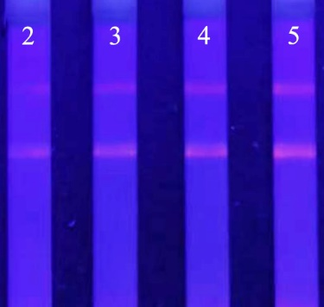
Fig. S1 Visual inspection by the FI_{T} and FI_{C} changes with various volume of AIEgens-mAb.
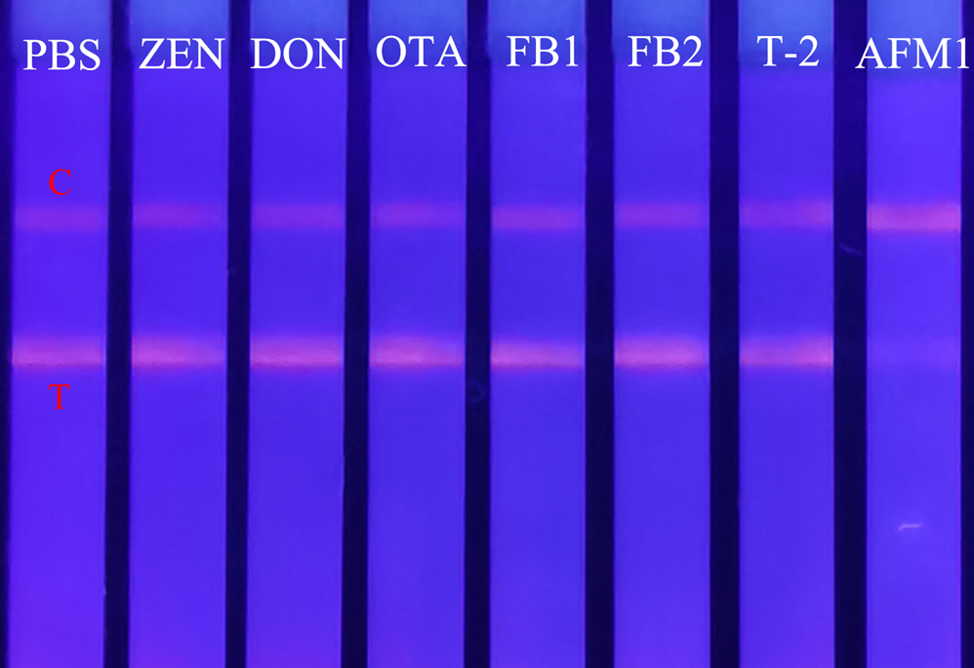
Fig. S2 Images of the AIEgens-LFIA with AFM1 and other mycotoxins under 365 nm UV excitation.

Table S1 Detection of AFM1 by AIEgens-LFIA at different storage temperatures.
Periods of experimental (days) | 4 °C |  |  |  | 25 °C
Periods of experimental (days) | F_{T} ª | F_{C} | F_{T}/F_{C} |  | F_{T} | F_{C} | F_{T}/F_{C}
0 | 6532 | 18624 | 0.35 |  | 8564 | 21546 | 0.40
1 | 7816 | 23017 | 0.34 |  | 6357 | 19654 | 0.32
3 | 6908 | 19354 | 0.36 |  | 7954 | 23516 | 0.34
7 | 5237 | 17008 | 0.31 |  | 5634 | 18645 | 0.30
15 | 8036 | 20347 | 0.39 |  | 6842 | 20019 | 0.34
30 | 7291 | 21368 | 0.34 |  | 8146 | 19658 | 0.41
60 | 5986 | 18624 | 0.32 |  | 6518 | 17359 | 0.38
90 | 7546 | 19534 | 0.39 |  | 8964 | 24618 | 0.36
180 | 8026 | 24038 | 0.33 |  | 9214 | 22835 | 0.40
Mean ±SD ^{b} | 7042±970 | 20213±2246 | 0.35±0.03 |  | 7577±1273 | 20872±2406 | 0.36±0.04
CV ^{c}（%） | 0.14 | 0.11 | 0.08 |  | 0.17 | 0.12 | 0.11
ª F_{T} represents the fluorescence intensity of the test line (AFM1, 0.5 ng/mL), and F_{C} represents the fluorescence intensity of the control line (AFM1, 0.5 ng/mL). The F_{T}/F_{C} represents the detected results, and the storage temperatures are 4 °C and 25 °C.
^{b} Standard deviation (SD) (n = 3).
^{c} Coefficient of variation (CV).

Table S2 Comparison of the analysis results for the AFM1 in spiked samples by AIEgens-LFIA and UPLC-MS/MS.
Spiked levels  (ng/mL) | AIEgens-LFIA |  |  | UPLC-MS/MS
Spiked levels  (ng/mL) | Mean  (ng/mL) | Recovery±SD  (%) |  | Mean  (ng/mL) | Recovery±SD  (%)
0.1 | 0.098 | 97.53±13.73 |  | 0.107 | 107.37±14.52
0.5 | 0.512 | 102.47±8.44 |  | 0.482 | 96.47±8.44
1 | 1.041 | 104.13±6.87 |  | 1.021 | 102.07±5.19

