Supplementary Figure 1 Flowchart illustrating patient selection process with inclusion/exclusion criteria, and cohort partitioning.
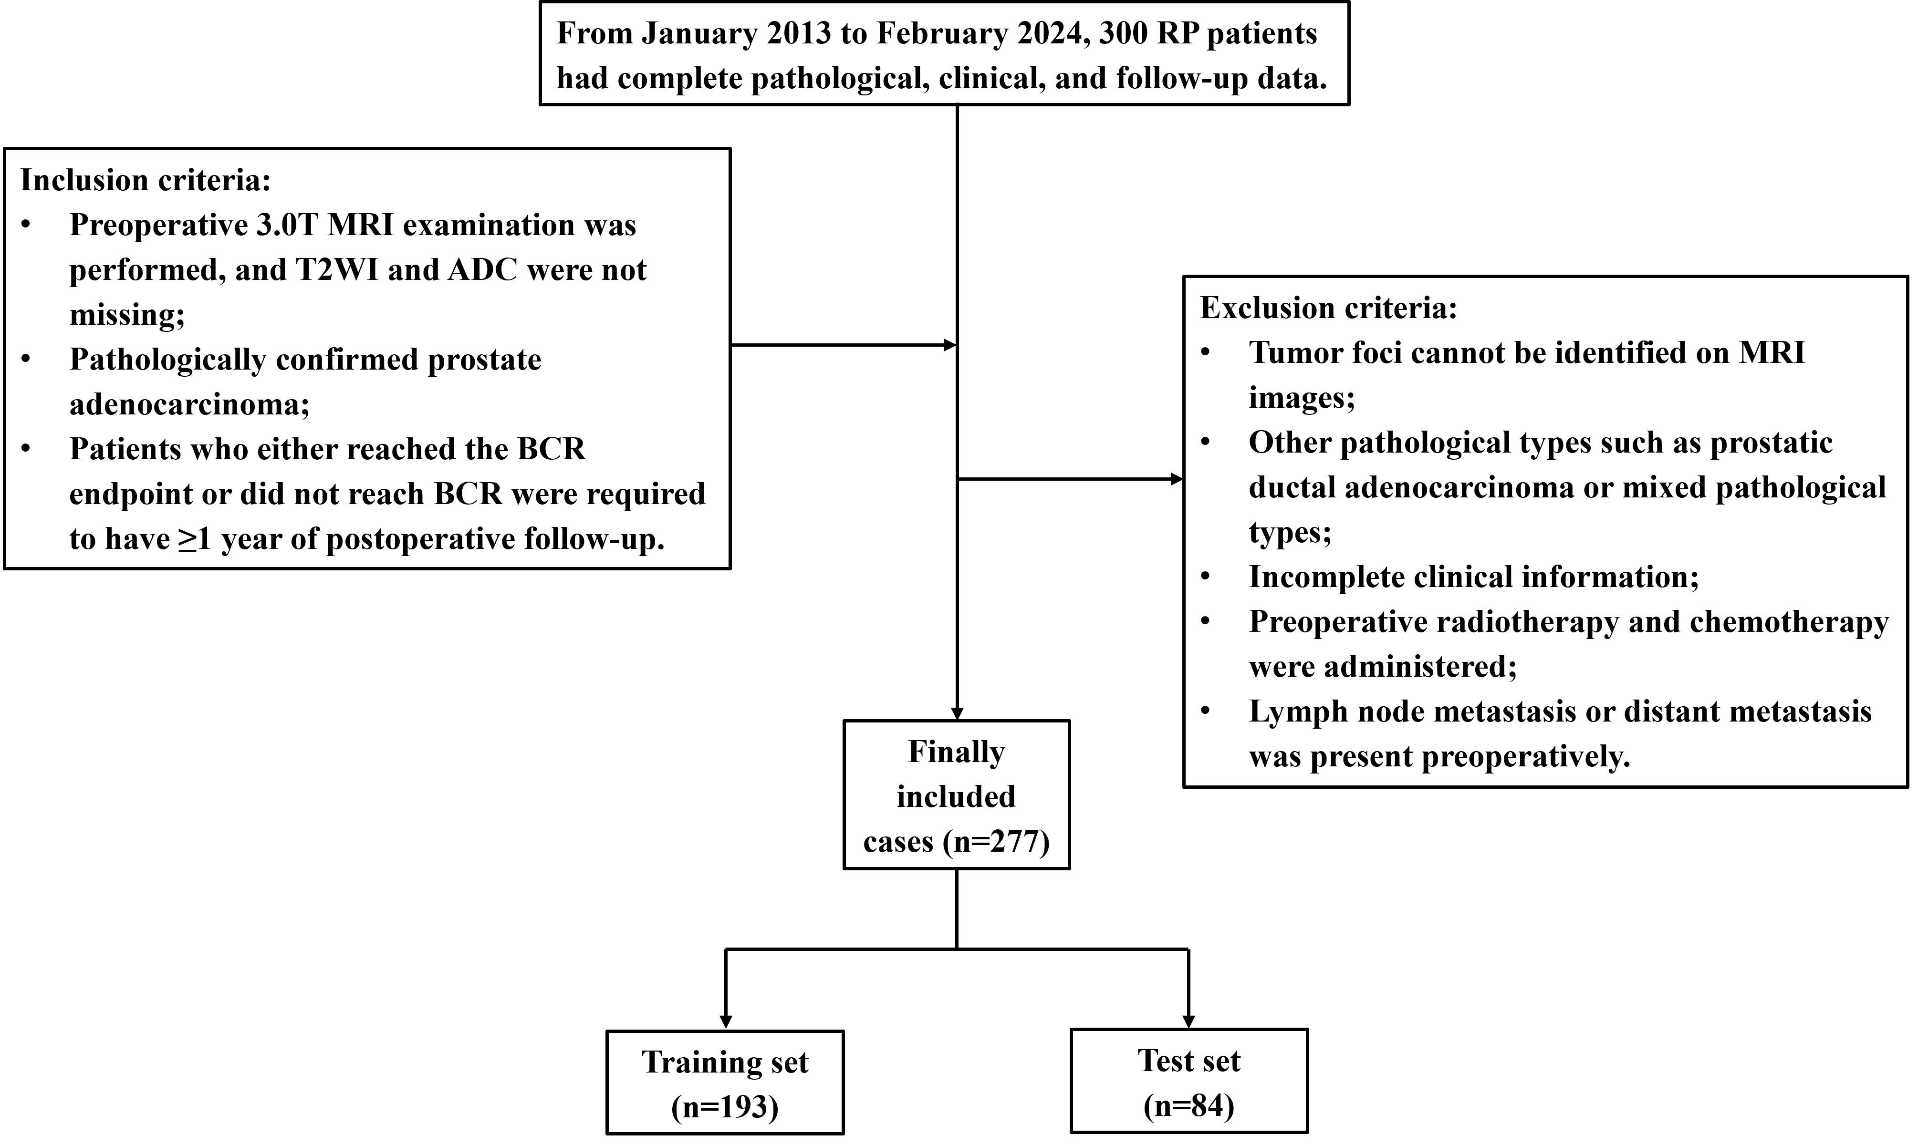

Supplementary Figure 2 Flowchart of model construction based on clinical data, and intratumoral/peritumoral radiomic features.

Supplementary Figure 3 Incremental value of radiomics features. A, B Integrated Discrimination Improvement (IDI) and C, D Net Reclassification Improvement (NRI) comparisons between training and validation sets.

