Supplementary material
Uncovering active bacterial symbionts in pollen-feeding beetles
Emiliano Mancini, Simone Sabatelli, Yi Hu, Sara Frasca, Andrea Di Giulio, Paolo Audisio, Christopher D. Brown, Jacob A. Russell, Marco Trizzino
1. Supplementary Methods
16S cDNA-based bacterial metabarcoding was performed on 66 specimens from Brassicogethes aeneus, B. matronalis and Meligethes atratus collected during Spring 2015 in semi-urban areas near Rome (Latium, Italy) while actively feeding on their respective host plants (Table S1). B. aeneus and M. atratus were collected in the same locality on Brassica nigra and Prunus spinosa, respectively, whereas B. matronalis was collected at a site approximately 50 km from the first locality on Hesperis matronalis (Table S1). Collected individuals were immediately placed in RNAlater (Sigma-Aldrich, St. Louis, MO, USA) and stored at -20°C until dissection. Heads and abdomens were dissected from all specimens and pooled in six separated vials, kept on ice. RNA was extracted immediately after dissections using the Total RNA Purification Kit (Norgen Biotek Corp., Thorold, ON, Canada) and quantified by NanoDrop 2000/2000c (Thermo Fisher Scientific, Wilmington, DE, USA). cDNAs (̴180-250 ng/ul) were generated from 1 µg of RNA by using the Tetro cDNA synthesis kit (Meridian Bioscience, Cincinnati, OH, USA) with oligo-dT in 20 µl reaction volumes following the manufacturer’s instructions.
cDNAs were then submitted for amplicon sequencing of the V4 hypervariable region of the 16S rRNA gene at Argonne National Laboratory (Argonne, IL, USA), where sequencing libraries were prepared and then sequenced on the Illumina MiSeq platform. Raw sequences have been deposited in the NCBI sequence read archive under project accession number (submitted not yet available). All raw read pairs were initially merged into contigs using Mothur v.1.35.1 [1]. Quality-filtered and trimmed reads within the 251-255 bp size range, with <10 ambiguous nucleotides, and homopolymer tracts no longer than 7 bp were processed to identify unique sequences, which were aligned to the SILVA database. The aligned sequences were checked for chimeras using UCHIME [2] and classified using the RDP training set (version 16). All sequences that were not classified as Eubacteria were subsequently removed. The remaining unique sequences were assigned to operational taxonomic units (OTU) at the 97% identity level using the default opticlust alogorithm. We further manually processed the output information to generate an OTU table, which includes the number of sequences assigned to each OTU, per library, and the taxonomic assignments of each OTU.
RDP taxonomic assessment was also complemented with BLASTn searches on nr database using default settings, generating the final taxonomic assignment reported in Supplementary data. 97% OTUs with a relative abundance >3% were the representative of unique bacterial genera (except for Pseudomonas; see main text). Using % relative abundance values for each OTU, we constructed bar graphs to compare both the relative abundances of endosymbionts at the genus level between heads and abdomens in each pollen-beetle species and among the three species (merging data from heads and abdomens) for higher bacterial taxonomic ranks (Fig. S1). All OTUs with a relative abundance <3% at each taxonomic level were clustered into "Others" to compose a single group of low-frequency or rare bacterial taxa.
To follow up on initial results revealing potentially common symbionts, we performed Sanger sequencing on 16S rRNA genes from the three most frequent Rickettsiales (i.e. Wolbachia, Rickettsia, Lariskella), after diagnostic PCR to screen 71 specimens of Brassicogethes aeneus, B. matronalis and Meligethes atratus collected during Spring/Summer 2018 and 2019 (Table S1). For this work, DNA was extracted from whole specimens following a salting out protocol [3]. Primers specifically targeting the three Rickettsiales (Table S2) were designed based on 16S rRNA gene sequences obtained by our initial cDNA-based metabarcoding. Each reaction was performed in a 25 uL volume consisting of: 1x PCR Reaction Buffer (Meridian Bioscience, Cincinnati, OH, USA), 4.0 mM MgCl₂, 1 unit of BioTaq polymerase (Meridian Bioscience, Cincinnati, OH, USA), 0.2 mM each of dATP, dTTP, dCTP, dGTP (ThermoFisher Scientific, WLM, MA, USA), 0.25 uM of each primer and 2-3 uL of template DNA (~2-3 ng). Thermocycler conditions included an initial denaturation step at 94°C for 5 min., followed by 38 cycles at 94°C for 30 sec., 50-52°C for 45 sec., 72°C for 45 sec. and a final elongation step at 72°C for 7 min. PCR amplification products were loaded onto a 2-3% (100 ml) agarose gel stained with 3.0 uL Midori Green Advance (Nippon Genetics, Tokyo, Japan) and run for 30–40 min at 85 V in 1x TBE buffer. All three PCR assays produced a 204 bp long fragment (Fig. S2) and resulting bands obtained from each (single OTU) gel run were compared with at least one positive control per Rickettsiales. These, not being available a priori, were gradually obtained from the first analysed specimens providing clear bands at the expected molecular weight. Purified PCR products were sequenced at Macrogen Europe Inc. (Netherlands) (sequences are available upon request) and then validated for their identity after BLASTn (NCBI) search. Specimens yielding a null or multi-banded (spurious) result were considered as missing the target symbiont when the same PCR batch yielded a positive control of excellent quality (Fig. S2). Based on presence/absence results, we produced a summary table reporting the prevalence of the three target Rickettsiales in the sampled natural populations of Meligethinae.

2. Supplementary tables and figures
Table S1 Sample collection for the cDNA-based 16S rRNA gene metabarcoding approach and for Sanger sequence-based genotyping of Rickettsiales
Species | Localities (date) | Coordinates | Host-plant | n.
a. cDNA-based 16S rRNA metabarcoding
B. aeneus | Latium, Pomezia, Borgo di Pratica di mare (17-IV-15) | 41°39'53"N 12°29'05"E | Brassica nigra | 26
B. matronalis | Latium, Palestrina, Pisoniano (18-VI-15) | 41°53'43"N 12°57'28"E | Hesperis matronalis | 21
M. atratus | Latium, Pomezia, Borgo di Pratica di mare (17-IV-15) | 41°39'53"N 12°29'05"E | Prunus spinosa | 19
b. 16S rRNA genotyping
B. aeneus | Latium, Pomezia, Borgo di Pratica di mare (03-VI-19) | 41°39'53"N 12°29'05"E | Brassica nigra | 27
 | Latium, Nemi, Via Francigena (03-VI-19) | 41°42'17"N 12°42'54"E | Ranuncolaceae | 17
 | Latium, Carpineto Romano, Pian delle faggete (12-IV-18) | 41°34'41"N 13° 06'20"E | n.a. | 3
B. matronalis | Latium, Nemi, Via dei Laghi (03/21-VI-19) | 41°43'57"N 12°42'50"E | Hesperis matronalis | 8
M. atratus | Piedmont, Val Maira, Chiappera (31-VII-18) | 44°30'00"N 6°55'04"E | Carduus sp | 7
 | Piedmont, Val Maira, Chiappera (31-VII-18) | 44°30'00"N 6°55'04"E | Carduus sp | 9

Table S2 Primers specifically targeting 16S rRNA gene, enabling amplification of 210 bp-long fragments from three common Rickettsiales of Meligethinae
Gene | Primer | Sequence
16S rRNA Lariskella | LaMeF |  | 5'-TGGGCGTAAGGCGTACGTAGGCGGC-3'
 | LaMeR |  | 5'-TTTCGTACAACAGCGTCAGTAATCAG-3'
16S rRNA Wolbachia | WoMeF |  | 5'-TGGGCGTAAAGGGCGCGTAGGCTGG-3'
 | WoMeR |  | 5'-CTTCGCGCCTCAGCGTCAGATTTGAA-3'
16S rRNA Rickettsia | RiMeF |  | 5'-CTGGGCGTAAAGAGTGCGTAGGTGGT-3'
 | RiMeR |  | 5'-TTTCGTGCATCAGTGTCAGTTGTAGC-3'

Figure S1 Relative abundances/activities of bacterial taxa in Meligethinae at taxonomic ranks above the genus level (Class, Order, Family). Each column corresponds to data from two sequence libraries (i.e. data from heads and abdomens were pooled) from all field-caught beetles of a given species. Rare bacteria never exceeding a relative abundance of 3% were lumped into the single category ‘Others’. Bacteria from the same Class, Order or Family are represented by the same color

Figure S2 Gel run of PCR products obtained after screening single pollen-beetle individuals for: a. Rickettsia, b. Wolbachia, c. Lariskella. Bm = B. matronalis, Ma = M atratus, Bae = B. aeneus. Acronyms following those used for species refer to the names of localities (see Table S1) and numbers specify single individuals. Positive individuals are denoted with (+). Ladder = 100 bp (BIOLINE) Hyperladder IV
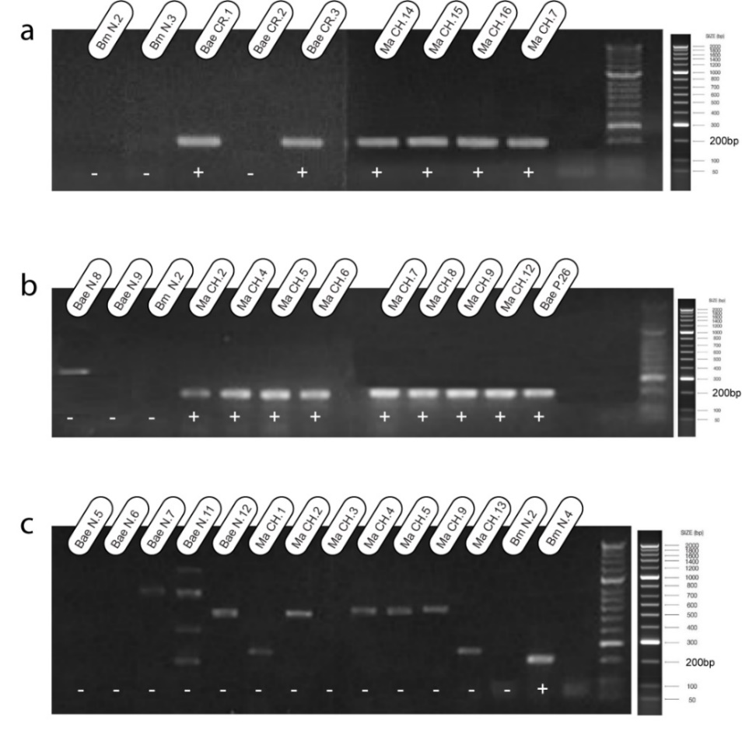
3. Supplementary References
1. Schloss PD, Westcott SL (2011). Assessing and improving methods used in OTU-based approaches for 16S rRNA gene sequence analysis. Appl Environ Microbiol 77:3219.
2. Edgar RC, Haas BJ, Clemente JC, Quince C, Knight R (2011). UCHIME improves sensitivity and speed of chimera detection. Bioinformatics 27:2194-2200.
3. Aljanabi SM, Martinez I (1997). Universal and rapid salt‐extraction of high-quality genomic DNA for PCR‐based techniques. NAR 25:4692–4693.

