Additional file 1.
We did k-fold validation first, and the results suggested that the 3.05 cm cutoff had reasonably good discriminatory power, but it also shows variability across folds, and some limitations in generalizability. therefore, we did sensitivity analyses below.
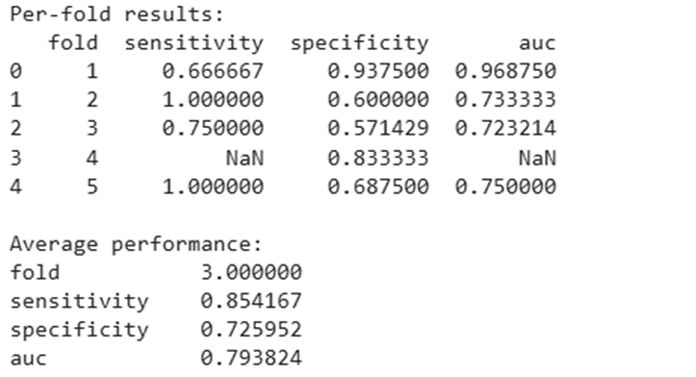
Therefore, we further conducted sensitivity analyses around 3.05cm cut off with multiple cut off.
