Supplementary

S1. The detail parameters of the validation case

1. Growth Mode
Three components were assumed with growth in the model, which were the factories demand, electricity grid price, and natural gas price. Based on the multi-year feature of HOMER, the growth was represented as percentage variation based on previous year, which was equivalent to an exponential growth at given rate. The demand growth rate was set as 5% per year, so does the growth rate of electricity grid price and natural gas price.

2. Electricity Grid
The grid structure used in the verification was based on the grid contract of the pharmaceutical company, with details listed below. The full grid cost included retail price, network cost, ancillary charge, and other management costs. It was then summarized to obtain the cost in each period.
Table S1 Electricity grid cost summary of HOMER model
Grid Cost Summary
Variable Cost in Different Period | 7:00 – 9:00 | 0.1360 | $/kW_{h}
Variable Cost in Different Period | 9:00 – 13:00 | 0.1360 | $/kW_{h}
Variable Cost in Different Period | 13:00 – 17:00 | 0.1690 | $/kW_{h}
Variable Cost in Different Period | 17:00 – 20:00 | 0.1690 | $/kW_{h}
Variable Cost in Different Period | 20:00 – 22:00 | 0.1360 | $/kW_{h}
Variable Cost in Different Period | Other and Weekend | 0.0852 | $/kW_{h}
Demand Charge |  | 13.55 | $/kVA/month
Other Fix Charge |  | 6264.04 | $/year
In the proposed method, the grid was further summarized to represent the different feature between daytime and night-time, as defined the generation output period of solar facilities. The grid cost of each period was calculated based on the length and the associated cost of this period. The further summarized grid cost structure was shown in Table S2:
Table S2 Electricity grid cost summary of proposed method
Electricity Grid Cost Summary
Variable Cost in Different Period | Day average | 0.1360 | $/kW_{h}
Variable Cost in Different Period | Night average | 0.1360 | $/kW_{h}
Demand Charge |  | 13.55 | $/kVA/month
Other Fix Charge |  | 6264.04 | $/year

3 Natural Gas Grid
The cost structure of the natural gas grid was represented differently in HOMER model and the proposed method. The unit of the usage charge was set as $/m³ in HOMER model, and it was converted to $/kWh using the calorific value of natural gas such that it is having the same unit as electricity for ease of calculation. The fixed charge of natural gas grid was only included in the proposed method as HOMER model does not support other cost structure other than simple rate. The summarized natural gas grid cost structure of HOMER model and the proposed method was shown in Table S3:
Table S3 Natural gas grid cost summary
Natural Gas Grid Cost Summary
Cost Type
Usage Charge | Proposed Method | 0.01719 | $/kWh
Usage Charge | HOMER | 0.19 | $/m³
Fix Charge | Proposed Method | 277.972 | $/day
Fix Charge | HOMER | 0 | $/day

4. Facility Setup
After setting up the details of the grid and factory demand used in the case, the cost parameters were required to be set up. In this section, the cost and performance parameter setup were demonstrated for both methods. However, as HOMER does not support solar thermal modules, only CHP, solar panels, and wind turbines will be included in this case.

5. CHP System
The main difference between the HOMER model and the model of proposed method was the description of CHP units. In HOMER, CHP was described as an hourly operating facility, with its lifespan in hours and O&M cost in $/hour. This was based on the hourly operating and dispatch strategy used in HOMER software. In the proposed method, the CHP was described as a % of the maximum operation capacity in each period, with its lifespan in years and O&M cost in $/kWh energy output. The conversion between these two types of description was multiplying the operating capacity in each period, which is varying during the entire project period. Therefore, the O&M cost was temporarily removed to proceed the verification process between the proposed method and HOMER. The lifespan of CHP units was based on previous technology specification, which was 10 years and 60,000 hours for each model.
Table S4 CHP cost and performance parameters
CHP Cost and Performance Parameters
Unit Size | 633 |  | kW_{e}
Capital Cost | 2837 |  | $/kW
O&M Cost | Proposed Method | 0.042 (0 in verification) | $/kW_{h}
O&M Cost | HOMER | 0 in verification case | $/hour
Electricity Efficiency | 0.3445
Heat Efficiency | 0.444
Lifespan | Proposed Method | 10 | Years
Lifespan | HOMER | 60,000 | Hours

6. Solar Panels
For an on-site solar installation, the factory has a limited area available. In this study, the available area for renewable energy installation was 8000 m2. For the solar panel module selected for this project, the average installation density was 200W per meter square, which led to a maximum installation of 1600 kW of solar panel.
For the installation setting of solar panel, the minimum installation unit size was assumed to be 10kW, which was equivalent to 50m2 of installation, about the size of installing solar panel as a full row same as the length of warehouse (around 30 m).
Table S5 Solar panel cost and performance parameters
Solar Panel Cost and Performance Parameters
Unit Size | 10 | kW
Area Required | 50 | m²/unit
Capital Cost | 2411 | $/kW
O&M Cost | 15 | $/kW/year
Lifespan | 20 | Years

7. Wind Turbine
The selected wind turbine to be used in this case has a unit size of 600 kW, with hub height of 60 m. The unit size of wind turbine is highly related to the rotor diameter, which leads to a higher hub height. In actual applications, this could be further limited by other constraints from government requirements to others. Based on the total area available for renewable facility installation, and the area required for each wind turbine (5000 m² for current model), the maximum installation of wind turbine was 1, and no further installation was allowed to be added.
Table S6 Wind turbine cost and performance parameters
Wind Turbine Cost and Performance Parameters
Unit Size | 600 | kW
Hub Height | 60 | M
Area Required | 5000 | m²
Capital Cost | 2078 | $/kW
O&M Cost | 20.78 | $/kW/year
Lifespan | 20 | Years

S2. Demand details of the validation case
The demand was analyzed and assumed to be distributed evenly among the year, with the demand power shown in Table S7:
Table S7 Demand details of validation case
Demand Type |  | Average Power | Unit
Electricity Demand |  | 2730 | kW
Heat Demand |  | 1800 | kW
Variation in Homer | Between timesteps | 10 | %
Variation in Homer | Day-to-day | 10 | %
Variation in Proposed Method | Between timesteps | 0 | %
Variation in Proposed Method | Day-to-day | 0 | %
The lifespan of CHP units was based on previous technology specification¹, which was 10 years and 60,000 hours for each model. For the solar panel module selected for this project, the average installation density was 200W per meter square, which led to a maximum installation of 1600 kW of solar panel. Based on the total area available for renewable facility installation, and the area required for each wind turbine (5000 m² for current model), the maximum installation of wind turbine was 1, and no further installation was allowed to be added.

S3 Limitation and Constraints of the validation case
The last thing before heading into the actual sizing was to determine several constraints. Two constraints were considered in this case. The area constraint limited the maximum installation of supply facilities, and the renewable energy constraints limited the renewable penetration of both renewable electricity and renewable heat.
1 Area Constraint
In the proposed method, the installation of renewable facilities must stay in the maximum area available in the project. In the current project, the area is 8000 m2, which assisted defining the solution space of the optimization problem. The constraint was controlled by applying penalty if excess installation was observed. However, HOMER does not support the automatic application of this constraint. Therefore, this constraint was only used to define the maximum installation of renewable facilities individually, and the penalty for excess installation in the proposed method was set as zero in the verification case.
2 Renewable Energy Constraints
The renewable energy portion constraints limit the maximum usage of renewable electricity and renewable heat in the entire energy usage profile. The limitation comes from various sources. For renewable heat, the main limitation is from the heat quality requirement. By calculating the enthalpy of the working fluid of renewable heat source based on the temperature and pressure, the maximum supply potential could be evaluated. Comparing with the enthalpy of required process temperature and pressure, the maximum portion of renewable heat in the entire heat supply profile could be calculated. The gap would be supplied by either gas boiler or other direct heating facilities.
For renewable electricity, high renewable penetration could lead to several problems. Intermittent renewable generation requires local grid or other support facilities to cover the gap between generation and demand. It could be limited by energy suppliers to maintain a stable grid supply. In addition, the export of excess generation is limited as well, commonly known as export limit. These limitations maintain the stability of the grid while allowing the renewable generation facilities to reduce the energy cost of the factory. These two parameters will be investigated in later sections. The RE ratio and RH ratio was set as one in current case, which could maximum allow full replacement of grid usage in this case.

S4 Optimization result under fixed installation
The fixed installation optimized the case with dynamic installation feature removed. The result suggested 1600 kW of solar panel, and 26 units of CHP. At year 11, the CHP units need to be renewed as it comes to the end of facility lifespan. The CHP capex took a large portion of the total cost as seen from figure S2. This option provided a total cost of 258.44 million USD among 20 years, with a simple payback time of 4 years.
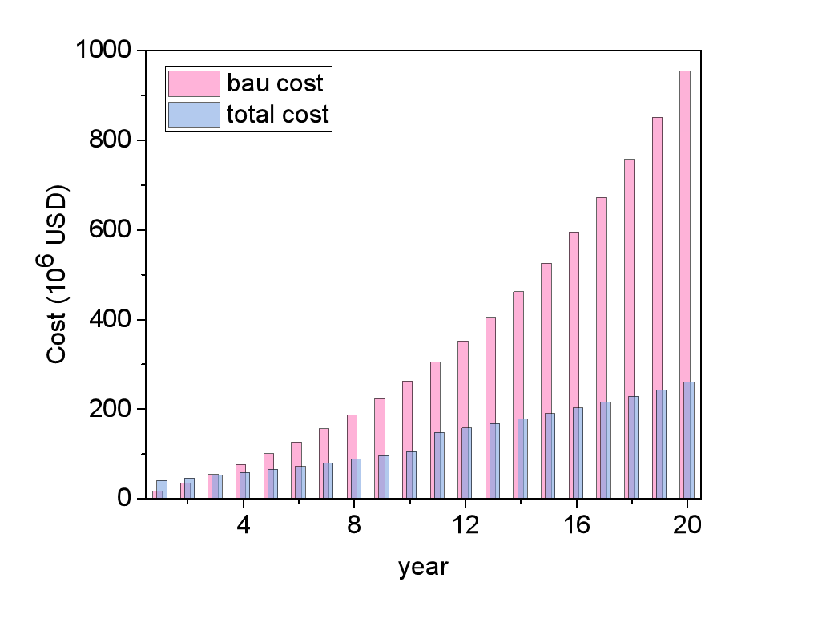
Figure S1 Total cost vs. BAU cost of fixed installation
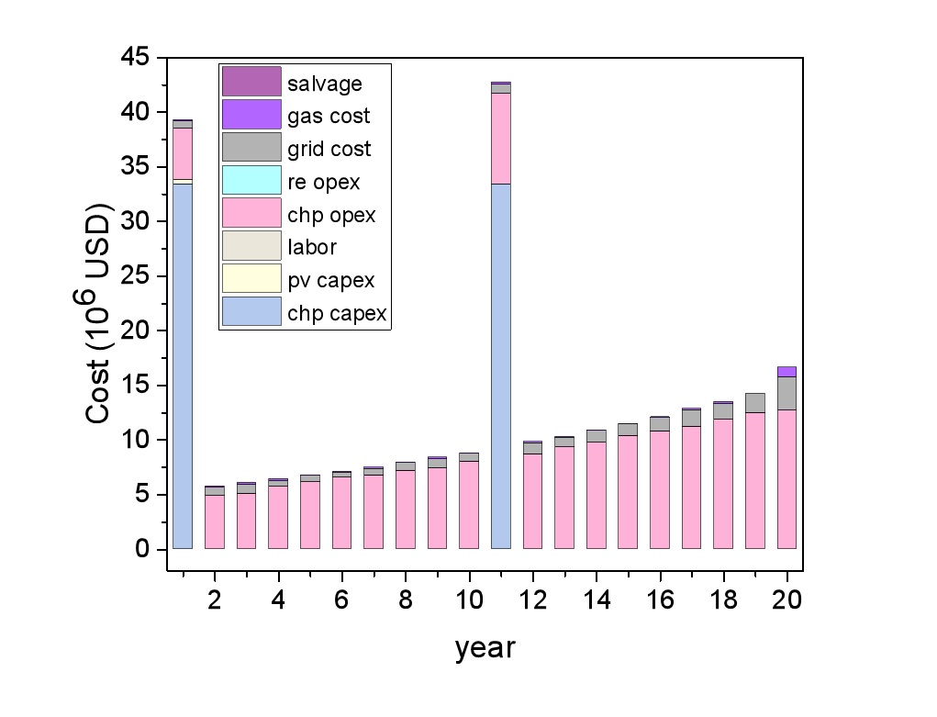
Figure S2 Yearly cash flow of fixed installation
Other than the CHP capex in year 1 and year 11, the major cost came from CHP opex, mainly the fuel cost. Grid cost is greater than the gas cost, demonstrated that the power to heat ratio of the demand is higher than the CHP output. Furthermore, this also demonstrated that the CHP is having cost advantage when both electricity and heat output were used directly, and the economical performance was less attractive when only electricity output could be utilized (excess heat output was released directly). This was also demonstrated in the energy usage details in figure S3.
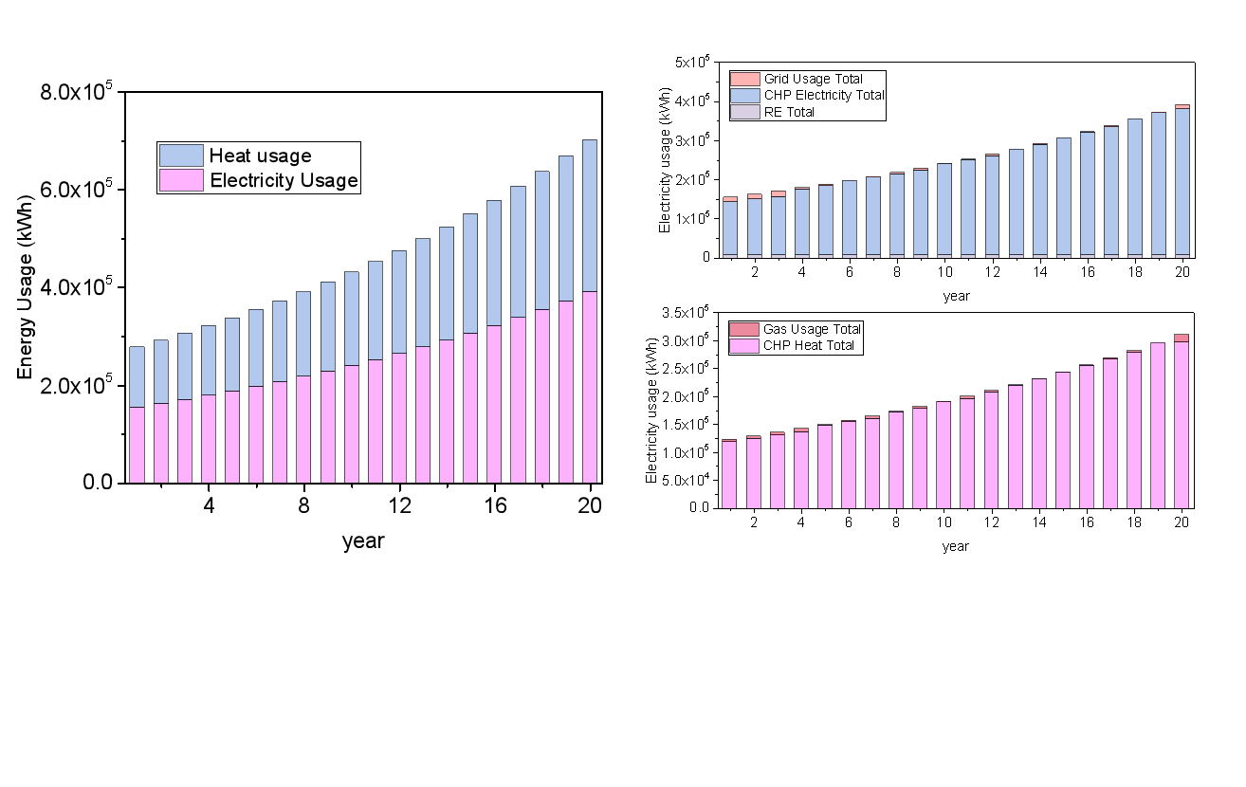
Figure S3 Energy usage detail. (a)Energy usage of the industrial park; (b) Electricity usage details; (c) Heat usage details of fixed installation
As the CHP is having significant cost performance advantage, the majority of the demand was fulfilled by CHP output, covering both electricity and cooling demand. However, at year 20, the demand could not be fulfilled by the CHP output, showed more grid and gas usage comparing to previous years. The was the main drawback of the fixed installation optimization, as it could not trace the changing demand dynamically. The optimization result must made decision from either over capacity in most years or less capacity in later years. In this case, the CHP units had good economical performance, such that the capacity was planed such that over capacity took place in most of the project time. This also led to less utilization rate of the CHP units, and unnecessary replacement cost of less utilized CHP units.

