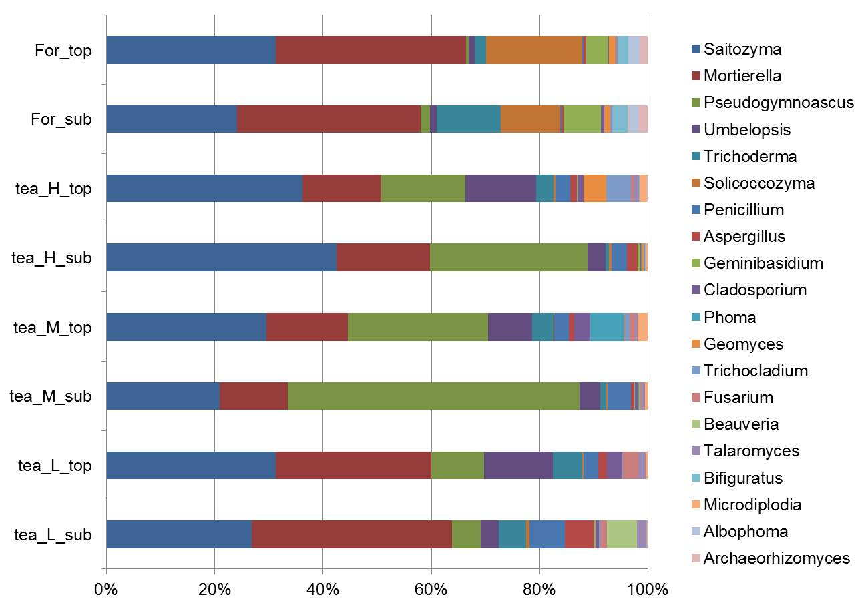
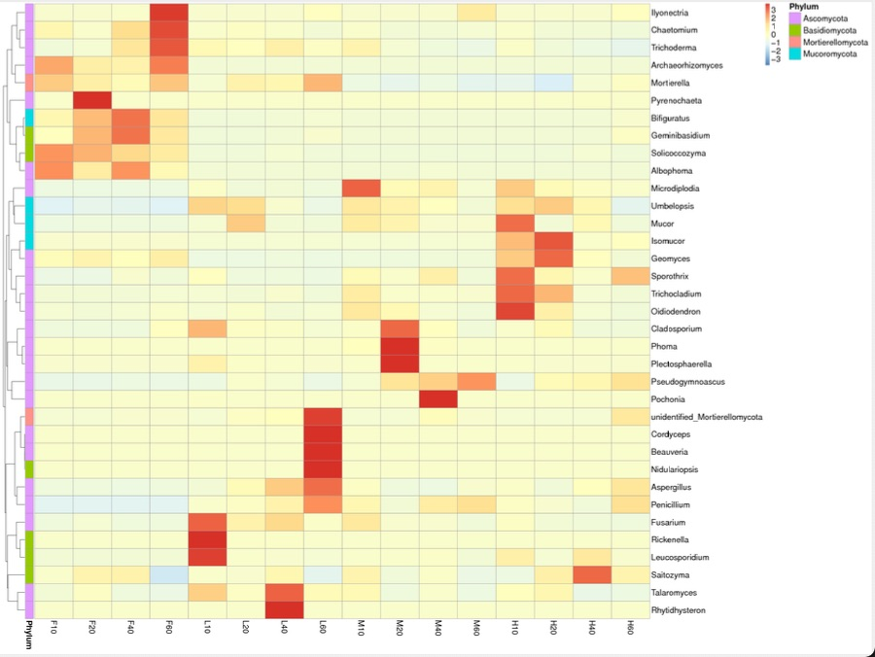

Fig S1 The relative abundances of top 20 abundant fungal genus and heatmap analysis of fungal composition.

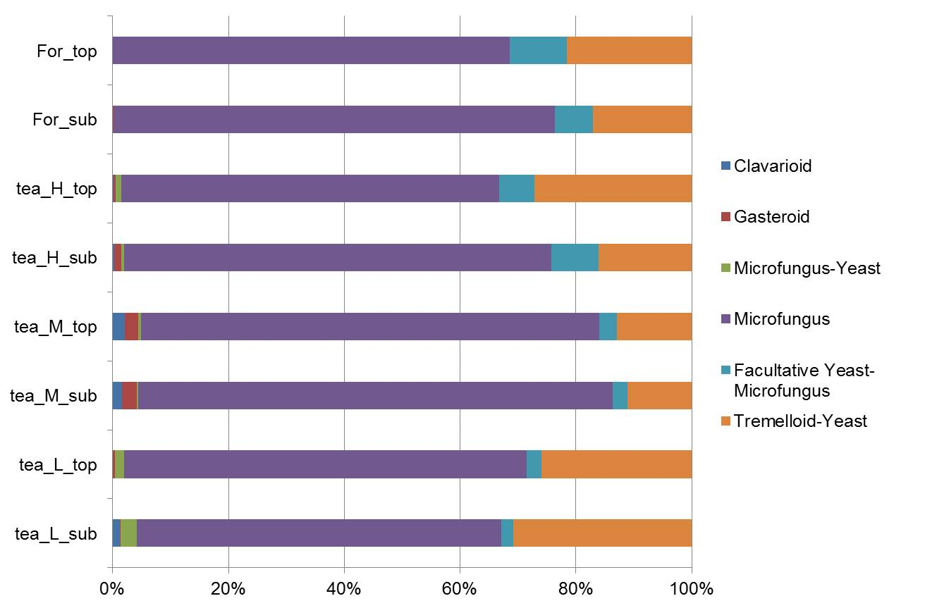

Fig. S2 fungal traits in tea garden in different soil layers under high, low and middle fertilizer inputs.

