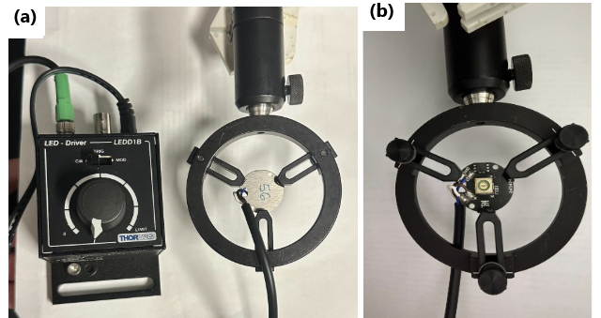
Fig. S1 Images of the deep UV LED light source assembly from (a) back and (b) front view.

Fig. S2 (a) SERS measurements of bare nickel foam (blue spectrum) and clean SERS sensor (orange spectrum), (b) SERS measurement of 2-QT (1x10⁻⁷ M) on SERS sensors. The orange green and light blue lines depict the spectrum of 2-QT on a signal, double and triple coat SERS sensors.

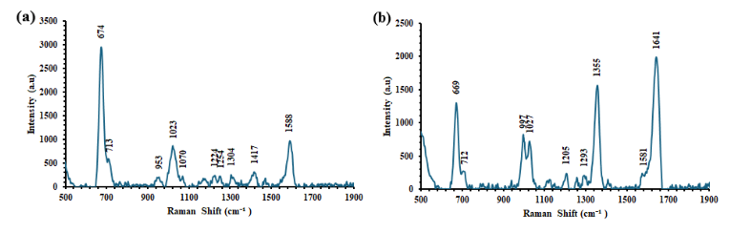
Fig. S3 SERS measurements of (a) Molidustat (concentration =20 μg/L) and (b) Vadadustat (concentration =20 μg/L) on SERS sensor after 4 hours.
Fig. S4 Molecular structure of (a) Molidustat and (b) Vadadustat
Fig. S5 HPLC-MS measurements of (a) DMSO solvent, (b) 100 µg/L & 0.01 µg/L Molidustat standard solutions, (c) 100 µg/L & 0.01 µg/L Vadadustat standard solutions.

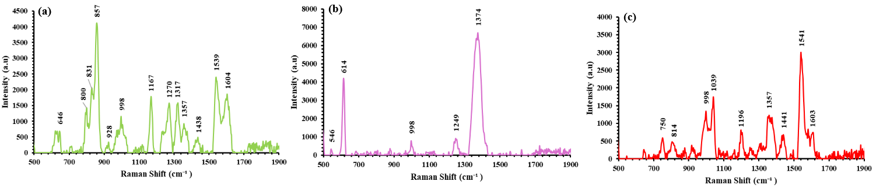
Fig. S6 SERS measurements of (a) acetaminophen (b) acetylsalicylic acid (c) loratadine on Au-Ni foam.

