Vibe Check
Addressing polysubstance use harms among young people in Australia using a youth-led, intersectional, digital harm reduction approach









This project is funded by a generous Lived Experience Partnership grant from The Matilda Centre for Research in Mental Health and Substance Use, University of Sydney. The research team work on unceded Gadigal land (University of Sydney) and unceded land owned by the Dhudhuroa Wiradjuri people (La Trobe University).

Our team

Ms Sasha Bailey (she/her)
University of Sydney
Mr Zachary Bryant (he/him)
University of Sydney
Ms Lyra Egan (she/her)
University of Sydney

Mr Thomas Norman (he/him)
La Trobe University
Prof Cath Chapman (she/her)
University of Sydney
Dr Katrina Champion (she/her)
University of Sydney

Ms Florens de Groot (she/her)
University of Sydney

Contents
Our team 2
Background 4
What is polysubstance use? 4
What are the potential harms from polysubstance use? 5
The role of harm reduction 8
Our study: Vibe Check 9
Project overview 9
Phase 1: Survey 9
Phase 2: Citizen Juries 10
What are citizen juries? 10
Your role as a juror 11
References 12

Background

What is polysubstance use?
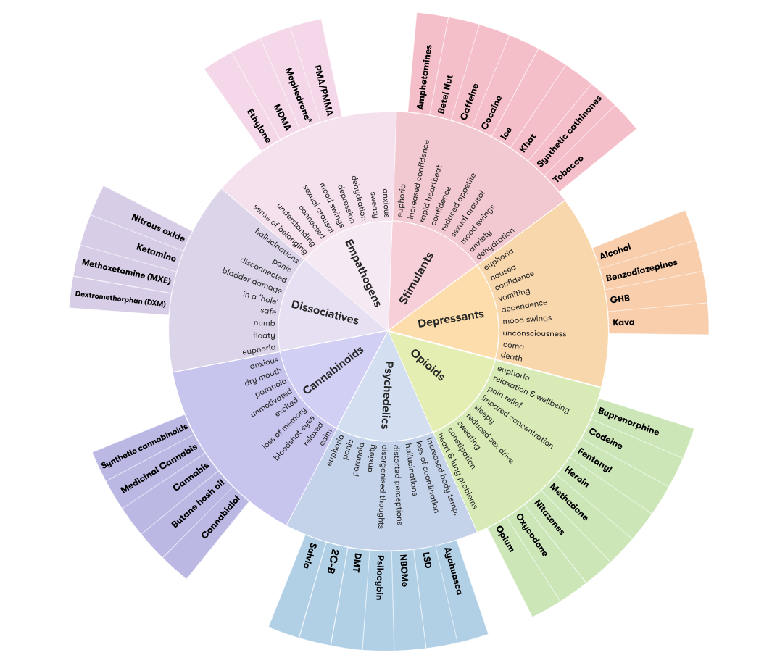
The use of alcohol, tobacco, cannabis, and other drugs is very prevalent among young adults aged 18 to 30 years in NSW.¹ Importantly though, the use of these substances is not siloed nor mutually exclusively and very often, young adults use more than one substance ‘at the same time’ (defined as same day), independently, sequentially, or simultaneously, also referred to as polysubstance use or polydrug use. ²⁻⁴ Young adults’ motives for engaging in polysubstance use are varied. Some may partake in polysubstance use to prolong a state of euphoria (“high”) or alleviate withdrawal symptoms. Others may use multiple substances with the intention to counteract or balance the effect/s of a substance with those of another, enhance a high or reduce overall use, and to mimic the effect of another unavailable or more expensive substance. Some young adults may also intend to self-medicate a pre-existing condition via polysubstance use.³

What are the potential harms from polysubstance use?
The following information is taken from the Australian Drug Foundation’s excellent resource on polysubstance use. This resource is available here.
Polysubstance use may affect everyone differently, based on:
- Size, weight and health
- Whether the person is used to taking the combination of drugs
- The amounts taken
- The strength of the drugs (varies from batch to batch for each illegally produced drug)
- If alcohol or medications are consumed as well
It is difficult to predict the effects of one drug, but it is even harder to predict the effects of multiple drugs.
Taking multiple drugs of the same class (such as two stimulants) increases the impact on the brain and body and overdose can occur.
Effects become even more complicated to predict if different classes of drugs are taken. For example, taking a stimulant with a depressant.
Any drugs taken in combination increase the risk of harm.
Mixing stimulants
When different stimulants are taken at the same time, such as cocaine and ice, the possibility of heart problems increases. Combining stimulants also increases the risk of psychosis, anxiety, or panic attacks. The likelihood of experiencing serotonin syndrome is also increased.³
Serotonin syndrome
Serotonin is a hormone found in the brain that controls our mood, feelings of well-being and happiness.⁴ Serotonin syndrome is a harmful drug reaction caused by too much serotonin and is often linked to MDMA, methamphetamine and cocaine. It can be fatal.
Mild side effects can include:
- mental confusion
- hyperactivity
- muscular problems.⁵

More serious side effects can include:
- fever and sweating
- rapid heartbeat
- muscle spasms⁵
- death

Mixing depressants
Depressant drugs slow down the activity of the central nervous system and reduce breathing rate.
When two or more depressants are combined there is an increased risk of:
- accidents or injury
- impaired judgement and coordination
- vomiting
- irregular or shallow breathing
- blackouts and memory loss
- unconsciousness
- coma
- death.⁶

Mixing depressants and stimulants
If stimulants are mixed with depressants the body is placed under a lot of stress as it tries to deal with the competing effects.
For example, when methamphetamine is combined with alcohol the heart experiences greater strain. This can lead to dangerous complications, particularly for someone with a heart condition.
Other effects of combining depressants and stimulants include:
- heart problems
- respiratory infections and bronchitis
- dehydration, overheating, and kidney failure.³

Mixing medications
Mixing medications, either prescribed medications or medications purchased ‘over the counter’, with other drugs can have negative effects.
Combining benzodiazepines with opioids can lead to a decreased breathing rate and an increased risk of overdose.⁷
Some pharmaceutical drugs, such as strong pain relievers, antidepressants, anticonvulsants, anti-psychotics, some antihistamines and over-the-counter medications, can have an adverse effect when taken with benzodiazepines, leading to breathing difficulties and an increased risk of overdose and death.⁸
The use of benzodiazepines to help with the comedown effects of stimulant drugs (such as amphetamines or ecstasy) may result in dependence on both types of drugs.
Mixing different medications can also have negative effects. If you have concerns about taking medications, or drinking alcohol with medication, you should consult a health professional.
Mixing alcohol
Alcohol interacts with many drugs including medications, over-the-counter medicines and illegal drugs.⁹
Mixing alcohol and medicines can be harmful.
Alcohol and some medications can make you tired, drowsy, or lightheaded. When mixing alcohol and medication the effects can be intensified.¹⁰
Other effects of mixing alcohol and medication include:
- difficulty concentrating
- inability to perform simple tasks
- risk of falls and injuries (especially in older people).⁹

Mixing alcohol with illegal drugs can have various effects depending on the type of drug.
Alcohol can increase the risk of drowsiness when mixed with other depressant drugs such as GHB or heroin. This can lead to overdose.³
Mixing alcohol with cocaine produces a chemical called cocaethylene, which is toxic and is associated with seizures, liver damage, and compromised immune system.¹¹
While polysubstance use in and of itself does not necessarily and always correspond to proportionately higher risk of substance use harms and costs, polysubstance use substantially increases the risk of substance dependence and/or abuse which, during young adulthood, may eventuate to chronic and entrenched substance disorders persisting across the lifespan.⁵
Increasing evidence highlights that young people partaking in polysubstance use are typically observed to be at greater risk of co-occurring mental ill-health symptoms, including depression, anxiety, and suicidality.⁶
Polysubstance use significantly increases the likelihood of adverse interactions between certain combinations of substances which can subsequently increase risk of serious injury, illness, or death.

The role of harm reduction
The following information has been paraphrased from the US-based National Harm Reduction Coalition, a nationwide advocate and ally for people who use drugs.
Harm reduction is a set of practical strategies and ideas aimed at reducing negative consequences associated with drug use. This may include strategies for promoting safer use, managed use, abstinence, meeting people who use drugs ‘where they’re at’, and addressing conditions of use along with the use itself. It is a movement for social justice built on a belief in, and respect for, the rights of people who use drugs.
The National Harm Reduction Coalition states the following principles are central to the effective practice of harm reduction principles:
- Accepts, for better or worse, that licit and illicit drug use is part of our world and chooses to work to minimize its harmful effects rather than simply ignore or condemn them
- Understands drug use as a complex, multi-faceted phenomenon that encompasses a continuum of behaviours from severe use to total abstinence, and acknowledges that some ways of using drugs are clearly safer than others
- Establishes quality of individual and community life and well-being — not necessarily cessation of all drug use — as the criteria for successful interventions and policies
- Calls for the non-judgmental, non-coercive provision of services and resources to people who use drugs and the communities in which they live in order to assist them in reducing attendant harm
- Ensures that people who use drugs and those with a history of drug use routinely have a real voice in the creation of programs and policies designed to serve them
- Affirms people who use drugs (PWUD) themselves as the primary agents of reducing the harms of their drug use and seeks to empower PWUD to share information and support each other in strategies which meet their actual conditions of use
- Recognizes that the realities of poverty, class, racism, social isolation, past trauma, sex-based discrimination, and other social inequalities affect both people’s vulnerability to and capacity for effectively dealing with drug-related harm
- Does not attempt to minimize or ignore the real and tragic harm and danger that can be associated with illicit drug use

Our study: Vibe Check

Project overview
This study, Vibe Check, is a large stage of young adults aged 18-30 years in New South Wales (NSW) aiming to answer three key research questions:
- What are the patterns, correlates, and motives of polysubstance use among young adults?
- What are the key potential harms associated with polysubstance use, according to young adults themselves?
- How can potential key harms associated with polysubstance use be best addressed, according to young adults themselves?
There are two phases of this project:
Phase 1 involved an online survey exploring the patterns, correlates and motives of polysubstance use among young adults aged 18 to 30 years in NSW.
Phase 2 involves a citizen jury comprising up to 8 eligible young adults in NSW which will provide more detail about the nature and potential harms of polysubstance use among young people in NSW, and how these can be best addressed using harm reduction messaging.

Phase 1: Survey
In March 2025, we launched Phase 1: an online survey of young people aged 18 to 30 years living in NSW with recent experience of polysubstance use (University of Sydney Human Research Ethics Committee Approval Number: 2024/HE001655). Respondents were asked to share information about their experiences of polysubstance use and perceptions of polysubstance use harms and harm reduction.
Preliminary findings
Who has responded to our survey?
Since its launch, approximately 41 young people aged 18 to 30 years living in NSW (Mage = 23 years) have generously shared their experiences and perspectives on polysubstance use with the Vibe Check team.
Among these 41 young people, there’s a relatively good representation of gender diversity. Around half (54%) of participants have been women (cis or trans), one in four (27%) have been men (cis or trans), and around one in five have been non-binary or gender diverse (19%).
Most participants so far have been queer, mainly bisexual/bi+, gay or lesbian, or queer; a minority (42%) have been straight (heterosexual).
Most participants are either working full-time (39%) or full-time students (29%) but reported incomes vary significantly. Relatively educated sample in that most respondents (~52%) have an undergraduate degree or postgraduate degree, most of remaining people have finished high school (39%).

What tips do young people have for people thinking of engaging in polysubstance use for the first time?
Preliminary analysis of open-ended responses reveals several recommendations for young people thinking of engaging in polysubstance use for the first time:
  - Be around trusted friends and people you are comfortable with
  - Know what you’re taking, including potentially harmful drug interactions
  - Know when, how, and from whom to seek help (e.g., medical help, calling an ambulance, alerting the med tent, using tripsit.me)
  - Make sure someone knows where you are, what you’re taking, how you feel. Important not to engaging in polysubstance use in secret; keep your phone charged.
  - Be in a safe environment
  - ‘Never buy drugs from someone you don’t know’
  - Pace yourself in quantity and frequency, starting slow, low, and small, building up, and getting used to one layer before adding another. ‘I don’t think anyone should mix substances they haven’t done in isolation’

Where do young people want to see and share harm reduction messaging and resources?
Preliminary findings found young people thought Instagram would be the best social media platform to share polysubstance use harm reduction messaging and resources for young adults, followed by dating apps, Facebook, and Snapchat.
Qualitative responses highlighted that messaging and resources would be best placed ‘in the field’, that is, in festivals, raves, and underground events. Respondents also noted that common nightlife places such as pubs, clubs, bathrooms at these venues, near servos, nightlife districts, would be good. Campaigns that are educational, sharing lived experience, and delivered via TikTok were also noted. University and other educational campuses were also noted.

Phase 2: Citizen Juries
If you are reading this text, then you have received the citizen jury pre-jury information pack indicating that you have agreed to participate in Phase 2: Citizen Jury. As mentioned above, you will be one of 10 young adults in NSW who will provide more detailed about the nature and potential harms of polysubstance use among young people in NSW, and how these can be best addressed using harm reduction messaging.

What are citizen juries?
Citizen science methods, such as citizen juries⁷ are intentionally democratic spaces share research decision-making and power equally between those people whose lives are actually affected by the research (i.e., in this case, young adults), with members of the research team.^{8, 9}
Citizen juries look different depending on the research question and jurors required, but typically it involves a small group of community members discussing and agreeing on important issues relevant to their health and wellbeing. Typically, a jury is said to be in agreement when there is consensus on a topic or position, or if there is a majority vote (if needed).^{10, 11}
Prior to actual citizen jury session, jurors are provided with evidence relating to the health topic of concern. At the beginning of the citizen jury session, jurors are then presented with evidence.¹⁰
Importantly, citizen jury methods are highly effective at achieving consensus among diverse jurors on nuanced and sometimes contentious topics.^{8, 9} For example, citizen juries have been previously used to establish research priorities for promoting the health of incarcerated populations⁹, and to improve the implementation of school-based adolescent immunisation programs.⁸
The governance of citizen juries is equally variable, depending on the health topic being consulted on. The citizen jury which you will participate in which be co-chaired by two members of the research team, including a lived experience (young adult) Research Assistant.

Your role as a juror
  - Be respectful and supportive of all individuals in attendance. The research team has a zero-tolerance policy for any offensive or potentially discriminatory behaviour or conduct, including but not limited to discrimination based on race, disability, relationship status, sexual orientation, gender identity,
  - Actively listen to other jurors and be open to other perspectives
  - Actively participate
  - Offer your perspective to other jurors
  - Do not judge or stigmatise other peoples’ ideas or viewpoints
  - Be excited about reaching agreement with your fellow jurors
Reminder: Data from the online citizen juries will be recorded using the recording function in zoom. Zoom will automatically record both audio and video recording unless videos are specifically disabled by the participant. Video recording will be deleted immediately after the juror session. Audio-recordings will be transcribed (written out) for the researchers to review and any details that identify you will be removed from the transcriptions to protect your confidentiality.

References

1. Australian Institute of Health and Welfare. Alcohol, tobacco and other drugs Online: Commonwealth of Australia; 2021 [Available from: https://www.aihw.gov.au/reports/children-youth/alcohol-tobacco-and-other-drugs.
2. Black N, Noghrehchi F, Yuen WS, Aiken A, Clare PJ, Chan G, et al. Transitions to polysubstance use: Prospective cohort study of adolescents in Australia. Addiction.n/a(n/a).
3. Boileau-Falardeau M, Contreras G, Gariépy G, Laprise C. Patterns and motivations of polysubstance use: a rapid review of the qualitative evidence. Health Promot Chronic Dis Prev Can. 2022;42(2):47-59.
4. Bunting AM, Shearer R, Linden-Carmichael AN, Williams AR, Comer SD, Cerdá M, Lorvick J. Are you thinking what I'm thinking? Defining what we mean by "polysubstance use.". Am J Drug Alcohol Abuse. 2024;50(1):1-7.
5. Goodwin SR, Moskal D, Marks RM, Clark AE, Squeglia LM, Roche DJO. A Scoping Review of Gender, Sex and Sexuality Differences in Polysubstance Use in Adolescents and Adults. Alcohol Alcohol. 2022;57(3):292-321.
6. Silveira ML, Green VR, Iannaccone R, Kimmel HL, Conway KP. Patterns and correlates of polysubstance use among US youth aged 15-17 years: wave 1 of the Population Assessment of Tobacco and Health (PATH) Study. Addiction. 2019;114(5):907-16.
7. Marks L, Laird Y, Trevena H, Smith BJ, Rowbotham S. A Scoping Review of Citizen Science Approaches in Chronic Disease Prevention. Front Public Health. 2022;10:743348.
8. Marshall HS, Proeve C, Collins J, Tooher R, O’Keefe M, Burgess T, et al. Eliciting youth and adult recommendations through citizens’ juries to improve school based adolescent immunisation programs. Vaccine. 2014;32(21):2434-40.
9. Simpson PL, Guthrie J, Jones J, Butler T. Identifying research priorities to improve the health of incarcerated populations: results of citizens' juries in Australian prisons. The Lancet Public Health. 2021;6(10):e771-e9.
10. Gooberman-Hill R, Horwood J, Calnan M. Citizens' juries in planning research priorities: process, engagement and outcome. Health Expect. 2008;11(3):272-81.
11. Street J, Duszynski K, Krawczyk S, Braunack-Mayer A. The use of citizens' juries in health policy decision-making: A systematic review. Social Science & Medicine. 2014;109:1-9.

