SUPPLEMENTARY DATA for
Historical changes in anthropogenic pressures, distribution and population structure of mangrove forests at a distributional range limit. Wetlands,
Anesu Machite and Janine B. Adams*.
DSI/NRF Research Chair: Shallow Water Ecosystems, Department of Botany, Institute of Coastal & Marine Research, PO Box 77000, Gqeberha, 6031, Nelson Mandela University, South Africa. Janine.Adams@mandela.ac.za
*Corresponding author, email: Janine.adams@mandela.ac.za
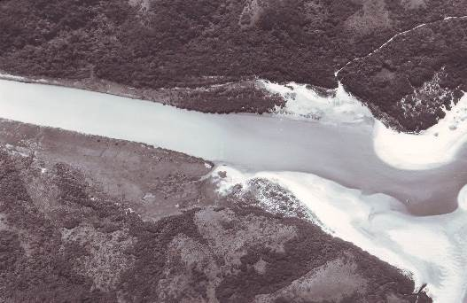  1977: <20 individuals | 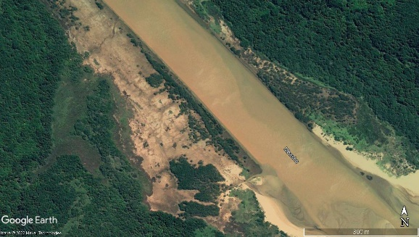  2011: 9.2 ha
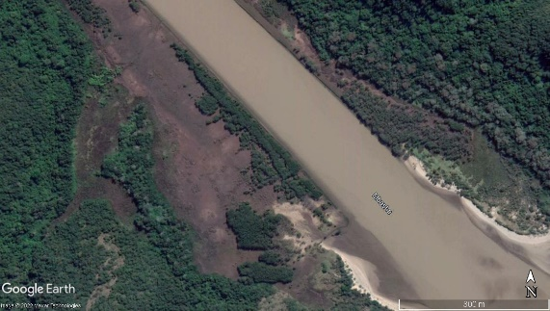  2016: 9.2 ha | 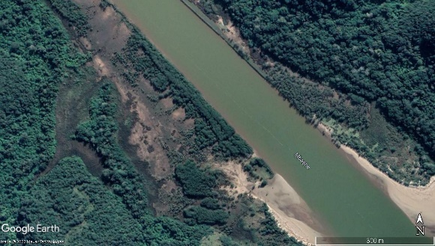  2021: 9.6 ha
Fig. S1: Aerial images of Mbashe Estuary between 1977 and 2021 showing the increase in Avicennia marina cover. Main mangrove stand only occurred on the eastern banks (top left) with few individuals on the western bank. From 1977 further growth and expansion of mangroves occurred on the western bank (bottom right), forming in an area that was previously bare ground or covered in salt marsh. (Yellow squares indicate the original stand, Green squares indicate where mangrove expansion has occurred) (Source: Google Earth; NRF/SAEON (2022))

Table S1: Density of mangrove seedlings, saplings, and adults for 2011 and 2021 and the average height and DBH of Avicennia marina. Estuaries with significant differences between years for A. marina are shaded in grey. Comparisons could not be made if A. marina was not present in the estuary as indicated by a blank cell.
Estuary | Seedlings (individuals ha⁻¹) |  | Saplings (individuals ha⁻¹) |  | Adults  (individuals ha⁻¹) |  | Average height (cm) |  | p-value | Average DBH  (cm) |  | p-value
Estuary | 2011 | 2021 | 2011 | 2021 | 2011 | 2021 | 2011 | 2021 |  | 2011 | 2021
Mnyameni | 52 355 |  | 1 733 |  | 1 066 |  |  | 60.8 ± 1.8 |  | 3.11 ± 1.8 | 5.4 ± 3.8
Mntafufu | 1 200 | 4 711 | 1 156 | 400 | 3 111 | 711 | 212.7 ± 14.7 | 75 ± 12.7 | p <0.0001 | 59.5 ± 7.5 | 11.5 ± 1.9 | p <0.0001
Mngazana | 7 062 | 1 556 | 16 567 | 6 978 | 16 937 | 9 022 |  | 105.5 ± 9.9 |  | 1.9 ± 0.2 | 14.5 ± 1.1
Mtakatye | 2 089 | 8 578 | 756 | 1 600 | 844 | 1 156 | 168 ± 33.1 | 90.3 ± 11.8 | p < 0.001 | 43.4 ± 8.6 | 16.9 ± 1.8 | p = 0.2
Mdumbi | 0 | 9 378 | 44 | 0 | 1 600 | 2 311 | 417.3 | 114 ± 12.9 | p < 0.0001 | 31.6 ± 3.9 | 36.5 ± 2.8 | p = 0.099
Mtata | 0 | 9 867 | 0 | 133 | 2 444 | 4 533 | 608.8 ± 25.4 | 212.9 ± 16.6 | p < 0.0001 | 34.8 ± 3.2 | 13.6 ± 1 | p < 0.0001
Xora | 10 666 | 21 822 | 6 888 | 356 | 3 377 | 1 600 |  | 55.2 ± 6.1 |  |  | 18.1 ± 1.1
Mbashe | 356 | 3 511 | 222 | 889 | 9 378 | 8 089 | 514.7 ± 15.1 | 352.1 ± 17 | p < 0.0001 | 12.7 ± 1.3 | 6.4 ± 0.3 | p < 0.0001
Nqabara | 756 | 3 467 | 3 244 | 1 733 | 5 644 | 8 267 |  | 243 ± 12.6 |  | 1.90 ± 0.31 | 9.8 ± 1.2
Nxaxo | 2 185 ±  1 093 | 22 622 | 6 978 | 3876 | 3 311 | 3 244 |  | 62.8 ± 4.5 |  | 1.29 ± 0.15 | 4.7 ± 0.8

Table S2: Density of mangrove seedlings, saplings and adults for 2011 and 2021 and the average height and DBH of Bruguiera gymnorrhiza. Estuaries with significant differences between years for B. gymnorrhiza are shaded in grey. Comparisons could not be made if B. gymnorrhiza was not present in the estuary as indicated by a blank cell.
Estuary | Seedlings  (individuals ha⁻¹) |  | Saplings  (individuals ha⁻¹) |  | Adults  (individuals ha⁻¹) |  | Average height  (cm) |  | p-value | Average DBH  (cm) |  | p-value
Estuary | 2011 | 2021 | 2011 | 2021 | 2011 | 2021 | 2011 | 2021 |  | 2011 | 2021
uMthavuna | 55 | 1 378 | 24 | 178 | 2.7 | 5 689 |  | 449.2 ± 23 |  |  | 14.7 ± 0.7
Mzamba | 30 400 | 18 133 | 13 333 | 33 933 | 18 400 | 26 533 | 100.6 ± 3.8 | 118.5 ± 3.6 | p <0.0001 | 8.2 ± 0.4 | 7.3 ± 0.3 | p < 0.0001
Mnyameni |  | 28 467 |  | 49 267 |  | 27 667 |  | 112 ± 3 |  |  | 1.8 ± 0.1
Mtentu | 6800 | 14133 | 2533 | 8400 | 7733 | 14400 | 118.9 ± 8.2 | 207.1 ± 18.4 | p value = 0.02 | 16.4 ± 1.1 | 10.8 ± 1. | p < 0.0001
Mzintlava | 5067 | 65533 | 8133 | 122000 | 15200 | 23467 | 174.4 ± 12 | 87.7 ± 2.2 | p <0.0001 | 7.6 ± 0.01 | 2.4 ± 0.2 | p < 0.0001
Mntafufu | 17378 | 32578 | 17022 | 7822 | 12311 | 19644 | 130.2 ± 4.4 | 123.9 ± 3.6 | p <0.0001 | 30.9 ± 1.3 | 3.4 ± 0.1 | p <0.0001
Mngazana | 7 062 | 4 356 | 16 567 | 6 178 | 16 937 | 6 356 |  | 135.9 ± 6.1 |  | 1.9 ± 0.2 | 3.7 ± 0.3
Mtakatye | 31333 | 32267 | 5022 | 7022 | 8889 | 8356 | 95.7 ± 4.4 | 99.5 ± 4.2 | p < 0.0002 | 10 ± 0.6 | 3.7 ± 0.2 | p <0.0001
Xora | 10 666 | 7 200 | 6 888 | 13 289 | 3 377 | 3956 |  | 111.1 ± 5.1 |  | 2 ± 0.45 | 2.9 ± 0.1
Nxaxo | 2 185 | 222 | 6 978 | 356 | 3 311 | 2044 |  | 207.7 ± 12.3 |  | 1.3 ± 0.15 | 3.2 ± 0.8

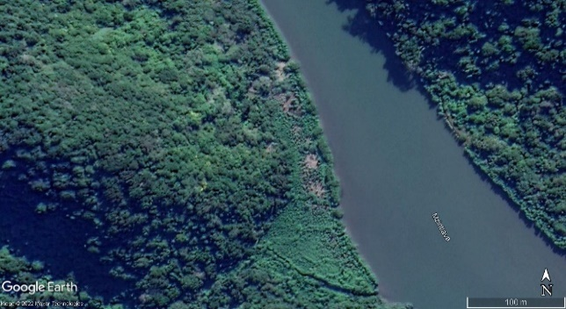  a) Mzintlava Estuary | 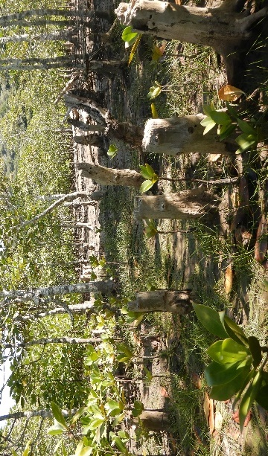
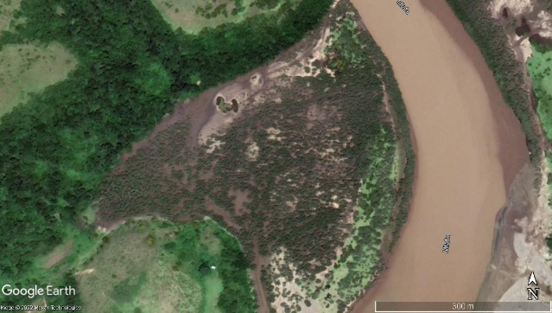  b) Mtata Estuary | 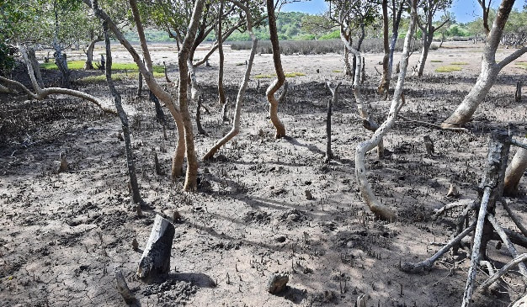
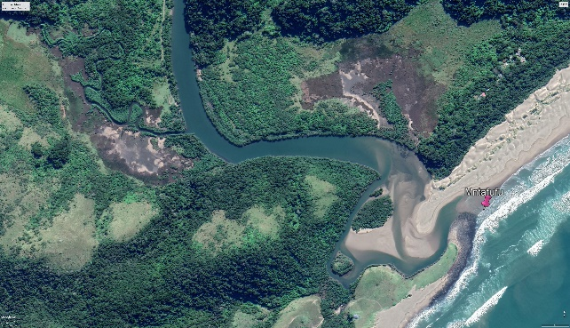  c) Mntafufu Estuary | 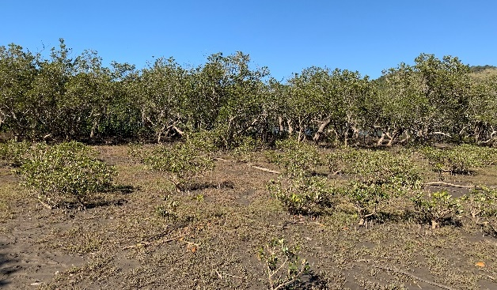
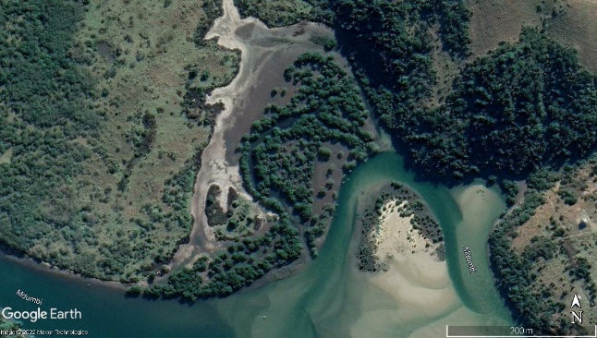  d) Mdumbi Estuary | 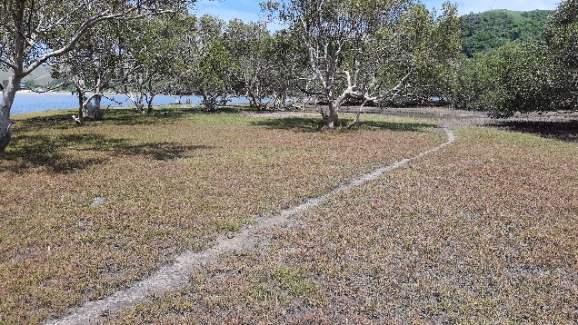
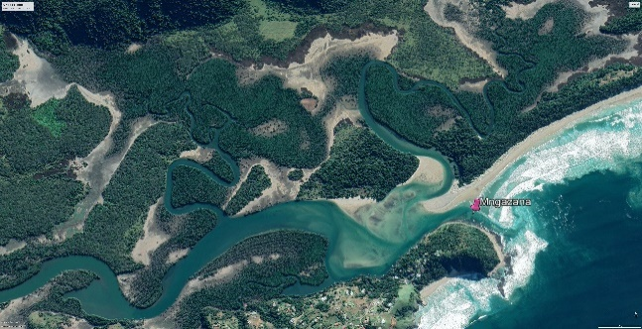  e) Mngazana Estuary | 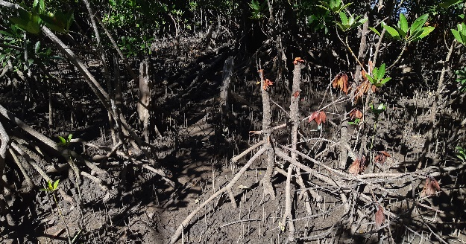

Fig. S2: Mangrove canopy gaps at Mzintlava Estuary (a) were caused by the harvesting of Bruguiera gymnorrhiza trees along the western bank. Canopy gaps at Mtata Estuary (b) were formed from wood harvesting of all three species, livestock browsing and footpaths in the lower reaches. At Mntafufu Estuary (c) canopy gaps, degradation, and stunted growth of Avicennia marina in the landward fringes were caused by livestock browsing and wood harvesting. Main pressures at Mdumbi Estuary (d) were footpaths and trampling in the mangroves and salt marsh vegetation. Pressures at Mngazana Estuary (e) included wood harvesting of all three species, footpaths and trampling and livestock browsing of A. marina. (Red square is corresponding location of canopy gap photo)

