Additional File 1: Table S1. List of the targeted genes.
No. | Gene | Number of target region | Size of target region (bp)
1 | PIK3CD | 22 | 4,013
2 | MTOR | 58 | 9,865
3 | SDHB | 8 | 1,151
4 | PIK3R3 | 11 | 1,877
5 | PRKAA2 | 9 | 2,019
6 | JAK1 | 24 | 4,425
7 | GLMN | 18 | 2,437
8 | NRAS | 4 | 730
9 | THEM4 | 6 | 963
10 | SHC1 | 12 | 2,235
11 | LMNA | 15 | 2,819
12 | GLUL | 6 | 1,362
13 | MAPKAPK2 | 12 | 1,591
14 | PFKFB2 | 15 | 2,184
15 | FH | 10 | 1,851
16 | AKT3 | 14 | 2,044
17 | LPIN1 | 24 | 3,975
18 | KCNK3 | 2 | 1,248
19 | SOS1 | 23 | 4,896
20 | ANTXR1 | 21 | 2,304
21 | BCL2L11 | 9 | 1,097
22 | ACVR1 | 9 | 1,890
23 | PDK1 | 13 | 1,769
24 | BMPR2 | 13 | 3,637
25 | PIKFYVE | 41 | 7,921
26 | IRS1 | 3 | 3,725
27 | EIF4E2 | 10 | 1,198
28 | VHL | 5 | 951
29 | RAF1 | 17 | 2,669
30 | MAPKAPK3 | 10 | 1,549
31 | GSK3B | 12 | 1,773
32 | PIK3CB | 22 | 4,059
33 | PDCD10 | 7 | 903
34 | PIK3CA | 20 | 3,979
35 | KDR | 30 | 5,258
36 | FAT4 | 18 | 15,485
37 | GAB1 | 11 | 2,615
38 | VEGFC | 8 | 1,512
39 | RICTOR | 39 | 6,733
40 | PRKAA1 | 11 | 2,205
41 | PIK3R1 | 17 | 2,977
42 | AGGF1 | 15 | 2,670
43 | RASA1 | 27 | 4,092
44 | PPP2CA | 7 | 1,210
45 | FLT4 | 30 | 5,276
46 | ATXN1 | 3 | 2,437
47 | MAPK14 | 13 | 1,723
48 | CDKN1A | 3 | 708
49 | VEGFA | 10 | 1,538
50 | SGK1 | 17 | 2,600
51 | CCM2 | 11 | 1,868
52 | HSPB1 | 3 | 738
53 | YWHAG | 2 | 824
54 | KRIT1 | 16 | 2,851
55 | SND1 | 24 | 3,693
56 | RHEB | 8 | 875
57 | PPP2CB | 7 | 1,210
58 | IKBKB | 22 | 3,244
59 | LYN | 12 | 2,019
60 | DEPTOR | 10 | 1,507
61 | PTK2 | 36 | 4,900
62 | RPS6 | 6 | 990
63 | TEK | 23 | 4,287
64 | GNAQ | 7 | 1,360
65 | SYK | 13 | 2,428
66 | MAPKAP1 | 12 | 2,063
67 | ENG | 15 | 2,560
68 | PTPA | 11 | 1,424
69 | TSC1 | 22 | 4,315
70 | MAP3K8 | 7 | 1,677
71 | GDF2 | 2 | 1,370
72 | DDIT4 | 2 | 779
73 | PTEN | 11 | 1,999
74 | PIK3AP1 | 17 | 3,098
75 | CHUK | 22 | 3,041
76 | PDCD4 | 12 | 1,876
77 | HRAS | 5 | 852
78 | ILK | 12 | 1,839
79 | WEE1 | 16 | 2,095
80 | RAG1 | 1 | 3,172
81 | ATG13 | 17 | 2,312
82 | VEGFB | 7 | 931
83 | BAD | 3 | 627
84 | CCND1 | 6 | 1,048
85 | GAB2 | 10 | 2,417
86 | SDHD | 4 | 640
87 | CDKN1B | 2 | 677
88 | KRAS | 5 | 887
89 | MDM2 | 11 | 1,934
90 | ATXN2 | 29 | 4,815
91 | NOS1 | 29 | 5,556
92 | PXN | 12 | 2,400
93 | UBC | 1 | 2,098
94 | ULK1 | 28 | 4,236
95 | SMAD9 | 6 | 1,644
96 | FOXO1 | 4 | 1,949
97 | TBC1D4 | 22 | 4,704
98 | SOS2 | 23 | 4,890
99 | HIF1A | 16 | 3,228
100 | PGF | 7 | 793
101 | AKT1 | 13 | 1,963
102 | RASGRP1 | 17 | 3,073
103 | MAP2K1 | 11 | 1,622
104 | TSC2 | 42 | 7,137
105 | MLST8 | 8 | 1,319
106 | PDPK1 | 14 | 2,231
107 | ABAT | 15 | 2,096
108 | EEF2K | 17 | 2,858
109 | PRKCB | 18 | 2,878
110 | MAPK3 | 8 | 1,460
111 | CDH5 | 12 | 2,760
112 | PLCG2 | 32 | 5,034
113 | YWHAE | 6 | 982
114 | TP53 | 11 | 1,672
115 | FLCN | 12 | 2,415
116 | MAP2K3 | 12 | 1,524
117 | NF1 | 59 | 10,808
118 | RPS6KB1 | 16 | 2,234
119 | PRKCA | 17 | 2,699
120 | MAP2K6 | 12 | 1,485
121 | RPTOR | 34 | 5,368
122 | SMAD4 | 11 | 2,071
123 | CCBE1 | 11 | 1,661
124 | PHLPP1 | 23 | 5,332
125 | BCL2 | 4 | 772
126 | STK11 | 9 | 1,662
127 | MAP2K2 | 11 | 1,630
128 | PIK3R2 | 17 | 2,526
129 | AKT2 | 13 | 1,966
130 | BAX | 6 | 959
131 | AKT1S1 | 6 | 996
132 | PRKCG | 20 | 2,859
133 | PLCG1 | 32 | 5,156
134 | YWHAB | 5 | 941
135 | ELMO2 | 20 | 2,963
136 | SOX18 | 4 | 1,073
137 | MYT1 | 23 | 4,033
138 | MAPK1 | 8 | 1,361
139 | YWHAH | 2 | 805
140 | PRR5 | 9 | 1,599
141 | VEGFD | 7 | 1,326
142 | XIAP | 6 | 1,720
143 | GAB3 | 10 | 2,151

Additional File 1: Table S2. Cytokine results of four patients that showed similar patterns of changes after propranolol administration.

Cytokine (pg/ml) | EGF | FGF-2 | TGF-a | G-CSF | Fractalkine | IFNa2 | sCD40L | IL-3 | IL-7 | IP-10 | VEGF
Pt.2 (before treatment) | 12.815 | 80.24 | 1.98 | 85.975 | 96.48 | 42.345 | 47.65 | 1.66 | 3.3 | 289.68 | 108.65
Pt.2 (after treatment) | 0.89 | 19.005 | 0.53 | 19.33 | 16.74 | 1.48 | 31.44 | 0.28 | 0.65 | 315.63 | 22.21
Pt.10 (before treatment) | 43.74 | 121.75 | 1.09 | 20.605 | 63.175 | 27.31 | 70.80 | 0.295 | 0.91 | 449.53 | 95.60
Pt.10 (after treatment 1) | 10.2 | 88.68 | 0.53 | 29.595 | 92.38 | 42.475 | 247.72 | 1.35 | 3.47 | 441.02 | 84.54
Pt.10 (after treatment 2) | 23.93 | 103.65 | 0.53 | 33.49 | 81.15 | 53.99 | 131.95 | 0.44 | 1.91 | 320.57 | 107.25
Pt.10 (after treatment 3) | 26.12 | 96.44 | 0.53 | 46.53 | 103.77 | 37.45 | 89.18 | 1.88 | 4.56 | 229.66 | 129.59
Average level after treatment of Pt. 10 | 20.08 | 96.25 | 0.53 | 36.53 | 92.43 | 44.63 | 156.28 | 1.22 | 3.31 | 330.41 | 107.12
Standard deviation | 8.628 | 7.486 | 0 | 8.869 | 11.31 | 8.479 | 82.02 | 0.72 | 1.33 | 106.02 | 22.52
Pt.11 (before treatment) | 39.01 | 86.77 | 0.635 | 159.14 | 177.86 | 49.06 | 429.28 | 2.575 | 4.295 | 363.31 | 91.74
Pt.11 (after treatment 1) | 16.605 | 105.36 | 0.53 | 186.32 | 96.19 | 53.98 | 77.01 | 1.4 | 3.56 | 370.30 | 94.1
Pt.11 (after treatment 2) | 12.95 | 78.59 | 0.805 | 72.23 | 73.79 | 30.69 | 115.38 | 0.28 | 0.65 | 584.61 | 63.76
Pt.11 (after treatment 3) | 14.45 | 82.78 | 0.88 | 144.77 | 119.17 | 47.45 | 115.91 | 2.06 | 3.83 | 592.96 | 116.8
Average level after treatment of patient 11 | 14.66 | 88.91 | 0.738 | 134.44 | 96.38 | 44.04 | 102.76 | 1.24 | 2.68 | 515.95 | 91.55
Standard deviation | 1.837 | 14.39 | 0.184 | 57.74 | 22.69 | 12.01 | 22.3 | 0.89 | 1.76 | 126.20 | 26.60
Pt.12 (before treatment) | 39.715 | 80.685 | 0.53 | 90.87 | 173.93 | 64.35 | 420.92 | 2.51 | 8.98 | 452.25 | 78.02
Pt.12 (after treatment 1) | 30.965 | 52.205 | 0.53 | 41.32 | 73.85 | 34.92 | 276.57 | 0.87 | 2.07 | 387.53 | 49.94
Pt.12 (after treatment 2) | 8.81 | 54.93 | 0.53 | 69.69 | 126.94 | 47.45 | 74.77 | 0.79 | 2.76 | 1982 | 71.12
Pt.12 (after treatment 3) | 16.04 | 30.74 | 0.53 | 58.19 | 66.56 | 20.51 | 190.69 | 0.28 | 0.65 | 733.46 | 22.21
Pt.12 (after treatment 4) | 55.79 | 94.58 | 0.53 | 59.48 | 217.02 | 60.44 | 399.4 | 2.24 | 3.65 | 405.99 | 81.41
Average level after treatment of patient 12 | 27.90 | 58.11 | 0.53 | 57.17 | 121.09 | 40.83 | 235.35 | 1.04 | 2.28 | 877.24 | 56.17
Standard deviation | 20.75 | 26.60 | 0 | 11.75 | 69.38 | 17.08 | 137.10 | 0.83 | 1.26 | 753.44 | 26.15
p-value | 0.06 | 0.14 | 0.28 | 0.14 | 0.14 | 0.27 | 0.27 | 0.14 | 0.27 | 0.27 | 0.27

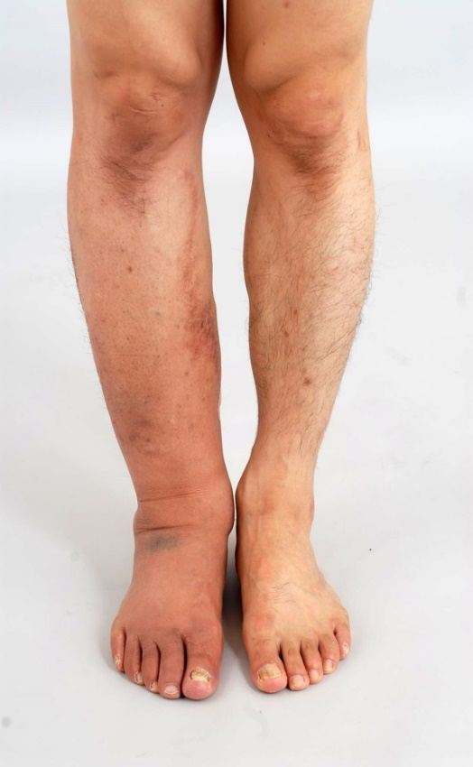
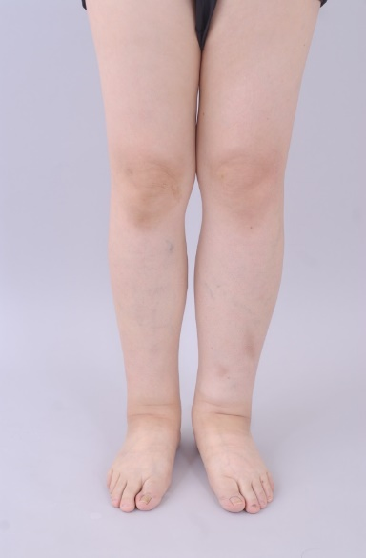
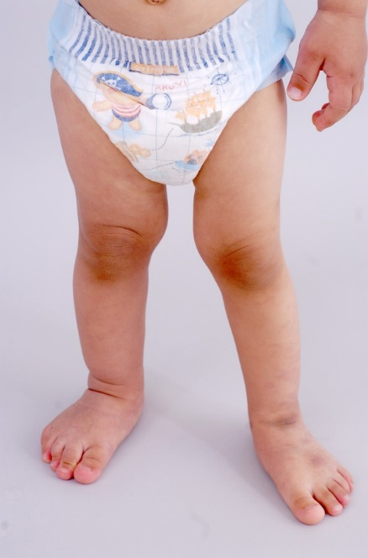
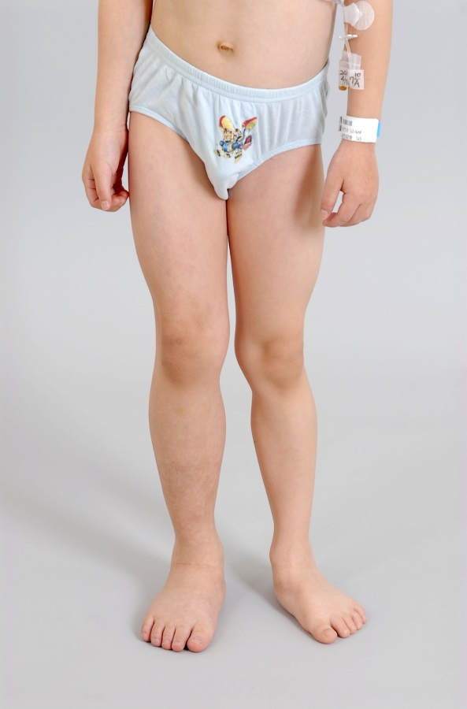
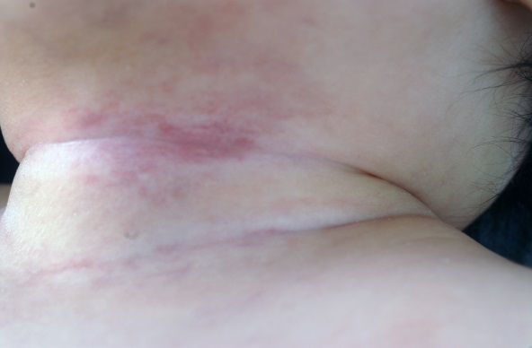
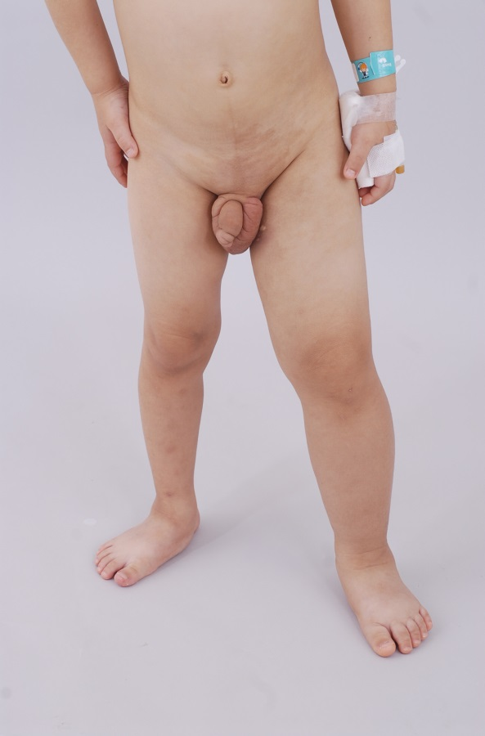
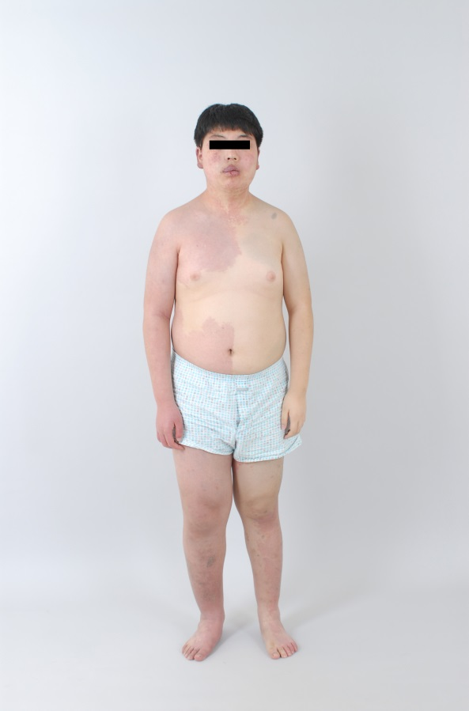
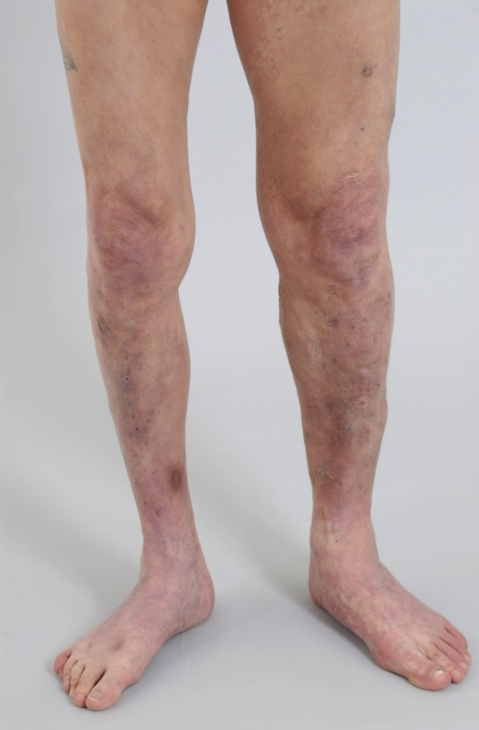
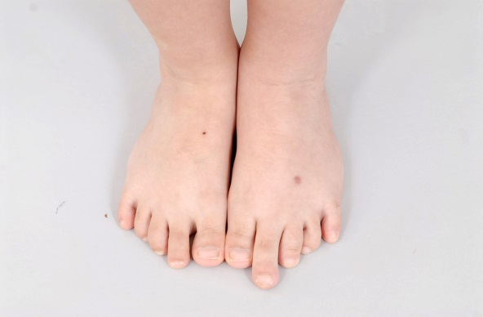
Additional File 1: Fig. S1. Clinical photos of the patients. (A) Patient 2 (PIK3CA mutation) with a long second toe of the left foot. (B) Patient 3 (PIK3CA mutation) with left leg overgrowth. (C) Patient 6 (PIK3CA mutation) with cutaneous capillary malformation on the neck. (D) Patient 7 (PIK3CA mutation) with right leg overgrowth. (E) Patient 8 (KRAS mutation) with right leg overgrowth. (F) Patient 11 (MAP2K3 mutation) with left leg overgrowth. (G) Patient 12 (GNAQ mutation) with right ipsilateral overgrowth and nevus flammeus. (H) Patient 13 (TBC1D4 mutation) with right leg overgrowth. (I) Patient 15 (no mutation identified) with right leg overgrowth and cutaneous capillary malformation.
(B)
(D)
(E)
(C)
(F)
(H)
(I)
(A)
(G)

Additional File 1: Fig. S2. Heatmap presenting the changes of cytokine levels before and after administration of propranolol in four patients who showed similar patterns of change.

