supplementary materials

 | Siemens VIDA | GE SIGNA Architect | United imaging uMR 880 | Manual background phase offset correction | Manual anti-aliasing | Segmentation Threshold
MASS | √ | √ | √ | NA | NA | NA
CVI42 | √ | √ | √ | √ | √ | √
TS FLOW | √ | NA | √ | NA | NA | √
Supplementary Materials 1. The post-processing characteristics of each software. Note: NA: not available. TS FLOW software is currently unable to process data from SIGNA Architect, GE Healthcare due to protocol incompatibility.

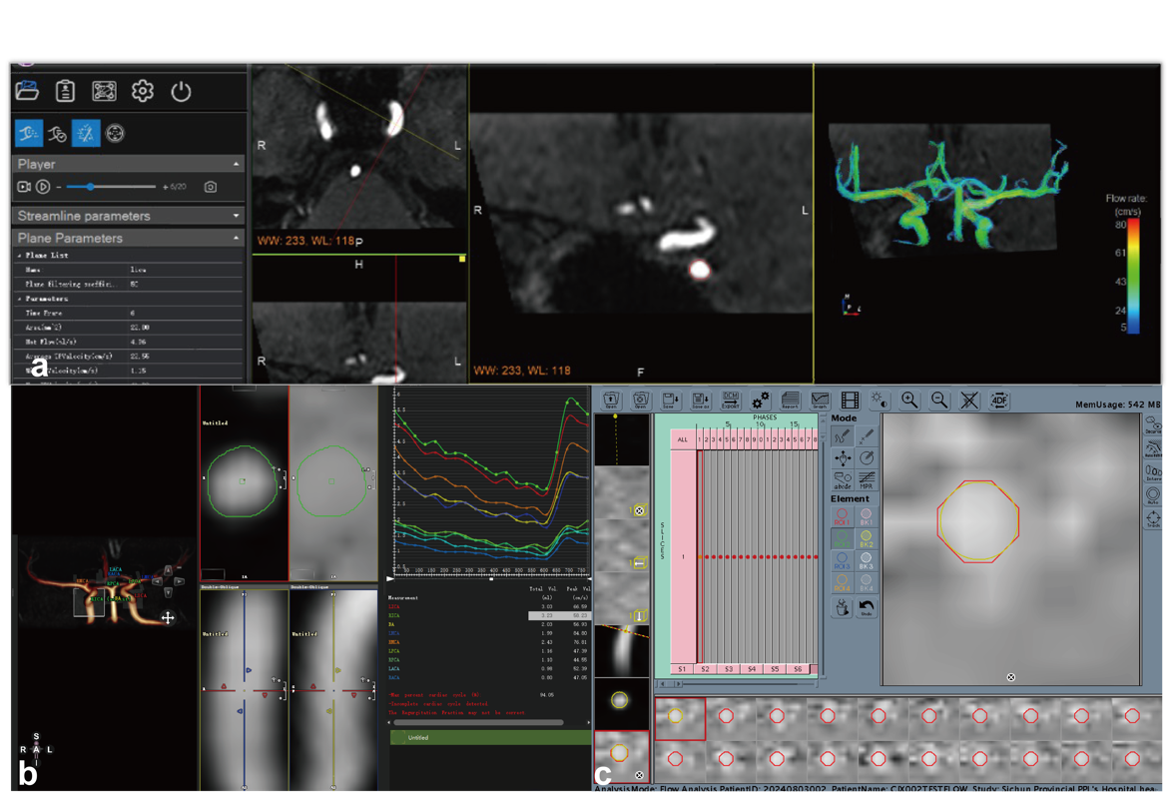

Supplementary Materials 2. Schematic illustration of ROI (Region of Interest) delineation for different software. (a) TS FLOW employs semi-automatic delineation, (b) MASS uses manual registration with customizable delineation and contour correction, and (c) CVI42 utilizes automatic registration delineation with contour correction.

ICC |  | LICA | BA | LMCA | LPCA | LACA
Flow  Rate | TS FLOW | 2.00±10.58 | -1.00±17.54 | 12.20±12.08 | -3.70±10.19 | -3.24±5.34
Flow  Rate | MASS | 5.15±15.66 | 4.70±14.68 | 2.11±10.06 | 2.08±3.91 | 4.20±6.41
Flow  Rate | CVI42 | -2.14±4.03 | 0.61±8.44 | -4.57±10.87 | -6.73±5.62 | -4.82±6.24
Vavg | TS FLOW | 0.51±1.30 | -1.74±4.19 | 1.29±2.80 | -0.17±2.14 | -0.39±1.85
Vavg | MASS | -0.67±2.59 | -2.38±4.32 | -0.53±2.85 | -1.69±2.57 | -0.66±3.05
Vavg | CVI42 | 1.86±3.40 | -1.36±3.21 | 1.14±2.56 | -0.69±1.07 | 2.57±4.75
Vmax | TS FLOW | 0.07±15.73 | -4.80±18.76 | 8.94±6.31 | 2.79±11.44 | 1.03±5.34
Vmax | MASS | 0.51±5.85 | -0.49±10.10 | 2.33±5.69 | 1.95±1.75 | -2.69±5.06
Vmax | CVI42 | 1.95±3.40 | -1.89±5.31 | -0.99±4.16 | 6.13±5.51 | 5.74±9.12

Supplementary Materials 3. Intra-observer variability for software TS FLOW, MASS and CVI42. Intra-observer variability expressed as mean bias ± standard deviation. The greatest standard deviation among the three software is indicated in bold. LICA: left internal carotid artery, BA: basilar artery, LMCA: left middle cerebral artery, LPCA: left posterior cerebral artery, LACA: left anterior cerebral artery.

The flow rate obtained by TS FLOW |  | Siemens VIDA |  |  | United imaging uMR 880 |  |  | p  （Wilcoxon） |  | ICC | 95% confidence interval
LICA |  | 327.96±62.18 |  |  | 327.09±64.81 |  |  | 0.936 |  | 0.861 | (0.681, 0.943)
RICA |  | 330.39±71.93 |  |  | 322.68±67.38 |  |  | 0.455 |  | 0.894 | (0.756, 0.956)
BA |  | 202.74±33.91 |  |  | 210.33±30.78 |  |  | 0.232 |  | 0.722 | (0.430, 0.879)
LACA |  | 80.13±11.85 |  |  | 82.72±15.10 |  |  | 0.156 |  | 0.834 | (0.630, 0.930)
RACA |  | 83.01±15.49 |  |  | 81.65±13.77 |  |  | 0.601 |  | 0.774 | (0.514, 0.904)
LMCA |  | 168.69±33.27 |  |  | 161.37±28.50 |  |  | 0.211 |  | 0.764 | (0.500, 0.899)
RMCA |  | 167.01±32.54 |  |  | 169.88±32.08 |  |  | 0.313 |  | 0.896 | (0.760, 0.957)
LPCA |  | 87.53±14.02 |  |  | 88.77±11.25 |  |  | 0.490 |  | 0.857 | (0.679, 0.941)
RPCA |  | 87.42±26.04 |  |  | 92.91±22.98 |  |  | 0.067 |  | 0.843 | (0.637, 0.935)
The flow rate obtained by MASS | Siemens VIDA |  | GE SIGNA Architect |  |  | United imaging uMR 880 |  |  | p  (Friedman) | ICC | 95% confidence interval
LICA | 234.51±39.59 |  | 229.97±42.24 |  |  | 226.91±39.61 |  |  | 0.449 | 0.863 | (0.740, 0.938)
RICA | 225.13±40.56 |  | 224.68±48.15 |  |  | 220.02±37.94 |  |  | 0.549 | 0.883 | (0.775, 0.948)
BA | 135.34±21.98 |  | 138.96±21.53 |  |  | 134.54±19.85 |  |  | 0.247 | 0.874 | (0.758, 0.943)
LACA | 66.34±13.82 |  | 69.95±16.97 |  |  | 66.17±16.50 |  |  | 0.091 | 0.822 | (0.670, 0.918)
RACA | 59.32±12.26 |  | 59.88±11.45 |  |  | 56.52±10.38 |  |  | 0.212 | 0.700 | (0.486,0.854)
LMCA | 135.09±26.05 |  | 136.30±21.26 |  |  | 134.69±24.93 |  |  | 0.705 | 0.768 | (0.582, 0.891)
RMCA | 139.14±29.26 |  | 142.39±26.20 |  |  | 138.70±37.93 |  |  | 0.212 | 0.847 | (0.712, 0.930)
LPCA | 60.50±10.78 |  | 62.02±11.98 |  |  | 60.99±13.03 |  |  | 0.705 | 0.780 | (0.602, 0.897)
RPCA | 62.11±18.20 |  | 65.46±17.26 |  |  | 62.92±17.11 |  |  | 0.165 | 0.890 | (0.786, 0.951)
The flow rate obtained by CVI42 | Siemens VIDA |  |  | GE SIGNA Architect |  |  | United imaging uMR 880 |  | p  (Friedman) | ICC | 95% confidence interval
LICA | 237.93±34.23 |  |  | 242.65±35.13 |  |  | 239.05±30.89 |  | 0.212 | 0.919 | (0.841, 0.964)
RICA | 232.51±42.93 |  |  | 247.39±41.92 |  |  | 238.51±43.16 |  | 0.085 | 0.915 | (0.820, 0.964)
BA | 143.11±20.38 |  |  | 148.10±21.40 |  |  | 145.22±19.47 |  | 0.056 | 0.803 | (0.630, 0.913)
LACA | 61.07±19.55 |  |  | 62.42±17.93 |  |  | 61.40±15.23 |  | 0.087 | 0.788 | (0.614, 0.902)
RACA | 63.40±17.18 |  |  | 61.92±13.27 |  |  | 62.79±16.07 |  | 0.675 | 0.858 | (0.073, 0.936)
LMCA | 141.98±31.78 |  |  | 146.50±30.17 |  |  | 136.11±37.52 |  | 0.142 | 0.741 | (0.546, 0.877)
RMCA | 138.70±38.25 |  |  | 146.99±28.96 |  |  | 145.88±32.59 |  | 0.058 | 0.859 | (0.721, 0.939)
LPCA | 65.32±15.36 |  |  | 70.66±14.08 |  |  | 66.60±15.96 |  | 0.387 | 0.703 | (0.490, 0.856)
RPCA | 61.51±12.13 |  |  | 64.80±10.93 |  |  | 64.45±14.31 |  | 0.277 | 0.793 | (0.624, 0.920)
Supplementary Materials 4. Consistency of blood flow rate of different scanners calculated by each software. Note: Data are presented as mean ± SD. ICC (p) is used to test whether the observed ICC value (or more extreme value) may be just the result of random variation. ICC (p) <0.05 reveal the consistency is unlikely to be just the result of random errors.

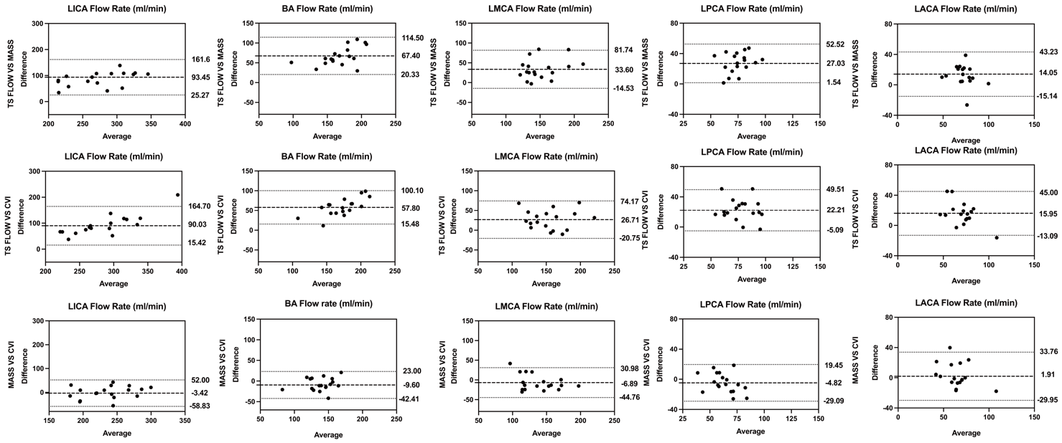
Supplementary Materials 5. Bland-Altman plots of flow rate between three software. Dashed lines indicate mean difference, dotted lines indicate limits of agreement.

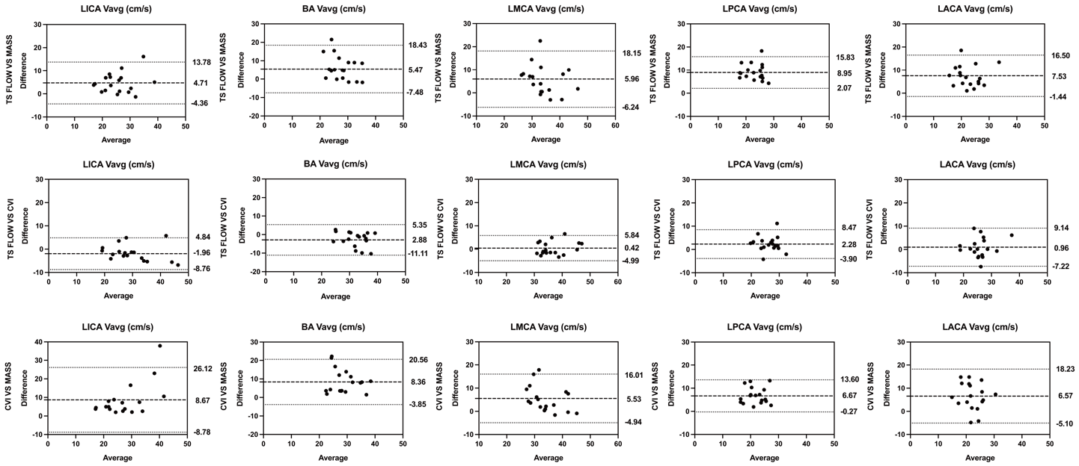
Supplementary Materials 6. Bland-Altman plots of Vavg between three software. Dashed lines indicate mean difference, dotted lines indicate limits of agreement.

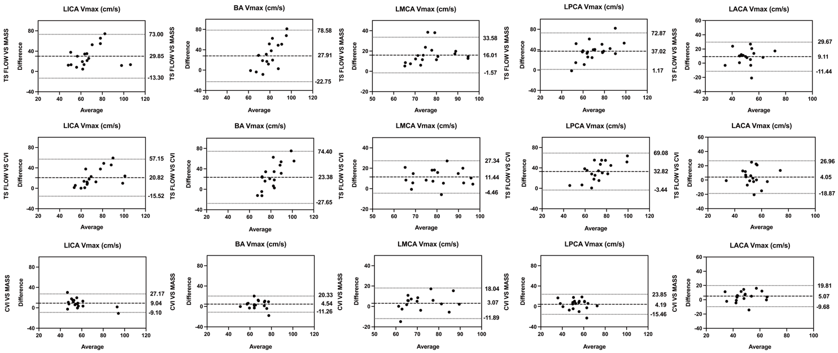

Supplementary Materials 7. Bland-Altman plots of Vmax between three software. Dashed lines indicate mean difference, dotted lines indicate limits of agreement.

ICC |  | LICA | RICA | BA | LMCA | RMCA | LPCA | RPCA | LACA | RACA
Flow  Rate | CVI42 | 0.845 | 0.746 | 0.921 | 0.727 | 0.970 | 0.759 | 0.936 | 0.834 | 0.871
Flow  Rate | MASS | 0.810 | 0.932 | 0.833 | 0.919 | 0.850 | 0.945 | 0.791 | 0.782 | 0.749
Flow  Rate | TS FLOW | 0.969 | 0.952 | 0.913 | 0.895 | 0.891 | 0.872 | 0.992 | 0.728 | 0.867
Vavg | CVI42 | 0.868 | 0.962 | 0.888 | 0.883 | 0.973 | 0.943 | 0.973 | 0.930 | 0.942
Vavg | MASS | 0.746 | 0.907 | 0.816 | 0.708 | 0.737 | 0.721 | 0.794 | 0.722 | 0.864
Vavg | TS FLOW | 0.957 | 0.935 | 0.785 | 0.906 | 0.750 | 0.746 | 0.705 | 0.858 | 0.852
Vmax | CVI42 | 0.785 | 0.791 | 0.874 | 0.899 | 0.962 | 0.749 | 0.606 | 0.665 | 0.624
Vmax | MASS | 0.729 | 0.879 | 0.658 | 0.740 | 0.658 | 0.618 | 0.669 | 0.743 | 0.822
Vmax | TS FLOW | 0.891 | 0.859 | 0.699 | 0.771 | 0.798 | 0.728 | 0.665 | 0.724 | 0.766
 | CVI42 | 0.753 | 0.600 | 0.846 | 0.719 | 0.812 | 0.563 | 0.643 | 0.644 | 0.695
Area | MASS | 0.099 | 0.392 | 0.076 | 0.457 | 0.541 | 0.660 | 0.470 | 0.167 | 0.754
 | TS FLOW | 0.934 | 0.966 | 0.886 | 0.895 | 0.979 | 0.898 | 0.992 | 0.821 | 0.909
Supplementary Materials 8. The Intra-observer Variation among different software in nine main large intracranial arteries

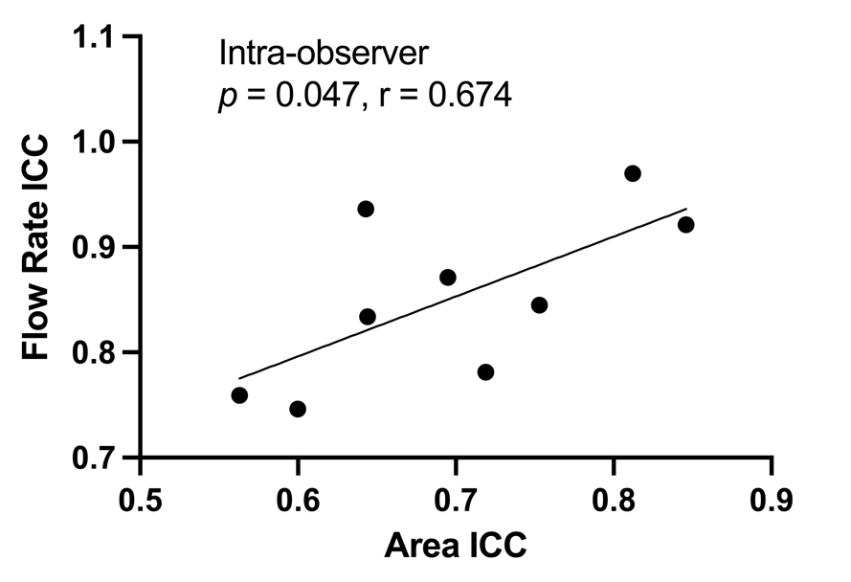
Supplementary Materials 9. Based on the intra-observer ICC results, a correlation analysis was performed between the ICC of flow rate and the ICC of Vessel area for the CVI42 software. Since the data were normally distributed, Pearson correlation coefficient was used for statistical analysis.

ICC |  | LICA | RICA | BA | LMCA | RMCA | LPCA | RPCA | LACA | RACA
Flow  Rate | CVI42 | 0.301 | 0.372 | 0.316 | 0.321 | 0.054 | 0.688 | 0.593 | 0.278 | 0.837
Flow  Rate | MASS | 0.900 | 0.831 | 0.818 | 0.752 | 0.689 | 0.657 | 0.317 | 0.179 | 0.510
Flow  Rate | TS FLOW | 0.973 | 0.903 | 0.896 | 0.893 | 0.759 | 0.837 | 0.958 | 0.691 | 0.590
Vavg | CVI42 | 0.785 | 0.865 | 0.968 | 0.859 | 0.759 | 0.763 | 0.776 | 0.630 | 0.607
Vavg | MASS | 0.920 | 0.907 | 0.828 | 0.832 | 0.754 | 0.249 | 0.480 | 0.477 | 0.412
Vavg | TS FLOW | 0.957 | 0.981 | 0.814 | 0.821 | 0.624 | 0.647 | 0.766 | 0.766 | 0.733
Vmax | CVI42 | 0.910 | 0.846 | 0.711 | 0.530 | 0.763 | 0.724 | 0.710 | 0.575 | 0.688
Vmax | MASS | 0.946 | 0.887 | 0.726 | 0.749 | 0.567 | 0.523 | 0.677 | 0.548 | 0.511
Vmax | TS FLOW | 0.891 | 0.714 | 0.731 | 0.703 | 0.786 | 0.733 | 0.719 | 0.727 | 0.695
 | CVI42 | 0.402 | 0.052 | 0.322 | 0.073 | 0.043 | 0.529 | 0.156 | 0.326 | 0.764
Area | MASS | 0.565 | 0.486 | 0.683 | 0.290 | 0.650 | 0.354 | 0.236 | 0.107 | 0.594
 | TS FLOW | 0.851 | 0.963 | 0.892 | 0.818 | 0.877 | 0.900 | 0.851 | 0.722 | 0.780

Supplementary Materials 10. The Inter-observer Variation among different software in nine main large intracranial arteries.

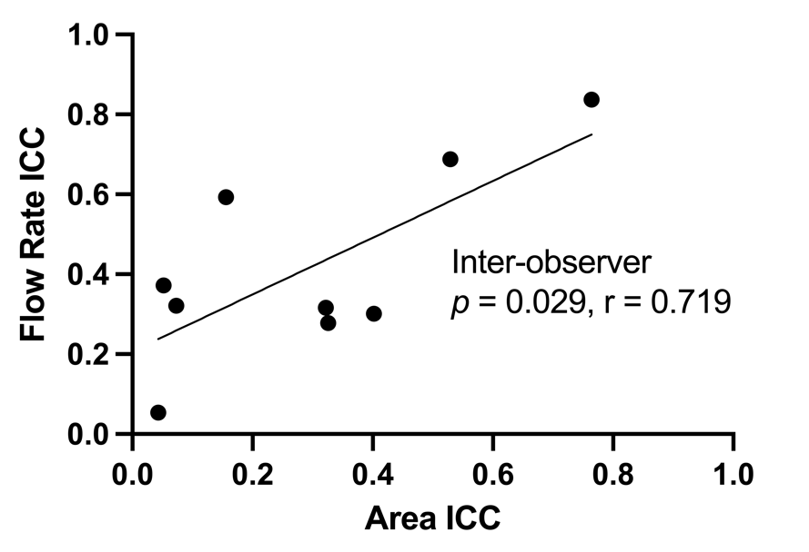
Supplementary Materials 11. Based on the inter-observer ICC results, a correlation analysis was performed between the ICC of flow rate and the ICC of Vessel area for the CVI42 software. Since the data were normally distributed, Pearson correlation coefficient was used for statistical analysis.

