Supporting Information

Table S1. Sequences of DNs used in this study
Six helix bundle
Name | Sequence (5’-3’)
helix-0 | TTTAGTGCCGATTCATTAATGCAGCTGGCACGACAGGTATCCCGACA
helix-1 | TTTCTAGGCGCTGCAGTGAGCGCAACGCAATTAATGTGAGCCAGCTTT
helix-2 | TTTCATCAGACACCCCAGGCTTTACACTTTATGCTTCGCAGGTTGTTT
helix-3 | TTTTGCCAGGCTGAGTGGATAACAAGTTCACACAGGCAGCAGCTG
helix-4 | TTTACCACGCTCACGAATTCGAGCTCGGTACCCGGGGATGCTGACTTT
helix-5 | TTTGACGCCATGCGTATACGGTCGCTAGCGGACTTGCCTCACTACTTT
helix-s-a | TTTTGTCGGGATGGCGTCGTCAGCATCCCCGGCACTCAGCGAAGCA
helix-s-b | ATTGCGTTAAAGCCGTGAACTTGTTATCGTACCGACGACCGT
helix-s-c | CGCCTAGCAACCTGCCTGGCA
helix-s-d | TAAAGTGTGCGCTCCGTGCCAGCTGCATCCGCTAGGCTCGAA
helix-s-e | CAGCTGCGCGTGGTGTAGTGAGGCAAGTTAATGAACACATTA
helix-s-e-Alexa 647 | / 5Alexa 647/ CAGCTGCGCGTGGTGTAGTGAGGCAAGTTAATGAACACATTA
helix-s-f | TTCGTGATGCCTGTTGGGGTGTCTGATGGCTGGCTTCGGCACT
helix-s-g | ATACGCATACCTGTACTGCAG
Three point star
Name | Sequence (5’-3’)
Star-Center | AGGCATATTGAATCGTTTACAGGATTAGTAATTAACAGCTTTAATATCATCGCCCATCGTAGGTTTCTTGCC
Star-E-a-N3 | CCACCTTAACACGCGATGATATTGCTGTTAATTAGGCTCGGT
Star-E-a | CCACCTTAACACGCGATGATATTGCTGTTAATTAGGCTCGGT
Star-E-b | CGATGTTGACGGACTAATCCTGTCGATTCAATATCTGTCGTC
Star-E-c | CGCCTAGCAACCTGCCTGGCAAGCCTACGATGGACACGGTAA
Star-S-a | TTTGACGACAGAGGTTGCTAGGCG
Star-S-b | TTACCGTGTGTGTTAAGGTGG
Star-S-b-Alexa 647 | / 5Alexa 647/ TTACCGTGTGTGTTAAGGTGG
Star-S-c | ACCGAGCCTCCGTCAACATCG
Tetrahedral DNA nanostructure
Name | Sequence (5’-3’)
A-1 | CCCTGTACTGGCTAGGAATTCACGTTTTAATCTGGGCTTTGGGTTAAGAAACTCCCCG
A-1-Alexa 647 | / 5Alexa 647/TACTGGCTAGGAATTCACGTTTTAATCTGGGCTTTGGGTTAAGAAACTCCCCG
A-2 | CGCTGGAGGCGCATCACCGTTTGCGTATGTGTTCTGTGCGGCCTGCCGTCCCGTGTGGG
B-1 | CGGTGATGCGCCTCCAGCGCGGGGAGTTTCTTAACCCTTTCCGACTTACAAGAGCCGG
B-2 | GCGAGACTCAGGTGGTGCCTTTGGCATTCGACCAGGAGATATCGCGTTCAGCTATGCCC
C-1 | CCCATGAGAATAATACCGCCGATTTACGTCAGTCCGGTTTCCCACACGGGACGGCAGGC
C-2 | CGCACAGAACACATACGCTTTGGGCATAGCTGAACGCGATATCTCCTGGTCGAATGCC
D-1 | GCCCAGATTAAAACGTGAATTCCTAGCCAGTACAGGGTTTCCGGACTGACGTAAATCGG
D-2 | CGGTATTATTCTCATGGGTTTGGCACCACCTGAGTCTCGCCCGGCTCTTGTAAGTCGG

Table S2. Primer sequences used in this study
Gene | Forward | Reverse
GAPDH (Homo sapiens) | CACCCACTCCTCCACCTTTG | CCACCACCCTGTTGCTGTAG
Col I (Homo sapiens) | AGTGGTTTGGATGGTGCCAA | GCACCATCATTTCCACGAGC
Col III (Homo sapiens) | CTTCTCTCCAGCCGAGCTTC | CCAGTGTGTTTCGTGCAACC
bFGF (Homo sapiens) | GGCTGCTACTTGGAGGCTTAT | AACACCTCCAGCATTTCGGT
αSMA (Homo sapiens) | CTTTGGCTTGGCTTGTCAGG | GTGCGGACAGGAATTGAAGC
Aggrecan (Homo sapiens) | CTTCCGCTGGTCAGATGGAC | CGTTTGTAGGTGGTGGCTGT
Col II (Homo sapiens) | TGGACGATCAGGCGAAACC | GCTGCGGATGCTCTCAATCT
Sox9 (Homo sapiens) | GGACCACCCGGATTACAAGT | AAGATGGCGTTGGGGGAGAT
MMP13 (Homo sapiens) | TGAGCTGGACTCATTGTCGG | GAGCCTCTCAGTCATGGAGC
GAPDH (Mus musculus) | TCAACGGCACAGTCAAG | ACTCCACGACATACTCAGC
MyoD (Mus musculus) | CCAGGACACGACTGCTTTCT | CAAGCCGTGAGAGTCGTCTT
Myf5 (Mus musculus) | CTTCGGAGCACACAAAGCTG | GGTTGACCTTCTTCAGGCGT
MyoG (Mus musculus) | CGGTGGAGGATATGTCTGTTG | GGTGTTAGCCTTATGTGAATGG
Myh3 (Mus musculus) | CTTCACCTCTAGCCGGATGGT | AATTGTCAGGAGCCACGAAAAT

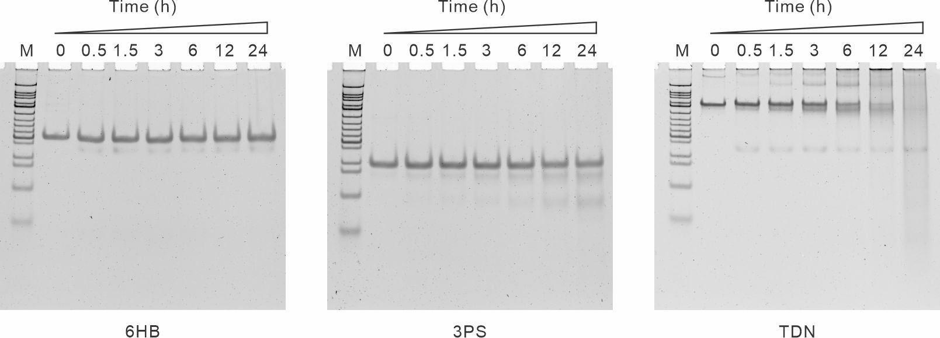
Figure S1. Stability of the DNA nanostructure (DN) in 10% FBS. DNs were incubated in DMEM medium with 10% FBS at 37 °C for 0, 1.5, 3, 6, 12, and 24 hours. The integrity of DNs was examined by non-denaturing 6% PAGE analysis. 6HB had the best stability among the three DNs, remaining above 95% after 24 hours.

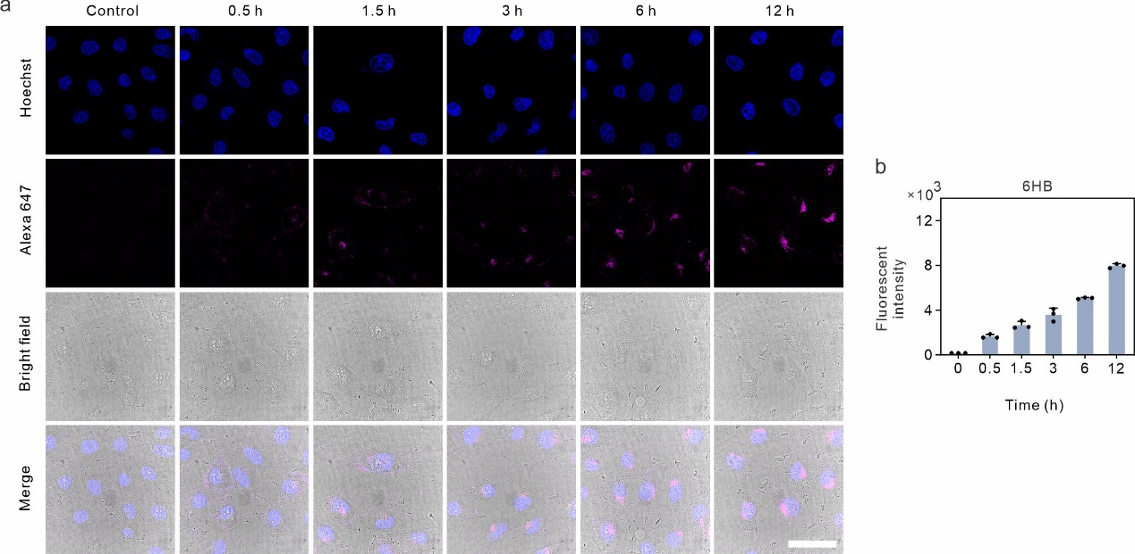
Figure. S2 Time-dependent cellular uptake of 6HB. a. Confocal images of HUVECs treated with 200 nM of Alexa 647 labelled 6HB for different periods of time (0.5 to 12 hours) at 37°C. Nontreated cells were studied as negative controls. Scale bar: 40 μm. b. Flow cytometry analysis of cellular uptake of Alexa 647-DNs. Quantification of the mean fluorescence intensities of cells was shown (n = 3 per group). Data are presented as the mean ± SD.

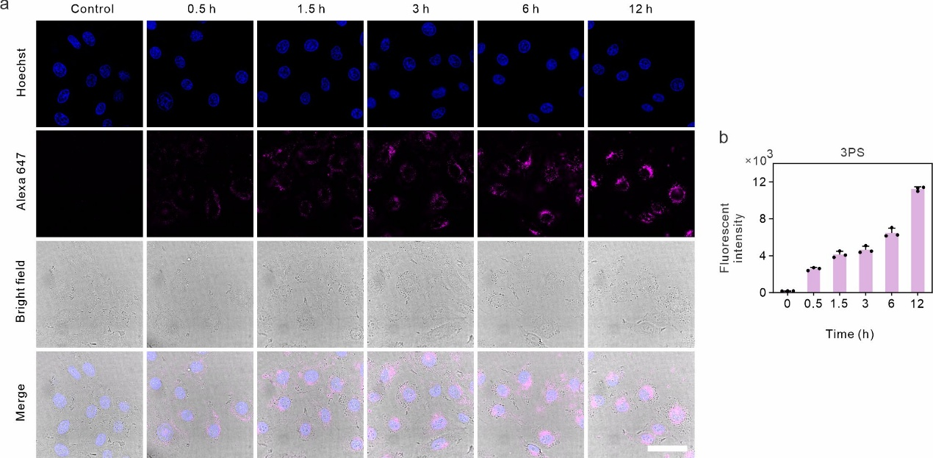
Figure. S3 Time-dependent cellular uptake of 3PS. a. Confocal images of HUVECs treated with 200 nM of Alexa 647 labelled 3PS for different periods of time (0.5 to 12 hours) at 37°C. Nontreated cells were studied as negative controls. Scale bar: 40 μm. b. Flow cytometry analysis of cellular uptake of Alexa 647-DNs. Quantification of the mean fluorescence intensities of cells was shown (n = 3 per group). Data are presented as the mean ± SD.

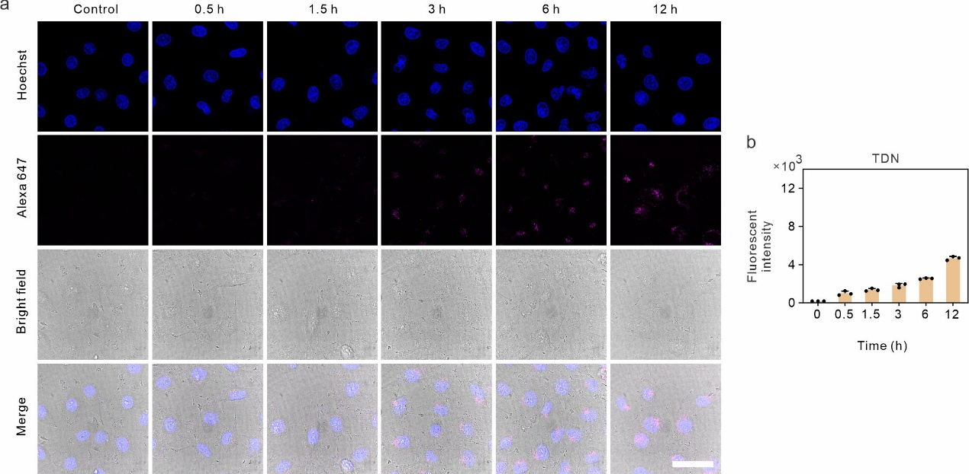
Figure. S4 Time-dependent cellular uptake of TDN. a. Confocal images of HUVECs treated with 200 nM of Alexa 647 labelled TDN for different periods of time (0.5 to 12 hours) at 37°C. Nontreated cells were studied as negative controls. Scale bar: 40 μm. b. Flow cytometry analysis of cellular uptake of Alexa 647-DNs. Quantification of the mean fluorescence intensities of cells was shown (n = 3 per group). Data are presented as the mean ± SD.

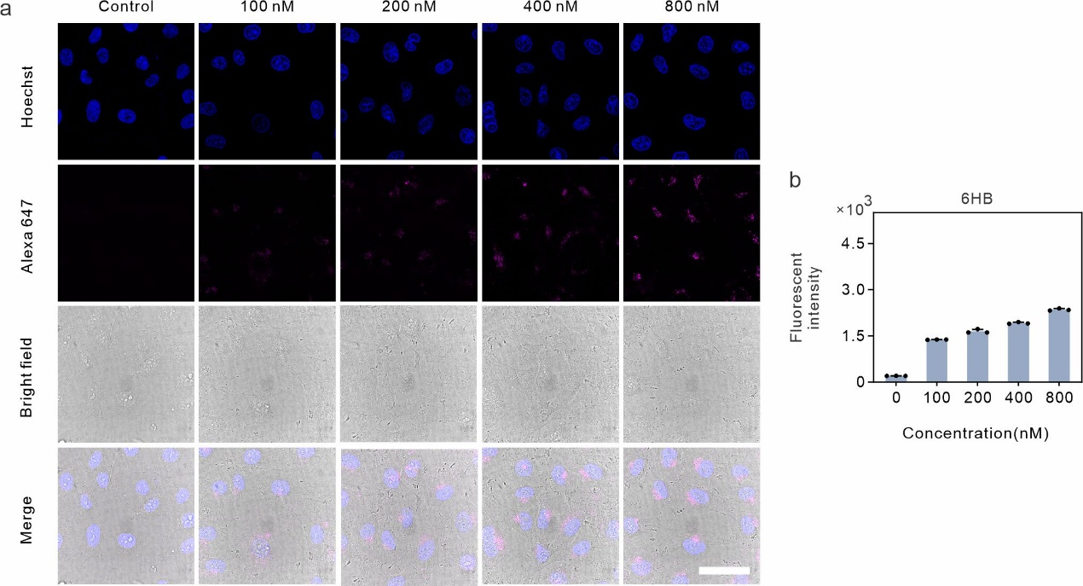
Figure. S5 Concentration-dependent cellular uptake of 6HB. a. Confocal images of HUVECs treated with different concentration (100 nM to 800 nM) of Alexa 647 labelled 6HB for 3 hours at 37°C. Nontreated cells were studied as negative controls. Scale bar: 40 μm. b. Flow cytometry analysis of cellular uptake of Alexa 647-DNs. Quantification of the mean fluorescence intensities of cells was shown (n = 3 per group). Data are presented as the mean ± SD.

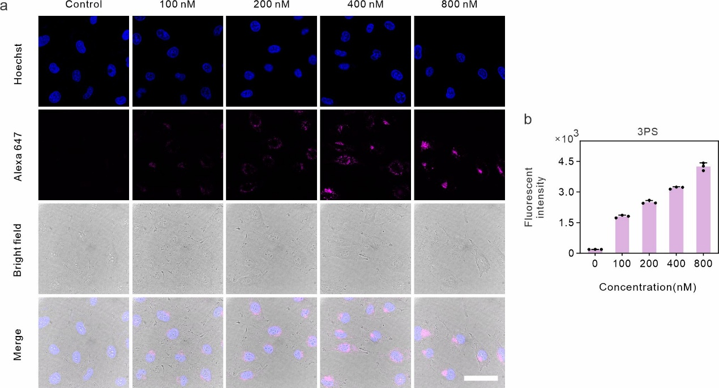
Figure. S6 Concentration-dependent cellular uptake of 3PS. a. Confocal images of HUVECs treated with different concentration (100 nM to 800 nM) of Alexa 647 labelled 3PS for 3 hours at 37°C. Nontreated cells were studied as negative controls. Scale bar: 40 μm. b. Flow cytometry analysis of cellular uptake of Alexa 647-DNs. Quantification of the mean fluorescence intensities of cells was shown (n = 3 per group). Data are presented as the mean ± SD.

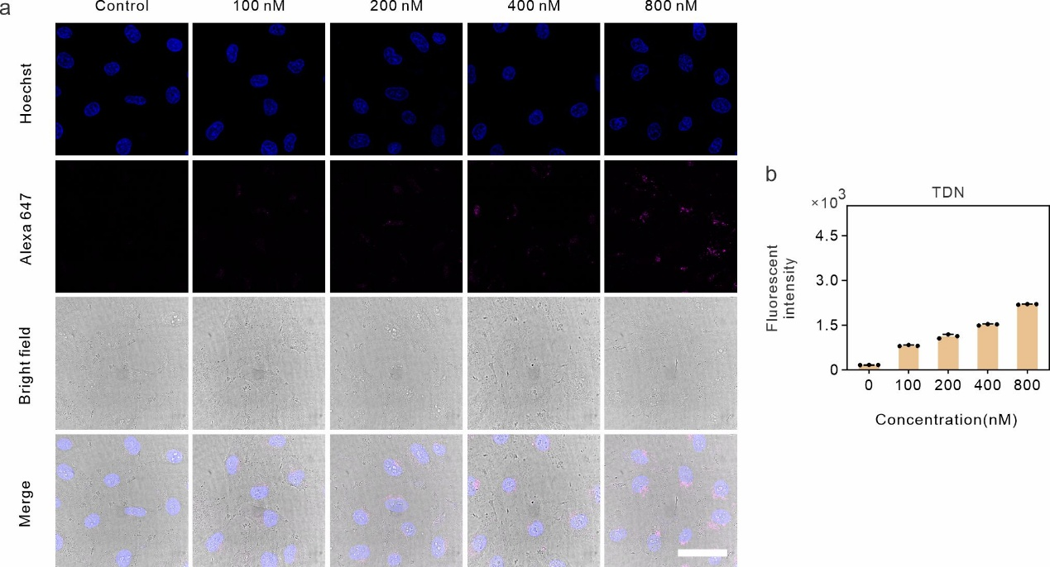

Figure. S7 Concentration-dependent cellular uptake of TDN. a. Confocal images of HUVECs treated with different concentration (100 nM to 800 nM) of Alexa 647 labelled TDN for 3 hours at 37°C. Nontreated cells were studied as negative controls. Scale bar: 40 μm. b. Flow cytometry analysis of cellular uptake of Alexa 647-DNs. Quantification of the mean fluorescence intensities of cells was shown (n = 3 per group). Data are presented as the mean ± SD.

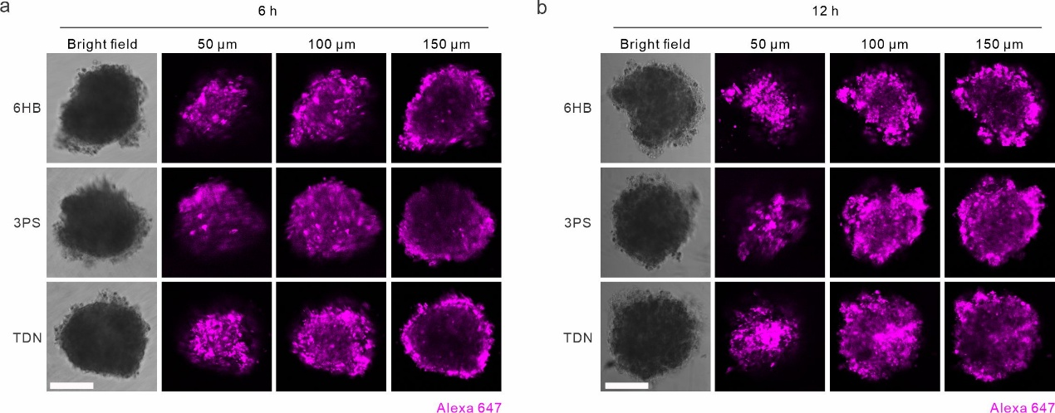
Figure. S8 3D cell invasion of DNs in the SW1353 spheroid model for 6 (a) and 12 (b) hours. All three structures penetrated to the inner layer after 12 hours. Scale bar: 200 μm.

