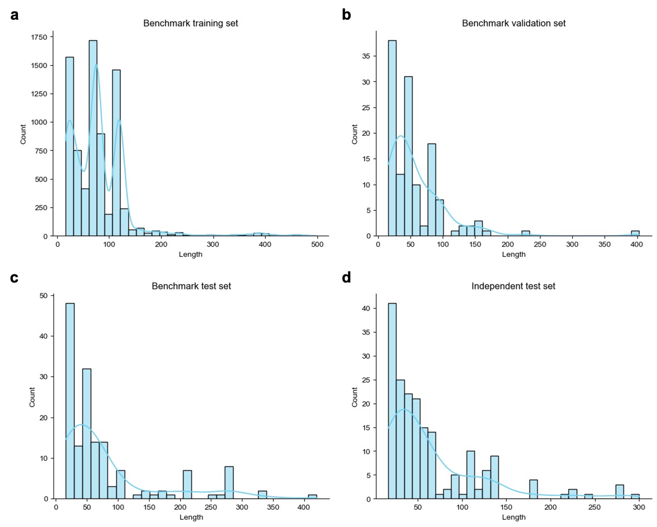
Fig. S1 | Sequence length distribution. Distribution of sequence lengths in the (a) benchmark training set, (b) benchmark validation set, (c) benchmark test set, and (d) independent test set.

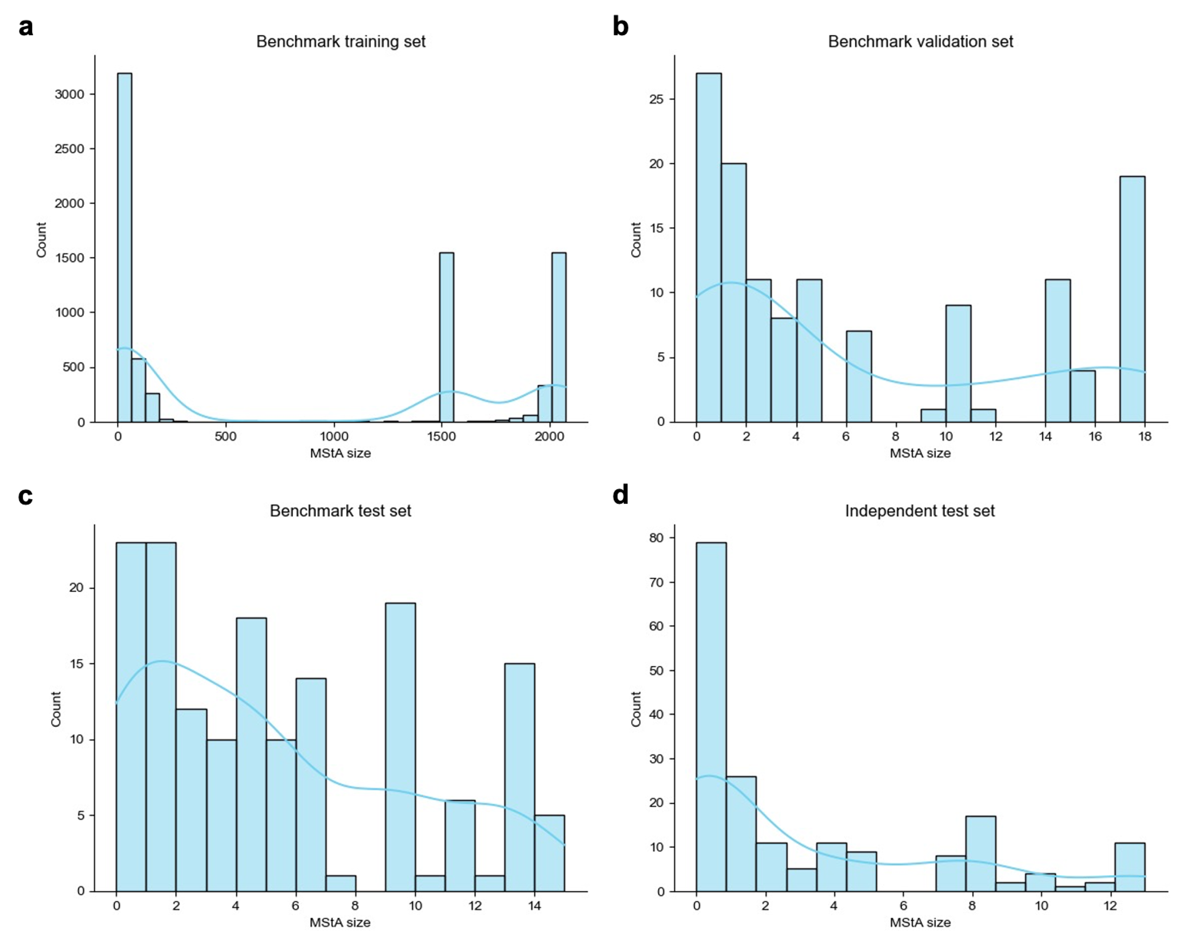
Fig. S2 | MStA size distribution. Distribution of MStA sizes in the (a) benchmark training set, (b) benchmark validation set, (c) benchmark test set, and (d) independent test set.

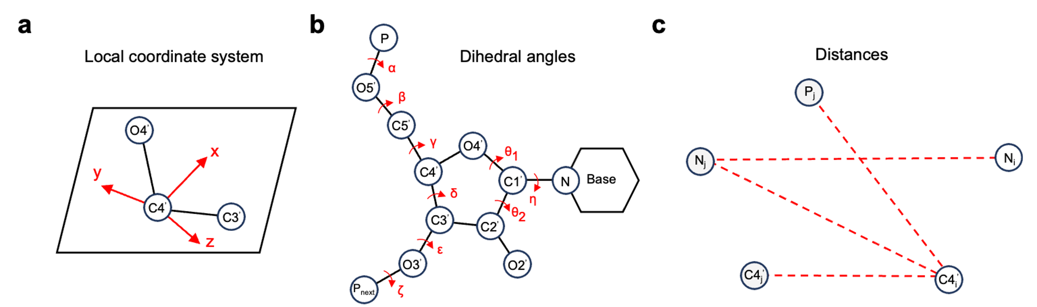
Fig. S3 | Extracted features from RNA backbone structures. a, Illustration of the local coordinate system defined by the C3’, C4’, and O4’ atoms. b, Six backbone torsion angles ($\text{α}$-$\text{ζ}$), one base orientation-related dihedral angle ($\text{η}$), and two additional dihedral angles C2’–C1’–O4’–C4’ (${\text{θ}}_{\text{1}}$) and O4’–C1’–C2’–O2’ (${\text{θ}}_{\text{2}}$) c, Inter-residue distances extracted to characterize structural features between adjacent nucleotides.

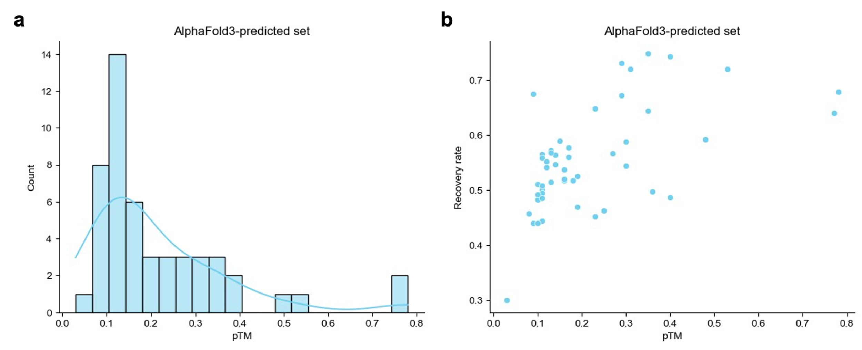
Fig. S4 | Analysis of the AlphaFold3-predicted set. a, Distribution of predicted TM-score (pTM) values in the AlphaFold3-predicted set. b, Correlation between pTM values and residue recovery rates, showing a positive trend.

