Platelet-derived exosomes in situ reprogramming macrophages for rheumatoid arthritis treatment

Dong Yuª, Dan Wangª, Yuqiu Yuª, Yinjin Xuª, Wenting Tangª, Yuehua Guo^{b}，Aidong Deng^{a,*}

ª Department of Hand Surgery, Affiliated Hospital of Nantong University, Nantong 226001, P.R. China
^{b} Research Center of Clinical Medicine, Affiliated Hospital of Nantong University, Nantong 226001, P.R. China
* Corresponding author.
- E-mail addresses: aidong_deng@163.com (A. Deng)

Supplementary figure S1. Proteomic analysis of PLT-Exos. a) Hierarchical clustering of differentially expressed proteins (DEPs) (Fold change > 1.5 and P value < 0.05) between platelet and PLT-Exos, with protein abundance being Z-score normalized. Rows represent proteins and columns represent individual replicates. b) Volcano plot showing significantly upregulated (red dots) and downregulated (blue dots) proteins in PLT-Exos, compared to platelet. c-e) GO enrichment analysis of DEPs in PLT-Exos. The Y-axis represents GO terms and the X-axis represents rich factor. The colour of the bubble represents enrichment significance and the size of the bubble represents number of upregulated proteins. f) Gene ontology (GO) analysis of DEPs in PLT-Exos, categorized into ‘Biological process’, ‘Cellular component’ and ‘Molecular function’. g) Kyoto Encyclopedia of Genes and Genomes (KEGG) pathway analysis of DEPs in PLT-Exos.

Supplementary figure S2. Effect of PLT-Exos on Macrophages Polarization In Vitro. mRNA expression levels of a) IL-6, b) IL-1β, c) TNF-α, d) Arg-1, e) TGF-β and f) IL-10 in M1 macrophages treated with different concentrations of PLT-Exos determined by qRT-PCR. β-Actin served as internal control. Data are presented as the mean ± SD (n = 3, * p < 0.05, *** p < 0.001, **** p < 0.0001).

Supplementary figure S3. Effect of PLT-Exos on recovery of motor function in CIA mice. a) Changes in forepaw grip strength over time for each treatment group (n = 5). b) Changes in hind paw grip strength over time for each treatment group (n = 5). c) Paw prints of hind feet collected after three weeks of treatment for each group. d) AFI for each group following three weeks of treatment.

Supplementary figure S4. The effect of PLT-Exos on the proportion of different immune cells in the blood and spleens of CIA mice. a-d) Representative plots (left) and quantification (right) of IFN-γ+CD4+ and Foxp3+CD25+ cells in spleens of CIA mice analyzed by flow cytometry (n=3). e-h) Representative plots (left) and quantification (right) of IFN-γ+CD4+ and Foxp3+CD25+ cells in the blood of CIA mice analyzed by flow cytometry (n=3). Data are represented as mean ± SEM. Statistical significance was calculated by Student’s t-test. *P<0.05, **P<0.01, ns, non-significant.

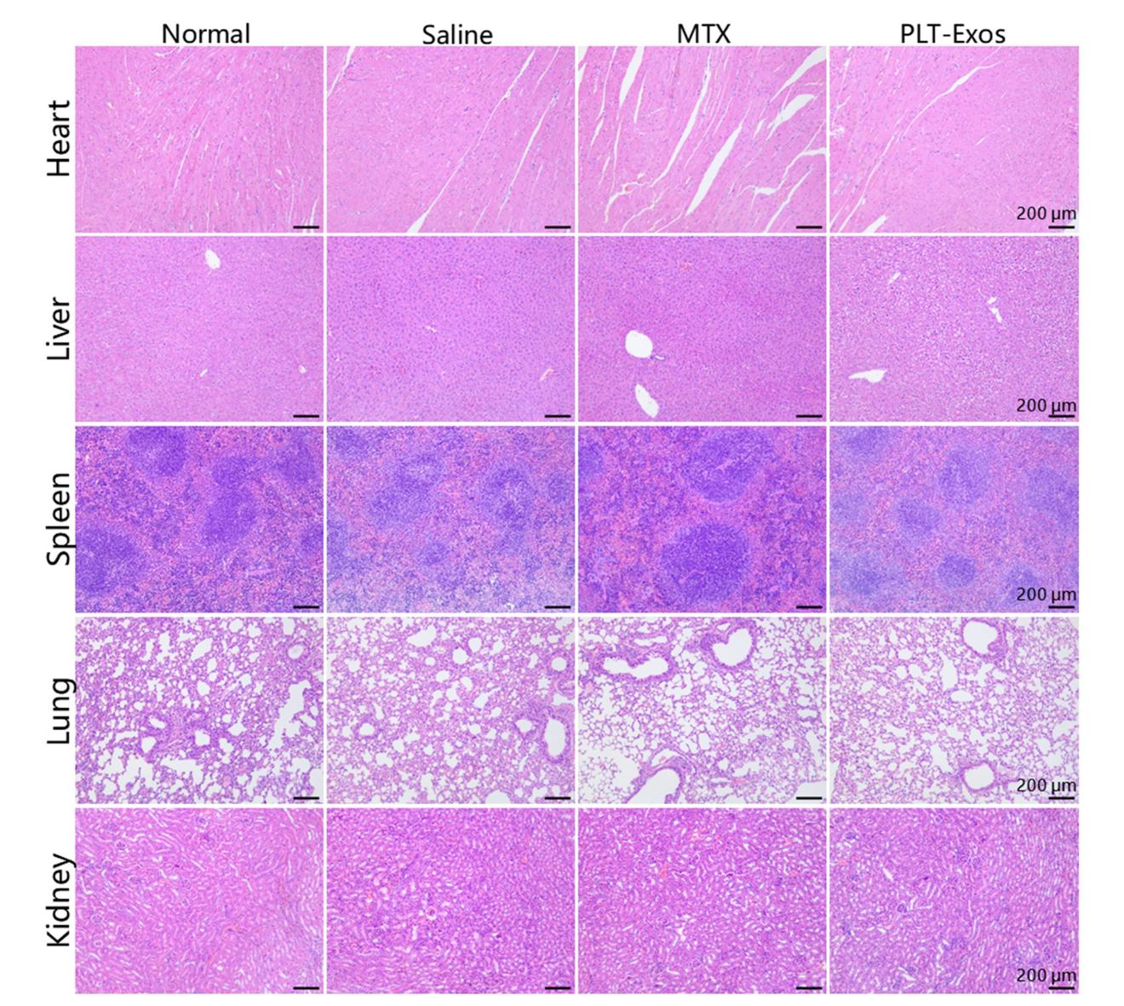
Supplementary figure S5. The safety of the PLT-Exos. HE straining of the major organs from CIA mice treated with PLT-Exos.

CD9

CD63

CD81

CD41

GAPDH

