Supplementary Materials

Dust and Smoke layers over the Atlantic Ocean weaken the underlying low-level cloud-top radiative cooling through different pathways.

Satyendra K. Pandey¹ and Adeyemi A. Adebiyi¹
¹Department of Life and Environmental Sciences, University of California - Merced, Merced, CA, USA

Table S1. Details of dataset used in the present study
Platform | Product Version | Key Parameters Used | Resolution | References
CALIPSO | CAL_LID_L2_05kmMLay, Version 4.20 | Aerosol Layer Top & Bottom Cloud Top and Bottom  Number of Layers  Feature Type and Subtype | 5 km horizontal,  30–180 m vertical | Winker et al., 2010; Vaughan et al., 2009; Liu et al., 2019
CALIPSO | CAL_LID_L2_05kmAProf Version 4.20 | Extinction Coefficient 532nm  Aerosol optical depth 532nm | 5 km horizontal,  30–180 m vertical | Winker et al., 2010; Vaughan et al., 2009; Liu et al., 2019
CALIPSO | Reanalysis, integrated in CALIPSO L2 | Temperature, Pressure, Relative Humidity | 5 km horizontal,  30–180 m vertical | Winker et al., 2010; Vaughan et al., 2009; Liu et al., 2019
CloudSat | 2B-FLXHR-LIDAR, Version R05  Radiative Flux | Shortwave/Longwave Flux (Up/Down),  Heating Rates All-sky and No-Aerosol Scenarios, | ~240 m vertical | Henderson et al., 2013; L’Ecuyer et al., 2008  Mace and Zhang, 2014
CloudSat | 2B-GEOPROF-LIDAR Version R05 | Cloud Fraction | ~240 m vertical
CloudSat | CloudSat ECMWF-AUX, interpolated to Cloud profiling radar bins | Temperature,  Pressure,  Specific Humidity, Surface Pressure, Surface Temperature |  | Cronk, 2017

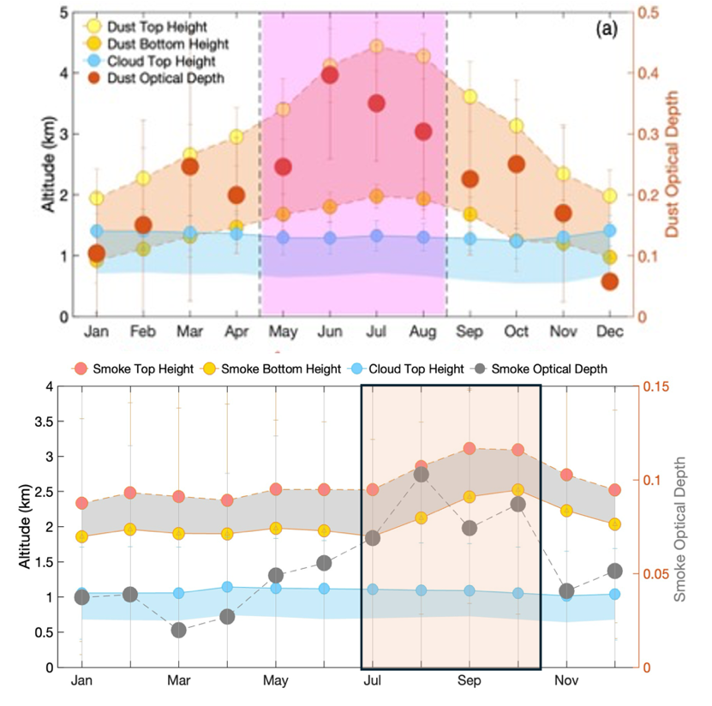

Figure S1: Seasonality of dust and smoke layer structure along with optical depth over the selected study domain.
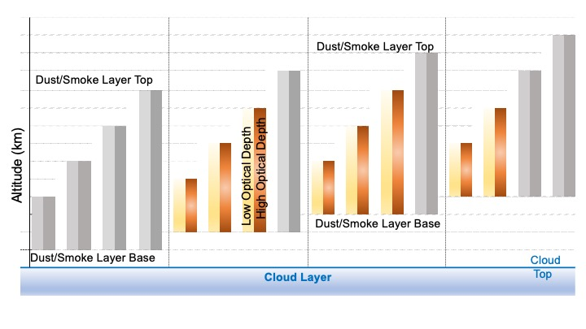
Figure S2: Categorization of smoke and dust layer based on geometrical thickness and layer base altitude. Highlighted are categories which satisfy the selection criteria and used in our analysis.
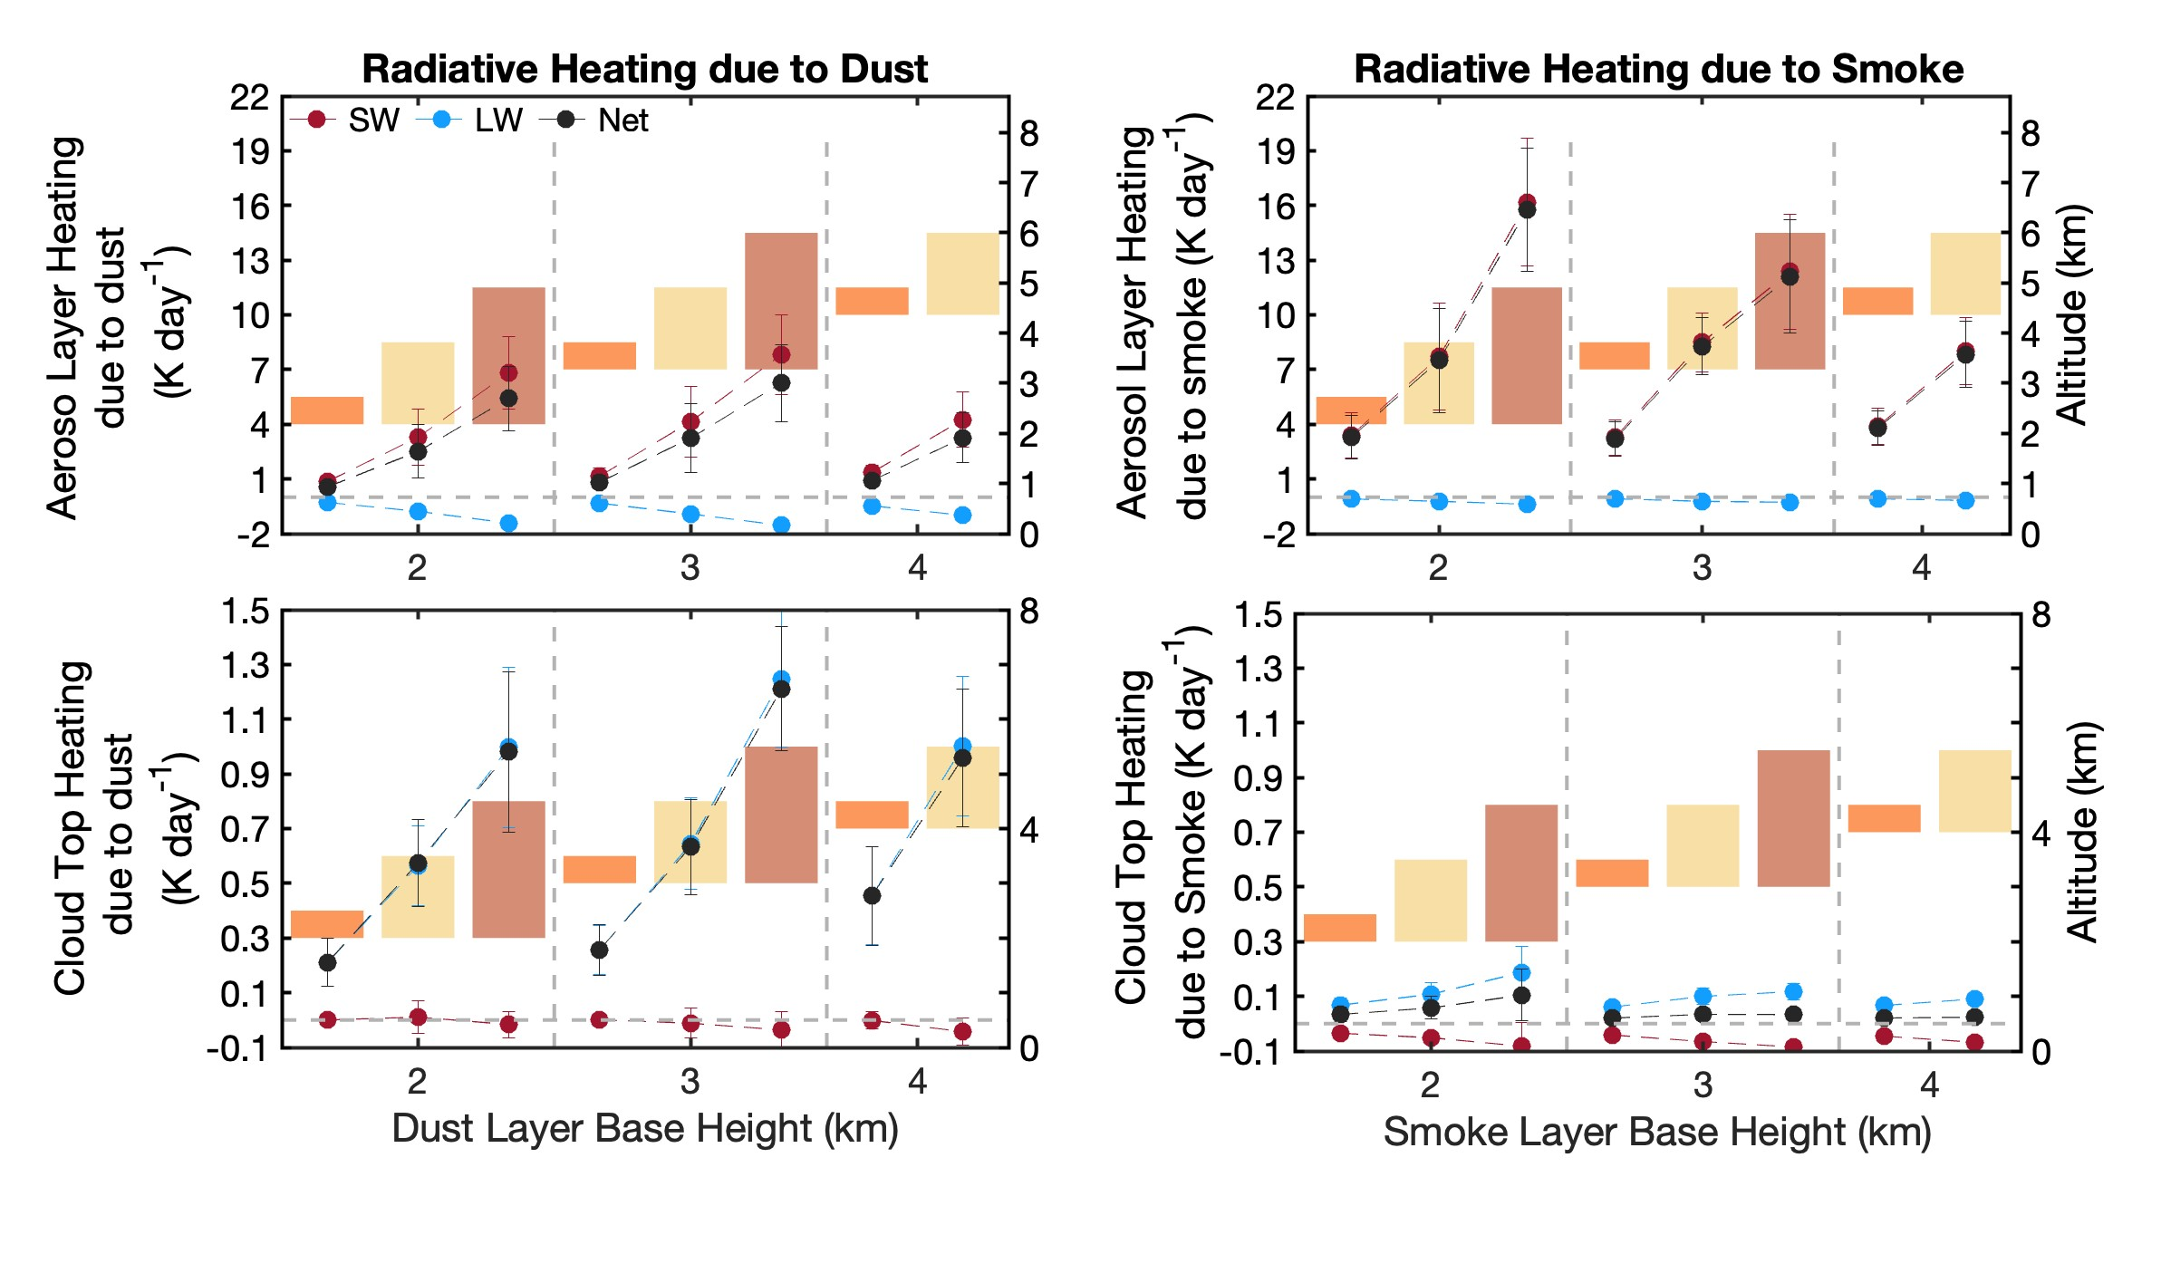
Figure S3: Radiative heating due to dust and smoke within the dust and smoke layers (top panels) and at the cloud top (bottom panels) is shown as a function of categories. Red dots represent shortwave, blue represents longwave, and black represents the net (shortwave minus longwave). Bars are grouped based on layer base altitude; layers with the same geometric thickness are shown in the same color. Orange, yellow, and purple represent layers 0.5km, 1.5km, and 2.5km thick, respectively.
Figure S4: Variation in (a) dust and (b) smoke optical depth (red dots), along with layer mean relative humidity (blue dots)
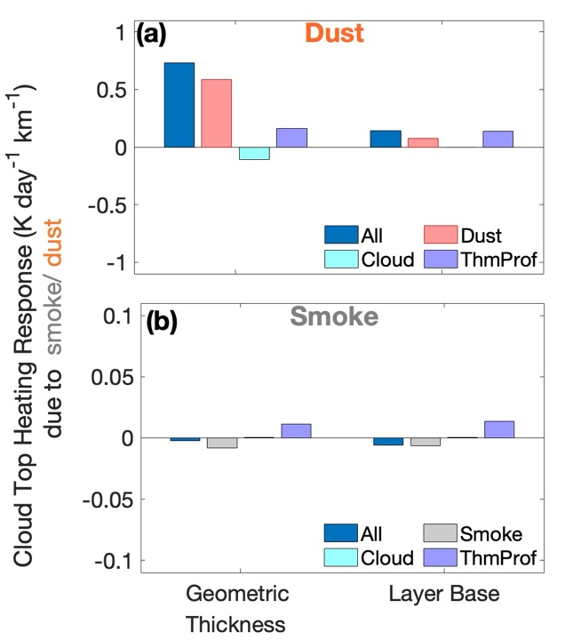
Figure S5: Response of (a) dust and (b) smoke induced heating at cloud top to per one-kilometer increases in geometric thickness and layer base altitude. Dark blue bars represent cases where all parameters across the categories in Fig. S2 are allowed to vary (separately for dust and smoke). Orange and grey bars show cases where only dust or smoke properties vary, cyan bars represent variations only in cloud properties (cloud optical depth and cloud top height), and light blue bars correspond to variations only in thermodynamic profiles (temperature and humidity).

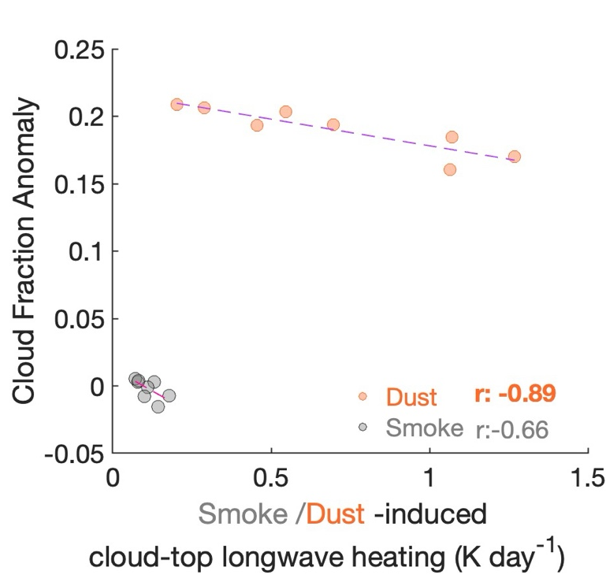
Figure S6: Scatter plot showing dependence of change in cloud fraction to aerosol-induced cloud top heating
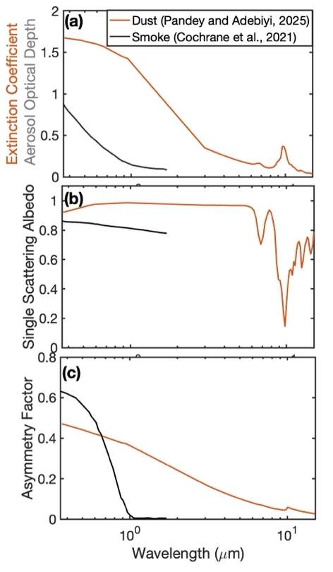
Figure S7: Spectrally variation of (a) extinction (b) single scattering albedo and (c) asymmetry parameter for dust (orange line) and smoke (black lines). Note, in panel (a) for smoke the variation is shown for observed smoke optical depth above low-level (Cochrane et al., 2021).
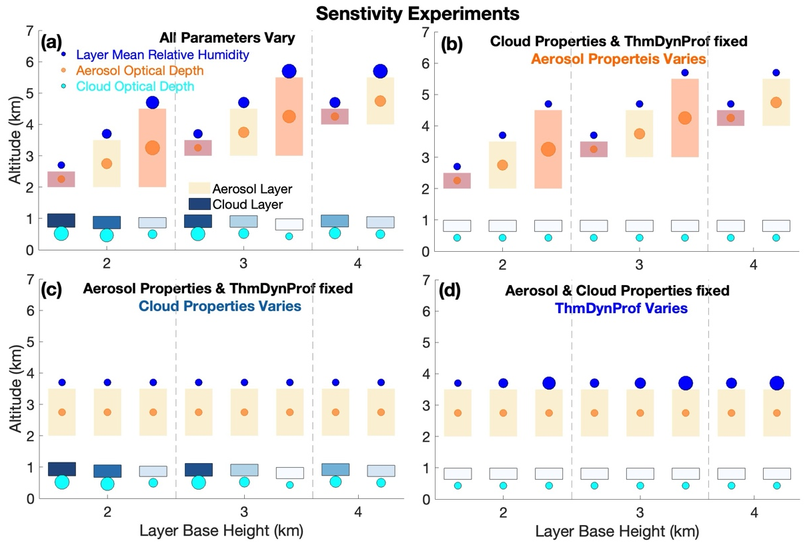
Figure S8. Schematic showing sensitivity experiments, (a) when all parameters were allowed to vary, (b) only aerosol properties, including vertical structure (bars) and aerosol optical depth (orange circles), (c) cloud properties, including cloud boundaries (cloud top and base heights, blue shaded boxes) and cloud optical depth (cyan circles), and (d) thermodynamic profiles (both temperature and humidity), keeping other parameters fixed. For convenience, mean layer relative humidity is plotted (blue circles) to show variation in thermodynamic profiles. The sizes of the circles are proportional to the values of the corresponding parameters, larger values for greater magnitude. Corresponding mean values of each parameter for smoke and dust are given in Table S2. For aerosol-layers equal thickness layers are shown by same colors and cloud layer is shaded proportional to cloud optical depth, darker shade means higher values.

Table S2. Values of aerosol optical depth, cloud optical depth and humidity used for the sensitivity simulations in SBDART.
 |  | Cat-1 | Cat-2 | Cat-3 | Cat-4 | Cat-5 | Cat-6 | Cat-7 | Cat-8 | Mean
Aerosol Layer Base |  | 2 | 2 | 2 | 3 | 3 | 3 | 4 | 4 | Mean
Aerosol Layer Geometric Thickness |  | 0.5 | 1.5 | 2.5 | 0.5 | 1.5 | 2.5 | 0.5 | 1.5 | Mean
Aerosol Optical Depth | Smoke | 0.07 | 0.17 | 0.34 | 0.07 | 0.18 | 0.27 | 0.09 | 0.19 | 0.17
Aerosol Optical Depth | Dust | 0.05 | 0.18 | 0.35 | 0.08 | 0.24 | 0.41 | 0.12 | 0.3 | 0.22
Cloud Optical Depth | Smoke | 7.95 | 7.57 | 6.04 | 7.82 | 6.41 | 5.61 | 6.84 | 6.05 | 6.79
Cloud Optical Depth | Dust | 6.95 | 6.39 | 4.76 | 6.36 | 5.52 | 4.82 | 6.7 | 6.3 | 5.98
Cloud Top Height (km) | Smoke | 1.15 | 1.07 | 1.03 | 1.12 | 1.09 | 0.99 | 1.11 | 1.06 | 0.99
Cloud Top Height (km) | Dust | 1.33 | 1.22 | 1.12 | 1.45 | 1.32 | 1.06 | 1.32 | 1.09 | 1.06
Cloud Base Height (km) | Smoke | 0.72 | 0.67 | 0.7 | 0.71 | 0.72 | 0.63 | 0.73 | 0.7 | 0.63
Cloud Base Height (km) | Dust | 0.84 | 0.79 | 0.71 | 0.94 | 0.86 | 0.7 | 0.86 | 0.71 | 0.7
Relative Humidity | Smoke | 0.3 | 0.35 | 0.45 | 0.34 | 0.39 | 0.5 | 0.38 | 0.5 | 0.4
Relative Humidity | Dust | 0.39 | 0.4 | 0.41 | 0.44 | 0.44 | 0.48 | 0.48 | 0.54 | 0.45

